L3 Multiple Choice Questions
- The primary winding of a transformer has a 120 V ac supply. What is the value of secondary voltage if the turn ratio is 10?
- 120 V
- 12 V
- 12000 V
- 1200 V
- Power transformers are designed to have maximum efficiency at
- No-load
- 60 % load
- 80 % load
- Full load
- 4) If the supply frequency (f) of a transformer decreases, the effect of frequency on the transformer's secondary output voltage?
- Remain the same
- Decreases
- Increases
- All of these
- Transformer core are laminated in order to
- Reduce copper loss
- Minimize eddy current loss
- Reduce eddy current and hysteresis loss
- Reduce hysteresis loss
- The short circuit test in the transformer is performed on
- High voltage side
- light voltage side
- Both
- Either option a or b.
- The secondary voltage is 440 Volt, and primary voltage is 220 Volt, then a comparison of the secondary coil and primary coil is
- 4/1
- 5/2
- 2/1
- 7/5
- The transformer ratings are expressed in terms of
- KW (Kilo-Watt)
- Volts
- KVAR (Kilo-Volt-Ampere-Reactive)
- KVA (Kilo-Volt-Ampere)
- Oil is provided in an oil-filled transformer for
- Lubrication
- Cooling
- Insulation
- Both cooling and Insulation
- The noise of the transformer primarily due to
- Mechanical vibration
- Cooling fan
- Magnetostriction in an iron core
- All of the above
- In a transformer, tapping’s are usually provided.
- High voltage side
- Low voltage side
- Primary side
- Both option a and b
- The Kirchhoff᾽s laws fail in
- Lumped parameters circuit
- Distributed parameters circuit
- Nonlinear circuits
- Linear circuit
- Bilateral circuit
- Which of the following statements is correct?
- The magnetic flux inside and exciting coil is greater than its outside surface.
- The magnetic flux inside and exciting coil is same as on its outside surface
- The magnetic flux inside an exciting coil is lower than its outside surface.
- The magnetic flux inside an exciting coil is zero
- The magnetic field around the conductor is determined by the
- Resistance divided by the current
- Current divided by the resistance
- Size of the conductor
- Amount of current
- Electromagnetic induction is related to
- Bohar
- Faraday
- Doppler
- Dalton
- What determine charge that flows through a circuit due to the induced EMF ?
- The rate change of magnetic flux
- The total change in magnetic flux
- The final magnetic flux
- The initial change in magnetic flux
- The magnitude of the induced emf in a coil is directly proportional to the rate of change of flux linkages. This known as
- Joule’s Law
- Faraday’s second Law of electromagnetic induction
- Faraday’s First Law of electromagnetic induction
- Coulomb’s Law
- Faraday’s laws are result of the conservation of which quantity?
a) Momentum
b) Energy
c) Charge
d) Magnetic field
- The induced emf persists only as long as the change in magnetic flux continues.
a) True
b) False
- A three phase induction motor is not self starting.
a) True
b) False
- Mark the correct waveform for the emf produced in an induction motor and the resultant flux density wave for a resistive load.
a) 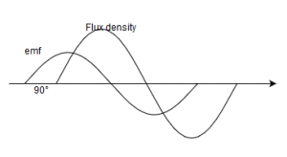
b) 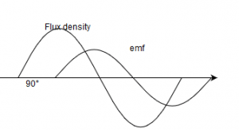
c) 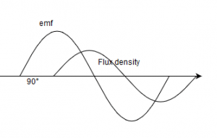
d) 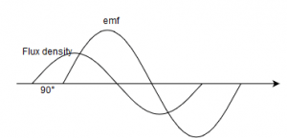
- Find the value of R if the power in the circuit is 1000W.
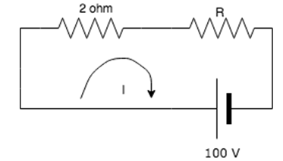
a) 10 ohm
b) 9 ohm
c) 8 ohm
d) 7 ohm
- Mesh analysis is generally used to determine_________
a) Voltage
b) Current
c) Resistance
d) Power
- What happens to the current in a coil while accelerating a magnet inside it?
a) Increases
b) Decreases
c) Remains constant
d) Reverses
- According to Faraday’s laws of electromagnetic induction, an emf is induced in a conductor whenever?
a) The conductor is perpendicular to the magnetic field
b) Lies in the magnetic field
c) Cuts magnetic lines of flux
d) Moves parallel to the magnetic field
- Direction of induced emf is determined by __________
a) Fleming’s left hand rule
b) Fleming’s right hand rule
c) Faraday’s law
d) Right hand thumb rule
- Magnetic field exists along which of the following?
a) Moving charges
b) Stationary charges
c) Copper
d) Iron
- When an electric current flows out of the page, what is the direction of the magnetic field?
a) Clockwise
b) Anti-clockwise
c) Cannot be determined
d) Parallel to the current
- Reluctance is ________________ to the area of cross section the material.
a) Directly proportional
b) Inversely proportional
c) Not related
d) Equal
- The electrical equivalent of reluctance is?
a) Resistance
b) Inductance
c) Capacitance
d) Conductance
- If the switch is opened, what is the current in the circuit?
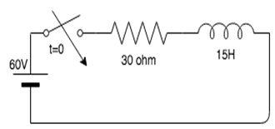
a) 0A
b) 1A
c) 2A
d) 3A
- What is the SI unit of mutual inductance?
a) Ohm
b) Henry
c) Volt
d) Siemens
- Practical application of mutual inductance is ____________
a) DC generator
b) AC generator
c) Transformer
d) Capacitor
- RMS stands for ________
a) Root Mean Square
b) Root Mean Sum
c) Root Maximum sum
d) Root Minimum Sum
- In an AC circuit, resistance 50 Ω, inductance 0.3 H and capacitance 15 μF is connected to an AC voltage source 25 V, 50 Hz. Determine the inductive reactance in the circuit.
a) 36 ohm
b) 95 ohm
c) 125 ohm
d) 140 ohm
- Quality factor is also known as _________
a) Voltage magnification
b) Current magnification
c) Resistance magnification
d) Impedance magnification
- Find the Q factor when the voltage across the inductor is 2000V and the source voltage is 100V.
a) 10
b) 20
c) 30
d) 40
- Maintenance helps an organization to ensure the health and safety of employees through:
a. Hazard identification and management
b. Achieving a competitive position
c. Increased efficiency and optimized cost
d. Improved safety at the workplace
- Which is a formal approach to increase the efficiency of the entire maintenance system by creating a balance between resources and requirements of maintenance?
a. Maintenance optimization
b. Precision maintenance
c. Maintainability improvement
d. Equipment improvement
- Who of the following is responsible for the maintenance of computer systems in an organization?
a. Network administrators
b. Office administrators
c. Store officers
d. Computer administrators
- A machine is said to be a quality machine if it meets the following requirements:
a. No downtime
b. No uptime
c. Working efficiency
d. Machine working
- An uninterrupted flow of production means:
a. Low cost
b. Efficient machines
c. Repair and maintenance
d. Cost incurred
- Sudden breakdown or failure results in considerable production loss represent which level of failure of machines?
a. Highly critical
b. Medium critical
c. Low critical
d. Normal
- A type of preventive maintenance wherein maintenance work is performed at regular time intervals is called:
a. Time-based preventive maintenance
b. Work-based preventive maintenance
c. Opportunity-based preventive maintenance
d. Condition-based preventive maintenance
- electrical shock can cause
- Hearing loss
- Death
- Blindless
- Chemical sensitivity
- Before using electrical tools
- Check the rating on the label
- Check for Brocken parts
- Check the handle is black
- All of the above
- Voltage at OR above which value below is considered hazardous
- 10 volts
- 30 volts
- 110 volts
- 240 volts
- Rubber soled shoes protect you from electrical shock
- True
- False
- Before plugging in an electrical tool OR appliance
- Check for broken plug
- Check for exposed wires
- Don’t over loud an outlet
- All of the above
- Which of the following problems can faulty electrical equipment cause?
- Shock.
- Fire.
- Explosion.
- All of the above
- The function of a fuse or circuit breaker is to interrupt the flow of electricity if the circuit becomes "overloaded"?
- True
- False

- What type of fire extinguisher should be used with electrical fires?
- Type A.
- Type B.
- Type C.
- Any of the above.

