Learner’s Guide

for

HOSPITALITY EXPERT
Date:

National Vocational & Technical
Training Commission

Introduction
Welcome to your Learner’s Guide for the hospitality expert programme. It will help you to complete the programme and to go on to complete further study or go straight into employment.
The hospitality expert programme is to engage young people with a programme of development that will provide them with the knowledge, skills and understanding to start this career in Pakistan. The programme has been developed to address specific issues, such as the national, regional and local cultures, the manpower availability within the country, and meeting and exceeding the needs and expectations of their customers.
The main elements of your learner’s guide are:
- Introduction:
  - This includes a brief description of your guide and guidelines for you to use it effectively
- Modules:
  - The modules form the sections in your learner’s guide
- Learning Units:
  - Learning Units are the main sections within each module
- Learning outcomes:
  - Learning outcomes of each learning units are taken from the curriculum document
- Learning Elements:
  - This is the main content of your learner’s guide with detail of the knowledge and skills (practical activities, projects, assignments, practices etc.) you will require to achieve learning outcomes stated in the curriculum
  - This section will include examples, photographs and illustrations relating to each learning outcome
- Summary of modules:
  - This contains the summary of the modules that make up your learner’s guide
- Frequently asked questions:
  - These have been added to provide further explanation and clarity on some of the difficult concepts and areas. This further helps you in preparing for your assessment.
- Multiple choice questions for self-test:
  - These are provided as an exercise at the end of your learner’s guide to help you in preparing for your assessment.

Module 1: Maintain professional standards and environment throughout shift
Objective of the module: The aim of this module to develop the knowledge, skills and understanding needed to maintain professional standards and environment throughout shift
Duration: | 120 hours | Theory: | 30 hours | Practical: | 90 hours

Learning Unit | Learning Outcomes | Learning Elements | Materials Required
LU1:  Ensure professional standards are maintained for uniform and hygiene throughout the shift | The learner will be able to:  Keep own self clean and hygienic  Follow the recommended procedures for washing hands at all appropriate times  Avoid any unsafe behaviour  Report any cuts, boils, grazes, injuries, illness and infections promptly to the appropriate person  Wear uniform that is clean, fit for use and worn correctly | The importance of keeping own self clean and hygienic, including having clean hair, skin and nails, minimal jewellery, for hygiene purposes, including preventing contamination of food being served  Recommended procedures for washing hands at all appropriate times, including wash hands for at least 20 seconds with antibacterial soap, washing whole hands thoroughly including the back of the hand, fingers, wrists, and forearms, palms and between fingers, where bacteria and pathogens tend to collect, dry in a sanitary manner: clean, unused paper towels or automatic hand dryer  Avoiding unsafe behaviour, including spitting, smoking, coughing, sneezing, touching own face, nose or mouth, blowing nose, scratching, chewing gum and eating, in order to prevent any contamination of food, equipment or work surfaces; organizational standards for safe behaviour in the work area  The importance of reporting cuts, grazes and skin conditions, illnesses (particularly stomach illnesses), and infections to the appropriate person (including supervisor/manager), in order to avoid any risk of spreading infection  Types of uniform which are appropriate to the task being carried out, appropriate to the organisation, aprons and overalls (for cleaning) in order to prevent accidents, protect the associate from spillages and to show any guests the hygiene values of the work area  The importance of ensuring that the uniform being used is clean and fit for use and changed when necessary in line with organizational procedures, in order to present a professional image and to avoid possible contamination of food through bacteria and germs carried on dirty clothing  Compliance with relevant regulations and standards | Equipment and materials for washing hands, including antibacterial soap, suitable wash basin, hand towels, hand dryers  Uniform according to job requirements, (appropriate to the organisation)  Hazard analysis and critical control points (HACCP) standards  Organisational guidelines for personal hygiene  Work area log to record injuries and illnesses
LU2:  Maintain the health, safety and security of the working environment | The learner will be able to:  Identify any hazards or potential hazards in the work area  Deal with identified hazards correctly  Report any accidents or near accidents quickly and accurately to the appropriate person  Follow the organization’s health and safety procedures in the work environment  Practice emergency procedures correctly  Follow the organization’s security procedures | The importance of working in a healthy, safe and hygienic way, including working tidily, following proper procedures and instructions, in order to avoid accidents and risks to guests  Taking personal responsibility, including taking reasonable care of own safety and the safety of others, following Standard Operating Procedures for safe working practice (including attending to spillages and slippery surfaces, using signs to warn others (including for spillages and wet floors), lifting and carrying, ensuring corridors and walkways are clear, care with lifting and carrying, seeking help when required), informing supervisor of anything that might be unsafe or cause an accident  Sources of information about health, hygiene and safety in the work area, including Standard Operating Procedures for work area, manuals, data sheet and instructions from manufacturers and suppliers, websites, training materials  Features of a healthy workplace, including suitable size; adequate lighting, heating and ventilation; safe floors (in good condition, ie not slippery, no torn or frayed carpeting, no obstructions), stairs, doors and windows; appropriate equipment that is regularly maintained; sufficient storage facilities; hygienic waste disposal facilities, assembly point for evacuations  The importance of warning other people (including verbally, using warning notices) about hazards, in order to avoid further accidents and injuries  Types of hazards to be found in the work area, including hazardous work areas (including slips; trips and falls; strains and sprains); sharp objects; cuts and lacerations; burns; hot food and service equipment; hazardous substances (including cleaning chemicals) or equipment, risks from working in a hurry (including hazardous work methods); fire risks (including hot stoves, electrical equipment); likelihood and potential impact of hazard  Methods to deal with hazards correctly, including removing or correcting the cause of risk, providing and using work area uniforms; working tidily, following proper procedures, warning others when necessary, providing additional training to use equipment and machinery correctly; maintaining equipment and machinery; adapting the workflow  Reducing the risk of working with hazardous substances (including cleaning chemicals), through proper training for using hazardous substances, following manufacturer’s guidelines and instructions for use, using appropriate protective equipment (including gloves, goggles, masks), using safe working methods  The importance of reporting all usual/non-routine incidents (including accidents, spillages and breakages, arguments, turning off dangerous equipment, removing dangerous items, dangerous work practices, theft) to the appropriate person (including supervisor/manager), in order to alert them to actions they may need to take  Ensuring relevant information is recorded in logs, including appropriate detail, people involved, time, actions taken, to ensure efficient operation  Types of emergencies that may happen in the work area, including fire, flood, accidents, gas leaks  Dealing with emergencies, including taking action within own responsibility, notifying engineering department, evacuating the area or building, ensuring security have been notified where necessary  The location of first aid equipment and the name of the first-aider in the work area  The importance of following fire safety laws (following safe working practice, preventing the build-up of rubbish, ensuring that flammable materials are not at risk, not smoking except in designated areas), in order to avoid risk to the lives of associates / guests and the fabric of the building  The organization’s emergency procedures, in particular for illness, fire, security, external emergency, tackling the emergency using relevant equipment (fire equipment properly maintained and in good working order, first aid equipment properly stocked)  Following emergency procedures, including alerting others, following instructions, taking action, evacuating the building  Compliance with relevant regulations and standards | Different types of emergency notices  Standard operating procedures for occupational health and safety  Fire equipment properly maintained and in good working order (See Complete list of tools and equipment for details)  First aid equipment properly stocked (see Complete list of tools and equipment for details)  Equipment for contacting security, including telephones and other electronic devices  Work area logs for recording accidents and incidents  Organisational procedures for dealing with emergencies and problems, including accidents, fire, evacuations  Organisational guidelines for responding to and reporting accidents  Contact details for colleagues, supervisors  Uniform according to job requirements  Case studies and other examples of health, safety and security incidents
LU3:  Communicate and work with associates and team efficiently and effectively throughout the shift | The learner will be able to:  Communicate efficiently with colleagues throughout shift  Work effectively as part of a hospitality team | The purpose (to support understanding) and benefits (to generate action) of making sure that communication delivers the ‘message’ in which it is intended to be received, using appropriate terminology  Appropriate methods of communication for work areas, including written, verbal, by telephone (or similar), guest’s order check, internal memo, e-mail, work area log; body language, visual signs  Appropriate styles of communication for different work area and other associates, including speaking, appropriate language use, tone, pitch, pace; listening skills, including asking associate appropriate questions, repeating back  Structuring work area communications so that they are clear and accurate (using technical language where appropriate), including making the topic clear, providing the message, obtaining a response  How non-verbal communication effects the impact of own behaviour on other people, including body language – posture/stance, facial expression, hand gestures, eye contact  Interpreting and responding positively to non-verbal communication, including showing understanding, providing positive body language in return  The purpose and benefits of giving work area and other associates the opportunity to ask questions and check their understanding, and the need to respond positively to these questions, including checking that the communication is properly understood and acted upon  The need for organizations to have a friendly and purposeful way of communicating with associates, including purpose (to support good open communications between associates and other departments) and benefits (to improve working relationships and create a better working environment)  Types of problems that may occur with contacts between associates – including conflict and aggression – and dealing with these, including developing better team-working skills, better use of communications, working with a supervisor as a broker, further training as required  Characteristics of a good team, including commitment to the work in hand, working together, good organisation, good communications  The benefits to self and own team for planning and organizing work, including smooth and effective service, developing good relations, improving guest service as a result  Making the most efficient use of own time, including good planning and preparation, avoiding things that may unnecessarily disrupt own time  Asking for help at the right time, including before and during service, when under pressure, particularly when asked to do something new, being uncertain, being unclear, not understanding  The benefits of effective teamwork, including efficient and effective working practice, correct timing of service, smooth service, high standards of service, good team spirit, shared responsibility for work effort of the work area  The responsibilities of the team and their importance to the organisation as a whole, including providing an efficient and effective service, cooperating with other team members, anticipating the needs of guests  Maintaining good working relationships with team members, including being reliable and organized, working methodically, helping others, sharing information, communicating clearly using technical language where appropriate  The scope and limits of job role, including duties and responsibilities, what can or cannot be done when helping team members  Essential information that needs to be passed on to a team member, including information about guests’ needs, information about the team (attendance and/or absence, illness, lateness) and the need to pass it on as soon as possible, in order to ensure an efficient and effective service and to plan and incorporate any necessary changes  The types of behaviour that help the team to work well (including being collaborative, supportive, communicative, attention to detail, honesty) and the types that do not (including having a selfish approach, not supporting others, being discourteous to other team members) | Pen  Note pads  Standard Operating Procedures for communication  Uniforms according to job requirements  Telephones / computers for phone messages and e-mails  Memo forms  Work area log for recording information
LU4:  Check that all products and equipment are in good order | The learner will be able to:  Ensure all products and equipment used are properly cleaned, well maintained and in good condition  Ensure that equipment and products are safely stored according to organizational requirements  Record any problems with the condition or function of any products or equipment and report them to the supervisor  Report any maintenance issues to the engineering department and to the next shift for appropriate follow up | Using equipment checklists to check that equipment used is properly cleaned, well maintained and in good condition, by proper preparation, additional cleaning of equipment if required, testing operation of electrical or mechanical equipment  Store equipment safely according to organizational requirements, including checking equipment is clean before storage, fitting protective covers where appropriate, storing in store cupboards, on shelving near work area  Recording and reporting any problems, including with the condition or function of any products or equipment, breakages, electrical faults, maintenance issues, by advising supervisor, checking that the problem is entered in work area log, ensuring that other departments (eg engineering) are advised through the work area log  Checking that any problems reported previously have been dealt with, by checking in the log and confirming that appropriate action has been taken  Compliance with relevant regulations and standards | Equipment checklists  Manufacturers’ guidelines for using equipment  Cleaning equipment, including small equipment (cloths, dusters, mops, brushes, buckets, hand-held cleaning spray), large equipment (dishwashers, jet washers, wet and dry vacuum cleaners)  Cleaning materials, including sanitizer, detergents, disinfectants, vinegar, lemon, degreaser  Work area log for recording problems and maintenance issues  Pen  Uniforms according to job requirements
LU5:  Dispose of waste | The learner will be able to:  Wear appropriate clothing  Prepare the waste for dispatch making sure you handle it carefully  Sanitize the waste containers following your workplace procedures | The impact of work area waste, including lost income through food or other resources being thrown away, cost of waste removal to the organization, impact on the environment, potential to attract pests  Disposing of work area waste promptly, hygienically and appropriately, including disposal or recycling as appropriate  Opportunities for waste reduction in the work area, including careful ordering of food for guests (not ordering wrong dishes), careful use of disposable and consumable items, including paper serviettes, drinks coasters, tray papers, effective use of cleaning materials and paper, taking care of equipment  Opportunities for avoiding and reducing work area waste through reuse and recycling, storing equipment properly  Potential barriers that may limit waste avoidance and reduction in the work area, including poor training, failure to follow proper procedure, broken or missing waste disposal equipment  Roles and responsibilities for work area associates to support waste minimization, including taking own responsibility for managing waste in own work area  Training needs and training for those work area associates responsible for reducing waste  Benefits achieved through work area waste reduction measures, including cost reductions for the organization, improved profitability, tidy work areas, benefits for the environment | Organizational policy and procedures for disposing of waste  Tools and equipment for disposing of waste, including waste disposal units, recycling bins  Standard Operating Procedures for work area and for waste handling  Uniforms according to job requirements
LU6:  Maintain tools and equipment | The learner will be able to:  Check the condition of tools and equipment on a regular basis  Keep tools and equipment clean and free from dust and debris  Use suitable tests to check the condition of tools or equipment  Arrange for repair or replacement of faulty tools or equipment  Follow safe working practices when maintaining tools and equipment | Types of tools and equipment, including electrical, manual, specific to work area  Checking the condition of different sorts of tools and equipment, including usage, major or minor damage, testing and dismantling, frequency of checks  The implications are of not maintaining tools and equipment, including breakdowns, loss of service, accidents and injuries  The implications are of not keeping tools and equipment clean, including failures, breakdowns  Storing tools and equipment properly, including proximity to area of use, labeling of cupboards, cleanliness of storage area  Recognizing tools and equipment that are damaged or need maintenance, including poor operation, frayed cables, damaged housings  Potential hazards that can arise from defective and faulty tools and equipment, including misuse, poor maintenance or storage | Organizational policy and procedures  Operating manuals and specifications for tools and equipment  Cleaning and storage equipment and facilities

Examples and illustrations

VIDEOS:
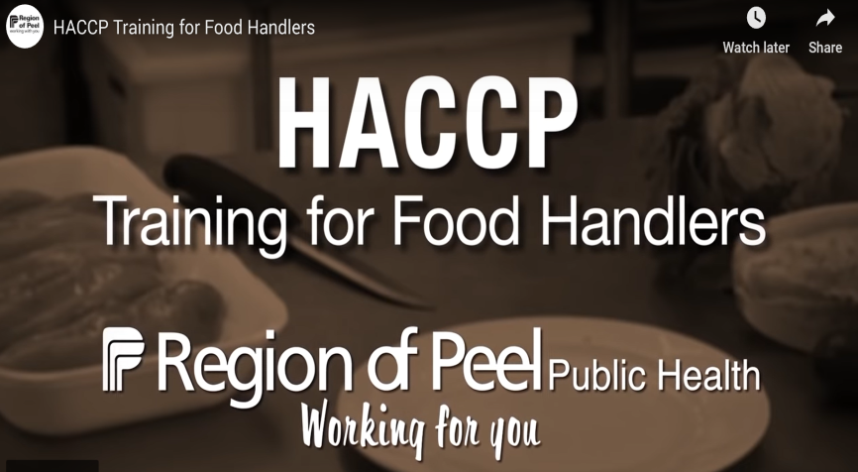 | HACCP Training for Food Handlers  https://www.youtube.com/watch?v=mE-q9W4jqQg
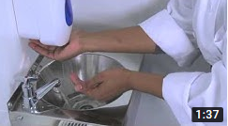 | Food safety coaching (Part 1): Handwashing  https://www.youtube.com/watch?v=cCpr11OuYKI
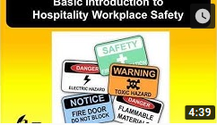 | Workplace health and safety - hospitality  https://www.youtube.com/watch?v=i061VSFh1OI

Emergency notices
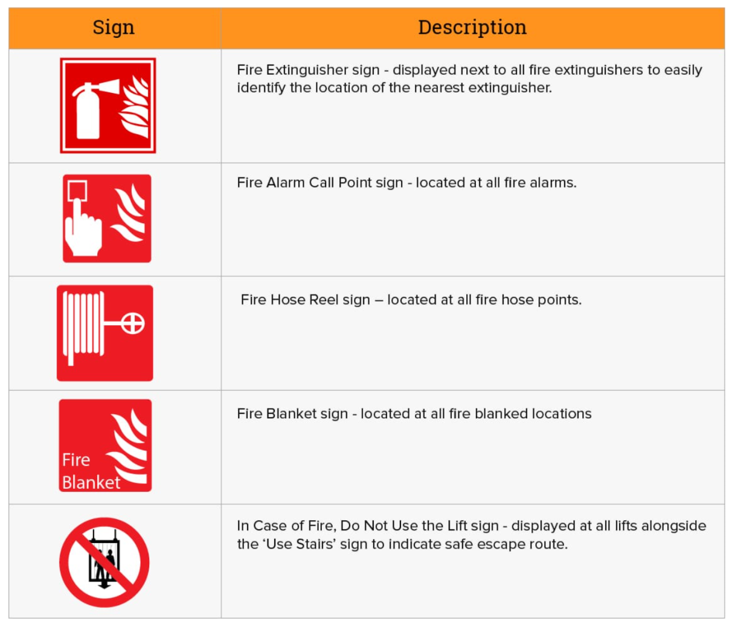
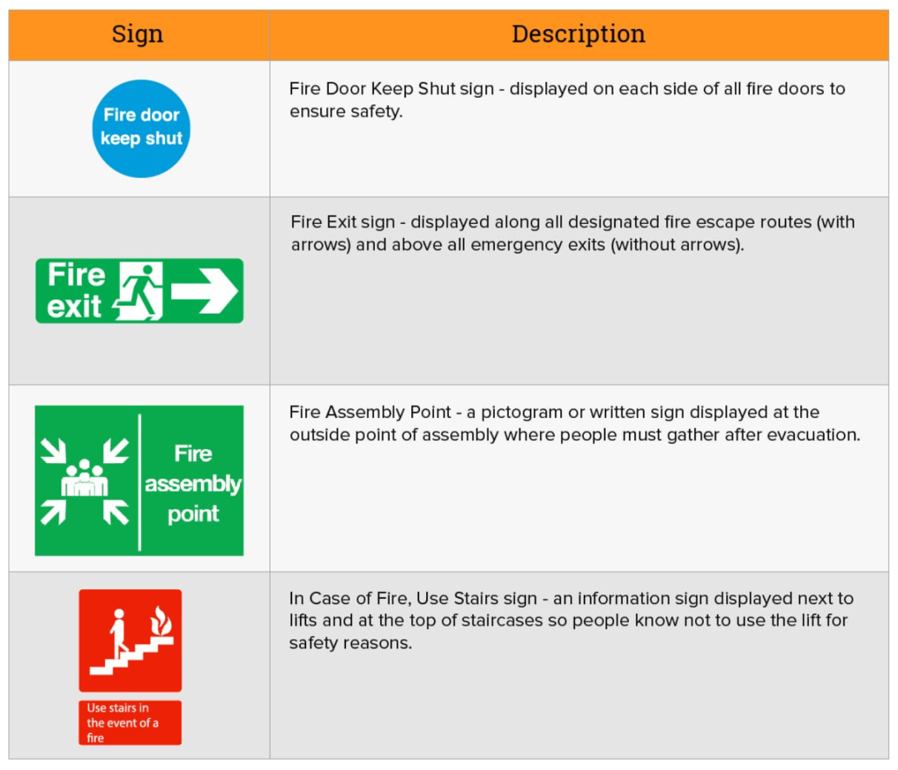
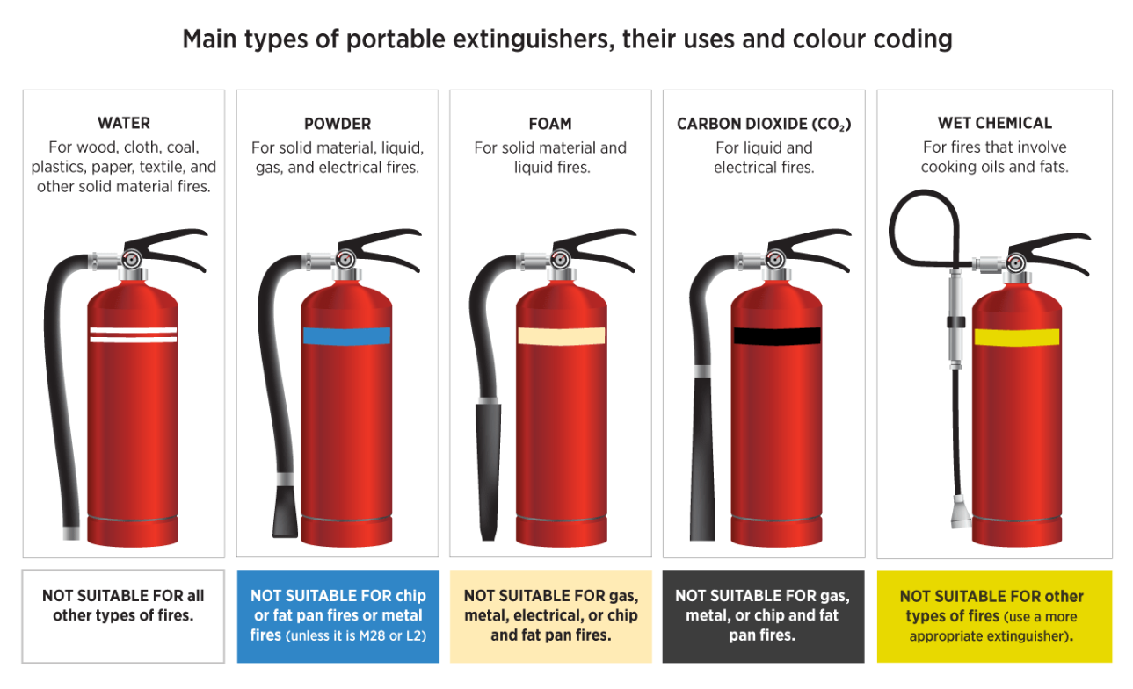
For more detailed information, please visit https://www.highspeedtraining.co.uk/hub/fire-safety-signs/

First aid equipment

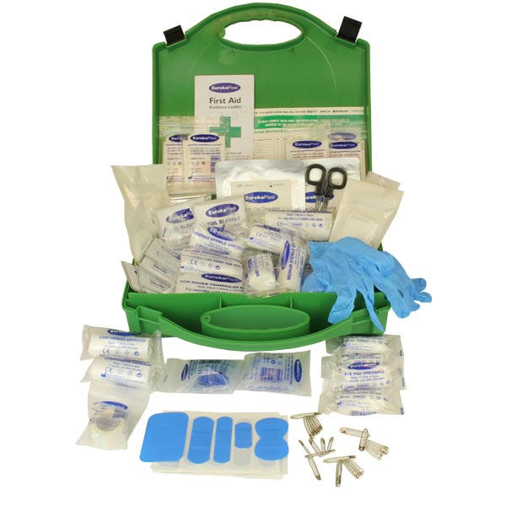
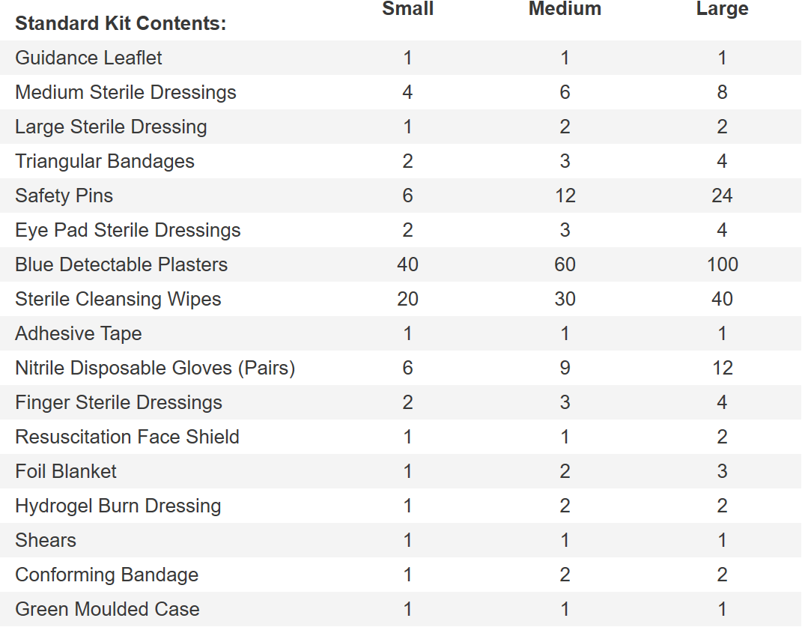
For more detailed information, please visit
https://www.eurekadirect.co.uk/First-Aid-Kits-Cabinets/Catering-First-Aid-Kits/Catering-Kit-BS85991-Compliant-Standard-Case

Accident and incident log
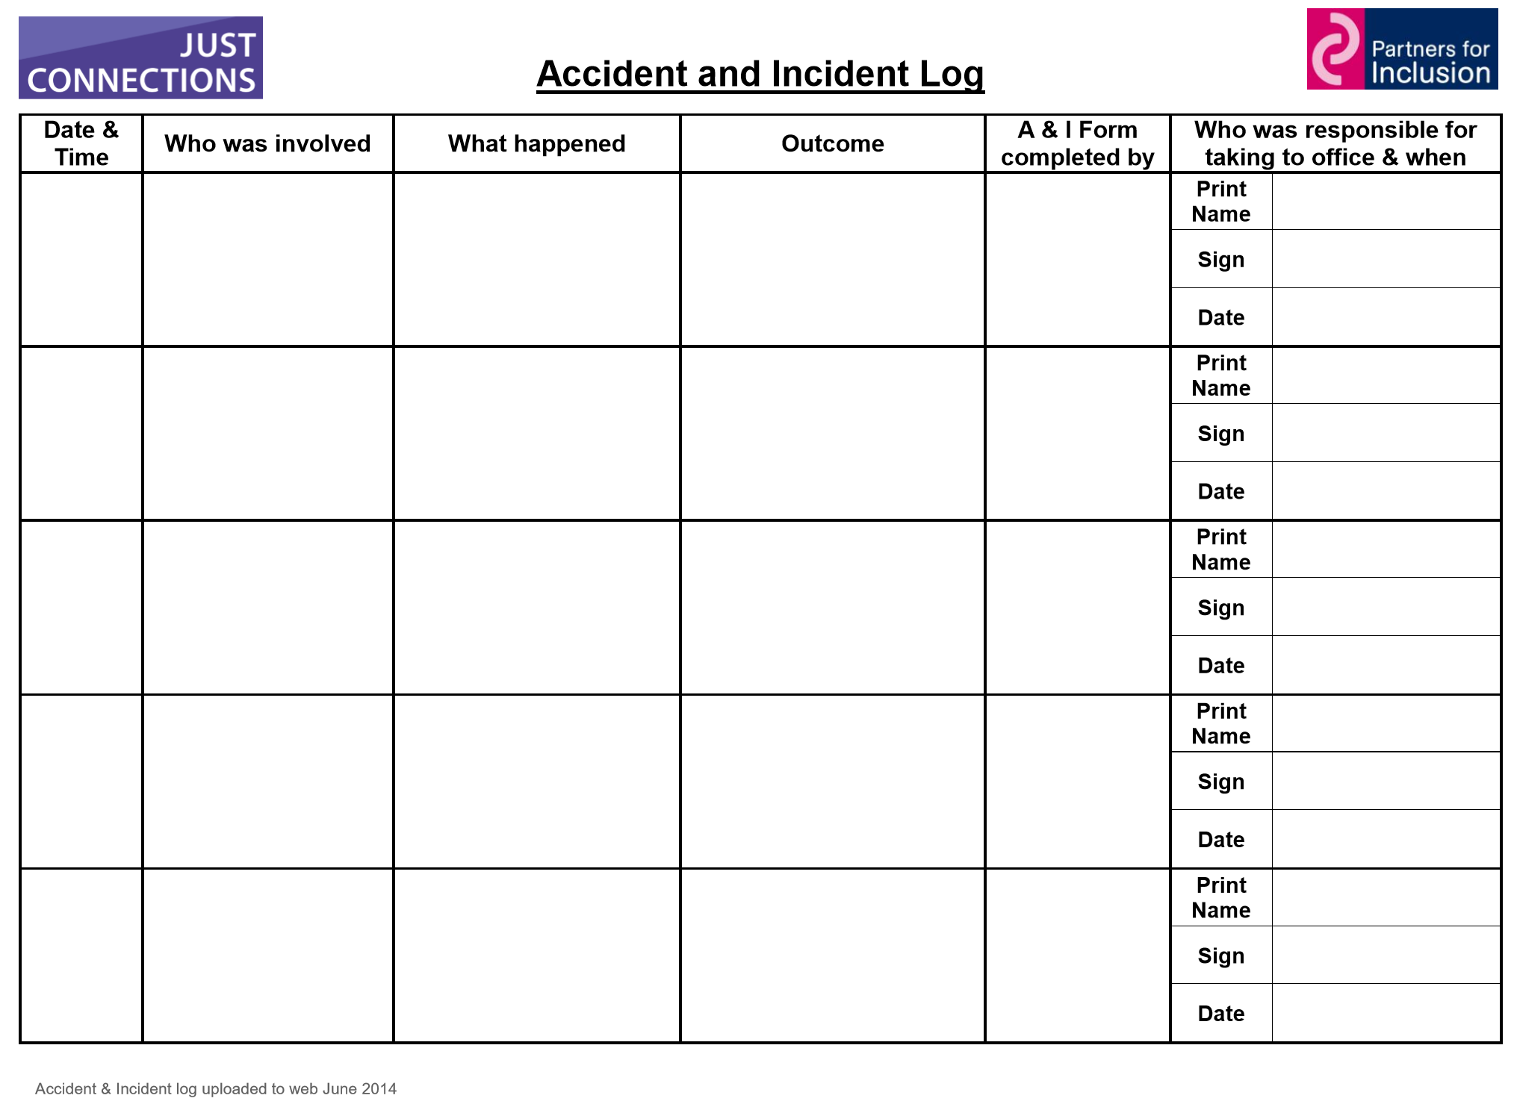
For more detailed information, please visit www.partnersforinclusion.org/

Creating a set of service standards
For more information, please visit https://www.instituteofcustomerservice.com/research-insight/guidance-notes/article/setting-customer-service-standards
There are at least seven potential sources of information to help define the service standards for an organisation:
- Management
- Employees
- Existing customers
- Potential customers
- Lost or former customers
- Competitors
- Regulatory authorities

Management
You should seek information from different levels of management. However, do not rely solely on management input – existing customers are a better source.

Employees
This group is too often overlooked – ‘what do they know?’ is a view that has been expressed.
In fact, employees interact with customers every day, so they're are a really valuable source of information and will expect to contribute to the process.

Existing customers
These are a rich source of information. A few focus groups will usually generate an excellent set of customer expectations.

Lost or former customers
Why did these customers not return? They will probably be pleased to tell you.

Potential customers
What can you learn from people who are choosing an alternative supplier?
The sales team may give you some input but there is no substitute for direct input from prospects.

Competitive information
Mystery shopping and monitoring competitors' web sites and literature can reveal useful input.

Regulatory authorities
The activities of some types of business are governed by a regulator who sets service standards that must used.

Restaurant hazards
Workers in restaurants are exposed to shocks and electrical hazards from:
- Worn electric cords or improperly used or damaged extension cords
- Improperly wired or ungrounded outlets
- Faulty equipment and wiring
- Damaged receptacles and connectors
- Wet clean-up processes
- Unsafe work practices

10 common office hazards – and how to reduce their risks
Office environments are generally considered low-risk workplaces, but this doesn’t mean you should neglect your health and safety duties.
Offices still contain health and safety hazards which need to be monitored and controlled.
Just the same as any workplace, offices need to have hazards identified and risk assessments carried out in order to implement control measures to reduce the likelihood of a workplace incident occurring.
Look for these common hazards in your office:
- poor or inadequate lighting;
- ergonomic hazards;
- extremes of temperature;
- manual handling hazards;
- slip, trip and fall hazards;
- electrical hazards (e.g. appliances, power sockets, etc.);
- contagious illnesses spread by sick workers;
- fire hazards;
- chemical hazards (e.g. cleaning products); and
- stress hazards.
Stress hazards can be difficult to identify – make sure you take the proper action to identify and remove stress hazards for your workers.
What to do once you have identified a hazard in your office…
All health and safety hazards, once identified, need to be risk assessed and controlled. To do this you need to determine the likelihood of the risks causing serious injury and, based on the assessment, put control measures in place to reduce or eliminate the risks.
After implementing control measures, it’s essential that you monitor and review them to ensure they remain effective.
Remember, other hazards may also exist for office workers while they are outside the workplace, including people working from home and workers who attend work-related social functions. Although liability can be a grey area, you still have an obligation to manage the health and safety of workers in these scenarios. As long as the connection can be made between employment and an incident, you may be liable and, therefore, you need to manage the risks.
For more information, please visit https://www.healthandsafetyhandbook.com.au/10-common-office-hazards-and-how-to-reduce-the-risk/

Daily briefings
A daily briefing (with the whole team if numbers are small enough to make this logistically possible is ideal, or by department) can update everyone on anything that affects that day’s operation. It’s also a great way to get feedback from them too on things that need addressing sooner rather than later.
Cover such information as:
- VIP guests
- Special needs (e.g. disabled guests, special diets)
- Regular guests and any known preferences, so staff can anticipate their requirements
- Today’s menu and tasting, with details of all the ingredients of each dish, what to promote today, and what’s in short supply (even if only one dish has changed from yesterday’s menu, make sure it is communicated)
- Staff shortages, and cover of responsibilities
These actions ensure your staff are fully briefed and competent to deal with any guest’s queries or concerns.
A daily briefing also provides an opportunity for you to get feedback on any guest comments. You can discuss any questions or suggestions your team may have about operational issues that could have a bearing on the level of service or sales potential of the hotel. So, even on your busiest mornings make sure these briefings still happen – it’s generally on the days that are your busiest that things go wrong, and it’s generally your busiest days when you have the best opportunities for increasing sales.
For more detailed information, please visit https://www.naturallyloyal.com/hotel-leadership-daily-briefings/

Module 2: Develop communication and social skills for hospitality
Objective of the module: The aim of this module to develop the knowledge, skills and understanding needed to develop communication and social skills for hospitality
Duration: | 60 hours | Theory: | 15 hours | Practical: | 45 hours

Learning Unit | Learning Outcomes | Learning Elements | Materials Required
LU1:  Develop and use communication skills in a hospitality setting | The learner will be able to:  Understand the expectations of guests and associates in a hospitality setting  Develop technical and social communication skills  Apply communication skills in a hospitality setting | Expectations of guests and associates, including being treated with dignity, respect, understanding and kindness, professionalism  Product and service knowledge to support communication skills, including information about the guest’s booking, information about the organization’s services, knowledge of associates’ job roles and responsibilities  Effective communication skills, including asking questions to find information, listening, giving information; technical, using technical terminology with associates when appropriate, avoiding using jargon when communicating with guests  Seeking information, including using open questions (beginning with ‘Who…’, ‘Where…’, ‘What…’, ‘When…’, ‘Why…’, ‘Which…’, ‘How…’); and using closed questions (that produce a response of ‘Yes’ or ‘No’)  The need to seek information, including obtaining new information, checking or confirming details  Understanding body language, including movements, gestures, facial expressions and shifts in the guest’s or associates body position or stance; standing straight but relaxed, facing the guest or associate directly, maintaining eye contact  Listening skills, including maintaining eye contact with the guest or associate, avoiding distractions and concentrating, showing interest by using body language, summarizing what has been said, letting the guest or associate finish speaking / not interrupting  Giving information, including information that is required, focusing on the information needed, being brief and to the point, confirming that the information given is appropriate, checking that the guest or associate is satisfied with the information given, asking questions to confirm  Barriers to good communications, including complicated messages or language, incorrect or inappropriate use of technical terminology or jargon, disregard for the needs of the guest or associate, fatigue, disinterest, poor listening skills, bad prior experiences with the guest or associate, noise or other distractions  Opportunities to apply social communication skills, including for newly arriving guests, guests already using hospitality services, guests who are leaving, associates needing help or support, new associates  Using social communication skills to manage difficult situations, including handling problems or complaints, handling conflict with a guest or associate, finding solutions | Copies of hotel brochures, menu, drinks list, function planner, room service menus, other promotional materials  Organisation’s guest service policy  Organisation’s aims and objectives statement  Guest services resources, handouts, articles, journals  Uniforms according to job requirements
LU2:  Develop and use social skills in a hospitality setting | The learner will be able to:  Understand the principles of developing and maintaining good relationships with guest and associates  Develop social skills  Apply social skills in a hospitality setting | Principles of developing and maintaining good relationships with guest and associates, including maintaining and enhancing self-esteem, listening and responding with empathy, checking understanding  Developing social skills, including good personal presentation, active listening, being objective, being assertive, being interested in the guest or associate, giving own name to support good relationships, maintaining eye contact at appropriate times  Asking for feedback, including from supervisor, from other associates, recognizing strengths and weaknesses of own social skills  Barriers to developing social skills, including lack of confidence, limited product or service knowledge, aggressive guests or associates, lack of support from supervisor  Opportunities to apply social skills in a hospitality setting, including with new or regular guests, with new or regular associates, with supervisor | Copies of hotel brochures, menu, drinks list, function planner, room service menus, other promotional materials  Organisation’s guest service policy  Organisation’s aims and objectives statement  Guest services resources, handouts, articles, journals  Uniforms according to job requirements
LU3:  Deal with guest complaints and complements | The learner will be able to:  Solve problems for guests  Handle complaints and complements within own role  Record information according to organizational procedures | Improving guest loyalty working relationships with service partners or associates by solving problems, including availability of organization’s services, timing of service  Identifying problems, including by communicating with guests, observing body language, sharing information with other associates  Negotiating with and reassuring guests while their problems are being solved, including keeping the guests informed in a positive and clear manner, including informing them of steps being taken to solve any service problems, prompt and polite advice to guest, ensuring supervisor is aware of the situation and monitors it  Securing agreement for the solution with guests or own supervisor, including verbally and in writing as required  Repeated guest service problems, including timing of service, quality of service, speed of service, problems with customer needs  Options for dealing with and avoiding repetition of a repeated guest service problem, including better briefing, more staffing, changes to services provided, changes to workflow patterns and procedures, better working practice, additional training  Identifying best options for solving a repeated guest service problem, including balancing guest expectations with the needs of the organisation  Obtaining the approval of somebody with sufficient authority to change organizational guidelines in order to reduce the chance of a problem being repeated, including providing appropriate details of problems, suggesting solutions  Monitoring the changes made to guidelines and adjusting them if appropriate  Handling complaints, including the importance of listening carefully to the complaint or complement being made by the guest, responding with empathy, apologizing for the situation or problem, suggesting and agreeing actions to resolve the complaint or problem, taking appropriate action promptly  Recording details of the complaint or complement according to organizational procedures, including making appropriate entries in the log  Actions to take resolve or progress the complaint or complement within the limits of own authority, including correcting simple errors, suggesting alternative courses of action  The importance of advising own supervisor in cases where resolving or progressing the complaint or complement is beyond the limits of own authority, in order to support resolution of the complaint and keep the guest satisfied  Ensure guest is informed of action taken as a consequence of making the complaint, including communicating verbally or in writing as required  Compliance with relevant regulations and standards | Work area log for recording guest complaints and complements  Organisation’s guest service policy  Organization’s aims and objectives statement  Organizational procedures for dealing with problems  Menus, drinks lists, brochures, prices (including room rates), other promotional materials (including posters, blackboard / whiteboards, illustrated menu boards, vouchers and loyalty cards, additional promotional information)  Guest services resources, handouts, articles, journals  Uniforms according to job requirements (appropriate to the organization)

Examples and illustrations
How should an organization communicate information to employees?
For more information, please visit https://smallbusiness.chron.com/effective-communication-methods-organization-2.html
Be timely. Do your best to ensure that employees hear news and information from you, not a third party. If the information is confidential, say so. People are known to be trustworthy with sensitive information; in fact, they're often flattered by the extension of trust. They tend to gossip and spread rumors in the absence of information.
Be honest. You may or may not subscribe to the idea of “transparency.” There may be times when you cannot, or should not, communicate certain information to your employees. But the information you do impart must be honest for you to be viewed as credible.
Be factual. Your credibility also depends on the quality of the information you provide. So if a third-party source bolsters your case, by all means, use it as support.
Be purposeful. Your employees should never be left to wonder, “What was the point of that?” In fact, you should have a clearly defined purpose before you even plan the content of a written or verbal message.
Be clear. Easier than it sounds, as clarity often comes with practice. Grease your learning curve by using simple, precise language and avoiding complex terms. This is not to say you should “dumb down” messages; your employees are probably highly astute. But if you fear that an idea or concept may create confusion, back it up with an illustration or example so your message is understood.
Be fair and respectful. Present all sides of a situation, and avoid biased, derogatory and hurtful language. It may help to remember that as a small business owner, you set the tone for your organization. And if your employees hear you, for instance, openly disparage a competitor, they will probably feel entitled to do the same.
Be confident. If you're not sure about the timing, nature or content of a message, follow your better instincts and give the matter more thought before you act. People are often quick to pick up on hesitation and uncertainty, and such doubts will almost certainly undermine your message.

Top ten best communication skills
For more information, please visit https://www.thebalancecareers.com/communication-skills-list-2063779
1. Listening
Being a good listener is one of the best ways to be a good communicator. No one likes communicating with someone who cares only about putting in her two cents and does not take the time to listen to the other person. If you're not a good listener, it's going to be hard to comprehend what you're being asked to do.
Take the time to practice active listening. Active listening involves paying close attention to what the other person is saying, asking clarifying questions, and rephrasing what the person says to ensure understanding ("So, what you're saying is…"). Through active listening, you can better understand what the other person is trying to say, and can respond appropriately.
2. Nonverbal Communication
Your body language, eye contact, hand gestures, and tone of voice all colour the message you are trying to convey. A relaxed, open stance (arms open, legs relaxed), and a friendly tone will make you appear approachable and will encourage others to speak openly with you.
Eye contact is also important; you want to look the person in the eye to demonstrate that you are focused on them and the conversation (however, be sure not to stare at the person, which can make him or her uncomfortable).
Also, pay attention to other people's nonverbal signals while you are talking. Often, nonverbal signals convey how a person is really feeling. For example, if the person is not looking you in the eye, he or she might be uncomfortable or hiding the truth.
3. Clarity and Concision
Good verbal communication means saying just enough – don’t talk too much or too little. Try to convey your message in as few words as possible. Say what you want clearly and directly, whether you're speaking to someone in person, on the phone, or via email. If you ramble on, your listener will either tune you out or will be unsure of exactly what you want.
Think about what you want to say before you say it. This will help you to avoid talking excessively and/or confusing your audience.
4. Friendliness
Through a friendly tone, a personal question, or simply a smile, you will encourage your co-workers to engage in open and honest communication with you. It's important to be nice and polite in all your workplace communications. This is important in both face-to-face and written communication. When you can, personalize your emails to co-workers and/or employees – a quick "I hope you all had a good weekend" at the start of an email can personalize a message and make the recipient feel more appreciated.
5. Confidence
It is important to be confident in your interactions with others. Confidence shows your co-workers that you believe in what you’re saying and will follow through. Exuding confidence can be as simple as making eye contact or using a firm but friendly tone. Avoid making statements sound like questions. Of course, be careful not to sound arrogant or aggressive. Be sure you are always listening to and empathizing with the other person.
6. Empathy
Using phrases as simple as "I understand where you are coming from" demonstrate that you have been listening to the other person and respect their opinions.
Even when you disagree with an employer, co-worker, or employee, it is important for you to understand and respect their point of view.
7. Open-Mindedness
A good communicator should enter into any conversation with a flexible, open mind. Be open to listening to and understanding the other person's point of view, rather than simply getting your message across. By being willing to enter into a dialogue, even with people with whom you disagree, you will be able to have more honest, productive conversations.
8. Respect
People will be more open to communicating with you if you convey respect for them and their ideas. Simple actions like using a person's name, making eye contact, and actively listening when a person speaks will make the person feel appreciated. On the phone, avoid distractions and stay focused on the conversation.
Convey respect through email by taking the time to edit your message. If you send a sloppily written, confusing email, the recipient will think that you do not respect her enough to think through your communication with her.
9. Feedback
Being able to appropriately give and receive feedback is an important communication skill. Managers and supervisors should continuously look for ways to provide employees with constructive feedback, be it through email, phone calls, or weekly status updates.
Giving feedback involves giving praise as well – something as simple as saying "good job" or "thanks for taking care of that" to an employee can greatly increase motivation.
Similarly, you should be able to accept and even encourage, feedback from others. Listen to the feedback you are given, ask clarifying questions if you are unsure of the issue, and make efforts to implement the feedback.
10. Picking the Right Medium
An important communication skill is to simply know what form of communication to use. For example, some serious conversations (layoffs, resignation, changes in salary, etc.) are almost always best done in person.
You should also think about the person with whom you wish to speak, if they are a very busy person (such as your boss, perhaps), you might want to convey your message through email. People will appreciate your thoughtful means of communication and will be more likely to respond positively to you.

Top 6 social skills?
For more information, please visit https://www.self-confidence.co.uk/articles/6-key-social-skills/
1) The ability to stay calm in social situations
Regardless of how many social skills you have; if you’re anxious then your brain won’t work properly. It’s always harder to think and speak clearly when we become agitated. So calming down is vital. But relaxing in social situations helps in another way too.
If your body and face give the unconscious message that you’re nervous, it will be more difficult for others to relax with you making harder for you to build rapport with them.
People make a huge mistake though when they assume that gaining good social skills is just about starting to speak well. Take a look at the next skill:
2) Listening skills: The art of connection
There is little more attractive and seductive than being truly listened to. Good listening skills include:
- Making 'I'm listening' noises - 'Uh-huh', 'really?', 'oh yes?' etc.
- Feeding back what you've heard - "So he went to the dentist? What happened?"
- Referring back to others' comments later on - "You know how you were saying earlier…"
- Physical stillness, eye contact and attentiveness while the other person is talking.
- To listen well to others you need to develop real interest in them.
3) Empathy with and interest in others' situations
A major part of social anxiety is self-consciousness, which is greatly alleviated by focusing strongly on someone else. A fascination (even if forced at first) with another's conversation not only increases your comfort levels, it makes them feel interesting. I never worry what I’m going to talk about because I know I can get other people to talk.
The best social situations are the ones in which you actually forget about yourself and become focused on what is going on and other people. A major social skill is being able to focus outward.
4) Knowing how to build rapport
Rapport is a state of understanding or connection that occurs in a good social interaction. It says basically "I am like you, we understand each other". Rapport occurs on an unconscious level, and when it happens between two people you can see it because, the language, speech patterns, body movement and posture of the two people seem to mirror and match.
Rapport is an unconscious process, but it can be increased as part of social skills training. Practice the following:
- Body posture 'mirroring', or movement 'matching'. When you are within someone match their body posture and expressions. Don’t mimic too closely this is supposed to have an unconscious effect.
- Reflecting back language and speech, including rate, volume, tone, and words.
- Feeding back what you have heard.
- Think about building rapport and you’ll feel naturally more socially confident as you’ll be focusing outward.
5) Knowing how, when and how much to talk about yourself - 'self disclosure'
Talking about yourself too much and too early can be a major turn-off for the other party in conversation. Good initial small-talk is often characterized by discussion of subjects not personal to either party, or by an exchanging of personal views in a balanced way. Immediately describing your deepest desires and darkest fears to a stranger may freak them out.
However, as conversations and relationships progress, disclosing personal facts (small, non-emotional ones first!) leads to a feeling of getting to know each other.
6) Look into their eyes and smile
If you don't look at someone when you are talking or listening to them, they’ll feel:
- You are ignoring them
- You are untrustworthy
- You don't like the look of them (!)
This doesn't mean you have to stare at them. Too much eye contact too early on in a relationship can be unsettling too.

Module 3: Deliver effective guest service
Objective of the module: The aim of this module to develop the knowledge, skills and understanding needed to deliver effective guest service
Duration: | 60 hours | Theory: | 15 hours | Practical: | 45 hours

Learning Unit | Learning Outcomes | Learning Elements | Materials Required
LU1:  Deliver effective and efficient service for guests | The learner will be able to:  Develop and maintain positive working relationships with guests  Deliver effective guest service at all times  Give guests a positive impression of self and the organisation | Types of guest, including individuals, business people, families, the elderly, disabled people, young people, foreigners  Creating a good first impression, including smiling, a neat uniform, a clear speaking voice, positive body language  The methods of communication available for work areas, including written, verbal, by telephone (or similar electronic system), guest’s reservation or order check, internal memo, work area log; body language, visual signs; using appropriate social communication skills with guests, using technical communication skills with associates and supervisors  Promoting a positive image of own self and the organization, including personal presentation, prompt attention, good social communications with guests, in order to provide efficient and effective guest service and to develop good relationships with guests and associates  Developing and promoting trust and respect with guests, including providing prompt and courteous attention, accurate information, maintaining good communications, informing the guest promptly of any problems  The importance of listening to requests and adhere to any promises made in a timely manner, in order to ensure a smooth and efficient service  The importance of having reliable and fast information for guests and the organization, in order to ensure that services are effective and efficient for both the organization and the guest  Responding appropriately to guests when they make comments about the products or services being offered, including thanking them for their feedback, advising supervisor, recording the information  Communicating positive and negative feedback from guests to others, including in writing, verbally, by ensuring the feedback is recorded in the work area log; providing accurate guest service information to others  The importance of sharing information with colleagues when appropriate and useful to the organisation, including verbally, in writing, through the work area log, in order to deliver and improve excellent guest service  Re-organizing own work to respond to unexpected additional workloads, including planning ahead, prioritizing work, asking for assistance at busy periods  The organization's guidelines for recognizing what the guest wants and responding appropriately, in order to meet guest needs and present a good image of the organization  Adapting behaviour to respond effectively to different guest behaviour, including angry, upset, rude or confused guests, guests in a hurry  Explaining carefully information that the guest might find complicated, in order to ensure understanding and support good guest service, and checking that they fully understand, including asking questions, watching body language  Adapting communication methods to suit the needs of guests and associates with different cultures or backgrounds, in order to support understanding and show respect for individuals and cultures  Innovative methods of improving relationships with guests, including offering and providing extra services, to enhance the guest experience and exceed guest expectations  Compliance with relevant regulations and standards | Record of guest reservations  Record of guest needs, likes and dislikes  Copies of menu, drinks list, function planner, brochures and price lists, other promotional materials  Organization’s guest service policy  Organization’s aims and objectives statement  Guest services resources, handouts, articles, journals  Uniforms according to job requirements (appropriate to the organisation)
LU2:  Meet and exceed guest expectations | The learner will be able to:  Promote additional services or products to guests  Deal with guests across a language divide  Support the improvement of service reliability for guests | Knowledge of the organization’s services or products and identifying ones that may interest the guest, including upgraded rooms, special dishes, special events, promotional offers; showing the guest a room or dish, drawing a picture  Introducing additional services or products to guests, including verbal suggestions or with support from brochures, price lists, menus, beverage lists and other promotional materials, outlining their benefits, overcoming resistance, agreeing to provide the additional services or products  Giving the guest time to ask questions about the additional services or products, in order to provide full information  Giving information to move the situation forward when the guest shows interest, including additional information, asking questions to identify guests’ needs and interests  Taking action to ensure prompt delivery of the additional services or products to the guest, including prompt service from work areas, recording guest wishes or new reservations in log or reservations system  Referring the guest to others (including supervisor or other associates) or to alternative sources of information (including website, promotional materials) if the additional services or products are not own responsibility  The languages that team is most likely to encounter among groups of the guests, including Urdu, English, other major international languages  Greeting guests (including individuals, groups), thanking and saying farewell to guests in their first languages, by learning and practicing common phrases in other major languages  The importance of identifying the guest's first language and indicating awareness of this to them, in order to support good guest service, develop good guest relations and ensure good communications  The benefits of dealing with guests in their first language if possible, including obtaining and giving accurate information  The importance of agreeing with colleagues informal signing options that may be used for key aspects of the services or products when dealing with somebody with a different first language, in order to seek or provide support to or from associates who are trying to communicate with guests in their first language  Benefits of developing a log of useful words and phrases to support dealings with a guest with a different first language, including practicing phrases with associates, enabling quick responses when using a foreign language  Benefits of using a few words of the guest's first language to create a rapport, including developing a quicker relationship with the guest, showing willing, helping to develop own language skills  The importance of tone, pace and volume when dealing with guests across a language divide, including maintaining a good rapport, ensuring the guest has time to understand and follow the conversation  Explaining to a guest the inability to hold an extended conversation in their first language, including written notices, agreed visual signals  Possible sources of assistance to use when a language barrier demands additional language skills, including word cards, visual cards to assist the conversation, finding another associate who understands the language  Rewording a question or explanation if the guest clearly does not understand the original wording, including breaking the question down into small parts, using words that can be supported by visual cards  Organisational guest service policy, including direction on meeting and exceeding guest needs, training for associates, responses to complements and complaints  Situations where guest service can be improved, including slow food service, slow room servicing, poor quality of service provision, lack of courtesy, incorrect information provided or recorded  Improving communication and social communication skills with guests, including appropriate language use, tone, pitch, pace, avoiding use of jargon; listening skills, including asking guests appropriate questions, repeating back  Working with others to plan improvements to the delivery of reliable guest service, including supervisors and other senior staff for feedback, HR department for training | Record of guest needs, likes and dislikes  Organization’s guest service policy  Organization’s aims and objectives statement  Menus, drinks lists, brochures and prices lists, other promotional materials (including posters, blackboard / whiteboards, illustrated menu boards, vouchers and loyalty cards, additional promotional information)  Work area log for recording details of unusual guest situations  Guest services resources, handouts, articles, journals  Uniforms according to job requirements (appropriate to the organisation)
LU3:  Handle telephone calls | The learner will be able to:  Answer telephone calls following organizational procedures  Use appropriate communication skills when answering telephone calls  Record appropriate details of telephone calls  Transfer telephone calls to others where appropriate | Types of call, including from guest wishing to make, amend or cancel a booking, from other associates or departments wishing to make, amend or cancel a booking on behalf of a guest, from associates seeking or providing information about operational issues  Organisational procedures for receiving telephone calls, including standard greeting, finding information, recording information, seeking help from others where necessary, confirming details with guest and other associates  Communication skills for answering telephone calls, including speaking clearly, speaking at an appropriate speed, announcing the name of the organisation and own self as appropriate to organizational procedures, repeating information back to guest to confirm accuracy  Recording appropriate details in writing, including important information (name, booking details, contact details including return telephone number, time of the call) | Telephone equipment  Notepads for recording messages  Reservations book  Work area log for recording relevant information  Pens

Examples and illustrations

Developing positive working relationships with guests
For more information, please visit https://www.answers.com/Q/Why_is_it_important_to_build_positive_working_relationships_with_your_customers_and_how_do_you_do_this
Why is it important to build positive working relationships with customers and how do you do so?
It is very important to build a positive working relationship with customers because your customers are the bloodline to your business. Without customers, you cannot create a cash flow for your business. You will not be able to pay your expenses to operate the business, pay your employees (if you have any) or pay yourself. It is an absolute must to demonstrate a positive attitude and greet your customers with a smile. Leave forms where your customers can leave surveys that give feedback and comments regarding the service you've provided. You also have to learn your customers and listen to their feedback. Show genuine interest in your customers and they will create referrals and also become repeat customers. If you treat your customers well, you will be highly recommended to others. Your magnetic personality and charisma will not only attract more customers and increase sales, it will help you attract quality business partnerships to help you increase and build your business.
What does an employer want to hear if they ask what you consider to be most important when working with customers?
I believe providing a "quality customer service" is the most important factor, that an employee should consider when working with customers. There is business because there are customers. Employees are the representatives of the company. If employees will serve the customers right, they are building good relationships to the company's customers. If they did not serve the customers well, they are pushing away the customers.

5 Ways to make a great impression on your new customer
For more information, please visit https://beyondphilosophy.com/5-ways-make-great-impression-new-customer/
Here are five tips on how you can make a great impression on your new customer:
1. Remember that body language says a lot. If you are talking to the customer face to face, it’s important that your body language supports an environment of helpfulness and attentiveness. Be aware of your posture, your arm position and your facial expression. Some organizations go so far as to give you hand positions and go-to motions (stroking your chin thoughtfully, as an example) that indicate you are listening. Avoid hands on hips or crossed arms, which are both nonverbal cues that you are aggressive or not interested. It’s also a good idea to match posture voice and words to theirs as most of us prefer to be with people who are the most like us.
2. When it comes to eye contact, make it a focus. Eye contact helps you establish that you are interested in a person. Since you want your new customer to know that you are interested in them, it’s a good idea to look them in the eye when you talk to them. If this isn’t natural for you, try to remember to look at your customer’s eyes long enough to figure out what color they are. That’s usually long enough to get the ball rolling. Looking down or away is a subconscious signal that you are not interested or hiding something, neither of which are a great way to make a good impression on the customer.
3. Smile, even if you don’t want to. Let’s face it: we don’t always feel like being cheerful and helpful. It’s natural to have moods that get in the way of your customer experience goals. It is important, however, when you are trying to make an impression on a customer that it is a positive one at the outset. So smile, even when you would rather not. Many positive attitude speakers and sales gurus will tell you that you should “fake it until you make it.” I agree. You may start with less than a sincere smile, but you will likely find that it becomes more genuine over time.
4. Remember that it isn’t about you, it’s about them. Customers are as the potential date you are trying to impress. You want them to know that they are the focus of this interaction. For example, imagine that a customer turns in their rental car with a story about a narrow escape with the law about their lack of a front license plate on the car you gave them. Try to remember that while your story about the time you talked your way out of a ticket in Colorado is pretty entertaining, this is not the time to share it. It is, however, a good idea to be empathetic and try the feel, felt, found approach that Apple Geniuses have mastered.
5. Admit that you don’t know when you don’t but commit to a solution plan. In some customer-facing positions, you meet customers once they have a problem. Customers want to feel cared for, especially when the have a concern or a problem with your product or service. If you are in over your head, don’t panic or abandon them to get help immediately. Focus on getting the details right about the situation, apologize that they are having this problem, and tell them what you are going to do before you do it (like put them on hold or find your supervisor). Focusing on hearing what they have to say will help them be more patient when you are trying to fix the problem.
Making a great impression on your customers is not that different from asking your potential date out, or making a friend at a social event, or networking with others at a business function. These tried and true methods will help you make a great impression with your customers, and lay the foundation for their return business.

How to Deal with a Customer’s Language Barrier
For more information, please visit
https://www.dummies.com/business/customers/how-to-deal-with-a-customers-language-barrier/
When dealing with a business customer who doesn’t speak your language (or doesn’t know much of the language), you can overcome that customer language barrier in a number of ways:
Show some emotion. Most emotions, such as excitement, joy, fear, frustration, and anger, are universal. Just remember that some cultures are more or less restrained in their expressions, so stay within your customers’ comfort zone. Follow the customer’s lead.
Slow down, but don’t shout. Even if a customer understands your language, different people have different levels of fluency. You may be speaking or introducing new concepts so fast that everything becomes a blur to them. Slow down, but avoid cranking up the volume. Customers who don’t comprehend your words probably aren’t hearing impaired.
Draw a picture to communicate an idea. Some people prefer to see things, as opposed to hearing about them, so even the most rudimentary drawing can be much more helpful than trying to repeat your words over and over. Also, finding a picture from a magazine or showing a customer a chart or graph can speak much more clearly than words.
Show without so much tell. Some people prefer to experience a product for themselves. If possible, let the person try out the product or service.
Ask for help. If others are around who speak your customer’s language, don’t be shy about asking for their assistance. People who are bilingual are often willing to translate for those who aren’t, whether you’re in a store, office, airport, hotel, or some other location. If you have a bilingual employee, all the better.
Double-check your customer’s understanding. If you’re unsure whether your client has understood your message, try to confirm meanings by asking the question a different way, or having him or her explain information back to you.
Be patient. The key to overcoming any language barrier is to exercise patience. It’s not your or the customer’s fault that you can’t speak each other’s language.
Maintain your sense of humour. Overcoming language barriers can be frustrating for you, as well as for your customer. A smile can help break the tension and make communicating easier.

Telephone handling skills
For more information, please visit https://www.skillsyouneed.com/rhubarb/customer-service-telephone-skills.html
1. Adopt a Positive Tone
Projecting an enthusiastic, natural, and attentive tone while on the phone can help a customer feel comfortable during a conversation.
2. Clear Enunciation
The ability to understand what someone is saying on the phone separates a productive conversation from one filled with tension.
3. Be Sincere
Starting with the greeting, conversations over the phone must be sincere. Say hello and be genuine. Try to avoid scripted greetings as most sound artificial and inauthentic.
4. Use Their Name
As soon as you receive a customer’s name, use it.
5. Leave the Customer Satisfied
As with most things, finishing a conversation on the right note can create lasting positivity and a satisfied customer.
Finishing a conversation in a positive manner can transform what may have started as an angry phone call to a pleasant experience for the customer.
In Summary
Effective telephone communication skills result in more productive relationships that lead to better customer service and perhaps increased sales.
Whenever you’re handling clients over the phone, remain positive and do all that you can to satisfy them. Empathize with them when necessary and be personable.
Customers will certainly recognize when they’re being treated with courteousness, care, and consideration, which will translate to repeat business.

Module 4: Provide housekeeping services
Objective of the module: The aim of this module to develop the knowledge, skills and understanding needed to provide housekeeping services
Duration: | 120 hours | Theory: | 30 hours | Practical: | 90 hours

Learning Unit | Learning Outcomes | Learning Elements | Materials Required
LU1:  Maintain housekeeping supplies | The learner will be able to:  Receive and check housekeeping supplies  Store and issue housekeeping supplies | Presenting yourself positively to external and internal delivery staff, including uniform, clean work areas  Receive deliveries of housekeeping supplies, ensuring that deliveries match orders and delivery notes, checking that goods are not damaged and are within their use-by-date  Completing delivery documents accurately, including which information needs to be recorded and retained, where documentation is obtained from, when documentation needs to be copied, where documentation needs to be kept; confidentiality of documentation, the implications of fraudulently completing documentation  Handling and moving housekeeping supplies to storage areas safely and without damage or loss, including seeking help with heavy items, wearing protective clothing, stacking correctly  Keeping receiving areas clean, tidy, hygienic and secure | Supplies, including bedsheets, pillow cases, towels, cleaning agents, equipment and supplies, paper towels  Work procedures, checklists, work schedules, duty rota, maintenance schedules; records  Uniforms, (appropriate to the organisation), for example aprons, housecoats, tabards, stout footwear
LU2:  Provide a linen service | The learner will be able to:  Receive and check clean linen  Store and issue clean linen | Positive image of your organisation to external and internal customers  Checking deliveries of linen supplies to ensure that they match orders and delivery notes  Completing delivery documentation accurately, accurate and complete records of items received, stored and issued, reporting any discrepancies with deliveries to the appropriate member of staff  Moving clean linen safely to the storage area and storing linen supplies under the correct conditions, stock rotation procedures  Checking linen meets presentation requirements and report any discrepancies to the appropriate member of staff  Keeping receiving areas clean, tidy, hygienic and secure  Issuing the correct type and quantity of linen to staff  Reporting signs of missing stock immediately  Reporting signs of pest infestation immediately | Linen supplies, including bedsheets, pillow cases, towels, cleaning agents, equipment and supplies, paper towels  Work procedures, checklists, work schedules, duty rota, maintenance schedules; records  Uniforms, (appropriate to the organisation), for example aprons, housecoats, tabards, stout footwear
LU3:  Collect linen and make beds | The learner will be able to:  Collect clean linen and bed coverings  Strip and make beds | Safe lifting and handling techniques and why you should always use them  Organizational standards for linen and bed coverings  Keeping linen and linen store secure, checking linen to make sure it is clean and up to standard, the right way to sort different fabrics  Types of problems that may happen when collecting linen from the linen store and how to deal with these  Keeping soiled linen separate from clean linen, the correct way to deal with soiled linen  Organizational procedures for making and re-sheeting beds, using the right sized linen  Types of problems or unexpected situations – including customer incidents – that may happen when stripping and making beds and how to deal with these  How to spot and what procedures to use, if encountering bedbugs or other infestations | Bedsheets, pillow cases, towels, cleaning agents, equipment and supplies, paper towels  Work procedures, checklists, work schedules, duty rota, maintenance schedules; records  Cleaning equipment, including small equipment (cloths, dusters, mops, brushes, buckets, hand-held cleaning spray),  Cleaning materials, including sanitizer, detergents, disinfectants, vinegar, lemon, degreaser  Uniforms, (appropriate to the organisation), for example aprons, housecoats, tabards, stout footwear
LU4:  Carry out periodic room servicing and deep cleaning | The learner will be able to:  Carry out periodic room servicing  Carry out periodic deep cleaning | Organization’s schedule for periodic room servicing and deep cleaning and why timescales are important; why it is important to follow this schedule  Why the work area needs to be inspected on completion  Organization’s quality standards for the appearance and cleanliness of rooms  Areas and items that may need specialist maintenance, and how to report these; identifying items that need replacing and obtain the correct items; procedures for dealing with items you have replaced  Preparations to carry out for periodic deep cleaning, and why these are important  Equipment and materials that you need for periodic deep cleaning, and how to obtain them, using the equipment and materials efficiently and safely, health and safety requirements for high dusting | Cleaning equipment, including small equipment (cloths, dusters, mops, brushes, buckets, hand-held cleaning spray), large equipment (jet washers, wet and dry vacuum cleaners)  Cleaning materials, including sanitizer, detergents, disinfectants, vinegar, lemon, degreaser  Uniforms, (appropriate to the organisation), for example aprons, housecoats, tabards, stout footwear
LU5:  Clean and service other housekeeping areas | The learner will be able to:  Clean and service toilet and bathroom areas  Clean and service furnished areas | Procedures if customers are present when you are cleaning rooms  Organization’s standards for cleaning toilet, bathroom and furnished areas, preparing the area and yourself before cleaning; and disposing of waste  Types of items in bathrooms and bedrooms that may need maintenance and repair, reporting items needing repair and who to report them to  Types of records to keep in relation to cleaning  Inspecting the work area on completion  The need for hazard signs in preparing the work area  Materials and equipment are used for cleaning different areas and how to choose the correct one  Unexpected situations that may happen when you are cleaning bathrooms, toilets and furnished areas and how to deal with these  Safe lifting and carrying techniques and why you should always use these  Why certain areas need to be kept secure from unauthorized access | Cleaning equipment, including small equipment (cloths, dusters, mops, brushes, buckets, hand-held cleaning spray), large equipment (jet washers, wet and dry vacuum cleaners)  Cleaning materials, including sanitizer, detergents, disinfectants, vinegar, lemon, degreaser  Uniforms, (appropriate to the organisation), for example aprons, housecoats, tabards, stout footwear
LU6: Provide basic laundry service | Learner will be able to:  Provide laundry service  Sort and process laundry items  Record and report laundry process  Selection of laundry method to use  Complete record and billing  Packaging and presenting laundry to guests | Follow the organizational standard procedure for the laundry services. Always count guest laundry items. Check all pockets and lapels for personal belongings and store securely if necessary.  Check items for damage or repair, mark item for identification. Check for stains and than sort into wash loads or for dry cleaning. | Laundry equipment  Washers, Dryers, irons, Steam presses, Sorting baskets and shelves, Heat sealing equipment and roll plastic, Hangers.  Packaging and presenting material (folding, wrapping, heat sealing, labeling and providing quality reports)

Examples and illustrations

Different types of bed linen?
For more information, please visit https://www.thespruce.com/guide-to-different-types-of-bedding-350493
Top sheet or flat sheet: Commonly used in North America, but uncommon in Europe, a top sheet, also known as a flat sheet, is the sheet that separates you from your comforter, blanket or quilt. In Europe (and very slowly catching on in the United States), the duvet cover takes the place of the top sheet.
Bottom sheet or fitted sheet: A bottom sheet, or fitted sheet, is the sheet with the elastic edge that fits over your mattress – hence the name bottom or fitted sheet. As today's mattresses have grown much thicker, it's important to check the measurements before buying a fitted sheet to make sure it will stretch all the way over your mattress.
Bedspread: A bedspread is a thin, decorative covering that normally covers the entire bed and touches the floor. Cotton, chenille, wool, or polyester are common bedspread materials.
Coverlet: A coverlet is a decorative fabric covering that does not touch the floor and normally does not cover the pillows. Woven coverlets and quilts fall into this category. These are normally bed accents and they can sit on top of bedspreads. If you think of hotel room bedding, these can also be found at the foot of the bed used like foot runners.
Blanket: Blankets are used to add warmth. While some people use a blanket on its own, others may prefer to top the blanket with a more attractive quilt, comforter, or duvet. Blankets are most commonly made of wool, cotton, polyester, microfiber plush, or a blend of fibres.
Comforter: A comforter is a bed cover stuffed with fibres or down for warmth, and then sewn together on all four sides. Comforters are available in a nearly endless range of colours, patterns, and styles and are a major decorative accent in the bedroom. Most are made of either cotton or polyester.
Duvet: A duvet is similar to a comforter except it requires the use of a duvet cover, where a comforter does not. Typically, a duvet is solid white, and stuffed with down or a down alternative.
Duvet cover: A duvet cover encases and protects a duvet. Like an envelope, it has an opening where the comforter or duvet is inserted. Once placed inside, the opening is closed with buttons or occasionally a zipper. Duvet covers are generally very decorative and are available in a nearly endless selection of colours and styles. The duvet cover takes the place of a top sheet in Europe, and some people in the U.S. also use it this way.

Different types of pillow?
For more information, please visit https://www.thespruce.com/guide-to-different-types-of-bedding-350493
Euro or continental pillow: A Euro or continental pillow—a large square pillow—is a decorative pillow that sits back against the headboard. The cover is removable for washing.
Sleeping pillow: A sleeping pillow is a rectangular pillow that you lay your head on when sleeping. Sleeping pillows have three sizes—standard, queen, or king—to fit your bed or sleeping habits. There are many styles of sleeping pillows.
Decorative or throw pillow: A decorative pillow, also referred to as an accent or throw pillow, is a small pillow that comes in many shapes, sizes and colours to add decoration to a bed.
Bolster pillow: A bolster pillow is a tubular pillow used for lumbar support while sitting up to read in bed, but more often, it’s used as a decorative pillow or accent pillow. These pillows range can be very small or can span the entire width of the bed.
Pillowcase: A pillowcase is used to cover a sleeping pillow, and sometimes decorative or bolster pillows. It’s normally a rectangular shape with an opening on one end where you insert the pillow.

Periodic Deep Cleaning
For more information, please visit http://www.bdcleaning.co.uk/cleaning-services/contracted-cleaning/periodic-deep-cleaning.html
Many environments require more than a daily clean to ensure a comfortable and safe environment for your employees, customers and visitors. The cleanliness of your premises also has an impact on the image of the business and a high level hygiene should be maintained.
Deep cleaning operations include, but are not limited to:
- Wash room deep clean
- Kitchen deep clean
- Office and Main Entrance deep clean
- Window cleaning - external and internal
- External signage - cleaning and graffiti removal
- Chewing gum removal
- Carpet cleaning
- Upholstery cleaning
- Grounds / car park maintenance
- PC, monitor and keyboard hygiene clean

5 pests that really annoy hotel guests and how to prevent them
For more information, please visit https://www.rentokil.com/hospitality/hotel-pest-prevention/
An encounter with a pest in a hotel can ruin a guest’s stay and result in negative comments on social media spreading a bad reputation for the hotel, seriously affecting business. An infestation of pests can also result in authorities taking legal action to ensure public safety, especially if the kitchens, restaurants and bars are affected.
Pests can enter any class of hotel — some are brought in by the guests themselves — so it is essential for every hotel to have effective procedures for preventing, monitoring and controlling pests.
Five of the most common pests that guests encounter in hotels are:
- bed bugs
- cockroaches
- fleas
- flies
- rodents

Bed bugs
In the last two decades bed bugs have become more common with the increase in international travel. Bed bugs are the most difficult pest to prevent from entering a hotel because they are mainly brought onto the premises by guests themselves — even the best hotels can suffer from an infestation.
Bed bugs can survive for several months without feeding so can easily be taken from hotel to hotel in luggage over several trips.
No guest wants to return from a hotel with a set of irritating bites that can last for days. A lingering reminder of a bad experience is far more likely to lead to a complaint on social media.
The key to preventing bed bugs attacking the guests is to identify the problem as early as possible and take steps to eliminate them.
Bed bug feeding
Bed bugs are attracted to a feeding host by warmth, carbon dioxide and various body chemicals. They need to stay near potential hosts to be successful at getting a blood meal. If they are starved, however, they will crawl some distance and spread from room to room, both horizontally and vertically to other floors.
Bed bugs are mainly nocturnal feeders, crawling out of their shelters in the dark and using their sensors to find a warm, breathing body. They crawl on the bedding and feed where bare skin touches the bedding, which is usually face, neck, hands and arms, leaving a distinctive line of bites on the skin. Bed bugs need only 5-10 minutes of undisturbed feeding to be full.
With an adequate supply of blood, a female bed bug can lay 200-500 eggs per month. The eggs hatch and the young mature into adults over about 5 weeks, which can lead to a rapid increase in population if not checked.
Bed bug prevention
Prevention of bed bugs requires an integrated approach to detect and eliminate them economically, with minimal danger to guests and staff, property, and the environment.
An effective bed bug prevention strategy requires a system of:
- inspection, identification and quantification
- implementing control measures
- monitoring the effectiveness of controls
- The best strategy is to implement suitable measures to prevent an infestation taking hold:
- good maintenance practices to remove access to harborage in the building structure and fittings
- use of bed bug traps to detect their presence
- train staff how to detect signs of bed bugs
- include checking for bed bugs in your room cleaning procedures
- set up an effective policy for dealing with a bed bug infestation
- have a procedure in place for handling bed bug complaints from guests

Cockroaches
Cockroaches are a pest where there are readily available food sources. In hotels, cockroaches can infest kitchens, restaurants, bars, public washrooms in the lobby or bathrooms in the guest rooms. They are primarily nocturnal, preferring to stay in a shelter during daytime and searching for food at night. They take shelter in small dark places in furniture, equipment, food packaging, cracks and crevices in the building structure, and in hidden places such as along pipework and cables and inside drain pipes and sewers.
There are several species of cockroach with slightly differing habitat preferences, but generally they prefer warm and humid places.
Apart from a negative reaction customers and staff may have on encountering this insect, cockroaches are a health hazard due to their habits of:
- feeding on foul contaminated matter such as mould, rotting food, fecal matter in sewers, from rodents and birds, and animal carcasses
- contaminating their environment by defecating where they run, frequently expelling saliva on surfaces to ‘taste’ their environment, and discarding cast skins and egg cases
- carrying pathogenic microorganisms, such as Salmonella, Staphylococcus, Listeria, E. coli and parasitic worms
- producing allergens from their droppings and shed skins
Cockroach prevention
Cockroaches can feed on almost anything organic, including cardboard, and on tiny amounts of foods and liquids, therefore good sanitation is the key to prevention. This includes:
- good cleaning practices in food storage and preparation areas to eliminate any residues on surfaces, including floors
- store food in cockroach-proof containers
- maintain drainage system in good condition
- implement waste handling processes to remove waste to suitable containers in a well maintained waste storage area
- good building design and maintenance to deny access and shelter
- implement a good inspection regime to quickly identify the presence of cockroaches in deliveries

Fleas
Fleas are a major annoyance to hotel guests because of their irritating bites. Also, unlike bed bugs, they are a potential health risk as they can give their hosts a number of diseases from bacteria, viruses and parasites that they carry.
Fleas tend to prefer particular animal hosts to feed and breed on, but there are several types that can bite humans apart from the human flea, including cat, dog, bird and rat fleas.
Hotel guests are a major source of fleas, as are pet dogs and cats. Pest animals can also bring fleas into hotels, including birds and rats nesting on or in the building. When the host animal leaves the nest, which could be as a result of pest control measures, fleas will seek new hosts elsewhere in the building.
Like bed bugs, fleas require a blood meal to lay eggs, but unlike bed bugs, fleas lay their eggs on an animal’s hair or feathers, human clothing, or in the sleeping area of the host animal. The eggs hatch into larvae in 2-14 days. These feed on any organic matter, especially adult flea feces in the nesting area of the host animal, vegetable matter and dead insects.
The larva of the human flea can take 19 days to develop into a pupa. The flea can survive over winter in the larva or pupa stage, or survive several months in the cocoon as an adult. However, once emerged from the cocoon the adults need a blood meal within a week to survive.
Flea prevention
It is difficult to prevent fleas from entering a hotel, but once present they can be controlled by having a suitable management policy, including:
- identify the pest species and determine the source of infection
- carefully remove infested bedding and wash on a hot cycle or dispose of
- vacuum around the infested areas
- treat the infested areas with approved flea killer
- treat pets with a suitable flea product

Flies
A number of species of fly that are attracted to food products, including food waste, are pests in hotels. House flies, fruit flies, drain flies and blow flies are attracted to the food odors from kitchens and food preparation areas. The main pest species are the house fly and the fruit fly.
House fly
House flies are not just a nuisance to guests, they are also a health hazard from their habit of feeding and breeding on animal feces, garbage and rotting food.
House flies are attracted to almost any food, which they will contaminate on landing on it, with matter picked up on their body, from regurgitating digestive juices and from defecating on the food.
Microorganisms that flies can carry include: E. coli, Campylobacter, Cryptosporidium, fungi and parasitic worms.
House flies can be a problem in restaurants, bars, kitchens, lobby areas and food delivery areas. Also, where food waste is stored outside flies can become a nuisance and enter rooms nearby via open windows and doors.
Fruit fly
Fruit flies are attracted to fermenting and sugary liquids. Sources of these include food waste, overripe and damaged fruit and some types of vegetable, old drinks bottles, liquid spills, kitchen drains.
Fruit flies can contaminate food because they will pick up microorganisms from wherever they feed, including feces, which contains both spoilage microorganisms and diseases.
Fruit flies can be a pest in bars and restaurants, where many sweet and fermented drinks are served, kitchens and near food waste storage areas. The eggs are laid in semi-liquid material in rotting fruit and vegetables. The life cycle from egg to adult is completed in 14 days at 68°F or just 8 days at 86°F.
Fly prevention
The most important way to control flies is by using standard food hygiene practices to deny them access to food sources, including food waste. These include:
- adequate cleaning in food preparation, storage and serving areas
- checking the state of food supplies as they are delivered and in storage
- hygienic management of food waste, including use of fly-proof containers
- keep drains clean and free of organic matter
- maintain barriers to flies, by using screens on windows and vents and keeping doors closed
- apply appropriate pesticides using trained personnel — only use as a last resort

Rodents
Rats and mice are attracted to hotels by the food supplies in kitchens, restaurants and waste storage areas. Populations can quickly build up if there are poor food and waste handling practices.
It is not just guests’ reactions to rodents that can damage a hotel business; rodents can contaminate food and surfaces they run along with a range of diseases, including Salmonella, E. coli, Leptospirosis. They cause stock loss and can also damage packaging, fixtures, equipment and even wiring.
Staff should be trained how to spot the signs of rodents and implement procedures for their control. Distinctive signs of rats and mice include:
- droppings
- distinctive noises: gnawing, scurrying , squeaks
- smudge marks along walls, piping and electrical cables
- gnaw marks around holes in the building and on food and packaging
Rodent prevention
The most important means of preventing rodents, as with the other pests that are attracted to food, is eliminating their access to food, water and shelter inside and outside the hotel. Standard food hygiene practices in the food delivery, storage, preparation, serving and disposal areas are essential to deny rats and mice access to food.
Doorways, vents, windows and entry points for pipes and cables, should be designed to have no gaps and maintained to prevent holes forming around them. Rats and mice, especially the young, can squeeze through tiny gaps — a pencil-sized gap under a door is enough for a small mouse to get in.
Traps and poisons can be used to control rodents, but these are governed by various pieces of legislation, including food law and also environmental, wildlife, health and safety laws. Hotel operators should use professional pest controllers to ensure legal compliance and effective control, helping to protect brand reputation.

Waste disposal best practice
Best practice in waste disposal is to apply the waste management hierarchy, which ensures that the economic and environmental benefits of each waste option are maximised.

Disposing of waste correctly
You have a number of obligations when dealing with waste disposal. In general terms you must:
- identify your source and type of waste accurately
- complete waste disposal documentation such as transfer, duty of care notes or hazardous waste consignment notes
- find a registered carrier to transport your waste
- store the waste safely and securely until it is removed
- dispose of waste only at facilities that are licensed to accept that type of material
- The requirements for disposing of hazardous waste are more complicated, and it's important to remember that this type of waste can't be disposed of at landfill in Northern Ireland.
- Disposal of waste should be the last option for your business waste, after identifying opportunities recycling your business waste.
For more information, please visit https://www.nibusinessinfo.co.uk/content/waste-disposal-best-practice

Module 5: Provide food and beverage services
Objective of the module: The aim of this module to develop the knowledge, skills and understanding needed to provide food and beverage services
Duration: | 120 hours | Theory: | 30 hours | Practical: | 90 hours

Learning Unit | Learning Outcomes | Learning Elements | Materials Required
LU1:  Prepare and clear equipment, materials and service area for food and beverages service | The learner will be able to:  Understand a range of food and beverage settings and cover lay-ups  Prepare and clear equipment and materials for food and beverages service in different settings  Prepare and clear service area for food and beverages service in different settings  Demonstrate safe and hygienic working practices when preparing and clearing dining and service areas and equipment for food and beverage service | Food and beverage settings, including breakfast, lunch, high tea, dinner, coffee shop/café, banqueting; room layouts for different settings (formal, informal, buffet)  Cover layups for different settings and styles, including table d’hôte, à la carte, functions, counter and take-away service  Equipment and materials needed for service area, including correct menus and beverages lists, cutlery/silverware, glassware, service dishes/flats, plate rings, sauce boats, soup tureens, hot plates/plate warmers (stocked as required for service), refrigerated units, hot/cold beverage service containers, trays/trolleys, condiments and accompaniments, equipment for making hot drinks (including still-set machines, coffee and espresso machines, kettles, supplies of tea, coffee and other drinks, milk/cream, sugar)  Preparation of service areas, including waiters’ pantry, sideboards/side tables/service station; ensuring there is sufficient space to carry out work activities, not overcrowding storage space, minimizing the risk of contaminating foods  Safe and hygienic working practices when preparing and clearing dining and service areas and equipment for food and beverage service, including waiter’s uniform, using correct equipment, following correct procedures, to ensure there is no danger or risk to food or guests’ and associates’ health  The need for an adequate stock of food service equipment and materials in the service area, in order to be fully prepared for service and to avoid delays during service period  Reasons for service equipment (including hot plates/plate warmers, refrigerated units, hot/cold beverage service containers, equipment for making hot drinks) should be turned on before service and off afterwards, including ensuring they are ready and operating at the correct temperature for use during service, saving power after service  Sources of information on health and safety and food information, including Standard Operating Procedures, Captain or supervisor, HR department  The importance of checking linen (including table cloths, buffet cloths, slip cloths, napkins, waiters’ cloths) and table items before service (clean and in good order), in order to provide a high standard of service and to avoid delays  The importance of checking heating/air conditioning/ventilation and lighting before use when preparing guest dining areas for table service, in order to create a welcoming atmosphere, to ensure a comfortable work area environment for guests, to enable any faults to be reported in good time  The cleanliness of the service area after service, to maintain professional standards and to support the next shift  Ensuring that food items and equipment are returned and/or stored appropriately following service, including checking and wrapping/covering any returned food items for re-use, returning food items for storage at the correct temperatures, disposing of any unsafe food correctly  Disposing of broken glass and crockery safely, by wrapping in old newspaper and securing with tape or string, warning guest and associates  Checking table and other linen for cleanliness following service period, returning used linen to housekeeping in line with organizational requirements  The types of unexpected situations that may occur when preparing and clearing dining and service areas and equipment, including shortage of equipment, shortage of staff, breakages and damage, and dealing with these, including advising Captain, seeking help from other associates, ensuring details are recorded in work area log  Compliance with relevant regulations and standards | Menus and beverages lists  Food and drink service equipment and utensils, including service cutlery as required, service cloths, cutlery/silverware, glassware, service dishes/flats, plate rings, sauce boats, soup tureens, hot plates/plate warmers (stocked as required for service), refrigerated units, hot/cold beverage service containers, trays/trolleys  Equipment for making hot drinks (including still-set machines, coffee and espresso machines, kettles, supplies of tea, coffee and other drinks, milk/cream, sugar)  Sideboards/side tables/service station  Condiments and accompaniments: Dry seasonings/ flavourings; mustards, sauces and salad dressings; prepared bread items, butter  Tableware (table coverings, cruet sets, table decorations, menu holders, ashtrays)  Work area log for recording complaints, complements and other issues  Order pads and notepads  Pen  Waiter’s uniform according to job requirements (black trousers, white shirt, black socks, black shoes, tie (appropriate to the organisation), jacket (appropriate to the organization))  Cleaning equipment, including small equipment (cloths, dusters, mops, brushes, buckets, hand-held cleaning spray), large equipment (dishwashers, jet washers, wet and dry vacuum cleaners)  Cleaning materials, including sanitizer, detergents, disinfectants, vinegar, lemon, degreaser
LU2:  Prepare and clear guest area for food, beverages and takeaway services | The learner will be able to:  Check at the beginning of a shift that the work area and service equipment are hygienic, free from damage and prepared ready for use  Check that there are sufficient stocks of service items ready for service  Switch on appropriate service equipment in time to reach the recommended operating temperature  Display promotional materials ready for guest use  Check that refuse and waste food containers are clean and ready for use  Display food immediately before service, in line with operational procedures  Assemble for cleaning or store any reusable service items and equipment from the food service  Where appropriate, store condiments and accompaniments for future use in line with food hygiene legislation  Dispose of rubbish, used disposables and waste food following recommended procedures  Check at the end of a shift that the work area and service equipment are clean, free from damage and ready for future use | Guest service areas, including eating area, reception area, payment area  Checking and cleaning furniture, including chairs and tables, for hygienic purposes and in order to present a good image of the organisation to guests  The importance of following safe and hygienic working practices when preparing and clearing food service areas for service, including waiter’s uniform, using correct equipment, following correct procedures, to ensure there is no danger or risk to food or guests’ and associates’ health  The importance of checking for damage in all work areas and service equipment, in order to maintain standards, ensure service areas and equipment meet service requirements, informing Captain if areas need attention or equipment needs replacing  Checking stocks of service items ready for service, including checking that they are clean, free from damage and arranged ready for service and prepare; displaying condiments and accompaniments ready for service where appropriate  Maintaining presentation standards in the display of food, in order to ensure food is appealing to guests and to promote sales  The importance of displaying hot and cold food safely, to ensure food is safe to eat, to avoid spillages on guests or staff, to make food look attractive and appealing to guests  The importance of checking expiry dates on appropriate food and drink items, to ensure that all food is safe to eat and there is no risk to guests’ health  The need to check all promotional material (including posters, blackboard / whiteboards, illustrated menu boards, vouchers and loyalty cards, additional promotional information) before use, to ensure that it is informative for guests and presents a good image of the organization  The importance of having the correct serving equipment available for service, in order to ensure a smooth service and avoid delays for the guest  Clearing techniques and equipment, including trolleys, trays, clearing glassware, linen, soiled linen (including returning to housekeeping for laundry)  The need to turn certain electrical and gas equipment (including hot plates/plate warmers, refrigerated units, hot/cold beverage service containers, equipment for making hot drinks) on and off before and after service, to ensure the equipment is ready for the service period, and to reduce costs and not waste gas and electricity after the shift  Handling and disposing of waste correctly, including proper use of waste bins, not allowing waste to build up, avoiding the risk of pests, recycling where possible  The need for all perishable food and drink items to be returned to the kitchen and storage area immediately after service, so that it can be re-used or disposed of as appropriate  Cleanliness of all service equipment and areas after service, including work area, tables, chairs, floor, dishwasher, sinks, waste disposal area  The types of unexpected situations that may occur when preparing and clearing areas, including shortage of service equipment, linen, table space, wrong allocation of table covers, and dealing with these, including informing the Captain, seeking help from other associates (including from other departments, - housekeeping, engineering)  Compliance with relevant regulations and standards | Menus and beverages lists  Food and drink service equipment and utensils, including service cutlery as required, service cloths, cutlery/silverware, glassware, service dishes/flats, plate rings, sauce boats, soup tureens, hot plates/plate warmers (stocked as required for service), refrigerated units, hot/cold beverage service containers, trays/trolleys  Equipment for making hot drinks (including still-set machines, coffee and espresso machines, kettles, supplies of tea, coffee and other drinks, milk/cream, sugar)  Sideboards/side tables/service station  Condiments and accompaniments: Dry seasonings/ flavourings; mustards, sauces and salad dressings; prepared bread items, butter  Tableware (table coverings, cruet sets, table decorations, menu holders, ashtrays)  Support material as required, including recipes, promotional materials (including posters, blackboard / whiteboards, illustrated menu boards, vouchers and loyalty cards, additional promotional information)  Cleaning equipment, including small equipment (cloths, dusters, mops, brushes, buckets, hand-held cleaning spray), large equipment (dishwashers, jet washers, wet and dry vacuum cleaners)  Cleaning materials, including sanitizer, detergents, disinfectants, vinegar, lemon, degreaser  Work area log for recording unexpected situations  Pen  Waiter’s uniform according to job requirements (black trousers, white shirt, black socks, black shoes, tie (appropriate to the organisation), jacket (appropriate to the organisation))
LU3:  Greet guests and take orders | The learner will be able to:  Greet guests, identify their requirements and check any booking records as appropriate to the service operation  Provide guests with assistance on arrival  Make sure guests have access to the correct menu  Give accurate information on individual dishes according to guests’ requirements  Take the opportunity to maximize the order using appropriate sales techniques  Identify, record and deal with their order promptly | Types of guest, including individuals, business people, families, the elderly, disabled people (including wheel-chair users, partially sighted or blind people, hard of hearing, other physical disabilities), children and young people, foreigners  Identifying guests with or without a reservation and following appropriate procedures, including checking reservation details, time, number of guests, confirming if guests without reservations can be accommodated, any delay in providing service  Greeting guests, including using the organization’s accepted greeting, identifying the host, giving full attention, being welcoming, offering assistance, showing them to their table; helping to seat the guests  Types of assistance that guests may need on arrival, including making or confirming booking / reservation, assistance with hanging coats / outdoor clothing, knowing where to go, and dealing with these, including checking booking records, taking and hanging coats, checking any special requirements  The need to check menus before use, to ensure correct menu is being used, to provide a good impression, to ensure availability of dishes, to be aware of any special offers  Understanding different dishes, including ingredients, composition, methods of cooking, flavour, use of herbs and spices, pricing of dishes  The importance of having knowledge of and giving accurate information (including about the menu and different dishes) to guests, including meeting guest needs, descriptions of dishes, ensuring sufficient dishes are available, avoiding food allergies, complying with health and safety  Opportunities and sales techniques for maximizing the order, including recommending special dishes, selling extra dishes (such as salads, bread, water), encouraging guests to order desserts  Assisting guests to make a choice where appropriate, including finding out about their likes and dislikes, knowing and explaining the composition of dishes on the menu, understanding the basic guidelines of menu planning and how to choose dishes, recommending appropriate dishes, special considerations (including shortage of time, religious or dietary needs)  Taking guests’ orders, including choosing the right time to take the order (not too soon or too late), checking guests are ready to order, standing by the host, being patient with indecisive guests or those who change their minds, recording number of dishes required, any special requirements or changes to normal dishes; manual/paper or electronic systems for taking orders, including first orders (starters and main courses), returning for second/third order (sweets and coffee/tea/other drinks)  The types of unexpected situations that may occur when greeting guests and dealing with their orders, including unexpected bookings, insufficient table space, insufficient staffing, and dealing with these, including recording reservation information, informing the guest about options (waiting for a table, choosing another work area), informing Captain about staffing issues  Compliance with relevant regulations and standards | Menus and beverages lists  Details of ingredients of each food and beverage item available on the menu  Support material as required, including recipes, promotional materials (including posters, blackboard / whiteboards, illustrated menu boards, vouchers and loyalty cards, additional promotional information)  Work area log for recording unexpected situations  Order pads and notepads  Pen  Waiter’s uniform according to job requirements (black trousers, white shirt, black socks, black shoes, tie (appropriate to the organization), jacket (appropriate to the organization))
LU4:  Use appropriate methods and equipment to serve food, accompaniments, hot and cold beverages to guests | The learner will be able to:  Use appropriate methods and equipment to serve food and accompaniments to guests in different settings  Prepare and serve drinks to guests in different settings  Maintain the food and beverage service throughout the shift  Demonstrate safe and hygienic working practices when serving food, accompaniments, and beverages to guests  Store food and equipment safely in line with organizational requirements  Dispose of waste in line with organizational requirements  Deal with unexpected situations in line with organizational guidelines | Food and beverage settings, including breakfast, lunch, high tea, dinner, coffee shop/café, banqueting  Methods of food service, including plate, family, solver, table theatre (cooking, carving, filleting, dressing), tray  Food service equipment and materials, including service cutlery as required, service cloths, cutlery/silverware, glassware, service dishes/flats, plate rings, sauce boats, soup tureens, hot plates/plate warmers (stocked as required for service), refrigerated units, hot/cold beverage service containers, trays/trolleys; correct service equipment for different menu items  Knowledge of menu items, food ingredients and approximate quantities of the food dishes available on the menu, hot and cold beverages, in order to meet guests’ needs accurately  Safe and hygienic working practices when serving guests' food and beverages orders and maintaining guest and service areas, including waiter’s uniform, using correct equipment, following correct procedures, to ensure there is no danger or risk to food or guests’ and associates’ health, to deliver quality standards and present a good image of the organisation  Reasons why food and beverages should be arranged and presented in line with the menu specifications, to meet organizational standards, to meet guest needs and to present a good impression of the organisation  Changing the cover at appropriate times, in order to meet the requirements of guests’ food orders, following organizational guidelines  The correct condiments and accompaniments for each menu item, including dry seasonings/ flavourings; mustards, sauces and salad dressings; prepared bread items, butter  The importance of taking care to serve food and beverages hygienically, in order to ensure high standards of food safety are maintained, to minimize the risk of food poisoning (particularly to babies and young children, pregnant women and nursing mothers, the elderly and infirm, those already suffering from illness or a medical condition)  Sequence of service in line with organizational requirements, including collecting food from the service point, carrying dishes safely, serving cold food before hot, ladies, gentlemen, children, the host, serving all guests at the same time  Timing of the service, including guest needs, guests in a hurry, guests wishing to relax, service timings from groups, responding to kitchen needs  The ability to work under pressure, including planning, prioritizing, communicating with guests or associates, teamwork, remaining polite and courteous  Maintaining the service throughout the shift, clearing tables in line with organizational requirements, including waiting till all guests have finished, using appropriate clearing techniques, clearing to sideboard or waiter’s pantry, tidying the table, adjusting covers  Holding hot and cold food for service, including using hot-cupboards for storing food above 63 degrees, not holding hot food at temperatures less than 63 degrees for more than 2 hours (disposing of such food after this period), holding cold food at less than 8 degrees (ideally less than 5 degrees), not holding cold food at temperatures at more than 8 degrees for more than 4 hours (disposing of such food after this period)  Types of drinks, including hot drinks (teas – black, green, fruit; coffee – instant, filter, specialty; chocolate), cold drinks (water, fruit drinks, soft drinks; milk; yoghurt-based); canned, bottled  Accompaniments for drinks, including sugar, milk, cream, sugar, ice, lemon, dustings  Equipment for drinks, including crockery, silverware, hot drinks machines, coffee and espresso machines, still sets, filter machines, urns, blenders, steamers, cream whippers, kettles and boilers, cafetières, vacuum flasks  The need for drink, supplies and accompaniments and drinks equipment to be available and ready for immediate use, in order to meet guests’ needs promptly  Preparing and serving drinks to guests, including following safe and hygienic practice, following organizational guidelines and procedures, serving drinks promptly to maintain the correct temperature (including hot or iced drinks)  The need for guest and service areas to be kept tidy and free from rubbish and food and beverages debris, to comply with organizational requirements and to present a good image of the organization to the guest  Handling and disposing of waste correctly, following organizational requirements and taking appropriate steps to reduce waste  The need for a constant stock of linen, table items and accompaniments, in order to re-lay tables promptly ready for next guest  The types of unexpected situations that may occur when serving food and beverages at table, including poor timing of service, incorrect quantity and/or quality of dishes, lack of service staff, and dealing with these, including informing the Captain and guest, seeking support from other associates  Assisting guests as they leave, including pulling the chair out, helping with coats, opening the door, thanking them for their custom, using the organization’s accepted farewell  Compliance with relevant regulations and standards | Menus and beverages lists  Food and drink service equipment and utensils, including service cutlery as required, service cloths, cutlery/silverware, glassware, service dishes/flats, plate rings, sauce boats, soup tureens, hot plates/plate warmers (stocked as required for service), refrigerated units, hot/cold beverage service containers, trays/trolleys  Equipment for making hot drinks (including still-set machines, coffee and espresso machines, kettles, supplies of tea, coffee and other drinks, milk/cream, sugar)  Supplies for drinks service, including tea, coffee, milk/cream, sugar, bottled drinks, ice, drinks accompaniments  Tableware (table coverings, cruet sets, table decorations, menu holders, ashtrays)  Sideboards/side tables/service station  Support material as required, including recipes, promotional materials (including posters, blackboard / whiteboards, illustrated menu boards, vouchers and loyalty cards, additional promotional information)  Work area log for recording unexpected situations  Order pads and notepads  Pen  Waiter’s uniform according to job requirements (black trousers, white shirt, black socks, black shoes, tie (appropriate to the organization), jacket (appropriate to the organization)
LU5:  Secure payment from guests for food and beverages using appropriate method | The learner will be able to:  Maintain clean and orderly checkout areas  Count float money at the beginning of shifts to ensure that amounts are correct and that there is adequate change  Prepare all the necessary items for making checks before the shifts starts and restock materials if required  Keep guest check ready at all times by posting food items as soon as possible  Re-check postings before handing over the check to the guest  Present the check to the guest according to the organization’s procedures  Receive payment by appropriate method and validate it if necessary  Carry out transactions without delay and give relevant confirmation to the guest  Give correct change for cash transactions  Make the payment point contents available for authorized collection when asked to  Look out for and report suspicious items or lost property | The organization’s security procedures for cash and other types of payments  Setting up the payment point, including collecting the float, preparing the cash till (mechanical or electronic)  Stocks of documentation and materials needed to set up and maintain the payment point, including till rolls, blank guest bills, reservations lists, menus and drinks lists, promotional information, pens, comment cards, cash summary sheets, error slips  The procedure for changing the till / debit / credit machine roll, following manufacturer’s recommended practice, in order to minimize disruption to the payment point and avoid delays for guests  Methods of payment, including cash, cheque, credit cards, vouchers, automatic debits or ledger payments, foreign currency, complimentary  The correct procedures for handling payments, including preparing guest’s bill, counting the money received from guest, counting out change returned to guest, processing payments using credit/debit cards or other forms of payment, never leaving payment point unattended, not allowing access to payment point by unauthorized people, keeping keys safe, being alert to security issues, managing the payment point during load-shedding or power failure  Particular methods of payment for counter and/or take-away food and drink service, including payment on receipt of food, payment at point of exit  Procedures for dealing with hand held payment devices, including taking them to the guest to ensure that debit or credit card remains in their sight  The procedure to follow when a payment has been declined, including informing the guest, informing the Captain if required, politely requesting alternative method of payment  Handling errors in payments, including over-rings, incorrect change given to guest, handling and gaining approval for refunds, guests who leave without paying, the consequences of not reporting errors  The importance of telling the guest about any delays, in order to avoid complaints, to provide assistance, and possible courses of action, including speaking to them promptly, advising Captain in case further support is needed  The types of problems that might happen with the payment point (including lack of or insufficient float, lack of stationery, equipment not working properly) and dealing with these problems (including collecting additional float or stationery, reporting equipment faults, seeking support from other associates, consulting with Captain)  The types of problems that may happen when taking payments (including queries on bills, guests unwilling to pay, malfunction of electronic equipment) and dealing with these problems (including checking details, seeking support from other associates, reporting to Captain)  The procedures for closing the payment point, including completing payment point documentation, collecting the contents of the payment point and who to hand payments over to  Reporting suspicious items and lost property, including bags or packages left by guests, to Captain or supervisor  Compliance with relevant regulations and standards | Notepads  Pen  Calculators  Check folders  Cash till (mechanical/ electronic)  Cash float  Mechanism for keeping cash secure  Guest comment cards  Cash summary sheets  Error slips  Computer, accessories, software  Work area log for recording problems, suspicious items, lost property and unexpected situations  Waiter’s uniform according to job requirements (black trousers, white shirt, black socks, black shoes, tie (appropriate to the organization), jacket (appropriate to the organization)
LU6:  Maintain food safety for work area when storing, holding and serving food | The learner will be able to:  Keep own self clean and hygienic  Keep the work area working area clean and hygienic  Store food safely  Hold and serve food safely | Ensuring that personal presentation and hygiene meet organizational requirements, including wearing waiter’s uniform, keeping hair, skin and nails clean and hygienic, following the recommended procedures for washing hands at all appropriate times, avoiding unsafe behaviour that could contaminate the food being served  Making sure work area surfaces and equipment are clean and in good condition, including carrying out additional cleaning if required  Using only clean and suitable cloths and equipment for wiping and cleaning between tasks, in order to maintain hygiene and prevent the risk of cross-contamination  Removing from use any work area equipment that is damaged or has loose parts, reporting it to the Captain  Identifying, taking appropriate action and reporting to the Captain any damage to work area surfaces, walls, floors, ceilings, furniture and fittings, or signs of pests  Disposing of work area waste material, including types of waste material generated in the work area work area, disposable or recyclable waste  Protecting food from hazards, including biological, chemical and physical hazards, by safe and hygienic handling and storage  Checking that food is safe for service, including properly prepared, holding at the appropriate temperature (about 63 degrees for hot food and below 5 degrees for cold food) using appropriate equipment, including hot plates, refrigerated display units  Preparing food for storage and putting it in the correct work area storage area (including dry stores, refrigerators at 1 – 5 degrees, freezers at –18 to –20 degrees) as quickly as necessary, in order to maintain its safety  Storing food so that cross contamination (including direct, indirect or by drip) is prevented  The cleanliness and suitable of work area storage areas and the need to maintain them at the correct temperature for different types of food  Stock rotation procedures for work area storage areas, including ensuring that foods prepared or delivered first are used first, including positioning new food items correctly so that older stock is selected first for service  Safely disposing of food that is beyond its `use-by date', including use of waste disposal units if appropriate, ensuring waste is placed in appropriate waste bin, no debris is left behind  Keeping necessary records up-to-date, including storage records, delivery records  Organization's procedures for items that may cause allergic reactions  Compliance with relevant regulations and standards | Waiter’s uniform according to job requirements, including black trousers, white shirt, black socks, black shoes, tie and jacket (appropriate to the organisation)  Small cleaning equipment to use for different tools and equipment, including cloths, dusters, mops, brushes, buckets, hand-held cleaning spray  Cleaning materials, including sanitizer, vinegar, lemon, degreaser  Holding equipment, including hot plates, refrigerated display units  Storage equipment, including refrigerator, freezer  Recording documentation, including for equipment issues, food delivery and storage details  Standard Operating Procedures for food hygiene practice  Waiter’s uniform according to job requirements (black trousers, white shirt, black socks, black shoes, tie (appropriate to the organisation), jacket (appropriate to the organisation)

Examples and illustrations
Different types of food service
For more information, please visit https://www.tutorialspoint.com/food_and_beverage_services/food_and_beverage_services_types_of_service.htm
Table Service
In this type of service, the guests enter the dining area and take seats. The waiter offers them water and menu card. The guests then place their order to the waiter. The table is covered in this service. It is grouped into the following types.
English or Family Service
Here, the host contributes actively in the service. The waiter brings food on platters, shows to the host for approval, and then places the platters on the tables. The host either makes food portions and serves the guests or allows the waiter to serve. To replenish the guests’ plates, the waiter takes the platters around to serve or to let the guests help themselves. This is a common family service in specialty restaurants where customers spend more time on premise.
American or Plate Service
The food is served on guest's plate in the kitchen itself in predetermined portion. The accompaniments served with the food, the color, and the presentation is determined in the kitchen. The food plates are then brought to the guest. This service is commonly used in a coffee shop where service is required to be fast.
French Service
It is very personalized and private service. The food is taken in platters and casseroles and kept on the table of guests near their plates. The guests then help themselves. It is expensive and elaborate service commonly used in fine dining restaurants.
Gueridon Service
In this service, partially cooked food from the kitchen is taken to the Gueridon Trolley for cooking it completely. This partial cooking is done beside the guest table for achieving a particular appearance and aroma of food, and for exhibiting showmanship. It also offers a complete view of food. The waiter needs to perform the role of cook partially and needs to be dexterous.
Silver Service
In this service, the food is presented on silver platters and casseroles. The table is set with sterling silverware. The food is portioned into silver platters in the kitchen itself. The platters are placed on the sideboard with burners or hot plates. At the time of serving, the waiter picks the platter from hot plate and presents it to the host for approval and serves each guest using a service spoon and fork.
Assisted Service
Here, the guests enter the dining area, collect their plates, and go to buffet counters and help themselves. The guests may partially get service at the table or replenish their own plates themselves.
Buffet Service
It this type of service, the guests get plates from the stack and goes to buffet counter where food is kept in large casseroles and platters with burners. The guests can serve themselves or can request the server behind the buffet table to serve. In sit-down buffet restaurants, the tables are arranged with crockery and cutlery where guests can sit and eat, and then replenish their plates.
Self Service
In this type of service, the guests enter the dining area and select food items. They pay for coupons of respective food items. They go to food counter and give the coupons to avail the chosen food. The guests are required to take their own plates to the table and eat.
Cafeteria Service
This service exists in industrial canteens, hostels, and cafeterias. The menu and the space is limited; the cutlery is handed over to the guests. The tables are not covered. Sometimes high chairs are provided to eat food at narrow tables. It is a quick service.
Single Point Service
In this type of service, the guest orders, pays for his order and gets served all at a single point. There may be may not be any dining area or seats. The following are the different methods of Single Point Service.
Food Court
This is an array of autonomous counters at which the customers can order, eat, or buy from a number of different counters and eat in adjacent eating area.
Take Away
Customer orders and avails food and beverage from a single counter and consumes it off the premises.

Different types of table setting
For more information, please visit https://www.tutorialspoint.com/food_and_beverage_services/food_and_beverage_services_preparing_the_table.htm
Setting Table for Formal Dining
This type of table setup is required for formal events like corporate lunch or dinner, or a wedding party. The formal dining contains multiple courses and second helpings are not offered.
This table setup looks as follows –
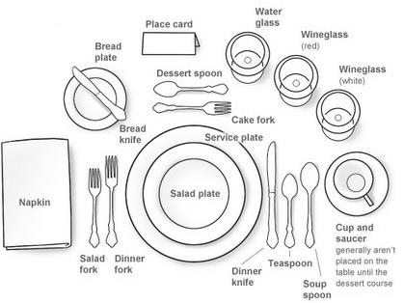
Setting Table for Casual Dining
This table setup is required for informal events like holiday parties and family gatherings. Casual dining can contain multiple courses and service staff offers or serves second rounds of helping when a guest requests for it. This table setup appears as follows −
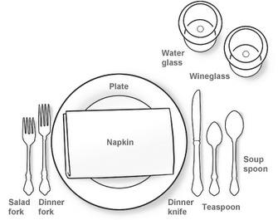

Setting a Buffet Table
This set up is required for catering to large groups of people. Buffet table setting can be done in numerous ways depending upon the size and shape of the place, the menu, and the number of guests.
The food items are placed in a sequence from lightest to heaviest, starters to desserts, or coolest to warmest.
Cutlery is placed on the guest tables.
Glasses, cups, and saucers are placed on a separate table to avoid congestion.
Table decoration pieces are placed such that they do not interfere with the food items.
Plates are stacked not more than 15 plates per stack.
Paper napkins are placed between the plates.
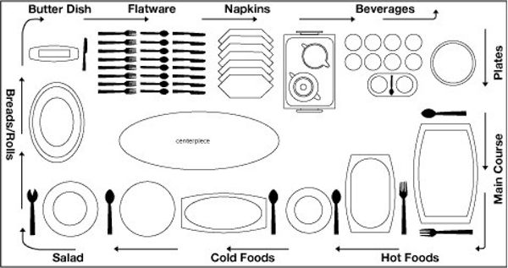

Taking orders in a restaurant
For more information, please visit https://careertrend.com/how-5350625-order-restaurant.html
One of the key elements of a customer's experience in a restaurant is the level of service offered by the wait staff. If you are a server, your primary responsibility is to ensure that all your customers are happy and their needs are met. You must also have a pleasant disposition and possess the flexibility to respond to a variety of demands from your customers. However, your most important duty is to ensure that you accurately take your customer's order so he receives the dish exactly the way he wants.
Prepare your order pad. Some restaurants may have a preconfigured pad with a sequential order of seats for all the tables at your station. If not, ensure that you have your own method of order-taking, such as a clockwise system or a coding system based on the number of guests, that assures everyone receives the correct dish.
Greet the guests at the table with a smile as you make eye contact with each of them. State the specials of the day and make several recommendations. Ask if anyone has questions about an item on the menu.
Take the first order from the female guests, if applicable. If there are no women at the table, take the order based on your restaurant's sequential system or from the male guest who seems most ready to order. If your customer is trying to decide among several menu items, provide assistance by explaining how each dish is prepared.
Repeat the order back to every guest to ensure it is accurate. If someone orders a dish that can be prepared several different ways – such as a steak – ask how the guest would like the item cooked. Repeating the order also allows you to ensure that you match each guest with the proper order.
Ask the diners if they would like to add anything to the order. Thank everyone, collect the menus and state that the meal will arrive shortly.
Tip
Know your restaurant's menu well so you can make recommendations, answer meal preparation questions and advise guests about possible allergic reactions due to the presence of ingredients such as nuts, dairy or wheat.
Warning
Do not tell a guest that a meal can be prepared in a special way unless you know that the chefs or cooks can do it. Otherwise, you could create resentment in the guest and may spoil her dining experience.

Point-of-Sale systems in food and beverage service
For more information, please visit https://www.tutorialspoint.com/food_and_beverage_services/food_and_beverage_services_cleaning_and_maintenance.htm
Today, many restaurants use Point-of-Sale (POS) equipment, a computer-based technology to take orders, record them, accept payments, and display or print their receipts. Restaurant servers, bartenders, and cashiers can use POS systems to enter and record food and beverage orders easily.
A POS system in the F&B Services can increase convenience and accuracy in order tracking, and can save time during rush hours. It can smoothly perform the following functions:
- Calculating cash due for every order entered for a table.
- Recording the method of payment.
- Tracking balance cash.
- Creating periodic sales reports.
- Calculating labor and payroll data.
- Recording daily check averages for each worker.
- Tracking the number of balance and sold food items.
- Recording information of repeat customers.

Cleaning equipment
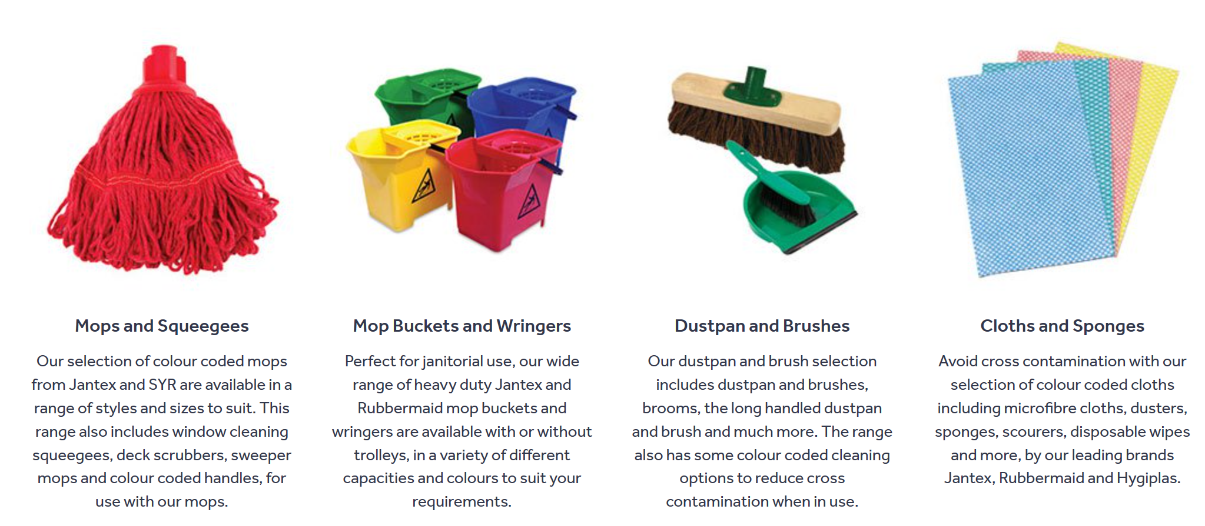
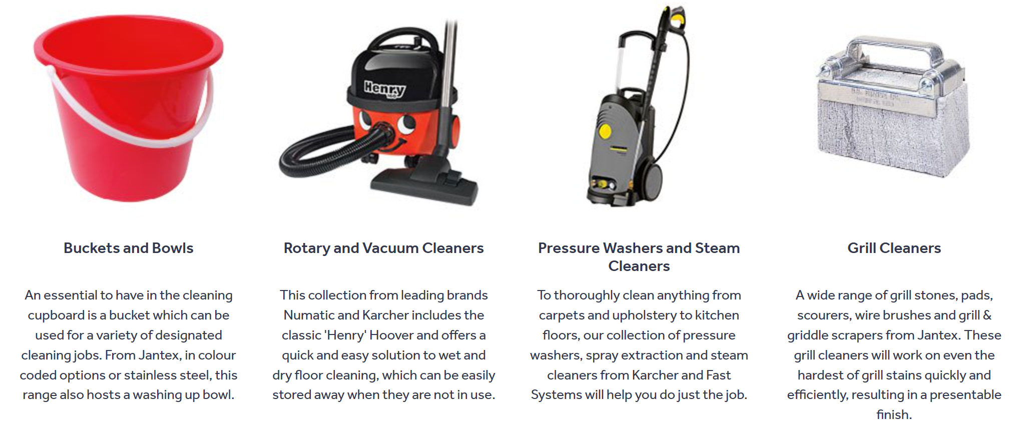
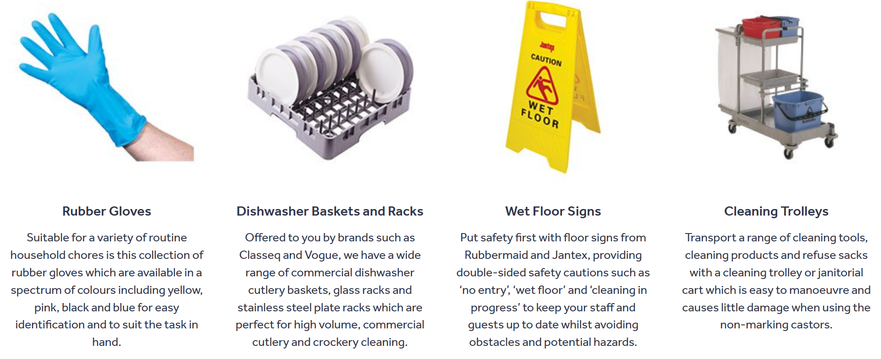
For more detailed information, please visit https://www.nisbets.co.uk/cleaning-and-hygiene/cleaning-equipment/_/a33-2

Module 6: Provide front office services
Objective of the module: The aim of this module to develop the knowledge, skills and understanding needed to provide front office services
Duration: | 120 hours | Theory: | 30 hours | Practical: | 90 hours

Learning Unit | Learning Outcomes | Learning Elements | Materials Required
LU1:  Deal with booking enquiries | The learner will be able to:  Deal with booking enquiries following organizational procedures according to the type of enquiry  Reply to the booking enquiry with accurate information  Take the opportunity to sell other products and services within the communication back to the customer where possible and appropriate  Invite your customers to make a booking where possible and take and record their details correctly  Allow for customer needs and requirements and follow organisation procedures accordingly | The importance of dealing with customers politely and helpfully at all times, giving accurate spoken and written information to customers  Organization's booking procedures and systems including third party systems, obtaining and recording booking details accurately  Intelligent and appropriate up-selling, room / product rates, added value, rate negotiation limits and yield management and how these apply to your work role  Confirmations and deposits, why these may be required from customers  Types of unexpected situations and problems that may occur with bookings, and how to deal with these correctly  Basic legal requirements relating to goods and services for sale when receiving, confirming, amending and cancelling booking enquiries | Office supplies, including desk, chairs, pens, IT equipment and software  Brochures and price lists  Front office stationery, including booking and amendment forms, arrivals and departure lists, house lists, accounting stationery, invoices  Telephone system  Room keys or cards  Standard operating procedures for front office, including handling problems and managing payments  Work area logs  Complaints Log  Uniforms (appropriate to the organisation)
LU2:  Confirm, cancel and amend bookings | The learner will be able to:  Deal with any confirmations, cancellations and amendments according to organizational procedures and requirements  Collect up to date information on rates, deals and third-party rules where applicable  Identify, check and follow up unconfirmed bookings in the booking system  Maintain records of all bookings in line with your organization's procedures | Procedures to cancel and amend bookings  Organization's and third party systems cancellation policies and procedures  Overbooking policy and procedures; how to deal with this and why it happens  Procedure for following up unconfirmed bookings | Office supplies, including desk, chairs, pens, IT equipment and software  Brochures and price lists  Front office stationery, including booking and amendment forms, arrivals and departure lists, house lists, accounting stationery, invoices  Telephone system  Room keys or cards  Standard operating procedures for front office, including handling problems and managing payments  Work area logs  Complaints Log  Uniforms (appropriate to the organisation)
LU3:  Deal with the arrival of customers | The learner will be able to:  Correctly identify customer requirements  Retrieve any customer booking details from the booking system and check them with the customer  Offer alternatives for any services that are not available as requested  Complete the registration document correctly  Give accurate information which meets customer needs  Promote the services and facilities of your organization when appropriate  Pass on customer details to the relevant departments in line with organization's procedures | Organization's standards for customer care and why these are important  Booking procedures, and why it is important to follow these correctly  Checking in procedures, and why it is important to follow these correctly  Basic legal requirements relating to accommodation, goods and services for sale  Unexpected situations and problems that may occur when customers arrive, and how to deal with these  Why registration documentation must be correctly completed by the customer  Specific requirements for registering overseas visitors  Organization's procedure for allocation of rooms  Why it is important to give accurate information to customers  Why it is important to correctly identify customer requirements  What registration information must be obtained, in order to comply with legislation  Why all correspondence relating to the booking should be available | Office supplies, including desk, chairs, pens, IT equipment and software  Brochures and price lists  Front office stationery, including booking and amendment forms, arrivals and departure lists, house lists, accounting stationery, invoices  Telephone system  Room keys or cards  Standard operating procedures for front office, including handling problems and managing payments  Work area logs  Complaints Log  Uniforms (appropriate to the organization)
LU4:  Prepare and maintain customer accounts | The learner will be able to:  Enter charges regularly and accurately against customer accounts in the account system  Record any account adjustments accurately against customer accounts  File and store account documents correctly at all times  Complete customer accounts for the customer  Make sure customer accounts cannot be accessed by unauthorized people | Know the organization's standards for customer care, and why it is important to follow these  Know the basic legal requirements relating to preparing and maintaining customer accounts  Know the organization's procedures for customer accounts, and why it is important to follow these  Understand why customer accounts must be updated regularly with charges and adjustments  Understand why it is important to give accurate verbal and written information to customers  Understand why customer accounts must be secured from unauthorized access  Know the types of unexpected situations and problems that may occur with customer accounts, and how to deal with these correctly | Office supplies, including desk, chairs, pens, IT equipment and software  Brochures and price lists  Front office stationery, including booking and amendment forms, arrivals and departure lists, house lists, accounting stationery, invoices  Telephone system  Room keys or cards  Standard operating procedures for front office, including handling problems and managing payments  Work area logs  Complaints Log  Uniforms (appropriate to the organisation)
LU5:  Process front office payments | The learner will be able to:  Ensure that customers are aware of the cost breakdown of chosen services and the final total amount to be paid  Ensure that customers are aware of the methods of payment that are acceptable, and any charges or restrictions that may be attached  Follow organization's policies and procedures regarding payment discrepancies, non-cash payments, transaction values, and limits  Ensure that change given for cash payments is accurate  Maintain the security of cash and other payments  Use correct procedures to maintain confidentiality of customers' purchases and payment information  Issue receipts and store payments so that all internal payment records are competed accurately  Follow the organization's procedures for issuing receipts and storing payments  Provide customers with legible and accurate receipts  Ensure that all payments are stored securely and protected | Organization's procedures for  - receiving, handling and receipting payments  - storing payments  - dealing with payment discrepancies  Differences between charge, credit, debit and currency cards; types of fraudulent card transactions, for example lost or stolen cards  Payment methods acceptable to the organisation, including chip & pin procedures  Confirming receipt of payments and giving change to customer, procedures when receiving and receipting payments from customers, potential consequences of incorrect calculations and payments  Handle customers when dealing with payment discrepancies, for example invalid currency, invalid card, suspected fraudulent use of card, payment disputes  Own authority levels for handling non-cash payments and dealing with payment discrepancies, who to contact if you need information, advice or payment authorization  Completing payment related documentation required by your organisation  Procedures to follow in emergency situations relating to payments | Notepads  Pen  Calculators  Check folders  Cash till (mechanical/ electronic)  Cash float  Mechanism for keeping cash secure  Guest comment cards  Cash summary sheets  Error slips  Computer, accessories, software  Work area log for recording problems, suspicious items, lost property and unexpected situations  Uniform (appropriate to the organisation)
LU6:  Deal with the departure of customers | The learner will be able to:  Prepare documents and other necessary items before the customer departs  Present the account to the customer for confirmation  Check customer account details and request payment as required  Complete documentation and deal with it using the correct account or booking system  Complete all other procedures for customer departures  Record customer comments, complaints and suggestions and feed them back to the appropriate person or department  Promote establishment services and facilities as appropriate | Organization's standards for customer care, and why it is important to follow these  Organization's procedures for customer departures  Organization's procedures for customer accounts, and why it is important to follow these, explaining details of any extra charges to the customer  Basic legal requirements relating to preparing and maintaining customer accounts and relating to accommodation, goods and services for sale  Safe and hygienic working practices when dealing with the departure of customers  Why complaints, comments and suggestions should be recorded and fed back to the appropriate person/department  Types of unexpected situations and problems that may occur with customer departures and how to deal with these correctly  Opportunities to promote the organisation when the customer is leaving | Office supplies, including desk, chairs, pens, IT equipment and software  Brochures and price lists  Front office stationery, including booking and amendment forms, arrivals and departure lists, house lists, accounting stationery, invoices  Telephone system  Room keys or cards  Standard operating procedures for front office, including handling problems and managing payments  Work area logs  Complaints Log  Uniforms (appropriate to the organisation)

Examples and illustrations

Reservation process and procedure
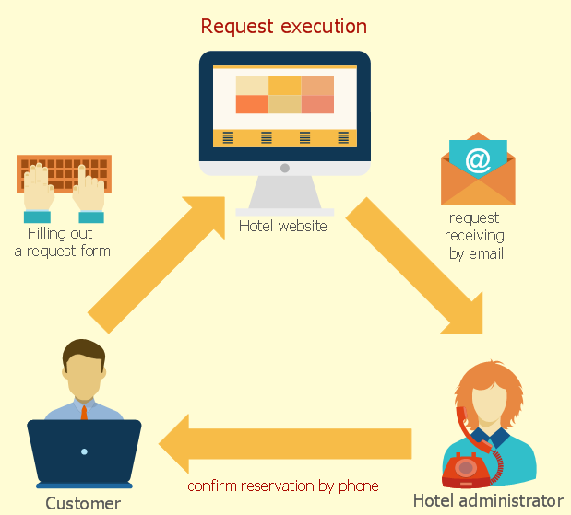

Hotel Front Office Reservation Procedures
For further information, please visit https://smallbusiness.chron.com/hotel-front-office-reservation-procedures-64861.html
Hotels often bleed money because their reservation process isn’t well-planned, which can frustrate guests and cause them to find another place to sleep. Reservations are the most reliable revenue stream for many hotels, and they affect everything from profit margin to staffing. Ensuring that guests get the accommodations when they expect them is the easiest way for a hotel to reduce complaints and increase guest satisfaction.

Finding a Room
When a guest calls to request a room for a specific place and time, this is called checking availability. Most hotels have a management system that tells reservation clerks the kinds and types of rooms available for given periods and lists prices for those rooms. Reservation clerks, once they have found a room for the guest, should provide a brief description of the facilities. The description should recount the bed size and number of beds in the room along with any special accommodations included, such as a refrigerator or balcony.

Requests and Guarantees
A critical part of any hotel reservation procedure is to note special requests so they are properly accommodated. If a particular room type is not available, for example, guests will make a reservation for a different room type and ask that their original preference is noted.
Alternately, a guest might require a crib or a roll-away bed for a child. Once the accommodations are settled, guests are often asked to guarantee a room with a credit card. Some hotel procedures allow a temporary hold with no credit card in expectation of a deposit.

Policies and Procedures
Since reservations are meant to prevent a hotel from being oversold, making sure a potential guest understands the reservation cancellation policies can prevent rooms from being held unnecessarily. Likewise, a guest should know what time he can check into a room and what time he must check out. Reservation procedures should direct front office clerks to make these clear to the guest before completing the reservation. A good reservation procedure includes instructions about parking and any associated fees as well as the availability of airport and public ground transportation.

Strong Confirmation Procedure
Recapping the reservation is possibly the most critical part of the process. It allows the reservation clerk to spell out clearly what she has marked down for the guest and for the guest to hear the terms of the room. The hotel employee should repeat the room type, with any special requests, the day and date of arrival and departure, the cost of the room and the guarantee and cancellation policies. Once all the information is repeated and the guest agrees, the reservation clerk provides a reservation confirmation number the guest can use when checking in or on future calls.

How to handle VIP and VVIP arrivals in hotels
For more information, please visit https://setupmyhotel.com/train-my-hotel-staff/front-office-training/306-vip-and-vvip.html
Who is a VIP guest ?
Criteria for categorizing guests as a VIP may differ from hotel to hotel, below are few examples for the same:
VIP: Decision Makers of Companies, Travel Agents, Honeymoon couples, A guest who had a bad experience on his last visit, Journalists, Event Planners, GM or Unit head of Companies etc.
VVIP: Board of Directors, Owners, Partners, Celebrities, Loyalty members, Head of States or countries, Senior Government officials etc.
Preparation for a VIP and VVIP arrival starts right from the reservation stage, All department must coordinate effectively and carefully controlled to have an effective VIP procedure.
A VIP status is often approved by the General Manager, Rooms Director/Director of Operations, or Director of Sales. Because all VIP's guests are pre-registered, the person approving the VIP status also assumes responsibility for the guest's credit status.
- Sales team should always inform the reservation department regarding VIP reservation well in advance, This lead time allows the reservation agent to block the appropriate room and also notify the same to other departments.
- During reservation an appropriate VIP code to be attached to the VIP reservation on the Property Management System.
- Tagging of VIP code to the reservation helps another department to easily identify the VIP status of the guest and do the required preparations.
- VIP Status is normally printed on reports like Arrival list, Room Boy list, Departure list etc. In addition to this new age hotel management software’s also give pop-up to users whenever they try to access the guest reservation. Eg: “GM / AGM to meet on arrival“
- After blocking the room for the VIP guest, Front office department should send the VIP requisition form to Housekeeping and Room service well in advance so they can do the required arrangements.
- If there is any further change in the room number at a later stage then same need to be communicated to Housekeeping and Room service immediately.
- Housekeeping department put a priority on VIP arrivals and return those rooms to Front office as soon as possible.
- HK department places all complimentary VIP welcome amenity in their rooms.
- The Welcome Amenities must reflect the prestige and cultural background of the Guest.
- Executive housekeeper / Asst. Executive housekeeper should verify the rooms before releasing the same to the front desk for check-in.
- On the arrival day Ensure that all special requests have been accommodated and actioned.
- Upon arrival Front desk team must inform the FOM / Resident Manager / General Manager to greet and meet the VIP Guest.
- Always accompany the VIP Guest to the room and proceed with the check-in procedures in the room.
- Fill in as much information that you can on the Registration Form prior to presenting it to the Guest.
- Offer a tour of the property at the Guest’s convenience and the person who escorted the Guest to make a courtesy call within the first 24 hours.
- List of VIP and VVIP guests are noted down on the white board at Back office, Operators Cabin and housekeeping control desk.

Hotel accounting terms
For more information, please visit https://careertrend.com/list-6688960-hotel-accounting-terms.html
Hotels follow the general principles of accounting, but due to the unique nature of guest accounting, hotel accounting departments use terms that may not be familiar to accountants in other industries. Accounting terms related to the management of guest payments, charges and disputes can be confusing to outsiders, but they represent everyday concepts in the hotel industry.
Folio
The record of all credits and debits associated with a guest or group is called an account and an account can be organized by sections, or folios. Common folio divisions include one each for room charges, food and beverage charges and miscellaneous charges. Multiple folios are often used with convention guest accounts, as the hotel room rate may be paid by the group while the individuals are responsible for their additional, or incidental charges.
Separation of folios allows printing options, which is useful for blind rates--when the group room rate must remain unknown to the guest. At checkout, a convention guest can present payment for incidental charges and receive a printed receipt for only the folios that contain the charges for which she paid. The balance from the room charges folio remains blind to the guest and is transferred to the group account for later billing.
Room Charge
Guests that have a credit card on file for an account are eligible to sign for charges to guest rooms. At the point of sale, guests sign a receipt authorizing the charge be paid by the method of payment on the account. The charge is then posted to the appropriate folio for the charge type.
The alternative to a room charge is using another method of payment for services, such as cash or credit. Guests without credit cards on file are considered cash-only guests and do not have room charging privileges.
Posting
Any charges posted to a guest account are posted, either manually or through the hotel’s computer system. Computer-posted charges are known as interface postings and these are common from hotel outlets that use a cash register and point of sale system, such as a restaurant or gift shop.
When room charge is designated as the payment type, the cashier enters the guest room number and the point of sale system interfaces with the property management system to post the charge. Manual charges are posted by a hotel employee, usually front desk or accounting. These charges might come from outlets without a point of sale system but are most commonly interface postings that did not go through due to system outage or incorrect room information.
Late Charge
A late charge occurs when a guest signs for a room charge after checking out of the hotel. Common late charges include breakfast or minibar charges and manual postings due to system outage. Since the guest had a credit card on file, the front desk is able to use same card is used to pay for the charge. If the credit card declines, an invoice is mailed to the guest&#039;s address of record.
Advance Deposit
Advance deposits are prepayments for guest rooms or other hotel services. These deposits are commonly used to secure reservations for weddings or conventions held at the hotel. In most catering or group events, the advance deposit is required 72 hours before the event occurs. The deposit is posted to the group account and charges are posted against the account as they occur.
Allowance
An allowance is a reversal of a posting. Allowances can occur due to duplicate posting, disputes or bad debt. Although a voided payment through the point of sale system can create a negative interface posting, this is a correction instead of an allowance because revenue is not reduced. Allowances are always manual posts, and department managers generally review and research large allowances that would seriously impact revenue prior to authorizing posting.

Module 7: Co-ordinate the operation of the work area
Objective of the module: The aim of this module to develop the higher level knowledge, skills and understanding needed to co-ordinate the operation of the work area
Duration: | 100 hours | Theory: | 25 hours | Practical: | 75 hours

Learning Unit | Learning Outcomes | Learning Elements | Materials Required
LU1:  Ensure professional work standards are maintained throughout the work area and on completion of shift | The learner will be able to:  Ensure that associates maintain personal hygiene and wear appropriate uniform throughout shift  Ensure that associates work effectively as part of a hospitality team and communicate efficiently with each other throughout shift  Ensure that associates know and understand how to respond to hazards, accidents and emergencies  Ensure waste is properly managed | Principles of professional standards, including personal hygiene and appropriate uniform (for health and safety purposes and to present a professional image), maintaining a safe, hygienic and secure working environment (to avoid any risks to guests and associates)  The benefits of working effectively as part of a hospitality team and communicating efficiently with each other throughout shift, including good working practices, using appropriate technical and social language, efficient delivery of services, contributing to excellence in guest service, meeting organizational goals, attending briefing  Supporting and developing safe work methods, including carrying out tasks in the right order, finishing one before starting the next, assembling tools and equipment before starting the task, allowing sufficient time and space to complete the task involved, following a logical sequence, ensuring there are no spillages or accidents  Types of hazards to be found in the work area, including slips; trips and falls; strains and sprains; sharp objects; cuts and lacerations; burns; hot liquids and surfaces; moving heavy items; working fast; likelihood and potential impact of hazard  Ensuring that associates know and understand methods to deal with hazards correctly, including providing and using uniform; non-slip flooring; working tidily, following proper procedures, warning others when necessary, providing additional training to use equipment and machinery correctly; maintaining equipment and machinery; adapting the workflow  Understanding risks from faulty equipment, including trapped hands or fingers, impact of a heavy object, contact with hot equipment, faulty electrical equipment, inappropriate use of equipment  Understanding the effects and implications of accidents, including wastage of materials, wastage of time, increase in workload for other associates, disruption of workflow, loss of revenue, increase in costs  Ensuring that associates understand the importance of warning other people (including verbally, using warning notices) about hazards, to avoid accidents and injuries  Ensuring that associates know the location of first aid equipment and the name of the first-aider in the workplace  Responding to accidents in accordance with organizational requirements, including arranging for first aid, alerting supervisors and/or management (depending on the nature and seriousness of the accident), recording the accident and the actions taken  Types of emergencies that may happen in the work area (including fire, flood, accidents, gas leaks)  Ensuring that associates understand how to deal with different types of emergency, including supporting associates in taking action within own responsibility, notifying engineering department, supervising the evacuation of the area or building, assembly point for evacuations  The importance of following fire safety laws, including preserving life, preserving the fabric of the building, equipment and materials  The possible causes of fire in the workplace, including poor working practices, build-up of waste, faulty equipment, careless practice  Minimizing the risk of fire, including monitoring working practices and ensuring they meet organizational standards, ensuring that disposal and recycling of waste is being properly carried out, checking equipment is in good working order, managing associates’ working practice  Managing fire situations, including knowing the location of fire alarms and checking that associates know how to set them off, reasons to never approach a fire unless it is safe to do so, including identifying the risks, using the correct equipment  Managing the evacuation of the building, including turning off all power supplies, closing all doors and windows, not gathering personal possessions, gathering in a designated area, taking roll call of names to ensure no-one is missing  The importance of maintaining records of and reporting all usual/non-routine incidents to the appropriate person, including name of those involved; date, place and time of incident, who was involved and what they saw, description of what happened, whether anyone was hurt, any damage to property, whether emergency services were called  Principles of waste management, including meeting food hygiene regulations, preventing contamination of service areas, avoiding pest infestation, reducing accidents and fire risks  Supervising clearance of waste areas, including properly fitting lids for waste bins, use of disposable sacks, not overfilling bins, regular emptying and cleaning of bins  Managing waste, including ensuring that associates identify opportunities for reducing and disposal of waste, follow organizational policies and procedures  Keeping the work area secure, including security of areas (key control), personal possessions, security of visitors and guests, following close-down procedures including managing work area and building security, including locking up, checking toilets and changing rooms are cleared, no open windows or doors, no hazards left (cooking and other equipment left on, cigarettes left burning), in order to protect staff, visitors and guests on the premises, to reduce theft and pilfering, and to keep the work area safe and secure  Dealing with problems and unexpected situations in an appropriate manner, including consulting with other associates, Head of Department, issuing directives, arranging training  Compliance with relevant regulations and standards | Duty rota  Job descriptions  Standard operating procedures for safe and hygienic working  Logbooks for recording accidents and incidents  Equipment checklists  Uniforms, (appropriate to the organisation)  Organisational policy on managing waste
LU2:  Manage the work area’s requisition requirements, work area and equipment | The learner will be able to:  Check current stock of requisition requirements available in different departments  Prepare requisition sheet to obtain appropriate amounts of requisition requirements from store  Use stock control systems to manage levels and usage of stock  Establish and maintain the condition of work areas and equipment  Ensure that equipment is being used correctly and efficiently by associates  Ensure that specific items of equipment are maintained, calibrated or replaced as required  Take corrective action where required to improve the safety of work areas | Operational knowledge and understanding of current and future requirements of business, including level of business for the day, number of restaurant bookings/room reservations, any special bookings, special requirements or special offers available  Assessing the level of current stock held by the department, including physical checks, checking records, checking current stock of food / cleaning materials / other items  Preparing requisition sheet to obtain appropriate amounts of items from store, including using known information of booking/reservation levels and existing stock levels  Checking that deliveries from store meet the type, quality and quantity requirements, including checking against requisition sheet for type and quantity, checking quality  Ensuring that associates understand the benefits of different systems for managing stock, eg First In First Out (FIFO), Last In First Out (LIFO), Last In Last Out (LILO)  Ensuring that associates operate appropriate stock management system according to organisation procedures, including checking stock usage, monitoring how associates use resources  Maintaining equipment, including its function and maintenance requirements; and work areas, including maintenance and refurbishment requirements; ensuring that equipment is being used correctly and efficiently by associates, checking with work area team if any products or equipment are in need of maintenance or attention, (including faulty equipment, worn fixtures and fittings), taking appropriate actions, advising engineering department  Appropriate staff training activities to promote efficient usage of equipment and awareness of maintenance requirements  Maintenance, calibration or replacement requirements for specific items of equipment, including following manufacturer’s requirements, arranging for maintenance or replacement of equipment, process for reporting any maintenance requirements to the appropriate department, procedure for ensuring that work area areas are refurbished at appropriate and agreed intervals  Compliance with relevant regulations and standards | Daily event sheets  Brochures and price lists  Regular and à-la-carte menus  Existing requisitions records and pads for developing new requisitions from stores  Cost reports  Weekly consumption reports  Work area equipment and operating instructions  Maintenance schedules for work area equipment  Standard Operating Procedures for preparing and maintaining work area areas and equipment  Fire equipment (see Complete list of tools and equipment for details)  First aid equipment (see Complete list of tools and equipment for details)  Equipment for contacting security  Uniforms (appropriate to the organisation)
LU3:  Support the work area’s head of department | The learner will be able to:  Discuss and agree on methods and formats of communication with the Head of department  Agree with the Head of department daily and medium-term areas for delegated responsibilities  Support the Head of department in undertaking training and inspections  Ensure that requirements of the work area are signed off by Head of department | Methods and formats for communication with the Head of Department, including verbally, in writing, using the log; communicating through positive body language  Agreeing on methods and formats of communication with the Head of Department, including formal, informal, verbally, in writing, through the log, using appropriate technical and social language  Areas for responsibilities delegated by Head of Department on a daily and medium-term basis, including operational, administrative and supervisory support  Agreeing with the Head of Department daily and medium-term areas for delegated responsibilities, including through discussion, negotiating own goals, developing own skills  Supporting the Head of Department in undertaking training and inspections, including observation, developing and providing training, recording the outcomes of inspections, evaluating the effectiveness of training  Ensuring that every-day requirements of section are signed off by Head of Department, including presenting completed requisitions for sign-off, raising queries and issues | Markers and pens  Notebook  Log book  Record of allocated duties and tasks  Notice board  Daily event sheets  Fire equipment (see Complete list of tools and equipment for details)  First aid equipment (see Complete list of tools and equipment for details)  Equipment for contacting security  Standard Operating Procedures  Uniforms (appropriate to the organisation)

Examples and illustrations

Bookings diary template
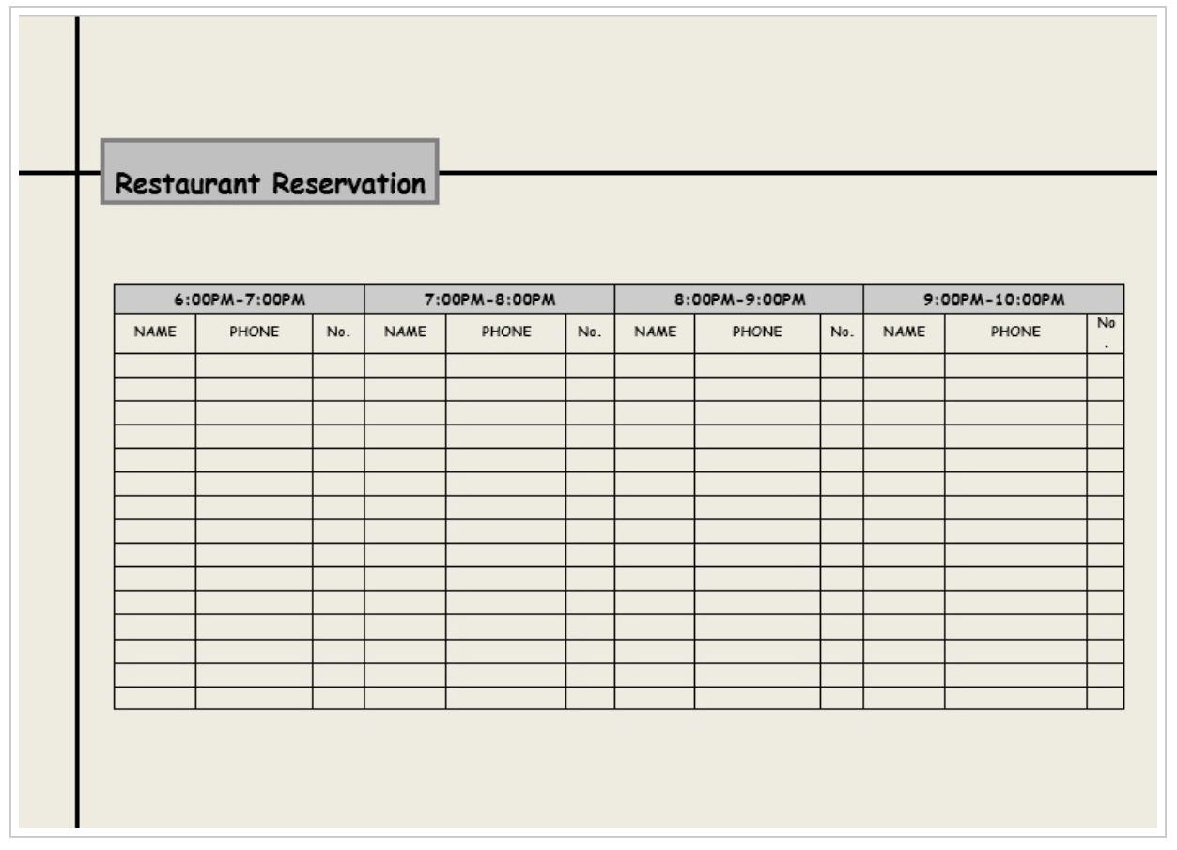
For more detailed information, please visit https://www.wordstemplatespro.com/restaurant-reservation-log-template.html

Sample job descriptions

Room Attendant
Room Attendant responsibilities include:
- Changing bed linen and making beds
- Replacing used towels
- Sweeping and mopping floors
Job brief
We are looking for a Room Attendant to join our team and provide excellent customer service to our hotel guests.
Room attendant responsibilities include changing towels, making beds and cleaning bathrooms. You will also address clients’ queries and make sure our rooms are fully-stocked, clean and inviting at all times. If you’re interesting in kick starting your career in the hotel industry, we’d like to meet you.
Ultimately, you will ensure a pleasant and comfortable experience for our guests during their stay with us.
Responsibilities
- Change bed linen and make beds
- Replace used towels
- Sweep and mop floors
- Vacuum carpets
- Dust furniture
- Replenish bath care products (e.g. soap and shampoo)
- Restock beverages and food items
- Clean public areas, like corridors
- Report any technical issues and maintenance needs
- Address guests’ queries (e.g. on additional services)
- Help guests retrieve lost items
- Ensure all assigned rooms are clean and tidy by the end of the shift
- Follow hotel security guidelines
Requirements
- Previous work experience as a Room Attendant
- Experience with industrial cleaning equipment and products
- Good physical health and stamina
- Flexibility to work in shifts
- Ability to work with little or no supervision while meeting high-performance standards
- Excellent organization skills
- Ability to follow instructions

Hotel Front Desk Agent
Hotel Front Desk Agent responsibilities include:
- Performing all check-in and check-out tasks
- Managing online and phone reservations
- Informing customers about payment methods and verifying their credit card data
Job brief
We are looking for a Hotel Front Desk Agent to serve as our guests’ first point of contact and manage all aspects of their accommodation.
Hotel Front Desk Agent responsibilities include registering guests, managing reservations and providing information about rooms, rates and amenities. If you have a knack for customer service and work experience in the hotel industry, we’d like to meet you.
Ultimately, you will help create a pleasant and memorable stay for our guests.
Responsibilities
- Perform all check-in and check-out tasks
- Manage online and phone reservations
- Inform customers about payment methods and verify their credit card data
- Register guests collecting necessary information (like contact details and exact dates of their stay)
- Welcome guests upon their arrival and assign rooms
- Provide information about our hotel, available rooms, rates and amenities
- Respond to clients’ complaints in a timely and professional manner
- Liaise with our housekeeping staff to ensure all rooms are clean, tidy and fully-furnished to accommodate guests’ needs
- Confirm group reservations and arrange personalized services for VIP customers and event attendees, like wedding guests
- Upsell additional facilities and services, when appropriate
- Maintain updated records of bookings and payments
Requirements
- Previous work experience as a Hotel Front Desk Agent, Receptionist or similar role
- Experience with hotel reservations software
- Understanding of how travel planning websites operate, like Booking and TripAdvisor
- Customer service attitude
- Excellent communication and organizational skills

Restaurant Server
Restaurant Server Responsibilities
- Preparing restaurant tables with special attention to sanitation and order
- Attending to customers upon entrance to the restaurant
- Presenting menus, serving and helping customers select food/beverages
Job brief
We are looking for a competent Restaurant Server to take and deliver orders. You’ll be the face of our restaurant and responsible for our customers’ experiences.
Food server responsibilities include ensuring our tables are clean and tidy when guests arrive, presenting menus and serving food and beverages. You need to be quick on your feet (literally and metaphorically) and have a polite and friendly attitude. If you enjoy talking to people and thrive in a fast-paced workplace, we’d like to meet you.
Your ultimate goal will be to provide high-quality service that will help us maintain and attract customers.
Responsibilities
- Prepare restaurant tables with special attention to sanitation and order
- Attend to customers upon entrance
- Present restaurant menus and help customers select food/beverages
- Take and serve orders
- Answer questions or make recommendations for complementary products
- Collaborate with other restaurant servers and kitchen/beverage staff
- Deal with complaints or problems with a positive attitude
- Issue bills and accept payment
Requirements
- Proven restaurant serving or waitering experience
- Hands-on experience in cashier duties
- Attention to cleanliness and safety
- Patience and customer-oriented approach
- Excellent people skills with a friendly attitude
- Responsible and trustworthy

Restaurant Manager
Restaurant Manager Responsibilities
- Coordinating daily restaurant management operations
- Delivering superior food and beverage service and maximizing customer satisfaction
- Responding efficiently and accurately to restaurant customer complaints
Job brief
We are looking for a Restaurant Manager to lead all aspects of our business. You will deliver a high-quality menu and motivate our staff to provide excellent customer service.
Restaurant manager responsibilities include maintaining the restaurant’s revenue, profitability and quality goals. You will ensure efficient restaurant operation, as well as maintain high production, productivity, quality, and customer-service standards.
To be successful in this role, you’ll need management skills and experience in both front and back of the house. We want you to know how to oversee the dining room, check-in with customers and balance seating capacity. Back of the house management experience is also essential, as you’ll hire qualified Cooks and Wait Staff, set work schedules, oversee food prep and make sure we comply with health and safety restaurant regulations.
We’ll expect you to lead by example and uplift our staff during busy moments in our fast-paced environment. Ultimately, you will ensure our restaurant runs smoothly and customers have pleasant dining experiences.
Responsibilities
- Coordinate daily Front of the House and Back of the House restaurant operations
- Deliver superior service and maximize customer satisfaction
- Respond efficiently and accurately to customer complaints
- Regularly review product quality and research new vendors
- Organize and supervise shifts
- Appraise staff performance and provide feedback to improve productivity
- Estimate future needs for goods, kitchen utensils and cleaning products
- Ensure compliance with sanitation and safety regulations
- Manage restaurant’s good image and suggest ways to improve it
- Control operational costs and identify measures to cut waste
- Create detailed reports on weekly, monthly and annual revenues and expenses
- Promote the brand in the local community through word-of-mouth and restaurant events
- Recommend ways to reach a broader audience (e.g. discounts and social media ads)
- Train new and current employees on proper customer service practices
- Implement policies and protocols that will maintain future restaurant operations
Requirements
- Proven work experience as a Restaurant Manager, Restaurant General Manager, Hospitality Manager or similar role
- Proven customer service experience as a manager
- Extensive food and beverage knowledge, with ability to remember and recall ingredients and dishes to inform customers and wait staff
- Familiarity with restaurant management software
- Strong leadership, motivational and people skills
- Acute financial management skills

Hotel Fire Safety Guide for Managers
For more information, please visit https://www.highspeedtraining.co.uk/hub/hotel-fire-safety/
The last thing your guests want is to hear the fire alarm and have to escape a building they’re unfamiliar with. It’s also the last thing you want. If a fire breaks out in your hotel, it puts dozens of people’s lives at risk (especially sleeping guests) and can damage your business irreparably.
Fire kills, and it usually takes victims of negligence. But if you apply sufficient fire safety measures in your hotel, you can prevent tragedy.
Carry out a fire risk assessment
To do so, you need to complete five steps.
- Identify the hazards: think about the ways a fire could start (such as faulty plug sockets, damaged kitchen appliances, or obstructed ventilation) and sources of kindling (including furniture, laundry, paper, chemicals, wall hangings, etc.).
- Consider who is at risk: guests are your primary concern. They aren’t familiar with the building and may even be asleep when a fire occurs, which puts them at serious risk. You need to ensure that vulnerable people can escape safely, such as those with mobility or hearing disabilities.
- Determine what measures are needed and apply them: for example, you may need better housekeeping to move sources of kindling away from fire escape routes and may need to arrange regular checks for appliances and plugs. If you don’t have any disability escape routes on floors above ground level, install them.
- Record your findings and changes: enforcing authorities will check your records for evidence that you manage fire safety risks, so keep on top of writing everything down. Records help you track what you’ve done and what you still need to do, and enable you to look back and assess what control measures did or didn’t work.
- Review and update: business premises, particularly hotels, will wear down from use over time, meaning new hazards appear and control measures become less effective. So you need to reassess risks, reapply control measures, and rerecord details.
Appoint fire wardens
You must appoint a competent person to take charge of fire safety prevention and evacuation procedures in your hotel. It can be yourself or someone else, but the person you assign must receive technical and practical fire safety training so they know how to prevent and fight fire.
Fire wardens are essential in a hotel. Guests aren’t familiar with the escape route and may depend entirely on someone to guide them in an emergency, especially if they were asleep, as they’ll likely feel disoriented. Your fire wardens should have a copy of the guest list and coordinate with fire rescue services if anyone fails to evacuate.
The number of fire wardens your business needs depends on numerous factors, including how many floors your hotel has, the size and complexity of its layout, the number of guests you accommodate, the number of shifts, and more. As a minimum, you should have one fire warden for every floor and on every shift. Also keep in mind holiday and sickness cover.
Train staff
Make sure employees know what to do if the alarm sounds – or how to sound an alarm themselves. Provide them with fire safety training that teaches hazard prevention methods, such as housekeeping, and how to spot and report issues.
Internal training should familiarise staff (including part time and temporary staff) with fire exit routes and the assembly point. Everyone should know who the designated fire wardens are and when they’re on duty.
Install detection and alarm systems
All hotels must legally have fire detection and alarm systems in place. You should install plenty of manual call points in obvious locations, which enable staff or guests to easily activate them if they discover a fire. Check smoke detectors regularly – at least once a month – and test manual call points during working hours once a week.
Consider whether you should use more than one form of fire alarm system, e.g. visual alarms, to alert people with hearing disabilities.
You need to also ensure alarms are loud enough to wake sleeping guests: alarms near the bed head should be around 75dB. It is absolutely vital that guests wake up immediately during a fire. People inhale smoke while asleep without noticing, which is often fatal if they don’t wake up in time.
Talk to your local Fire Service if you need further guidance.
Arrange maintenance and repairs
Either a competent person in the business or an external service engineer or contractor can check equipment and carry out repairs.
Examples of what they should check include:
- Fire doors, emergency lighting, and firefighting equipment.
- Kitchen appliances.
- Equipment in rooms.
- Plug sockets.
Keep records of maintenance and repairs. They act as proof of compliance and help you know when your equipment is next due for routine servicing. You should familiarise yourself with the manufacturer’s instructions for all your equipment, as they provide recommendations for how frequently you should carry out checks.
Plan fire routes
Escape routes should enable anyone to reach a place of safety during a fire, even if the fire blocks one of the escape paths. Therefore, you should have more than one route in place and should test each one regularly.
To make your fire escape routes effective, you should:
- Ensure they are constructed and enclosed by fire and smoke resistant materials.
- Install suitable emergency lighting and signs.
- Keep them free from obstructions.
- Ensure they have suitable access for people with disabilities.
- Install ventilators in stairwells to remove smoke from the atmosphere.
- Make sure everyone keeps fire doors closed to prevent smoke and fire from spreading.
Plan your fire evacuation strategy
Not all evacuation strategies are suitable for every type of building. This is particularly true for hotels, where the size and complexity often varies between premises.
You’ll most likely implement one of two evacuation strategies:
Simultaneous evacuation – if your hotel is small with a simple layout, the alarms can alert every room and floor at once and prompt people to evacuate at the same time.
Vertical or horizontal phased evacuation – if your hotel accommodates a large number of guests, has multiple floors, and is complex in design, you need to sound an alarm and evacuate people in areas that are at immediate risk before others. So the floor where the fire is located (and those above it) would evacuate first, while you temporarily delay those below.
Your risk assessment will help you identify factors and decide what strategy you should use. Seek advice from your local Fire Service if you need further advice.
Provide information to guests
From the moment your guests arrive, they should know where to find fire escape routes and manual call points.
During check in, draw guests’ attention to fire safety notices around the premises and point out the main exits. Hand over information sheets or display them in each bedroom in an obvious location.
Fire safety information sheets for hotel guests should explain:
- What to do if they discover a fire or if the alarm sounds.
- The nearest fire exit route (consider including a floor plan).
- The location of the nearest assembly point.
- What guests should do during a fire depending on the time of day (e.g. at night they should wake everyone in the room and not stop to fully dress themselves).
If you provide a rundown of fire safety beforehand, guests are more likely to take prompt action when a fire alarm sounds. Plus, you demonstrate that you’re committed to protecting your guests, meaning they feel safe staying at your hotel.

Immediate steps if you receive a bomb threat communication
For more information, please visit https://www.gov.uk/government/publications/bomb-threats-guidance/procedures-for-handling-bomb-threats
Any member of staff with a direct telephone line, mobile phone, computer or tablet etc., could conceivably receive a bomb threat. Such staff should, therefore, understand the actions required of them as the potential first response to a threat message.
If you receive a telephone threat, you should:
- stay calm and listen carefully
- have immediate access to a checklist on key information that should be recorded
- if practical, keep the caller talking and alert a colleague to dial the emergency services
- if displayed on your phone, note the number of the caller
- if the threat is a recorded message write down as much detail as possible
- If the threat is received via text message do not reply to, forward or delete the message. Note the number of the sender and follow police advice
- know who to contact in your organisation upon receipt of the threat, e.g. building security/senior manager. They will need to make an assessment of the threat
If the threat is delivered face-to-face:
- try to remember as many distinguishing characteristics of the threat-maker as possible
If discovered in a written note, letter or as graffiti:
- treat as police evidence and stop other people touching the item
If the threat is received via email or social media application:
- do not reply to, forward or delete the message
- note the sender’s email address or username/user ID for social media applications
- preserve all web log files for your organisation to help the police investigation (as a guide, 7 days prior to the threat message and 48 hours after)

Module 8: Supervise operations in the work area
Objective of the module: The aim of this module to develop the higher level knowledge, skills and understanding needed to supervise operations in the work area
Duration: | 140 hours | Theory: | 35 hours | Practical: | 105 hours

Learning Unit | Learning Outcomes | Learning Elements | Materials Required
LU1:  Supervise preparation of the work area for operations | The learner will be able to:  Supervise preparation of the work area  Ensure preparations are carried out in good time to allow the scheduled service to be provided  Ensure that professional work standards are maintained throughout the shift  Deal with problems that may affect the standard of service  Maintain and monitor the cleaning programme | Work areas, including food and beverage outlets, housekeeping, front office  Understanding and directing the skills, knowledge and resources of associates to carry out their responsibilities, following job descriptions, responding to training, taking personal responsibility  Purpose of cleaning programme, including encouraging safe working methods, helping to prevent accidents, reducing risks from pests, keeping the work area pleasant to work in  Functions of the cleaning programme, including working stations that are clean, cleared and sanitized; fixtures that are clean, cleared and well maintained; equipment that is clean and ready to use; guest walkways that are clean and cleared  Managing the cleaning programme, including ensuring that all associates understand their role in undertaking cleaning duties; ensuring that there are sufficient associates to undertake the cleaning programme effectively; ensuring that associates have the cleaning tools and materials they need to undertake cleaning duties for their area of work, ensuring that associates are using cleaning tools and materials safely, effectively and efficiently  Appropriate checklists to ensure that the cleaning programme has been completed correctly and according to organizational standards  The importance of maintaining work areas at the correct controlled temperature, to ensure guests are comfortable and that associates are working in a pleasant environment  Providing feedback on the effectiveness of preparation procedures in own area of responsibility to the Head of Department  Problems that may affect the standard of service, including preparation of service or guest area, service equipment, levels of staffing  Checking that there are no hazards present that would affect preparation of the work area, including making hazards safe, reporting hazards to others (for example Head of Department, engineering department)  Implications of hazards, including serious safety hazards, high levels of wastage, maintenance requirements, training requirements  Compliance with relevant regulations and standards | Preparation checklists  Job descriptions  Duty roster  Cleaning equipment and materials: small cleaning equipment to use for different tools and equipment, including cloths, dusters, mops, brushes, buckets; large cleaning equipment, including dishwasher, jet washer, wet and dry vacuum cleaner; sanitizer, vinegar, lemon, degreaser  Record of expected bookings and room reservations  Reservations book or system  Writing and order pads  Hotel brochures and price lists  Menus and beverages lists  Support material as required, including promotional materials  Complaints Log  Lighter  Pen  Uniforms (appropriate to the organisation)
LU2:  Supervise the operation of the work area | The learner will be able to:  Co-ordinate the operation of the work area  Monitor service to ensure that guest needs are being met at all times  Identify and resolve any problems with service  Manage the service log on a daily basis | Work areas, including food and beverage outlets, housekeeping, front office  Coordinating with work area associates to ensure services to guests are provided according the standards and procedures  Understanding the range of products and services offered by the organisation  Monitoring and addressing conduct and communications with guests, including advising and guiding associates, intervening if and when necessary, using appropriate social language  Identifying and resolving problems with service, including problems with poor standards of work, equipment, pests, quality services provided to guests, management of waste  The importance of logging any problems or issues with services provided according to organizational standards  Monitoring the preparation of payment points, including ensuring preparations of necessary items for and making checks before the shifts starts  Managing the payment point, including following proper procedures, reducing the risk of errors, maintaining the security of guests and staff, position of cash desk, managing keys; ensuring there is sufficient money in cash drawers at the beginning of shifts to manage payments from guests  Supervising the processing of guest accounts, including ensuring that postings are properly checked before handing over the check to the guest, to ensure that checks are ready at appropriate times for payment by guests  Ensuring and supervising staff when presenting checks to guests according to organizational standards  Making sure that all received payments by cash, check, credit cards, vouchers, or automatic debits are properly processed  Ensuring all the work area log books are filled in daily according to organizational requirements  Managing records for lost property and suspicious items, including recording when and where lost property items were found, recording; recording items left behind by guests and ensuring they are kept safe; managing the handling of suspicious items in line with organizational requirements  Compliance with relevant regulations and standards | Duty roster  Record of expected bookings or room reservations  Reservations book or system  Writing and order pads  Menus and beverages lists  Hotel brochures and price lists  Support material as required, including promotional materials  Standard operating procedures for work areas, including handling problems and managing payments  Work area logs  Complaints Log  Lighter  Pen  Uniforms (appropriate to the organisation)
LU3:  Manage communications between the work area and other departments | The learner will be able to:  Agree with other department heads the most appropriate written, verbal and social media methods of communicating different types of information  Ensure that agreed methods of communication are used clearly, coherently and promptly to provide information about work area service to other departments  Communicate appropriate information with other departments and make sure the communication has been delivered and received as intended  Ensure that other departments have the opportunity to ask questions and check their understanding  Present a positive image of own self and work area | The purpose and benefits of making sure that communication delivers the ‘message’ in which it is intended to be received, including providing information, giving instructions, giving responses, using appropriate technical and social language  Methods of communication that are available, including written communications, e-mails, verbal communications, using appropriate technical and social language; styles, including formal, informal; structuring communication so that it is clear and accurate  The different departments which might need to communicate and their needs, including restaurant, kitchen, housekeeping, front office, engineering; appropriate methods of communication for different departments; ensuring that communications with other departments have met their purposes  The importance of non-verbal communication (body language), including how non-verbal communication impacts on other people, interpreting and responding positively to non-verbal communication  The purpose and benefits of giving other departments the opportunity to ask questions, including checking their understanding, responding positively  The purpose and value of presenting a positive image of own self and work areas, including reflecting and generating confidence, providing assurances of effective service  The purpose and benefits for other departments to have a friendly and purposeful way of communicating with them, including developing good working relationships, using appropriate technical and social language, adding value to the guest experience  Types of problems that may occur with contacts, including conflict and aggression, finding ways to deal with these | Notepads  Pens  Daily event sheets  Regular and à-la-carte menu  Brochures and price lists  Requisitions  Cost reports  Weekly consumption reports  Communication systems, including electronic (by telephone) and manual (written format)  Uniforms (appropriate to the organisation)
LU4: Ensure health and safety practices are followed by work area operatives | The learner will be able to:  Ensure that all associates are aware of and follow health and safety requirements in line with organizational requirements  Ensure that associates follow safe working practices at all times  Ensure that associates identify any hazards or potential hazards and deal with these correctly  Ensure that associates report any accidents or near accidents quickly and accurately to the proper person  Ensure that associates practice emergency and security procedures correctly  Complete records as required to demonstrate that section team follows health and safety requirements | The importance of working in a healthy, safe and hygienic way, to ensure there are no risks to guests or associates  Key elements of a safety policy, including standards of personal hygiene, procedures for reporting sickness and accidents, requirements for pest control measures, minimum acceptable standards of cleaning  Organizational safety and hygiene practices, including carrying out tasks in the right order, finishing one before starting the next, assembling tools and equipment before starting the task, allowing sufficient time and space to complete the task involved, following a logical sequence, ensuring there are no spillages  Ensuring that associates know and understand methods to deal with emergencies, including taking action within own responsibility, notifying engineering department, evacuating the area or building, ensuring security have been notified where necessary  Ensuring that associates following emergency procedures, including alerting others, following instructions, taking action  Completing records as required to demonstrate that associates follow health and safety requirements  Advising associates of the sources of information about health, hygiene and safety in the work area, including Standard Operating Procedures for work area, manuals, data sheet and instructions from manufacturers and suppliers, websites, training materials  Compliance with relevant regulations and standards | Emergency notices  Standard operating procedures for health and safety  Equipment for contacting security, including telephones and other electronic devices  Fire equipment (see Complete list of tools and equipment for details)  First aid equipment (see Complete list of tools and equipment for details)  Equipment for contacting security  Logbooks for recording accidents and incidents  Uniforms (appropriate to the organisation)

Examples and illustrations

The 9 Skills Every Great Supervisor Needs
If you're a supervisor, chances are you feel you don’t always get the respect you deserve. Some lower-level staff think supervision is easy. Outsiders, too, may look at the organization’s figureheads – the top bosses and the young talent – and think “these are the people driving success."
They couldn’t be more wrong. The fact is, a good supervisor tends to deal with more responsibilities in any 10-minute period than most other employees handle in a week.
A supervisor often supports team members in a range of roles, which means they need to understand lots of different jobs, and how to solve all the problems associated with each one.
A good supervisor also motivates. They make sure their team has the tools to do their job, and the confidence to do it brilliantly. Without a supervisor, things break down fast.
None of the above is easy. But then, you probably know that – and you might be doing it already.
Or, perhaps you’re a newly-promoted supervisor - and you’re working hard to develop the skills you need to be a truly great one.
To help, we’ve broken down this important specialism into 9 essential skills that every great supervisor needs. Check if you already have them, identify the ones you need to work on - and learn how to use them.
1. Being proactive
As a supervisor, your team needs you to (1) set standards, (2) give direction and (3) provide support when things go wrong. That means you need to be one step ahead of your staff. You must be ready with instructions and answers.
In other words, you must be proactive. Make sure you:
- Plan ahead
- Solve problems as soon as you spot them
2. Creativity
Ever heard someone say, “no two days are alike in this job”? You might have said it a few times yourself! As a supervisor, you’re constantly challenged by new problems and goals. That means you must be creative in solving them. To be a creative problem solver you must:
- Be open to new ideas
- Keep your mind on your job – think about how to improve performance, even when away from work
3. Quick-thinking
Two things make the modern workplace hectic: constant change, and the quest for higher performance. As a supervisor, you must be ready to grasp new ideas fast, and juggle multiple problems at once. The skill of quick-thinking is essential. Great supervisors demonstrate it by:
- Being alert to new challenges
- Addressing issues as soon as they arise
4. Technical expertise
At the heart of the supervisor’s role is the need for a conscientious expert - someone who can make sure the team’s work meets the high standards required. That person is you.
Great supervisors have comprehensive technical knowledge of each role they support. It takes a high-caliber individual – but nobody ever said being a supervisor was easy. Make sure you have:
- The right qualifications
- The experience needed to measure help improve performance
5. Being a continuous learner
Standards and technologies change over time. So, to remain an expert, you must never stop learning or refreshing your knowledge.
A great supervisor should:
- Stay abreast of current trends, by reading relevant journals and studies
- Updates your training and qualifications regularly
- Always be on the lookout new ideas that can benefit the team
6. Good communication
This is perhaps the most important skill on our list. You can possess every other skill in spades – technical, mental, or strategic – but if you can’t connect with your team, you’re done for.
A supervisor’s job is ultimately to support the team. You need to give them what they need to excel at their job, whether that is a pep talk, advice, or a telling off. Everything you give them requires good communication. Great supervisors are, undoubtedly, great communicators too. Make sure you:
- Speak regularly to every member of your team, whether at employee review meetings or in normal work settings
- Tell supervisees about problems, successes, and new methods
- Are respectful and supportive
7. Having self-control
Things get heated in every workplace - when work pressures are high, when personalities clash, or when colleagues disagree on the right way forward. In these situations, the staff you supervise may lose their tempers and resort to arguments and name-calling, and it's up to you to sort this out. If you have your own issues with anger, the charity Mind has help and advice.
A great supervisor sets the right example by having self-control. When things get heated, you bring the focus back to work by keeping a level head. Check your self-control by making sure you:
- Don’t lose your temper unnecessarily
- Bring something positive to every interaction – never start or escalate negative situations
8. Listening
As we said earlier, being a supervisor is a support role. It's not just about telling people what to do, or what they did wrong. You also need to help your staff to solve problems and become better at their job.
That means being a good listener. Make sure you:
- Are approachable and your team know they can talk to you
- Listen carefully to supervisees’ needs
- Act on team members’ requests in a way that helps improve performance
9. Being even-handed
Finally, good supervisors always reward their supervisees fairly. When something goes wrong, you need to make sure the person responsible know how to improve next time. But as their supervisor, you must also take responsibility. And when you achieve success, a fair supervisor shares the credit with the team. You’ll quickly lose their respect otherwise.
A fair supervisor:
- Is just as ready to give praise as to accept it
- Accepts responsibility when things go wrong
- Only uses disciplinary measures to address real problems, never for personal reasons
Conclusion
Being a great supervisor requires more intelligence and guile than most people realise.
As we’ve seen, your skills make everyone else better at their jobs. Without a great supervisor, morale and performance suffer.
But with a supervisor who is pro-active, communicative, supportive and fair? That’s when a team can really succeed. If you learn the nine skills described above, you’ll be well on your way to greatness.

Module 9: Supervise hospitality events
Objective of the module: The aim of this module to develop the higher level knowledge, skills and understanding needed to supervise hospitality events
Duration: | 140 hours | Theory: | 35 hours | Practical: | 105 hours

Learning Unit | Learning Outcomes | Learning Elements | Materials Required
LU1:  Understand the importance of planning hospitality events | The learner will be able to:  Explain the health and safety and legislative requirements relevant to hospitality events  Explain the importance of assessing the impact that the event is likely to have on others  Identify the information required to plan different types of events  Explain how to deal with additional requirements for different client groups  Explain the importance of obtaining reliable sources of information  Explain the importance of briefing staff prior to the event and after the event  Explain how to ensure the products and services available support a variety of events  Explain how to ensure appropriate management of contractors likely to be employed for events  Explain how to carry out a risk assessment of the premises | Types of events, including banquets, corporate entertainment events, receptions, conferences, parties, weddings, promotions, fundraising; themed events  Carrying out a risk assessment of the premises: fire and health and safety risk assessment including identifying hazards, looking around the premises, asking staff and suppliers, and checking records of any health and safety incidents, long-term health problems,  Managing hazards, including considering who could be affected by the hazard, evaluating the scale of the risk and how effective any existing precautions are, complying with specific health and safety regulations and meeting industry standards  Importance of assessing the impact that the event is likely to have on others, including the use of resources (such as water, police, emergency services, increase in traffic), impact on local community (such as economic benefits, noise, possible conflicts), avoiding complaints from local community  Information required to plan different types of events, including guests’ specific requirements (purpose of event, guest needs, date and time, location, budget, number of guests, catering requirements, records of communication with guest, using appropriate social language), staffing, equipment, venue capacity, other specifications (ticketing, entertainment, publicity, legislation, applications for licenses)  Dealing with additional requirements for different client groups, including children, older people, people with disabilities  Importance of obtaining reliable sources of information, including smooth running of the event, guest satisfaction, legislation compliance  Importance of briefing staff: prior to the event, including providing information, going over service standards and encouraging team members to ask questions regarding service and product knowledge, confirming duties, motivating team members  Debriefing staff after the event, including assessing if objectives and service targets have been achieved, giving individuals or team the opportunity to talk about their experience, discussing how they managed to carry out their duties, identifying individuals in need of support, giving support and monitoring their future performance  Ensuring the products and services available support a variety of events, including according to guest requirements, objectives, time planning, venue, entertainment, catering requirements, staffing requirements, contingency arrangements, marketing and publicity, control of attendance, facilities  Ensuring appropriate management of contractors, including contract details (cost, staffing, event details, legal requirements), expectations (clear communication, using appropriate technical and social language, commitment, legislation compliance, meeting agreed requirements) | Event booking form  Details of event organizer, date and time of event, costs, numbers of people attending  Job descriptions for events roles  Risk assessment forms  HACCP standards  Menus and beverages lists  Support material as required, including recipes, promotional materials  Standard operating procedures for food outlet, including handling problems and managing payments
LU2:  Understand how to supervise events | The learner will be able to:  Explain how to monitor the event  Explain how to carry out an inspection of equipment used during events  Explain how information about the event should be communicated to guests and staff  Explain the importance of communicating with the organizer of the event  Explain the legislative requirements relevant to the clearing of the venue where the event is being held  Explain how to deal with problems that may arise during and after an event | Monitoring the event: including observing and assessing the performance of individuals and teams against set standards and targets, guest feedback, support and development of team members performing below target, possible revision of team responsibilities, reviewing and evaluating team-working arrangements, application of corrective measures to remedy team underachievement, maintaining team focus  Carrying out an inspection of equipment to be used during events, including deciding what to inspect, how often it needs to be inspected, who should carry out the inspection, what specific items or areas need inspecting, standard required (legal requirements, local needs), checking that the working environment and procedures are meeting the required standards, checking that equipment is available and is not faulty or broken, use of checklists, procedures for remedial action  Importance of communicating with the organizer of the event, including using appropriate social language, reducing mistakes, gaining clarification, ensuring understanding, maintaining standards, ensuring guest satisfaction, dealing with problems, making changes/adjustments to services and products if necessary  Legislative requirements relevant to the venue where the event is being held  Dealing with problems that may arise: during an event including identifying with the guest, listening to the guest and acknowledging the guest's point of view, asking the guest what resolution they would like to see, asking colleagues’ opinions; after the event including identification of the situations, complaint-handling procedures, seeking advice from appropriate person/s, consistency, timeliness/responsiveness, providing information to guests, using appropriate documentation relating to service, using corrective action in response to problems | Event booking form  Details of event organizer, date and time of event, costs, numbers of people attending  Job descriptions for events roles  Risk assessment forms  HACCP standards  Menus and beverages lists  Support material as required, including recipes, promotional materials  Standard operating procedures for food outlet, including handling problems and managing payments
LU3:  Plan and supervise an event | The learner will be able to:  Ensure equipment and materials needed for the event are available to the staff that will need to use them  Inspect the event venue to ensure that it has been prepared as agreed  Communicate the legal requirements of the event to guests and staff  Liaise with relevant people before, during and after the event  Monitor the event to ensure that it is running to plan  Record relevant information about the event | Ensuring availability of equipment and materials needed for the event, including availability of equipment including use of checklist of equipment and materials needed, checking the equipment and materials needed are available before the event and checking with appropriate staff on the day of the event that they have what they need, checking the equipment and materials are in working order and are appropriate for their purpose; staffing  Inspecting the event venue to ensure that it has been prepared as agreed, including layout, access, cleanliness, set-up of equipment/materials, meets with legal requirements  Communicating the legal requirements of the event: verbal including tone of voice, appropriate technical language (such as evacuation procedures, emergency exits); nonverbal, body language including facial expression, posture, maintaining personal space, eye contact, smiling; written conventions including correct layout, accurate spelling, grammar and punctuation (such as signs and notices); behaviour including welcoming, offering help and assistance, active listening, selecting and providing accurate information, recording and relaying messages, keeping records and information  Liaising with relevant people before, during and after the event, including police (such as routing and road closures, signage, transport requirements, parking, crowd control), venues (such as price, date), catering providers (such as quantity, cost, food, staffing), arranging equipment hire (such as seating, staging, lighting, sound, portable lavatories), booking entertainment, applications for licenses (such as music), fire brigade and first-aid organizations  Monitoring the event to ensure that it is running to plan, including observing and assessing the performance of individuals and teams against set standards and targets, guest feedback, supporting and development of team members performing below target, possible revision of team responsibilities, reviewing and evaluating team-working arrangements, application of corrective measures to remedy team underachievement, maintaining team focus, adapting as required  Recording relevant information about the event, including guests’ data, sales figures, keeping receipts, reportable injuries | Preparation checklists  Job descriptions  Duty roster  Cleaning equipment and materials: small cleaning equipment to use for different tools and equipment, including cloths, dusters, mops, brushes, buckets; large cleaning equipment, including dishwasher, jet washer, wet and dry vacuum cleaner; sanitizer, vinegar, lemon, degreaser  Record of expected bookings  Reservations book or system  Writing and order pads  Menus and beverages lists  Support material as required, including recipes, promotional materials  Complaints Log  Lighter  Pen  Uniform (appropriate to the organisation)

Examples and illustrations

Event management
For more information, please visit http://hospitalitysolutions.co.nz/event-management-articles/event-catering/
Event and function catering require both a good understanding of catering and also good planning and organisational skills - most people do not think sufficiently about or have the necessary “event catering experience” to guarantee that the catering at a function will be successful and result in a memorable function for them and their guests.
As we all know, successful catering is critical to the success of nearly all functions - getting the "right" caterer to look after your important function, and the briefing of that caterer are so important.
Below are some important pieces of advice for successful catering, which could be really valuable as you think about an upcoming, important function which you need to organise.
- Quality, accurate catering is generally regarded as the most important component of a successful function/ event
- A poor catering performance is the biggest reason for dissatisfaction or disappointment with a function or an event eg All Blacks test match hospitality
- Understanding the strengths and abilities of a prospective caterer is a very significant driver for a successful function
- Choosing the best caterer for your particular function will greatly assist in the function being successful with catering that meets your expectations
- Having a good understanding of current catering pricing (both food and beverage) helps greatly in ensuring that you pay a fair and reasonable price for your catering requirements and work within your budget
- Accurate briefing of and negotiations with a caterer will likely result in a quality catering performance
- Only experience of and professional understanding of “catering” will provide the necessary assurance regarding briefing and negotiations with a caterer
- This experience will generally only be found with an experienced event manager or person who has significant experience or background in the food/ hospitality industry
- This experience will significantly assist you and your guests in experiencing a memorable, rather than disappointing function

 | EVENT PLANNER TEMPLATE |  | For more information, please visit  https://www.smartsheet.com/free-event-planning-templates
 | E V E N T O V E R V I E W
 | EVENT TITLE
 | EVENT DATE |  |  | EVENT TIME
 | EVENT LOCATION
 | EVENT DESCRIPTION
 | E V E N T C O O R D I N A T O R I N F O R M A T I O N
 | COORDINATOR NAME
 | COORDINATOR ORG
 | TELEPHONE |  |  | MAILING ADDRESS
 | "DAY OF" PHONE |  |  | MAILING ADDRESS
 | FAX |  |  | MAILING ADDRESS
 | EMAIL |  |  | WEBSITE
 | ADD'L CONTACT NAME |  |  | ADD'L CONTACT EMAIL
 | CONTACT PHONE 1 |  |  | CONTACT PHONE 2

 | E V E N T S C O P E
 | TARGET AUDIENCE
 | MESSAGING
 | OBJECTIVES
 | RISK MANAGEMENT
 | IDENTIFIED RISKS |  | RISK MITIGATION
 | MILESTONES, BENCHMARKS, AND MEASURES OF SUCCESS

 | T A S K C H E C K L I S T + D E L E G A T I O N
 | DATE COMPLETED | TASK | PARTY RESPONSIBLE
 |  | TEAM IDENTIFIED
 |  | FUNDING SOURCED
 |  | SPONSORSHIP OBTAINED
 |  | LOCATION SECURED
 |  | PERMISSION REQUESTED
 |  | PERMITS ISSUED / REQUESTED
 |  | PARKING / TRANSPORTATION LOGISTICS
 |  | EVENT ENTERTAINMENT / SPEAKERS CONFIRMED
 |  | TALENT REHEARSALS SCHEDULED
 |  | INVITE LIST COMPILED
 |  | RSVP PROCESS DEFINED
 |  | INVITATIONS COMPOSED / PRINTED
 |  | INVITATIONS SENT
 |  | PRINT ADVERTISING
 |  | RADIO / TELEVISION ADVERTISING
 |  | MEDIA ADVERTISING
 |  | EVENT SIGNS / SIGNAGE
 |  | PROGRAMS / CATALOGUES
 |  | PROMOTIONAL GIFTS
 |  | PRIZES / GIVEAWAYS
 |  | DECORATIONS / FLORAL
 |  | SEATING
 |  | TABLES / LINENS
 |  | GLASSES / DISHES / FLATWARE / NAPKINS
 |  | FOOD / MENU / DIETARY CONCERNS ADDRESSED
 |  | BEVERAGES
 |  | ADDITIONAL STAFF
 |  | SECURITY / FIRST AID
 |  | ADA ACCESS
 |  | HOUSEKEEPING
 |  | EVENT FLOOR PLAN / SET-UP
 |  | GUEST GREETERS / USHERS
 |  | REGISTRATION AREA AND PROCESS
 |  | GUEST AND PARTICIPANT FEEDBACK / REVIEW SYSTEM DEVELOPED

 | S P E C I F I C A T I O N S
 | EQUIPMENT REQUIRED | COMMENTS: AVAILABLE IN-HOUSE, SPEAKER WILL PROVIDE, ETC.
 | LIGHTING
 | SOUND
 | MICROPHONES
 | STAGE
 | PODIUM
 | BACKGROUND MUSIC
 | DESCRIBE STAGING SET-UP AND REQUIREMENTS
 | A/V POINT OF CONTACT |  | A/V PHONE
 | A/V EMAIL |  | ADDITIONAL STAFF
 | DESCRIBE ANY ADDITIONAL SET-UP REQUIREMENTS

P O S T - E V E N T E V A L U A T I O N
OBJECTIVES MET?
BUDGETARY CONSTRAINTS MET?
UNINTENDED POSITIVE OUTCOMES?
UNINTENDED NEGATIVE OUTCOMES?
FEEDBACK ANALYSIS
STAFF AND VENDOR EVALUATION
REVIEW OF
MEASUREMENTS FOR SUCCESS
CELEBRATION & THANK YOUS TO TEAM , STAFF, VENDORS, GUESTS, ETC.
A D D I T I O N A L C O M M E N T S

Module 10: Identify and pursue new business opportunities in the hospitality sector
Objective of the module: The aim of this module to develop the higher level knowledge, skills and understanding needed to identify and pursue new business opportunities in the hospitality sector
Duration: | 120 hours | Theory: | 30 hours | Practical: | 90 hours

Learning Unit | Learning Outcomes | Learning Elements | Materials Required
LU1:  Identify business opportunities in the hospitality sector | The learner will be able to:  Look for, and recognize, business opportunities in the hospitality sector  Create hospitality business opportunities where they do not obviously exist  Quickly identify potential hospitality business developments and how they will affect the new business  Identify the additional benefits of potential hospitality business opportunities | Hospitality sector, including hotels, restaurants, cafés, clubs, industrial canteens, non-commercial organizations, similar establishments  Size and importance of the hospitality industry in Pakistan, turnover, contribution to the economy  Factors affecting the hospitality industry, including tourism, business usage, inflation and other economy issues, terrorism  Looking for and identifying opportunities, including new business or existing business, checking profitability, market research (including with guests, competitors, qualitative research – thoughts and opinions, quantitative research – numerical), sales forecasts, competition, strengths and weaknesses, market trends; environmental issues; setting goals and targets  Challenges and opportunities in the new business environment (for example, changes in the marketplace, employment issues, competition, government policies or other changes in the environment)  Implications of any new venture for the new business’s direction, image and profitability  Creativity and innovation when recognizing new opportunities for the new business, including recognizing new areas of business or residential development, responding to new trends in hospitality, including new approaches to cooking such as fusion cooking and healthy eating, changes in social trends, the impact of fast food  Taking advantage of opportunities presented, including discussing opportunities with advisors, developing a business plan, seeking funding  Taking into account the lessons learned from previous business successes or failures, including poor planning, insufficient staffing, weak arrangements with suppliers and/or guests, lack of marking plan  Identifying and weighing up the risks linked to different courses of action, including considering the likelihood and the impact of the risk, discussing with stakeholders, taking and justifying decisions  Collecting and using evidence to support decisions, including appropriate research, developing a sound business plan  Own costs to deliver the deal, including margins and break-even point  Effect of own behaviour on other people or organizations, including positive and negative behaviors, willingness of others to work with or for the new business  Listening to what the other person is really saying, including asking appropriate questions, repeating back important information to the other person, looking attentive  Building rapport, empathy and long-lasting relationships, including the value of information available, refocusing the development, identifying strengths and weaknesses, winning guests, improving efficiency, reducing uncertainty  The effect of behaving ethically on guests’ use of the new business in the future, including behaviour that is fair, honest, not detrimental to the business or its guests  Compliance with relevant regulations and standards | Directories of existing businesses  Examples of business plans  Examples of financial plans  Advertising materials for potential business premises  Copies of job advertisements for hospitality jobs  Information on sources of finance  Business planner templates  Start-up-costs estimator  Business information, including company annual reports, journals, magazines, company websites and newspapers
LU2:  Develop the structure of the new hospitality business | The learner will be able to:  Check what laws and other regulations will affect the new hospitality business  Work out what money needed to start the new hospitality business and keep it running  Identify own contribution to running the new hospitality business  Determine the staff needed for the new hospitality business  Sourcing suppliers for the new hospitality business  Decide how to use quality standards in the new hospitality business  Decide on the new hospitality business’s policy for looking after guests  Investigate suitable premises for the new hospitality business  Decide how you will get equipment, tools and materials  Identifying other sources of support | Business laws and regulations, including trading terms and conditions, obtaining approval of company name through the Securities and Exchange Commission of Pakistan, paying fees for name registration and company incorporation, registering the company, applying for a national tax number and registering for income tax, registering for sales tax by applying for a Sales Tax Number; record keeping  Finance, including bank loans, family finance, other investors; personal (and family) survival budget, cost of premises / equipment / supplies, running and staffing costs, forecasting, record keeping  Finding and securing the services of a good accountant, including checking advertisements, references, recommendations from other hospitality colleagues  Own contribution, including technical/operational – relating to products/services, management, recording and checking performance of business, personal selling, administration, previous experience, strengths and weaknesses  Staffing for the new business, including skilled, unskilled, number of staff needed, cost implications, timescales, training needed, getting professional help, engaging and dismissing staff, contracts for staff, labour rights, including Industrial Relations Ordinance 2008, Workers Welfare Fund Ordinance 1971, Minimum Wages Ordinance, 1961 and similar legislation  Suppliers, including equipment, food and drink, other consumables, local, national, arranging terms, delivery schedules  Quality standards, including inspections by Pakistan Tourism Board and similar organizations  Guest service policy, including ensuring standards, quality, quantity, nature, performance, balancing the interests of the business and the guest, certification and accreditation from Consumer Rights Commission of Pakistan  Suitable premises, including purchase or rental, size suitability, services (gas, water electricity), location, need for maintenance and repair; fire and security protection, sources of advice including associates and other hospitality professionals, legal advice, financial advice  Sourcing tools, equipment, materials and consumables, including choosing a supplier, reliability of supplier and equipment, range of tools, equipment and materials required, cost (for equipment, premises, including purchase new, second hand or rent; for materials and consumables, including discounts for bulk purchasing)  Sources of support, including Chambers of Commerce, colleagues in the hospitality industry, associates, training providers | Directories of existing businesses  Examples of business plans  Examples of financial plans  Advertising materials for potential business premises  Copies of job advertisements for hospitality jobs  Information on sources of finance  Business planner templates  Start-up-costs estimator  Business information, including company annual reports, journals, magazines, company websites and newspapers
LU3:  Communicate the new hospitality business’s services to guests | The learner will be able to:  Know the competition from other hospitality businesses and be able to explain to guests the advantages of own offer  Clearly define what products or services the new business delivers and make sure that it is presented to guests in a way they can relate to  Tell potential guests how the new hospitality business is aiming to meet their needs and about new developments  Check that the marketing strategy is based on an accurate understanding of potential guest’s needs and preferences | The vision of the new business, the products or services it provides (eg food, drink, accommodation, take-away or delivered service), and how best to communicate this information clearly and passionately to potential guests, including ensuring information is clear, focused and persuasive  Methods of communication that are available to tell potential guests about the new business, including through advertising, promotions, word of mouth, personal reputation and personal selling, friends and family  Improving the experience new guests have when dealing with the new business, including maintaining contact with them, tailoring products or services to meet their specific needs, offering discounts for guest loyalty  Regularly reminding guests of the benefits of dealing with the new business, including in person, by e-mail, through advertising or promotional campaigns | Directories of existing businesses  Examples of business plans  Examples of financial plans  Advertising materials for potential business premises  Copies of job advertisements for hospitality jobs  Information on sources of finance  Business planner templates  Start-up-costs estimator  Business information, including company annual reports, journals, magazines, company websites and newspapers
LU4: Negotiate arrangements for the new hospitality business | The learner will be able to:  Clearly explain the features of the arrangements that need to be made and the benefits to the other person or organization  Think whether there is anything to negotiate on other than price  Negotiate arrangements calmly and effectively  Behave ethically throughout negotiations  Sign off arrangements so they are clear to all parties | Arrangements, including with staff, with suppliers, with guests  Negotiations other than on price (for example delivery costs and times, product and service specification, service level and extras)  The advantages of negotiating on things other than profitability  The importance of not getting emotional or personal about a deal, including getting upset or angry, and the impact of this on the deal, including losing or modifying the deal as a result  Recalculating and presenting an offer in a different way to meet developments whilst making a deal  Closing a deal, including making assumptions beyond the deal, creating a sense of urgency, using competition as a lever, being prepared not to close  Recording the outcome of the deal so it is clear to all parties and legally sound, including contractual arrangements, communicating the agreement by e-mail or fax | Case studies of arrangements agreed between hospitality business owners and other people or organizations

Examples and illustrations
Business plans
If you’re thinking about setting up your own company, getting your business plan right is crucial. Check out our top tips on how to write the perfect plan.
A business plan gives an outline of your business, the market in which it will operate and how it aims to make money - and should answer this question: why will your business succeed when so many others fail?
We can help you answer this during our Enterprise programme, which provides you with the skills, tools and confidence you need to become your own boss. But, there's no reason why you can't start crafting your business plan today.
Top Tips
Be concise
It’s really important that potential investors can understand what your business is all about from a quick glance at your plan. Make sure you include a summary of your business, and how it will make money right from the start, and use simple language throughout.
Be specific
Being specific is just as important as being concise. The details will help you drill down into how you will actually deliver your plan.
Know your market
A big part of knowing whether your business will be successful is understanding your audience. Make sure your plan is clear about your target market – who will you be selling to and how many other companies are already selling similar products?
Know your finances
The other essential part of a business plan is the finance section. If your business isn’t going to make any money, it won’t be successful so you need to be very clear on how you will make a profit. Use it to your advantage – your plan will be incredibly useful when it comes to securing loans and investment, but that’s not its only use. It’s also a personal tool to help you understand your objectives.
For more detailed information, please visit https://www.gov.uk/write-business-plan
Start-up costs estimator
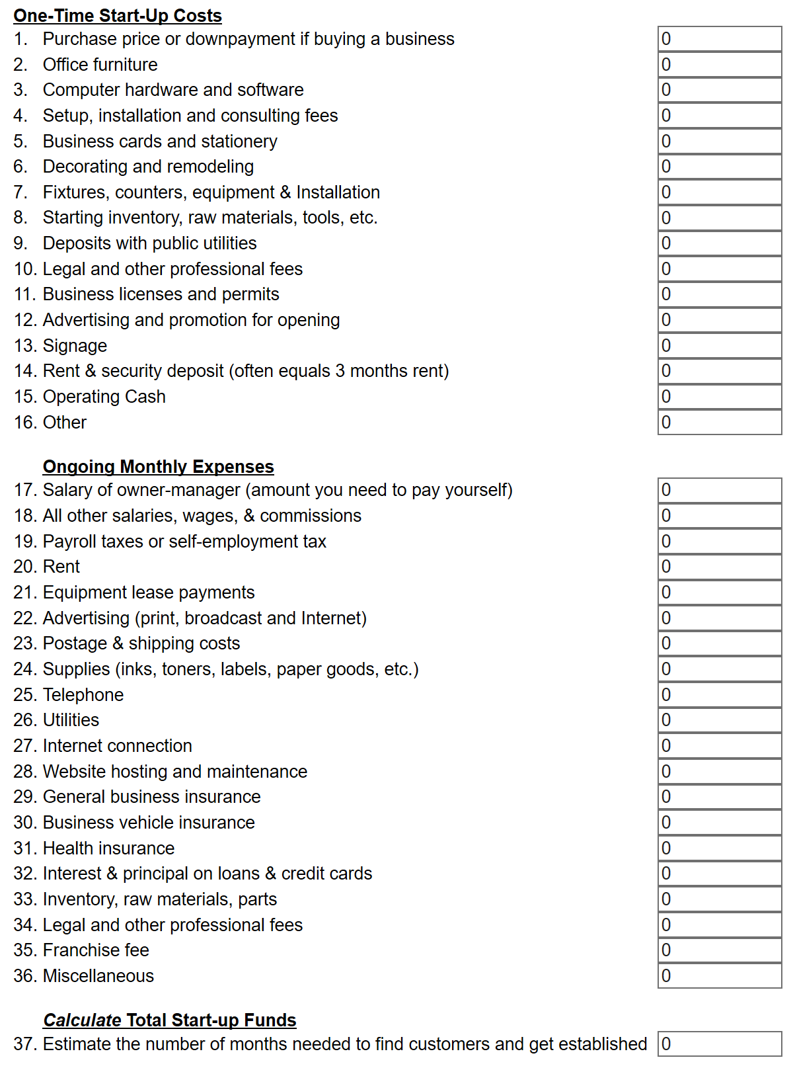
For more detailed information, please visit https://www.businessknowhow.com/startup/startup.htm
Case studies
Hotel Industry and Environmental Laws: A Case Study of Selected Restaurants in Islamabad
For more detailed information, please visit https://www.pide.org.pk/pdf/Working%20Paper/EE_Working_Paper-14.pdf

Module 11: Develop own skills and practice
Objective of the module: The aim of this module to develop the higher level knowledge, skills and understanding needed to develop own skills and practice
Duration: | 100 hours | Theory: | 25 hours | Practical: | 75 hours

Learning Unit | Learning Outcomes | Learning Elements | Materials Required
LU1:  Develop own personal and professional skills | The learner will be able to:  Review and evaluate own skills, knowledge and career development practice against current performance requirements  Identify trends and developments relevant to own skills, knowledge and career development practice  Identify and critically reflect on how own values, beliefs and attitudes influence own career development practice  Seek feedback to reflect on and evaluate own performance  Ensure own career development practice is inclusive and promotes equality and diversity  Address internal and external constraints that impact on own practice  Plan and access development opportunities needed to keep own knowledge, skills and practice up to date and enable own work to be carried out more effectively  Use records of own actions, development plans and progress to support and inform ongoing reflective practice  Apply new knowledge and skills to consolidate learning and improve own practice  Review the effectiveness of newly acquired knowledge and skills  Engage positively with opportunities for support and supervision  Share effective practice with other practitioners | The benefits of continuously reflecting on, evaluating and developing the skills, knowledge, practice, efficiency and effectiveness of career development practice, including a personal journal, reflective practice  Aims, values, policies, procedures, roles and ways of working of own organisation  The extent and limitations of the requirements and responsibilities associated with own role  Organizational, team and own professional goals  Current performance requirements relevant to own practice  Impact of values, beliefs and attitudes based on reflective practice and learning and development  Methods to evaluate and review own skills, knowledge and practice  How to provide and act on feedback  Ways to evaluate the effectiveness of learning resources and learning provision you have used  Benefits of sharing own learning and development | Examples of records of work on keeping up-to-date on the requirements of job role  Examples of records of how to keep abreast of developments in learning and development  Examples of feedback  Examples of self-evaluations  Template for personal development plan  Examples of records of continuing professional development activities
LU2:  Work as a member of a team to achieve defined goals and implement agreed plans | The learner will be able to:  Effectively manage own time  Recognize and respect diversity, individual differences and perspectives  Accept and provide feedback in a constructive and considerate manner  Understand the responsibilities of colleagues  Identify obstacles to effective teamwork | Objectives of teamwork, for example shared goals, problem solving, productivity, co-operation  Agree roles and responsibilities, for example, team leader, supervisor, operative; formal/informal  Identifying activities required to support overall objective  Personal work plans, including short, medium or long-term goals; specific areas of development, time management, tracking the plan  Identifying factors that could influence the outcome of working together as a team  Supporting co-operative working, including being part of a group, working cooperatively with other members toward the achievement of a common work-related goal | Examples of team objectives  Template for personal work plan
LU3:  Improve personal effectiveness | The learner will be able to:  List the aims and objectives of the organization  State the organization’s brand or image  Identify the organization’s structure, roles and responsibilities  Identify potential improvements to working practices | Organizational aims and objectives  The organizational vision within the marketplace, clarity and commitment  Structure of the organization to include roles and responsibilities  The importance of current working practices and how they can be improved  Self-organization skills, assertive communication skills, relationship building skills | Organisational mission and vision statements  Organisational chart

Examples and illustrations

Important personal skills that most employers look for
For more information, please visit https://www.thebalancecareers.com/personal-skills-list-2063763

Critical Thinking
Employers want employees who can solve problems on their own using creative thinking and make informed decisions using thoughtful analysis. Critical thinkers are useful in every industry, from healthcare and engineering to education. Whether you are a restaurant manager, an engineer, or a teacher, you need to be able to understand problems, think critically, and devise solutions. Skills required for critical thinking include creativity, problem-solving, and curiosity.
- Artistic aptitude | - Desire to learn | - Resourcefulness
- Creativity | - Flexibility | - Thinking outside the box
- Critical observation | - Innovation | - Tolerance of change and uncertainty
- Critical thinking | - Logical thinking | - Troubleshooting
- Curiosity | - Problem-solving | - Value education
- Design aptitude | - Research | - Willingness to learn

Problem Solving
How well do you problem solve? Problem-solving is going to come up in virtually every job. Employers value strong problem solvers, as they effectively and swiftly make decisions while largely keeping their emotions at bay. They gather as much information as they can and let intuition, logic, and innovative thinking drive the best solution. Being a great collaborator and open to the ideas and opinions of others is also very important. So be sure to highlight your ability to work with others to find the best solution.
- Accuracy | - Humble | - Perceptive
- Assertive | - Influential | - Practical
- Conflict management | - Insightful | - Realistic
- Decision making | - Intuitive | - Reflective
- Diplomatic | - Listening | - Teamwork
- Ethical | - Patience

Flexible/Dependable
Dependability and flexibility work in tandem, as flexible employees are always dependable, and vice versa. Employers need employees who demonstrate reliability, responsibility, and trustworthiness. Flexible employees can adapt to change, take on projects outside of their scope, and shift their schedule if necessary. A flexible and dependable employee is also willing to help their colleagues with projects, even when the subject matter is unfamiliar.
- Accountable | - Helpfulness | - Responsible
- Adaptability | - Honesty | - Teachable
- Capable | - Loyal | - Trustworthy
- Competence | - Punctual
- Dynamic | - Reliable

Interpersonal Skills
Interpersonal skills, also known as people skills, are those related to how you communicate and interact with those around you. Employers want employees who are compatible with their employers, their colleagues, and clients. It is a particularly important trait when collaboration is encouraged, and those who embody it will climb the ladder more quickly than their counterparts.
Being a good listener is key to being a strong communicator. Employers want employees who can both share their own ideas and also listen empathetically to others. Listening is a very important skill in customer service, human resources, and in all leadership positions.
Displaying such skills will impress your potential employer and could lead to future opportunities for promotions and raises.
- Articulate | - Listening | - Sincere
- Attentiveness | - Management | - Sociable
- Collaborative | - Negotiation | - Storytelling
- Conscientiousness | - Nonverbal communication | - Teaching
- Considerate | - Persuasion | - Training
- Empathy | - Professional | - Understanding
- Encouraging | - Relationship building | - Verbal communication
- Inclusive | - Respectful
- Leadership | - Sense of humor

Intrinsically Motivated
Employers seek employees who are positive and passionate about their jobs and are motivated by internal forces. These individuals tend to put the most effort into their work and learn from their mistakes and failures. These individuals also tend to enjoy the process far more than those motivated by money and glory, thus making these employees more pleasant to work with and trustworthy in the eyes of employers.
- Ambition | - Energy | - Strong Work ethic
- Alertness | - Hardworking | - Productive
- Amiability | - Independent | - Enterprising
- Confidence | - Life skills | - Visionary
- Dedication | - Optimism | - Passion
- Dependability | - Positive
- Determination | - Resilience

Inclusivity action plan
For more information, please visit https://publishers.org.uk/news/releases/2017/pa-launches-10-point-inclusivity-action-plan/
- Develop an inclusivity policy, which is embedded throughout the organization and which has strong leadership commitment
- Undertake an internal workforce audit and providing the (organization) with the data on an annual basis so that industry wide statistics can be published
- Ensure all staff involved with hiring attend unconscious bias training
- Nominate an inclusivity champion on your board or management committee who can monitor action on equality
- Provide opportunities for flexible or agile working
- Analyse job descriptions, recruitment strategies and interview practices for hidden biases
- Develop a mentoring scheme that supports new staff or those at transitional career stages who are from traditionally underrepresented groups
- Ensure there is a balanced speaker panel for any events you are running or speaking on
- Consider hiring an inclusivity apprentice or intern
- Become an ambassador, as well as encouraging colleagues to give a careers talk to a local school or university

Equality and diversity – what’s the difference?
What’s the difference between equality and diversity? What's the meaning of equality and diversity?
Equality is about ensuring everybody has an equal opportunity, and is not treated differently or discriminated against because of their characteristics.
Diversity is about taking account of the differences between people and groups of people, and placing a positive value on those differences.

Equality of opportunity
Equality of opportunity is about ensuring everybody has an equal chance to take up opportunities and also to make full use of the opportunities on offer and to fulfil their potential.
"Regardless of age, race, gender, class, sexual orientation, religion or belief, disability or the passport they hold, every worker should enjoy an equal chance to up-skill or learn something new at work." - Frances O’Grady, Breaking through the barriers
We are still working hard to get equality of opportunity. For example, women still earn less than men, and people from black and minority ethnic groups still do less well in terms of education and the jobs they do than people from other groups. Part-time, temporary and shift workers may not have access to training or opportunities to progress at work.
Examples of inequalities in learning include:
- Older Workers may have been in the job for longer but this may only mean that the longer you are in a job the less training you will receive.
- Manual workers and/or workers with few qualifications are mainly overlooked for training as those who have a lot of education and training tend to benefit from any training on offer.
- Part-time workers and temporary workers are often left behind when training is on offer as employers place a greater value on permanent or full-time workers at the cost of temporary or part-time workers. Women make up the majority of part-time workers.
- Workers for whom English is a second language may find that the only jobs open to them are manual / low skilled jobs. Whilst some will have qualifications, these may have been achieved in another country and employers will often overlook them. A lack of spoken English is often a barrier to moving on.
- Shift workers are least likely to participate in learning in colleges because of working patterns, or to be offered training by their employer. They may need to be encouraged when learning is promoted and shift times taken into account when onsite learning takes place.
- Discrimination often plays a role when access to job and training opportunities are based on negative stereotypes and perceptions of what people can and can’t do.
As a union learning rep (ULR), you will already know about barriers to learning and about how a lack of skills or qualifications can make you feel less confident and de-motivated.
“Union learning has a massive contribution to make in building individual and collective confidence, and dealing with discrimination, disadvantage and unfairness wherever we find it.”

Diversity
Diversity is about celebrating and valuing how different we all are. This is strongly linked with promoting human rights and freedoms, based on principles such as dignity and respect. Diversity is about recognizing, valuing and taking account of people's different backgrounds, knowledge, skills, and experiences, and encouraging and using those differences to create a productive and effective workforce.
Diversity is something that applies to everyone, and should be part of everything we do. It is an important part of our work and not just a side issue. It requires everyone to play a full part. It is important to recognize that none of us fit neatly into separate ‘packages’ which can be neatly labeled or discriminated against.
Everyone has something about them that is different. It makes no sense to discriminate or stereotype people because they are different from us.

What do equality and diversity have to do with learning?
How does this link with learning? ULRs can help to ensure that everyone can participate in learning and share their ideas and experiences with others. They can also encourage discussion about equality and diversity to make sure that everyone can have a say.
The Equality Act
Under the Equality Act (2010) people are protected from discrimination on these grounds:
- Ethnicity
- Sex
- Gender reassignment
- Disability
- Religion and belief
- Age
- Sexual orientation
- Pregnancy and maternity
- Marriage and civil partnerships
All of these have the potential to impact on a person’s opportunities to access learning.
It is also important to consider the potential impact of a person’s social background or class on their access to learning opportunities. Trade unions have made the greatest impact amongst those on low wages with few or no qualifications. Amongst these there are groups considered particularly ‘hard to reach’ e.g. older men who find it hard to engage in learning or young workers who did not get on a school.

What is a Professional Development Plan?
For more information, please visit https://www.highspeedtraining.co.uk/hub/professional-development-plan/
A Professional Development Plan (PDP), also known as an Employee Development Plan or an Individual Development Plan, is used to document career goals and set out a strategy on how to meet them.
Creating a PDP takes time and planning. But, writing and implementing a PDP can help you to identify and develop the professional skills needed to reach your goals, and can keep you on the track to success. It’s an important process that helps you achieve your potential, reach your goals and take charge of your professional development.
Now is the time to start thinking about where you want your future to take you.

It’s Important to Take your Career into Your Own Hands
Your professional development is your responsibility. While your employer might require or encourage you to create a PDP as part of your performance review process, the chances are this will involve you steering clear of any goals that see you leaving your current company.
Writing your own, private PDP can help you plan to meet your long-term career goals, and will assist in identifying the skills and actions you need to reach them.
Your dreams will only ever be dreams if you do nothing about them. Writing a PDP is taking the first step to making those dreams come true.

How to Write a Professional Development Plan
There are 9 steps to completing a PDP:
- Assess where you are now.
- Identify your specific career goals.
- Gather information.
- Identify what professional skills you already have and which you need to work on.
- Choose how you will accomplish your goals.
- Develop a timeline for accomplishing your specific targets and goals.
- Write it all down.
- Evaluate your plan.
- Measure your progress.

Assess where you are now.
How is your career currently progressing? Assessing your current career situation is a good place to start. Ask yourself the following questions:
- What have you been doing over the past year, 3 years or 5 years to help your professional development?
- Are you where you thought you’d be at this stage in your career?
If the answers are ‘nothing’ and ‘no’, a PDP is a great place to start to begin turning that around. Even if those were not your answers, this step will give you the chance to assess the effectiveness of the strategies and actions you have been taking in the past.
Take this opportunity to reflect on your actions, and be honest with yourself. Identify, and write down, any actions that have specifically helped, or hindered, your professional development.

Identify your specific career goals.
Where do you want to be? Answering this question can take a lot of time. It is a good idea to carve out a block of about thirty minutes; sit calmly and don’t rush.
To help you get started with identifying your career goals, ask yourself the following questions:
- What does success mean to you? Is it financial success, a promotion to a managerial position or starting your own business? The definition of ‘success’ varies from person to person. There is no ‘one-size-fits-all’, so you need to understand what your motivations are to answer this question.
- What activities do you love the most? Are these activities a part of your current job? If not, can you change this?
- Are you experiencing a version of this success in your current job?
- Where would you like to be in 5 years’ time? Ten years? This is a good time to identify your long-term goals.
Defining your long and short-term goals can be scary. It can take a long time and a lot of thought, and you might start to get overwhelmed by the enormity of all the decisions, but that’s alright. Remember it’s okay to think big (like ‘dream job’ big) because with a proper PDP anything should be possible.
Just make sure that your goals are ‘SMART’:
- Specific
- Measurable
- Achievable
- Realistic
- Timely

Gather information.
What professional skills are needed to get where you want to go? After you have identified your long and short-term goals, researching what you need to achieve them is the next step. Which skills under your belt will impress at interviews and make you an ideal candidate?
Take this time to break your long-term goals down into more manageable steps. For example, if your long-term goal is to become a General Manager, identify what the individual steps required to reach that position might be. These could be progressing to a supervisor position, being promoted to Head of Department and then Assistant General Manager. Each one of these positions will have different job and skill requirements, and breaking them down into individual steps will allow you to create a better plan for the future.
Meeting with your line manager is a good place to start, as they might help you identify other areas you need to work on and offer suggestions about upcoming training opportunities provided by the company. Researching the criteria for the job you envision yourself having, and looking into new workshops that target the key skills needed in your profession, can also be helpful.
This step is important because it helps you identify the professional skills and abilities you need to help you reach your goals, enabling you to plan new learning and development opportunities that are relevant to your professional development.

Evaluate your professional skills.
Now that you have identified what professional skills are desirable for your ideal career path, take a moment to tick off ones you’re already proficient in.
Knowing your current strengths is important, so you can clearly distinguish what you are lacking that might be holding you back.

Decide on a strategy.
Now that you have identified the areas you need to work on, it is time to decide how you will remedy this. To be effective, your professional development should be;
- Job embedded
- Strategic
- Continuous and ongoing
Perhaps you could sign up to skills workshops and seminars that your company is offering, get involved in formal CPD training, or keep up to date with new technology relating to your field.
There are many strategic ways to develop the skills you need to accomplish your goals; take it in small chunks, relate all learning experiences to the skills identified by your PDP and remember this is a process of continual development – not a one-time thing.

Develop a timeline.
It is important to decide when you want to achieve your goals and laying out a time-frame is an important factor in making sure that you stick to your PDP. Knowing you have given yourself a deadline means you are more likely to achieve your plans.
Plan your targets on a yearly basis, make sure to give each target more time than you envision it taking because things rarely go to plan, and schedule your targets around opportunities you’d like to achieve.
By planning and scheduling your professional development, you’ll be the ideal candidate by the time that promotion you want rolls around.

Write it all down.
Keep detailed notes of your Professional Development Plan that you can update and alter as you go along. Writing it all down will help you remember your overall goal and all the steps you have laid out for yourself.
A PDP is not something to be written and forgotten. It is a career-long tool that you should refer to regularly.
Writing it down will also be handy for when you are ready to apply for that new position or promotion. You will have a detailed list of all the professional skills you have been working on, and examples of just how you have gone about facilitating your own professional development.

Evaluate your plan.
Before you commit to your PDP, look over it. Check again that all the goals and steps are:
- Specific
- Measurable
- Achievable
- Realistic
- Timely
Even though you should dream big, setting unreasonable goals and targets will make the experience of following a PDP stressful and disheartening. It’s important to evaluate your plan to make sure you can meet your targets – be it task or time-frame – and that your goals are realistic and achievable.

Measure your progress.
Are you meeting your targets? Assessing your progress regularly is important. Even though you know your professional development is important (you’ve made a plan for it, after all) professional education can quickly fall in priority.
Measuring your progress will help you know if you are hitting your ‘check lists’, meeting your targets and are on track for reaching your goals. You may need to set more manageable steps, or make new targets, or even set new goals.
Remember that plans change and, as you go through your career, your goals will progress with you. Learning is a lifelong process, and it’s important to continue your professional development to ensure career success.

What are your long-term goals? | What are your specific career goals?  (Divide them down into individual, more manageable steps) | What are the key skills needed for each one of your goals? | What skills do you need to work on? | What actions are you going to take?  (What training opportunities are you going to take  advantage of?) | When are you going to complete your training by?  (Set realistic timelines)

Important Team Building Skills That Employers Value
For more information, please visit https://www.thebalancecareers.com/list-of-team-building-skills-2063772
When a group works well together, it achieves the best results. Employers, therefore, want to hire people with team building skills. Good team builders are able to help groups work together well and meet their goals.
Being able to build and manage a successful team is a qualification for many different types of jobs. If you’re being considered for a position that requires managing or being part of a team, you will need to show that you have the team building skills necessary for the job.

What Are Team Building Skills?
Team building knows how to help individuals work as a cohesive group where all members feel invested in the direction and accomplishments of the team. All members have input towards developing goals and defining the steps to take to reach those goals. Everyone is able to work together to achieve the group's objectives.
Note: Employers believe that highly collaborative teams will achieve greater productivity, higher morale, less counter-productive conflict, and better customer relations.
Even though companies want all of their employees to have team building skills, they are particularly important for managers, supervisors, and outside consultants that oversee groups of employees.

Types of Team Building Skills
Communication
If you are helping to unite a team, you need to have strong communication skills. Using both written and verbal communication skills, you will have to explain company goals, delegate tasks, resolve conflicts between members, and more. It is important that you are able to clearly express ideas in ways that others can understand.
In order to problem solve and make sure every team member feels heard, you will also have to listen. You will need to understand the concerns of every member so that they each feel that they are being considered and appreciated.
- Clarity | - Interpersonal | - Written Communication
- Specificity | - Active Listening | - Verbal Communication
- Facilitating Group Discussion | - Reading Body Language (Nonverbal Communication)
Problem Solving
When team building, you will need to solve problems. These might include issues related to the group’s goals. However, these might also include interpersonal problems between group members.
A team builder must help to resolve both. He or she needs to be a mediator who can listen to two sides of a problem and help everyone come to an agreement. The goal of a team builder is to solve problems in a way that helps the team achieve its goals and keeps its members working well together.
- Brainstorming | - Mediation | - Analytical Skills
- Achieving Consensus | - Negotiation | - Flexibility
- Conflict Resolution | - Problem Sensitivity
Leadership
Being a team builder often requires assuming a leadership role for a team. You need to make decisions when there is conflict, establish group goals, and confront team members that are not producing their best. All of this requires leadership and management.
- Aligning Team Goals with Company Goals | - Hiring | - Talent Management
- Decision Making | - Management | - Consistency
- Establishing Standard Operating Procedure | - Firing | - Integrity
Teamwork
While being a good leader is important in team building, so is being a good team player. You can help build a strong team by showing the team what it means to work well in a group.
You will need to collaborate and cooperate with team members, listen to their ideas, and be open to taking and applying their feedback.
- Ability to Follow Instructions | - Cooperation | - Responding to Constructive Criticism
- Adaptability | - Reliability | - Proactivity
- Collaboration
Motivation
A team builder gets other team members excited about setting and achieving project goals. This kind of motivational energy can take many forms. Perhaps you come to work every day with a positive attitude, or maybe you encourage your other teammates with positive feedback.
Another way to motivate team members is to provide incentives. These might range from bonuses and other financial rewards to extra days of fun group activities. A team builder can think of creative ways to inspire the team to do its best.
- Mentoring New Leaders | - Encouragement | - Recognizing and Rewarding Group Achievements
- Developing Relationships | - Persuasive | - Recognizing and Rewarding Group Achievements
Delegation
A good team builder knows he or she cannot complete group tasks alone. Team builders clearly and concisely lay out each team member’s responsibilities. This way, everyone is responsible for a piece of the group goal.
Good delegation leads to project efficiency, and it can help a group achieve a goal on time or even ahead of schedule.
- Assign Roles | - Scheduling | - Time Management
- Defining Objectives | - Setting and Managing Expectations | - Project Management
More Team Building Skills
- Positive Reinforcement | - Creating Mission Statements | - Passionate About Diversity
- Negative Reinforcement | - Creating Milestones | - Interviewing
- Human Resources | - Coordinating | - Integration
- Customer Service | - Evaluating | - Versatility
- Assessing Group Progress | - Goal Oriented | - Concision
- Coaching | - Resilience | - Confidence
- Training | - Empathy | - Ongoing Improvement
- Creativity | - Imagination | - Presentation
- Identifying the Strengths and Weaknesses of Team Members | - Innovation | - Process Management

Module 12: Monitor the duties and activities of a team
Objective of the module: The aim of this module to develop the advanced knowledge, skills and understanding needed to monitor the duties and activities of a team
Duration: | 120 hours | Theory: | 30 hours | Practical: | 90 hours

Learning Unit | Learning Outcomes | Learning Elements | Materials Required
LU1:  Observe and check that professional standards are maintained throughout operations and on and completion of shift | The learner will be able to:  Monitor the use of personal hygiene and wear appropriate uniform throughout shift by associates  Monitor the extent to which associates maintain a safe, hygienic and secure working environment  Observe and check that associates work effectively as part of a hospitality team and communicate efficiently with each other throughout shift  Ensure that associates attend briefing and be aware of daily requirements and other issues  Monitor the extent to which associates check that all equipment is in good working order and check the quality and quantity of food delivered to the section | Principles of professional standards, including personal hygiene and appropriate uniform (for health and safety purposes and to present a professional image), maintaining a safe, hygienic and secure working environment (to avoid any risks to guests and associates)  The benefits of working effectively as part of a hospitality team and communicating efficiently with each other throughout shift, including good working practices, using technical and social language as appropriate, efficient production and service of food, contributing to excellence in guest service, meeting organizational goals  The features of a good briefing, including rotas for the day, level of bookings, any guests’ special requirements, special information on standards expected; and how it should be delivered, including using clear language, watching the body language of associates, providing opportunities to ask questions  Checking that all equipment is in good working order, including cleanliness, testing the equipment, and checking the quality and quantity of food delivered to the section, using organizational standards  Key elements of an organizational safety policy, including standards of personal hygiene, procedures for reporting sickness and accidents, requirements for pest control measures, minimum acceptable standards of cleaning  Food safety when storing, preparing and cooking food, including handling food hygienically, preparing and cooking food carefully and thoroughly, storing food correctly, keeping all kitchen areas clean, avoiding cross-contamination  Problems and unexpected situations, including unexpected contamination, failure of Standard Operating Procedures (eg sanitization)  Responding to accidents in accordance with organizational requirements, including arranging for first aid, alerting supervisors and/or management (depending on the nature and seriousness of the accident), recording the accident and the actions taken  Dealing with problems and unexpected situations in an appropriate manner, including consulting with associates, issuing directives, arranging training  Compliance with relevant regulations and standards | Duty rota  Job descriptions  Standard operating procedures for safe and hygienic working  Logbooks for recording accidents and incidents  Uniform (appropriate to the organisation)
LU2:  Check that operatives are present and manage absence issues for operational areas | The learner will be able to:  Check the service requirements for the day  Check that the number of associates at work match both the rota and service requirements  Adjust the duty rota according to requirements  Tackle the absent associates with appropriate methods  Take appropriate steps to motivate staff to avoid absenteeism | Operational knowledge and understanding of work areas, including food and beverage outlets, housekeeping, front office  Checking the production requirements for the day, including levels of bookings and room reservations, special requirements or events (banquets, corporate entertainment events, receptions, conferences, parties, weddings)  Checking that the number of associates at work match both the rota and production requirements, including checking staffing rota, understanding job descriptions, being aware of associates’ capabilities, levels of training, appraisals  Adjusting the duty rota according to requirements, tackling absenteeism, including keeping a record of the reasons staff give for absence, monitoring trends, discussing absence with associates, providing management and peer support during and after absence,  Taking appropriate steps for motivation of staff to avoid absenteeism, including promoting staff loyalty, managing teamwork and the team effort, understanding the health backgrounds of associates | Daily events plan  Record of bookings and functions  Copies of staffing rotas  Job descriptions  Training records  Appraisals  Log for recording absences  Uniform (appropriate to the organisation)
LU3:  Support the head of department | The learner will be able to:  Discuss and agree on methods and formats of communication with the Head of department  Agree with the Head of department daily and medium-term areas for delegated responsibilities  Support the Head of department in managing work area activities and responsibilities  Ensure that every-day work area requirements of section are signed off by Head of department | Methods and formats for communication with the Head of Department, including verbally, in writing, using the log; communicating through positive body language  Agreeing on methods and formats of communication with the Head of Department, including formal, informal, verbally, in writing, through the log, using appropriate technical and social language  Areas for responsibilities delegated by Head of Department on a daily and medium-term basis, including operational, administrative and supervisory support  Agreeing with the Head of Department daily and medium-term areas for delegated responsibilities, including through discussion, negotiating own goals, developing own skills  Supporting the Head of Department in undertaking training and inspections, including observation, developing and providing training, recording the outcomes of inspections, evaluating the effectiveness of training  Ensuring that every-day requirements of section are signed off by Head of Department, including presenting completed requisitions for sign-off, raising queries and issues | Markers and pens  Notebook  Log book  Record of allocated duties and tasks  Notice board  Daily event sheets  Fire equipment (see Complete list of tools and equipment for details)  First aid equipment (see Complete list of tools and equipment for details)  Equipment for contacting security  Standard Operating Procedures  Uniforms (appropriate to the organisation)
LU4:  Supervise operatives in work areas | The learner will be able to:  Ensure that associates are punctual and efficient in carrying out their duties  Communicate instructions and other information clearly to associates  Motivate associates in a timely and efficient manner to complete all their duties  Ensure that all staff are performing at the optimum level when carrying out work area duties  Create a friendly, professional environment which inspires teamwork within work area  Monitor the extent to which quality service is provided | Encouraging punctuality and efficiency, including leading by example, observing, investigating problems and issues  The methods of communication with associates, including verbally and in writing, using appropriate technical language, and using them effectively, including managing the volume and tone of verbal communications, ensuring written communications are legible and passed on to the right person  Motivating staff effectively, including leading by example, praise and encouragement at the right time, providing additional support where required  Ensuring that all associates are performing at optimum levels, including optimum allocation of roles and responsibilities, monitoring workloads, providing additional support where required  Ensuring that associates are producing the highest quality of service, enhancing the guest experience  Creating a friendly, professional environment which inspires teamwork, including a positive working environment, good communications between associates, using technical and social language appropriately, effective team leadership and management  Compliance with relevant regulations and standards | Markers and pens  Notebook  Log book  Record of allocated duties and tasks  Notice board  Daily event sheets  Regular and à-la-carte menu  Brochures and price lists  Fire equipment  First aid equipment  Equipment for contacting security  Standard operating procedures for work areas  Uniforms (appropriate to the organisation)

Examples and illustrations

Receiving goods
For more information, please visit https://www.bizmove.com/general/m6i6.htm
Upon receiving purchased goods from a supplier, it is important that the shipment is checked to make sure that the correct quantity and quality was received. A receiving report should immediately be completed which indicates:
- The date the material was received
- Whether the delivery was on time
- The quantity of material received and whether any discrepancies exist when compared with the packing slip
- Whether the quality of the material meets specifications
- The names of the personnel who performed these checks
This receiving report can be of great help to the bookkeeper in maintaining accurate records, and when paying the bills.

Quantity Check
When a shipment arrives, it is a good idea for receiving personnel to check it against the packing slip to make sure that the quantities are correct.
The thoroughness of the quantity check depends upon how many packages are involved, and how important the contents of the package are. If there are many packages, and there are many items in each package to count, complete counts would be a very time consuming process. In such cases, it may be better to use sampling to establish the quantity received.
Total weight or physical dimensions can be used for fairy accurate estimates of quantities in a shipment. When the material is packed in boxes, suppliers can be asked to write the quantity on the cut-side of each box so that in a shipment of several or many boxes, a few can be picked for a detailed check. If they turn out to be accurate, then there is considerable assurance that the shipment is complete.
A bulk count may be necessary when unit price is high. The receiving report should show how the count was made, i.e., by full count, by weighing and calculating the quantity, or by spot checks of packages.

Quality Inspection
It is important, upon receiving a shipment, to make sure that the material meets quality specifications. If it is of great importance that no defects in quality exist, you will probably want to run a quality check on each item of the entire shipment.
Spot checks on quality can be made on a small representative portion of the shipment. The reasoning behind spot checks is that if some of the material is defective, then you should have a fairly good chance of finding some defects if you sample items at random. Thus, you might pick some material from different places in the shipment. In the case of several packages, you might select a few pieces from the top of one package, from the bottom of another one, from the sides of a third one, etc., and run quality checks on this material instead of on the whole shipment.
Some conditions for using spot checks, or sampling, are as follows:
- Complete accuracy in locating all defects with a shipment cannot be required. No sampling method can find all defective material.
- It should be possible to obtain a representative sampling of materials from the shipment.
- An accurate method for judging the quality of the material must exist. A quality inspector must be able to reliably judge what is acceptable, and what is defective.
The procedure for correctly sampling material and conducting spot checks is somewhat complicated, however, and involves looking up figures in statistical tables. One principle, of course, applies: a larger sample size, or spot checking more items, will naturally increase chances of finding defective parts, if they exist.

Report To Accounts payable
To assure that payment will be made only if the merchandise which the vendor bills has been received in the proper quantity and of acceptable quality, the person making out the check should compare:
- Purchase order
- Receiving report
- Packing slip, when one is received, and
- Invoice from the vendor
These documents should therefore be filed together so they are available when bills are being paid.

FOLLOW-UP
Good purchasing procedures require follow-up evaluation of suppliers, and sometimes even of individual purchases. You should consider whether or not your purchasing objectives have been met and whether you are buying the best overall value in terms of the best quality, prices and service. Did the supplier provide on-time delivery and quality as promised? Were there any considerations which were forgotten in deciding upon the purchase? Did you buy the most economical quantity? Did the supplier satisfactorily resolve any problems which may have cropped up? These are some of the questions you should be asking yourself at this time.
Answers to these questions provide ideas on how purchasing can be improved in the future.

Managing absences
For more information, please visit http://www.acas.org.uk/index.aspx?articleid=4199

Be prepared: Looking after your staff and your business
People are going to be off sick from time to time. Most employees feel bad about letting down their colleagues and most employers are reasonably sympathetic about their staff's welfare.
But absence because of sickness, or another unexpected reason, can put your business in a tricky situation, particularly if you have no policies in place for dealing with it.
You need to know why staff are off, when they will come back and how you will deal with:
- short-term sickness absence which lasts less than a week
- repeated short-term sickness absences which may follow a pattern
- long-term sickness absence lasting several weeks or more
- unauthorised absence for other reasons.
Sickness absence can be caused by a mixture of:
- an employee's general physical condition
- working conditions including health and safety standards, levels of stress, and harassment and bullying
- family or emotional problems, or mental health issues other than stress.
Managers and employees often appreciate clarity and honesty about how such personal issues will be managed.
There are some legal issues to take into account, but making sure your staff are well, happy and working effectively is largely a matter of doing the right thing and using common sense.

Module 13: Manage employee workplace health and safety
Objective of the module: The aim of this module to develop the advanced knowledge, skills and understanding needed to manage employee workplace health and safety
Duration: | 100 hours | Theory: | 25 hours | Practical: | 75 hours

Learning Unit | Learning Outcomes | Learning Elements | Materials Required
LU1:  Ensure that all associates follow organizational requirements for health and safety | The learner will be able to:  Assess the risks in work environments  Check the extent to which all associates are aware of and follow health and safety requirements in line with organizational requirements  Ensure that associates follow safe working practices at all times  Monitor the extent to which associates identify any hazards or potential hazards and deal with these correctly  Monitor the reports made by associates on any accidents or near accidents  Monitor the way that associates practice emergency and security procedures correctly  Ensure that appropriate records are completed as required to demonstrate that section team follows health and safety requirements | Effective implementation of HACCP (Hazard Analysis and Critical Control Points) standards, including assessment of health and safety risks, identifying hazards, who might be harmed and how, evaluating risks and deciding on appropriate precautions, recording and implementing findings, reviewing and updating assessments as necessary  First aid, fire fighting training and anti allergic medicine to be available, assembly point for evacuations  Features of a risk assessment, including who might be harmed, what hazards exist, what could go wrong, how likely it is to happen, how many people could be hurt, what precautions could be taken to reduce risks  Benefits of risk assessment, including helping to prevent accidents, making it easier for associates to carry out their work, improving the standard of work produced, complying with organizational requirements or guidelines  The importance of working in a healthy, safe and hygienic way, to ensure there are no risks to guests or associates  Key elements of an organisational safety policy, including standards of personal hygiene, procedures for reporting sickness and accidents, requirements for pest control measures, minimum acceptable standards of cleaning  Organisational safety and hygiene practices, including carrying out tasks in the right order, finishing one before starting the next, assembling tools and equipment before starting the task, allowing sufficient time and space to complete the task involved, following a logical sequence, ensuring there are no spillages  Observing and checking that associates know and understand methods to deal with emergencies, including taking action within own responsibility, notifying engineering department, evacuating the area or building, ensuring security have been notified where necessary  Observing and checking that associates know and understand how to follow emergency procedures, including alerting others, following instructions, taking action  Completing records as required to demonstrate that section team follows health and safety requirements  Advising associates of the sources of information about health, hygiene and safety in the work area, including Standard Operating Procedures for work area, manuals, data sheet and instructions from manufacturers and suppliers, websites, training materials  Causes of food poisoning, including chemicals, viruses, moulds, physical contaminants  Compliance with relevant regulations and standards | Emergency notices  Standard operating procedures for health and safety  Fire equipment  First aid equipment  Logbooks for recording accidents and incidents  Organizational health and safety policy  HACCP standards  Standard operating procedures for safe working in work areas  Uniforms (appropriate to the organisation)
LU2:  Monitor efficient and effective use of equipment | The learner will be able to:  Ensure that all equipment is working correctly in work areas  Arrange for appropriate maintenance for all equipment available in work areas on a regular basis  Ensure that appropriate equipment is properly calibrated according to operating instructions in work areas  Check that associates are using equipment correctly, efficiently and effectively in work areas  Take corrective action where required to improve the safety of work areas | Maintaining equipment, including its function and maintenance requirements; and work areas, including maintenance and refurbishment requirements; ensuring that equipment is being used correctly and efficiently by associates, checking with kitchen teams if any products or equipment are in need of maintenance or attention, (including faulty equipment, worn fixtures and fittings), taking appropriate actions, advising engineering and/or housekeeping department  Maintenance, calibration or replacement requirements for specific items of equipment, including following manufacturer’s requirements, arranging for maintenance or replacement of equipment, process for reporting any maintenance requirements to the appropriate department, procedure for ensuring that food outlet areas are refurbished at appropriate and agreed intervals  Observing and checking the use of equipment by associates, including in line with organizational requirements and manufacturers’ guidance, using correct equipment for proper purposes, advising and guiding associates on the use of equipment in different circumstances, arranging appropriate staff training activities to promote efficient usage of equipment and awareness of maintenance requirements  Understanding and responding to risks from faulty equipment, including trapped hands or fingers, impact of a heavy object, contact with hot equipment, faulty electrical equipment, inappropriate use of equipment; HACCP implications  Compliance with relevant regulations and standards | Work area equipment and operating instructions  Maintenance schedules for work area equipment  Standard operating procedures for using work area equipment  Safety equipment  Preventive maintenance program  Uniforms (appropriate to the organisation)
LU3:  Maintain and monitor the cleaning programme | The learner will be able to:  Ensure that all associates understand their role in undertaking cleaning duties  Monitor the number of associates to undertake the cleaning programme effectively  Observe and check that associates have the cleaning tools and materials they need to undertake cleaning duties for their area of work  Check that there are no hazards present that would affect the cleaning programme  Observe and check that associates are using cleaning tools and materials safely, effectively and efficiently  Monitor appropriate checklists to ensure that the cleaning programme has been completed correctly and according to organizational standards | Purpose of cleaning programme, including encouraging safe working methods, helping to prevent accidents, reducing risks from pests, keeping the work area pleasant to work in  Functions of the cleaning programme, including work areas that are clean, cleared and sanitized; fixtures that are clean, cleared and well maintained; equipment that is clean and ready to use; routes around work area that are clean and cleared  Managing the cleaning programme, including ensuring that all associates understand their role in undertaking cleaning duties; monitoring the number of associates needed and present to undertake the cleaning programme effectively; checking that associates have the cleaning tools and materials they need to undertake cleaning duties for their area of work  Preparing and implementing cleaning schedules, including defining cleaning standards, what items and surfaces are to be cleaner, where they are to be cleaned, who is to carry out the cleaning, how often the cleaning is to be carried out, when the cleaning should be done, the method of cleaning that should be used, how long it should take to clean correctly, what chemicals and equipment should be used, what safety precautions should be taken  Assessing and planning rotas to include servicing the cleaning programme, including levels of manpower, ensuring associates are appropriately trained to use specialized cleaning equipment  Understanding the range of tools and cleaning materials needed to support the cleaning programme within work areas, ensuring that tools and materials are provided, appropriately serviced and maintained  Developing appropriate checklists to ensure that the cleaning programme has been completed correctly and according to organizational standards, monitoring completed checklists  HACPP and other guidelines for the safe use of cleaning tools and materials, including uniforms, appropriate storage of tools and materials, particularly for hazardous chemicals  Problems with cleaning, equipment or products, including wrong products or equipment, equipment not working, product not satisfactory  Compliance with relevant regulations and standards | Staff rotas  Procedures for carrying out the cleaning programme  Instruction manuals for specialist cleaning equipment  Checklists for monitoring the cleaning programme  Weekly, fortnightly, monthly, quarterly and annual cleaning schedule  HACCP standards  Uniforms (appropriate to the organisation)
LU4:  Manage risk in the workplace | The learner will be able to:  Conduct a formal risk assessment  Assess level of risk associated with hazards  Document hazards and risks in a formal workplace risk assessment  Identify and formally document workplace control measures  Implement control measures that reduce risks  Ensure that safety policies, plans, procedures and systems information are circulated to appropriate colleagues | Operations and activities which might impact on the safety of:  - Associates  - Guests  - Contractors and other visitors  Current health and safety at work regulations, guidance and codes  Locating and selecting information, relevant to the area of responsibility and authority, concerning:  - Hazards  - Risks  - Regulatory changes  - Incidents and accidents  - Organisation safety and industry good practice  - Operations and activities  Conducting a formal safety risk assessment  Types of control measures appropriate to different work areas and their respective benefits/constraints  Assessing the risk mitigation effect of control measures  Principles, content and format of safety documentation for different work areas  Where and how to locate appropriate information in relation to organizational health and safety key performance indicators | Standard operating procedures for different work areas  Examples of risk assessments in hospitality  Risk assessment template  Examples of control measures  Examples of safety documentation for different work areas  Examples of organizational health and safety key performance indicators

Examples and illustrations

Preparing a health and safety policy
For more information, please visit http://www.hse.gov.uk/simple-health-safety/policy/

Overview
The law (in the UK) says that every business must have a policy for managing health and safety.
A health and safety policy sets out your general approach to health and safety. It explains how you, as an employer, will manage health and safety in your business. It should clearly say who does what, when and how.
If you have five or more employees, you must write your policy down. If you have fewer than five employees you do not have to write anything down, but it is useful to do so.
You must share the policy, and any changes to it, with your employees.

How to write your policy
Your policy should cover three areas.

Part 1: Statement of intent
State your general policy on health and safety at work, including your commitment to managing health and safety and your aims. As the employer or most senior person in the company, you should sign it and review it regularly.

Part 2: Responsibilities for health and safety
List the names, positions and roles of the people in your business who have specific responsibility for health and safety.

Part 3: Arrangements for health and safety
Give details of the practical arrangements you have in place, showing how you will achieve your health and safety policy aims. This could include, for example, doing a risk assessment, training employees and using safety signs or equipment.
The following pages provide an example and a template for writing a health and safety policy.

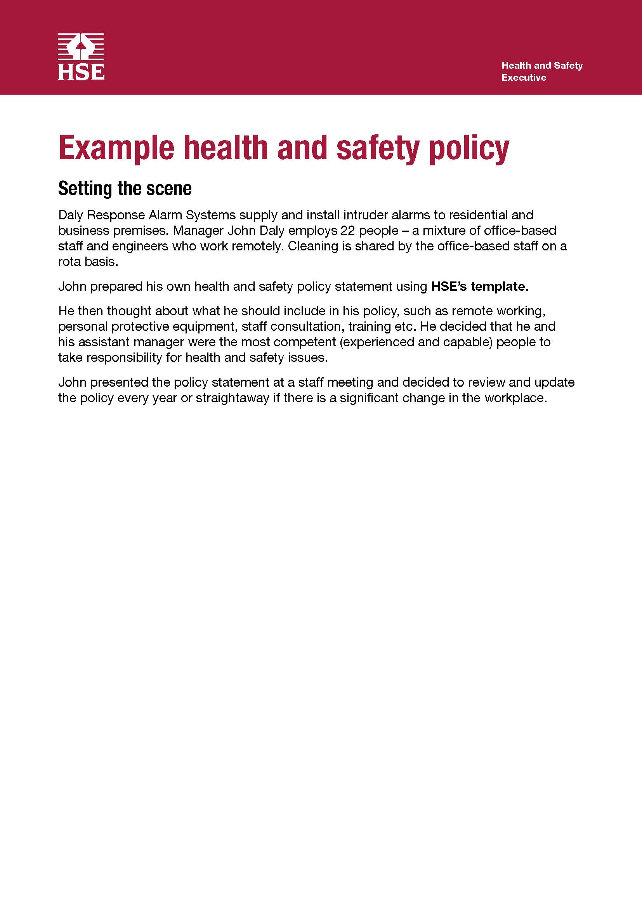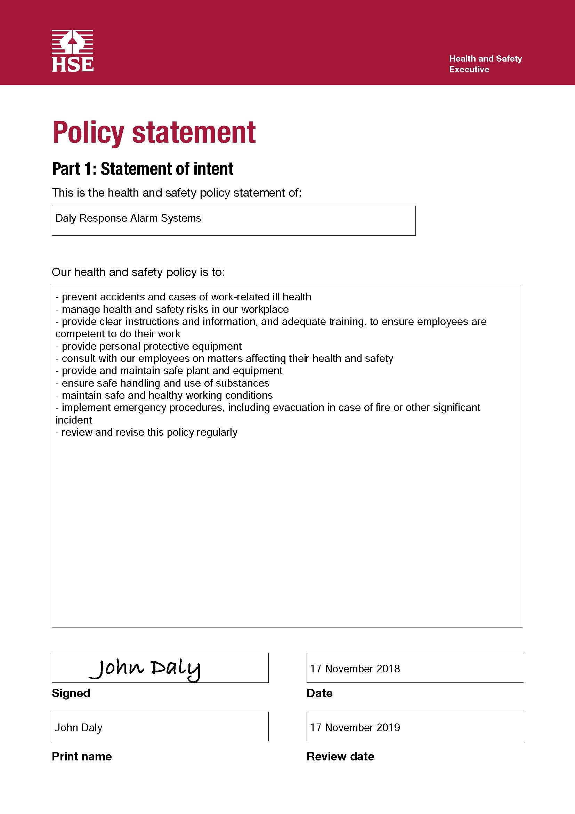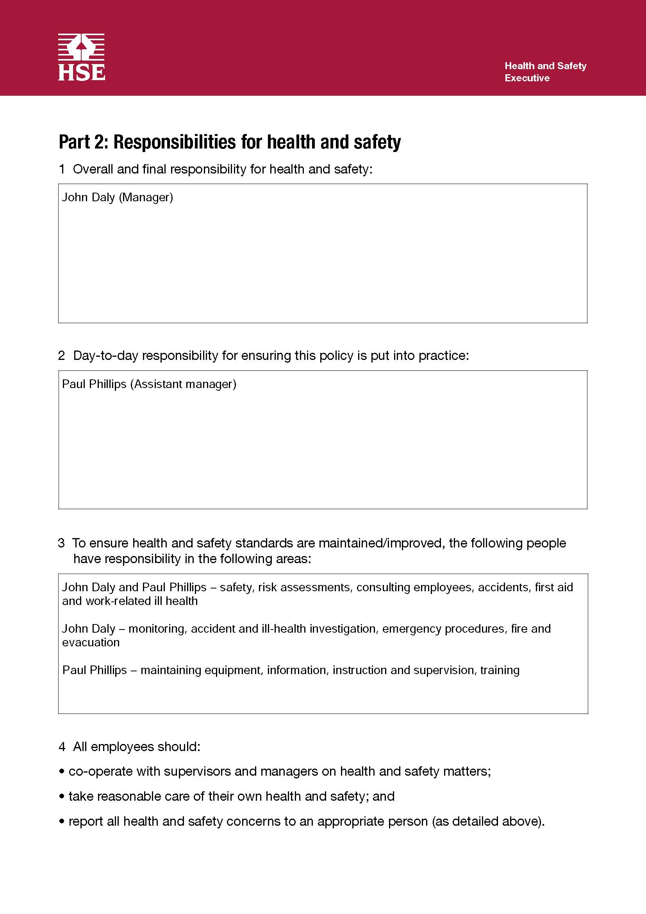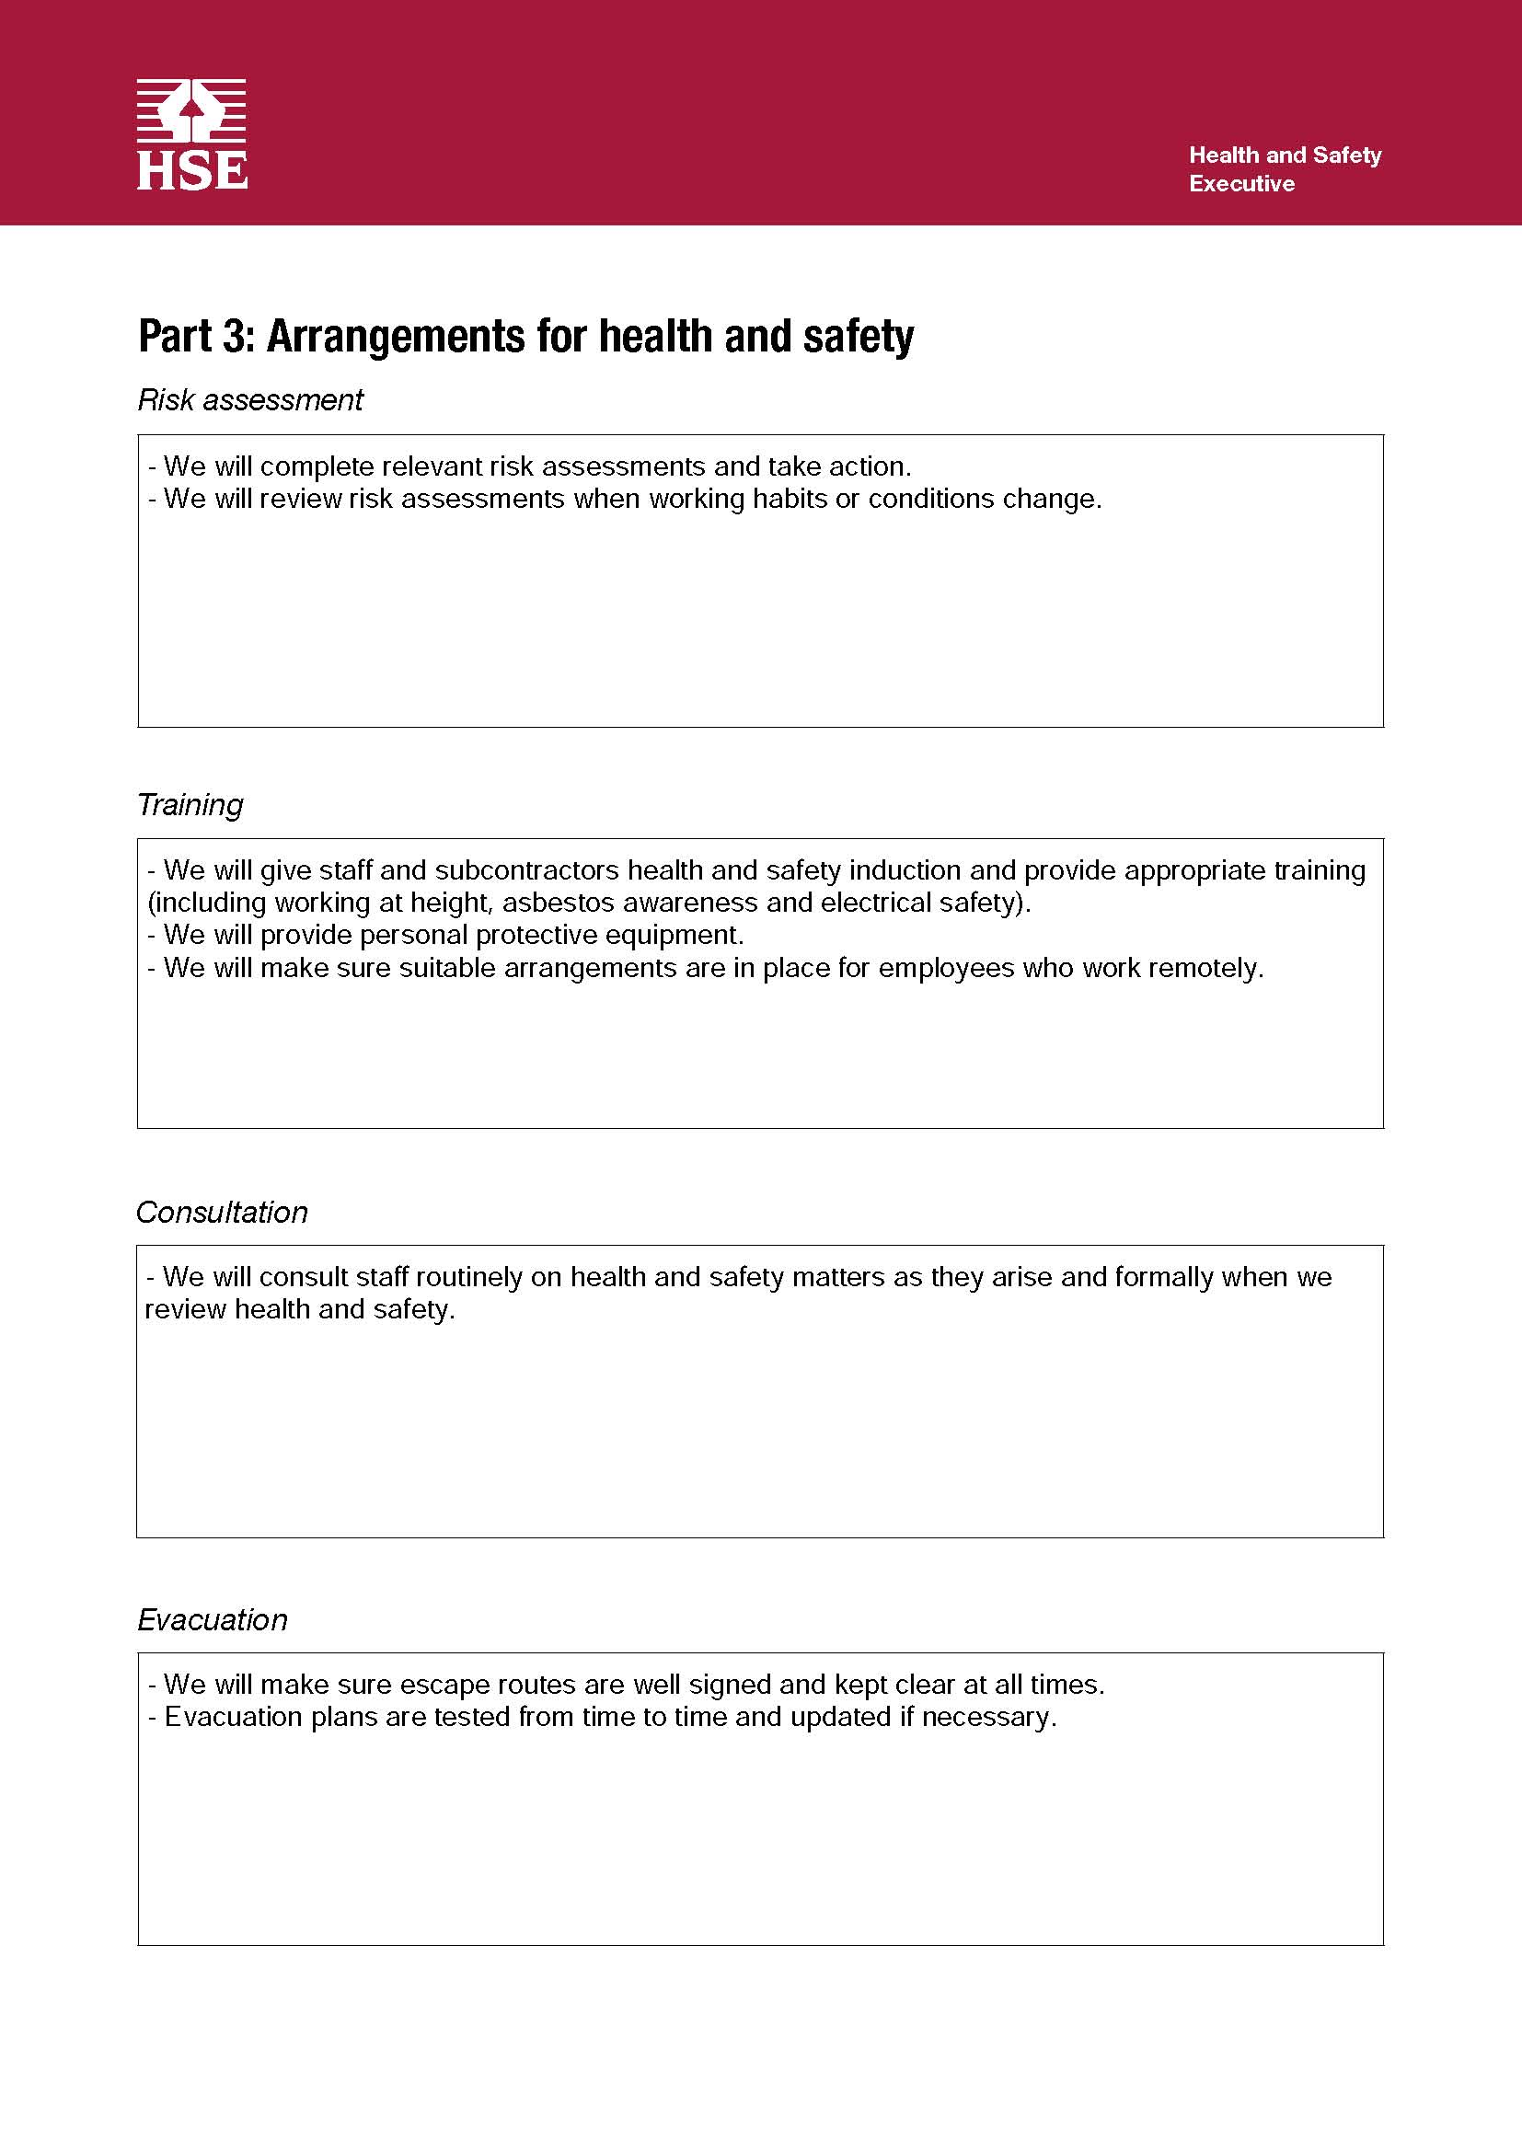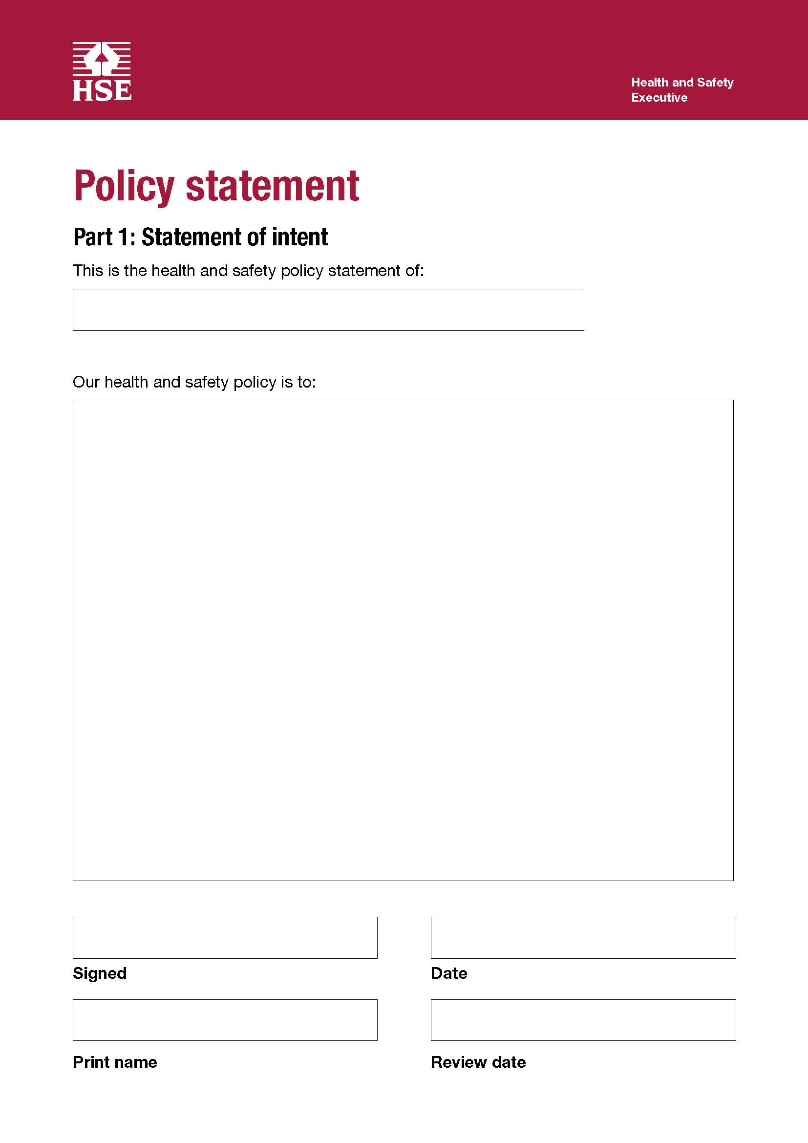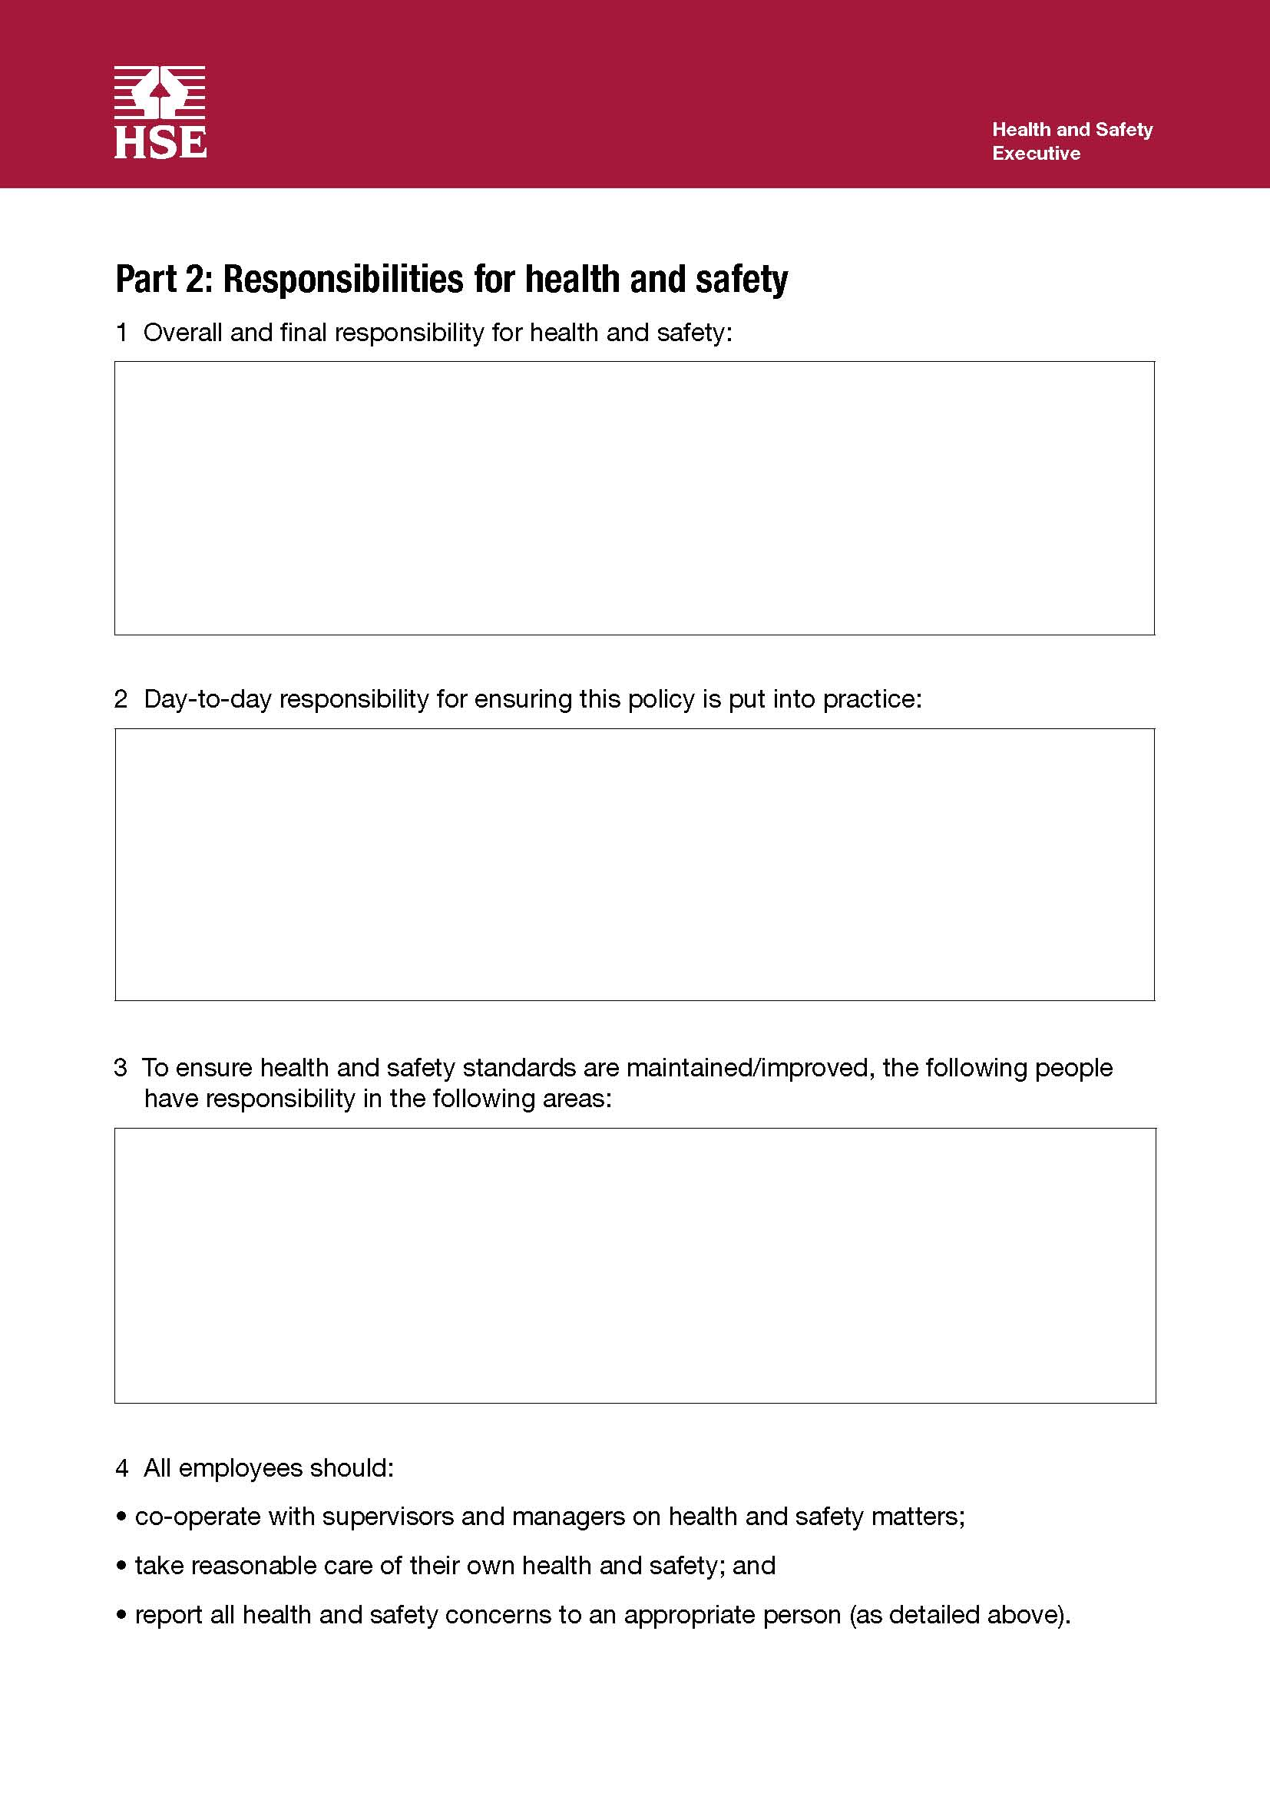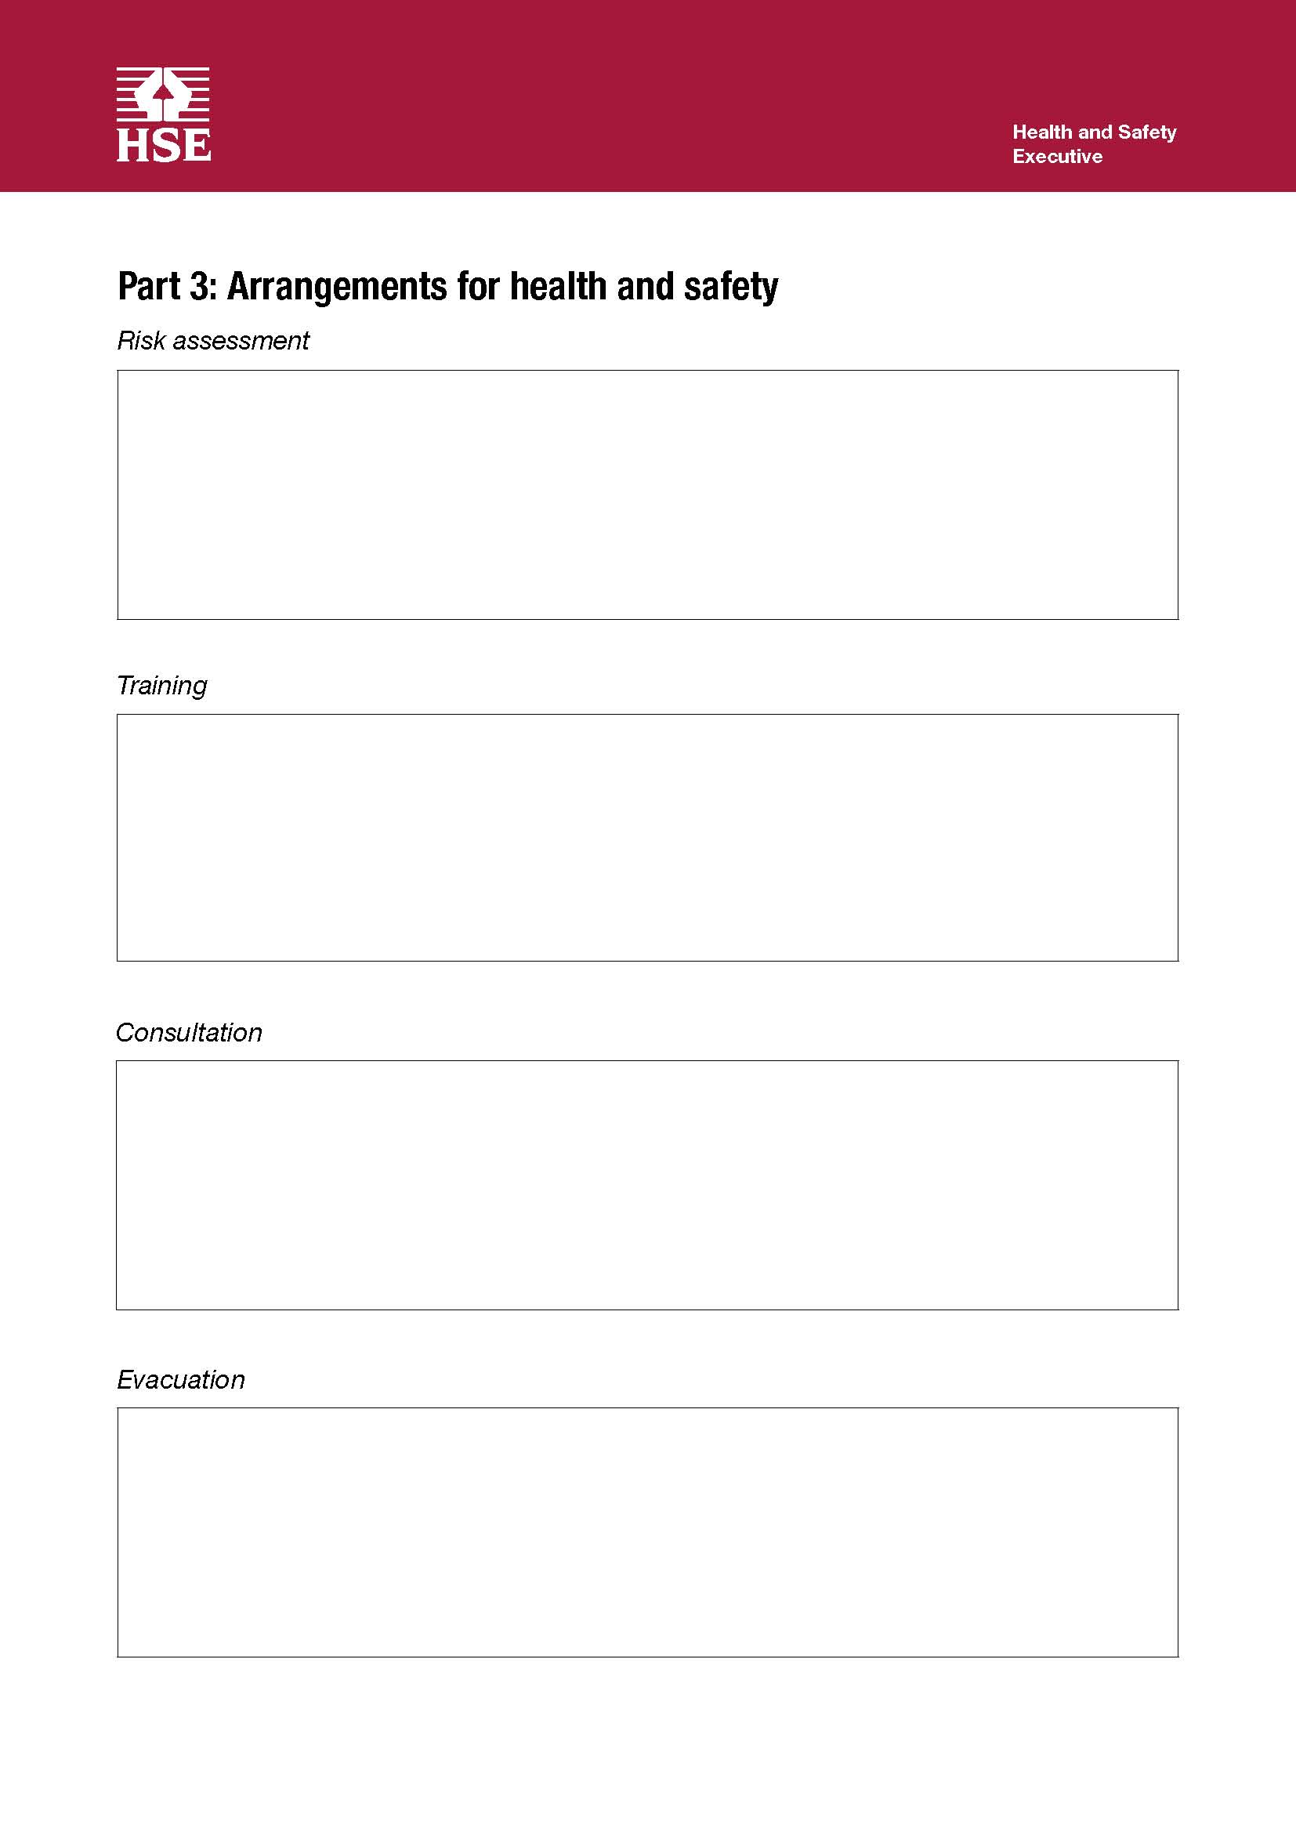

Managing risk
For more information, please visit http://www.hse.gov.uk/risk/

How do I do a risk assessment?
To do a risk assessment, you need to understand what, in your business, might cause harm to people and decide whether you are doing enough to prevent that harm. Once you have decided that, you need to identify and prioritize putting in place, appropriate and sensible control measures.
Start by:
- identifying what can harm people in your workplace
- identifying who might be harmed and how
- evaluating the risks and deciding on the appropriate controls, taking into account the controls you already have in place
- recording your risk assessment
- reviewing and updating your assessment
This is not the only way to do risk assessment as there are no fixed rules about how a risk assessment should be carried out. However, we believe that the controlling the risks in the workplace guidance provides the most straightforward way for most businesses.

What should I include in my risk assessment?
Your risk assessment should include consideration of what in your business might cause harm and how and, the people who might be affected. It should take into account any controls which are already in place and identify what, if any, further controls are required.
You should be able to show from your assessment that:
- a proper check was made
- all people who might be affected were considered
- all significant risks have been assessed
- the precautions are reasonable
- the remaining risk is low
You do not need to include insignificant risks. You do not need to include risks from everyday life unless your work activities increase the risk.
Any paperwork that is produced should help with communicating and managing the risks in your business.

When do I need to do a risk assessment?
You should carry out an assessment before you do work which presents a risk of injury or ill health.
You only need to do a risk assessment if you are an employer or a self-employed person.
The following pages provide a template for carrying out a risk assessment (www.hmrc.gov.uk/gds/agl/attachments/generic_ra.doc )

General risk assessment form

Risk assessments should be reviewed at least annually, or after accidents, near misses and when significant changes in personnel or work practices occur.
To assist managers when completing their risk assessments, guidance, information and a number of generic risk assessments and/or checklists are available on the HMRC Intranet under Health and Safety.

Advice on hazards, risks and risk assessment is available from the HMRC H&S Advisers. You can contact them through the HR Service Centre.
 | Location |  |  |  |  |  | Activity
 | Issue
 | Number | Hazard  Something with the potential to harm: hazards listed should be all those present before controls are in place. | Possible effects/harm  Where a group of people may be affected differently, for example young people or expectant mothers, identify the separate effects/harm and risk rating. | Risk rating H, M, L  Indicate the rating prior to controls being in place. (See page 7 for guidance on rating the risk.) | Detail existing controls  Provide details of control measures already in place. If measures are detailed in other documents, state where. |  |  | Detail further action required to reduce risk  Note the action required, responsible person and target date. | Revised risk rating  H, M, L  Indicate the rating following implementation of controls.
 | 1
 | 2
 | 3
 | …..

Example risk assessment for general office cleaning
For more information, please visit http://www.hse.gov.uk/risk/casestudies/officecleaning.htm
Important reminder
This example risk assessment shows the kind of approach a small business might take. It can be used as a guide to think through some of the hazards in your business and the steps you need to take to control the risks. Please note that it is not a generic risk assessment that you can just put your company name on and adopt wholesale without any thought. This would not satisfy the law - and would not be effective in protecting people.
Every business is different - you need to think through the hazards and controls required in your business for yourself.
Setting the scene
Smith’s Cleaners provide commercial cleaning services to businesses, and employ 20 part-time cleaners. They recently won a contract to clean two floors of an office complex in a city centre, Monday to Friday. Three cleaners, working every day from 5.00 pm to 7.00 pm, machine clean hard floors in the reception, kitchen and toilet areas and generally clean the offices. If a regular cleaner is sick or on holiday, a temporary worker from an agency is used. The offices have 24-hour security cover.
The contracts manager did the risk assessment.
How was the risk assessment done?
- To identify the hazards, the manager:
- looked at HSE’s website for free health and safety advice and guidance for the cleaning industry;
- walked the areas where cleaning staff will be working, noting things that may pose potential risks and taking HSE guidance into account;
- talked to workplace health and safety representatives and cleaning staff about the risks, taking into account the needs of any particular staff members, such as whether they are pregnant or aged under 18;
- talked to the client company and agreed issues such as:
  - lines and frequency of communication between the cleaning company and the client company;
  - the client company’s own standard of housekeeping, eg clear walkways, spills cleared up immediately etc;
  - facilities and equipment available to the cleaners, including the amount of storage space available, location of sinks and taps etc;
  - the system for reporting near-miss accidents and risks discovered by cleaners, eg damaged floor tiles, that can cause accidents in the client company;
  - the security of cleaning equipment and substances, to ensure only trained cleaners can access and use them; and
  - making sure that all cleaners know what they must do if there is a fire.
- The manager wrote down who would be harmed by the hazards and how.
- For each hazard, the manager wrote down what controls, if any, were in place to manage these hazards. The manager then compared these controls to the good practice guidance set out on HSE’s website. Where existing controls were not considered good enough, the manager wrote down what else needed to be done to control or eliminate the risk.
- The manager discussed the findings with the staff cleaning those offices, making sure they understood the risks of the job and how these risks would be controlled and monitored. One cleaner, whose first language was not English, had difficulty understanding this, so the manager arranged for a bi-lingual cleaner from another team to translate. The manager pinned a copy of the risk assessment in the cleaning cupboard for all staff to see. When putting the risk assessment into practice, the manager decided to prioritise and tackle the most important things first. This included identifying when the actions should be done and who would do them. As each action was completed, they were ticked off the plan.
- The manager decided to review and update the risk assessment every year, or straightaway if major changes happened in the workplace – including changes in the use of equipment or chemicals.

Module 14: Manage comments and complaints relating to operations
Objective of the module: The aim of this module to develop the advanced knowledge, skills and understanding needed to manage comments and complaints relating to operations
Duration: | 60 hours | Theory: | 15 hours | Practical: | 45 hours

Learning Unit | Learning Outcomes | Learning Elements | Materials Required
LU1:  Manage comments relating to operations | The learner will be able to:  Develop good relationship with associates and work teams to get regular verbal feed back  Ask guests for feedback during service  Ensure that written guest feedback is collected and discussed with work teams  Ensure that feedback is gathered from different channels and recorded for further improvement in system  Monitor work teams to ensure improvement based on feedback from various sources | Comments on the range of products and services provided by the organisation, including rooms, front office, food and beverage outlets and service  Channels of feedback, including verbal comments, written feedback, feedback from senior management; formal and informal comments  Sources, including from guests, associates, supervisors and heads of department; formal and informal  Recognizing and responding to comments, including verbal or written responses, direct (to the guest, associates, supervisors and heads of department) or indirect (via a third party colleague, senior manager, guest services department); acknowledging comment, providing additional information  Sources of information and advice for responding to positive comments within the organization, including verbal sources (other colleagues), written sources (brochures and price lists, menus, recipes, work area logs, the internet)  Organizational procedures for gathering information and responding to comments, including responding within a certain time limit, recording the comment including who made it, when, in what format; recording the response given, by whom, in what format | Organisational guest feedback system  Daily event sheets  A-la-carte and other menus  Brochures and price lists  Logs and other documentation for recording information relating to comments  Computer, software, accessories  Training manual for associates on all sections  Guest service policy
LU2:  Manage complaints relating to operations | The learner will be able to:  Gather sufficient information to enable assessment of the nature and severity of the complaint  Respond to the person making the complaint if the complaint cannot be resolved within required timescales  Report any complaints that are outside own authority to deal with to the appropriate person  Make appropriate notes and a record of the complaint and the actions taken  Identify any changes to the organization's procedures which are necessary to avoid future similar complaints  Comply with legal requirements, industry regulations, including ethical standards and health and safety, organizational policies and professional codes | Complaints relating to the range of products and services provided by the organisation, including rooms, front office, food and beverage outlets and service  Types of complaints, including not asking for help, not working together as a team, not providing sufficient support  Recognizing the level of seriousness of a complaint, including format, tone of language, visual clues; developing an appropriate response  The importance of seeking further information where necessary, in order to fully investigate the complaint  Complaints involving service recovery methods, including anticipating the need for recovery, quick decision making, delegating responsibilities, providing training  Sources of information and advice for responding to complaints within the organisation, including verbal sources (other colleagues), written sources (brochures and price lists, menus, recipes, work area logs, the internet)  Difficult/sensitive situations/issues, including guests who are upset and emotional, incidents involving or spoiling a special occasion, incidents that may lead to disciplinary procedures; aiming always for a positive and creative response  The limits of own authority and the action required if a complaint is beyond own authority to handle, including gathering sufficient relevant information, identifying the appropriate colleague to refer to, ensuring details of the complaint are explained fully  Ethical standards, including ensuring that all behaviour and operations are fair, honest, not detrimental to the business or its guests  Organizational procedures for gathering information and responding to complaints, including responding within a certain time limit, recording the comment including who made it, when, in what format; recording the response given, by whom, in what format | Organisational guest feedback system  Daily event sheets  A-la-carte and other menus  Brochures and price lists  Standard operating procedures for service recovery  Logs and other documentation for recording information relating to complaints  Computer, software, accessories  Training manual for associates on all sections  Guest service policy

Examples and illustrations

How to respond to comments and complaints
This text has been adapted for the hospitality sector. For more information, please visit https://dsdweb.co.uk/care-certificate/standard-3-duty-of-care/care-workers-how-to-manage-comments-and-complaints-effectively/
Having a robust and swift comments and complaints procedure is an essential requirement for all service providers so you need to be aware of your duties and your organisation’s agreed ways of working.
You should ensure that your guests know that they have the right to make a comment and complaint and you should always remain positive about any feedback given to you. All complaints and comments should be treated seriously.
If someone wants to make a complaint to you face to face, you should remain calm and listen intently to what they have to say. If possible, have the conversation somewhere private, for example in an office. Be non-judgmental and offer support but do not agree to anything – instead, explain the complaints process and reassure them that it will be taken seriously but an investigation must take place before any decisions can be made. Ensure they understand how their complaint will be dealt with and with timescales.
Your organisation should have a comments and complaints policy and procedure, which you should follow. This usually involves filling out a form and passing it on to senior management or a dedicated complaints department. You should also inform your line manager whenever a complaint or comment has been made.

Getting advice & support
If you are unsure about how to deal with a complaint or require clarity about the complaints policy and procedure, you should speak to your manager. They may offer guidance or deal with the complaint themselves.
You may also get support from other members of staff, especially senior or more experienced members of staff who may have dealt with similar situations in the past.

Learning from comments & complaints
Comments and complaints should be welcomed as feedback is essential for improving your work, the service your organisation provides and the organisation you work for as a whole.
It can highlight areas where you may be lacking and provide you with the opportunity to make things better – some things you may not have even realised were an issue until somebody told you.

How to turn guest complaints into complements
For more information, please visit https://socialhospitality.com/2013/06/complaining-customer-turning-the-complaint-into-a-compliment/
The hotel industry is notorious for guest complaints. If you’ve ever worked retail, you know the saying “the customer is always right.” This applies to the hotel industry as well since the customer is buying a room for a night or more. How customer complaints are handled is often key to keeping that customer and gaining more.
I recently stayed at The Damai Resort in Orlando in Florida, USA, and overheard a very upset guest’s reaction to the pool being closed for routine clean up. While I was also looking forward to the pool that day, I understand that routine maintenance must happen. But what I was most impressed with was how the staff member handled this upset guest and seemed to turn his attitude around by the end of the conversation. It seemed that by simply listening to the guy and giving value to his concerns and offering fun Orlando alternatives, the guest left happy and content.
Here’s what I learned:
THE EASY FIX
A guest calling to request an extra blanket or towel isn’t complaining, yet. But that request can turn into a complaint if not handled properly. At current hotel prices per night, a customer expects his request to be met quickly. Maybe the call was placed and the customer left the room for a few hours. That blanket should be on the bed waiting for the customer upon return. There should never be a second call for a simple request.
LISTEN AND L.E.A.R.N.
The word LEARN is an acronym for how best to handle a customer with a complaint. First, you need to L or listen. This is absolutely the most important because it’s only by listening that you can assess exactly how best to handle the situation. Allow the guest to explain the problem.
E or empathize is next. Be empathetic to the situation by recognizing the inconvenience or disruption. Don’t point fingers or try to explain why something isn’t your fault. It may be that the customer is upset about something else and the complaint is a way of blowing off steam. Regardless of reason, convey sorrow that the customer is upset.
A is for act. After listening and understanding, you must act. If the room is dirty or the bill is wrong, see to it immediately or as soon as humanly possible. Wasting time or putting off repairing the situation will only make it worse.
R means a report must be made. In order to keep the same thing from happening, report the problem to the supervisor so it can be addressed in a staff meeting. Sometimes, discussing a complaint can lead to innovative solutions and fewer repeats of the issue.
N is for notify. Notify the customer that the problem has been handled. If the customer is already aware that the problem is handled, simply check with the customer later. You can do this on the same day or the next, but be sure to find out if everything else is ok or if there is anything else that needs to be done. A little extra attention after a complaint goes a long way toward making the customer feel he matters.
ATTITUDE
The overall attitude of the staff has a lot to do with customer satisfaction. If guests hear staff gathered in groups complaining, it lowers the satisfaction level. When bringing a problem to the attention of staff, a guest doesn’t want to hear the staff complain or explain why something didn’t happen correctly. After all, it’s the guest paying for the room and amenities.
Bottom line is that there are several ways to turn around a disgruntled guest. Many times it ends up being something small that could have and should have been fixed and doesn’t. If you can manage to turn around a frustrated customer, you’ll have a repeat customer for sure and may even get new business from them as well. Whether it’s the fault of the staff or the hotel or not, the end goal should still be a happy guest. That is the goal of customer satisfaction after all.

Module 15: Support the professional development of the operations team
Objective of the module: The aim of this module to develop the advanced knowledge, skills and understanding needed to support the professional development of the operations team
Duration: | 120 hours | Theory: | 30 hours | Practical: | 90 hours

Learning Unit | Learning Outcomes | Learning Elements | Materials Required
LU1:  Contribute to the development of teams and individuals | The learner will be able to:  Contribute to the identification of development needs for individuals and teams accurately  Ensure that the development needs identified are consistent with team objectives and organizational values  Ensure that contributions to the planning process reflect the identified development needs of all those associates under own responsibility  Agree ideas with individual team members  Contribute to development activities to support team objectives and plans  Take into account the work activities, learning abilities and personal circumstances of individual team members  Encourage and use feedback from those taking part in the activities to improve own future contributions to development activities  Contribute to the assessment of associates against development objectives  Provide information about assessments to authorized people only, in the required format and to agreed deadlines | Identifying development needs for individuals and teams accurately, including individual personal objectives, team objectives, development and retraining objectives  The importance of using sufficient, reliable and valid information, in order to plan effectively, to maximize opportunities, to add value to the organization’s goals  Presentation of development needs to associates in a way which is likely to influence their decision-making positively, including providing guidance, support and motivation  The importance of team development to the continuing effectiveness of the organisation, including own role and responsibilities in contributing to this process, developing and securing support from associates, seeking contributions to the development process from associates  Collecting and validating relevant information needed to identify development needs, including informally from associates, formally through guest surveys, job appraisals  Team objectives and organizational values, including delivering excellent food service and guest service, which have a bearing on development needs, including development opportunities, training and re-training needs  Analyzing different decisions whether development needs are consistent with organizational objectives and values, including identifying and defining development needs, evaluating these against organizational objectives, prioritizing development  Assessing associates against development objectives using clear, agreed criteria and sufficient, valid and reliable information, including job appraisals, feedback from guests and other associates  The importance of taking account of the work activities of associates, their learning abilities and personal circumstances when agreeing ideas with individual team members | Standard Operating Procedures for training and development  Job descriptions and evaluations  Training schedules and reviews  Markers and pens  Notebook  Log book  Notice board  Business objectives  And appropriate analysis reports  Uniforms (appropriate to the organisation)
LU2:  Contribute to the provision of required operational associates | The learner will be able to:  Use methods to assess and select associates that meet organizational requirements  Provide information that is complete, accurate and supports the fair assessment of associates  Make suggestions for the selection of associates that are based on objective assessments of the information against agreed selection criteria  Make suggestions for selection that are clear and accurate  Make suggestions available only to authorized people  Handle communications with associates in a manner and at a level and pace appropriate to their needs  Make sure records of own contribution to the selection process are complete, accurate, clear and meet organizational requirements | Presenting suggestions for selection effectively, based on sound information, including known capabilities, job descriptions, performance appraisals, training schedules and review  Communicating effectively with the range of associates involved, including verbally and in writing, using technical language appropriately  The importance of confidentiality during selection processes including the kinds of information that may be made known to associates  The importance of keeping accurate, complete and clear records of own contributions to the selection process, in order to support and audit decisions and judgments made  The range of methods which may be used for the assessment and selection of staff, including formal and informal, and the relative advantages and disadvantages of these for the team  Possible contributions to the assessment and selection of staff, including contributing to appraisals, providing formal and informal feedback to the associate, to the HR department  Making fair and objective assessments against criteria during the selection process, including understanding the criteria, ensuring that assessments are objective and not influenced by personal views | Standard Operating Procedures for workforce planning  Job descriptions and evaluations  Training schedules and reviews  Markers and pens  Notebook  Standard formats for selection assessments  Notice board  Uniforms (appropriate to the organisation)
LU3:  Lead the work of teams and individual associates to achieve objectives | The learner will be able to:  Plan the work of teams and individuals  Involve the team and individuals when planning their work  Present work plans in a way that gains the support and commitment of those involved  Assess the work of teams and individuals  Provide both positive and negative feedback to teams and individuals on their work  Review the work of the team and individuals on a regular basis  Provide support for continuous improvement for teams and individuals | The importance of effective communication when explaining work plans and allocations, including clear explanations, using technical language, ensuring associates have the opportunity to ask questions  The importance of the associate being clear about the purpose of the work to be done, including communicating this effectively to those involved, understanding role and responsibilities  The importance of regularly reviewing work, using own observations, job descriptions and evaluations, training schedules and reviews, in order to manage time, the achievement of objectives, provide support and guidance  The importance of assessing the on-going work of teams and individuals, including the associate's role and responsibilities in relation to this, reviewing and revising objectives in order to deliver an effective team effort  The importance of providing clear and accurate feedback to team members on their performance, including the associate's role and responsibilities in relation to this, reviewing the associate’s own objectives and modifying them if required  The importance of providing team members with the opportunity to contribute to the planning and organisation of their work, in order to manage the whole team effort, motivate the team, support effective team working  The importance of providing opportunities to team members to assess their own work, including ways to encourage and enable this involvement, identifying for the associates the benefits of doing this  Motivating team members and gain their commitment by providing feedback, in order to maximize their own effort, help them to achieve their personal objectives and contribute to the team effort  The importance of good communication skills when providing feedback on work and performance, including adopting a positive approach, using technical and social language as appropriate, being supportive, encouraging the associate to ask questions  Providing positive feedback to individual associates and the team, including choosing an appropriate time and a place to give feedback, providing feedback in a way which encourages team members to feel that the associate respects them, the importance of being encouraging when providing feedback to team members and showing respect for those involved  Importance of provide constructive suggestions on how performance can be improved, in order to maintain commitment and maximise the individual/team effort  The importance of giving those involved the opportunity to provide suggestions on ways to improve their work, including ensuring they feel part of the team and that their contribution is valued  The importance of planning work activities and the associate's role and responsibilities in relation to this, including matching activities to each associate’s job role and capabilities, challenging and stretching associates, developing realistic and achievable work plans for teams and individuals both in the short and medium term | Standard Operating Procedures for leading a department  Job descriptions and evaluations  Training schedules and reviews  Markers and pens  Notebook  Standard formats for selection assessments  Notice board  Uniforms (appropriate to the organisation)
LU4:  Manage own self in an operational environment | The learner will be able to:  Develop objectives for own work role which are compatible with the vision, objectives and values of the organisation  Agree, with line manager, objectives for own work role and ways to evaluate progress and achievement  Prioritize objectives and manage own time in order to achieve them and delegate objectives and responsibilities  Use technology effectively to help achieve own objectives  Identify and eliminate distractions and activities that do not support the achievement of own objectives  Monitor changes to the organization’s objectives, processes, systems and structures and how these impact on own role  Identify and respond quickly and positively to new opportunities and urgent situations when they arise, revising own objectives and priorities as necessary  Get regular feedback on own performance from those who are able to provide objective, specific and valid feedback  Monitor progress towards own objectives and evaluate, with line manager, the extent to which objectives have been achieved  Agree, with line manager, any changes to own objectives in the light of own performance, feedback received or changes in organizational priorities | The organization's structure, systems, business processes and organizational objectives  The importance of gathering valid information, in order to plan own development effectively and set appropriate benchmarks by which to measure progress  Analyzing own work role and relating to other roles in the organisation, including identifying long term and short term aims  Monitoring changes, trends and developments, including technological advances, recycling and energy consumption issues, the visual appeal of food outlets, levels of staff usage  The impact of different factors on own role, including time, cost, support from others (associates, managers, HR department)  The importance of managing own resources, particularly knowledge, understanding, skills and time  Identifying the requirements of own work role and others, including developing better productivity for whole team, sharing new skills with other associates, improving motivation, developing and improving the reputation of the whole team  Setting work objectives which are SMART (Specific, Measurable, Achievable, Realistic and Time-bound), in order to plan out development and organize any formal learning to be undertaken  Measuring the progress against work objectives, in order to judge progress, to reflect on achievements, to modify the plan, to set new objectives  Getting and making effective use of feedback on own performance, including informally from associates, formally through guest surveys, job appraisals  Updating work objectives in the light of own performance, including feedback received or changes in organizational priorities  Recording the use of own time and identifying possible improvements, including judging the effectiveness of development activities, prioritizing activities, balancing development activities against main work role  Working with individuals within own area of work, including understanding their roles, responsibilities, competences and potential, helping them with their own development, maximizing support based on own experience  The agreed requirements of own work role including the limits of own responsibilities, including matching these requirements to personal development plan, identifying and agreeing personal work objectives with HR department | Job description and evaluations  Markers and pens  Notebook  Log book  Notice board  Standard format and forms  Computer, software and accessories  Communication devices (including telephone and mobile)  Uniforms (appropriate to the organisation)
LU5:  Contribute to the identification and implementation of sales development activities | The learner will be able to:  Support the management team in establishing clear sales development activities for the organisation  Assist in preparing a sales plan that identifies and prioritizes sales development activities that are consistent with the vision of the organisation  Ensure that the plan is flexible and open to change  Discuss and agree who should be responsible for implementing sales development activities and then allocate resources effectively  Agree with senior colleagues measures for monitoring and evaluating performance against sales development activities  Gain the commitment of associates for the implementation of sales development activities  Bring together the needs and expectations of associates with what is required of them to implement sales development activities | The importance of developing and implementing sales development activities, in order to add value to the organization’s objects, to contribute to profitability  The importance of creativity and innovation in sales development activities, including responding to trends, experimenting with new approaches and ideas to support sales  Developing sales objectives which are SMART (Specific, Measurable, Achievable, Realistic and Time bound), including short and long-term objectives, individual and team objectives  Delegating responsibility and allocating resources to support implementation of sales development activities, including to different departments, allocating time, funding, materials  Developing measures and methods for monitoring and evaluating performance against the implementation of sales development activities, including establishing clear monitoring and evaluation criteria, establishing appropriate timelines  Understanding the market in which the organisation works, including the guest base (leisure, business, combination; actual and potential guests), location (city-centre, rural), size of organisation  Understanding the needs and expectations of actual and potential guests, including level and speed of service and attention, range of products  Understanding actual and potential competitors and partners, including what they offer, their competitive edge  New and available opportunities for sales development activities, including new products (dishes, menus, beverages, room types), new services (type of food service, conference and banqueting services)  The needs and expectations of colleagues and other key stakeholders, including associates within own team, other departments, stakeholders in the organisation (managers, backers, shareholders)  Sources of information that can aid monitoring and evaluation for sales development activities, including questionnaire data, research, sales figures, opinion polls | Standard Operating Procedures for selling practices in food outlets  Example sales plans  Report templates  Markers and pens  Notebook  Log book  Notice board
LU6:  Prepare, deliver and evaluate training sessions for operational associates and teams | The learner will be able to:  Prepare appropriate training plans and materials  Produce specific aims and objectives for the session  Identify the resources needed to deliver the session  Select appropriate methods to delivery training  Ensure all learning materials are available  Deliver training to individuals or groups  Use a range of appropriate techniques and activities throughout the session, including technology-based learning  Carry out assessments at appropriate points to ensure that learning has taken place  Evaluate the effectiveness of training for associates and teams | The purpose of and necessary outcomes from the training session, including personal, departmental or organizational objectives, new or corrective/remedial training  Different ways to deliver the session, including on and off the job, single sessions, series of training sessions  Appropriate use of technology-based delivery and e-learning, including reducing the costs associated with delivering training, increasing the effectiveness of the training environment, helping training to contribute to organizational goals  Ways of delivering the session which meet the aims and objectives of the session, including practical activities, role plays, case studies, live on-the-job training  An appropriate plan for the training session, including teaching and learning methods, aims and objectives; topics; variety of methods; timing; resources; checks on learning, resources and assessment methods  Selecting and using an appropriate range of methods and resources to support delivery of the training session, including teacher centered (lecture, explanation, demonstration); learner centered (goal setting, self-direction, problem solving, negotiation, discussion, presentation, journals)  Managing the training process, including following the plan; supporting learners; accommodating learning preferences; barriers to learning; independent working; feedback; managing group dynamics; differences; inappropriate behaviour; ensuring that the methods chosen will promote equal opportunities and access  Review the effectiveness of the training session, including sources of feedback (learners; self; other stakeholders; informal and formal checks)  Determine the strengths and weaknesses of the training session, including achievement against targets; feedback from associates, HR department; evaluative comments; reviews  Make recommendations for improving the training session, including the action plan; professional development; schemes of work; session plans; teaching techniques; resources used; teaching style; implementation of changes; record of modifications | Standard Operating Procedures for training and development  Job descriptions and evaluations  Markers and pens  Notebook  Log book  Notice board  Standard training formats for preparing, delivering and evaluating  Training resources, including flip charts, markers, projectors, screens, handouts, notes, case studies, problems, exercises, textbooks, videos, audio materials, computer assisted learning materials, internet, experimental materials, work place facilities, training rooms, support materials support staff  Uniform (appropriate to the organisation)

Examples and illustrations

Team development
Successful Team Development
Traditionally, a team goes through five stages of development, with each stage presenting its own challenges. The goal is for a cohesive team of people to produce a positive outcome that contributes to the success of the organization.
Proper Team Support
The team and the organization take specific actions at each stage to support the team's success in accomplishing its mission. Supporting the team at each stage of development will help it accomplish its goal.
With a thoughtful look at each stage of team development, you can solve problems before they derail the team. You cannot treat a team the same at each stage of its development because the stages dictate different support actions. These support actions, taken at the right time, will allow your teams to develop and successfully meet their challenges.
Leadership Is Key
Most importantly, at each stage, the behavior of the leader must adapt to the changing and developing needs of the group. An effective leader who other members of the team want to follow is indispensable when the group is trying to progress through the stages of development.
Generally, the leader reports to a manager. The manager, as the team sponsor, must understand how to support the team at each stage of development. This understanding by company leadership is critical to the team’s success.
Stages of Team Development
Dr. Bruce W. Tuckman, a professor of educational psychology at the Ohio State University, who researched the theory of group dynamics, published one of his theories in 1965 called "Tuckman's Stages of Group Development." Thus, emerged a four-stage team development model, "Forming, Storming, Norming, and Performing," with a fifth stage, "Adjourning," added in 1977.
The five stages of team development include suggested actions to best support the team:
Forming:
- A group of people comes together to accomplish a shared purpose. Their initial success will depend on their familiarity with each other's work style, their experience on prior teams, and the clarity of their assigned mission. As a sponsor, your role is to help the team members get to know each other whether you offer team building activities or just a listening ear.
Storming:
- Disagreement about mission, vision, and ways to approach the problem or assignment are constant at this stage of development. This struggle is combined with the fact that team members are still getting to know each other, learning to work with each other, and growing familiar with the interaction and communication of group members. As a sponsor, once again, your role is to help the team get to know each other whether you offer team building activities or just a listening ear. Help your team leader clarify each of these assignments so that the team succeeds.
Norming:
- The team has consciously or unconsciously formed working relationships that are enabling progress on the team’s objectives. The members have consciously or unconsciously agreed to abide by certain group norms and they are becoming functional at working together. As a sponsor, ask for periodic updates from the team. Regularly check the team's progress at agreed-upon intervals and critical steps on the path to a successful conclusion.
Performing:
- Relationships, team processes, and the team’s effectiveness in working on its objectives are syncing to bring about a successfully functioning team. This is the stage at which the real work of the team is progressing. As a sponsor, ask for periodic updates from the team. Help solve problems and provide input as needed. Make sure that team members are communicating with all of the other appropriate parties in your workplace.
Adjourning:
- The team has completed its mission or purpose and it is time for team members to pursue other goals or projects. As a sponsor, make sure that the team schedules an ending ceremony. Whether they debrief the project and discuss how the team could have been more successful or they just order pizza, you will want to mark a clear ending to the team or project.
These stages can be applied to all teams. However, in the case of ongoing teams, such as a department team, social media team, a customer service team, the "Ending" stage is not applicable.
The length of time necessary for progressing through these stages depends on the experience, knowledge, and skills of the members and the support they receive. In addition, teams may work at varying rates based on issues and obstacles they may encounter, such as changing team members, tasks, and goals.

Closing Thoughts
The purpose of creating teams is to provide a framework that will increase the ability of employees to participate in planning, problem-solving, and decision making to better serve customers. Increased participation promotes:
- A better understanding of decisions
- More support for and participation in implementation plans
- Increased contribution to problem-solving and decision making
- More ownership of decisions, processes, and changes
In order for teams to fulfill their intended role of improving organizational effectiveness, it is critical that they develop into working units that are focused on their goal, mission, or reason for existing. They do this by effectively progressing through the stages of development.
For more detailed information, please visit https://www.thebalancecareers.com/what-are-the-stages-of-team-development-1919224

Objectives of Team Development
There are a number of different potential objectives when you are planning any corporate team building, team activities or games. These objectives help you determine the goals of the event and understand what you are wanting to get out of the event. From knowing your objectives you can determine whether the event has been a success.
Some of the Key team building objectives might be:

Collaboration
A key element of any successful teams is how well the team collaborates together and how well it collaborates with other teams. Having teams who want to help each other to make the company succeed in its main goals can make a huge difference to how successful a company is. Collaborative based team building events help teach your teams the benefit of working together and not against each other.

Communication
A team which communicates well will achieve far more than one which doesn't. Because communication is so important to any team it’s often a key focus on many of our team events. Communication based activities are designed to help your team members make the most of their communication skills.

Change management
Change is necessary in every team on an almost continual basis. One of the worst phrases in any business is "Because we've always done it that way." We don't mean changing for changing’s sake but having the ability to make the most out of change and managing the change within teams so it becomes a benefit rather than a negative.

Problem solving
Like Change problems will always arise in any businesses and every team. However good your risk management is and your foresight to see problems before they arise there will always be some issues which need to be ironed out. Problem solving activities help teach how to react to problems in a calm manner and overcome them without them becoming far larger than they were.

Flexible thinking
The ability to be flexible is a vital skill within every team because there will always be new challenges and tasks arising which are not specifically part of anyone’s job description. The ability to see the benefits in working another way and to try new ideas can be a huge boon for any business.

Morale building
No one wants to work in a team which has low morale however a team with high morale and a great working relationship can be seen as the place to be. A high general morale can help lower staff turnover and increase staff retention which will reduce your recruitment and trainings costs as a result.

Trust
A team which doesn’t trust each other will struggle to function beyond the most basic terms. Trusting your colleagues to hold up their end of the workload and trust from managers to complete a project without the need for micromanagement can greatly increase the efficiency of any team.

Vision
The ability to see the bigger picture is the ability to see where a small project fits in to the larger goals of the company even where it isn’t always immediately apparent. Understanding where you fit in to the bigger organizational goals can help an employee see their worth to the company and their feeling of being valued.

Delegation
Delegation is more common for team leaders and managers as they more often have the need to delegate tasks or projects to their team members and subordinates. The ability to delegate effectively can also become an important skill where a team member might head up and individual project with others reporting to them.

Lean Thinking
Not wasting resources is really important to every business and not just in tough economic times. A company which employs a lean thinking and reducing wastage policy will be in a better position to weather tough economic times. Lean thinking needs to be built in to the company ethos from top to bottom to be fully effective.

Conflict Resolution
In most teams sooner or later there will be some element of conflict and being able to resolve this amicably can enhance the performance of the team and have a positive effect on team morale. By resolving conflict quickly you also gain the benefit of not allowing problems to fester and become much larger than they initially were.
For more detailed information, please visit http://www.demonwheelers.co.uk/team-building/objectives.htm

Recruitment processes
There are seven simple recruitment process steps that you should follow every time you hire.
The recruitment process can be incredibly time-consuming. The good news is that nearly every recruitment drive can be broken down into seven steps, many of which you will be familiar with already.
Here's a one-stop guide that you can use time and again. Perfect for staying in line with legislation, running a fool-proof recruitment process and hiring the right candidates to last and reduce costs down the line.

1. Know what you need
The key to getting what you want? Knowing what you are looking for. That's where good planning comes in. Ensuring you have an in-depth understanding of the role you are hiring for will make the rest of the recruitment process easier and faster, since you’ll quickly be able to determine who has the experience required to successfully fulfill the role. It also ensures candidates have a clear purpose and planned goals for the position when they join, removing any ambiguity on where they fit within wider business objectives.
Key questions to answer:
- Why is a new employee needed?
- What duties and responsibilities will the successful candidate have?
- What skills or abilities are required to succeed in the role?
- Where does this role fit within the wider business structure?

2. Prepare the job description and person specification
These are written descriptions of the role you are recruiting for; and the type of candidate needed to fill it.
They will be one of the first things jobseekers read when they find your job vacancy. Attracting the right applicants during the recruitment process is largely about getting these two documents right, so it's worth spending time on them before moving to the next recruitment steps.
- Try to include key responsibilities in the job description to give a good idea for what the role involves, as well as giving a feel for who they’d be working with and what success looks like.
- Person specifications help you characterise the type of skills and mindsets that will flourish in the role.

3. Choose where to advertise

Job sites
- Benefits: a quick way to gain widespread visibility of your vacancy to thousands of registered job seekers.
- Drawbacks: you may well end up with hundreds of CVs to sift through, and it’s likely you’ll get a lot of random applications as people ‘spam’ their CV out in hope of uptake.
Internally
- Benefits: the person you’re looking for could be right under your nose! Saving time and money on recruiting costs, motivating employees through opportunity provision, plus they’re already integrated to the culture and rhythm of the business.
- Drawbacks: For some roles, bringing in a fresh perspective or new set of skills can help add depth to the capabilities in your team.
Social media
- Benefits: LinkedIn is the no1. social platform for recruiting and screening candidates with more than 350 million professionals present, above Facebook and Twitter, and allows specific targeting of content to the skills and expertise required for a role.
- Drawbacks: your company page needs to show good quality content - the platform is as much for candidates to review if it’s the right workplace for them as much as if they are right for you.
Seek specialist support
If you are already struggling to fit everything in during the process of recruitment, you might want to consider outsourcing to a recruitment agency, especially if you are serious about finding the candidate that ticks the right boxes.
- Benefits: a good recruitment agency can take care of everything, without forcing you to relinquish control of the important decisions.
- Drawbacks: costs associated with using recruitment consultants can be off putting, in particular to smaller businesses. However, using a specialist can both strengthen and speed up the process, giving you valuable time back to achieve more within the business.
4. Review your applications
Good candidates should quickly and clearly highlight how their experience aligns with the available role. So revisit your job description and person specification for a reminder of what you are looking for. Don't feel bad about scan-reading applications. The onus is on your applicants to prove their suitability as quickly as possible.
No matter how well you crafted your job description and person specification, you will always receive wildcards. And they shouldn't always be discredited. Sometimes judicious flexibility can pay off.
5. Conducting interviews
The key moment giving you invaluable contact time with your candidates is the interview stage. Good preparation is key to getting the most out of the conversation. Enter knowing what talking points are most important to cover, including highlights from their CV or application, and of course key requisites for the role. We are also witnessing the rapid transformation of the interview process through new video technologies.
Candidates expectations are advancing just as any consumer, with higher desire for convenient, mobile experiences with a seamless transition between digital and physical interactions with a brand. It’s worth exploring how new tools and technologies can enhance your candidate experience throughout the process.

Interview Tips
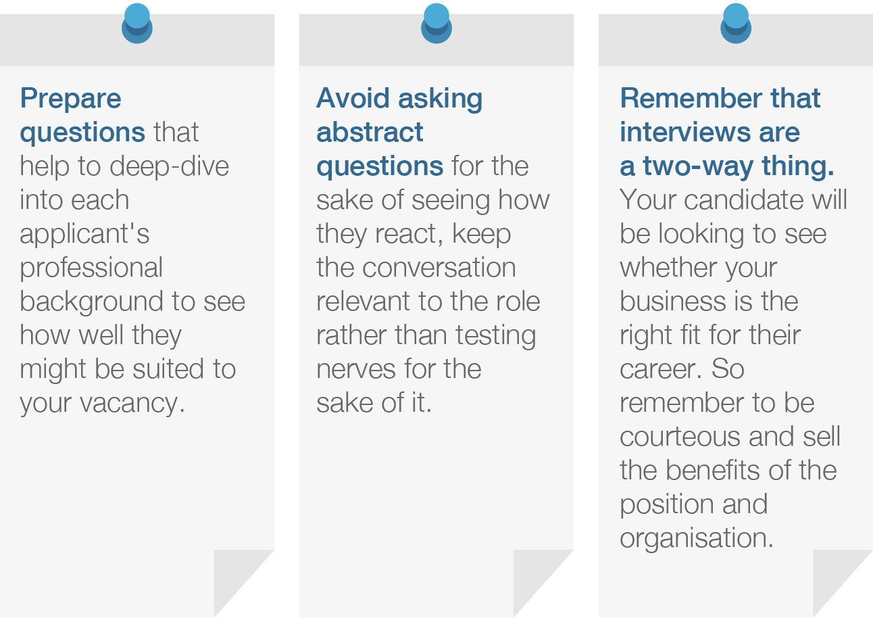

6. Checking references, drawing up a contract and offering the job
Once you have shortlisted your top candidates it's time to check their references. Many employers miss this recruitment step, but it's essential to check your candidate's background to help make sure they are everything they claim to be. (Hiring the wrong person can be eye-wateringly costly.)
For more detailed information, please visit https://www.reedglobal.com/blog/2017/06/7-steps-to-a-foolproof-recruitment-process

Employee feedback

6 Guidelines For Giving Powerful Employee Feedback
Don’t let your team wonder if they’re on the right track. Here are six ways to motivate them with feedback.
Feedback can be a double-edged sword. If provided effectively, feedback can inspire, uplift, and motivate the recipient to do better. However, if the job is botched, bad feedback can result in lingering anger, demotivation, resentment, loss of respect, and permanent damage to the relationship.
The underlying belief of giving good feedback is that the recipient is capable of doing better. Here are five steps to motivating your people with feedback:

1. Make it timely
The time to give feedback is as soon as possible after a situation or event has occurred. As time passes, memory fades, and people are more likely to interpret the situation differently.
Giving critical feedback may be difficult, but it won’t get any easier over time. Keeping the task on the back-burner will take up energy and occupy space in our minds that could be better used. The sooner you jump in and get it over with, the quicker you can move forward.

2. Prepare before the meeting
Before you schedule a time for feedback, ensure you are in the right frame of mind. Reflect on your feelings and intentions. If your predominant sentiment is anger and judgment, it is not time to provide feedback. Your emotions and energy will be felt by the person right away and the feedback will not be received positively. If you are unsure of how your feedback will be interpreted, practice with a trusted colleague, friend, or family member.

3. Ask the recipient for his own feedback
The most powerful and beneficial feedback will come from the recipient himself. Offer him the opportunity to tell you what he thinks and feels before you give him your viewpoint.
If his response is on board with what you were intending to share with him, give him credit for his insight and ask him what he thinks he can do to change his behavior or the situation at hand. The more buy-in you glean from the recipient, the more likely the person will be motivated to change.

4. Stick to the facts
Talk about what you witnessed and don’t get into what you think happened. For example, you could say that the report you needed wasn’t done on time, but don’t assume it was because he is not interested in his job. Instead, talk about the impact of not receiving the report on time and how that affected others. Give him a chance to explain why it wasn’t completed at the deadline.

5. Actively listen and check your emotions
How well your feedback is received and translated into positive results depends on how well the recipient feels he is heard when he responds. Pause after you have said what you needed to and allow him the time he needs to collect his thoughts and respond without interruption.
Repeat to him, in your own words, what you heard him say. If you are feeling angry or upset by what he just told you, give yourself a few moments to collect your thoughts. If you are still feeling a strong emotional charge, it is better to tell him you will need to think about this and set a time to get back to him.

6. End on a positive note
If you are able to, begin with something positive that you have observed. This will help balance any negative or critical feelings and lower the defensiveness the recipient may feel.
Similarly, end on a positive note. For example, express the belief that he is capable of improving and that you have faith he will do better and use the feedback to his benefit. Good communication always begets better relationships.
For more detailed information, please visit https://www.fastcompany.com/3028126/5-guidelines-for-giving-powerful-employee-feedback

Personal development

Set your main objectives
First things first, you need to define your goals.
For some, these could have been set in the back of your mind for years, just waiting for the right time to make an appearance – but for others, it could take a bit of soul-searching.
If you’re stuck, ask yourself the following questions: ‘where do you want to progress in your career?’, ‘will you be happier in a different job?’, ‘what new skills and knowledge would make you more fulfilled?’, and most importantly, ‘what type of achievements are most significant to you?’
Once you’ve set aside your goals, consider prioritising them – and try not to tackle too many at once. Be realistic with what you want to achieve, and remember that these goals can be anything from short-term to long-term, big or small.

Identify your current strengths
Once you’ve decided on your main goals, it’s time to consider your relevant strengths.
What attributes do you already have that could help this goal become a reality? Are there any transferrable skills you could utilise?
Even if you don’t have any direct experience in the field your objectives are based in, a strength can be anything from dedication, a creative mind and a keen interest in a particular area of academia, through to excellent people skills or a knack for numbers.

Decide on your key areas for development
If you often draw a blank when it comes to the common interview favourite, ‘what are your weaknesses?’ – this section of your PDP could help with that.
Identify the main areas of your career, or skills that will need improvement to be able to achieve your goals, and from there, you’ll be able to come up with realistic actions to turn your weaknesses into strengths.
Make sure the areas that need work are linked directly to your main objectives, so you’ll actually be motivated to improve on them.

Research the skills you’ll need to gain to achieve your goals
Do some in depth research on what it takes to achieve your goals, and what kind of skills, knowledge, or qualifications will help you overcome your key weaknesses.

Put in place some actions
By identifying all of the above, you should be ready to set some concrete actions that will put you on the right track to achieving your goals.
Your actions should be heavily based on your weaknesses and areas of improvement, and what skills you will need to go ahead with fulfilling your ambitions. The amount of actions you set for each objective is solely dependent on you, your individual plan, and the complexity of your aims.

Give yourself a clear timeframe for each goal
Setting a deadline for each one of your goals will give you a visible target to reach for, not to mention ensure you’re on the right track throughout your career.
Be realistic with your timeframes, and take into account how long each individual action will take. You should also consider the potential obstacles that could delay you along the way, because things may not always run as smoothly as you hope.
This is real life, after all.

Track your progression
Finally, always track your development.
Not only does this help to emphasise where you’ve improved (which boosts your confidence and motivation), it also shows you what areas your exceling in, and what areas might need work.
By recognising the obstacles, you’ll be able to put in place new actions or alter your current ones in a way that better fits in with your main objective.
For more detailed information, please visit https://www.reed.co.uk/career-advice/personal-development-plan-template/

Sales Plan Ideas

1. Prospect Intelligently
Part of developing a successful sales plan is figuring out whom you are going to sell to and where you are going to sell. Many businesses make the mistake of ignoring existing customers when prospecting, but part of your sales plan should include reaching out to current customers to see if they are using all of your products or could possibly need an upgrade to include more users or departments.

2. Develop New Businesses
A critical aspect of your sales plan is to figure out how you are going to develop new business. That means planning new sales territories and industries to move into. Make a good impression on prospective clients by sending out a high-touch program that makes it difficult for them not to take your meeting.
Another good tactic is to send out an introduction letter with a gift. It should be built into the sales plan that building a positive rapport with prospective clients and checking back in with them every few weeks is mandatory behaviour for sales reps.

3. Work with Current Customers
Part of the existing sales plan should be to set up a protocol to build healthy relationships with customers even after the ink is dry on the contract. This means keeping in contact so that you can work on press releases together, get testimonials, and gain referrals.
When you get a new customer it’s the opportunity to build a relationship that’s beneficial for both parties. This means reaching out regularly, providing them with tips, and keeping lines of communication open at all times.

4. Remember your Sales Plan isn’t Set in Stone
Of course you want to develop a detailed plan, but that doesn’t mean you won’t need to change it. In fact, a truly effective sales plan is never done. That’s because an effective sales plan depends on the market, which is always changing. Your number one goal is to ensure that you sell your product, and to do that you might have to switch up territories, sales quotas, and strategy quarterly.

5. Link up with Marketing
Part of your sales plan should be staying closely aligned with Marketing. This means having a quarterly meeting with both departments, or at least the leaders from each department, to nail down nurturing campaigns and projects that will both create brand awareness and bring in new leads.

6. Sales Cycle Analysis
One of the ways that companies can get a serious leg-up is to analyze its losses. However, this can be difficult to do if there isn’t sufficient data in the system. Ensure that your reps are logging detailed notes throughout the buying cycle about each customer in Salesforce or your CRM.
This is incredibly useful if the sale is a success, or if you lose the deal. Successful sales cycles can be emulated, and losses can be analyzed and mitigated. However, none of this useful analysis can take place unless gathering data is part of your sales plan.

7. Set Performance Measures
Not all of your reps are going to have the same performance measures. Different roles on your sales team will have different quotas, and different ways that you measure them. Make sure that your detailed sales plan takes into account each specific reps quota, territory, and accelerators.

8. Governance
When it comes to a sales compensation plan there are bound to be a few discrepancies or conflicts over bonuses, quota, or territories, Before the quarter begins make sure your sales plan includes how you will resolve questions or conflicts that come up unexpectedly.
Remember, the most important part of a sales plan is continuous analysis. Just like the rest of your business it’s critical to be dynamic and ready to respond to market changes quickly. With these eight ideas you’re on your way to creating a sales plan that will bring your company another year of continued growth and improvement.
For more detailed information, please visit https://www.xactlycorp.com/blog/ideas-develop-successful-sales-plan/

Planning a Training Session: Organizing Key Concepts for Learning
A training session plan is a road map of your lesson.
Imagine that you've just led a training session. Unfortunately, it didn't go as well as you'd hoped.
First, you forgot to cover some important points in your presentation. Then, you ran out of time to answer questions, because you had to change your session "on the fly" to cover the points you'd missed.
All in all, you're not sure that people learned what they needed to know, and you wish you'd had a clearer plan for the session.

What Is a Training Session Plan?
A training session plan – also called a learning plan – is an organized description of the activities and resources you'll use to guide a group toward a specific learning objective.
It details the subject matter that you'll teach, how long each section should take, the methods of instruction for each topic covered, and the measures you'll use to check that people have learned what you needed them to learn.
It can be as simple as a brief outline, or more complex, with scripts, prompts, and lists of questions that you plan to ask.

Why Use a Training Session Plan?
It takes time to plan a good training session. However, you and your trainees will benefit from this preparation.
As you plan, you visualize each step of the class. This helps you ensure that you've thought about everything that you need to say, and that you present information in a logical order. You'll also be able to prepare for points that people might find difficult to understand.
After your session, you can use your plan to work out what went well – and what didn't – so that you can adapt it for future lessons.
Last, a training session plan will be invaluable for a substitute instructor, if you can't make it to class.

How to Develop a Session Plan
To develop a session plan, it's useful to use a standard training plan template. This helps you organize material consistently over sessions, and avoid duplicating topics.
Then, to plan your session, follow the steps below.

Step 1: Define Learning Objectives
Your first step is to specify what you want your trainees to learn, and determine how you will measure this.
Think about these questions:
- What are the most important concepts or skills that trainees need to understand by the end of the class?
- Why are these concepts and skills important?
- How will you know that they have understood these correctly?

Tip 1:
You can use the ABCD Learning Objectives Model (For more detailed information, please visit https://www.mindtools.com/pages/article/abcd-learning-objectives-model.htm) to set a training objective that comprehensively addresses your learners' needs.
This helps you understand your Audience, define the Behavior needed at the end of the session, specify the Conditions under which knowledge will be used, and determine the Degree of knowledge needed.

Tip 2:
You should only have one or two learning objectives for each class. If you have more, you are likely to have too much information to cover, and trainees may feel overwhelmed with information.

Step 2: Clarify Key Topics and Related Concepts
Your class will focus on a few central ideas or skills, but you'll need to explain related concepts to reach your learning objectives.
List your key topics and their related concepts, and then group them together to show how they're connected.

Step 3: Organize Material
Once you have a general idea of what you need to cover, draft a lesson outline. List all of the points that you need to cover, in the order in which you'll cover them.
Use the 5 E Learning Cycle (For more detailed information, please visit https://www.mindtools.com/pages/article/5E-learning-cycle.htm) to link information to trainees' existing skills and knowledge. This will help them put it into a personal context, which, in turn, will help them retain it better.
Now, insert the information from your outline into your training plan template. Check back against your initial brainstorming document to make sure that you've covered everything that you need to say. Also, compare your template with your objectives for the session, to make sure that you'll achieve them.

Step 4: Plan Presentation Techniques
Now think about how you will teach this material to your students. It's best to use several different presentation approaches to keep students engaged, and to appeal to people with different learning styles (For more detailed information, please visit https://www.mindtools.com/mnemlsty.html) . (This is very important, because learning styles vary widely.)
Consider using these activities in your training session:
- Lectures are ideal for introducing a topic. Keep lectures to 30 minutes or less, and summarize the important points at the beginning and end. You may want to use a guest speaker if the topic is highly specialized.
- Demonstrations work best when you need to show the steps in a process or task. Learners can try the task out for themselves, or you can demonstrate it in front of the group.
- Discussions and debates are useful after a lecture, because they allow trainees to ask questions about the concepts that they have just learned. Consider handing out a list of questions or topics to prompt a discussion.
- Online learning is helpful when trainees need to gain practical experience of IT skills, if they need to access video or audio material, or if quizzes and self-test activities will be useful.
- Role play involves trainees acting out a new skill in a simulated environment, and learning from feedback from other participants.
- Small group teaching helps learners clarify their understanding of the new information. They can explain it to one another in their own words, and answer questions.
- Case studies can help learners put new information into context. As they process the information and relate it to a situation that's relevant to them, they create mental connections that will help them recall the information later.
Once you've decided which training methods to use, note them in your template.

Step 5: Include Evaluation
Now, think about when you'll check that students have understood key points. Build in learning checks and question-and-answer sessions, and include these in your template.
Also, consider how you will evaluate the session. You may want to use a formal measurement approach, or you may want to create a simple on- or off-line questionnaire that will help you tell if the session has been successful.

Step 6: Focus on Timing
Finally, think about the timing of your session. Some concepts or skills will take more time to master than others, so identify these up front, and allow students extra time to absorb or practice the material.
Record the time that you will allocate for each concept or section on your training plan, and make sure that you've allowed plenty of time to focus on the core concepts – if you don't have enough time, you'll need to run additional sessions, or narrow your learning objectives and reduce the number of topics that you plan to cover.

Note:
You can use the same steps to create a plan for an online training session.
However, you'll want to allow extra time for learners to log in to the training platform, ask questions about it, and resolve any technical problems.
You’ll also need to include extra opportunities to check for comprehension, because it can be harder to see if students have fully understood the lesson when you're not in the same room as them. Ask frequent open-ended questions to confirm understanding.
Example Training Session Plan: The example below shows a completed training session plan.
Learning Objective: To teach new team members in a call center how to handle challenging customer calls more effectively.
Key Points | Training Aids/Tools | Time | Learning Check
Introduction
Open session: introduce tutor, outline structure, explain "housekeeping." | Handouts showing session structure | 10 mins. | Confirm that students understand the session format.
Employees need to be able to handle difficult customers confidently.  When customers feel that they haven't had a positive interaction, they are more likely to switch suppliers. | Recordings of positive and negative customer calls.  Circle activity: ask each trainee for a comment on the recordings. What words come to mind? How well are the recorded agents handling their calls?  Circle activity: ask each trainee to share a negative call that they've experienced as a customer, and to explain how they felt about it. | 30 mins. | Check that each trainee has given a response in both activities.
Main Session
Run through the full call process:  Answer call and determine customer needs.  Gather customer information.  Analyze customer's emotion.  Present solutions based on customer's needs. | Group activity: trainees discuss how to assess needs and information during the call.  Pair activity: use role play to practice difficult calls. | 60 mins. | Check that trainees come up with a variety of realistic responses.  Ensure that each trainee demonstrates one successful interaction.
Conclusion
Summarize practical methods of handling difficult callers | Group summary activity: students list the solutions that they found most effective, and why, on a flip chart. | 30 mins. | Check that each group has at least three responses on their flip chart.
Wrap-up questions | Open question session | 10 mins. | Check for questions.
Evaluation | Pass out questionnaires to evaluate the effectiveness of the session. | 10 mins. | Collect a questionnaire from each trainee.

Key Points
A training session plan provides a useful format for thinking about the activities and resources you'll use to guide a group toward a learning objective.
To create an effective training session plan, take the following steps:
- Step 1: Define your objectives.
- Step 2: Clarify key topics and related concepts.
- Step 3: Organize material.
- Step 4: Plan presentation techniques.
- Step 5: Include evaluation.
- Step 6: Focus on timing.
Training session plans take time to create, but they ensure that the information you need to teach follows a logical sequence. This will help your students engage with it, and, ultimately, understand and retain it.
You can also use training session plans for online training sessions, although you'll need to allow extra time, and include extra learning checks, as it may be harder to gauge whether students have understood all of your points.
For more detailed information, please visit https://www.mindtools.com/pages/article/planning-training-session.htm

Module summary
Module | Learning Unit | Duration
Module 1:  Maintain professional standards and environment throughout shift  Aim:  The aim of this module to develop the knowledge, skills and understanding needed to maintain professional standards and environment throughout shift | LU1: Ensure professional standards are maintained for uniform and hygiene throughout the shift  LU2: Maintain the health, safety and security of the working environment  LU3: Communicate and work with associates and team efficiently and effectively throughout the shift  LU4: Check that all products and equipment are in good order  LU5: Dispose of waste  LU6: Maintain tools and equipment | 120 hours
Module 2:  Develop communication and social skills for hospitality  Aim:  The aim of this module to develop the knowledge, skills and understanding needed to develop communication and social skills for hospitality | LU1: Develop and use communication skills in a hospitality setting  LU2: Develop and use social skills in a hospitality setting  LU3: Deal with guest complaints and complements | 60 hours
Module 3:  Deliver effective guest service  Aim:  The aim of this module to develop the knowledge, skills and understanding needed to deliver effective guest service | LU1: Deliver effective and efficient service for guests  LU2: Meet and exceed guest expectations  LU3: Handle telephone calls | 60 hours
Module 4:  Provide housekeeping services  Aim:  The aim of this module to develop the knowledge, skills and understanding needed to provide housekeeping services | LU1: Maintain housekeeping supplies  LU2: Provide a linen service  LU3: Collect linen and make beds  LU4: Carry out periodic room servicing and deep cleaning  LU5: Clean and service other housekeeping areas  LU6: Provide basic laundry service | 120 hours
Module 5:  Provide food and beverage services  Aim:  The aim of this module to develop the knowledge, skills and understanding needed to provide food and beverage services | LU1: Prepare and clear equipment, materials and service area for food and beverages service  LU2: Prepare and clear guest area for food, beverages and takeaway services  LU3: Greet guests and take orders  LU4: Use appropriate methods and equipment to serve food, accompaniments, hot and cold beverages to guests  LU5: Secure payment from guests for food and beverages using appropriate method  LU6: Maintain food safety for work area when storing, holding and serving food | 120 hours
Module 6:  Provide front office services  Aim:  The aim of this module to develop the knowledge, skills and understanding needed to provide front office services | LU1: Deal with booking enquiries  LU2: Confirm, cancel and amend bookings  LU3: Deal with the arrival of customers  LU4: Prepare and maintain customer accounts  LU5: Process front office payments  LU6: Deal with the departure of customers | 120 hours
Module 7:  Co-ordinate the operation of the work area  Aim:  The aim of this module to develop the higher-level knowledge, skills and understanding needed to co-ordinate the operation of the work area | LU1: Ensure professional work standards are maintained throughout the work area and on completion of shift  LU2: Manage the work area’s requisition requirements, work area and equipment  LU3: Support the work area’s head of department | 100 hours
Module 8:  Supervise operations in the work area  Aim:  The aim of this module to develop the higher-level knowledge, skills and understanding needed to supervise operations in the work area | LU1: Supervise preparation of the work area for operations  LU2: Supervise the operation of the work area  LU3: Manage communications between the work area and other departments  LU4: Ensure health and safety practices are followed by work area operatives | 140 hours
Module 9:  Supervise hospitality events  Aim:  The aim of this module to develop the higher-level knowledge, skills and understanding needed to supervise hospitality events | LU1: Understand the importance of planning hospitality events  LU2: Understand how to supervise events  LU3: Plan and supervise an event | 140 hours
Module 10:  Identify and pursue new business opportunities in the hospitality sector  Aim:  The aim of this module to develop the higher-level knowledge, skills and understanding needed to identify and pursue new business opportunities in the hospitality sector | LU1: Identify business opportunities in the hospitality sector  LU2: Develop the structure of the new hospitality business  LU3: Communicate the new hospitality business’s services to guests  LU4: Negotiate arrangements for the new hospitality business | 120 hours
Module 11:  Develop own skills and practice  Aim:  The aim of this module to develop the higher-level knowledge, skills and understanding needed to develop own skills and practice | LU1: Develop own personal and professional skills  LU2: Work as a member of a team to achieve defined goals and implement agreed plans  LU3: Improve personal effectiveness | 100 hours
Module 12:  Monitor the duties and activities of a team  Aim:  The aim of this module to develop the advanced knowledge, skills and understanding needed to monitor the duties and activities of a team | LU1: Observe and check that professional standards are maintained throughout operations and on and completion of shift  LU2: Check that operatives are present and manage absence issues for operational areas  LU3: Support the head of department  LU4: Supervise operatives in work areas | 120 hours
Module 13:  Manage employee workplace health and safety  Aim:  The aim of this module to develop the advanced knowledge, skills and understanding needed to manage employee workplace health and safety | LU1: Ensure that all associates follow organizational requirements for health and safety  LU2: Monitor efficient and effective use of equipment  LU3: Maintain and monitor the cleaning programme  LU4: Manage risk in the workplace | 100 hours
Module 14:  Manage comments and complaints relating to operations  Aim:  The aim of this module to develop the advanced knowledge, skills and understanding needed to manage comments and complaints relating to operations | LU1: Manage comments relating to operations  LU2: Manage complaints relating to operations | 60 hours
Module 15:  Support the professional development of the operations team  Aim:  The aim of this module to develop the advanced knowledge, skills and understanding needed to support the professional development of the operations team | LU1: Contribute to the development of teams and individuals  LU2: Contribute to the provision of required operational associates  LU3: Lead the work of teams and individual associates to achieve objectives  LU4: Manage own self in an operational environment  LU5: Contribute to the identification and implementation of sales development activities  LU6: Prepare, deliver and evaluate training sessions for operational associates and teams | 120 hours

Frequently Asked Questions
Why wear protective clothing when working with food?  https://www.nisbets.co.uk/protectiveclothing | Wearing protective clothing when preparing and cooking food helps to protect both your customers and yourself. Food safe gloves and hair nets help you to hygienically prepare food and prevent foreign objects in falling in to food. Clean aprons, gloves, towels and more will help you to hygienically prepare food, protecting your customers from food poisoning or injury. Clothing can also help to protect you from injury when working with food too.
What protective clothing should be worn when cleaning?  https://www.nisbets.co.uk/protectiveclothing | Commercial cleaning chemicals can be dangerous if not use correctly or if you’re not wearing the right protective equipment. Strong acids can damage skin and eyes, so wearing the right protective clothing and equipment is crucial to maintaining safety.  Safety goggles are the best way to protect your eyes from accidental splashes of cleaning fluids. They are made from strong plastics and rubbers that make them comfortable to wear whilst giving you reliable protection. Goggles offer more protection when using chemicals as they have a surround that hugs your face, leaving no gaps for liquids to get in. Cleaning staff should also use rubber gloves to protect their skin from burns and irritation. These are available in a range of lengths and thicknesses to offer different levels of protection. Colour coded gloves are perfect for washing up and light duty cleaning, whilst long length, heavy duty gloves are great for use with strong chemicals or tricky cleaning tasks such as cleaning ovens.  Waterproof aprons prevent damage to your clothing and add a layer of protection on top of your lab coat or overalls. They are available in both heavy and light duty variations for different tasks and environments; from washing dishes to bleaching floors. You can also use tabards rather than waterproof aprons. These often come with pockets for storing cleaning equipment, such as cloths and sprays. These aren’t waterproof however, so are best suited to general cleaning duties such as dusting, polishing and vacuuming.
What is HACCP?  https://www.food.gov.uk/business-guidance/hazard-analysis-and-critical-control-point-haccp | HACCP is a way of managing food safety hazards. Food safety management procedures should be based on HACCP principles.  HACCP involves:  - looking closely at what you do in your business, what could go wrong and what risks there are to food safety  - identifying any critical control points the areas a business needs to focus on to ensure those risks are removed or reduced to safe levels  - deciding what action you need to take if something goes wrong  - making sure that your procedures are being followed and are working  - keeping records to show your procedures are working  It is important to have food safety management procedures that are appropriate for your business.
Why is handwashing important?  http://www.handinspection.co.uk/Pages/food1 | Food production workers and foodservice personnel must be taught to use correct hand and fingertip washing, by management, in preparation for work. Regulatory authorities do not require the use of a fingernail brush. However, correct use of a fingernail brush to wash hands and fingertips is the best way to assure removal of transient microorganisms.  Clearly, the food preparation industry has so many areas of possible contamination and there are an enormous variety of infections possible from the types of food handled from raw meats, vegetables, pastries, eggs, milk, and pre-prepared / cook-chill manufacture but the principals are a constant – that being, without good hygiene and hand washing practices, the risks are potentially enormous.
How do you create a set of service standards?  https://www.instituteofcustomerservice.com/research-insight/guidance-notes/article/setting-customer-service-standards | There are at least seven potential sources of information to help define the service standards for an organisation:  - Management  - Employees  - Existing customers  - Potential customers  - Lost or former customers  - Competitors  - Regulatory authorities
What are the key components of a health and safety plan?  https://smallbusiness.chron.com/workplace-health-safety-security-procedures-2608.html | A reporting system: A simple, clear , well-communicated procedure to report accidents (including near misses), injuries and illness, as well as potential hazards in the workplace.  Training programs: Some aspects may be legal requirements, such as dangerous goods handling, while other components may deal with the facility, and specific aspects of the health and safety plan.  Inspections: Employee and management teams regularly inspect the workplace to identify changing conditions or activities that may compromise safety.  Emergency planning: Foreseeable emergencies such as fires and flooding have developed action plans that are well-communicated with all staff through meetings and workplace postings.  Continuous improvement: Management seeks staff input before implementing changes to the workplace, and regular meetings address not only current health and safety issues, but also improvements to the health and safety plan.
What is the best practice for disposing of waste?  https://www.nibusinessinfo.co.uk/content/waste-disposal-best-practice | In general terms you must:  - identify your source and type of waste accurately  - complete waste disposal documentation such as transfer, duty of care notes or hazardous waste consignment notes  - find a registered carrier to transport your waste  - store the waste safely and securely until it is removed  - dispose of waste only at facilities that are licensed to accept that type of material
How To Achieve Perfect Hospital Corners  https://www.youtube.com/watch?v=1Itmy_ybiEs | 
What do I need to know about food accompaniments?  https://fnbclasses.blogspot.com/2010/07/food-and-accompaniments.html | Accompaniments are highly flavored seasonings of various kinds offered with certain dishes. The object of offering accompaniments with certain dishes is to improve the flavor of the food or to counteract its richness.  Many dishes have separate accompaniments and as they are not always mentioned on the menu, the waiter must know them. He should always have specific accompaniments ready for service at the right time.  Hot adjuncts come with the dish from the kitchen, but cold sauces are often to be found at the buffet or sideboard. They should be served directly with a dish to which they belong. They should be served from the guest’s left on to the top right of his plate (not on the rim). While serving from a sauceboat, the boat should be on an under dish or small plate, carried on the palm of the left hand. In serving, the sauceboat, lip should point towards the guest’s plate.
How do I keep food hot during service?  https://www.food.gov.uk/sites/default/files/media/document/hot-holding.pdf | Hot food must be kept at 63°C or above, except for certain exceptions. When you display hot food, e.g. on a buffet, you should use suitable hot holding equipment to keep it above 63°C.  If this is not possible, you can take food out of hot holding to display it for up to two hours, but you can only do this once. Food that has not been used within two hours, should either be reheated until it is steaming hot and put back in hot holding or chilled down as quickly as possible to 8°C or below. If it has been out for more than two hours throw it away.  Remember to keep the food at a safe temperature until it is used. If you do take food out of hot holding to display it, remember not to mix new food with the food that is already on display. This could lead to the older food being left out for too long.
How should I maintain personal standards at work? | Always be neat and clean including your teeth, fingernails, face, hair and even your shoes.  Keep your pockets empty and as much as possible avoid tinkling coins or keys and bulges.  Avoid eating candies, smoking cigarettes and chewing gum when you are at work.
What is a risk assessment?  http://www.hse.gov.uk/risk/controlling-risks.htm | As part of managing the health and safety of your business you must control the risks in your workplace. To do this you need to think about what might cause harm to people and decide whether you are taking reasonable steps to prevent that harm. This is known as risk assessment.  A risk assessment is not about creating huge amounts of paperwork , but rather about identifying sensible measures to control the risks in your workplace. You are probably already taking steps to protect your employees, but your risk assessment will help you decide whether you have covered all you need to.  Think about how accidents and ill health could happen and concentrate on real risks – those that are most likely and which will cause the most harm.  For some risks, other regulations require particular control measures. Your assessment can help you identify where you need to look at certain risks and these particular control measures in more detail. These control measures do not have to be assessed separately but can be considered as part of, or an extension of, your overall risk assessment.

Test Yourself (Multiple Choice Questions)
MODULE | 1
Question | 1 | Why is it important to have clean hair, skin and nails? | A | To demonstrate a good attitude as a team player
 |  |  | B | To be able to work more efficiently in the kitchen
 |  |  | C | To prevent contamination of food being prepared and cooked
 |  |  | D | To meet the requirements of the human resources department
Question | 2 | Why is it important to report cuts, grazes and skin conditions to the appropriate person? | A | To secure prompt and effective first aid attention
 |  |  | B | To avoid any risk of spreading infection
 |  |  | C | To gain permission to continue working
 |  |  | D | To be able to work more quickly
Question | 3 | Which TWO of the following are reasons for wearing clean chef’s uniform and headgear? | A | To save money on buying and cleaning your own clothes
 |  |  | B | To present a professional image when working in the kitchen
 |  |  | C | To avoid possible contamination of food through germs carried on dirty clothing
 |  |  | D | To ensure that customers recognize chefs when working in public areas
Question | 4 | Which of the following is in the correct order if you discover a fire? | A | Raise the alarm; Report your supervisor; Go to the assembly point; Evacuate the building
 |  |  | B | Evacuate the building; Go to the assembly point; Raise the alarm; Report your supervisor
 |  |  | C | Report your supervisor; Raise the alarm; Evacuate the building; Go to the assembly point
 |  |  | D | Raise the alarm; Evacuate the building; Go to the assembly point; Report your supervisor
Question | 5 | Which of the following temperatures identifies the danger zone – the temperature range in which food-borne bacteria can grow? | A | 8º C – 70º C
 |  |  | B | 3º C – 65º C
 |  |  | C | 5º C – 63º C
 |  |  | D | 7º C – 68º C
MODULE | 2
Question | 6 | Which of the following is an ‘open’ question? | A | Would you like the bill now?
 |  |  | B | Is your room large enough?
 |  |  | C | What time would you like the taxi?
 |  |  | D | Can I clear the table please?
Question | 7 | Which TWO of the following are forms of body language? | A | Maintaining eye contact with the guest
 |  |  | B | Asking the guest probing questions
 |  |  | C | Standing straight but relaxed
 |  |  | D | Listening attentively to the guest
Question | 8 | Which TWO of the following are barriers to developing social skills? | A | A limited range of products and services
 |  |  | B | Limited knowledge of products and services
 |  |  | C | Lack of support from the supervisor
 |  |  | D | Under-developed practical skills
Question | 9 | Which of the following is the correct sequence for handling a complaint? | A | Empathize with the guest; listen carefully and understand the complaint; offer a solution; follow-up; execute the solution
 |  |  | B | Empathize with the guest; offer a solution; execute the solution; listen carefully and understand the complaint; follow-up
 |  |  | C | Offer a solution; execute the solution; listen carefully and understand the complaint; empathize with the guest; follow-up
 |  |  | D | Listen carefully and understand the complaint; empathize with the guest; offer a solution; execute the solution; follow-up
Question | 10 | Is the following statement true or false? | A | TRUE
 |  | All solutions to guest complaints should be recorded in writing, no matter how trivial | B | FALSE
MODULE | 3
Question | 11 | Which of the following type of guest is most likely to need prompt service in a restaurant? | A | The elderly
 |  |  | B | Families
 |  |  | C | Business people
 |  |  | D | Foreigners
Question | 12 | Which of the following is the most secure method of confirming arrangements for a conference booking? | A | By telephone
 |  |  | B | In writing
 |  |  | C | By social media
 |  |  | D | Face to face
Question | 13 | Which TWO of the following are good ways to present a positive image of your own self and your organisation? | A | Good social communications with guests
 |  |  | B | A wide range of products and services
 |  |  | C | A quick response to complaints
 |  |  | D | Good personal presentation
Question | 14 | Which of the following is the best way to explain a menu dish to a foreign guest who does not speak the local language? | A | Ask a colleague to help
 |  |  | B | Speak loudly and clearly
 |  |  | C | Find a dictionary
 |  |  | D | Show the guest a picture
Question | 15 | Which TWO of the following are good communication skills when answering a telephone call? | A | Asking lots of questions
 |  |  | B | Speaking clearly
 |  |  | C | Giving detailed explanations
 |  |  | D | Speaking at an appropriate speed
MODULE | 4
Question | 16 | Which of the following is the most important when storing and issuing housekeeping supplies? | A | Completing the stores documentation accurately
 |  |  | B | Minimizing the stores that need to be issued
 |  |  | C | Delivering the stores personally
 |  |  | D | Asking why the supplies are needed
Question | 17 | Which of the following is most important when handling or moving heavy housekeeping supplies? | A | Keeping the stores area clean and tidy
 |  |  | B | Asking for help to move the supplies
 |  |  | C | Moving the supplies as quickly as possible
 |  |  | D | Recording the movement of the supplies
Question | 18 | Why is it important to check deliveries of linen supplies? | A | To reduce the overall costs of linen supplies
 |  |  | B | To provide an efficient linen supplies service
 |  |  | C | To meet health and safety requirements
 |  |  | D | To ensure they match orders and delivery notes
Question | 19 | How long can bed bugs survive without feeding? | A | Several hours
 |  |  | B | Several days
 |  |  | C | Several weeks
 |  |  | D | Several months
Question | 20 | Why is it important to report items in bedrooms and bathrooms that need repair? | A | To reduce the cost of maintenance for faulty items
 |  |  | B | To make sure that maintenance records are kept
 |  |  | C | To ensure that excellent service to guests is maintained
 |  |  | D | To meet professional housekeeping standards
MODULE | 5
Question | 21 | Which of the following types of lunch service is most suitable for a large conference? | A | Table d’hôte
 |  |  | B | Buffet
 |  |  | C | À-la-carte
 |  |  | D | Take-away
Question | 22 | Why is it important to follow safe and hygienic working practices when preparing and clearing food service areas for service? | A | To reduce the need for cleaning during the food service period
 |  |  | B | To avoid complaints about or problems with the standard of food service
 |  |  | C | To ensure there is no danger or risk to associates’ or guests’ health
 |  |  | D | To reduce the number of associates needed for preparing and cleaning
Question | 23 | Which TWO of the following are most important when taking guests’ orders? | A | Checking that the guest has a reservation
 |  |  | B | Choosing the right time to take the order
 |  |  | C | Asking the kitchen if they are ready for service
 |  |  | D | Being patient with indecisive guests
Question | 24 | Which of the following is the correct standard for holding hot food for service? | A | 50º for not more than one hour
 |  |  | B | 63º for not more than two hours
 |  |  | C | 75º for not more than three hours
 |  |  | D | 80º for not more than four hours
Question | 25 | Which TWO of the following are correct procedures for handling payments? | A | Checking that the guest has asked for the bill
 |  |  | B | Counting the money received from the guest
 |  |  | C | Never leaving the payment point unattended
 |  |  | D | Ordering a taxi for the guest if needed
MODULE | 6
Question | 26 | Which TWO of the following are reasons for confirming the details of a reservation request with a customer? | A | It allows the reservation clerk to spell out clearly what they recorded for the guest
 |  |  | B | It ensures that the guest will settle their account on departure
 |  |  | C | It provides the reservations clerk with new opportunities to sell extra services
 |  |  | D | It enables the guest to hear clearly the details and the terms of the room
Question | 27 | What does ‘over-booking mean? | A | Booking a higher grade of room than the guest asked for
 |  |  | B | Accepting more room reservations than there is room for
 |  |  | C | Using sales techniques to encourage the guest to ask for extra services
 |  |  | D | Having a greater number of reservations clerks on duty than are needed
Question | 28 | Which of the following is a form of up-selling that can be used when a guest arrives? | A | Giving accurate information which exceeds the guest’s needs
 |  |  | B | Exceeding the basic legal requirements relating to accommodation services
 |  |  | C | Offering alternative accommodation to the guest’s original requirements
 |  |  | D | Persuading the guest to book a table in one of the hotel’s food service areas
Question | 29 | How would you describe a situation when a guest signs for a breakfast check after settling their hotel account? | A | A folio charge
 |  |  | B | A posted charge
 |  |  | C | A late charge
 |  |  | D | An allowance charge
Question | 30 | A guest is paying their account using a card that draws the money from their account straight away. What type of card is this? | A | Credit card
 |  |  | B | Debit card
 |  |  | C | Charge card
 |  |  | D | Currency card
MODULE | 7
Question | 31 | Why is it important to determine the current and future levels of bookings for a hospitality outlet? | A | To enable the manager to make changes to the range of services if necessary
 |  |  | B | To allow training to take place for extra staff that may be required
 |  |  | C | To ensure that there are sufficient staff available to provide the services offered
 |  |  | D | To check that the budget is sufficient to deliver the services offered
Question | 32 | Which TWO pieces of information should be included in a briefing to a hospitality team? | A | The cost of the different services offered
 |  |  | B | The number of bookings expected
 |  |  | C | Special guests or requirements
 |  |  | D | The time that stores will be delivered
Question | 33 | Why is stock rotation important for kitchen operations? | A | Food loses quality and may be wasted the longer it is kept
 |  |  | B | Menu items may need to be changed if stock is not rotated
 |  |  | C | Poor stock rotation will impact directly on the prices for certain dishes
 |  |  | D | Kitchen staff may become confused if stock is not rotated
Question | 34 | Why is the FIFO method of stock control used? | A | The price of stock won’t change
 |  |  | B | The newest stock is used first
 |  |  | C | The oldest stock is used first
 |  |  | D | New stock is always available
Question | 35 | What TWO ways can a Head of Department use to actively support their team? | A | Checking what time stores will deliver the resources required for the shift
 |  |  | B | Checking how many bookings are expected
 |  |  | C | Helping an associate directly with their preparation for their shift
 |  |  | D | Asking others to help an associate with their work tasks
MODULE | 8
Question | 36 | Which TWO of the following are important reasons for a head of department to ask associates questions about their work? | A | To check their understanding
 |  |  | B | To identify new service ideas
 |  |  | C | To monitor their work
 |  |  | D | To ensure customer satisfaction
Question | 37 | What does the term ‘yield management’ mean in accommodation and front office situations? | A | The return on capital employed by the business
 |  |  | B | The number of rooms sold each night
 |  |  | C | The benefit of employing more staff
 |  |  | D | The maximum number of rooms available
Question | 38 | Which TWO of the following are part of the purpose of an organisation’s cleaning programme? | A | Encouraging safe working methods
 |  |  | B | Helping to prevent accidents
 |  |  | C | Ensuring that fixtures are well maintained
 |  |  | D | Ensuring the supply of tools and equipment
Question | 39 | Which of the following cleaning operations would require a hazard notice to be displayed? | A | Cleaning waste bins
 |  |  | B | Cleaning work surfaces
 |  |  | C | Cleaning baths
 |  |  | D | Cleaning floors
Question | 40 | Which TWO of the following could result from an accident in the restaurant? | A | Wastage of food
 |  |  | B | Loss of revenue
 |  |  | C | Loss of documentation
 |  |  | D | Wastage of power
MODULE | 9
Question | 41 | Which TWO of the following are reasons why planning an event is important? | A | Planning will provide reasons for carrying out a risk assessment for the event
 |  |  | B | Planning enables you to assess the impact the event will have on others
 |  |  | C | Planning will ensure that staff are properly briefed prior to the event
 |  |  | D | Planning will confirm the exact expectations of the client paying for the event
Question | 42 | Why is it important to de-brief staff after the event? | A | To identify the potential for any complaints from those attending the event
 |  |  | B | To ensure that the costs of the event have been matched by the service provided
 |  |  | C | To review the level of satisfaction from those attending the event
 |  |  | D | To assess if the event’s objectives and service targets have been achieved
Question | 43 | Why is it important to inspect equipment to be used during events? | A | To ensure that staff have been properly trained to use the equipment
 |  |  | B | To ensure that equipment is available and not faulty or broken
 |  |  | C | To confirm that equipment maintenance schedules have been met
 |  |  | D | To identify what additional equipment might be needed during the event
Question | 44 | Which TWO of the following are reasons to inspect the event venue in advance of the event? | A | To ensure there are sufficient staff for the event
 |  |  | B | To confirm that equipment is appropriate for the event
 |  |  | C | To ensure that it has been prepared as agreed
 |  |  | D | To confirm the cleanliness of the event venue
Question | 45 | Which TWO of the following are important elements of planning and supervising an event? | A | Training and developing appropriate skills for event staff
 |  |  | B | Discussing routing and road closures with the police
 |  |  | C | Applying to the appropriate authorities for music licenses
 |  |  | D | Using the right form of communications when liaising with the client
MODULE | 10
Question | 46 | Which TWO of the following can be recognized as challenges and opportunities in the new hospitality business environment? | A | Changes in manufacturing costs
 |  |  | B | Changes in the market place
 |  |  | C | Changes in employment legislation
 |  |  | D | Changes in environmental legislation
Question | 47 | Which of the following organizations is responsible for approving the name of a new hospitality organisation? | A | The Ministry of Labour
 |  |  | B | The Competition Commission of Pakistan
 |  |  | C | The Ministry of Housing and Works
 |  |  | D | The Securities and Exchange Commission
Question | 48 | Which TWO of the following are the best ways to attract potential guests to a new hospitality business? | A | Communicating information clearly and passionately to potential guests
 |  |  | B | Having a wide-ranging menu to cover as many guests as possible
 |  |  | C | Ensuring that pricing is always lower than the competition
 |  |  | D | Ensuring information is focused on the business’s services
Question | 49 | What is the quickest way to communicate information about the business to a wide range of potential guests? | A | By post
 |  |  | B | Through an advertising campaign
 |  |  | C | Using social media
 |  |  | D | By personal selling
Question | 50 | Which TWO of the following could the owner of a new hospitality business negotiate on? | A | Levels of taxation
 |  |  | B | Business rates
 |  |  | C | Delivery costs and times
 |  |  | D | Product and service specification
MODULE | 11
Question | 51 | Which of the following best describes celebrating and valuing how different we all are | A | Positive discrimination
 |  |  | B | Diversity
 |  |  | C | Equality
 |  |  | D | Self-importance
Question | 52 | Which of the following is the correct sequence for completing a professional development plan? | A | Gather information; Choose how you will accomplish your goals; Develop a timeline for accomplishing your specific targets and goals; Identify what professional skills you already have and which you need to work on; Evaluate your plan
 |  |  | B | Gather information; Identify what professional skills you already have and which you need to work on; Choose how you will accomplish your goals; Develop a timeline for accomplishing your specific targets and goals; Evaluate your plan
 |  |  | C | Identify what professional skills you already have and which you need to work on; Gather information; Evaluate your plan; Develop a timeline for accomplishing your specific targets and goals; Choose how you will accomplish your goals
 |  |  | D | Identify what professional skills you already have and which you need to work on; Choose how you will accomplish your goals; Gather information; Evaluate your plan; Develop a timeline for accomplishing your specific targets and goals;
Question | 53 | Which TWO of the following are benefits of feedback associated with implementing a professional development plan? | A | It provides your supervisor with regular opportunities to discuss your development
 |  |  | B | It enables you to inform your HR department to support future pay rises
 |  |  | C | It identifies opportunities for you to modify or adapt your professional development plan
 |  |  | D | It guarantees further development opportunities if you are promoted
Question | 54 | Is the following statement true or false? | A | TRUE
 |  | Even though organizations want all of their employees to have team building skills, they are particularly important for managers and supervisors that oversee groups of employees | B | FALSE
Question | 55 | Which of the following will help to improve your own personal effectiveness? | A | Knowing the range of services provided by your organisation
 |  |  | B | Identifying obstacles to effective teamwork
 |  |  | C | Knowing the aims and objectives of your organisation
 |  |  | D | Accepting and providing feedback in a constructive manner
MODULE | 12
Question | 56 | Which of the following is an effective way of maintaining professional standards? | A | Checking the production requirements for each department
 |  |  | B | Briefing the team on the roles and responsibilities for the shift
 |  |  | C | Adjusting duty rotas to align with the level of bookings for the day
 |  |  | D | Taking appropriate steps to motivate staff and avoid absenteeism
Question | 57 | Which of the following will help to manage absenteeism? | A | Keeping a record of the reasons for absenteeism
 |  |  | B | Modifying job descriptions for staff who are frequently absent
 |  |  | C | Monitoring the level of bookings to reduce staff overload
 |  |  | D | Checking the number of associates match service requirements
Question | 58 | Which TWO of the following ways can a head of department use to ensure that the number of associates at work match the rota and production requirements? | A | Revising service standards
 |  |  | B | Checking the day’s service requirements
 |  |  | C | Understanding job descriptions
 |  |  | D | Being aware of associates’ capabilities
Question | 59 | Which TWO of the following are ways in which the Head of Department can directly support the General Manager? | A | Estimating service demand
 |  |  | B | Monitoring absence of associates
 |  |  | C | Monitoring professional standards
 |  |  | D | Checking the level of stores available
Question | 60 | Which TWO of the following approaches can a Head of Department use to ensure that all associates are performing at optimum levels? | A | Optimum allocation of roles and responsibilities
 |  |  | B | Managing the tone of verbal communications
 |  |  | C | Monitoring workloads and providing additional support
 |  |  | D | Ensuring written communications are legible
MODULE | 13
Question | 61 | Which TWO of the following are features of a healthy workplace? | A | Clear displays of emergency evacuation signs in case of fire
 |  |  | B | A suitable level of heating, lighting and ventilation to allow comfortable working
 |  |  | C | Doors and windows that are free from obstructions and suitable for the purpose
 |  |  | D | Well maintained first aid facilities with suitably trained staff
Question | 62 | What is the correct sequence of events for an incident reporting procedure? | A | Investigate the incident; consider what changes should be introduced; prepare a written record of what happened; monitor the implementation of changes
 |  |  | B | Consider what changes should be introduced; monitor the implementation of changes; investigate the incident; prepare a written record of what happened
 |  |  | C | Prepare a written record of what happened; investigate the incident; consider what changes should be introduced; monitor the implementation of changes
 |  |  | D | Investigate the incident; consider what changes should be introduced; monitor the implementation of changes; prepare a written record of what happened
Question | 63 | How can a Head of Department ensure that appropriate equipment is working effectively? | A | Use the equipment personally to check that service provision is effective
 |  |  | B | Arrange a programme of maintenance and calibration of the equipment
 |  |  | C | Provide staff training to ensure that associates use the equipment properly
 |  |  | D | Monitor the yield levels of services that are using the equipment
Question | 64 | Which of the following describes the definition below: | A | Hazard
 |  | A potential harm or danger anticipated in the future, which could be mitigated or avoided | B | Risk
 |  |  | C | Incident
 |  |  | D | Accident
Question | 65 | Which of the following is the correct sequence of actions for carrying out a risk assessment? | A | Identify potential risks; examine alternative solutions; decide which solution to use and implement it; monitor results; measure frequency and severity
 |  |  | B | Identify potential risks; measure frequency and severity; examine alternative solutions; decide which solution to use and implement it; monitor results
 |  |  | C | Measure frequency and severity; identify potential risks; monitor results; examine alternative solutions; decide which solution to use and implement it
 |  |  | D | Identify potential risks; monitor results; decide which solution to use and implement it; measure frequency and severity; examine alternative solutions
MODULE | 14
Question | 66 | Why is it helpful to ask guests for feedback during their stay? | A | It enables managers to discipline staff promptly and avoid later complaints
 |  |  | B | It enables HR managers to judge the level of staff needed to provide good service
 |  |  | C | It helps owners and managers to understand the value of guest services being provided
 |  |  | D | It enables owners and managers to determine what new services to introduce
Question | 67 | Is the following statement true or false? | A | TRUE
 |  | Praise received verbally from a guest at their point of departure is a form of formal feedback | B | FALSE
 |  |  | C
 |  |  | D
Question | 68 | A guest has complained to the front office manager that they were quoted the wrong price for their accommodation by the front office clerk. Who should provide an immediate response to the guest? | A | The front office clerk
 |  |  | B | The front office manager
 |  |  | C | The accommodation services manager
 |  |  | D | The general manager
Question | 69 | Which TWO of the following are reasons to monitor the level of customer satisfaction? | A | To develop future development strategies
 |  |  | B | To monitor staff development needs
 |  |  | C | To identify new marketing techniques
 |  |  | D | To improve the profitability of the organisation
Question | 70 | Which of the following is a useful written source of information and advice for responding to positive comments within the organisation | A | Sales reports
 |  |  | B | Profit and loss accounts
 |  |  | C | Job descriptions
 |  |  | D | Work area logs
MODULE | 15
Question | 71 | Which TWO of the following are likely to result directly from defining departmental team objectives and organizational values? | A | Improvements to the performance of the team
 |  |  | B | Identification of new recipe ideas by the team
 |  |  | C | A reduction in the level of complaints about the team
 |  |  | D | Identification of training opportunities for the team
Question | 72 | Which TWO of the following are appropriate sources of information to identify departmental team development needs? | A | Staff attendance records
 |  |  | B | Guests surveys
 |  |  | C | Job appraisals
 |  |  | D | Sales and marketing data
Question | 73 | Which of the following is the likely outcome of providing clear and accurate feedback to kitchen team members on their performance? | A | Innovative ideas for new services
 |  |  | B | More accurate yield management
 |  |  | C | Improved engagement and motivation
 |  |  | D | Decreased service costing
Question | 74 | How might the Head of Department manage their own role in the work environment? | A | Provide 1 to 1 training and support for departmental team members
 |  |  | B | Identify own short term and long-term development aims
 |  |  | C | Agree to take on more responsibility from the General Manager
 |  |  | D | Measure the progress of the departmental team against their work objectives
Question | 75 | Which of the following are learner-centered methods of training? | A | Demonstration
 |  |  | B | Explanation
 |  |  | C | Lectures
 |  |  | D | Problem solving

Answers
MODULE | 1
Question | 1 | Why is it important to have clean hair, skin and nails? | C | To prevent contamination of food being prepared and cooked
Question | 2 | Why is it important to report cuts, grazes and skin conditions to the appropriate person? | B | To avoid any risk of spreading infection
Question | 3 | Which TWO of the following are reasons for wearing clean chef’s uniform and headgear? | B | To present a professional image when working in the kitchen
 |  |  | C | To avoid possible contamination of food through germs carried on dirty clothing
Question | 4 | Which of the following is in the correct order if you discover a fire? | D | Raise the alarm; Evacuate the building; Go to the assembly point; Report your supervisor
Question | 5 | Which of the following temperatures identifies the danger zone – the temperature range in which food-borne bacteria can grow? | C | 5º C – 63º C
MODULE | 2
Question | 6 | Which of the following is an ‘open’ question? | C | What time would you like the taxi?
Question | 7 | Which TWO of the following are forms of body language? | A | Maintaining eye contact with the guest
 |  |  | C | Standing straight but relaxed
Question | 8 | Which TWO of the following are barriers to developing social skills? | B | Limited knowledge of products and services
 |  |  | C | Lack of support from the supervisor
Question | 9 | Which of the following is the correct sequence for handling a complaint? | D | Listen carefully and understand the complaint; empathize with the guest; offer a solution; execute the solution; follow-up
Question | 10 | Is the following statement true or false? | B | FALSE
 |  | All solutions to guest complaints should be recorded in writing, no matter how trivial
MODULE | 3
Question | 11 | Which of the following type of guest is most likely to need prompt service in a restaurant? | C | Business people
Question | 12 | Which of the following is the most secure method of confirming arrangements for a conference booking? | B | In writing
Question | 13 | Which TWO of the following are good ways to present a positive image of your own self and your organisation? | A | Good social communications with guests
 |  |  | D | Good personal presentation
Question | 14 | Which of the following is the best way to explain a menu dish to a foreign guest who does not speak the local language? | D | Show the guest a picture
Question | 15 | Which TWO of the following are good communication skills when answering a telephone call? | B | Speaking clearly
 |  |  | D | Speaking at an appropriate speed
MODULE | 4
Question | 16 | Which of the following is the most important when storing and issuing housekeeping supplies? | A | Completing the stores documentation accurately
Question | 17 | Which of the following is most important when handling or moving heavy housekeeping supplies? | B | Asking for help to move the supplies
Question | 18 | Why is it important to check deliveries of linen supplies? | D | To ensure they match orders and delivery notes
Question | 19 | How long can bed bugs survive without feeding? | D | Several months
Question | 20 | Why is it important to report items in bedrooms and bathrooms that need repair? | C | To ensure that excellent service to guests is maintained
MODULE | 5
Question | 21 | Which of the following types of lunch service is most suitable for a large conference? | B | Buffet
Question | 22 | Why is it important to follow safe and hygienic working practices when preparing and clearing food service areas for service? | C | To ensure there is no danger or risk to associates’ or guests’ health
Question | 23 | Which TWO of the following are most important when taking guests’ orders? | B | Choosing the right time to take the order
 |  |  | D | Being patient with indecisive guests
Question | 24 | Which of the following is the correct standard for holding hot food for service? | B | 63º for not more than two hours
Question | 25 | Which TWO of the following are correct procedures for handling payments? | B | Counting the money received from the guest
 |  |  | C | Never leaving the payment point unattended
MODULE | 6
Question | 26 | Which TWO of the following are reasons for confirming the details of a reservation request with a customer? | A | It allows the reservation clerk to spell out clearly what they recorded for the guest
 |  |  | D | It enables the guest to hear clearly the details and the terms of the room
Question | 27 | What does ‘over-booking mean? | B | Accepting more room reservations than there is room for
Question | 28 | Which of the following is a form of up-selling that can be used when a guest arrives? | D | Persuading the guest to book a table in one of the hotel’s food service areas
Question | 29 | How would you describe a situation when a guest signs for a breakfast check after settling their hotel account? | C | A late charge
Question | 30 | A guest is paying their account using a card that draws the money from their account straight away. What type of card is this? | B | Debit card
MODULE | 7
Question | 31 | Why is it important to determine the current and future levels of bookings for a hospitality outlet? | C | To ensure that there are sufficient staff available to provide the services offered
Question | 32 | Which TWO pieces of information should be included in a briefing to a hospitality team? | B | The number of bookings expected
 |  |  | C | Special guests or requirements
Question | 33 | Why is stock rotation important for kitchen operations? | A | Food loses quality and may be wasted the longer it is kept
Question | 34 | Why is the FIFO method of stock control used? | C | The oldest stock is used first
Question | 35 | What TWO ways can a Head of Department use to actively support their team? | C | Helping an associate directly with their preparation for their shift
 |  |  | D | Asking others to help an associate with their work tasks
MODULE | 8
Question | 36 | Which TWO of the following are important reasons for a head of department to ask associates questions about their work? | A | To check their understanding
 |  |  | C | To monitor their work
Question | 37 | What does the term ‘yield management’ mean in accommodation and front office situations? | B | The number of rooms sold each night
Question | 38 | Which TWO of the following are part of the purpose of an organization’s cleaning programme? | A | Encouraging safe working methods
 |  |  | B | Helping to prevent accidents
Question | 39 | Which of the following cleaning operations would require a hazard notice to be displayed? | D | Cleaning floors
Question | 40 | Which TWO of the following could result from an accident in the restaurant? | A | Wastage of food
 |  |  | B | Loss of revenue
MODULE | 9
Question | 41 | Which TWO of the following are reasons why planning an event is important? | B | Planning enables you to assess the impact the event will have on others
 |  |  | C | Planning will ensure that staff are properly briefed prior to the event
Question | 42 | Why is it important to de-brief staff after the event? | D | To assess if the event’s objectives and service targets have been achieved
Question | 43 | Why is it important to inspect equipment to be used during events? | B | To ensure that equipment is available and not faulty or broken
Question | 44 | Which TWO of the following are reasons to inspect the event venue in advance of the event? | C | To ensure that it has been prepared as agreed
 |  |  | D | To confirm the cleanliness of the event venue
Question | 45 | Which TWO of the following are important elements of planning and supervising an event? | B | Discussing routing and road closures with the police
 |  |  | C | Applying to the appropriate authorities for music licenses
MODULE | 10
Question | 46 | Which TWO of the following can be recognized as challenges and opportunities in the new hospitality business environment? | B | Changes in the market place
 |  |  | C | Changes in employment legislation
Question | 47 | Which of the following organizations is responsible for approving the name of a new hospitality organisation? | D | The Securities and Exchange Commission
Question | 48 | Which TWO of the following are the best ways to attract potential guests to a new hospitality business? | A | Communicating information clearly and passionately to potential guests
 |  |  | D | Ensuring information is focused on the business’s services
Question | 49 | What is the quickest way to communicate information about the business to a wide range of potential guests? | C | Using social media
Question | 50 | Which TWO of the following could the owner of a new hospitality business negotiate on? | C | Delivery costs and times
 |  |  | D | Product and service specification
MODULE | 11
Question | 51 | Which of the following best describes celebrating and valuing how different we all are | B | Diversity
Question | 52 | Which of the following is the correct sequence for completing a professional development plan? | B | Gather information; Identify what professional skills you already have and which you need to work on; Choose how you will accomplish your goals; Develop a timeline for accomplishing your specific targets and goals; Evaluate your plan
Question | 53 | Which TWO of the following are benefits of feedback associated with implementing a professional development plan? | A | It provides your supervisor with regular opportunities to discuss your development
 |  |  | C | It identifies opportunities for you to modify or adapt your professional development plan
Question | 54 | Is the following statement true or false? | A | TRUE
 |  | Even though organizations want all of their employees to have team building skills, they are particularly important for managers and supervisors that oversee groups of employees
Question | 55 | Which of the following will help to improve your own personal effectiveness? | C | Knowing the aims and objectives of your organisation
MODULE | 12
Question | 56 | Which of the following is an effective way of maintaining professional standards? | B | Briefing the team on the roles and responsibilities for the shift
Question | 57 | Which of the following will help to manage absenteeism? | A | Keeping a record of the reasons for absenteeism
Question | 58 | Which TWO of the following ways can a head of department use to ensure that the number of associates at work match the rota and production requirements? | C | Understanding job descriptions
 |  |  | D | Being aware of associates’ capabilities
Question | 59 | Which TWO of the following are ways in which the Head of Department can directly support the General Manager? | A | Estimating service demand
 |  |  | C | Monitoring professional standards
Question | 60 | Which TWO of the following approaches can a Head of Department use to ensure that all associates are performing at optimum levels? | A | Optimum allocation of roles and responsibilities
 |  |  | C | Monitoring workloads and providing additional support
MODULE | 13
Question | 61 | Which TWO of the following are features of a healthy workplace? | B | A suitable level of heating, lighting and ventilation to allow comfortable working
 |  |  | C | Doors and windows that are free from obstructions and suitable for the purpose
Question | 62 | What is the correct sequence of events for an incident reporting procedure? | C | Prepare a written record of what happened; investigate the incident; consider what changes should be introduced; monitor the implementation of changes
Question | 63 | How can a Head of Department ensure that appropriate equipment is working effectively? | B | Arrange a programme of maintenance and calibration of the equipment
Question | 64 | Which of the following describes the definition below: | B | Risk
 |  | A potential harm or danger anticipated in the future, which could be mitigated or avoided
Question | 65 | Which of the following is the correct sequence of actions for carrying out a risk assessment? | B | Identify potential risks; measure frequency and severity; examine alternative solutions; decide which solution to use and implement it; monitor results
MODULE | 14
Question | 66 | Why is it helpful to ask guests for feedback during their stay? | C | It helps owners and managers to understand the value of guest services being provided
Question | 67 | Is the following statement true or false? | B | FALSE
 |  | Praise received verbally from a guest at their point of departure is a form of formal feedback
Question | 68 | A guest has complained to the front office manager that they were quoted the wrong price for their accommodation by the front office clerk. Who should provide an immediate response to the guest? | B | The front office manager
Question | 69 | Which TWO of the following are reasons to monitor the level of customer satisfaction? | A | To develop future development strategies
 |  |  | C | To identify new marketing techniques
Question | 70 | Which of the following is a useful written source of information and advice for responding to positive comments within the organisation | D | Work area logs
MODULE | 15
Question | 71 | Which TWO of the following are likely to result directly from defining departmental team objectives and organizational values? | A | Improvements to the performance of the team
 |  |  | D | Identification of training opportunities for the team
Question | 72 | Which TWO of the following are appropriate sources of information to identify departmental team development needs? | B | Guests surveys
 |  |  | C | Job appraisals
Question | 73 | Which of the following is the likely outcome of providing clear and accurate feedback to kitchen team members on their performance? | C | Improved engagement and motivation
Question | 74 | How might the Head of Department manage their own role in the work environment? | B | Identify own short term and long-term development aims
Question | 75 | Which of the following are learner-centered methods of training? | D | Problem solving

