Instruction Sheet for the Candidate

Qualification | Marble Technician Level - 4
Competency Standard(s) | - Perform CAD/CAM Operations  - Ensure Quality
Purpose of Assessment | Summative Assessment
Candidate Details | Name________________________________________________________  Registration/Roll Number______________________________________
Guidance for Candidate | To meet this standard you are required to complete the following within the given time frame (for practical demonstration & assessment):  - Develop a design on a given marble tile of size (4 x 4 x 1 Inches) as in (Annexure – A) on CNC Machine and check Quality of the Tile.  - Knowledge Assessment.
Time: 4 Hours | During a practical assessment, under observation by an assessor, you are required to  - Collect a Marble Tile of size (4 x 4 x 1 inches).  - Scan given design (picture) in computer.  - Set dimensions of (4 x 4 x 1 inches)  - Make a vector file of given design (picture)  - Make G-code of vector file of given design (picture)  - Verify G-code in simulator and make changes as desired  - Upload G-Code to CNC machine  - Clamp the Marble Tile on CNC Table  - Run CNC and make design on Marble Tile.  - Stop the CNC and take out the Marble Tile.  - Clean Marble Tile.  - Check Sizes of marble Tile with specification  - Inspect edges of marble Tile  - Check smoothness of marbles surface  - Check shine of marble  - Check quality of polishing materials
Minimum Evidence Required

 Instruction Sheet for the Candidate 

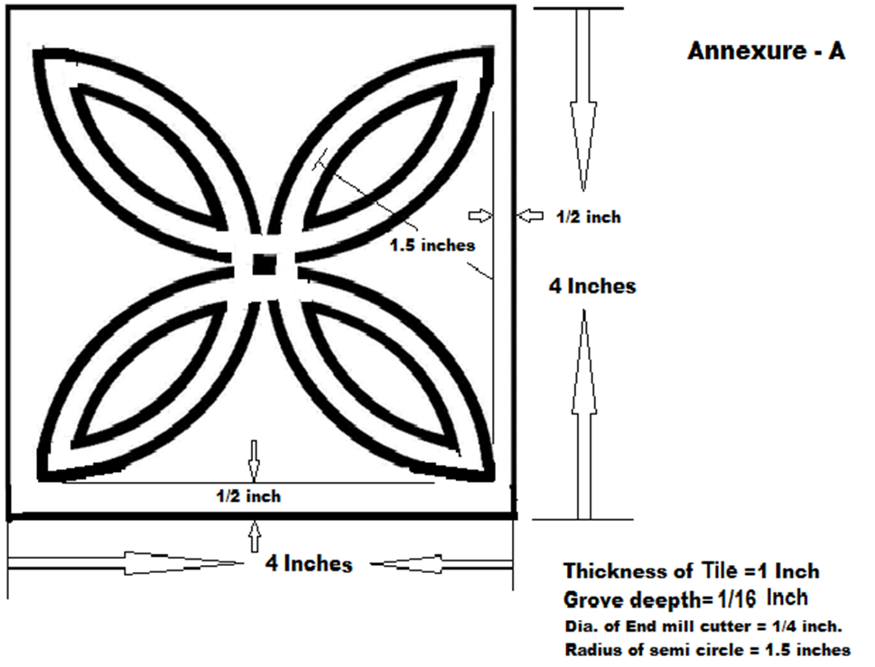
Self-Assessment Checklist
Candidate Name
Registration No.
Qualification | Marble Technician Level - 4
Competency Standards | - Perform CAD/CAM Operations  - Ensure Quality
Assessment Task | Develop a design on a given marble tile of size (4 x 4 x 1 Inches) as in (Annexure – A) on CNC Machine and check Quality of the Tile.

I can……………….
Performance Criteria | Yes | No
- Collect a Marble Tile of size (4 x 4 x 1 inches).
- Scan given design (picture) in computer.
- Set dimensions of (4 x 4 x 1 inches)
- Make a vector file of given design (picture)
- Make G-code of vector file of given design (picture)
- Verify G-code in simulator and make changes as desired
- Upload G-Code to CNC machine
- Clamp the Marble Tile on CNC Table
- Run CNC and make design on Marble Tile.
- Stop the CNC and take out the Marble Tile.
- Clean Marble Tile.
- Check Sizes of marble Tile with specification
- Inspect edges of marble Tile
- Check smoothness of marbles surface
- Check shine of marble
- Check quality of polishing materials

Candidate’s Signature___________________ Assessor’s Signature_____________________
Date: ________________________________

Assessors Judgment Guide
Qualification | Marble Technician Level - 4
Competency Standard(s) | - Perform CAD/CAM Operations  - Ensure Quality
Candidate Details | Name:_______ _______________________________________  Registration/Roll Number: ________________________ Signature: __________________
Assessment Outcome | COMPETENT NOT YET COMPETENT  Name of the Assessor________________________ Assessor’s code:___________________  Signature:__________________________________

Assessment Summary (to be filled by the assessor)
Activity | Method |  |  |  |  | Result
Nature of Activity | Written | Oral | Observation | Portfolio | Role Play | Competent | Not Yet Competent
Practical Skill Demonstration
Knowledge Assessment
Other Requirement

Observation Checklist
Assessment Task |  | Develop a design on a given marble tile of size (4 x 4 x 1 Inches) as in (Annexure – A) on CNC Machine and check Quality of the Tile.
During the practical assessment, candidate demonstrated the following: |  |  |  | Yes | No | Remarks
 | Collect a Marble Tile of size (4 x 4 x 1 inches).
 | Scan given design (picture) in computer.
 | Set dimensions of (4 x 4 x 1 inches)
 | Make a vector file of given design (picture)
 | Make G-code of vector file of given design (picture)
 | Verify G-code in simulator and make changes as desired
 | Upload G-Code to CNC machine
 | Clamp the Marble Tile on CNC Table
 | Run CNC and make design on Marble Tile.
 | Stop the CNC and take out the Marble Tile.
 | Clean Marble Tile.
 | Check Sizes of marble Tile with specification
 | Inspect edges of marble Tile
 | Check smoothness of marbles surface
 | Check shine of marble
 | Check quality of polishing materials
Competent |  |  | Not Yet Competent

Knowledge Assessment
Qualification | Marble Technician Level - 4
Competency Standard(s) | - Perform CAD/CAM Operations  - Ensure Quality
Candidate Details | Name:_______________________________________________________________________  Registration/Roll Number: __________________ Candidate Signature:__________________
Assessment Outcome | COMPETENT NOT YET COMPETENT  Name of the Assessor:__________________________ Assessor’s code:_________________  Signature of the Assessor:_______________________
Candidate’s response is not required to be identical, but similar concepts and/or keywords must be used. Oral questioning may be used to clarify candidate understanding of topic and its application.

Questions (Candidate confidently answered questions correctly and demonstrated understanding of the topics and their application) |  | Satisfactory | Not Satisfactory
 | Name Tools/commands used for drawing in CAD software.
 | What is 3D drawings?
 | Name various Bits/cutters of CNC machines.
 | What is Simulation of CNC machine?
 | What is calibration of CNC machine?
 | What CNC stand for?
 | What are quality standards?
 | Which parameters are to be considers for a quality marble.
 | What is precision measurements?
 | Which instrument is used to measured smooth surface.

Feedback to the Candidate
Candidate’s Signature___________________ Assessor’s Signature ____________________

