Assessment Evidence Guide
For
Graphic Designer (Screen Printing)
Level-3
(Summative)


National Vocational & Technical Training Commission Islamabad

Instruction Sheet for the Candidate
Qualification | National Vocational Certificate Level-3 in Graphic Designer(Screen Printing)
Competency Standards | - Follow Occupational Health and Safety Practices  - Manage the Workstation  - Apply basic design fundamentals  - Prepare In-Page documents  - Design in Adobe Illustrator  - Design in Adobe Photoshop  - Design in CorelDRAW  - Apply entrepreneurial through Print on Demand
Purpose of Assessment | Summative Assessment
Candidate Details | Name_______________________________________________________  Registration Number_________________________________________________
Guidance for Candidate | To meet this qualification level, you are required to perform and demonstrate the procedures/skills of Design following branding elements for a clothing brand named as “ Cool ClothLab” according to the given colors scheme and samples.
Time: 04 Hours | To meet this qualification standard, you are required to perform the following tasks during practical and knowledge assessment, under observation by an assessor:  Design following branding elements for a clothing brand named as “ Cool ClothLab” according to the given colors scheme and samples.  - Logo  - Business Card  - Letterhead  - Advertisement Flyer  - T-shirt Mockup
Minimum Evidence Required | - Logo  - Create a logo with Adobe Illustrator by following the given sample.  - Apply Black, yellow, orange and white colors.  - Apply typography as per given sample.  - Apply graphic elements related to the clothing brand.  - Apply vectorization techniques.  - Export files of the logo design for web and print purpose.  - Business Card  - Design a business card in Adobe Photoshop following the sample.  - Choose standard 3.5" x 2.0" inches dimensions of business card.  - Apply the combination of Black, yellow, orange and white colors.  - Apply appropriate font size for contact information on business card.  - Export files of the business card for printing purpose  - Letterhead  - Create a letterhead design using CorelDraw as per sample.  - Open standard A4 size artboard for letterhead.  - Apply black, yellow, orange and white colors.  - Arrange the header, footer, and contact information effectively.  - Export the print ready file of the letterhead.  - Advertisement Flyer  - Design a flyer in adobe illustrator according to the given sample.  - Open the artboard of the 8.5 × 11 in size.  - Apply appropriate graphic elements on the flyer.  - Apply shades of Black yellow, orange and white colors.  - Save the JPEG + PDF file of the flyer.  - T-shirt Mockup  - Create a T-shirt Mockup using adobe Photoshop  - Take black and white T shirt for mockup.  - Arrange the logo in middle of T-shirt.  - Apply an appealing background behind the T-shirt.  - Save the JPEG and PNG files.

Self-Assessment Checklist
Candidate Name
Registration No.
Qualification | National Vocational Certificate Level-3 in Graphic Designer(Screen Printing)
Purpose of Assessment | Summative Assessment
Assessment Task | Design following branding elements for a clothing brand named as “ Cool ClothLab” according to the given colors scheme and samples.  - Logo  - Business Card  - Letterhead  - Advertisement Flyer  - T-shirt Mockup
I can……………….
Performance Criteria | Yes | No
1.Create a logo with Adobe Illustrator by following the given
sample.
2. Apply Black, yellow, orange and white colors.
3. Apply typography as per given sample.
4. Apply graphic elements related to the clothing brand.
5. Apply vectorization techniques.
6. Export files of the logo design for web and print purpose.
7.Design a business card in Adobe Photoshop following the
sample.
8. Choose standard 3.5" x 2.0" inches dimensions of business
card.
9. Apply the combination of Black, yellow, orange and white colors.
10. Apply appropriate font size for contact information on business
card.
11. Export files of the business card for printing purpose
12. Create a letterhead design using CorelDraw keeping the
sample in mind.
13. Open standard A4 size artboard for letterhead.
14. Apply black, yellow, orange and white colors.
15. Arrange the header, footer, and contact information effectively.
16. Export the print ready file of the letterhead.
17. Design a flyer in adobe illustrator according to the given
sample.
18. Open the artboard of the 8.5 × 11 in size.
19. Apply your own creativity and graphic elements on the flyer.
20. Apply shades of Black yellow, orange and white colors.
21. Save the JPEG + PDF file of the flyer.
22. Create a T-shirt Mockup using adobe Photoshop
23. Take black and white T-shirt for a mockup.
24. Arrange the logo in the middle of the T-shirt.
25. Apply an appealing background behind the T-shirt.
26. Save the JPEG and PNG files.

Candidate’s Signature__________________ Assessor’s Signature__________________
Date: _______________________________
Assessors Judgment Guide
Qualification | National Vocational Certificate Level-3 in Graphic Design (Screen Printing)
Purpose of Assessment | Summative Assessment
Candidate Details | Name:______________________________________________________________  Registration Number: ________________________Signature: _________________
Assessment Outcome | COMPETENT NOT YET COMPETENT  Name of the Assessor________________________________________________  Assessor’s code:___________________Signature:________________________

Assessment Summary (to be filled by the assessor)
Activity | Method |  |  |  |  | Result
Nature of Activity | Written | Oral | Observation | Portfolio | Role Play | Competent | Not Yet Competent
Practical Skill Demonstration |  |  | ✔
Knowledge Assessment |  | ✔
Other Requirement

Observation Checklist
Assessment Task |  | Design following branding elements for a clothing brand named as “ Cool ClothLab” according to the given colors scheme and samples.  - Logo  - Business Card  - Letterhead  - Advertisement Flyer  - T-shirt Mockup
During the practical assessment, candidate demonstrated the following: |  |  |  | Yes | No | Remarks
 | Created a logo with Adobe Illustrator by following the given sample.
 | Applied Black, yellow, orange and white colors.
 | Applied typography as per given sample.
 | Applied graphic elements related to the clothing brand.
 | Applied vectorization techniques.
 | Exported files of the logo design for web and print purposes.
 | Designed a business card in Adobe Photoshop following the sample.
 | Chosen standard 3.5" x 2.0" inches dimensions of business card.
 | Applied the combination of Black, yellow, orange and white colors.
 | Applied appropriate font size for contact information on a business card.
 | Exported files of the business card for printing purpose
 | Created a letterhead design using CorelDraw keeping the sample in mind.
 | Opened standard A4 size artboard for letterhead.
 | Applied black, yellow, orange and white colors.
 | Arranged the header, footer, and contact information effectively.
16 | Exported the print ready file of the letterhead.
17 | Designed a flyer in adobe illustrator according to the given sample.
18 | Opened the artboard of the 8.5 × 11 in size.
19 | Applied your own creativity and graphic elements on the flyer.
20 | Applied shades of Black yellow, orange and white colors.
21 | Saved the JPEG + PDF file of the flyer.
22 | Created a T-shirt Mockup using adobe Photoshop
23 | Taken black and white T-shirt for a mockup.
24 | Arranged the logo in the middle of T-shirt. .
25 | Applied an appealing background behind the T-shirt.
26 | Saved the JPEG and PNG files.
Competent |  |  | Not Yet Competent

Knowledge Assessment
Qualification | National Vocational Certificate Level-3 in Graphic Design (Screen Printing)
Purpose of Assessment | Summative Assessment
Candidate Details | Name:______________________________________________________________  Registration Number: __________________ Candidate Signature:_____________
Assessment Outcome | COMPETENT NOT YET COMPETENT  Name of the Assessor:__________________________  Assessor’s code:_________________Signature of the Assessor:_______________
Candidate’s response is not required to be identical, but similar concepts and/or keywords must be used. Oral questioning may be used to clarify candidate understanding of topic and its application.
Questions (Candidate confidently answered questions correctly and demonstrated understanding of the topics and their application) |  | Satisfactory | Not Satisfactory
 | Which software can be used to design a logo?
 | How can you ensure the logo design is scalable?
 | Which technique applied to the processing of fresh meat?
 | What are some important elements to consider when designing a logo?
 | Which file formats are suitable for exporting the logo design for web and print purposes?
 | Why is vectorization important for logo design?
 | Which file formats are used for printing purposes?

Feedback to the Candidate
Candidate’s Signature__________________Assessor’s Signature ___________________

List of Tools and Equipment
Sr. No. | List of Tools/Equipment | Quantity ( 25 Candidates)
01 | Computer System | 25
02 | Printer | 01
03 | CD/DVDs of Software | 25
04 | Power sockets | 25
05 | Chair | 25
06 | Tables | 25

List of Consumables
Sr. No. | List of Consumables | Quantity ( 25 Candidates)
1 | Paper Rim | 01
2 | Pencil | 25
3 | Eraser | 25
4 | Ruler | 25

LOGO.

BUSINESS CARD
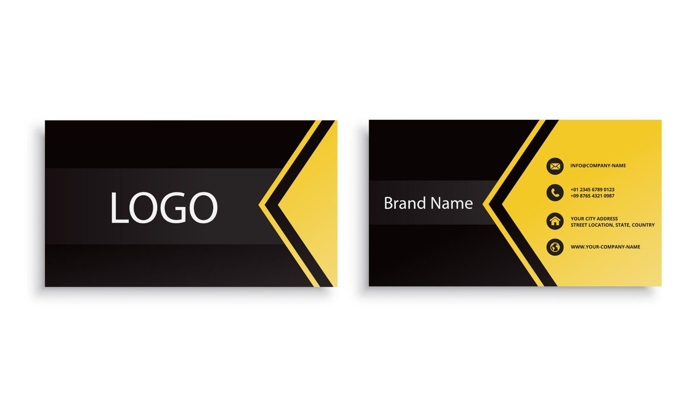

LETTERHEAD
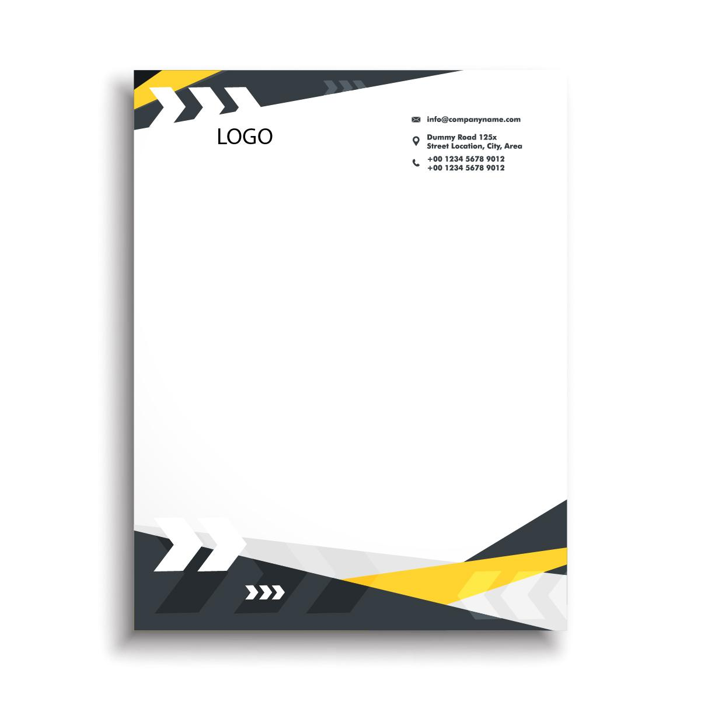

T-SHIRT MOCKUP

