National Vocational Qualification

Competency Standards
for
TEXTILE WEAVING MACHINE MECHANIC – Level 3

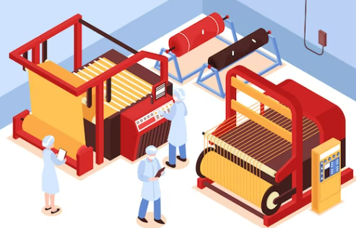


National Vocational and Technical Training Commission, Islamabad

ACKNOWLEDGEMENTS

National Vocational and Technical Training Commission (NAVTTC) extends its gratitude and appreciation to representatives of business, industry, academia, government agencies, provincial TEVTAs, sector skill councils and trade associations who spared time and extended their expertise for the development of National Vocational Qualification for the trade of Level 3 in Textile Weaving machine Mechanic. This work would not have been possible without the technical support of the above personnel.
It may not be out of place to mention here that all the experts of Industry, Academia and TVET experts of TEVTAs, BTEs and PVTC work diligently for making this qualification worthy and error free for which all credit goes to them. However, NAVTTC accepts the responsibility of all the errors and omissions still prevailing in the Qualification document.
It is also noteworthy that development of Skill Standards is a dynamic and ongoing process, and the developed skill standards needs periodic review and updating owing to the constant technological advancements, development in scientific knowledge, and growing experience of implementation at the grass root level as well as the demand of industry. NAVTTC will ensure to keep the qualifications abreast with the changing demands of both national and international job markets.

Executive Director (NAVTTC)

CONTENTS

Sr. No | Table of contents | Page No.
1. | INTRODUCTION | 4
2. | PURPOSE OF THE QUALIFICATION | 5
3. | CODE OF QUALIFICATION | 5
4. | QUALIFICATION DEVELOPMENT COMMITTEE | 6
5. | QUALIFICATION VALIDATION COMMITTEE | 7
6. | ENTRY REQUIREMENTS | 8
7. | REGULATIONS FOR THE QUALIFICATION AND SCHEDULE OF UNITS | 8
8. | PACKAGING OF THE QUALIFICATION | 9
9. | SUMMARY OF COMPETENCY STANDARDS | 12
Competency Standards
00000001 | Identify the basics of weaving technology | 12
00000002 | Use mathematical methods for weaving | 14
00000003 | Maintain health, safety and security at workplace | 16
00000004 | Identify weaving Processes | 19
00000005 | Identify woven design structure | 21
00000006 | Maintain Textile weaving Machines | 23
00000007 | Conduct quality checks during weaving process | 26
00000008 | Identify Fabric for reproduction | 28
00000009 | Perform Computer aided skills for weaving | 30
000000010 | Comply with industry requirements | 32
List of Tools and Equipment |  | 33

1. | INTRODUCTION

The National Vocational and Technical Training Commission (NAVTTTC) in collaboration with Deutsche
Gesellschaft für Internationale Zusammenarbeit (GIZ) GmbH has developed the Textile Weaving Machine Mechanic qualification levels 3. The primary objective of this program is to equip trainees in the Technical and Vocational Education and Training (TVET) sector in Pakistan with the necessary skills and knowledge to implement sustainable Textile weaving practices in line with the principles of green transition in Textiles.
The course for textile weaving machine mechanic is designed to provide students with a comprehensive understanding of the process of creating fabrics by weaving. The program focuses on the theory and practical aspects of weaving, including the use of different looms, yarns, fibers, and weaving techniques.
The course curriculum covers a wide range of topics, including textile fiber properties, fabric structure, yarn preparation, fabric analysis, and textile design. Students learn about the different types of fibers used in weaving, such as cotton, wool, silk, and synthetic fibers. They also learn about the characteristics of different types of yarns and how they can be prepared for weaving.
The course also covers various types of looms, including power looms, and automated looms, and how they are used in the weaving process. Students learn about the different types of weaves, such as plain weave, twill weave, and satin weave, and how they can be used to create different fabrics.
The program also includes practical training in weaving techniques, including warp and weft preparation, warp and weft winding, weaving, and fabric analysis. Students learn how to analyze fabrics for quality, durability, and performance.
Upon completion of this course, students can pursue careers in the textile industry in areas such as textile weaving machine mechanic, weaving production. Graduates can also opt to continue their education and pursue higher degrees in textile technology or related fields.
Level 3- This level is designed for skilled workers, and focuses on the development of green skills pertaining to precision Textile weaving and the environment. Trainees will be taught to use modern technologies and techniques to optimize Textile weaving machine mechanisms while reducing the negative impact of textile practices on the environment.

2. | PURPOSE OF QUALIFICATION:

In this training program, trainee will learn and acquire specialized knowledge and particle skills required to function as a Textile machine Mechanic in the Textile Weaving industry. Textile weaving machine mechanic will be responsible to follow the process and procedures as per industry SOPs. The specific objectives of this training course are as under:
- Improve the overall quality of training delivery and setting national benchmarks for training of textile weaving machine mechanic in the country
- Provide flexible pathways and progressions to learners enabling them to receive relevant, up-to-date and recent skills
- Provide basis for competency-based assessment which is recognized and accepted by employers
- Establish a standardized and sustainable system of training for textile weaving machine mechanic at regional/national/international levels

3. | CODE OF QUALIFICATION:
The International Standard Classification of Education (ISCED) is a framework for assembling, compiling, and analyzing cross-nationally comparable statistics on education and training, ISCED codes for these qualifications as assigned as follow:

ISCED Classification for Textile Weaving Technology level – 3
Code | Description
0723T(3) | National Vocational Certificate Level – 3 in Textile Weaving machine mechanic

4. QUALIFICATION DEVELOPMENT COMMITTEE
The following members participated in the qualification development workshop from 2003-2023 in 24-03-2023 in Islamabad:

S# Name ofExpert Designation /Department |  |  | Organisation
1. | Ms. Mohni Saif | DACUM Expert Textile  Weaving | STEP, Institute of Art, Design 3  Management  Lahore
2. | Mr. Muhammad  Nasrullah | Senior instructor Textile Weaving | VTI (PVTC) Jaranwala
3. | Mr. Abdul  Quddus Imran | instructor Textile Weaving | VTI (PVTC) Muzffargrah
4. | Mr. Engr.  Muhammad Irfan | Director | GAMTI (P-TEVTA)  Lahore
5. | Ms. Qurbat Zahra | Director | Adamji ENTERPRISES Lahore
6. | Dr. Muhammad Usman Javed | Lecturer School of Arts &  Design | National Textile University Faisalabad
7. | Dr. Muhammad Ayub Asghar | Assistant Professor Department of Weaving | National Textile University Faisalabad
8. | Ms. Ghazala  Aman | Textile Designer Trade Instructress Fashion designing | GPI(W) Hayatabad (KP –TEVTA) Peshawar
9. | Ms. Bisma Shahbaz | Textile Designer | Noorangi Clothing (Brand) Lahore
10. | Ms. Rida Ramzan | Textile Designer | Running own Boutique  Abottabad
11. | Ms. Farzana Farooq | Representative – DD (TE) | NAVTTC HQ  Islamabad
12. | Mr. Muhammad Naeem Akhtar | (Representative)  TECHNICAL ADVISOR | NAVTTC HQ (GIZ)  Islamabad

5. | QUALIFICATION VALIDATION COMMITTEE

The following members participated in qualification review and validation workshop from 15.05.2023 to 19.05.2023 held at Lahore:

Sr. | Name | Designation | Organization
1. | Ms. Mohni Saif | DACUM Expert Textile Weaving | Step Institute of Art Design Management Lahore
2. | Mr. Muhammad Irfan | Industrial Engineering Officer | Govt. Apparel Manufacturing Training Institute Lahore
3. | Mr. Abdul Oaddus Imran | Instructor Weaving | VTI (PVTC) Muzaffargarh
4. | Mr. DR Muhammad Ayub Asghar | Assistant Professor | National Textile University Faisalabad
5. | Mr. Dr Muhammad Usman Javed | Assistant Professor | National Textile University Faisalabad
6. | Ms Saima Asghar | Free Lane Consultant Lahore | Lahore
7. | Ms Ghazala Aman | Textile Designer Trade Instructress Fashion Designing | GPI(W) Hayatabad (KP- TEVTA)
8. | Ms. Rida Ramzan | Textile Designer | Running Own Boutique Abbottabad
9. | Ms. Shahida Asif | CBT Assessor Sr. Instructor DDM | (PVTC)VTI Samanabad Pounch Road Chuburji Lahore
10. | Mr. Muhammad Naeem Akhtar | (Representative)  Technical Advisor | NAVTTAC HQ (GIZ)  Islamabad
11. | Mr. Muhammad Hamza Nadeem | Coordinator | NAVTTC, Islamabad

6. | ENTRY REQUIREMENTS

Entry requirements of these qualifications are level 2 in Textile weaving machine Operator

7. | REGULATIONS FOR THE QUALIFICATION AND SCHEDULE OF UNITS

Not Applicable
8. | PACKAGING OF THE QUALIFICATION

The national vocational qualifications are packaged as per the following:

LEVEL-3 (60 Credits) [20:80]
Textile weaving machine mechanic

- Identify the basics of weaving technology
- Use mathematical methods for weaving
- Maintain health, safety and security at workplace
- Identify weaving Processes
- Identify woven design structure
- Maintain Textile weaving Machines
- Conduct quality checks during weaving process
- Identify Fabric for reproduction
- Perform Computer aided skills for weaving
- Comply with industry requirements

Code | Competency Standards | Level | Theory  Total  (Hours  ) | Practical Total  (Hours) | Total  (Hours  ) | Credit  (Hours  ) | Category
1. | Identify the basics of weaving technology | 3 | 10 | 24 | 34 | 3..4 | Functional l
2. | Use mathematical methods for weaving | 3 | 6 | 30 | 36 | 3.6 | Functional l
3. | Maintain health, safety and security at workplace | 3 | 6 | 20 | 26 | .2.6 | Generic
4. | Identify weaving Processes | 3 | 15 | 50 | 65 | 6.5 | Technical
5. | Identify woven design structure | 3 | 15 | 60 | 65 | 6.5 | Technical
6. | Maintain Textile weaving Machines | 3 | 15 | 60 | 65 | 6.5 | Technical
7. | Conduct quality checks during weaving  process | 3 | 15 | 66 | 81 | 8.1 | Functional
8. | Identify Fabric for reproduction | 3 | 14 | 60 | 74 | 7.4 | Technical
9. | Perform Computer aided skills for weaving | 3 | 12 | 70 | 82 | 8.2 | Functional
10. | Comply with industry requirements | 3 | 12 | 60 | 72 | 7.2 | Generic
 | Total |  | 120 | 480 | 600 | 60

OCCUPATIONS AND LEVELS DESCRIPTOR
Level 1 Level 2 Level 3

S # | Occupations | No of Modules/CS | Level | Occupation Credit Hours | Training duration
 | Weaving Technology Specialist | 9 | 1 | 600 | 6 Months
 | Textile Weaving Production Coordinator | 7 | 2 | 600 | 6 Months
 | Textile Weaving Design Assistant: | 16 | 3 | 600 | 6 Months

Qualification Levelling and Packaging
Level 2
Textile Weaving Production Coordinator
- Identify the basics of weaving technology
- Use mathematical methods for weaving
- Conduct quality checks during weaving process
- Identify fabric for reproduction
- Comply with industry requirements
- Maintain health, safety and security at workplace
- Use computer functions to access and update production data and quality record
Level 1
Textile Weaving Technology Specialist

- Weaving Technology Specialist:
- Identify the basics of weaving technology
- Use mathematical methods for weaving
- Identify weaving processes
- Identify woven design structure
- Conduct quality checks during weaving process
- Perform computer-aided skills for weaving
- Comply with industry requirements

LEVEL3
Textile Weaving Design Assistant
- Identify the basics of weaving technology
- Use mathematical methods for weaving
- Identify woven design structure
- Conduct quality checks during weaving process
- Perform computer-aided skills for weaving
- Identify fabric for reproduction
- Comply with industry requirements

9. | SUMMARY OF COMPETENCY STANDARDS

0723T-16. Identify the Basics of Weaving Technology

Overview
This Competency Standard focuses on the attitudes required to define weaving tools and equipment, classify textile raw materials, different types of fibers and yarns used in weaving and fabric properties influenced by weaving techniques. Trainee will learn the basics elements of weaving technology. They will identify different type of auxiliary machines used in weaving and different type of hand and power tools necessarily needed for weaving.

Competency Units | Performance Criterion
CU1.  Identify weaving technology | P1. Identify different types of warp shedding systems used in weaving machines  P2. Enlist different types of weft insertions system used in weaving machines  P3. Identify different parts of weaving machines  P4. Identify passage of yarn through the weaving machine  P5. Identify secondary motions used in weaving machines  P6. Identify different type of auxiliary motions used in weaving machines  P7. Identify different type of sensors used in weaving machines
CU2.  Identify tools and  equipment for weaving | P1. Identify different type of hydraulic lifters  P2. Identify different type of auxiliary machines  P3. Identify different types of hand and power tools used for weaving machines
CU3  Classify Textile raw materials | P1. Collect types of yarn on the base of fiber nature (natural or manmade)  P2. Collect types of yarn on the base of fiber materials  P3. Collect types of yarn on the base of fiber staple length  P4. Collect types of yarn on the base of different yarn counting (fineness) systems  P5. Collect types of yarn on the base of spinning techniques (ring, open-end, carded, combed, waste)
CU4.  Identify fabric properties | P1. Perform Fabric tear resistance test  P2. Perform Fabric drape test  P3. Perform Crease resistance test  P4. Perform Fabric bending test  P5. Undertake the Fabric moisture management test  P6. Identify the procedure regarding fabric properties

Knowledge and Understanding

The candidate must possess underpinning knowledge and understanding required to carry out tasks covered in this competency standard. Therefore, he/she must be able to understand:

- different types of warp shedding systems used in weaving machines
- different types of weft insertions system used in weaving machines
(shuttle, projectile, airjet, waterjet, rapier, needle weft insertion systems)
- secondary motions used in weaving machines
- different type of auxiliary motions used in weaving machines
- different parts of weaving machines
- passage of yarn through the weaving machine
- different type of sensors used in weaving machines
- types of yarn on the base of fiber nature (whether natural, regenerated or manmade fibers)
- types of yarn on the base of fiber materials (animal fiber, plant fiber, mineral fiber, polyester, jute, linen, wool, silk.)
- Types of yarn on the base of fiber staple length (short staple, cut staple or filament fibers)
- Types of yarn on the base of different yarn counting (fineness) systems (direct yarn counting system, cotton count system, indirect system, woolen and worsted systems)
- Types of yarn on the base of spinning techniques (ring, open-end, carded, combed, waste)
- DIfferent type of hydraulic lifters (cloth trolly, beam trolly, beam gaiting lifter)
- Different type of auxiliary machines (article change machine, knotting machine, oiling machine, greasing machine, dobby punching machine, tappet indexing machine)
- Different type of hand and power tools used for weaving machines
- Different types of tests to be performed on the yarn and woven fabric (count lea strength product test (CLSP), yarn and fabric strength test, fabric tear, drape, crease resistance, bending, pilling, moisture management tests)

Critical Evidence(s) Required

The candidate needs to produce the following critical evidence(s) to be competent in this competency standard:
- User/individual need to know and understand how to:
- adjust the shedding system for a given fabric design
- operate shuttle, projectile, airjet, waterjet, rapier, needle weaving machines
- differentiate between natural and synthetic yarns, staple and filament yarns, vegetable and animal origin yarns
- differentiate between yarns on the bases of different spinning techniques (ring, open-end, carded, combed, waste)
- operate hydraulic lifters
- operate article change machine, knotting machine, oiling machine, greasing machine, dobby punching machine, tappet indexing machine
- operate hand and power tools

0723T-17. Use Mathematical Methods for Weaving

Overview
This Competency Standard focuses on the attitudes required for calculation requirements. Trainees will be able to Interpret work order and will be able to use appropriate mathematical methods and tools to perform calculations as per instruction.

Competency Units | Performance Criterion
CU1. Identify calculation requirements in the workplace | - Perform the calculation of creel of warping  - Practice the calculation of creel of sizing  - Perform counting the number of thread  - Count the warp and weft
CU2. Interpret work order in the workplace | - Check the sample of fabric for the work order  - Identify the relevant information in the work order, including the type of fabric, the number of warp and weft threads, and the desired weave pattern.  - Determine the appropriate loom settings, such as the warp and weft tension, the reed size, and the shuttle speed, based on the work order specifications.  - Analyze the work order to identify any potential issues or challenges that may arise during the weaving process, such as yarn breakage or pattern inconsistencies.  - Check the weaving process to ensure that the fabric meets the work order specifications and quality standards.  - Make any necessary adjustments to the loom settings or weaving process to achieve the desired fabric quality and appearance.  - Document the work order details, including any modifications made during the weaving process, for future reference.
CU3. Use appropriate mathematical methods for the calculation as per instructions  . | - Identify appropriate mathematical methods for the calculation as per instructions  - Enlist the mathematical methods for the calculation  - Calculate the required amount of yarn for the job, taking into account the fabric's dimensions, the yarn's count, and the desired weight of the fabric.

Knowledge and Understanding

The candidate must possess underpinning knowledge and understanding required to carry out tasks covered in this competency standard. Therefore, he/she must be able to:

- Understand the different types of fabric and their characteristics, including the importance of selecting the appropriate fabric for the job.
- Know the different yarn counts and their impact on the fabric's weight, texture, and appearance.
- Understand the principles of weaving, including the warp and weft threads, the reed size, and the shuttle speed.
- Know the different weave patterns and their impact on the fabric's appearance and texture.
- Understand the importance of analyzing the work order to identify any potential issues or challenges that may arise during the weaving process.
- Know of the different loom settings and their impact on the fabric's quality and appearance.
- Understand the importance of monitoring the weaving process to ensure that the fabric meets the work order specifications and quality standards.
- Know of the different techniques for addressing issues or challenges that may arise during the weaving process, including adjusting the loom settings, selecting different yarns, or modifying the weave pattern.
- Understand the importance of documenting the work order details, including any modifications made during the weaving process, for future reference.

Critical Evidence(s) Required
The candidate is required to produce the following critical evidence(s) to be competent in this competency standard:

- Work order documents that demonstrate the ability to identify relevant information, including the type of fabric, the number of warp and weft threads, and the desired weave pattern.
- Calculations that demonstrate the ability to accurately determine the required amount of yarn for the job, taking into account the fabric's dimensions, the yarn's count, and the desired weight of the fabric.
- Work order documentation that demonstrates the ability to document the work order details, including any modifications made during the weaving process, for future reference.

0723T-18 Maintain health, safety and security at workplace

Overview:
This Competency Standard focuses on the attitudes required to Use Health, Safety and security hazards and risks to the supervisor managing waste and Support work environment . Trainees are expected to identify and gather the appropriate tools for a given task, inspect them for damage, properly store them and also understand how to safely and correctly operate. And organized workspace by following established procedures for tool storage and maintenance

.
Competency Units | Performance Criterion
CU1. Use Health, Safety and Security Procedures | P1. Comply with health and safety related instructions applicable to the workplace  P2. Use personal protective equipment such as ear plug, nose mask, head cap etc., as per protocol  P3. Carry out own activities in line with approved guidelines and procedures  P4. Use environment management system related procedures  P5. Minimize health and safety risks to self and others due to own actions
CU2. Recognize the hazard and safety techniques | P1. Identify different kinds of possible hazards (environmental, personal, ergonomic, chemical) of the industry  P2. Recognize other possible security issues existing in the workplace  P3. Recognize different measures to curb the hazards
CU3. Report hazards and risks to the supervisor | P1. Identify risks at workplace  P2. Report any service malfunctions that cannot be rectified.  P3. Follow organization procedures for shutdown and evacuation when required  P4. Report hazards and potential risks/ threats to supervisors or other authorized personnel
CU4. Use Health, Safety and security procedures for managing waste | - Remove safely the waste  - Maintain a healthy lifestyle according to the given standards  - Guard against dependency on intoxicants
CU5. Support work environment that promotes diversity | P1. Store materials and equipment in line with organizational requirements  P2. Undertake first aid, fire-fighting and emergency response training, if asked to dd  P3. Apply the Correction (if possible) of malfunctions in machinery and equipment  P4. Communicate the safety plan to everyone  P5. Attach disciplinary rules with the implement  P6. Monitor the workplace and work processes for potential risks and threat  P7. Carry out periodic walk-through to keep work area free from hazards and obstructions, if assigned

Knowledge and Understanding

The candidate must possess underpinning knowledge and understanding required to carry out tasks covered in this competency standard. Therefore, he/she must be able to:

- Standard operating procedures (SOP)and regulations in a weaving mill
- safe working practices to be adopted in weaving mill
- quality systems and other processes practiced in the weaving mill
- health and safety related practices applicable at the workplace
- potential hazards, risks and threats based on nature of operations
- organizational procedures for safe handling of equipment and machine operations
- potential risks due to own actions and methods to minimize these
- environmental management system related procedures at the workplace
- layout of the plant and details of emergency exits, escape routes, emergency equipment and assembly points
- potential accidents and emergencies and response to these scenarios
- reporting protocol and documentation required
- details of personnel trained in first aid, fire-fighting and emergency response
- actions to take in the event of a mock drills/ evacuation procedures or actual accident, emergency or fire

Critical Evidence (s) Required

The candidates need to produce following critical evidence(s) in order to be competent in this competency standard:
A person who demonstrates competency in this unit must be able to provide evidence of the ability to follow work health and safety policies. The evidence should integrate employability skills with workplace tasks and job roles and verify competency is able to transfer to other circumstances and environments.
  - Explain clearly established workplace safety and hazard control practices and procedures
  - Identify hazards/risks in the workplace and its corresponding indicators in accordance with company procedures
  - Recognize contingency measures during workplace accidents, fire and other emergencies
  - Identify terms of maximum tolerable limits based on threshold limit value- TLV.
  - Follow Occupational Health and Safety (OHS) procedures for controlling hazards/risks in workplace
  - Complete and update OHS personal records in accordance with workplace requirements

0723T-19. Identify weaving Processes

Overview
This Competency Standard focuses on the attitudes required to identify back-weaving, weaving-machine and post-weaving processes. Trainees are expected to identify back-weaving, weaving-machine and post-weaving processes. They will be able to identify the fabric faults caused by the pre-weaving processes and those which are caused by weaving machine malfunctioning
Competency Units | Performance Criterion
CU1.  Identify back weaving Process | P1. Practice the given warping procedure  P2. Counting of warp bags  P3. Counting of the warp yarn packages  P4. Identify the number of warper’s beams as per total number of ends on weaver’s beam  P5. Identify the sizing material require in the process  P6. Follow the quality insurance regarding the material use in sizing  P7. Identify the Drawing-in process according to the given fabric construction
CU2.  Identify weaving machine Process | P1. Recognize basic operation for smooth running of the weaving machine  P2. Identify methods of weaving machine  P3. Comprehend starting a weaving machine after stoppage without creating a fault in the fabric  P4. Recognize weaver’s knots  P5. Recognize weaver’s tie up.  P6. Recognize the warp yarn drafting on the weaving machine  P7. Recognize the repair of broken leno yarns  P8. Recognize the passage of catch cords in leno selvedge
CU3.  Identify post weaving processes | P1. Examine the final product  P2. Examine the quality of the fabric according to the order of the customer as per supervisor’s instructions
P1. Identify fabric faults in post weaving fabric inspection department
P2. Identify the fabric faults caused by pre-weaving processes
P3. Identify the fabric faults purely caused by poor weaving machine maintenance
P4. Identify mendable faults during folding
P5. Identify non mendable faults during folding
P6. Identify fabric rejection report
P7. Identify the fabric packing process according to the demand of customer as per supervisor’s instructions.

Knowledge and Understanding

The candidate must possess underpinning knowledge and understanding required to carry out tasks covered in this competency standard. Therefore, he/she must be able to:

- Understand the warping process, its importance for weaving
- Understand name and function of basic parts of warping machine
- Understand passage of yarn through the warping machine
- Comprehend calculations for a warp set
- Understand the sizing process, name and function of basic parts
- Understand the passage of yarn through the sizing machine,
- Comprehend size baking and sizing stains on warp sheet and its effects on weaving
- Understand the importance of applying size material coating on warp yarns during the sizing process
- Know calculations for deciding the total number of warp threads on weaver’s beam
- Know different ingredients used in sizing recipe, starches, polyvinyl alcohol, acrylic, lubricants, softeners, after waxing
- Know size pickup and size percent
- Know different stretching zones in sizing machine, their importance and aftereffects on weaving (adverse effect of high sizing stretch in warp breakage during weaving)
- Know moisture regain in sizing and its aftereffects on weaving
- Know the Drawing-in process for a given fabric construction
- Know the passage of yarn through drawing-in process (through droppers, heald frames and reed)
- Know the passage of yarn through automatic drawing-in machine (through droppers, heald frames and reed)
- Comprehend the working of automatic drawing-in machine
- Comprehend the meaning of an article change on weaving machine
- Comprehend the beam gaiting (beam tie up) process for the article change
- Understand the difference of article change and knotting process
- know/record the production of own shift
- final product and its quality according to the order of customer
- Identify the grey fabric inspection process after weaving
- Identify the grey fabric quality standards and grading systems
- Know/record the fabric rejection in own shift
- Understand mendable and non-mendable fabric faults in inspection department
- Able to trace back the actual source/reason of fabric faults
- Identify packing of the fabric as per supervisor’s instructions

Critical Evidence(s) Required

The candidate needs to produce the following critical evidence(s) to be competent in this competency standard:
- Know the faults in the fabric caused by the pre-weaving processes
- How to differentiate between the fabric faults caused by the poor weaving machine maintenance and faults caused by the pre-weaving process
- How to reduce the fabric rejection on the bases of information provided by the fabric inspections department
- Know the lbs/bk (pounds per brake) report of warping to adjust the weaving machine accordingly for higher efficiency and minimum warp breakages
- How to adjust the weaving machine on the bases of stretch applied on warp sheet during sizing process
- Know how to adjust the weaving machine on the bases of ‘number of lappets’ report from sizing process
- Identify packing of the fabric as per supervisor’s instructions
- Determine timely correction of errors to avoid redoing of work

0723T-20. Identify woven design structure

This Competency Standard focuses on the Knowledge, skills and attitudes to use woven designs, identify basic weaves and identify advance weaves. Trainees are expected to identify the appropriate designs for a given fabric specimen and differentiate basic and advance weaves.

Competency Units | Performance Criterion
CU1.  Use woven Designs | P1. Demonstrate woven design structure i.e. (weave design, draft and lifting plan, warp and weft yarns count and color)  P3. Prepare loom for weaving i.e. (number of warp yarns on weaver’s beam, weight of warp and weft yarns required, adjust the tension and position of the warp and weft, and prepare the weaving machine for operation)  P4. Select appropriate shedding techniques to weave the fabric i.e. the use of tappet or dobby shedding mechanisms, and the number of heald frames required)  P5. Weave the fabric with given design i.e. (minimizing downtime and optimizing the production output)
CU2.  Identify basic weaves | P1. Identify the basic weave structures i.e., plain weave and its derivatives, twill weaves, and satin weaves,  P2. Identify properties of basic weaves for the end use of the fabric  P4. Interpret weave designs, drafts and lifting plans on graph paper i.e. (graphical representations of the weave structure, warp and weft yarns interaction to create the desired pattern, heald frames and lifting order of heald frames)
CU3.  Identify advance  weaves | P1. Identify advanced weave structures i.e., (tappet weaves, dobby weaves, combined twills, pointed twills, herring bone twill, skipped twills, crepe weaves)  P2. Identify weave structure in complex fabric samples (combined twill, pointed twills, herring bone twill, skipped twills, crepe weaves)

Knowledge and Understanding
The candidate must possess underpinning knowledge and understanding required to carry out tasks covered in this competency standard. Therefore, he/she must be able to:

- Understand woven design structure
(weave design, draft and lifting plan, warp and weft yarns count and color)
- Understand how to prepare the loom for weaving i.e. (number of warp yarns on weaver’s beam, weight of warp and weft yarns required, adjust the tension and position of the warp and weft, and prepare the weaving machine for operation)
- Understand which type of shedding techniques should be appropriate to weave a fabric i.e., the use of tappet or dobby shedding mechanisms, and the number of heald frames required
- Practically weave the fabric with given design
- Analise advanced weave structures i.e., (tappet weaves, dobby weaves, combined twills, pointed twills, herring bone twill, skipped twills, crepe weaves)
- draw weave designs, drafts and lifting plans on graph paper i.e. (graphical representations of the weave structure, warp and weft yarns interaction to create the desired pattern, heald frames and lifting order of heald frames)

Critical Evidence(s) Required

The candidate needs to produce following critical evidence(s) to be competent in this competency standard:
- Draw weave designs, drafts and lifting plans on graph paper
- Understand which shedding system is required to weave the given fabric construction and how to adjust it on weaving machine
- Practically weave the fabric with given fabric construction

0723T-21. Maintain textile weaving machines
0723T-21. Maintain textile weaving machines
Overview
This Competency Standard focuses on the attitudes to maintain Looming machines, troubleshoot mechanical problems and repair machine parts with welding. Trainees are expected to identify and gather the appropriate tools for a given task, inspect them for damage, properly store them and also understand how to safely and correctly operate. And organized workspace by following established procedures for tool storage and maintenance.

Competency Units | Performance Criterion
CU1.  Maintain Shuttle  Loom | P1. Add maintenance tag at the weaving machine  P2. Apply personal padlock to the machine under maintenance  P3. Follow Maintenance at article change  - Set Shedding System  - Set Weft insertions system  - Set weft density  P4. Follow Maintenance during Knotting  P5. Follow Periodical Maintenance Schedule
CU2.  Maintain Shuttle less  Loom | P1. Add maintenance tag at the weaving machine  P2 Apply personal padlock to the machine under maintenance  P3. Follow Maintenance at article change  - Set Shedding System  - Set Weft insertions system  - Set of weft density  P4. Follow Maintenance during Knotting  P5. Follow Maintenance Schedules
CU3.  Maintain Looming Machines | P1. Add maintenance tag at the weaving machine  P2. Follow periodical maintenance schedule for knotting machine  P3 Follow periodical maintenance schedule for beam gaiting machine  P4. Follow periodical maintenance schedule for automatic drawing-in machine  P5. Follow periodical maintenance schedule for hydraulic lifters (beam trolly, cloth roll trolly, beam gaiting trolly)
CU4.  Troubleshoot Mechanical Problems | P1. Add maintenance tag at the weaving machine  P2. Apply personal padlock to the machine under maintenance  P3. Respond the weaving machine stopped due to mechanical fault immediately  P4. Find the reason of fault for the given machine  P5. Rectify the fault of the machine  P6. Conform the normal working of the machine  P7. Observe smooth running of the machine
CU5. Repair Machine Parts | P1. Add maintenance tag at the weaving machine  P2. Apply personal padlock to the machine under maintenance  P3. Access the level of fault in the machine  P4 Find the possible solutions for the given faulted parts  P5 Repair the defective parts of the given machine  P6. Fit the repaired part according to machine instruction manual  P7. Run the machine according to SOPs  P8. Observe smooth running of the machine
CU6. Perform Arc Welding | - Adjust welding parameters (current, voltage etc.) of welding plant  - Maintain gap between electrode and base metal as per standard practices  - Deposit root pass as per welding procedure specifications/job requirements  - Deposit filling passes as per welding procedure specifications/job requirements  - Deposit capping pass as per welding procedure specifications/job requirements  - Remove slag after every pass with chipping hammer  - Check root, filling and capping passes for any visual discontinuities as per acceptance standards  - Clean work area in accordance with workplace safety practices  - Maintain and store tools/equipment/consumable materials in accordance with organization guidelines

Knowledge and Understanding
The candidate must possess underpinning knowledge and understanding required to carry out tasks covered in this competency standard. Therefore, he/she must be able to:

- Understand shedding elements
- Set all shedding elements required at an article change for a new fabric construction
- Understand primary and secondary motion of a weaving machine
- Understand auxiliary motion of the weaving machine
- Understand how to change the weft density
- Understand how to adjust the back rest
- Understand and set all the fabric faults related to weaving machine malfunctioning
- Understand all the fabric faults which are not related to weaving machine malfunctioning
- Understand the purpose of all the warning lights on a weaving machine
- Understand tappet, dobby and jacquard shedding mechanism
- Set tappet, dobby and jacquard shedding mechanism according to fabric construction
- Knowledge of lubricant types and usages
- Understand the technical terms related to maintenance
- Understand what an article-change and its importance is
- Able to implement the article change process
- Understand the working of knotting machine
- Understand to maintain the knotting machine
- Knowledge and skill to implement the beam knotting process
- Knowledge and skill to maintain the beam knotting process
- Understand maintenance schedules
- Understand periodic maintenance need and methods
- Understand preventive maintenance
- Underpinning troubleshooting maintenance
- Familiar to the name and types of different weaving machine parts
- Able to read, understand, interpret the weaving machine maintenance catalogue and implement the correct machine settings
- Understand to operate all necessary tools involved in the maintenance of weaving machine
- Under machine interference
- Understand working of stroboscope and its use for setting of weaving machine+
- Understand Welding positions
- Understand Types of passes
- Understand Specifications/ classification of electrode/s required for the job
- Understand Electrical parameters like (voltage, current etc.) and their effects on welding
- Understand Welding techniques as per WPS/instruction sheet

Critical Evidence(s) Required

The candidate needs to produce following critical evidence(s) to be competent in this competency standard:
- Maintain Shuttle Loom
- Maintain Shuttle less Loom
- Maintain Looming Machines
- Troubleshoot mechanical faults
- Repair different parts of machine
- Perform arc welding

0723T-22. Conduct quality checks during weaving process

Overview
This Competency Standard focuses on the attitudes required to maintenance of weaving equipment’s, monitoring weaving process for defects and irregularities of fabric quality standards and defects in the fabric. Trainees are expected to identify and gather the appropriate tools for a given task, inspect them for damage, properly store them and understand how to operate safely and correctly, and organize workspace by following established procedures for tool storage and maintenance. They will be able to use the tools as per SPOs for properly adjusting the weaving machine with improved efficiency and minimum fabric faults.

Competency Units | Performance Criterion
CU1.  Maintain the  work area, tools and machines | P1. Handle materials and tools safely and correctly  P2. Use materials to minimize waste of the workplace  P3. Maintain a clean and hazard free working area  P4. Maintain the tools of the workplace sequentially  P5. Carry out maintenance and/or cleaning within one’s responsibility  P6. Report/record damaged tools & materials of machine  P7. Work in a comfortable position with the correct posture  P8. Dispose of waste safely in the designated location  P9. Store cleaning equipment safely after use  P10. Carry out cleaning according to schedules and limits of responsibility  P11. Use appropriate tool for a specific task
CU2. Monitor weaving process for defects and irregularities | P1. Minimize the defect rate during the weaving process  P2. Minimize weaving machine stoppage for maximum efficiency  P2. Monitor weaving machine speed to ensure production target  P3. Maintain safe machine speed for longer life of machine parts without compromising the efficiency  P4. Maintain weaving Machine to ensure that it is operating properly (cleaning, lubricating, and replacing worn or damaged parts as per schedule).  P5. Use records to identify trends and areas for improvement in the weaving process  P6. Maintain logbook for the repair/replacement of spare parts
CU3.  Check fabric  for quality standards | P1. Compare the freshly woven fabric after article change with the parameters of actual fabric specimen to be produced, as per supervisor’s instructions  P2. Keep accurate Records of all production runs  P3. Send woven fabric samples for testing in order to compare with actual costumer’s sample, as per supervisor’s instructions
 | P3. Minimize waste of fabric
CU4.Identify defects in the fabric | P0. Check the fabric for defects related to the malfunctioning of weaving machine  P1. Identify fabric faults related to machine start after stoppage (starting marks)  P2. Identity and troubleshoot machine faults responsible for frequent stoppage (resulting into starting marks, warp and weft breakages)  P2. Ensure fabric parameter to be equal to the actual sample as per supervisor’s instructions (ends/inch, picks/inch, fabric weave design, fabric width)

Knowledge and Understanding

The candidate must possess underpinning knowledge and understanding required to carry out tasks covered in this competency standard. Therefore, he/she must be able to know:
- Understand and set all the fabric faults related to weaving machine malfunctioning
- Able to read pneumatic gauges and adjust pneumatic pressure accordingly as per weft yarn being used on the weaving machine
- Understand all the fabric faults which are not related to weaving machine but blamed for
- Understand back-tracing of fabric faults in order to locate the root cause
- Familiar to the name and types of different weaving machine parts
- Able to read, understand, interpret the weaving machine maintenance catalogue and implement the correct machine settings to minimize fabric faults
- Understand to operate all necessary tools involved in the maintenance of weaving machine
- Understand the use of gauges to be used for machine settings
- Understand necessary lab tests to be performed on the yarn and fabric which may, intern, help to adjust the weaving machine for low stoppages and higher efficiency
- Understand mandible and non-mandible fabric faults
- Understand fabric grading system so as to rectify fabric faults accordingly with collaboration to the fabric inspection department

Critical Evidence(s) Require
The candidate needs to produce the following critical evidence(s) to be competent in this competency standard:
- Knowledge of fabric faults related to weaving machine malfunctioning
- Knowledge of fabric faults which are not related to weaving machine malfunctioning
- knowledge of using related tools
- knowledge of using related machine gauges

0723T-23. Identify Fabric for reproduction

Overview:
This Competency Standard focuses on the attitudes to Identify fabric construction, Design, reproduction, aerial, weight and first meter Test as per supervisor’s instructions. Trainees are expected to identify and gather the appropriate tools for a given task. They should have the capability to analyze the given fabric specimen for reproduction, including determining all necessary parameters needed for reproduction. They will acquire the knowledge of determining the nature and types of yarns being used for weaving so as to adjust the weaving machine accordingly.

Competency Units | Performance Criterion
CU1.  Identify fabric construction | P1. Perform identification of warp yarns in the given fabric sample  P2. Perform identification of weft yarns in the given fabric sample  P3. Count the ends per inch in the given fabric sample  P4. Count the picks per inch in the given fabric sample  P5. Recognize the Warp and weft fineness (count) in the given fabric sample  P6. Recognize the Yarn material of Warp and weft  P7. Identify the face and back of given fabric sample  P8. Perform the calculation of Crimp % of warp and weft in the given fabric sample  P8. Perform the calculation of shrinkage % of warp and weft in the given fabric sample  P9. Calculate the reed count based on shrinkage %  P10. Calculate the aerial weight of the given fabric sample (GSM)
CU2.  Identify fabric design for reproduction | P1. Analyze the Weave design of the given fabric sample on graph paper  P2. Perform Drawing-in and Draft for the given fabric sample  P3. Apply the heald frame lifting plan for reproduction of fabric sample
CU3.  Identify fabric aerial weight for reproduction | P1. Measure fabric aerial weight of fabric using GSM cutter technique (ASTM D 3776 )  P2. Calculate Fabric Aerial weight by formula
CU4.  Follow first meter test as per supervisor’s instructions | P1. Set fabric construction parameters according to customer’s requirement as per supervisor instructions  P2. Follow fabric weave design according to customer’s requirement as per supervisor instructions
P3. Identify fabric fault caused by wrong drawing-in and lifting plan
P4. Check fabric aerial weight as per requirement
P5. Check fabric width as per requirement
P6. Check selvedge as per requirement

Knowledge and Understanding
The candidate must possess underpinning knowledge and understanding required to carry out tasks covered in this competency standard. Therefore he/she must be able to:
- Know different raw materials of yarns to be used in woven fabrics (cotton, wool, linen, jute, hemp, viscose, polyester, nylon, silk…)
- Know different types of fabrics; woven, knitted, braided, felted
- Understand basic elements of a woven fabric including: (warp, weft, warp and weft densities, fabric design, draft, heald frame lifting plan, reed, denting order of reed)
- Know measurement/calculation of warp and weft yarn crimp and contraction
- Understand how to find out aerial weight of fabric
- Understand how to make the fabric weave design using graph paper
- Know different basic weaves, plain, twill, satin
- Know to analyze the fabric samples for reproduction (fabric face, identification of warp and weft, warp and weft densities, warp and weft crimp, warp and weft contractions, fabric aerial weight)

Critical Evidence(s) Required
The candidate needs to produce following critical evidence(s) to be competent in this competency standard:
- Describe different raw materials used in woven fabrics (cotton, wool, linen, jute, hemp, viscose, polyester, nylon, silk)
- What are different types of fabrics, (woven, knitted, braided, felted)
- Describe basic elements of a woven fabrics (warp, weft, warp and weft
densities, fabric design, draft, heald frame lifting plan)
- Describe how to measure crimp of warp and weft yarn and their contractions.
- How to measure aerial weight of fabric?
- How to translate the fabric weave design on graph paper?
- How to translate the fabric weave design through software
- Explain different basic weaves, plain, twill, satin and method of analyzing such weaves
- How to identify fabric face, warp and weft
- Describe how to find out warp and weft densities, crimp and contraction

0723T-24. Perform Computer aided skills for weaving

Overview
This Competency Standard focuses on the attitudes to Work with Microsoft office Comprehend with machine interface digital construction weave design and skills. Trainees are expected to identify and gather the appropriate tools for a given task, good knowledge of computer skills for date storing and retrieving. Should have good e-communication skills using emails, should be able to understand, interact with machine panel for necessary data input and retrieving in order to adjust the weaving machine for smooth fault free working. Must be able to have fabric designs skills on designing software.

Competency Units | Performance Criterion
CU1.  Work with MS Office | P1. Comprehend the use of MS Word for documenting P2. Comprehend the use of MS Excel for data storing and retrieving  P3. Comprehend the use of MS Outlook for communication through email
CU2.  Comprehend with machine interface | P1. Identify interface with machine panel  P2. Perform input information  P3. Retrieve required information with machine interface
CU3.  Apply Digital weave construction skills | P1. Use computer software construction tools  P2. Apply weave construction skills to create a weave  P3. Identify drafting plan for a weave construction  P4. Apply heald frame lifting plan of a weave construction
CU4. Apply Digital weave design skills | Using computer software application student be able to:  P1. Apply weave design concepts to create and weave  P2. Find out the drafting plan of a weave design  P3. Make a frame lifting plan of a weave design

Knowledge and Understanding

The candidate must possess underpinning knowledge and understanding required to carry out tasks covered in this competency standard. Therefore, he/she must be able to:

- Basic knowledge to operate PC
- Understand the use of MS Word to produce basic documents
- Understand the use of MS Excel to organize data
- Understand the use of MS outlook to be able use email communication.
- Knowledge of computer interfaces
- Knowledge of input and output devices use for interface

Critical Evidence(s) Required

The candidate needs to produce following critical evidence(s) to be competent in this competency standard:
- Understand how to use MS Word to write example: applications, letters, reports,
- Knowledge of inserting tables, picture, page numbering and other document formats
- Understand how to print the document for certain type of page size
- Understand how to print the document for certain type of printer
- Concept of cell in a spread sheet
- Concept of different types of data input in cells
- Understand basics of charting / graphing
- Understand basics of excel formulae for mathematics and statics operations
- Knowledge of email working
- Use of outlook to edit, send, receive, forward and other operations of email management

0723T-25. Comply with industry requirements

Overview
This Competency Standard focuses on the attitudes to follow the sense of corporate social responsibility, green technology for weaving, renewable energy resources and conserve the energy. Trainees are expected to follow sense of CSR, understand the use of green technology monitor and conserve the renewable energy resources according to industry requirement for Textile weaving

Competency Units | Performance Criterion
CU1.  Follow sense of corporate social responsibly | P1. Identify the potential social impacts of the textile weaving machine industry  P2. Follow corporate social responsibility (CSR) strategy as per company's goals.  P3. Engage with stakeholders (employees, customers, suppliers, and local communities) for company's CSR initiatives
CU2.  Follow Green technology in weaving | P1. Follow key principles of green technology for weaving technology  P2. Select appropriate green technologies and weaving techniques that minimize waste  P3. Use sustainable practices to ensure that weaving processes are environmentally friendly  P4. Troubleshoot issues with green technology practices (adjusting settings and parameters to optimize performance and reduce waste)  P5. Maintain equipment and machinery used for green weaving technologies (conducting routine inspections, cleaning and lubricating machinery, and performing repairs) as needed
CU3. Use renewable energy resources | P1. Identify renewable energy sources used for textile weaving (solar, wind, hydroelectric, or biomass energy)  P2. Use suitable renewable energy sources for weaving (availability, reliability, cost, and environmental impact)  P3. Monitor renewable energy systems to ensure their functions.  P4. Maintain renewable energy systems by performing routine inspections (cleaning, repairs as needed)
CU4. Conserve energy | P1. Monitor energy consumption during weaving processes  P2. Follow strategies to reduce waste generated during weaving process  P3. Communicate effectively with other team members, (managers, supervisors, and colleagues) to ensure the integration of conserve energy into all aspects

Knowledge and Understanding

The candidate must possess underpinning knowledge and understanding required to carry out tasks covered in this competency standard. Therefore, he/she must be able to:

- Understand corporate social responsibility of Textile weaving Industry
- Integrate energy conservation practices into all aspects of weaving technology.
- Know different techniques that can be used to reduce energy consumption during weaving, such as using energy-efficient machinery, optimizing production scheduling,
- Understand the benefits of energy conservation, including reduced operating costs, improved environmental performance, and enhanced company reputation

Critical Evidence(s) Required

The candidate needs to produce the following critical evidence(s) to be competent in this competency standard:
- Troubleshoot issues with green technology practices and adjust settings and parameters to optimize performance and reduce waste.
- Maintain equipment and machinery used for green weaving technologies by conducting routine inspections, cleaning and lubricating machinery, and performing repairs as needed.
- Analysis of understanding of different renewable energy sources available for textile weaving, their suitability for weaving based on availability, reliability, cost, and environmental impact, and their proper maintenance.
- Analysis of understanding of sustainable practices that can be used to ensure that weaving processes are environmentally friendly, including choosing appropriate weaving techniques and materials.
- Monitor energy consumption during weaving processes and follow strategies to reduce waste generated during weaving processes.
- Evidence of ability to apply the principles of social and environmental responsibility, renewable energy sources, and energy conservation
LIST OF TOOL AND EQUIPMENT

P a g e | 34
SR.NO | Tools | Quantity
 | Hand loom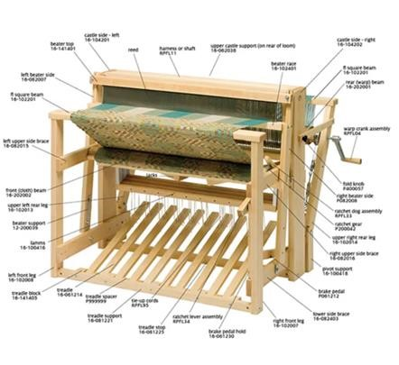
1. | Hand looms (including all accessories and spare parts) | 5
2. | Hand loom weaver’s hooks 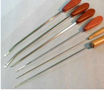 | 5
3. | Hand loom reed knifes (reed hook) 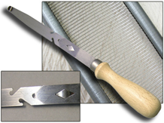 | 2
4. | Hand loom shuttles   | 5
5. | 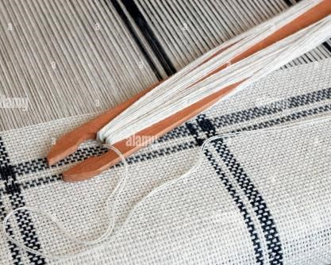  Hand loom stick shuttle | 5
6. | Hand loom shuttle perns (bobbin inside shuttle) 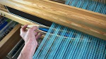 | 5
7. | Hand loom manual pern winding machine  | 1
National Vocational and Technical Training Commission, Govt. of Pakistan

 | Hand loom warping bracket (for manually winding the weaver’s beam) 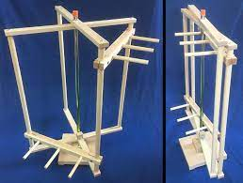
8. |  | 2
9. | Warp Yarn for weaving (for all weaving machines) | 25 kg
10. | Weft yarn for weaving (for all weaving machines) | 25kg
11. | Yarn cutters   | 5
Power loom
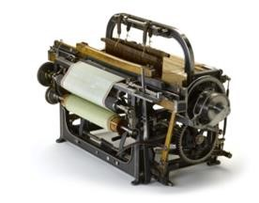
12. | Stroboscope (used for machine speed) 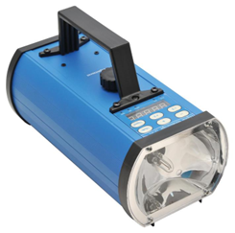 | 1
13. | Power loom (including all accessories and spare parts) | 1
14. | Power loom weaver’s hooks | 5
15. | Power loom reed knifes (reed hook) | 2
16. | Power loom shuttles   | 5
17. | Power loom shuttle perns (bobbin inside shuttle) | 5
18. | Power loom pern winding machine   | 1
19. | Degree meter (wheel) | 1

20. | Cam (for design change) | 4 (for plain weave)
21. | Dobby paper punching machine | 1
22. | Dobby punching paper | 1 roll
23. | Jacquard cards punching machine | 1
24. | Jacquard cards | 200
25. | Bubble leveler (for weaving machine leveling) | 1
Airjet weaving machine
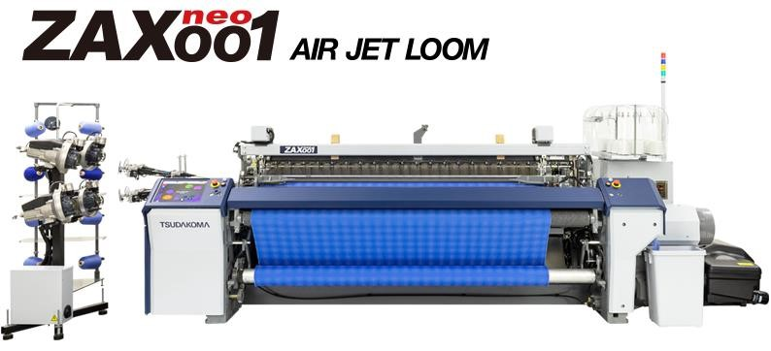
26. | Airjet weaving machine | 1
27. | Weaver’s hooks for airjet | 5
28. | Reed knife (hook) for airjet | 2
29. | Ultrasonic nozzle cleaner bath (used to clean clogged airjet nozzles)  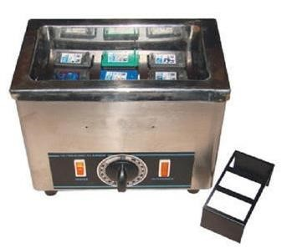 | 1
30. | Leno heddles (used for leno selvedge)  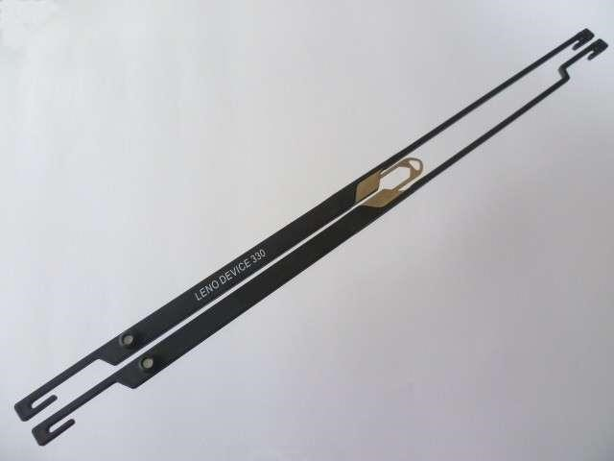 | 10 sets
31. | Stroboscope (used for machine speed) | 1
32. | Nozzle gauges 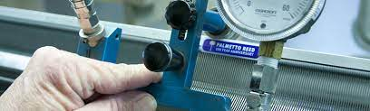 | 1

33. | thickness gauges | 1
34. | Gauge for EGP pin (for weft color selection) | 1
35. | Leno blade sharpener grinder (in workshop) | 1
36. | Shim for cam setting (for degree indexing) | 1 set
37. | Bearing puller | 1
38. | Pulley puller | 1
39. | Toolbox, spanner set, Allen key set | 1 set
40. | Temple shims | 1 set
41. | Tuck in needle and grippers | 1 set
42. | Selvedge cutters | 5 sets
43. | Waste cutters | 2 sets
44. | Pressure pipe for nozzle testing | 2
45. | Pressure gauge | 2
46. | Bubble leveler (for weaving machine leveling) | 1
47. | Tool trolly (with all general workshop tools)  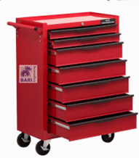 | 1
48. | Pattern trolly (for article change) | 1
49. | Cam change trolly (for fabric design change) | 1
50. | Back rest gauge (for back rest leveling) | 1
51. | Degree wheel | 1
52. | Dobby paper punching machine 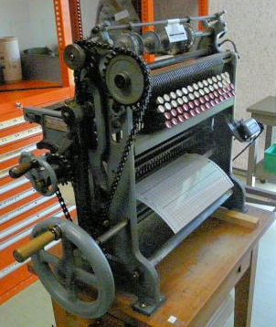 | 1
53. | Dobby paper punching paper | 1 roll
54. | Jacquard cards punching machine
55. | Jacquard cards | 2000
Rapier weaving machine
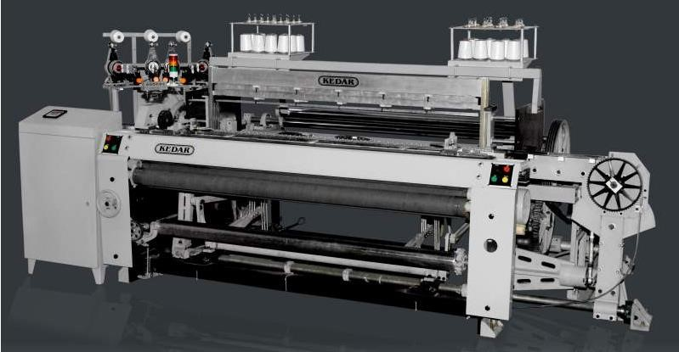
56. | Stroboscope (used for machine speed) | 1
57. | Watch maker set | 1 set
58. | Guide teeth gauge | 1
59. | Degree wheel | 1
60. | Bubble leveler (for weaving machine leveling) | 1
61. | Leno heddles | 5 sets
62. | Drawing in hook | 1
63. | Gear puller | 1

64. | Pulley puller | 1
65. | Dobby paper punching machine | 1
66. | Dobby paper punching paper | 1 roll
67. | Jacquard cards punching machine | 1
68. | Jacquard cards | 2000
Sulzer projectile weaving machine
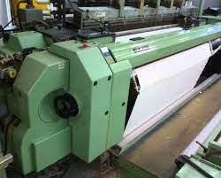
69. | Stroboscope (used for machine speed) | 1
70. | Guide teeth gauge (for projectile path alignment) | 1
71. | Tool trolly (with all general workshop tools) | 1
72. | Pattern trolly (for article change) | 1
73. | Cam change trolly (for fabric design change) | 1
74. | Dobby paper punching machine | 1
75. | Dobby paper punching paper | 1 roll
76. | Jacquard cards punching machine | 1
77. | Jacquard cards | 2000
78. | Bearing puller | 1
79. | Pulley puller | 1
80. | Gear puller | 1
81. | Degree wheel | 1
82. | Thickness gauge | 1
83. | Deep gauge | 1
84. | Screw gauge | 1
85. | Bubble leveler (for weaving machine leveling) | 1
86. | heald frame lifting lever | 1
87. | Cam alignment rod (for cam setting) | 1
 | Waterjet weaving machine

 | 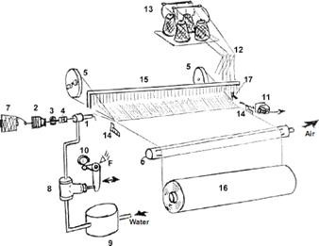
88. | Stroboscope (used for machine speed) | 1
89. | Anti-corrosive heald wires | 1000
90. | Anti-corrosive droppers | 1000
91. | Waterjet weaving machine with all accessories | 1
92. | Anti-corrosive weaver’s hooks for waterjet | 5
93. | Anti-corrosive reed knife (hook) for waterjet | 2
94. | Ultrasonic nozzle cleaner bath (used to clean clogged airjet nozzles) | 1
95. | Stroboscope (used for machine speed) | 1
96. | Bearing puller | 1
97. | Pulley puller | 1
98. | Toolbox, spanner set, allen key set | 1
99. | Bubble leveler (for weaving machine leveling) | 1
100. | Tool trolly (with all general workshop tools) | 1
101. | Pattern trolly (for article change) | 1
102. | Cam change trolly (for fabric design change) | 1
103. | Degree wheel | 1
 | PPEs
104. | Gloves | 26 pairs

105. | Long sleeves | 26 pcs
106. | Hats | 26 pcs
107. | Rubber boots | 26 pairs
108. | First aid kit | 1 set
 | General workshop tools required for maintenance of weaving machines
109. | Vernier callipers | 1
110. | Screw gauge | 1
111. | Measuring scales | 5
112. | Deep gauge | 1
113. | Filter opener | 1
114. | Pipe clumps   | 50
115. | Emery papers   | 50
116. | Polishing pasts   | 1 bottle
117. | Grinding disks  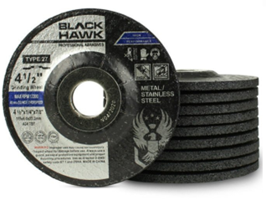 | 10
118. | Grinding wheels | 10
119. | Buff polishing wheel | 2
120. | Wire cutter | 2
121. | Pipe cutters  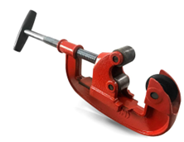 | 1
122. | Internal lock opening plyers | 2
123. | External lock opening players | 2
124. | Nose players | 2
125. | Main player | 2
126. | Grip player  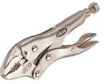 | 2
127. | Screw drivers flat head | 5
128. | Screw drivers Philip head | 5
129. | Allen key set (millimeters) | 2 sets
130. | Allen key set (inches) | 2 sets
131. | Raymer tool (for hole size precision setting) | 2 sets
132. | Watch maker set | 1
133. | Goti ratchet set | 1
134. | Plastic hammer | 3
135. | Wooden hammer | 3
136. | Metal hammer | 2
137. | Scissors | 5
138. | Metal sheet cutter | 2
139. | Jigsaw   | 1
140. | Bandsaw | 1
141. | Flat file (fine) | 5
142. | Flat file (coarse) | 5
143. | Round file (fine) | 5
144. | Round file (coarse) | 5
145. | Half round file (fine) | 5
146. | Half round file (coarse) | 5
147. | Drill machine | 2
148. | Drill bits (wood) | 2 sets
149. | Drill bits (metal) | 2 sets

150. | Drill bits (concrete) | 2 sets
151. | Hose pipe clumps | 50
152. | Tourque wrenches | 2
153. | Spanner set (half open half close) | 2 sets
154. | Adjustable wrench | 2
155. | Center punch | 2
156. | Angle cutter | 1
157. | Welding unit | 1
158. | Hot glue gun | 2
159. | First Add Box | 1
160. | Fire Extinguisher | 2
161. | Computer system (for store inventory) | 1
162. | Rubber seals | 20
163. | Marker pen (for marking mechanical parts) | 5
164. | Thimble (for electric wire repair) | 20
165. | Silicon adhesive   | 5
166. | Epoxy adhesives   | 5 sets of magic depoxy
167. | Rubber glue  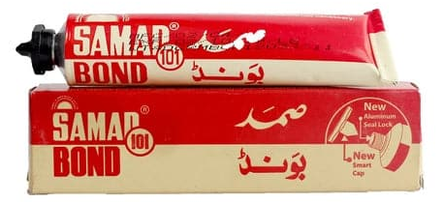 | 2 large tubes
168. | Paper tape   | 5 rolls
169. | Plastic tape | 5 rolls
170. | Insulation tape   | 5 rolls
171. | Board marker | 3
172. | Logbook (for inventory record)  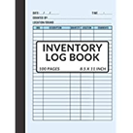 | 2
173. | Fabric cleaning rugs (for cleaning parts & tools) | 5 kgs
174. | Selvedge wastes (for cleaning) | 5 kgs
175. | Oiling pump (for adding oil to the machines) | 1
176. | Weaving machine oils | 10 lit
177. | Grease lubricant | 5 kgs
178. | Grease gun   | 1
179. | Card board (for tagging) | 50
180. | Plastic (for packaging) | 1 roll
181. | Boxes (for packaging) | 5
182. | Bubble lever (for weaving machine leveling) | 2

