CURRICULUM for TOURISM MANAGEMENT
(LEVEL 3)


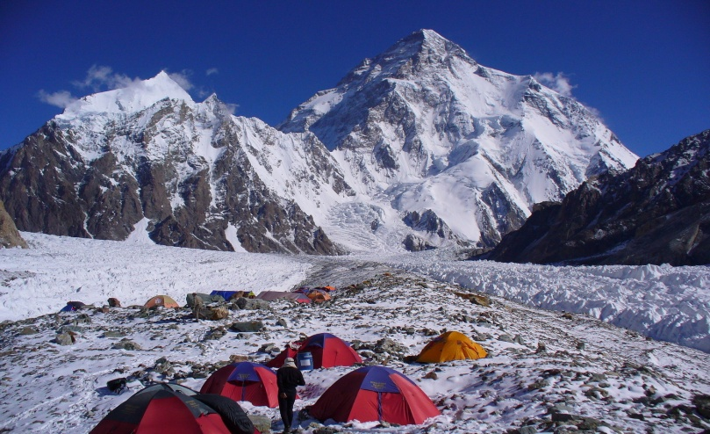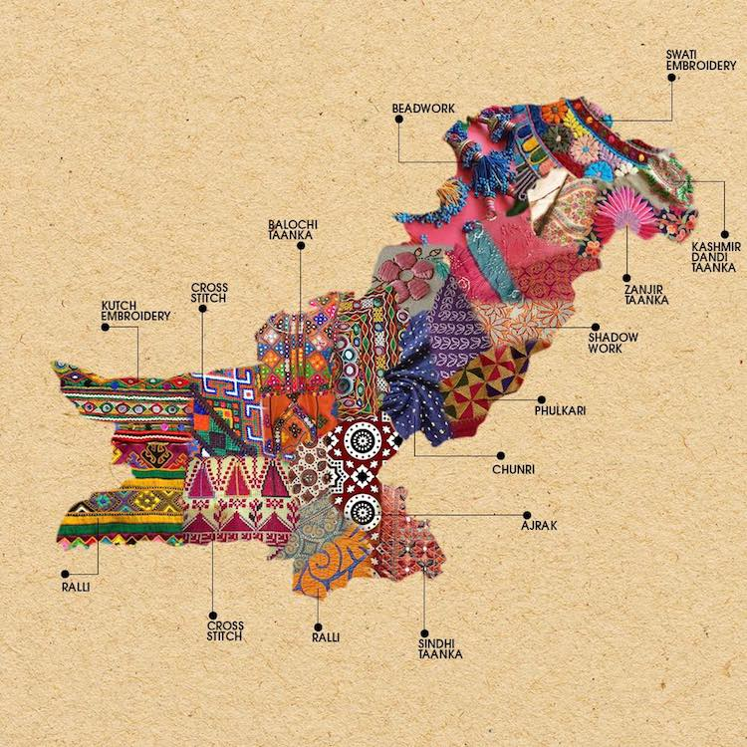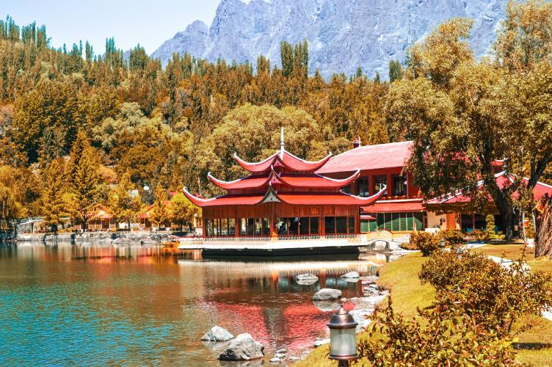
NATIONAL VOCATIONAL & TECHNICAL TRAINING COMMISSION, ISLAMABAD
GOVERNMENT OF PAKISTAN

Contents
CURRICULUM for TOURISM MANAGEMENT 1
1. Introduction 5
2. Purpose the Qualification 6
3. Overall objectives of training course 6
4. Competencies to be gained after completion of course 7
5. Job opportunities available immediately and in the future 8
6. Trainee Entry Level: 8
7. Minimum Qualification of Trainer 8
8. Recommended trainer: trainee ratio 8
Medium of Instruction: 8
10. QUALIFICATION DEVELOPMENT COMMITTEE 9
11. Duration of Course (Total time, theory & practical) 10
12.SUMMARY OF COMPETENCY STANDARDS 13
13. SUMMARY – OVERVIEW OF THE CURRICULUM (Core Competences) 13
LEVEL-3 36
Module 6 Develop Online Communication 37
Module 7 Maintain Financial Records and Audit Procedures 39
Module 8 Develop Front Office Skills 43
Module 9: Conduct Tours 46
Digital Skills 119
Module 1: Use social media tools for collaboration and engagement 125
Module 2: E-Commerce – Social Media Marketing 127
Soft Skills 128
Module 1: Develop workplace documents 136
Module 2: Maintain professionalism at workplace 139

Introduction

Tourism is one of the major & fastest growing industries of the modern world and helps create business opportunities as well as jobs at the local community levels. The present federal Govt. has rightly recognized the immense potential of tourism industry in our country and is now taking steps to tap this potential to overcome the shortfall of foreign exchange. National Tourism Coordination Board (NTCB) has been constituted for the first time involving industry professionals to tackle issues currently faced by the tourism industry as well as others stakeholders.
Pakistan is one of the very few countries to have natural landscapes form the depth of ocean to the highest mountains. We have the three highest mountains ranges of the world and 5 summits above 8,000 meters. These mountains offer fascinating valleys and unique cultures for the visitors. We host some of the earliest civilizations of the world; from Mehr Garh to Indus valley civilization to Gandhara. This fascinating heritage is one of the many reasons, tourists visit Pakistan, but it is certainly not the only one. Exciting adventure attractions, varied animal life, historical ruins and monuments, and the beautiful sceneries are just few of the many reasons to visit Pakistan. The mountain ranges feature alpine meadows and coniferous forests, leading down into desert plains, coast line and lands basin, also attract tourists to see all beautiful places located in different parts of Pakistan.
With consistent & sustained growth in domestic tourism over the last few years, it is imperative to train local staff with skills necessary for successfully running the local businesses. Now local tourists find it easier and faster to travel to their desired locations to spend their vacations. At popular domestic destinations we are already facing situations where tourists far outnumber the accommodation available and end up sleeping in their cars. We need to train our youth to benefit from these lost opportunities.
Tourism calls for coordination and cooperation between airlines, travel agents, tour operators, hoteliers, transporters, restaurants, theme parks, gift shops and tourists. The industry relies more heavily on services than on goods. Consequently, it creates a lot of jobs in the remote villages & valleys and also in major cities. With trained & skilled manpower from local host communities, we can offer superior services to tourists at their desired destinations.
This course on Tourism Management is designed as a comprehensive training program to study the subject contents both for male and female trainees at Diploma level. This training program covers basics of the subject like introduction of the concept, principles, constituents, organization, entrepreneurship skills; the economic and managerial aspects of tourism; the historical and modern insights into the industry; the marketing, organizational and technological issues involved at national level. It involves the management of multiple activities such as studying tour destination, planning the tour, making travel arrangements and providing accommodation. It also covers marketing efforts to attract tourists to travel particular destinations at local, regional, national and international levels.

2. Purpose the Qualification

The purpose of this qualification is to give the trainee a thorough understanding of the tourism sector as an industry. The tourism sector is diversified and continuously subject to changes. It is therefore important to stress the need for a multidisciplinary approach to meet the challenges within the sector. Upon successful completion of this course the trainees should be able to:
- Explain the core elements and the historical development of the tourism value chain.
- Give an account of essential tourism trends.
- Demonstrate an understanding of different tourism and hospitality products.
- Understand how tourism and hospitality products are marketed.
- Discuss issues/challenges in tourism industry, such as the impacts of tourism and corporate social responsibility practices for implementation.
- Point out relevant industry stakeholders & their roles in driving innovative tourism policy-making and strategic decision-making.

3. Overall objectives of training course

The primary objective of this training program is to provide the trainees with up-to-date knowledge and skills required for tour management operations to cope the challenges of the tourism industry. After qualifying the course at different levels (Level 3,

The overall objectives of this qualification are to:

- Improve the overall quality of training delivery and setting national benchmarks for training of Tourism Management (Level 3) at national level.
- Provide flexible and progressive learning opportunities for trainees to receive relevant and up-to-date skills in tourism industry.
- Provide basics for competency-based assessment which is recognized and accepted by employers in modern days.
- Establish a standardized and sustainable training in consultation with the tourism industry.

4. Competencies to be gained after completion of course

After completing this course, the students will be capable of performing different tourism management operations effectively in tourism industry. Furthermore, this skilled training program enables the students to develop multispectral competencies such as creative thinking, problem solving, research skills, personal and group management, presentation and communication skills, technical and professional negotiations related to Tourism Management operations. The below listed competencies imprinted by this training program are quite prominent to the students’ profile to enhance their employability in Tourism Industry:

- Knowledge and concepts of processing operations in tourism industry.
- Creative thinking and troubleshooting skills in operations.
- Potential to translate theoretical knowledge into practice.
- Identify and explore potential areas of opportunities.
- Develop strategies to maintain quality and safety.
- Time management, team building and conflict resolution with stakeholders.
- Safe and secure use of workplace tools, techniques and materials at on sites.
- Digital documentation and effective communication skills.
- Working in commercial setups and meeting the timelines.

5. Job opportunities available immediately and in the future

The International Standard Classification of Education (ISCED) is a framework for assembling, compiling, and analyzing cross-nationally comparable statistics on education and training, ISCED codes for these qualifications as assigned as follow Tourism Transport Assistant Level 2, Ticketing reservation Assistant Level 2, Tour Guide Level 3, Camp Supervisor Level 3,

6. Trainee Entry Level:

Entry requirements of these qualifications are of level 4 or equivalent.

7. Minimum Qualification of Trainer
- 2-5 years of professional experience in tourism industry or (Tourism Management) diploma level 4/ Bachelors degree in Tourism Management.

8. Recommended trainer: trainee ratio
- The recommended trainer and trainee ratio is 1:24 per class

Medium of Instruction:
- Urdu, English or Local Language

10. QUALIFICATION DEVELOPMENT COMMITTEE
The following members participated in the qualifications development workshop from 25-29,Jan, 2021, in Lahore:
Sr. No | Name & Designation | Organization
 | Mr. Muhammad Asim  Coordinator/ Deputy Director | SS&C Wing-NAVTTC, Islamabad
 | Mr. Muhammad Nasir Khan  DACUM Facilitator | EX-DD, SS&C Wing-NAVTTC, Islamabad
 | Mr. Ali Raza  Instructor | GSTC, Faisalabad
 | Mr. Muslim Farooq  Tourism Instructor | ITHM, Lahore
 | Mr. Mohsin Ali Sindhu  Director Operations / Consultant | Bara-Dari Event Complex , Lahore
 | Ms. Haifa Azhar  Manager Sales & Marketing | Park Lane Hotel, Lahore
 | Ms. Mariyam Zahid  Sr Trainer/Freelancer/Consultant | Hashoo Foundation, Lahore
 | Mr. Mujahid Hussain  Freelancer/ Trainer/Consultant | Islamabad
 | Mr. Muhammad Mazhar Virk  Administrator | Offroad Travel and Tours, Lahore
 | Mr. Numan Asif  Consultant/ Visiting faculty | COTHM, Lahore
 | Mr. Qasim Raza  Manager Academics/Sr Instructor | ITHM, Faisalabad
 | Ms. Farwah Munir  Freelancer | Lahore

11. Duration of Course (Total time, theory & practical)
Module # | Title | Theory Total  (Hours | Practical Total  (Hours) | Total  (Hours) | Credit hours
 | Develop Online Communication | 20 | 50 | 70 | 7
 | Maintain Financial Records and Audit Procedures | 20 | 50 | 70 | 7
 | Develop Front Office Skills | 10 | 50 | 60 | 6
 | Conduct Tours | 10 | 60 | 70 | 7
 | Use social media tools for collaboration and engagement | 15 | 65 | 80 | 8
 | E-commerce social media marketing | 25 | 65 | 90 | 9
 | Maintain professionalism at workplace | 25 | 55 | 80 | 8
 | Develop workplace documents | 25 | 55 | 80 | 8
181119
Total hours | 150 | 450 | 600 | 60

12.SUMMARY OF COMPETENCY STANDARDS

The proposed curriculum is composed ofcore along with generic modules that will be covered in 3600 hrs. It is proposed that the course will be delivered in three years period (Level 3). The distribution of contact hours (practical & theory) is given below:

- Theory: 150 hours

- Practical: 450 hours

13. SUMMARY – OVERVIEW OF THE CURRICULUM (Core Competences)

LEVEL-3

Module 1 Develop Online Communication
Objective: After completing this module, the learner will be able to utilize online communication tools for tourist.

Duration: | Total hours | 70 | Practical | 50 | Theory | 20

Learning Unit | Learning Outcomes | Learning Elements | Duration | Materials (Tools  & Equipment) Required | Learning Place
LU-1. Gain the knowledge to evaluate online information | - Recognize the existing and required information  - Analyze type of information needed  - Access tourist related information from multiple online sources  - Evaluate retrieved information as per quality of source | - Application of multiple online sources.  - Retrieve quality information. | 06 hours Theory  20 hours Practical  Total hours: 26 | Android / IOS applications (such as Face book, Twitter, Skype, etc.)  Computer software (such as professional version of Windows, etc.) | Class Room and workplace
LU-2. Assess online collaboration tools | - Collaborate software tools like email, calendaring, text chat, wiki and bookmarking  - Assess social network tools like WhatsApp, twitter, Instagram, Facebook, Snapchat, etc.  - Evaluate the potential of social network tools in tourism management | - Evaluating accuracy and credibility of online information  - Niche oriented online tools. | 06 hours Theory  30 hours Practical  Total hours: 36 | Internet access  Portable Camera (such as above the monitor or embossed in Laptop) | Class Room and workplace
LU3. Perform an online communication | - Demonstrate and maintain online contact with relevant stakeholders  - Perform Web Conferencing and online training | - Describe use of social networking tools.  - Conducting video conferencing | 08 hours Theory  30 hours Practical  Total hours: 38 |  | Class Room and workpla • Diff between sustainability and non-sustainability developmentce

Module 2 Maintain Financial Records and Audit Procedures
Objective: After completing this module, the learner will be able to recognize, analyze and solve problems related to financial management.
Duration: | Total hours | 70 | Practical | 50 | Theory | 20

Learning Unit | Learning Outcomes | Learning Elements | Duration | Materials (Tools & Equipment)  Required | Learning Place
LU-1. Process the payments and receipts | - Identify the loop holes in the payment process  - Administer(Manage) billing and settling plan  - Explain credit terms and conditions  - Issue invoices timely with clarity and accuracy  - Operate computerized credit transactions | - Understand common mistakes found in billing and payment settlements.  - Communication skills while dealing with colleagues and clients. | 05 hours Theory  20 hours Practical  Total hours: 25 | Desktop computer  Record books  Ledger books  Stationary | Class Room and workplace
LU 2. Handle the petty cash and control overheads | - Calculate and handle average cash in hand  - Identify and apply the alternative ways to compensate cash deficiencies at times  - Identify to reduce the costs such as utilities and office equipment  - Identify the checklist to manage with minimum appliances | - Record and monitor everyday cost.  - Techniques of book keeping and record control. | 05 hours Theory  20 hours Practical  Total hours: 25 | Desktop computer  Record books  Ledger books  Stationary | Class Room and workplace

LU 3. | Maintain and update accounting records | - (Maintain) the possibility to avoid late payments  - Ensure to enclose the entry as occurs  - Identify the step-by-step procedure to track expenses, debtors and creditors  - Make accurate and appropriate journal entries in the relevant books of account  - Settle accounts on a regular basis to ensure accurate record-keeping and track financial situation | - Understand bookkeeping principles and terminology.  - Differentiate typical and modern record keeping systems. | 05 hours Theory  10 hours Practical  Total hours: 15 | Desktop computer  Record books  Ledger books  Stationary | Class Room and workplace
 | LU 4. Manage Payroll Records | - Prepare payroll data in a timely and accurate manner  - Process payment of salaries according to organizational and legal requirements  - Administer salary records as required to meet legal requirements and the needs of employees | - Understanding of bookkeeping principles  - Typical financial control processes and procedures as appropriate to industry sector | 05 hours Theory  10 hours Practical  Total hours: 15 | Desktop computer  Record books  Ledger books  Stationary | Class Room and workplace
 | LU 5. Audit Financial Procedures | - Monitor financial procedures to ensure they achieve their intended purpose which meet organizational and legal requirements  - Complete financial reports that provide accurate information on the organizational position and meet legal requirements | - Auditing and financial reporting processes (both internal and external)  - Importance of auditing and reporting processes in overall financial management of an establishment  - Understanding of how the auditing process impacts on overall financial management | 05 hours Theory  10 hours Practical  Total hours: 15 | Desktop computer  Record books  Ledger books  Stationary | Class Room and workplace
 | LU 6. Prepare Financial Statements | - Post transactions to relevant ledgers accurately and as required by the organizational operating procedures  - Make end of period adjustments as required and in the correct manner to comply with financial and accounting requirements  - Produce balance sheets and profit and loss statements when required that accurately reflect the trading and financial position of the organization | - Double entry system and concept of debits and credits in bookkeeping  - Basic transaction groups – assets, liabilities, proprietorship, income, expenses  - Balance sheet/profit and loss statement preparation  - Understanding of general accounting principles and practices | 05 hours Theory  10 hours Practical  Total hours: 15 | Desktop computer  Record books  Ledger books  Stationary | Class Room and workplace

Module 3 Develop Front Office Skills

Objective: After completing this module, the learner will be able to develop front office skills.

Duration: | Total hours | 60 | Practical | 50 | Theory | 10

Learning Unit | Learning Outcomes | Learning Elements | Duration | Materials (Tools & Equipment)  Required | Learning Place
LU 1. Develop Tourism Relationship skills | - Review tourist arrival list to welcome them  - Attend special tourists (e.g. VIPs) and answer their inquiries  - Provide information about area and attractions and promote services  - Address tourist complaints and escalate to Relations Manager where required  - Ensure compliance with health and quality standards  - Operate reservation system | - Define tourist registration and welcome procedures.  - Gather Information about area and attractions.  - Learn how to resolve tourists complain. | 06 hours Theory  27 hours Practical  Total:33hours | Reception Desk, Electronic cash register, Safe deposit box, Stationary | Class Room and workplace
LU 2.  Apply Reception skills | - Prepare reception area for service and check all necessary equipment prior to use as per establishment procedures  - Check arrival details and review prior to tourist arrival as per establishment procedures  - Operate PMS (Property Management System) and maintain reports  - Organize tourist departure  - Address the switchboard, screening and forwarding incoming phone calls | - Explain Standard Operating Procedures SOP’s at front office.  - Elaborate and understand PMS.  - Dress code of conduct | 06 hours Theory  27 hours Practical  Total:33hours | Computer, Telephone, Fax, Printer, weigh scale, Key card machine, Internet device | Class Room and workplace
LU 3. Develop Concierge Skills | - Develop information on recreational services and process memberships  - Advise tourists on local area (tourism or business locations, sights or events)  - Provide knowledge of hotel facilities and services to tourists  - Assist with tourist luggage when required  - Ensure to have information of daily functions, events, VIP and group arrivals | - Handle reception, business center & guest relation desk  - Property management system, reports making and handle ancillary services.  - Presentation on hotel facilities functions. | 08 hours Theory  26 hours Practical  Total:34hours | Calculating machine, Credit cards machine, Cash registers, software | Class Room and workplace

Module 4: Conduct Tours
Objective: After completing this module, the learner will be able to conduct tours/organize tours. The trainees will also be able to perform as professional tour leader.
Duration: | Total hours | 70 | Practical | 60 | Theory | 10

Learning Unit | Learning Outcomes | Learning Elements | Duration | Materials (Tools & Equipment) Required | Learning Place
- Conduct Pre-departure Checks | - Identify tour requirements to ensure all necessary materials and equipment are available  - Collect necessary tour related documents i.e. itinerary, tourist information, logistics, entry passes, Travel document, and budget  - Check equipment and supplies to ensure they are in sound order and sufficient for the needs of the tour group  - Load equipment and supplies carefully to avoid damage and ensure easy access when required  - Complete necessary documentation in order  - Check necessary medications as per medical history | - Know about Identifying interesting ways of explaining to the tourists.  - Demonstrate GPS and compass usage.  - Explain Communicating effectively  - Tracking the route details | 05 hours  Theory  15 hour  Practical  Total:20 hours | World Globe  Stationery  GPS  Compass | Classroom and workplace
- Liaison with tour group for necessary information and procedures | - Ensure personal dress up and hygiene  - Confirm the date and duration of tour travel  - Obtain visitors interest from the itinerary  - Ensure Morning Briefing for whole day activity  - Liaison with industry colleagues to maximize the tour experience and provide all necessary services  - Introduce the driver and other people travelling with group  - Apply technique using the microphone, if appropriate | - Personal grooming and hygiene  - Skills and interpret tourist requirements  - Prepare checklist for personal grooming & tourist requirement | 05 hours  Theory  15 hour  Practical  Total:20 hours | Personal Grooming checklist  Tourist requirement list | Classroom and workplace
- Conduct a Tour Group and Deliver Tour Commentary | - Prepare information for delivery to customers that is complete, interesting and coordinates with the tour activities  - Introduce yourself as the Guide  - Inform the tourists about venue, highlights of the sightseeing and timing of tour  - Communicate refreshments, lunch, toilet stops to be made  - Mark passing landmarks and places of interest for the information of visitors  - Present commentary to customers in a clear and interesting way so that all participants can hear  - Develop a rapport with visitors group  - Realize importance of being polite and courteous with tourist  - Apply etiquette / maintain appropriate physical distance with visitors during briefing and conversation  - Communicate immediate or possible solutions to delay or other problems related to tour  - Summarize after a tour to improve the tour operation and effectiveness in future | - Recognizing ethics of Tour Guiding  - Presentation on tourist point and sightseeing.  - Role play on possible solution for delay occurs during tour.  - Demonstrate etiquette during presentation.  Flexibility towards group members considering age and special | 05 hours  Theory  15 hour  Practical  Total:20 hours | Mic  Computer system with MS Office  Stationery  Brochures | Classroom/ workplace
- Lead a Tour at Different Types of Tourist sites | - Obtain tourist interest at particular places and sites during tour  - Lead a group at indoor sites  - Lead a group at outdoor sites  - Lead a group at Cultural and traditional food sites  - Manage time efficiently in a way the location is visited as per the planned itinerary or the time availability of the tourists  - Identify if photography is allowed and permits are required at the places to be visited  - Manage and handle tourist queries about sites  - Apply the guide’s code of conduct | - Mannerism and sense of humor  - Patience and anger management  - Leadership skills  - Handling difficult questions and crisis situations  - Typical tour documentation | 05 hours  Theory  15 hour  Practical  Total:20  Hours | Play-Cards.  Stationery  Tour related documents template

Module 5: Develop workplace documents
Objective: After completing this module, the learner will be able to prepare different kinds of documents related to workplace, including designing, drafting and finalizing.

Duration: | Total hours | 60 | Practical | 40 | Theory | 20

Learning Unit | Learning Outcomes | Learning Elements | Duration | Materials (Tools & Equipment) Required | Learning Place
- Interpret written information | - Read workplace materials to identify the subject and key information for using or reporting to others.  - Read procedural manuals and codes of practice to locate specific information to carry out work functions in accordance with policy and standards  - Read a range of written materials to locate and select required information for summaries, short reports and response to requests.  - Identify the cultural context and prior knowledge required to interpret workplace information and obtain assistance when required.  - Determine candidate and purpose for the document  - Seek assistance with interpretation of complex materials in accordance with organizational procedures. | - Explain the reading and writing procedures  - Explain the integration of information from a number of sources  - Describe the ways to write and sequence paragraphs | 4 hours  Theory  8 hour  Practical  Total:12 hours | Internet  Laptop/Computer  White board  Projector screen  Multimedia  projector | Class Room and workplace
- Develop written materials | - Identify and comply with established requirements for a range of written materials  - Determine format and structure  - Identify organizational requirements  - Establish method of communication  - Develop introductory guide for incumbents | - Describe the different methods to prepare information according to target audience | 4 hours  Theory  8 hour  Practical  Total:12 hours | Internet  Laptop/Computer  White board  Projector screen  Multimedia  projector | Class Room and workplace
- Draft document | - Develop draft document to communicate key points  - Obtain and include any required additional information | - Explain the ways to concise the information with eco- friendly practices | 4 hours  Theory  8 hour  Practical  Total:12 hours | Internet  Laptop/Computer  White board  Projector screen  Multimedia  projector | Class Room and workplace
- Review document | - Check draft for suitability of tone for audience, purpose, format and communication style  - Check draft for readability, grammar, spelling, sentence and paragraph construction and correct any inaccuracies or gaps in content.  - Check draft for sequencing and structure  - Check draft to ensure it meets organizational requirements  - Ensure draft is proofread, where appropriate, by supervisor or colleague | - Proof reading  - Explain the use of words against tone of the document | 4 hours  Theory  8 hour  practical  Total:12 hours | Internet  Laptop/Computer  White board  Projector screen  Multimedia  projector | Class Room and workplace
- Write final document | - Make and proofread necessary changes  - Ensure document is sent to intended recipient within required time frames  - File copy of document in accordance with organizational policies and procedures | - Explain the resources to assist in document production, such as dictionary, templates and style sheets  - Demonstrate the ways to store the document according to enterprise standards | 4 hours  Theory  8 hour  Practical  Total:12 hours | Internet  Laptop/Computer  White board  Projector screen  Multimedia  projector | Class Room and workplace

Module 6: Maintain professionalism at workplace
Objective: After completing this module, the learner will be able to practice the required professional image in the workplace, including behaving ethically, demonstrating motivation, respecting timeframes and maintaining personal appearance.

Duration: | Total hours | 60 | Practical | 40 | Theory | 20

Learning Unit | Learning Outcomes | Learning Elements | Duration | Materials (Tools & Equipment) Required | Learning Place
LU1. Respect work timeframes | - Demonstrate punctuality in meeting, set working hours and times.  - Utilize working hours only for working and follow company regulations.  - Complete work tasks within deadlines according to order of priority  - Perform extra ordinary during working hours | - Explain code of conducts of the organization | 5 hours  Theory  10 hours  Practical  Total: 15 hours | Internet  Laptop/Computer  White board  Projector screen  Multimedia  projector | Class Room and workplace
LU2. Maintain personal appearance and hygiene | - Clean hair, body and nails regularly  - Wear suitable cloths for the workplace, and respect local and cultural contexts  - Meet specific company dress code requirements  - Keep smiling and have positive body language during working hours | - Describe oral and personal hygiene | 5 hours  Theory  10 hours  Practical  Total: 15 hours | Internet  Laptop/Computer  White board  Projector screen  Multimedia  projector | Class Room and workplace

LU3. Maintain adequate distance with colleagues and clients | - Respect personal space of colleagues and clients with reference to local customs and cultural contexts  - Avoid cross transmission of infections (especially through respiration). | - State workplace hygiene standards  - Explain social distancing | 5 hours  Theory  10 hours  Practical  Total: 15 hours | Internet  Laptop/Computer  White board  Projector screen  Multimedia  projector
LU4. Work in an ethical manner | - Follow company values/ethics codes of ethics and/or conduct, policies and guidelines.  - Use company resources in accordance with company ethical standards.  - Undertake work practices in compliance with company ethical standards, organizational policy and guidelines  - Instruct co-workers on ethical, lawful and reasonable directives.  - Share Company values/practices with co-workers using appropriate behavior and language.  - Report work incidents/situations and/or resolved in accordance with company protocol/guidelines. | - Outline the Company regulations, performance and ethical standards  - Explain work responsibilities/job functions | 5 hours  Theory  10 hours  Practical  Total: 15 hours | Internet  Laptop/Computer  White board  Projector screen  Multimedia  projector | Class room and work place

Module 7: E-Commerce – Social Media Marketing
Objective: After completing this module, the learner will be able to develop effective E-Marketing strategies by using different tools on social media to increase the footprint of the organization.
Duration: | Total hours | 70 | Practical | 50 | Theory | 20

Learning Unit | Learning Outcomes | Learning Elements | Duration | Materials (Tools & Equipment) Required | Learning Place
LU1. Social Media Marketing | - Develop different Social media marketing techniques  - Apply suitable Classified Advertisement techniques on social media | - Introduction of Modern marketing techniques while using social media | 10 hours  Theory  25 hour  Practical  Total:35 hours | Internet  Laptop/Computer  White board  Projector screen  Multimedia  projector | Class Room and workplace
LU2. Utilization of social media | - Perform Electronic Mail Marketing  - Create Blogs | - Uses and impact of electronic marketing | 10 hours  Theory  25 hour  Practical  Total:35 hours | Internet  Laptop/Computer  White board  Projector screen  Multimedia  projector | Class Room and workplace

Module 8: Use social media tools for collaboration and engagement
Objective: After completing this module, the learner will be able to use social media applications to create channels to engage the end users and guests.
Duration: | Total hours | 60 | Practical | 50 | Theory | 10

Learning Unit | Learning Outcomes | Learning Elements | Duration | Materials (Tools & Equipment) Required | Learning Place
- Describe different types of social media tools and applications | - Identify different types of social-media tools and applications  - Illustrate some of the issues associated with the use of social media tools and applications | - Explain characteristics of the term social media | 4 hours theory  10 hours practical  Total 14 hours | Internet  Laptop/Computer  White board  Projector screen  Multimedia  projector | Class Room and workplace
- Compare different types of social media tools and applications | - Select one social media type for review  - Review most popular tools and applications within that social media type  - Itemize benefits across a range of the most popular tools and applications.  - Select most appropriate social media tool or application | - Importance of uses of social media applications | 3 hours  Theory  15 hour  Practical  Total 18 hours | Internet  Laptop/Computer  White board  Projector screen  Multimedia  projector | Class Room and workplace
- Set up and use popular social media tools and applications professional practice | - Identify social media tools and applications for possible implementation  - Initiate preferred social media tools and applications for use  - Establish social media interface using text and file content  - Initiate social networking interaction  - Test and evaluate tools and applications for ease of use  - Present findings | - Understanding of popular social media applications | 3 hour  Theory  25 hour  Practical  Total: 28 hours | Internet  Laptop/Computer  White board  Projector screen  Multimedia  projector | Class Room and workplace

