Skill Assessment

For

“General Fitter (Basic)”
Level 2

Date 29May to 02 June, 2023

National Vocational & Technical Training Commission

ACTIVITIES FOR GENERAL FITTER (Basic) LEVEL 2
- Perform measurement using different types of Vernier caliper
- Take dimension using inside & outside caliper
- Perform measurement according to Job requirement using inside micrometer.
- Perform measurement according to Job requirement using outside micrometer.
- Perform measurement according to Job requirement using bore micrometer.
- Perform measurement according to Job requirement using depth micrometer.
- Verify the squareness of edges & marked lines using meter square as per provided drawing.
- Mark and verify 45 degrees using try square.
- Inspect the given angles of workpiece using bevel protector.
- Inspect level using spirit level as per requirement.
- inspect level using magnetic level as per requirement.
- Inspect measurement using feeler gauge.
- Inspect measurement using snap gauge.
- Inspect threads pitch using pitch thread gauge.
- Inspect diameter of wire using wire gauge.
- Carryout marking according to drawing using height gauge.
- Inspect radius according to the requirement using radius gauge
- Dial machine and vice using dial indicator.
- Dial workpiece using dial indicator as per requirement.
- Measure and inspect the given component using calipers, micrometer, dial indicator, angular and engineering gauges and levels.
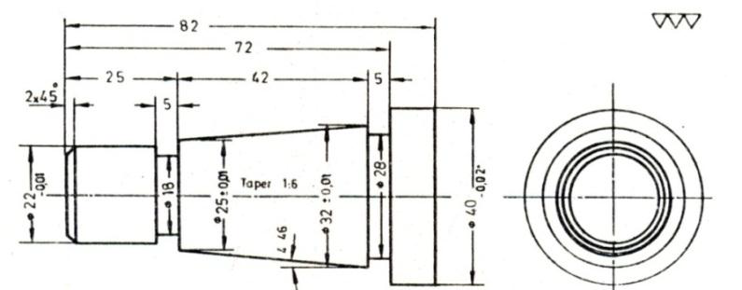
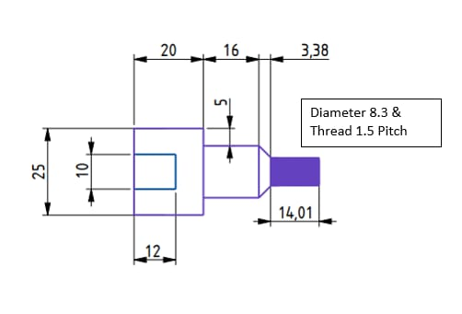

- Perform measurement using different types of Vernier caliper
- Take dimension using inside & outside caliper
- Perform measurement according to Job requirement using inside micrometer.
- Perform measurement according to Job requirement using outside micrometer.
- Perform measurement according to Job requirement using bore micrometer.
- Perform measurement according to Job requirement using depth micrometer
- Verify the squareness of edges & marked lines using meter square as per provided drawing.
- Mark and verify 45 degrees using try square.
- Inspect the given angles of workpiece using bevel protector.
- Inspect level using spirit level as per requirement.
- inspect level using magnetic level as per requirement.
- Inspect measurement using feeler gauge.
- Inspect measurement using snap gauge.
- Inspect threads pitch using pitch thread gauge.
- Inspect diameter of wire using wire gauge.
- Carryout marking according to drawing using height gauge.
- Inspect radius according to the requirement using radius gauge
- Dial machine and vice using dial indicator.
- Dial workpiece using dial indicator as per requirement.
- Interpret symbols from the given drawing.
- Interpret different types of abbreviations from the given drawing.
- Extract dimensions from the given drawing.
- Estimate material from the given job specification/ drawing.
- Interpret different section views/ coordinated sections from the given drawing.
- Interpret revisions in drawing.
- Mark points as per dimensions taken from drawing.
- Mark lines between points.
- Perform center punching in the layout as per job requirement.
- Verify the marked layout as per given drawing before starting the operations.
- Mark layout as per given drawing and estimate materials.
- Select appropriate blade according to the material and set in hacksaw frame.
- Mark layout of job as per drawing using appropriate marking tool.
- Perform clamping of the work piece according to the instructions.
- Perform sawing according to the instructions.
- Check quality of the component at suitable intervals.
- Verify the final job with the given drawing.
- Select appropriate file type according to the material & profile.
- Select appropriate marking tool and mark layout of job as per drawing.
- Select appropriate clamping device and clamp the work piece.
- Perform filing as per standard procedures.
- Check quality of the component at suitable intervals.
- Verify the final job with the given drawing.
- Select appropriate chisel type and size according to the material & profile.
- Select appropriate marking tool and mark layout of job as per drawing.
- Select appropriate angle during the work performance.
- Perform chiseling as per standard procedures.
- Check quality of the component at suitable intervals.
- Verify the final job with the given drawing
- Select appropriate straightening tool/hammer according to the material & profile.
- Select appropriate clamping device and clamp the work piece.
- Select appropriate hammering during the work performance.
- Check quality of the component at suitable intervals.
- Verify the final job with the given drawing
- Select appropriate rivet type and size according to the material & profile.
- Select appropriate marking tool and mark layout of job as per drawing.
- Select appropriate clamping device and clamp the work piece.
- Select appropriate hammering/strokes during the work performance.
- Perform riveting as per standard procedures.
- Check quality of the component at suitable intervals.
- Verify the final job with the given drawing
- Select appropriate tap/die according to the job specification.
- Select appropriate marking tool and mark layout of job as per drawing.
- Select appropriate clamping device and clamp the work piece.
- Perform pre-drilling to produce hole according to tap size.
- Perform taping as per job specification.
- Verify the final job with given drawing
- Select appropriate portable grinding machine according to the job specification.
- Select appropriate marking tool and mark layout of job as per drawing.
- Select appropriate clamping device and clamp the work piece.
- Perform grinding to complete size.
- Perform grinding as per job specification.
- Verify the final job with given drawing.
- Select appropriate pedestal grinder & grinding wheel as per job specifications
- Check tool rest and cooling water pot mounted with pedestal grinder
- Perform tool or work piece grinding operation by holding the tool or work piece firmly against the rotating wheel by placing it on the tool rest.
- Dip tool or work piece in coolant at intervals to avoid over heating of the job.
- Adopt techniques and methods as per requirements of tool or work piece geometry.
- Check quality of the tool or work piece at suitable intervals.
- Perform grinding as per standard procedures.
- Switch off the grinder after finishing the work.
- Prepare component as per the given drawing
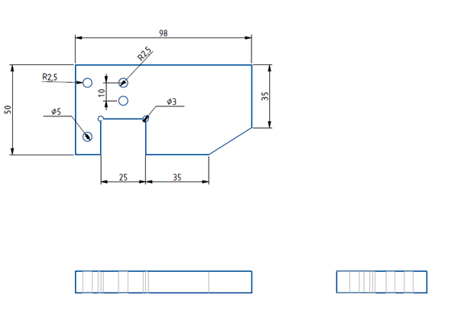

- Switch on the machine
- Check oil levels
- Run machine warm-up cycle
- Select appropriate tool & clamping device according to the job requirement.
- Manage the measuring instruments as per job requirement.
- Select safe procedures and tools to accomplish the work.
- Clamp the tool in tool post & set in required angle
- Set machine parameter as per job specifications
- Start facing operation by initial touching and adjust the depth of cut as per SOPs.
- Carry out facing operation as per given drawing.
- Centring the work piece as per SOPs.
- Start turning operation by initial touching and adjust the depth of cut as per SOPs.
- Carry out turning operation as per drawing.
- Check quality of the component at suitable intervals.
- Clamp & set the tool in tail stock.
- Perform drilling to produce appropriate hole size for boring as per SOPs.
- Clamp the boring tool in the tool post.
- Carry out Boring operation as per drawing.
- Carry out machining operation for knurling as per drawiang
- Start thread cutting operation by initial touching and adjust the depth of cut micrometer at zero point.
- Carry out tool and machine setting for turning at required taper angle.
- Start taper turning operation by initial touching and adjust the depth of cut as per SOPs.
- Set machine gear drive mechanism and other parameters as per job specifications
- Engage half nut lever at specific point on thread dial.
- Disengage half nut lever at the end of threading length.
- Move back the cross slides to maintain appropriate clearance distance between tool and job. Move back the carriage before starting point of thread.
- Set the next depth of cut and repeat threading cycle up to the completion of thread according to required depth.
- Check quality of the component at suitable intervals.
- Shut down the machine at safe position after finishing the work.
- Select safe procedures and tools to accomplish the work.
- Set up drilling machine for producing holes according to job requirement.
- Manipulate machine tool controls safely and correctly in line with operational procedures.
- Produce components to the required quality and within the specified dimensional accuracy as per SOPs.
- Carry out quality sampling checks at suitable intervals.
- Shut down the equipment to a safe condition on conclusion of the machining activities.
- Select safe procedures and tools to accomplish the work.
- Select relevant tools according to the information given in engineering drawings and job specifications.
- Ensure tooling is correct in terms of size, shape, type, and grade for the work.
- Position the work-piece on the machine table in such a way that it is aligned, secured and stable during operation.
- Adjust speeds and feeds of tool in accordance with the size, type, and hardness of work-piece material, for optimum cutting.
- Complete the job according to SOPs
- Select safe procedures and tools to accomplish the work.
- Clamp work-piece in the vice properly.
- Select reamer according to hole size and drawing requirements
- Set reamer in the drill chuck according to procedure.
- Use coolants during reaming for smooth cutting.
- Align reamer properly during operations.
- Complete the job according to SOPs.
- Perform drilling operations on the workpiece as per given drawing

Counter Sinking
Reaming
Counter Boring /Threading

- Check pressure from gauges on Oxygen and Acetylene cylinder.
- Open oxygen and acetylene gas valve slightly to balance the both gases as per requirement of flame:
- Produce oxidizing flame.
- Produce neutral flame.
- Produced carburizing flame.
- Take work pieces as per drawing.
- Grind the work pieces on grinding machine to prepare the edges flat and parallel to each other.
- Place the Bottom piece on work table and place the top plate along the marked line
- Complete the bead as per assessor instruction.
- Start cutting of work piece while maintaining
- Adjust welding parameters as per welding procedure specifications/job requirement to produce acceptable weld.
- Carry out welding as per given metal properties.
- Deposit filling passes as per welding procedure specifications/job requirements
- Check root, filling and capping passes for any visual discontinuities as per acceptance standards.
- Follow applicable manufacturing codes and standards for acceptance criteria of visual welding defects Perform marking as per instruction.
- Cut the metal sheet as per instruction using shearing machine
- Straighten the material with help of hammer
- File work if required
- Select the correct size of the nozzle
- Use copper filler rod as filler metal
- Perform brazing as per standard
- Inspect weld visually and mark any visual defects, as required
- Carry out repair work in accordance with approved procedures, as required
- Carry out finishing work of welds following standard procedures
- Inspect weld visually and mark any visual defects, as required
- Clean work area in accordance with workplace safety practices
- Maintain and store tools/equipment/consumable materials in accordance with organization guidelines
- Segregate the following wastes according to the types:
    - General waste
    - Construction and demolition waste
    - Hazardous waste
    - Industrial waste
- Handle types of waste as per Standard Operating Procedures.
- Dispose of waste as per the Standard Operating Procedures
- Implement strategies of waste reduction:
      - Reuse the material from generated waste at the work place.
      - Reduce the use of environmental adversely affecting materials
- Implement resource of conservation techniques as per the Standard Operating Procedures.

