Skill Assessment

For

“General Fitter (Advance)”
Level 3

Date 29May to 02 June, 2023

National Vocational & Technical Training Commission

ACTIVITIES FOR GENERAL FITTER (ADVANCE) LEVEL 3

ACTIVITY 1.
- Draw the given drawing annexed-1 according to the given dimensions. All dimensions are in mm. Assume missing dimensions.
- Draw pentagon outside a circle of diameter 50mm.
ACTIVITY 2.
- Draw first angle projection of given job in annexture-1
- Draw third angle projection of given job in annexture-2
- Draw different section views of given jobs.
- Set and create dimensioning with value and tolerance.
ACTIVITY 3.
- Draw development drawing of cylinder
- Draw development drawing of cube
- Draw development drawing of cone
ACTIVITY 4.
- Draw different types of screw threads
- Draw different types of rivet joints.
- Draw views of nut and bolts
ACTIVITY 5.
- Draw different drawing with geometric tolerance

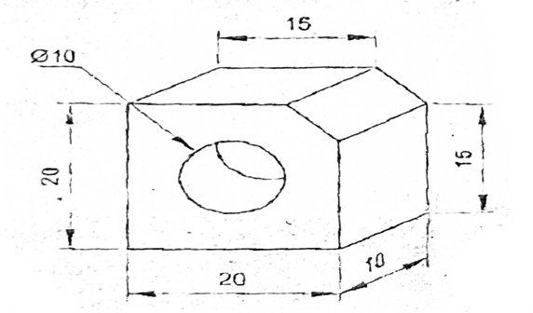

ACTIVITY 06:
- Interpret engineering drawing.
- Identify requirements of the material(s) for the work in accordance to the drawing
- Confirm the requirement of the materials from the supervisor for accurate estimation
- Quantify materials as per drawing
- Use appropriate methods for the calculation of cost of materials and accessories keeping in view the current market prices
- Present the cost estimates to the client or supervisor for approval
- Make necessary adjustments in estimates, where required
ACTIVITY 07:
- Calculate man-hours and machine-hours for work in accordance with the job requirements
- Prepare labour cost for the work using appropriate procedures

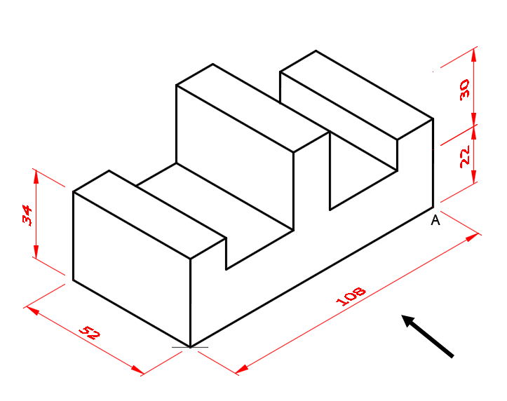
ACTIVITY 08:
- Perform measurement of pipe according to the drawing/ job specification
- Mark the job piece according to the drawing/ job specification
- Select appropriate tools/ equipment according to the given material
- Cut the pipe as per job requirement and according to safety rules
- Remove burr.
- Select appropriate tools/ equipment to thread the given pipe.
- Perform threading of pipes using pipe threading die as per standard
- Make thread joint
- Make flanged joint
- Perform grooved joint
- Prepare braze joint
- Identify tools for pipe bending
- Select appropriate tools/ equipment to bend the given pipe.
- Bend pipes according to the given job
ACTIVITY 09:
- Switch on the machine
- Check oil levels
- Run machine warm-up cycle
- Select appropriate tool & clamping device according to the job requirement.
- Manage the measuring instruments as per job requirement.
ACTIVITY 10:
- Select safe procedures and tools to accomplish the work.
- Clamp the material of work-piece and tool into its holding devices as per standard practice.
- Maintain safe distance between surface of work-piece and tooltip as per prescribed method.
- Adjust the ram placement and stroke length according to the length of job.
- Adjust the parameters of shaping (speed and feed) from control unit as per prescribed method.
ACTIVITY 11:
- Select safe procedures and tools to accomplish the work.
- Perform the shaping operation at top surface of work piece to get flatness as per initial requirements
- Re-clamp the work-piece by rotating to next surface as per prescribed method
- Shape entire work-piece by following the above stated method for next surfaces to get square shaped work piece according to drawing
- Check quality of the component at suitable intervals.
- Shut down the machine at safe position after finishing the work.
ACTIVITY 12:
- Select safe procedures and tools to accomplish the work.
- Mark work-piece according to the drawing
- Ensure proper clamping of the work-piece and the tool according to standard practice
- Set and align the sliding degree of head according to required angle
- Start the angular shaping operation to get required angle as per marked lines of layout.
- Shape entire work-piece to get angle and sizes of work-piece according to the drawing
- Check quality of the component at suitable intervals.
- Shut down the machine at safe position after finishing the work.
ACTIVITY 13:
- Produce square shape component according to the given drawing.

ACTIVITY 14:
- Select safe procedures and tools to accomplish the work.
- Select appropriate tool & clamping device according to the job requirement.
- Set machine parameters according to the job requirement
- Arrange cutting fluid as per job requirement.
- Clamp the tool properly in tool holding device.
- Clamping and aligning the work piece as per SOPs
- Ensure final clamping of work piece & set work piece in required position using job clamping devices.
- Start squaring operation by initial touching and adjust the depth of cut as per SOPs.
- Carry out squaring operation on all six faces of job as per drawing.
- Start step milling operation by initial touching and adjust the depth of cut as per SOPs.
- Carry out step milling operation as per standard drawing.
- Start slot cutting operation by initial touching and adjust the depth of cut as per SOPs.
- Carry out slot cutting operation as per standard drawing.
- Check quality of the component at suitable intervals.
- Shut down the machine at safe position after finishing the work.

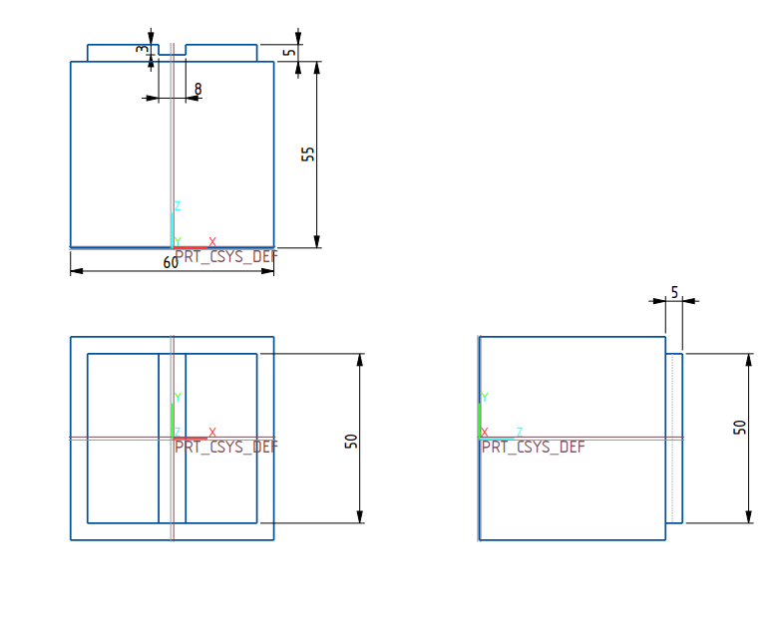
ACTIVITY 15:
- Mount the grinding wheel as per standard procedure
ACTIVITY 16:
- Dress the grinding wheel as per standard procedure
- Shut down the machine after completion the task.

ACTIVITY 17:
- Arranged the measuring instruments as per job requirement.
- Switch on the machine and check coolant levels
- Run machine warm-up cycle
- Clamp the work piece as per standard procedure
- Set travel length of machine table as per work piece
- Check the grinding machine safety covers before starting the process
- Maintain safe distance between work piece & grinding wheel
- Apply coolant on grinding surface
- Perform grinding as per standard procedure.
- Clean & deburr the work piece
- Verify dimensional and geometrical accuracy at suitable intervals.
- Shut down the machine in safe position after finishing the work.

ACTIVITY 18:
- Select the proper location for the installation.
- Follow the manufacturer’s instruction and safety guidelines for the specific drill machine.
- Clear the work area from obstructions and ensure the access to the selected area.
- Ensure the feasibility of the site for transportation, Power supply and any other environmental consideration.
- Unpack the machine and inspect all the components for any kind of damage.
- Verify all the necessary parts are available.
- Select the proper tool to assemble/install the machine.
- Install the base on the surface and align it properly
- Ensure the base is level and stable.
- Install the column on the base as per manufacturer’s instruction
- Ensure the column is securely fastened and aligned vertically.
- Install the head assembly as per manufacturer’s instruction and ensure it is aligned properly.
- Install the table and secure it with provided fasteners.
- Ensure the table is leveled.
- Install the accessories such as chuck, vice and depth stop as per manufacturer’s instructions.
- Verify all the components and connections.
- Adjust the machine as per operation manual.
- Turn on the machine and verify the smooth operation without any noise or vibration.
- Check all the control and features are functional.
- Perform a test drill to ensure the proper alignment of all parts.
- Switch off the machine.
- Clean the installation area from any packing.
- Secure the tools as per given SOPs.

