Assessment Evidence Guide
For
Architectural Drafting
Level-2
Formative Assessment
0732BCE1802- Demonstrate Basic Numeracy Skills
Date 4th -9th Nov, 2024
Lahore


National Vocational & Technical
Training Commission

Instruction Sheet for the Candidate
Qualification | National Vocation Certificate Level -2 in Architectural Drafting
Competency Standard | 0732BCE1802- Demonstrate Basic Numeracy Skills
Purpose of Assessment | Formative Assessment
Candidate Details | Name______________________________________________________  Registration/Roll Number_______________________________________
Guidance for Candidate | To meet this standard, you are required to complete the following within 04 Hrs. time frame (for practical demonstration & assessment):  - Apply Basic Numeracy Skills  - Perform Measurement  - Calculate Area and Volume  Activity-1:  Calculate the total, covered open areas and FAR of the given house plan. (annexure-1 is attached)  Activity-2:  Calculate the perimeter of the given Sketch (annexure -2 is attached)
Time: 4 Hrs. | During a practical assessment, under observation by an assessor, you are required to
Minimum Evidence Required | Activity-1:  - Perform Addition  - Perform Subtraction  - Perform Multiplication  - Perform Division  - Calculate percentage  - Select measuring tools as per requirement  - Identify imperial and metric system  - Perform inter conversion of Measuring Units  Activity-2:  - Calculate parameters

Self-Assessment Checklist
Candidate Name
Registration No.
Qualification | National Vocation Certificate Level -2 in Architectural Drafting
Competency Standard | 0732BCE1802-Demonstrate Basic Numeracy Skills
Purpose of Assessment | Formative Assessment
Assessment Task | - Apply Basic Numeracy Skills  - Perform Measurement  - Calculate Area and Volume  Activity-1:  - Calculate the total, covered, open areas and FAR of the given house plan. (annexure-1 is attached)  Activity-2:  - Calculate perimeter of given Sketch (annexure -2 is attached)
I can……………….
Performance Criteria | Yes | No
Activity-1:
- Perform Addition
- Perform Subtraction
- Perform Multiplication
- Perform Division
- Calculate percentage
- Select measuring tools as per requirement
- Identify imperial and metric system
- Perform inter conversion of Measuring Units
Activity-2:
- Calculate parameters
Candidate’s Signature__________________ Assessor’s Signature____________________

Date: _______________________________

Assessors Judgment Guide
Qualification | National Vocation Certificate Level -2 in Architectural Drafting
Competency Standard | 0732BCE1802- Demonstrate Basic Numeracy Skills
Purpose of Assessment | Formative Assessment
Candidate Details | Name: _____________________________________________________________  Registration/Roll Number: ______________________  Signature: _______________
Assessment Outcome | COMPETENT NOT YET COMPETENT  Name of the Assessor________________________________________________  Assessor’s code: ____________________________________________________  Signature: ________________________________

Assessment Summary (to be filled by the assessor)
Activity | Method |  |  |  |  | Result
Nature of Activity | Written | Oral | Observation | Portfolio | Role Play | Competent | Not Yet Competent
Practical Skill Demonstration
Knowledge Assessment
Other Requirement

Observation Checklist
Assessment Task |  | - Maintain Occupational Safety and Health at Workplace  - Use Personal Protective and Safety Equipment (PPEs)  Activity-1:  Calculate the total, covered open areas and FAR of the given house plan. (annexure-1 is attached)  Activity-2:  Calculate perimeter of given Sketch (annexure -2 is attached)
During the practical assessment, candidate demonstrated the following: |  |  |  | Yes | No | Remarks
 | Activity-1:
 | Perform Addition
 | Perform Subtraction
 | Perform Multiplication
 | Perform Division
 | Calculate percentage
 | Select measuring tools as per requirement
 | Identify imperial and metric system
 | Perform inter conversion of Measuring Units
 | Activity-2:
 | Calculate parameters
Competent |  |  | Not Yet Competent

Knowledge Assessment
Qualification | National Vocation Certificate Level -2 in Architectural Drafting
Competency Standard | 0732BCE1802-Demonstrate Basic Numeracy Skills
Purpose of Assessment | Formative Assessment
Candidate Details | Name: ______________________________________________________________  Registration/Roll Number: _________________  Candidate Signature: ___________
Assessment Outcome | COMPETENT NOT YET COMPETENT  Name of the Assessor: ________________________________________________  Assessor’s code: ____________________________________________________  Signature of the Assessor: _______________________

Candidate’s response is not required to be identical, but similar concepts and/or keywords must be used. Oral questioning may be used to clarify candidate understanding of topic and its application.

Questions (Candidate confidently answered questions correctly and demonstrated understanding of the topics and their application) |  | Satisfactory | Not Satisfactory
Subtraction the given figures
310.3456 – 0.756
 | What is the volume of a cone with a radius of 4 cm and a height of 9 cm?
 | Write down the formulas of area of geometrical figures such as Square, Rectangle, Triangle, Circle etc.
 | What is the average of the numbers 4, 8, 15, 16, and 23?

Feedback to the Candidate
Candidate’s Signature__________________ Assessor’s Signature _________________

ANNEXURE -1

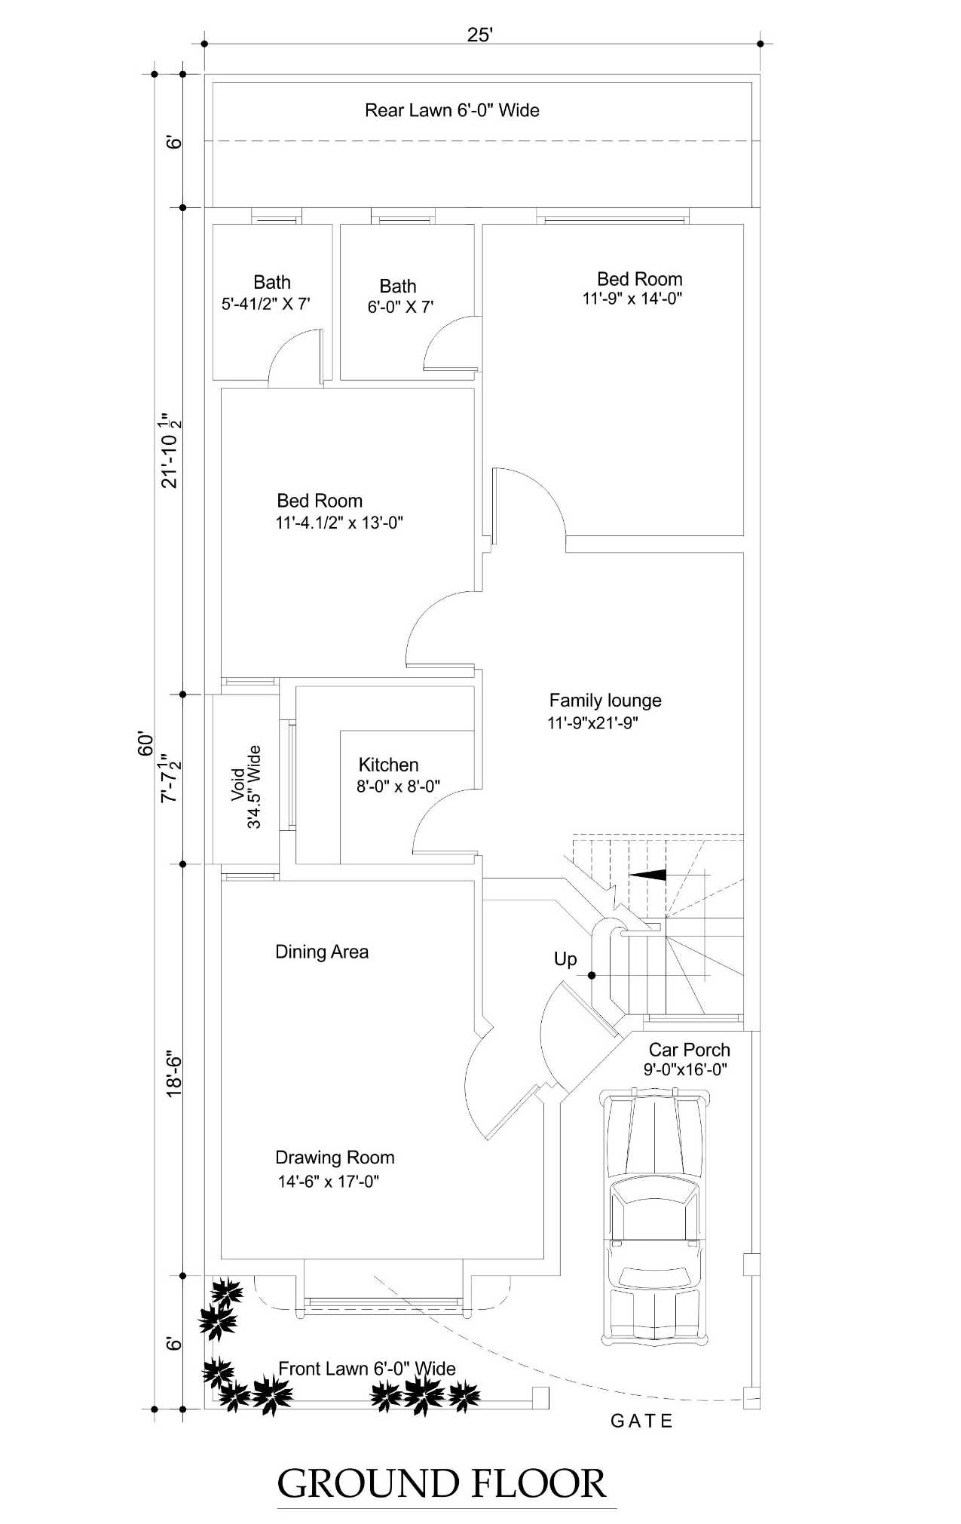

ANNEXURE -2

