Assessment Evidence Guide
For
Architectural Drafting
Level-2
Formative Assessment
0732BCE1803-Perform Basic Architectural Drawings

Date 4th -9th April, 2024
Lahore


National Vocational & Technical
Training Commission

Instruction Sheet for the Candidate
Qualification | National Vocation Certificate Level -2 in Architectural Drafting
Competency Standard | 0732BCE1803-Perform Basic Architectural Drawings
Purpose of Assessment | Formative Assessment
Candidate Details | Name______________________________________________________  Registration/Roll Number_______________________________________
Guidance for Candidate | To meet this standard, you are required to complete the following within 04 Hrs. time frame (for practical demonstration & assessment):  - Perform Freehand Sketching  - Draw Geometrical Sketches  - Draw Objects on Different Scales  - Draw Lettering  - Draw Technical Drawings  Activity-1: Draw given plan on scale ¼” =1’-0” (Annexure-1 attached)  or  Activity-2: Develop front elevation and section from given plan (Annexure-2 attached)
Time: 4 Hrs. | During a practical assessment, under observation by an assessor, you are required to
Minimum Evidence Required | Activity:  - Arrange drawing tools  - Perform drawing on both sides of paper  - Recycle drawing papers  - Draw different lettering styles  - Draw Types of Doors.  - Draw Types of Windows.  - Draw Types and parts of Stairs case.  - Draw plans, elevation and section

Self-Assessment Checklist
Candidate Name
Registration No.
Qualification | National Vocation Certificate Level -2 in Architectural Drafting
Competency Standard | 0732BCE1803-Perform Basic Architectural Drawings
Purpose of Assessment | Formative Assessment
Assessment Task | - Perform Freehand Sketching  - Draw Geometrical Sketches  - Draw Objects on Different Scales  - Draw Lettering  - Draw Technical Drawings  Activity-1: Draw given plan on scale ¼” =1’-0” (Annexure-1 attached)  or  Activity-2: Develop front elevation and section from given plan (Annexure-2 attached)
I can……………….
Performance Criteria | Yes | No
- Arrange drawing tools
- Perform drawing on both sides of paper
- Recycle drawing papers
- Draw different lettering styles
- Draw Types of Doors.
- Draw Types of Windows.
- Draw Types and parts of Stairs case.
- Draw plans, elevation and section
Candidate’s Signature__________________ Assessor’s Signature____________________

Date: _______________________________

Assessors Judgment Guide
Qualification | National Vocation Certificate Level -2 in Architectural Drafting
Competency Standard | 0732BCE1803- Perform Basic Architectural Drawings
Purpose of Assessment | Formative Assessment
Candidate Details | Name: ______________________________________________________________  Registration/Roll Number: ______________________  Signature: _______________
Assessment Outcome | COMPETENT NOT YET COMPETENT  Name of the Assessor________________________________________________  Assessor’s code: ____________________________________________________  Signature: ________________________________

Assessment Summary (to be filled by the assessor)
Activity | Method |  |  |  |  | Result
Nature of Activity | Written | Oral | Observation | Portfolio | Role Play | Competent | Not Yet Competent
Practical Skill Demonstration
Knowledge Assessment
Other Requirement

Observation Checklist
Assessment Task |  | - Perform Freehand Sketching  - Draw Geometrical Sketches  - Draw Objects on Different Scales  - Draw Lettering  - Draw Technical Drawings  Activity-1: Draw given plan on scale ¼” =1’-0” (Annexure-1 attached)  or  Activity-2: Develop front elevation and section from given plan (Annexure-2 attached)
During the practical assessment, candidate demonstrated the following: |  |  |  | Yes | No | Remarks
 | Arrange drawing tools
 | Perform drawing on both sides of paper
 | Recycle drawing papers
 | Draw different lettering styles
 | Draw Types of Doors.
 | Draw Types of Windows.
 | Draw Types and parts of Stairs case.
 | Draw plans, elevation and section
Competent |  |  | Not Yet Competent

Knowledge Assessment
Qualification | National Vocation Certificate Level -2 in Architectural Drafting
Competency Standard | 0732BCE1803- Perform Basic Architectural Drawings
Purpose of Assessment | Formative Assessment
Candidate Details | Name: ______________________________________________________________  Registration/Roll Number: _________________  Candidate Signature: ___________
Assessment Outcome | COMPETENT NOT YET COMPETENT  Name of the Assessor: ________________________________________________  Assessor’s code: __________________  Signature of the Assessor: _______________________
Candidate’s response is not required to be identical, but similar concepts and/or keywords must be used. Oral questioning may be used to clarify candidate understanding of topic and its application.
Questions (Candidate confidently answered questions correctly and demonstrated understanding of the topics and their application) |  | Satisfactory | Not Satisfactory
 | What are common scales used in drawings?
 | What are the main views used in an orthographic projection?
 | What are the main types of doors based on their operation?
 | Enlist any four types of windows used in buildings?
 | Enlist any four types of staircases based on design?
 | Differentiate tread and riser?

Feedback to the Candidate
Candidate’s Signature__________________ Assessor’s Signature _________________

Annurex-1
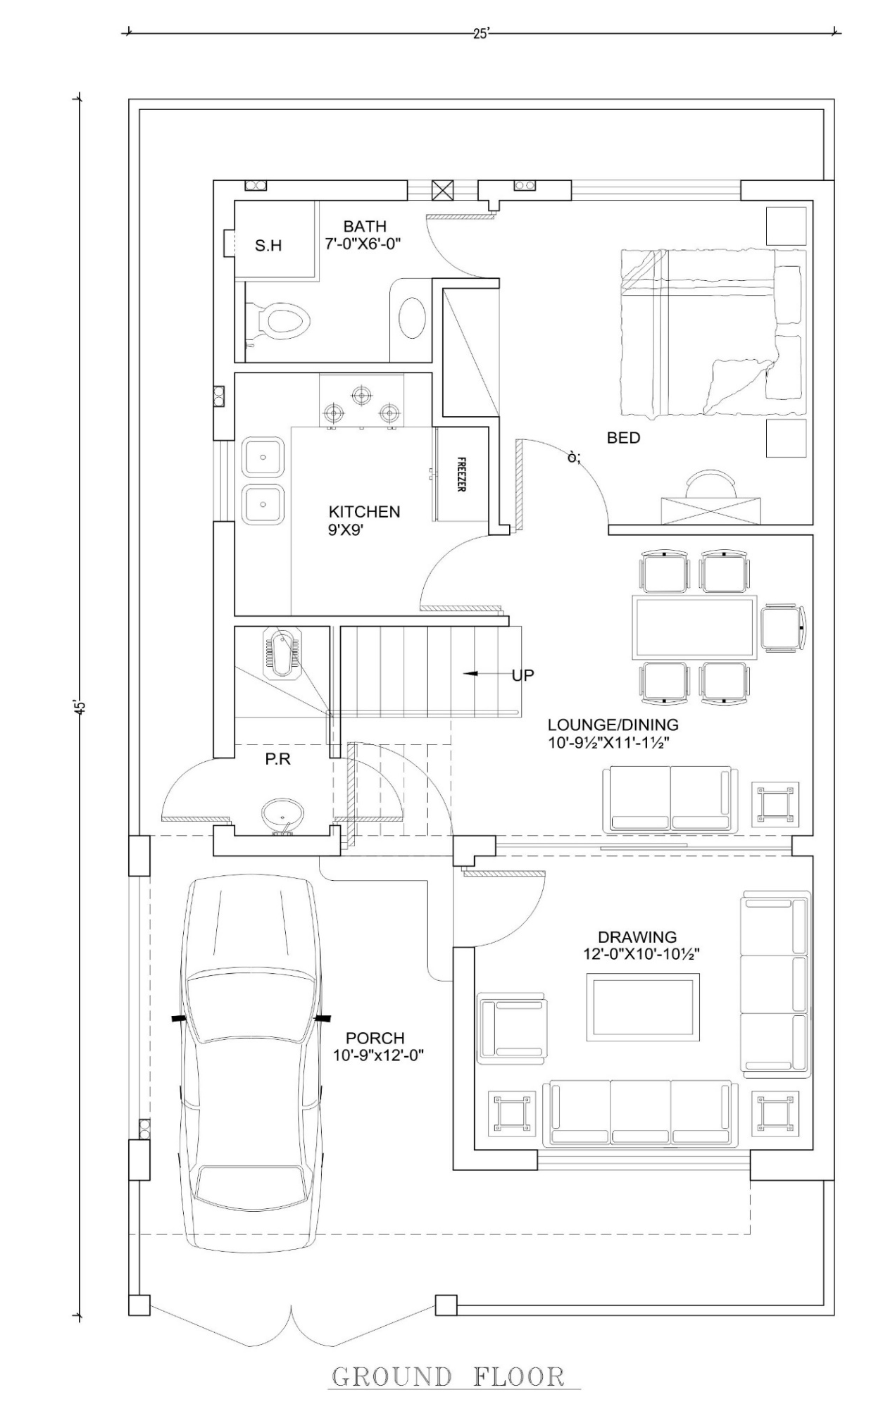

Annurex-2
