Assessment Evidence Guide
For
Architectural Drafting
Level -3

Formative Assessment
0732BCE1901-Perform Advance Architectural Drawings
Date 4th -9th Nov, 2024
Lahore


National Vocational & Technical
Training Commission

Instruction Sheet for the Candidate
Qualification | National Vocation Certificate Level -3 in Architectural Drafting
Competency Standard | 0732BCE1901-Perform Advance Architectural Drawings
Purpose of Assessment | Formative Assessment
Candidate Details | Name______________________________________________________  Registration/Roll Number_______________________________________
Guidance for Candidate | To meet this standard, you are required to complete the following within 04 Hrs. time frame (for practical demonstration & assessment):  - Draw Space Planning/ Spatial Planning  - Draw set of Working Drawing  Activity 1: Develop working plan from given house plan as shown in figure 1.  OR  Activity 2: Develop excavation plan from given house plan as shown in figure 1.  OR  Activity 3: Develop working section from given plan as shown in figure 1
Time: 4 Hrs. | During a practical assessment, under observation by an assessor, you are required to
Minimum Evidence Required | - Design a Bathroom  - Design a Kitchen/Dinning  - Design a Bedroom  - Design a lounge  - Design a Drawing Room  - Draw Working Plan Set  - Draw Working Elevation & Section

Self-Assessment Checklist
Candidate Name
Registration No.
Qualification | National Vocation Certificate Level -3 in Architectural Drafting
Competency Standard | 0732BCE1901-Perform Advance Architectural Drawings
Purpose of Assessment | Formative Assessment
Assessment Task | - Draw Space Planning/ Spatial Planning  - Draw set of Working Drawing  Activity 1: Develop working plan from given house plan as shown in figure 1.  OR  Activity 2: Develop excavation plan from given house plan as shown in figure 1.  OR  Activity 3: Develop working section from the given plan as shown in figure 1
I can………………
Performance Criteria | Yes | No
- Design a Bathroom
- Design a Kitchen/Dinning
- Design a Bedroom
- Design a lounge
- Design a Drawing Room
- Draw Working Plan Set
- Drawing Foundation Details
- Draw Working Elevation and Section
Candidate’s Signature__________________ Assessor’s Signature____________________

Date: _______________________________

Assessors Judgment Guide
Qualification | National Vocation Certificate Level -3 in Architectural Drafting
Competency Standard | 0732BCE1901-Perform Advance Architectural Drawings
Purpose of Assessment | Formative Assessment
Candidate Details | Name: _____________________________________________________  Registration/Roll Number: _______________ Signature: _______________
Assessment Outcome | COMPETENT NOT YET COMPETENT  Name of the Assessor________________________________________________  Assessor’s code: ____________________________________________________  Signature: ________________________________

Assessment Summary (to be filled by the assessor)
Activity | Method |  |  |  |  | Result
Nature of Activity | Written | Oral | Observation | Portfolio | Role Play | Competent | Not Yet Competent
Practical Skill Demonstration
Knowledge Assessment
Other Requirement

Observation Checklist
Assessment Task |  | - Draw Space Planning/ Spatial Planning  - Draw set of Working Drawing  Activity 1: Develop working plan from given house plan as shown in figure 1.  OR  Activity 2: Develop excavation plan from given house plan as shown in figure 1.  OR  Activity 3: Develop working section from the given plan as shown in figure 1
During the practical assessment, candidate demonstrated the following: |  |  |  | Yes | No | Remarks
 | Design a Bathroom
 | Design a Kitchen/Dinning
 | Design a Bedroom
 | Design a lounge
 | Design a Drawing Room
 | Draw Working Plan Set
 | Drawing Foundation Details
 | Draw Working Section
Competent |  |  | Not Yet Competent

Knowledge Assessment
Qualification | National Vocation Certificate Level -3 in Architectural Drafting
Competency Standard | 0732BCE1901-Perform Advance Architectural Drawings
Purpose of Assessment | Formative Assessment
Candidate Details | Name: _________________________________________________________  Registration/Roll Number: ___________ Candidate Signature: ___________
Assessment Outcome | COMPETENT NOT YET COMPETENT  Name of the Assessor: ________________________________________________  Assessor’s code: ____________________________________________________  Signature of the Assessor: _______________________

Candidate’s response is not required to be identical, but similar concepts and/or keywords must be used. Oral questioning may be used to clarify candidate understanding of topic and its application.

Questions (Candidate confidently answered questions correctly and demonstrated understanding of the topics and their application) |  | Satisfactory | Not Satisfactory
 | Define space planning
 | What are the key elements of space planning?
 | What are working drawings?
 | What is the purpose of working drawings?
 | What are the main components of set of working drawings?

Feedback to the Candidate
Candidate’s Signature__________________ Assessor’s Signature _________________

ANNEXURE

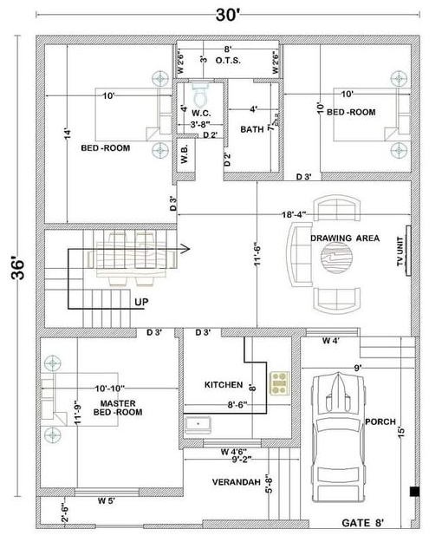
FIGURE 1

