Assessment Evidence Guide
For
Architectural Drafting
Level-3
Formative Assessment
0732BCE1903-Develop 3D in AutoCAD
Date 4th -9th Nov, 2024
Lahore


National Vocational & Technical
Training Commission

Instruction Sheet for the Candidate
Qualification | National Vocation Certificate Level -3 in Architectural Drafting
Competency Standard | 0732BCE1903-Develop 3D in AutoCAD
Purpose of Assessment | Formative Assessment
Candidate Details | Name______________________________________________________  Registration/Roll Number_______________________________________
Guidance for Candidate | To meet this standard, you are required to complete the following within 04 Hrs. time frame (for practical demonstration & assessment):  - Draw Basic 3D Surfaces  - Develop 3D model  - Comprehend complex 3D surfaces  - Render 3D Model
Time: 4 Hrs. | During a practical assessment, under observation by an assessor, you are required to
Minimum Evidence Required | - Locate Mesh tab from 3D Modelling dropdown option of solids panel  - Create 3D models  - Create opening (Door, windows & ventilated in 3D model as per requirements.  - Customize 3D object as per requirement  - Create 3D solid or surface in the space between several cross sections  - Edit the existing surfaces  - Assign material to required 3D Model as per given specification  - Install lights to get requisite scene of required 3D model  - Assign cameras to execute different views of required 3D Model.  - Create portfolio in pdf format (soft form)

Self-Assessment Checklist
Candidate Name
Registration No.
Qualification | National Vocation Certificate Level -3 in Architectural Drafting
Competency Standard | 0732BCE1903-Develop 3D in AutoCAD
Purpose of Assessment | Formative Assessment
Assessment Task | - Draw Basic 3D Surfaces  - Develop 3D model  - Comprehend complex 3D surfaces  - Render 3D Model  Activity 1: Develop an exterior 3D view from the given plan and render it  or  Activity 2: Develop 3D view of given Kitchen and render it
I can……………….
Performance Criteria | Yes | No
- Locate Mesh tab from 3D Modelling dropdown option of solids panel
- Create 3D models
- Create opening (Door, windows & ventilated in 3D model as per requirements.
- Customize 3D object as per requirement
- Create 3D solid or surface in the space between several cross sections
- Edit the existing surfaces
- Assign material to required 3D Model as per given specification
- Install lights to get requisite scene of required 3D model
- Assign cameras to execute different views of required 3D Model.
- Create portfolio in pdf format (soft form)
Candidate’s Signature__________________ Assessor’s Signature____________________

Date: _______________________________

Assessors Judgment Guide
Qualification | National Vocation Certificate Level -3 in Architectural Drafting
Competency Standard | 0732BCE1903-Develop 3D in AutoCAD
Purpose of Assessment | Formative Assessment
Candidate Details | Name: _______________________________________________________  Registration/Roll Number: _____________________ Signature: _________
Assessment Outcome | COMPETENT NOT YET COMPETENT  Name of the Assessor________________________________________________  Assessor’s code: ____________________________________________________  Signature: ________________________________

Assessment Summary (to be filled by the assessor)
Activity | Method |  |  |  |  | Result
Nature of Activity | Written | Oral | Observation | Portfolio | Role Play | Competent | Not Yet Competent
Practical Skill Demonstration
Knowledge Assessment
Other Requirement

Observation Checklist
Assessment Task |  | Activity 1: Develop an exterior 3D view from the given plan and render it  or  Activity 2: Develop 3D view of given Kitchen and render it
During the practical assessment, candidate demonstrated the following: |  |  |  | Yes | No | Remarks
 | Locate Mesh tab from 3D Modelling dropdown option of solids panel
 | Create 3D models
 | Create opening (Door, windows & ventilated in 3D model as per requirements.
 | Customize 3D object as per requirement
 | Create 3D solid or surface in the space between several cross sections
 | Edit the existing surfaces
 | Assign material to required 3D Model as per given specification
 | Install lights to get requisite scene of required 3D model
 | Assign cameras to execute different views of required 3D Model.
 | Render and print the 3D images according to required size & orientation
 | Create portfolio in pdf format (soft form)
Competent |  |  | Not Yet Competent

Knowledge Assessment
Qualification | National Vocation Certificate Level -3 in Architectural Drafting
Competency Standard | 0732BCE1903-Develop 3D in AutoCAD
Purpose of Assessment | Formative Assessment
Candidate Details | Name: ______________________________________________________________  Registration/Roll Number: _________________ Candidate Signature: ___________
Assessment Outcome | COMPETENT NOT YET COMPETENT  Name of the Assessor: ________________________________________________  Assessor’s code: ____________________________________________________  Signature of the Assessor: _______________________

Candidate’s response is not required to be identical, but similar concepts and/or keywords must be used. Oral questioning may be used to clarify candidate understanding of topic and its application.

Questions (Candidate confidently answered questions correctly and demonstrated understanding of the topics and their application) |  | Satisfactory | Not Satisfactory
 | How a 3D surface typically represented in computer graphics?
 | What is 3D modeling?
 | What does mesh mean in 3D modeling?
 | Where is complex 3D surface commonly used?
 | What software is best for creating complex 3D surface?

Feedback to the Candidate
Candidate’s Signature__________________ Assessor’s Signature _________________

ANNEXURE

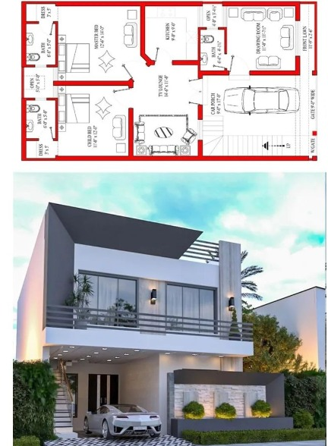

Figure 1 3D House for modelling

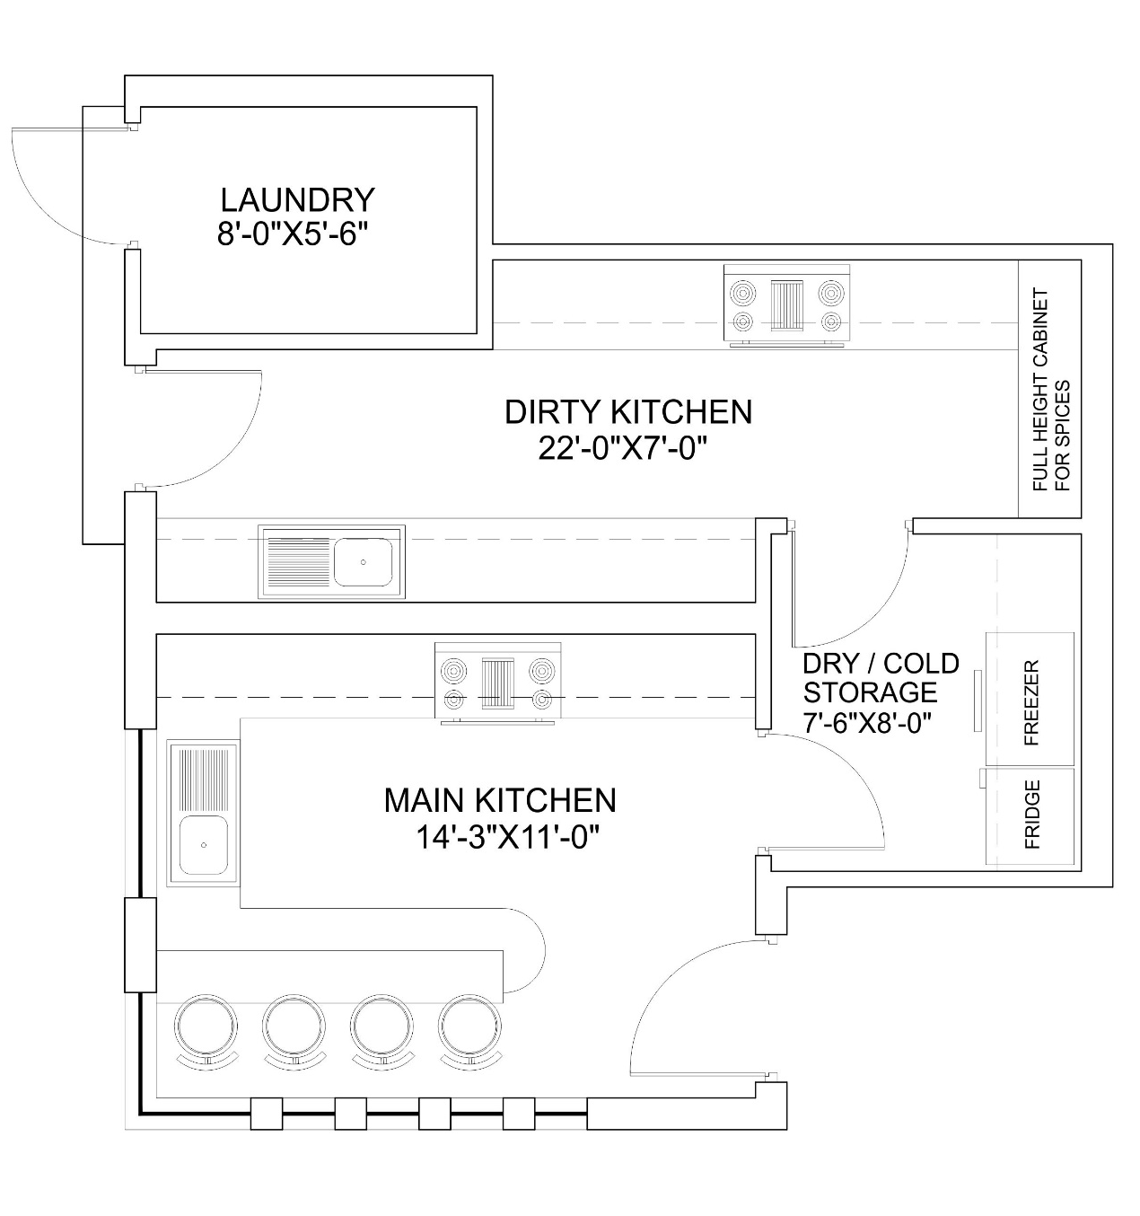

Figure 2 3D Kitchen for Interior modelling & Rending

