Assessment Evidence Guide
For
Architectural Drafting
Level-3
Formative Assessment
0732BCE1902-Perform Architectural Graphics
Date 4th -9th Nov, 2024
Lahore


National Vocational & Technical
Training Commission

Instruction Sheet for the Candidate
Qualification | National Vocation Certificate Level -3 in Architectural Drafting
Competency Standard | 0732BCE1902-Perform Architectural Graphics
Purpose of Assessment | Formative Assessment
Candidate Details | Name______________________________________________________  Registration/Roll Number_______________________________________
Guidance for Candidate | To meet this standard, you are required to complete the following within 04 Hrs. time frame (for practical demonstration & assessment):  - Perform Toning and Shading  - Perform Manual Rendering  Activity 1: Draw basic design elements as shown in figure 1 includes various lines, shapes, textures, and shades etc.  Or  Activity 2: Render the design as shown in figure 2 using different color techniques (pencil color or water color)
Time: 4 Hrs. | During a practical assessment, under observation by an assessor, you are required to
Minimum Evidence Required | Activity 1  1. Draw different shapes  2. Practice of Sociography with shades and shadows  Activity 2  3. Render different shapes with tints and shades  4. Render design with different color schemes  5. Render design with pencil color technique  6. Render design with poster color technique  7. Render design with graphite pencil technique  8. Render design using waste materials (paper, bottle caps, nut shells etc.)

Self-Assessment Checklist
Candidate Name
Registration No.
Qualification | National Vocation Certificate Level -3 in Architectural Drafting
Competency Standard | 0732BCE1902-Perform Architectural Graphics
Purpose of Assessment | Formative Assessment
Assessment Task | - Perform Toning and Shading  - Perform Manual Rendering  Activity 1: Draw basic design elements as shown in figure 1 includes various lines, shapes, textures, and shades etc.  Or  Activity 2: Render the design as shown in figure 2 using different color techniques (pencil color or water color)
I can……………….
Performance Criteria | Yes | No
Activity 1
- Draw different shapes
- Practice of Sociography with shades and shadows
Activity 2
- Render different shapes with tints and shades
- Render design with different color schemes
- Render design with pencil color technique
- Render design with poster color technique
- Render design with graphite pencil technique
- Render design using waste materials (paper, bottle caps, nut shells etc.)
Candidate’s Signature__________________ Assessor’s Signature____________________

Date: _______________________________

Assessors Judgment Guide
Qualification | National Vocation Certificate Level -3 in Architectural Drafting
Competency Standard | 0732BCE1902-Perform Architectural Graphics
Purpose of Assessment | Formative Assessment
Candidate Details | Name: ______________________________________________________________  Registration/Roll Number: ______________________ Signature: _______________
Assessment Outcome | COMPETENT NOT YET COMPETENT  Name of the Assessor________________________________________________  Assessor’s code: ____________________________________________________  Signature: ________________________________

Assessment Summary (to be filled by the assessor)
Activity | Method |  |  |  |  | Result
Nature of Activity | Written | Oral | Observation | Portfolio | Role Play | Competent | Not Yet Competent
Practical Skill Demonstration
Knowledge Assessment
Other Requirement

Observation Checklist
Assessment Task |  | - Perform Toning and Shading  - Perform Manual Rendering  Activity 1: Draw basic design elements as shown in figure 1 includes various lines, shapes, textures, and shades etc.  Or  Activity 2: Render the design as shown in figure 2 using different color techniques (pencil color or water color)
During the practical assessment, candidate demonstrated the following: |  |  |  | Yes | No | Remarks
Activity 1
 | Draw different shapes
 | Practice of Sociography with shades and shadows
 | Render different shapes with tints and shades
Activity 2
 | Render design with different color schemes
 | Render design with pencil color technique
 | Render design with water color technique
 | Render design with graphite pencil technique
 | Render design using waste materials (paper, bottle caps, nut shells etc.)
Competent |  |  | Not Yet Competent

Knowledge Assessment
Qualification | National Vocation Certificate Level -3 in Architectural Drafting
Competency Standard | 0732BCE1902-Perform Architectural Graphics
Purpose of Assessment | Formative Assessment
Candidate Details | Name: ______________________________________________________________  Registration/Roll Number: _________________ Candidate Signature: ___________
Assessment Outcome | COMPETENT NOT YET COMPETENT  Name of the Assessor: ________________________________________________  Assessor’s code: ____________________________________________________  Signature of the Assessor: _______________________
Candidate’s response is not required to be identical, but similar concepts and/or keywords must be used. Oral questioning may be used to clarify candidate understanding of topic and its application.
Questions (Candidate confidently answered questions correctly and demonstrated understanding of the topics and their application) |  | Satisfactory | Not Satisfactory
 | What is toning in art?
 | What is shading?
 | What tools can be used for shading?
 | What are the common techniques for shading?
 | What are some key techniques used in manual rendering?
 | What materials are commonly used for manual rendering?

Feedback to the Candidate
Candidate’s Signature__________________ Assessor’s Signature _________________

ANNEXURE-1
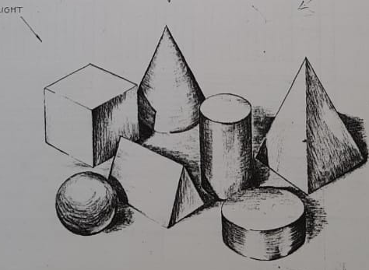

Figure 1 Geometric shapes with pencil shading

ANNEXURE-2
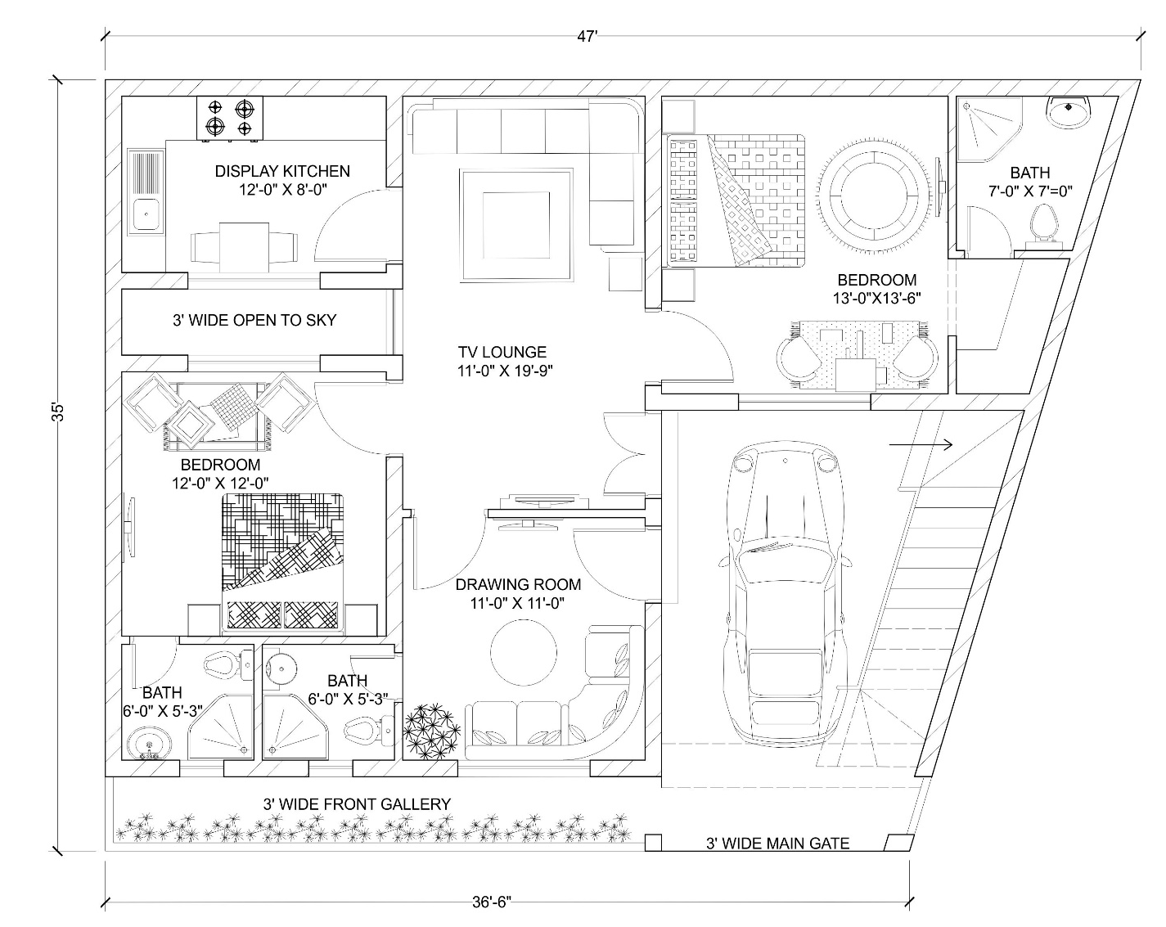
Figure 2 Plan for Manual rendering

