Assessment Evidence Guide
For
Architectural Drafting
Level-4
Formative Assessment
0732BCE2001-Perform Advance Architectural Graphics
Date 4th-9th Nov, 2024
Lahore


National Vocational & Technical
Training Commission

Instruction Sheet for the Candidate
Qualification | National Vocation Certificate Level -4 in Architectural Drafting
Competency Standard | 0732BCE2001-Perform Advance Architectural Graphics
Purpose of Assessment | Formative Assessment
Candidate Details | Name______________________________________________________  Registration/Roll Number_______________________________________
Guidance for Candidate | To meet this standard, you are required to complete the following within 04 Hrs. time frame (for practical demonstration & assessment):  - Draw Perspectives  - Perform Advance Manual Rendering  - Prepare Basic Model
Time: 4 Hrs. | During a practical assessment, under observation by an assessor, you are required to
Minimum Evidence Required | - Arrange tools and material  - Draw Three-point perspective  - Draw Two-point perspective  - Use both sides of drawing sheets for drawing  - Render design with types of Colouring material

Self-Assessment Checklist
Candidate Name
Registration No.
Qualification | National Vocation Certificate Level -4 in Architectural Drafting
Competency Standard | 0732BCE2001-Perform Advance Architectural Graphics
Purpose of Assessment | Formative Assessment
Assessment Task | - Draw Perspectives  - Perform Advance Manual Rendering  - Prepare Basic Model  Activity 1: Draw and render three-point perspective of given building’s exterior as shown in figure 1 with color pencils/watercolor/ink pen/ballpoint techniques.  Activity 2: Draw and render two-point perspective of given interior’s view as shown in figure 2 with color pencils/watercolor/ink pen/ballpoint techniques.
I can……………….
Performance Criteria | Yes | No
- Arrange tools and material
- Draw Three-point perspective
- Draw Two-point perspective
- Use both sides of drawing sheets for drawing
- Render design with types of Colouring material
Candidate’s Signature__________________ Assessor’s Signature____________________

Date: _______________________________

Assessors Judgment Guide
Qualification | National Vocation Certificate Level -4 in Architectural Drafting
Competency Standard | 0732BCE2001-Perform Advance Architectural Graphics
Purpose of Assessment | Formative Assessment
Candidate Details | Name______________________________________________________  Registration/Roll Number_______________________________________
Assessment Outcome | COMPETENT NOT YET COMPETENT  Name of the Assessor________________________________________________  Assessor’s code: _________________________________________  Signature: ________________________________

Assessment Summary (to be filled by the assessor)
Activity | Method |  |  |  |  | Result
Nature of Activity | Written | Oral | Observation | Portfolio | Role Play | Competent | Not Yet Competent
Practical Skill Demonstration
Knowledge Assessment
Other Requirement

Observation Checklist
Assessment Task |  | - Draw Perspectives  - Perform Advance Manual Rendering  - Prepare Basic Model  Activity 1: Draw and render three-point perspective of given building’s exterior as shown in figure 1 with color pencils/watercolor/ink pen/ballpoint techniques.  Or  Activity 2: Draw and render two-point perspective of given interior’s view as shown in figure 2 with color pencils/watercolor/ink pen/ballpoint techniques.
During the practical assessment, candidate demonstrated the following: |  |  |  | Yes | No | Remarks
 | Arrange tools and material
 | Draw Three-point perspective
 | Draw Two-point perspective
 | Use both sides of drawing sheets for drawing
 | Render design with types of Coloring material
Competent |  |  | Not Yet Competent

Knowledge Assessment
Qualification | National Vocation Certificate Level -4 in Architectural Drafting
Competency Standard | 0732BCE2001-Perform Advance Architectural Graphics
Purpose of Assessment | Formative Assessment
Candidate Details | Name: ______________________________________________________________  Registration/Roll Number: _________________  Candidate Signature: ___________
Assessment Outcome | COMPETENT NOT YET COMPETENT  Name of the Assessor: ________________________________________________  Assessor’s code: __________________________________  Signature of the Assessor: _______________________
Candidate’s response is not required to be identical, but similar concepts and/or keywords must be used. Oral questioning may be used to clarify candidate understanding of topic and its application.
Questions (Candidate confidently answered questions correctly and demonstrated understanding of the topics and their application) |  | Satisfactory | Not Satisfactory
 | Define One-Point Perspective
 | Define two-Point Perspective
 | Define three-Point Perspective.
 | Define bird-eye Perspective.
 | Enlist the sustainable materials for model making.

Feedback to the Candidate
Candidate’s Signature__________________ Assessor’s Signature _________________

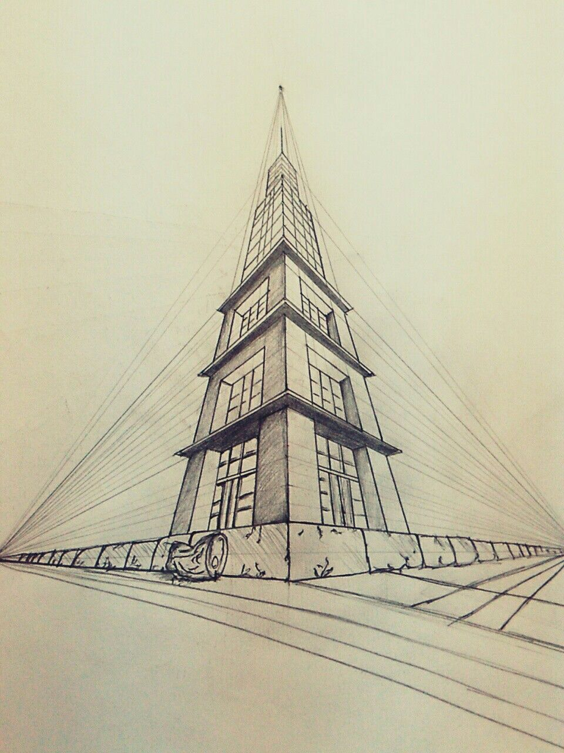
Figure 1: 3point perspective of building exterior

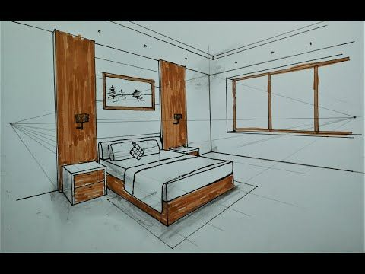
Figure 2: 2 point perspective of room interior

