Assessment Evidence Guide
For
Architectural Drafting
Level-4
Formative Assessment

0732BCE2002-Manipulate Images in Adobe Photoshop

Date 4th-9th Nov, 2024
Lahore


National Vocational & Technical
Training Commission

Instruction Sheet for the Candidate
Qualification | National Vocation Certificate Level -4 in Architectural Drafting
Competency Standard | 0732BCE2002-Manipulate Images in Adobe Photoshop
Purpose of Assessment | Formative Assessment
Candidate Details | Name______________________________________________________  Registration/Roll Number_______________________________________
Guidance for Candidate | To meet this standard, you are required to complete the following within 04 Hrs. time frame (for practical demonstration & assessment):  - Format an Image in Adobe Photoshop  - Design Layers in Moving Objects  - Design Objects  - Render Images
Time: 4 Hrs. | During a practical assessment, under observation by an assessor, you are required to
Minimum Evidence Required | Activity1:  - Open the image  - Select the required tool and apply on image  - Check the image  - Create and name the layers  - Select objects on specific layers  - Insert new layers to add additional design elements  - Merge layers to simplify the drawing  - Draw different shapes as required  - Reshape the objects  - Align the objects as required  - Transform the objects as required  - Apply paint tools on image for rendering  - Apply required filters on image  - Apply textures as per design  - Insert text on image  - Save image in required format (jpg, PNG etc.)

Self-Assessment Checklist
Candidate Name
Registration No.
Qualification | National Vocation Certificate Level -4 in Architectural Drafting
Competency Standard | 0732BCE2002-Manipulate Images in Adobe Photoshop
Purpose of Assessment | Formative Assessment
Assessment Task | - Format an Image in Adobe Photoshop  - Design Layers in Moving Objects  - Design Objects  - Render Images  Activity1:  Format given image (Annexure attached) in Adobe Photoshop, then create and organize layers. Render the final composition to enhance visual quality and cohesiveness.
I can……………….
Performance Criteria | Yes | No
- Open the image
- Select the required tool and apply on image
- Create and name the layers
- Select objects on specific layers
- Insert new layers to add additional design elements
- Merge layers to simplify the drawing
- Draw different shapes as required
- Reshape the objects
- Align the objects as required
- Transform the objects as required
- Apply paint tools on image for rendering
- Apply required filters on image
- Apply textures as per design
- Insert text on image
- Save image in required format (jpg, PNG etc.)
Candidate’s Signature__________________ Assessor’s Signature____________________

Date: _______________________________

Assessors Judgment Guide
Qualification | National Vocation Certificate Level -4 in Architectural Drafting
Competency Standard | 0732BCE2002-Manipulate Images in Adobe Photoshop
Purpose of Assessment | Formative Assessment
Candidate Details | Name______________________________________________________  Registration/Roll Number_______________________________________
Assessment Outcome | COMPETENT NOT YET COMPETENT  Name of the Assessor________________________________________________  Assessor’s code: ____________________________________________________  Signature: ________________________________

Assessment Summary (to be filled by the assessor)
Activity | Method |  |  |  |  | Result
Nature of Activity | Written | Oral | Observation | Portfolio | Role Play | Competent | Not Yet Competent
Practical Skill Demonstration
Knowledge Assessment
Other Requirement

Observation Checklist
Assessment Task |  | - Format an Image in Adobe Photoshop  - Design Layers in Moving Objects  - Design Objects  - Render Images  Activity: Format an image in Adobe Photoshop, then create and organize layers. Render the final composition to enhance visual quality and cohesiveness.
During the practical assessment, candidate demonstrated the following: |  |  |  | Yes | No | Remarks
 | Open the image
 | Select the required tool and apply on image
 | Create and name the layers
 | Select objects on specific layers
 | Insert new layers to add additional design elements
 | Merge layers to simplify the drawing
 | Draw different shapes as required
 | Reshape the objects
 | Align the objects as required
 | Transform the objects as required
 | Apply paint tools on image for rendering
 | Apply required filters on image
 | Apply textures as per design
 | Insert text on image
 | Save image in required format (jpg, PNG etc.)
Competent |  |  | Not Yet Competent

Knowledge Assessment
Qualification | National Vocation Certificate Level -4 in Architectural Drafting
Competency Standard | 0732BCE2002-Manipulate Images in Adobe Photoshop
Purpose of Assessment | Formative Assessment
Candidate Details | Name: ______________________________________________________________  Registration/Roll Number: _________________ Candidate Signature: ___________
Assessment Outcome | COMPETENT NOT YET COMPETENT  Name of the Assessor: ________________________________________________  Assessor’s code: ____________________________________________________  Signature of the Assessor: _______________________
Candidate’s response is not required to be identical, but similar concepts and/or keywords must be used. Oral questioning may be used to clarify candidate understanding of topic and its application.
Questions (Candidate confidently answered questions correctly and demonstrated understanding of the topics and their application) |  | Satisfactory | Not Satisfactory
 | What are the primary components of the Photoshop interface?
 | What is the primary use of the Pen tool in Photoshop?
 | What are the three types of Lasso tools available in Photoshop?
 | Which color spaces are commonly used in Photoshop?
 | How can hide a layer in Photoshop?
 | What are some common graphic file formats for saving images in Photoshop?

Feedback to the Candidate
Candidate’s Signature__________________ Assessor’s Signature _________________

ANNEXURE
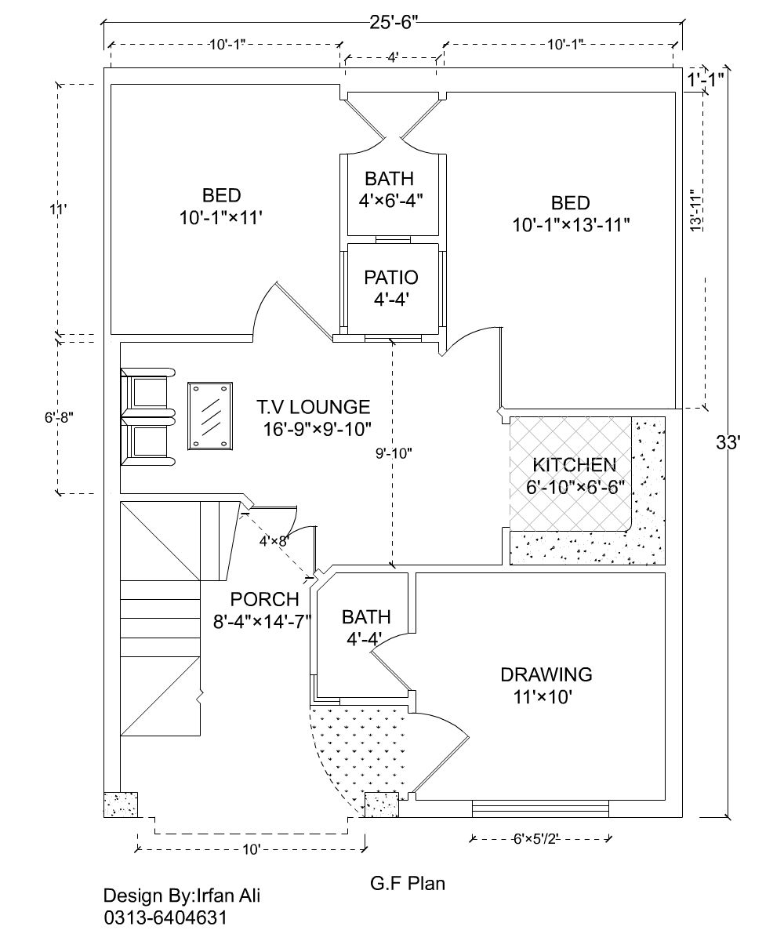
Figure 1 Plan of residential unit

