Assessment Evidence Guide
For
Architectural Drafting
Level-4
Formative Assessment
0732BCE2003-Develop 3D Model Sketch Up
Date 4th-9th Nov, 2024
Lahore


National Vocational & Technical
Training Commission

Instruction Sheet for the Candidate
Qualification | National Vocation Certificate Level -4 in Architectural Drafting
Competency Standard | 0732BCE2003-Develop 3D Model Sketch Up
Purpose of Assessment | Formative Assessment
Candidate Details | Name______________________________________________________  Registration/Roll Number_______________________________________
Guidance for Candidate | To meet this standard, you are required to complete the following within 04 Hrs. time frame (for practical demonstration & assessment):  - Develop 3D Objects  - Modify 3D objects  - Apply Material and Textures on 3D Objects  - Render 3D Model
Time: 4 Hrs. | During a practical assessment, under observation by an assessor, you are required to
Minimum Evidence Required | - Set up template for required specifications  - Import/create 2D Drawing/image as per assigned specification.  - Create 3D object from 2D drawing/image in line with given measurements.  - Navigate 3D objects as per required job.  - Modify 3D objects in line with requirements.  - Create/assign specified materials and textures to 3D Model.  - Edit materials and textures to get realistic outcome.  - Add scene of 3D model according to specification  - Add lights for illumination to get the requisite scene of 3D model.  - Assign cameras to execute different views of 3D Model.  - Add Render Components to make scene more realistic.  - Render the 3D model according to required image size or resolution& orientation.  - Create portfolio in PDF format (Soft Copy)

Self-Assessment Checklist
Candidate Name
Registration No.
Qualification | National Vocation Certificate Level -4 in Architectural Drafting
Competency Standard | 0732BCE2003-Develop 3D Model Sketch Up
Purpose of Assessment | Formative Assessment
Assessment Task | - Develop 3D Objects  - Modify 3D objects  - Apply Material and Textures on 3D Objects  - Render 3D Model  Activity:  Develop and modify three images on sketch up, apply materials and texture for final rendering.
I can……………….
Performance Criteria | Yes | No
- Set up template for required specifications
- Import/create 2D Drawing/image as per assigned specification.
- Create 3D object from 2D drawing/image in line with given measurements.
- Modify 3D objects in line with requirements.
- Create/assign specified materials and textures to 3D Model.
- Edit materials and textures to get realistic outcome.
- Add scene of 3D model according to specification
- Add lights for illumination to get the requisite scene of 3D model.
- Assign cameras to execute different views of 3D Model.
- Add Render Components to make scene more realistic.
- Render the 3D model according to required image size or resolution& orientation.
Candidate’s Signature__________________ Assessor’s Signature____________________
Date: _______________________________

Assessors Judgment Guide
Qualification | National Vocation Certificate Level -4 in Architectural Drafting
Competency Standard | 0732BCE2003-Develop 3D Model Sketch Up
Purpose of Assessment | Formative Assessment
Candidate Details | Name______________________________________________________  Registration/Roll Number_______________________________________
Assessment Outcome | COMPETENT NOT YET COMPETENT  Name of the Assessor________________________________________________  Assessor’s code: ________________________________________  Signature: ________________________________

Assessment Summary (to be filled by the assessor)
Activity | Method |  |  |  |  | Result
Nature of Activity | Written | Oral | Observation | Portfolio | Role Play | Competent | Not Yet Competent
Practical Skill Demonstration
Knowledge Assessment
Other Requirement

Observation Checklist
Assessment Task |  | - Develop 3D Objects  - Modify 3D objects  - Apply Material and Textures on 3D Objects  - Render 3D Model  Activity:  Develop and modify three images on sketch up, apply materials and texture for final rendering.
During the practical assessment, candidate demonstrated the following: |  |  |  | Yes | No | Remarks
 | Set up template for required specifications
 | Import/create 2D Drawing/image as per assigned specification.
 | Create 3D object from 2D drawing/image in line with given measurements.
 | Modify 3D objects in line with requirements.
 | Create/assign specified materials and textures to 3D Model.
 | Edit materials and textures to get realistic outcome.
 | Add scene of 3D model according to specification
 | Add lights for illumination to get the requisite scene of 3D model.
 | Assign cameras to execute different views of 3D Model.
 | Add Render Components to make scene more realistic.
 | Render the 3D model according to required image size or resolution& orientation.
Competent |  |  | Not Yet Competent

Knowledge Assessment
Qualification | National Vocation Certificate Level -4 in Architectural Drafting
Competency Standard | 0732BCE2003-Develop 3D Model Sketch Up
Purpose of Assessment | Formative Assessment
Candidate Details | Name: ______________________________________________________________  Registration/Roll Number: _________________ Candidate Signature: ___________
Assessment Outcome | COMPETENT NOT YET COMPETENT  Name of the Assessor: ________________________________________________  Assessor’s code: ____________________________________________________  Signature of the Assessor: _______________________

Candidate’s response is not required to be identical, but similar concepts and/or keywords must be used. Oral questioning may be used to clarify candidate understanding of topic and its application.

Questions (Candidate confidently answered questions correctly and demonstrated understanding of the topics and their application) |  | Satisfactory | Not Satisfactory
 | How can you reset the axes in a SketchUp model?
 | What is the shortcut key for drawing a line in SketchUp?
 | What is the keyboard shortcut for the Pan tool in SketchUp?
 | How can you apply a texture to a surface in Sketch Up?
 | What is the difference between a material and a texture in Sketch Up?

Feedback to the Candidate
Candidate’s Signature__________________ Assessor’s Signature _________________

ANNEXURE

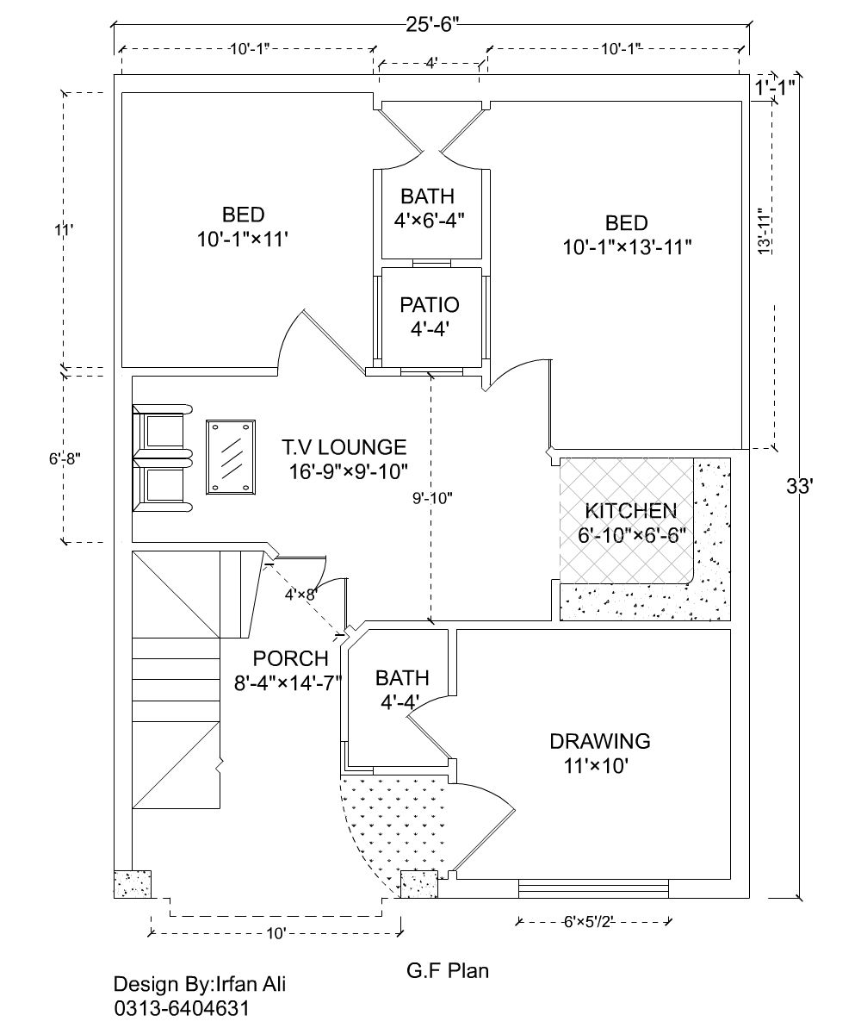

Figure 2 House Plan

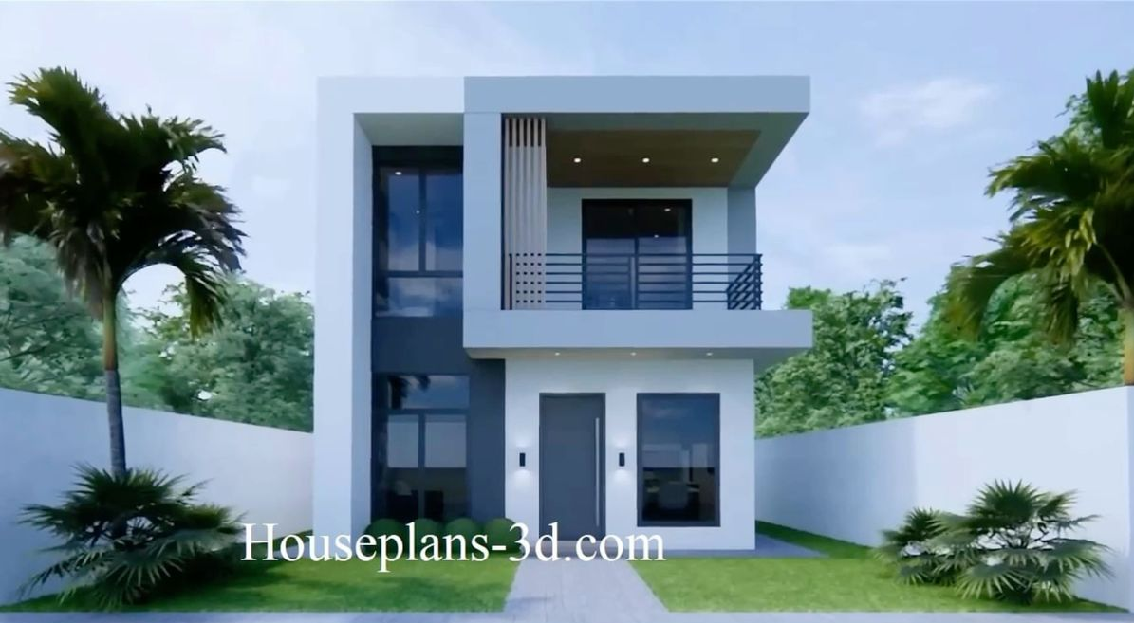

Figure 1 3d Rendered image

