Assessment Evidence Guide
For
Architectural Drafting
Level-4
Formative Assessment
07732BCE2004-Develop 3D Model in Autodesk REVIT
Date 4th-9th Nov, 2024
Lahore


National Vocational & Technical
Training Commission

Instruction Sheet for the Candidate
Qualification | National Vocation Certificate Level -4 in Architectural Drafting
Competency Standard | 07732BCE2004-Develop 3D Model in Autodesk REVIT
Purpose of Assessment | Formative Assessment
Candidate Details | Name______________________________________________________  Registration/Roll Number_______________________________________
Guidance for Candidate | To meet this standard, you are required to complete the following within 04 Hrs. time frame (for practical demonstration & assessment):  - Setup Interface  - Create Building Layout  - Perform Advance Modeling & Visualization Techniques  - Create Construction Document  - Render Model  - Add Rendering Plugins  - Apply AI tools for Planning  - Create Building Information Modeling Model
Time: 4 Hrs. | During a practical assessment, under observation by an assessor, you are required to
Minimum Evidence Required | Activity 1:  1. Create custom user interface as per requirement of specific trade.  2. Create drawings to make layout according to the given requirements.  3. Load, Create and draw the walls according to the given specifications.  4. Load and install building component (door, windows, ventilators etc.).  5. Create and draw floor and roofs by boundary according structural specification.  6. Install fixture and furnishes  7. Create 3D prototype model of the drawing according to given measurements.  8. Place stair by component.  9. Create Conceptual mass (generic modelling).  10. Applying conceptual mass to the project.  11. Create and apply materials on building model as per design.  12. Model the site and topography  13. Model the site using Topo solid.  14. Create specification/detail for various parts according to given requirements (apply Annotation Tags, area tags, dimensions) on building plans according to requirement.  15. Apply Annotation Tags, area tags, dimensions on building plans according to requirement for elevations for building documentation  16. Creating a door and window legend  17. Work with sheets  18. Set for print  Activity 2:  19. Set sun and Shadows  20. Add lights for illumination to get the requisite scene of 3D model.  21. Apply material to the 3D model as per given specification.  22. Apply texture to 3D model as per given specification.  23. Assign cameras to execute different views of 3D Model.  24. Add scene of 3D model according to specification.  25. Render the 3D model according to required image size or resolution & orientation  26. Set environment on specified plugin.  27. Apply and edit materials on the given model specified plugin.  28. Set Resolution and visibility according to the requirement specified plugin.  29. Render the model  Activity 3:  30. Import Revit architecture model in Structure template  31. Import Revit architecture model in Systems template

Self-Assessment Checklist
Candidate Name
Registration No.
Qualification | National Vocation Certificate Level -4 in Architectural Drafting
Competency Standard | 07732BCE2004-Develop 3D Model in Autodesk REVIT
Purpose of Assessment | Formative Assessment
Assessment Task | - Setup Interface  - Create Building Layout  - Perform Advance Modeling & Visualization Techniques  - Create Construction Document  - Render Model  - Add Rendering Plugins  - Apply AI tools for Planning  - Create Building Information Modeling Model  Activity1:  Develop a building layout (small unit), apply annotation as shown in figure 2.  Activity 2:  Render the 3d and plan on the provided plugin according to assessor guide as shown in figure 1. (Annexure attached)  Activity 3:  Import Revit files (drawn in activity 1) in required format.
I can……………….
Performance Criteria | Yes | No
Activity 1:
- Create custom user interface as per requirement of specific trade.
- Create drawings to make layout according to the given requirements.
- Load, Create and draw the walls according to the given specifications.
- Load and install building component (door, windows, ventilators etc.).
- Create and draw floor and roofs by boundary according structural specification.
- Install fixture and furnishes
- Create 3D prototype model of the drawing according to given measurements.
- Place stair by component.
- Create Conceptual mass (generic modelling).
- Applying conceptual mass to the project.
- Create and apply materials on building model as per design.
- Model the site and topography
- Model the site using Topo solid.
- Create specification/detail for various parts according to given requirements (apply Annotation Tags, area tags, dimensions) on building plans according to requirement.
- Apply Annotation Tags, area tags, dimensions on building plans according to requirement for elevations for building documentation
- Creating a door and window legend
- Work with sheets
- Set for print
- Set sun and Shadows
Activity 2:
- Add lights for illumination to get the requisite scene of 3D model.
- Apply material to the 3D model as per given specification.
- Apply texture to 3D model as per given specification.
- Assign cameras to execute different views of 3D Model.
- Add scene of 3D model according to specification.
- Render the 3D model according to required image size or resolution & orientation
- Set environment on specified plugin.
- Apply and edit materials on the given model specified plugin.
- Set Resolution and visibility according to the requirement specified plugin.
- Render the model
Activity 3:
- Import Revit architecture model in Structure template
- Import Revit architecture model in Systems template
Candidate’s Signature__________________ Assessor’s Signature____________________
Date: _______________________________

Assessors Judgment Guide
Qualification | National Vocation Certificate Level -4 in Architectural Drafting
Competency Standard | 07732BCE2004-Develop 3D Model in Autodesk REVIT
Purpose of Assessment | Formative Assessment
Candidate Details | Name______________________________________________________  Registration/Roll Number_______________________________________
Assessment Outcome | COMPETENT NOT YET COMPETENT  Name of the Assessor________________________________________________  Assessor’s code: _______________________________________  Signature: ________________________________

Assessment Summary (to be filled by the assessor)
Activity | Method |  |  |  |  | Result
Nature of Activity | Written | Oral | Observation | Portfolio | Role Play | Competent | Not Yet Competent
Practical Skill Demonstration
Knowledge Assessment
Other Requirement

Observation Checklist
Assessment Task |  | - Setup Interface  - Create Building Layout  - Perform Advance Modeling & Visualization Techniques  - Create Construction Document  - Render Model  - Add Rendering Plugins  - Apply AI tools for Planning  - Create Building Information Modeling Model  Activity 1:  Develop a building layout (small unit), apply annotation as shown in figure 2.  Activity 2:  Render the 3d and plan on the provided plugin according to assessor guide as shown in figure 1. (Annexure attached)  Activity 3:  Import Revit files (drawn in activity 1) in required format.
During the practical assessment, candidate demonstrated the following: |  |  |  | Yes | No | Remarks
 | Create custom user interface as per requirement of specific trade.
 | Create drawings to make layout according to the given requirements.
 | Load, Create and draw the walls according to the given specifications.
 | Load and install building component (door, windows, ventilators etc.).
 | Create and draw floor and roofs by boundary according structural specification.
 | Install fixture and furnishes
 | Create 3D prototype model of the drawing according to given measurements.
 | Place stair by component.
 | Create Conceptual mass (generic modelling).
 | Applying conceptual mass to the project.
 | Create and apply materials on building model as per design.
 | Model the site and topography
 | Model the site using Topo solid.
 | Create specification/detail for various parts according to given requirements (apply Annotation Tags, area tags, dimensions) on building plans according to requirement.
 | Apply Annotation Tags, area tags, dimensions on building plans according to requirement for elevations for building documentation
 | Creating a door and window legend
 | Set sun and Shadows
 | Add lights for illumination to get the requisite scene of 3D model.
 | Apply material to the 3D model as per given specification.
 | Apply texture to 3D model as per given specification.
 | Assign cameras to execute different views of 3D Model.
 | Add scene of 3D model according to specification.
 | Render the 3D model according to required image size or resolution & orientation
 | Set environment on specified plugin.
 | Apply and edit materials on the given model specified plugin.
 | Set Resolution and visibility according to the requirement specified plugin.
 | Render the model
 | Import Revit architecture model in Structure template
 | Import Revit architecture model in Systems template
 | Work with sheets
 | Set for print
Competent |  |  | Not Yet Competent

Knowledge Assessment
Qualification | National Vocation Certificate Level -4 in Architectural Drafting
Competency Standard | 07732BCE2004-Develop 3D Model in Autodesk REVIT
Purpose of Assessment | Formative Assessment
Candidate Details | Name: _________________________________  Registration/Roll Number: _________________  Candidate Signature: ___________
Assessment Outcome | COMPETENT NOT YET COMPETENT  Name of the Assessor: ________________________________________________  Assessor’s code: _________________________________  Signature of the Assessor: _______________________

Candidate’s response is not required to be identical, but similar concepts and/or keywords must be used. Oral questioning may be used to clarify candidate understanding of topic and its application.

Questions (Candidate confidently answered questions correctly and demonstrated understanding of the topics and their application) |  | Satisfactory | Not Satisfactory
 | Which plugins are commonly used to improve Revit rendering quality?
 | What is a BIM model in Revit, and why is it important for project coordination?
 | How does Revit assist in creating annotated construction documents?
 | What are families in Revit?
 | Why are families important for modeling?

Feedback to the Candidate
Candidate’s Signature__________________ Assessor’s Signature _________________

ANNEXURE

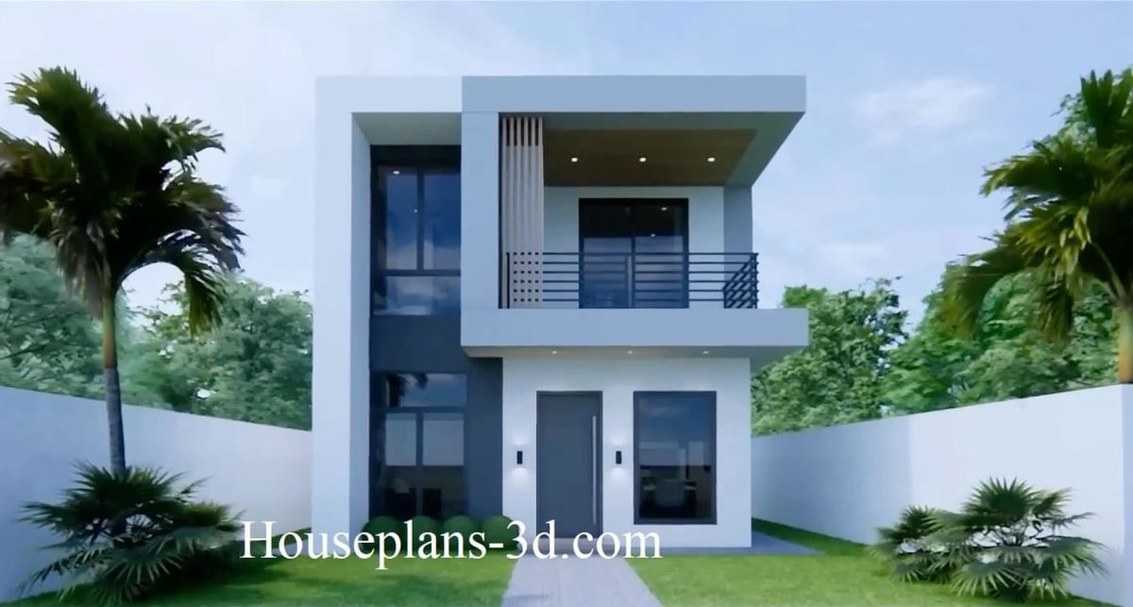
Figure 1 Rendered image of house

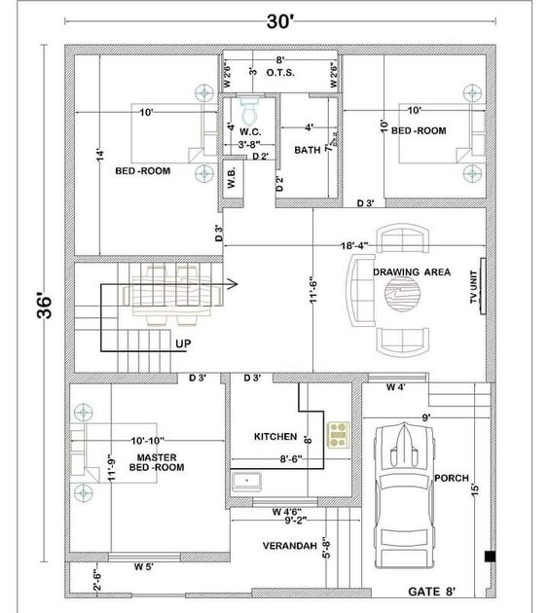
Figure 2 working plan of house

