Assessment Evidence Guide
For
Architectural Drafting
Level-4
Summative Assessment

Date 4th -9th Nov, 2024
Lahore


National Vocational & Technical
Training Commission

Instruction Sheet for the Candidate
Qualification | National Vocation Certificate Level -4 in Architectural Drafting
Competency Standard | 0732BCE2001-Perform Advance Architectural Graphics  0732BCE2002-Manipulate Images in Adobe Photoshop  0732BCE2003-Develop 3D Model Sketch Up  0732BCE2004-Develop 3D Model in Autodesk REVIT  0732BCE2006- Develop Entrepreneurial Skills
Purpose of Assessment | Summative Assessment
Candidate Details | Name______________________________________________________  Registration/Roll Number_______________________________________
Guidance for Candidate | To meet this standard, you are required to complete the following within 05 Hrs. time frame (for practical demonstration & assessment):  Activity 1: Draw and render three-point perspective of given building’s exterior as shown in figure 1 and 2-point perspective of building interior as shown in figure 2 with color pencils/watercolor/ink pen/ballpoint techniques.
Time: 05 Hrs. | During a practical assessment, under observation by an assessor, you are required to
Minimum Evidence Required | ACTIVITY 1  1. Arrange tools and material  2. Draw Three-point perspective  3. Draw two-point perspective  4. Render design with types of Coloring material

Self-Assessment Checklist
Candidate Name
Registration No.
Qualification | National Vocation Certificate Level -4 in Architectural Drafting
Competency Standard | 0732BCE2001-Perform Advance Architectural Graphics  0732BCE2002-Manipulate Images in Adobe Photoshop  0732BCE2003-Develop 3D Model Sketch Up  0732BCE2004-Develop 3D Model in Autodesk REVIT  0732BCE2006- Develop Entrepreneurial Skills
Purpose of Assessment | Summative Assessment
Assessment Task | Activity 1: Draw and render three-point perspective of given building’s exterior as shown in figure 1 and 2-point perspective of building interior as shown in figure 2 with colour pencils/watercolor/ink pen/ballpoint techniques.

I can……………….
Performance Criteria | Yes | No
ACTIVITY 1
- Arrange tools and material
- Draw Three-point perspective
- Draw two-point perspective
- Render design with types of Coloring material

Candidate’s Signature__________________ Assessor’s Signature____________________

Date: ______________________________

Assessors Judgment Guide
Qualification | National Vocation Certificate Level -4 in Architectural Drafting
Competency Standard | 0732BCE2001-Perform Advance Architectural Graphics  0732BCE2002-Manipulate Images in Adobe Photoshop  0732BCE2003-Develop 3D Model Sketch Up  0732BCE2004-Develop 3D Model in Autodesk REVIT  0732BCE2006- Develop Entrepreneurial Skills
Purpose of Assessment | Summative Assessment
Candidate Details | Name: ______________________________________________________  Registration/Roll Number: ______________________  Signature: _______________
Assessment Outcome | COMPETENT NOT YETCOMPETENT  Name of the Assessor___________________________________  Assessor’s code: _____________________________________  Signature: ________________________________

Assessment Summary (to be filled by the assessor)
Activity | Method |  |  |  |  | Result
Nature of Activity | Written | Oral | Observation | Portfolio | Role Play | Competent | Not Yet Competent
Practical Skill Demonstration
Knowledge Assessment
Other Requirement

Observation Checklist
Assessment Task |  | Activity 1: Draw and render three-point perspective of given building’s exterior as shown in figure 1 and 2-point perspective of building interior as shown in figure 2 with colour pencils/watercolor/ink pen/ballpoint techniques.
During the practical assessment, candidate demonstrated the following: |  |  |  | Yes | No | Remarks
 | ACTIVITY 1
 | Arrange tools and material
 | Draw Three-point perspective
 | Draw 2-point perspective
 | Render design with types of Colouring material
Competent |  |  | Not Competent

Knowledge Assessment
Qualification | National Vocation Certificate Level -4 in Architectural Drafting
Competency Standard | 0732BCE2001-Perform Advance Architectural Graphics  0732BCE2002-Manipulate Images in Adobe Photoshop  0732BCE2003-Develop 3D Model Sketch Up  0732BCE2004-Develop 3D Model in Autodesk REVIT  0732BCE2006- Develop Entrepreneurial Skills
Purpose of Assessment | Summative Assessment
Candidate Details | Name: ____________________________________  Registration/Roll Number: _____________Candidate Signature: ___________
Assessment Outcome | COMPETENT NOT YETCOMPETENT  Name of the Assessor: ___________________________________  Assessor’s code: _______________________________________  Signature of the Assessor: _______________________

Candidate’s response is not required to be identical, but similar concepts and/or keywords must be used. Oral questioning may be used to clarify candidate understanding of topic and its application.

Questions (Candidate confidently answered questions correctly and demonstrated understanding of the topics and their application) |  | Satisfactory | Not Satisfactory
 | Which color spaces are commonly used in Photoshop?
 | How can hide a layer in Photoshop?
 | Enlist the sustainable materials for model making.
 | What is the shortcut key for drawing a line in Sketch Up?
 | What is the keyboard shortcut for the Pan tool in Sketch Up?

Feedback to the Candidate
Candidate’s Signature__________________ Assessor’s Signature _________________

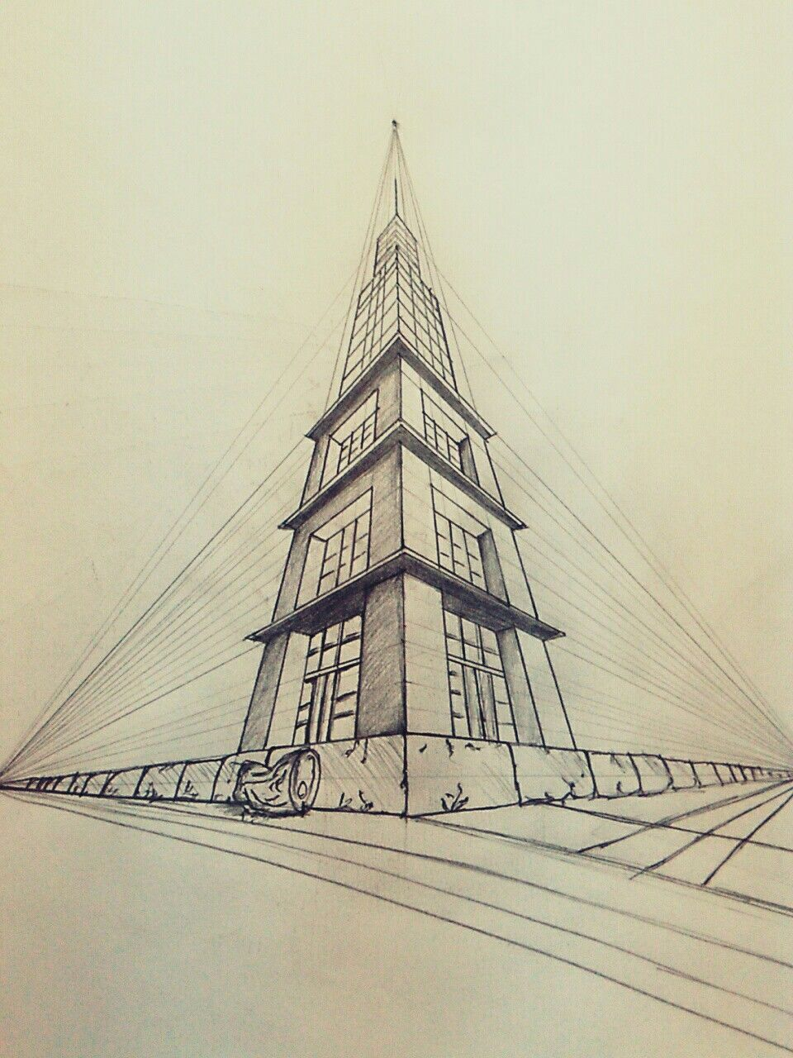
Figure 1: 3point perspective of building exterior

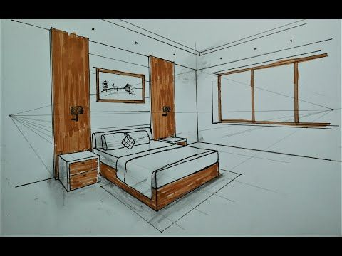
Figure 2: 2point perspective of room interior

