Assessment Evidence Guide
For
Architectural Drafting
Level-4
Summative Assessment

Date 4th -9th Nov, 2024
Lahore


National Vocational & Technical
Training Commission

Instruction Sheet for the Candidate
Qualification | National Vocation Certificate Level -4 in Architectural Drafting
Competency Standard | 0732BCE2001-Perform Advance Architectural Graphics  0732BCE2002-Manipulate Images in Adobe Photoshop  0732BCE2003-Develop 3D Model Sketch Up  0732BCE2004-Develop 3D Model in Autodesk REVIT  0732BCE2006- Develop Entrepreneurial Skills
Purpose of Assessment | Summative Assessment
Candidate Details | Name______________________________________________________  Registration/Roll Number_______________________________________
Guidance for Candidate | To meet this standard, you are required to complete the following within 05 Hrs. time frame (for practical demonstration & assessment):  Activity 2: Develop a building layout and model 3D on rivet, apply annotation as shown in figure 3. Format an image in Adobe Photoshop, then create and organize layers. Render the final composition to enhance visual quality and cohesiveness. (Annexure attached)
Time: 05 Hrs. | During a practical assessment, under observation by an assessor, you are required to
Minimum Evidence Required | Activity 2  - Load, Create and draw the walls according to the given specifications.  - Load and install building component (door, windows, ventilators etc.).  - Install fixture and furnishes  - Applying conceptual mass to the project.  - Create and apply materials on building model as per design.  - Advance Modeling and Visualization Techniques Model the site and topography  - Create specification/detail for various parts according to given requirements (apply Annotation Tags, area tags, dimensions) on building plans according to requirement.  - Work with sheets  - Render the plan model according to required image size or resolution & orientation  - Transform the objects as required  - Apply paint tools on image for rendering  - Apply required filters on image  - Apply textures as per design  - Save image in required format (jpg, PNG etc.)

Self-Assessment Checklist
Candidate Name
Registration No.
Qualification | National Vocation Certificate Level -4 in Architectural Drafting
Competency Standard | 0732BCE2001-Perform Advance Architectural Graphics  0732BCE2002-Manipulate Images in Adobe Photoshop  0732BCE2003-Develop 3D Model Sketch Up  0732BCE2004-Develop 3D Model in Autodesk REVIT  0732BCE2006- Develop Entrepreneurial Skills
Purpose of Assessment | Summative Assessment
Assessment Task | Activity 2: Develop a building layout and 3d, apply annotation as shown in figure 3 and figure 4. Format an image in Adobe Photoshop, then create and organize layers. Render the final composition to enhance visual quality and cohesiveness. (Annexure attached)

I can……………….
Performance Criteria | Yes | No
Activity 2
- Load, Create and draw the walls according to the given specifications.
- Load and install building component (door, windows, ventilators etc.).
- Install fixture and furnishes
- Apply conceptual mass to the project.
- Create and apply materials on building model as per design.
- Model the site and topography
- Create specification/detail for various parts according to given requirements (apply Annotation Tags, area tags, dimensions) on building plans according to requirement.
- Work with sheets
- Open the image
- Transform the objects as required
- Apply paint tools on image for rendering
- Apply required filters on image
- Apply textures as per design
- Save image in required format (jpg, PNG etc.)
Candidate’s Signature__________________ Assessor’s Signature____________________
Date: ______________________________
Assessors Judgment Guide
Qualification | National Vocation Certificate Level -4 in Architectural Drafting
Competency Standard | 0732BCE2001-Perform Advance Architectural Graphics  0732BCE2002-Manipulate Images in Adobe Photoshop  0732BCE2003-Develop 3D Model Sketch Up  0732BCE2004-Develop 3D Model in Autodesk REVIT  0732BCE2006- Develop Entrepreneurial Skills
Purpose of Assessment | Summative Assessment
Candidate Details | Name: _____________________________________________  Registration/Roll Number: ________________Signature: _______________
Assessment Outcome | COMPETENT NOT YETCOMPETENT  Name of the Assessor________________________________________________  Assessor’s code: ________________________________________  Signature: ________________________________

Assessment Summary (to be filled by the assessor)
Activity | Method |  |  |  |  | Result
Nature of Activity | Written | Oral | Observation | Portfolio | Role Play | Competent | Not Yet Competent
Practical Skill Demonstration
Knowledge Assessment
Other Requirement

Observation Checklist
Assessment Task |  | Activity 2: Develop a building layout and 3d, apply annotation as shown in figure 3. Format an image in Adobe Photoshop, then create and organize layers. Render the final composition to enhance visual quality and cohesiveness. (Annexure attached)
During the practical assessment, candidate demonstrated the following: |  |  |  | Yes | No | Remarks
 | ACTIVITY 2
 | Load, Create and draw the walls according to the given specifications.
 | Load and install building component (door, windows, ventilators etc.).
 | Install fixture and furnishes
 | Applying conceptual mass to the project.
 | Create and apply materials on building model as per design.
 | Advance Modeling and Visualization Techniques Model the site and topography
 | Create specification/detail for various parts according to given requirements (apply Annotation Tags, area tags, dimensions) on building plans according to requirement.
 | Work with sheets
 | Open the image
 | Transform the objects as required
 | Apply paint tools on image for rendering
 | Apply required filters on image
 | Apply textures as per design
 | Save image in required format (jpg, PNG etc.)
Competent |  |  | Not Competent

Knowledge Assessment
Qualification | National Vocation Certificate Level -4 in Architectural Drafting
Competency Standard | 0732BCE2001-Perform Advance Architectural Graphics  0732BCE2002-Manipulate Images in Adobe Photoshop  0732BCE2003-Develop 3D Model Sketch Up  0732BCE2004-Develop 3D Model in Autodesk REVIT  0732BCE2006- Develop Entrepreneurial Skills
Purpose of Assessment | Summative Assessment
Candidate Details | Name: ___________________________________  Registration/Roll Number: ____________ Candidate Signature: ___________
Assessment Outcome | COMPETENT NOT YET COMPETENT  Name of the Assessor: _____________________________________  Assessor’s code: _____________ Signature of the Assessor: _________

Candidate’s response is not required to be identical, but similar concepts and/or keywords must be used. Oral questioning may be used to clarify candidate understanding of topic and its application.

Questions (Candidate confidently answered questions correctly and demonstrated understanding of the topics and their application) |  | Satisfactory | Not Satisfactory
 | Which color spaces are commonly used in Photoshop?
 | How can hide a layer in Photoshop?
 | Enlist the sustainable materials for model making.
 | What is the shortcut key for drawing a line in Sketch Up?
 | What is the keyboard shortcut for the Pan tool in Sketch Up?

Feedback to the Candidate
Candidate’s Signature__________________ Assessor’s Signature _________________

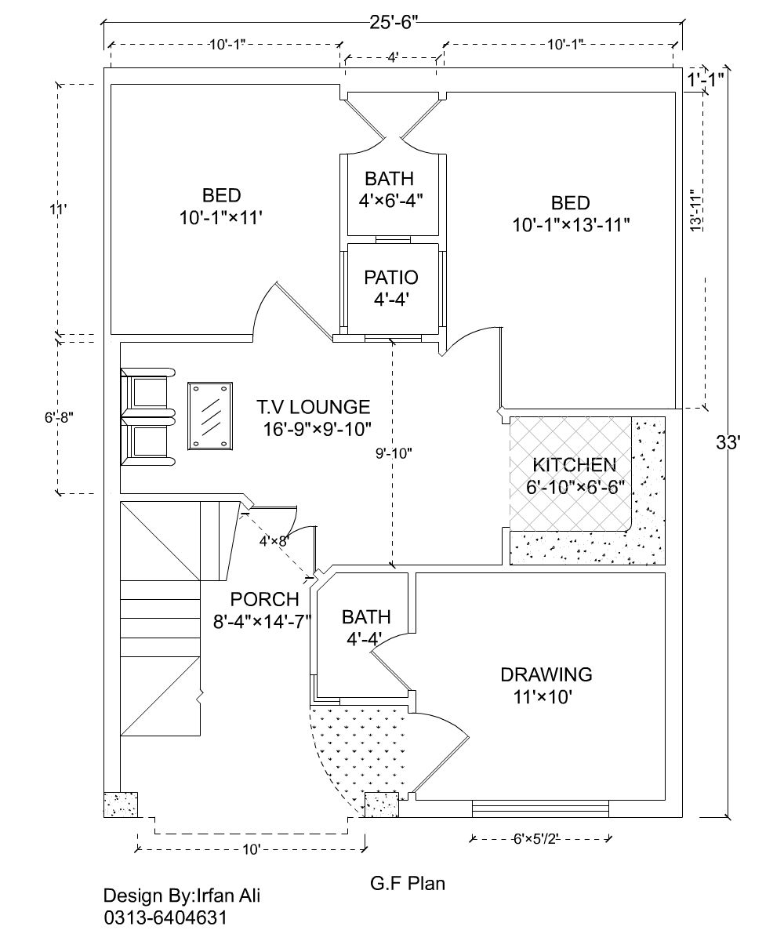

Figure 3 Plan of residential unit

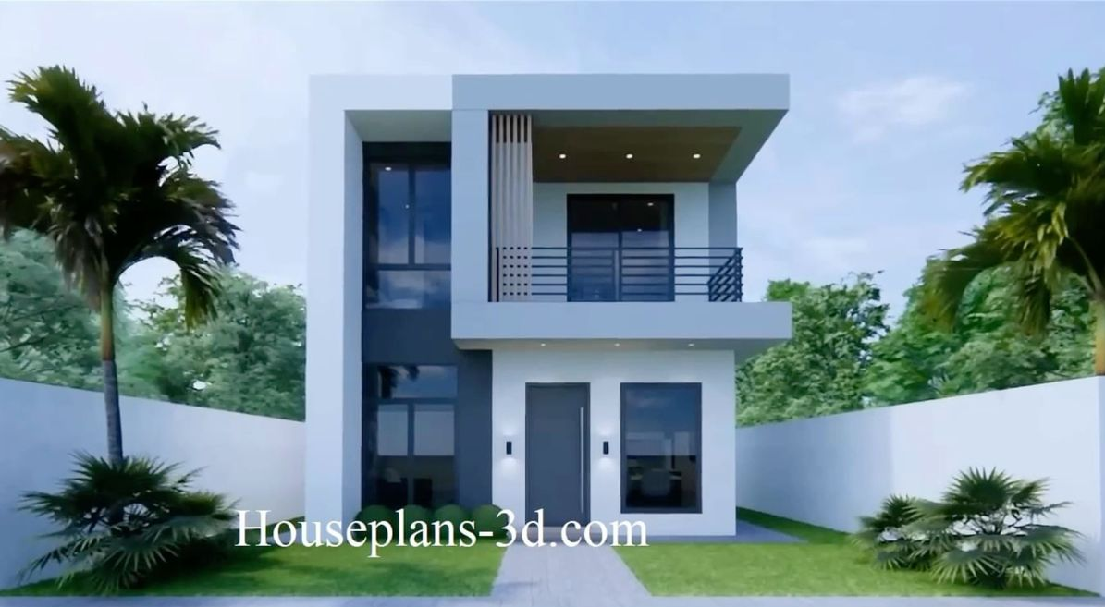

Figure 4 3d rendered image

