Assessment Evidence Guide
For
Architectural Drafting
Level-4
Summative Assessment

Date 4th -9th Nov, 2024
Lahore


National Vocational & Technical
Training Commission

Instruction Sheet for the Candidate
Qualification | National Vocation Certificate Level -4 in Architectural Drafting
Competency Standard | 0732BCE2001-Perform Advance Architectural Graphics  0732BCE2002-Manipulate Images in Adobe Photoshop  0732BCE2003-Develop 3D Model Sketch Up  0732BCE2004-Develop 3D Model in Autodesk REVIT  0732BCE2006- Develop Entrepreneurial Skills
Purpose of Assessment | Summative Assessment
Candidate Details | Name______________________________________________________  Registration/Roll Number_______________________________________
Guidance for Candidate | To meet this standard, you are required to complete the following within 05 Hrs. time frame (for practical demonstration & assessment):  Activity 3: Develop and modify building as shown in figure 4 on sketch up, apply materials and texture for final rendering.
Time: 05 Hrs. | During a practical assessment, under observation by an assessor, you are required to
Minimum Evidence Required | Activity 3  - Create 3D object from 2D drawing/image in line with given measurements.  - Modify 3D objects in line with requirements.  - Create/assign specified materials and textures to 3D Model.  - Add scene of 3D model according to specification  - Add lights for illumination to get the requisite scene of 3D model.  - Assign cameras to execute different views of 3D Model.  - Add Render Components to make scene more realistic.  - Render the 3D model according to required image size or resolution& orientation.

Self-Assessment Checklist
Candidate Name
Registration No.
Qualification | National Vocation Certificate Level -4 in Architectural Drafting
Competency Standard | 0732BCE2001-Perform Advance Architectural Graphics  0732BCE2002-Manipulate Images in Adobe Photoshop  0732BCE2003-Develop 3D Model Sketch Up  0732BCE2004-Develop 3D Model in Autodesk REVIT  0732BCE2006- Develop Entrepreneurial Skills
Purpose of Assessment | Summative Assessment
Assessment Task | Activity 3: Develop and modify building as shown in figure 3 and figure 4 on sketch up, apply materials and texture for final rendering.

I can……………….
Performance Criteria | Yes | No
Activity 3
- Create 3D object from 2D drawing/image in line with given measurements.
- Modify 3D objects in line with requirements.
- Create/assign specified materials and textures to 3D Model.
- Add scene of 3D model according to specification
- Add lights for illumination to get the requisite scene of 3D model.
- Assign cameras to execute different views of 3D Model.
- Add Render Components to make scene more realistic.
- Render the 3D model according to required image size or resolution& orientation.

Candidate’s Signature__________________ Assessor’s Signature____________________

Date: ______________________________

Assessors Judgment Guide
Qualification | National Vocation Certificate Level -4 in Architectural Drafting
Competency Standard | 0732BCE2001-Perform Advance Architectural Graphics  0732BCE2002-Manipulate Images in Adobe Photoshop  0732BCE2003-Develop 3D Model Sketch Up  0732BCE2004-Develop 3D Model in Autodesk REVIT  0732BCE2006- Develop Entrepreneurial Skills
Purpose of Assessment | Summative Assessment
Candidate Details | Name: _____________________________________________________  Registration/Roll Number: ______________________  Signature: _______________
Assessment Outcome | COMPETENT NOT YETCOMPETENT  Name of the Assessor______________________  Assessor’s code: ________________________________________  Signature: ________________________________

Assessment Summary (to be filled by the assessor)
Activity | Method |  |  |  |  | Result
Nature of Activity | Written | Oral | Observation | Portfolio | Role Play | Competent | Not Yet Competent
Practical Skill Demonstration
Knowledge Assessment
Other Requirement

Observation Checklist
Assessment Task |  | Activity 3: Develop and modify building as shown in figure 4 on sketch up, apply materials and texture for final rendering.
During the practical assessment, candidate demonstrated the following: |  |  |  | Yes | No | Remarks
 | Activity 3
 | Create 3D object from 2D drawing/image in line with given measurements.
 | Modify 3D objects in line with requirements.
 | Create/assign specified materials and textures to 3D Model.
 | Add scene of 3D model according to specification
 | Add lights for illumination to get the requisite scene of 3D model.
 | Assign cameras to execute different views of 3D Model.
 | Add Render Components to make scene more realistic.
 | Render the 3D model according to required image size or resolution& orientation.
Competent |  |  | Not Yet Competent

Knowledge Assessment
Qualification | National Vocation Certificate Level -4 in Architectural Drafting
Competency Standard | 0732BCE2001-Perform Advance Architectural Graphics  0732BCE2002-Manipulate Images in Adobe Photoshop  0732BCE2003-Develop 3D Model Sketch Up  0732BCE2004-Develop 3D Model in Autodesk REVIT  0732BCE2006- Develop Entrepreneurial Skills
Purpose of Assessment | Summative Assessment
Candidate Details | Name: ______________________________________  Registration/Roll Number: _________________  Candidate Signature: ___________
Assessment Outcome | COMPETENT NOT YET COMPETENT  Name of the Assessor: _______________________________  Assessor’s code: ____________ Signature of the Assessor: ____________

Candidate’s response is not required to be identical, but similar concepts and/or keywords must be used. Oral questioning may be used to clarify candidate understanding of topic and its application.

Questions (Candidate confidently answered questions correctly and demonstrated understanding of the topics and their application) |  | Satisfactory | Not Satisfactory
 | Which color spaces are commonly used in Photoshop?
 | How can hide a layer in Photoshop?
 | Enlist the sustainable materials for model making.
 | What is the shortcut key for drawing a line in Sketch Up?
 | What is the keyboard shortcut for the Pan tool in Sketch Up?

Feedback to the Candidate
Candidate’s Signature__________________ Assessor’s Signature _________________

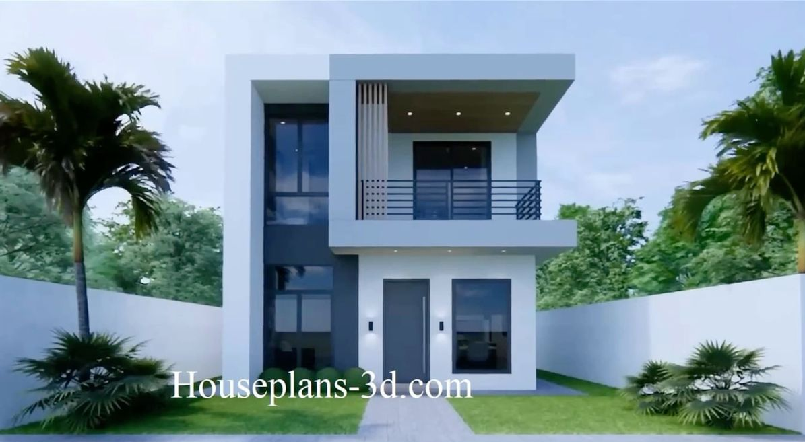

Figure 4 3d rendered image

