Assessment Evidence Guide
For
Architectural Drafting
Level-3
Summative Assessment

Date 4th -9th Nov, 2024
Lahore


National Vocational & Technical
Training Commission

Instruction Sheet for the Candidate
Qualification | National Vocation Certificate Level -3 in Architectural Drafting
Competency Standard | 0732BCE1901-Perform Advance Architectural Drawings  0732BCE1902-Perform Architectural Graphics  0732BCE1903-Develop 3D in AutoCAD
Purpose of Assessment | Summative Assessment
Candidate Details | Name______________________________________________________  Registration/Roll Number_______________________________________
Guidance for Candidate | To meet this standard, you are required to complete the following within 05 Hrs. time frame (for practical demonstration & assessment):  Activity:  Create 3D view (Auto CAD) in of given plan as shown in annexure.
Time: 05 Hrs. | During a practical assessment, under observation by an assessor, you are required to
Minimum Evidence Required | - Create 3D models  - Create opening (Door, windows & ventilated in 3D model as per requirements.  - Customize 3D object as per requirement  - Assign material to required 3D Model as per given specification  - Install lights to get requisite scene of required 3D model  - Assign cameras to execute different views of required 3D Model.  - Render and print the 3D images according to required size & orientation  - Create portfolio in pdf format (soft form)

Self-Assessment Checklist
Candidate Name
Registration No.
Qualification | National Vocation Certificate Level -3 in Architectural Drafting
Competency Standard | 0732BCE1901-Perform Advance Architectural Drawings  0732BCE1902-Perform Architectural Graphics  0732BCE1903-Develop 3D in AutoCAD
Purpose of Assessment | Summative Assessment
Assessment Task | Activity:  Create 3D view (Auto CAD) in of given plan as shown in annexure

I can……………….
Performance Criteria | Yes | No
- Create 3D models
- Create opening (Door, windows & ventilated in 3D model as per requirements.
- Customize 3D object as per requirement
- Assign material to required 3D Model as per given specification
- Install lights to get requisite scene of required 3D model
- Assign cameras to execute different views of required 3D Model.
- Render and print the 3D images according to required size & orientation
- Create portfolio in pdf format (soft form)

Candidate’s Signature__________________ Assessor’s Signature____________________
Date: ______________________________

Assessors Judgment Guide
Qualification | National Vocation Certificate Level -3 in Architectural Drafting
Competency Standard | 0732BCE1901-Perform Advance Architectural Drawings  0732BCE1902-Perform Architectural Graphics  0732BCE1903-Develop 3D in AutoCAD
Purpose of Assessment | Summative Assessment
Candidate Details | Name: ______________________________________________________________  Registration/Roll Number: ______________________Signature: _______________
Assessment Outcome | COMPETENT NOT YETCOMPETENT  Name of the Assessor________________________________________________  Assessor’s code: ____________________________________________________  Signature: ________________________________

Assessment Summary (to be filled by the assessor)
Activity | Method |  |  |  |  | Result
Nature of Activity | Written | Oral | Observation | Portfolio | Role Play | Competent | Not Yet Competent
Practical Skill Demonstration
Knowledge Assessment
Other Requirement

Observation Checklist
Assessment Task |  | Activity:  Create 3D view (Auto CAD) in of given plan as shown in annexure
During the practical assessment, candidate demonstrated the following: |  |  |  | Yes | No | Remarks
 | Create 3D models
 | Create opening (Door, windows & ventilated in 3D model as per requirements.
 | Customize 3D object as per requirement
 | Assign material to required 3D Model as per given specification
 | Install lights to get requisite scene of required 3D model
 | Assign cameras to execute different views of required 3D Model.
 | Render and print the 3D images according to required size & orientation
 | Create portfolio in pdf format (soft form)
Competent |  |  | Not Competent

Knowledge Assessment
Qualification | National Vocation Certificate Level -3 in Architectural Drafting
Competency Standard | 0732BCE1901-Perform Advance Architectural Drawings  0732BCE1902-Perform Architectural Graphics  0732BCE1903-Develop 3D in AutoCAD
Purpose of Assessment | Summative Assessment
Candidate Details | Name: _______________________________________________  Registration/Roll Number: _________________  Candidate Signature: ___________
Assessment Outcome | COMPETENT NOT YETCOMPETENT  Name of the Assessor: _______________________________________  Assessor’s code: ___________Signature of the Assessor: ______________

Candidate’s response is not required to be identical, but similar concepts and/or keywords must be used. Oral questioning may be used to clarify candidate understanding of topic and its application.

Questions (Candidate confidently answered questions correctly and demonstrated understanding of the topics and their application) |  | Satisfactory | Not Satisfactory
 | What is a mesh in 3D modeling?
 | What is the purpose of working drawings?
 | What are the main components of set of working drawings?
 | What tools can be used for shading?
 | What are the common techniques for shading?

Feedback to the Candidate
Candidate’s Signature__________________ Assessor’s Signature _________________

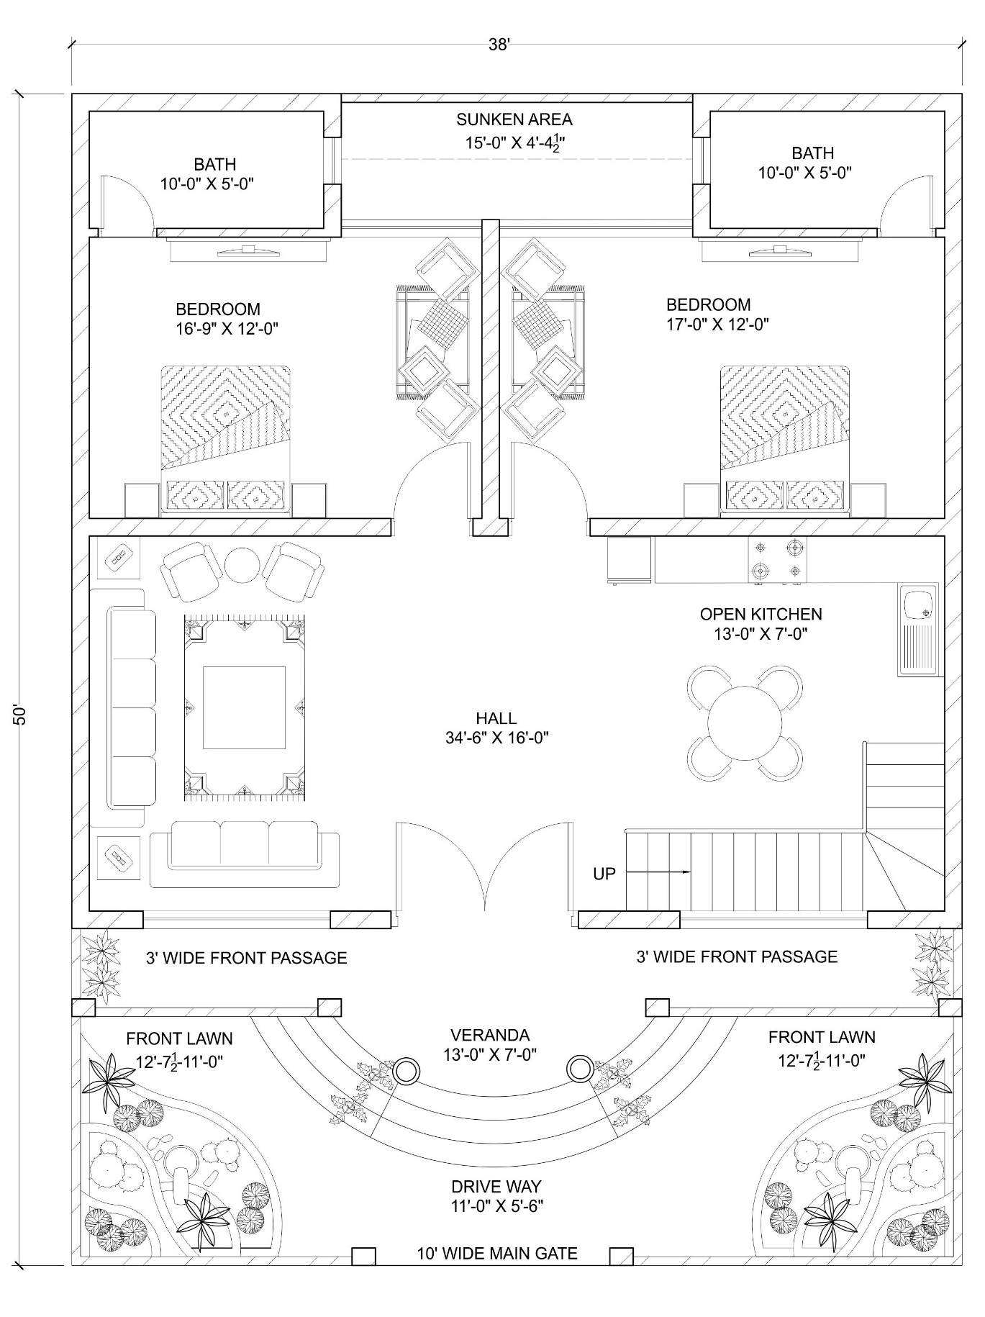
Annexure-1 Figure 1: 8 Marla House plan

