Assessment Evidence Guide
For
Architectural Drafting
Level-3
Summative Assessment

Date 4th -9th Nov, 2024
Lahore


National Vocational & Technical
Training Commission

Instruction Sheet for the Candidate
Qualification | National Vocation Certificate Level -3 in Architectural Drafting
Competency Standard | 0732BCE1901-Perform Advance Architectural Drawings  0732BCE1902-Perform Architectural Graphics  0732BCE1903-Develop 3D in AutoCAD
Purpose of Assessment | Summative Assessment
Candidate Details | Name______________________________________________________  Registration/Roll Number_______________________________________
Guidance for Candidate | To meet this standard, you are required to complete the following within 05 Hrs. time frame (for practical demonstration & assessment):  Activity:  Draw working plan of given house plan as shown in figure and render half plan with different color schemes.
Time: 05 Hrs. | During a practical assessment, under observation by an assessor, you are required to
Minimum Evidence Required | - Draw Working Plan Set  - Render design with different color schemes  - Render design with pencil color technique

Self-Assessment Checklist
Candidate Name
Registration No.
Qualification | National Vocation Certificate Level -3 in Architectural Drafting
Competency Standard | 0732BCE1901-Perform Advance Architectural Drawings  0732BCE1902-Perform Architectural Graphics  0732BCE1903-Develop 3D in AutoCAD
Purpose of Assessment | Summative Assessment
Assessment Task | Activity:  Draw working plan of given house plan as shown in figure and render half plan with different color schemes.

I can……………….
Performance Criteria | Yes | No
- Draw Working Plan Set
- Render design with different color schemes
- Render design with pencil color technique

Candidate’s Signature__________________ Assessor’s Signature____________________
Date: ______________________________

Assessors Judgment Guide
Qualification | National Vocation Certificate Level -3 in Architectural Drafting
Competency Standard | 0732BCE1901-Perform Advance Architectural Drawings  0732BCE1902-Perform Architectural Graphics  0732BCE1903-Develop 3D in AutoCAD
Purpose of Assessment | Summative Assessment
Candidate Details | Name: _________________________________  Registration/Roll Number: ________________Signature: _______________
Assessment Outcome | COMPETENT NOT YETCOMPETENT  Name of the Assessor________________________________  Assessor’s code: ____________ Signature: ____________

Assessment Summary (to be filled by the assessor)
Activity | Method |  |  |  |  | Result
Nature of Activity | Written | Oral | Observation | Portfolio | Role Play | Competent | Not Yet Competent
Practical Skill Demonstration
Knowledge Assessment
Other Requirement

Observation Checklist
Assessment Task |  | Activity:  Draw working plan of given house plan as shown in figure and render half plan with different color schemes.
During the practical assessment, candidate demonstrated the following: |  |  |  | Yes | No | Remarks
 | Draw Working Plan Set
 | Render design with different color schemes
 | Render design with pencil color technique
Competent |  |  | Not Competent

Knowledge Assessment
Qualification | National Vocation Certificate Level -3 in Architectural Drafting
Competency Standard | 0732BCE1901-Perform Advance Architectural Drawings  0732BCE1902-Perform Architectural Graphics  0732BCE1903-Develop 3D in AutoCAD
Purpose of Assessment | Summative Assessment
Candidate Details | Name: ______________________________  Registration/Roll Number: _________________  Candidate Signature: ___________
Assessment Outcome | COMPETENT NOT YETCOMPETENT  Name of the Assessor: _________________________________  Assessor’s code: ____________________________________  Signature of the Assessor: _______________________

Candidate’s response is not required to be identical, but similar concepts and/or keywords must be used. Oral questioning may be used to clarify candidate understanding of topic and its application.

Questions (Candidate confidently answered questions correctly and demonstrated understanding of the topics and their application) |  | Satisfactory | Not Satisfactory
 | What is a mesh in 3D modeling?
 | What is the purpose of working drawings??
 | What are the main components of set of working drawings?
 | What tools can be used for shading?
 | What are the common techniques for shading?

Feedback to the Candidate
Candidate’s Signature__________________ Assessor’s Signature _________________

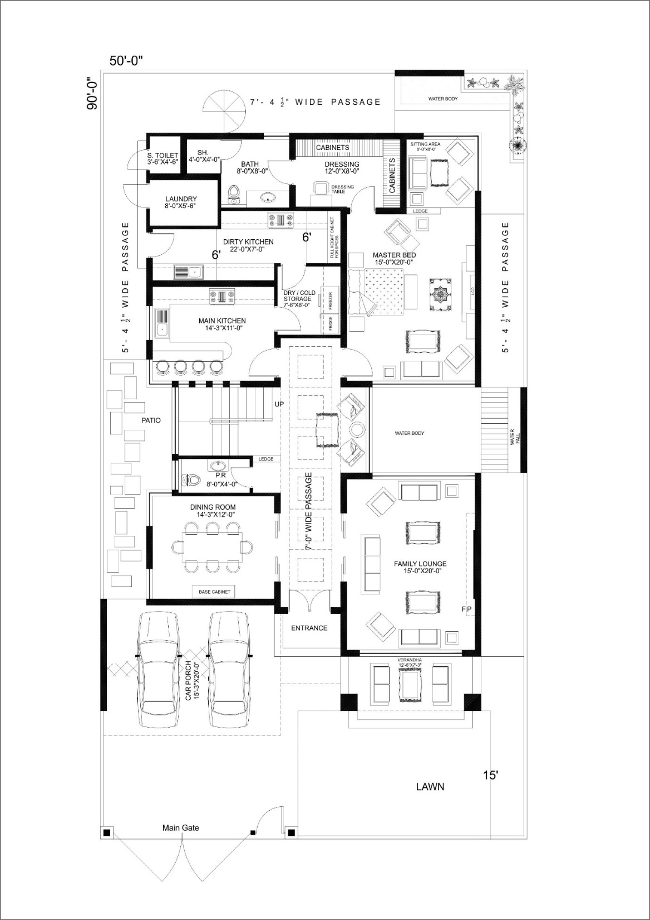
ANNEXURE

Figure:1Kanal house plan

