National Competency Standards Level 2 for Architectural Drafting
Draftsman/Draftsperson

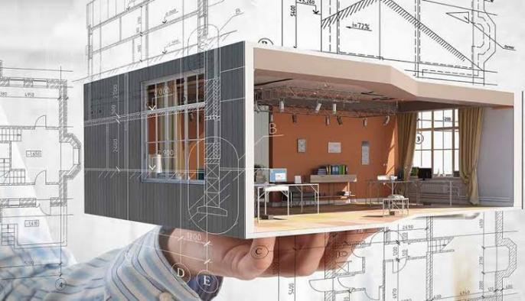
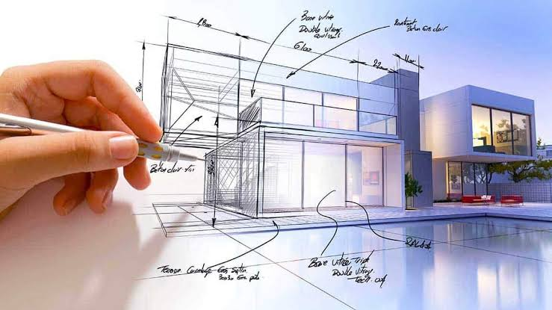

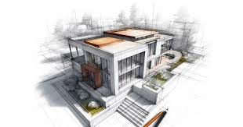

National Vocational and Technical Training Commission (NAVTTC),
Government of Pakistan

FOREWORD

The National Vocational and Technical Training Commission (NAVTTC) extends its gratitude and appreciation to representatives of business, industry, academia, government agencies, provincial TEVTAs, sector skill councils, and trade associations who dedicated their time and expertise for the development of the National Vocational Qualification for level 2 to 4 Architectural Drafting. This work would not have been possible without the technical support of these experts.
It is worth mentioning that all the experts from Industry, Academia, and TVET experts from TEVTAs, BTEs, and PVTC worked diligently to make this qualification valuable and error-free, for which all credit goes to them. However, NAVTTC accepts responsibility for any errors and omissions that may still be present in the qualification document.
The development of Skill Standards is a dynamic and ongoing process, and the competency standards need periodic review and updating due to constant technological advancements, developments in scientific knowledge, and growing experience of implementation at the grassroots level, as well as industry demands. The NAVTTC, Government of Pakistan, will ensure that the qualifications remain up-to-date with the changing demands of both national and international job markets.
job markets.

Executive Director (NAVTTC)

Table of Contents
1.1.Introduction 4
1.2.Date of development: 4
1.3.Date of review & validation: 4
1.4.Entry requirement: 4
2.Codes of qualification 4
3.Summary of competencies 5
0732BCE1801: Follow Safety Rules at the Workplace 6
0732BCE1802: Demonstrate Basic Numeracy Skills 8
0732BCE1803: Perform Basic Architectural Drawings 10
0732BCE1804: Perform Basic Computer Operations 12
0732BCE1805: Develop 2D Drawings in Auto CAD 14
4.Tools, Equipment and Consumables Required 15
5.Members of Qualification Development & Review Committee 16

1.1.Introduction

The vocational professions are increasingly getting attention in Pakistan, not only among the youth seeking to enter the job market but also among adults who wish to polish their skills to develop a career out of it. Architectural Drafting is rapidly expanding in Pakistan because of its popularity and the Construction industry.

The Government of Pakistan through the National Vocational & Technical Training Commission (NAVTTC) in collaboration with German Development Company & BMZ has devised a 24-month (Level 4) training program, which not only allows trainees to be equipped with growing Industrial trends but will be beneficial in rapidly capturing the job market across the globe.

The importance of an Architectural Drafting course lies in its ability to enhance productivity and efficiency by equipping users with the skills to produce high-quality, detailed drawings and models. This proficiency improves individual competency and contributes to better project outcomes, reduced errors, and streamlined workflows in professional settings. Thus, investing in Architectural Drafting is invaluable for professionals seeking to elevate their technical capabilities and remain competitive in the evolving landscape of design and drafting.

1.2.Date of development: | 22nd to 27th July, 2024
1.3.Date of review & validation: | 3rd to 7th Sep,2024
1.4.Entry requirement: | The entry level for National Vocational Certificate Level 2 in Architectural Drafting is Middle.

2.Codes of qualification
The International Standard Classification of Education (ISCED) is a framework for assembling, compiling and analyzing cross-nationally comparable statistics on education and training. ISCED codes for these qualifications are assigned as follows:

ISCED Classification
Code | Description
0732BCE18 | National Vocational Certificate Level 2 in Architectural Drafting

3.Summary of competencies

Sr.No. | Competency standard | NVQF Level | Category | Estimated contact hours |  |  | Cr. Hr.
 |  |  |  | Th | Pr | Tot. | Cr. Hr.
0732BCE1801 | Follow Safety Rules at Workplace | 2 | Generic | 5 | 15 | 20 | 2
0732BCE1802 | Demonstrate Basic Numeracy Skills | 2 | Functional | 10 | 30 | 40 | 4
0732BCE1803 | Perform Basic Architectural Drawings | 2 | Technical | 50 | 130 | 180 | 18
0732BCE1804 | Perform Basic Computer Operations | 2 | Functional | 15 | 35 | 50 | 5
0732BCE1805 | Develop 2D Drawings in AutoCAD | 2 | Technical | 35 | 255 | 290 | 29
 | Adopt Soft Skills | 2 | Generic | 5 | 15 | 20 | 2
 | Total (%) |  |  | 120 | 480 | 600 | 60

732BCE1801: Follow Safety Rules at the Workplace
Overview:
After this Competency Standard, the trainee will be able to develop the skill and competence required to maintain occupational health and safety and take measures to deal with the emergencies professionally. The learner will also be able to practice green skills and become more environmentally friendly.

Competency Units | Performance Criteria
Maintain Occupational Safety and Health at Workplace | - Assess the situation.  - Select the equipment based on the type.  - Verify the working condition.  - Identify basic elements for first aid kit  - Maintain a fully stacked first aid kit  - Check expiry date of medicines  - Recycle waste material
Use Personal Protective and Safety Equipment (PPEs) | - Arrange required personal protective equipment  - Check functional condition of PPE’s  - Wear / use personal protective equipment  - Store PPE at appropriate place after use  - Clean / care required personal protective equipment  - Check expiry of PPE

Knowledge & Understanding
- Types of hazards
- Basic first aid treatment
- Safety signs and symbols
- Standard procedure of handling, storing and stacking material.
- Usage of Appropriate PPE for different situations

Critical Evidence(s) Required
The candidate needs to produce following critical evidence(s) in order to be competent in this competency standard:
- Use of PPEs according to hazard/job
- Keep the workplace clean and tidy
- Balance the load while handling manually
- Perform mock first aid treatment for minor injuries

The tools and equipment required for this competency standard are given below
Sr.No. | Items | Quantity
1 | Masks | 2 boxes
2 | Fire Blanket | 1
3 | Fire Extinguisher | 2
4 | Emergency Alarm/Bell | 1
5 | Fire Hoses | 1
6 | First Aid kit | 5
7 | Safety standard book | 1

732BCE1802: Demonstrate Basic Numeracy Skills
Overview
This module covers the skills and knowledge required to apply basic numeracy skills, and perform measurement, and basic mathematical calculations your underpinning knowledge will be sufficient to provide you the basis for your work.

Competency Units | Performance Criteria
Apply Basic Numeracy Skills | - Perform addition  - Perform subtraction  - Perform multiplication  - Perform division  - Calculate percentage
Perform Measurement | - Select measuring tools as per requirement  - Identify imperial and metric system  - Perform inter conversion of Measuring units
Calculate Area and Volume | - Calculate area of geometrical figures  - Calculate volume of solid figures  - Calculate parameters  - Calculate average

Knowledge & Understanding
- Basic principles of addition, subtraction, multiplication and division
- Imperial and metric system
- Basic measuring units and its interring conversion
- Area and Volume of solid figures
- Time saving practices
- Parameters
- Calculate average
Critical Evidence(s) Required
The candidate needs to produce following critical evidence(s) in order to be competent in this competency standard:
- Perform addition
- Perform subtraction
- Perform multiplication
- Calculate percentage
- Perform division
- Inter convert measuring units.

The tools and equipment required for this competency standard are given below
Sr.No. | Items | Quantity
1 | Measurement Tools | 10
2 | Note Books | 25
3 | Pencil | 25

732BCE1803: Perform Basic Architectural Drawings
Overview:
After this Competency Standard, the Trainee will be able to develop skill and competence required to draw freehand sketches, geometrical sketches, objects on different scales and different technical drawings. The learner will also be able to practice green skills and become more environmentally friendly.

Competency Units | Performance Criteria
Perform Freehand Sketching | - Arrange drawing tools  - Draw different types of lines  - Draw different objects  - Draw top, front, side views of objects/drawing(isometric)  - Perform drawing on both sides of paper  - Recycle drawing papers
Draw Geometrical Sketches | - Arrange drawing tools  - Draw different types of angular shapes  - Draw different types of curved shapes  - Draw Different types of polygon and geometrical shapes.
Draw Objects on Different Scales | - Arrange Scales Tools  - Draw Different Patterns with different Scales
Draw Lettering | - Arrange drawing tools  - Draw lettering strokes  - Draw different lettering styles
Draw Technical Drawings | - Develop orthographic Projection  - Draw Types of Doors.  - Draw Types of Windows.  - Draw Types and parts of Stairs case.  - Draw plans, elevation and section

Knowledge & Understanding
- Drawing tools
- Drawing material
- Techniques of Freehand sketching
- Types of lines
- Geometrical shapes
- Uses and types of scale
- Isometric views and different bonds
- Study of building materials
- Types of doors and its materials
- Types of windows and its materials

Critical Evidence(s) Required
The candidate needs to produce following critical evidence(s) in order to be competent in this competency standard:
- Draw different types of lines on A4 size paper
- Draw objects
- Draw different geometrical shapes
- Draw top, front, side views of objects/drawing
- Draw free hand isometric views/sketch of object/drawing
- Draw orthographic projections
- Draw different types of doors, windows and stairs (section)
- Draw plans, elevation and section
- Draw working drawings
- Draw types of foundations
The tools and equipment required for this competency standard are given below
Sr.No. | Items | Quantity
1 | Computer system core i7 | 01
2 | Multimedia projector with screen | 01
3 | Drawing boards 20 x 30 | 10
4 | Drawing boards 20 x 18 | 10
5 | Professional Drafting table | 25
7 | Tracing table | 05
9 | Drawing instrument box | 10
10 | Architectural scales | 25
11 | Set square | 25
12 | T square | 25
13 | Steel ruler | 5
14 | French curves | 5
15 | Pencils with different numbers | 10
16 | Erasers | 15
17 | sharpeners | 15
18 | Drawing sheets | As per requirement
19 | Tracing sheets | As per requirement
20 | Scholar sheets | As per requirement
21 | A4 size sheets | As per requirement
22 | A3 size sheet | As per requirement
23 | Sheet cutter | 10

732BCE1804: Perform Basic Computer Operations
Overview:
This module aims to equip individuals with the foundational skills necessary to effectively use a computer in a professional setting. This module covers essential computer literacy skills that are critical for a wide range of tasks in today's digital workplace. Key components of this module include:
Competency Units | Performance Criteria
Configure Computer Systems | - Connect computer components and peripherals as per requirement.  - Install Drivers and applications according to the software specification.  - Troubleshoot Applications to trace and fix faults in a specific application to bring it in a running condition.
Prepare a Document using MS WORD | - Compose a document as per the requirement.  - Format Word Document according to given requirements.  - Print Word Documents according to requirements.  - Print both sides of paper
Prepare a Worksheet using MS EXCEL | - Develop a worksheet as per given data.  - Format the worksheet according to given criteria.  - Apply Formulas according to the requirement.  - Generate Charts/Graphs according to the given data.
Prepare a Presentation using MS PowerPoint | - Insert Slides with different Layouts according to requirements of presentation.  - Insert text, tables, images, etc. according to the requirement.  - Apply a set of effects to animate the slide according to requirement.  - Apply Slide Transitions on Slides according to requirement.  - Apply Sound Effects on Objects/text/images according to requirement.  - Present a presentation according to 7Cs of communication.

Knowledge & Understanding
- Operating systems
- Hardware and Software
- Troubleshooting
- Internet and E-mailing
- Hyperlink and referencing
- Printing
- Formulas
- Short Keys
- WPM (Word Per Minute)
- 7 Cs of communication
- Green Practices

Critical Evidence(s) Required
The candidate needs to produce following critical evidence(s) in order to be competent in this competency standard:
- Install MS Office Application correctly
- Prepare a formatted document using MS Word
- Enter data into the respective columns and rows as per given instructions
- Set page layouts and margins
- Apply any slide transition on entire presentation.

The tools and equipment required for this competency standard are given below
Sr.No. | Items | Quantity
1 | Computer System | 26
2 | MS Office suite | 2
3 | Printer | 1
4 | Scanner | 1
5 | Printing Paper A4 Size | As Needed

732BCE1805: Develop 2D Drawings in Auto CAD
Overview:
This module aims to provide individuals with the essential skills and knowledge required to create precise and detailed 2D drawings using AutoCAD software. This module covers key aspects of 2D drafting, which are fundamental for professionals in construction sector.

Competency Units | Performance Criteria
Develop 2D Objects | - Setup & save drawing interface for required specifications.  - Setup user interface settings for required specifications.  - Create 2D objects with given measurements.  - Edit 2D Objects to meet set standards.
Draw Prepare Final set of 2D Drawings | - Develop 2D Drawing with given project specification and measurements.  - Plot drawing on scale according to required size & orientation  - Use of AI Tools for assistance.  - Plot drawing on scale according to required size & orientation
Knowledge & Understanding
- Basic drawing concepts
- Terminologies and vocabulary of AutoCAD software.
- Types of Unit measurement systems and conversions.
- Scale and paper sizes
- Commands and tools
- AI Tools
Critical Evidence(s) Required
The candidate needs to produce following critical evidence(s) in order to be competent in this competency standard:
- Set of 2D Drawings including Plan, working plan, section, elevation, legend, schedule, areas & measurements.
The tools and equipment required for this competency standard are given below
Sr.No. | Items | Quantity
1 | Computer System | 26
2 | AutoCAD Software | 2
3 | Printer | 1
4 | Scanner | 1
5 | Printing Paper A4 Size | As Needed

4.Tools, Equipment and Consumables Required
The tools and equipment required for this competency standard are provided below:

Sr.No. | Items | Quantity
1 | Computer system | 25
2 | Whiteboard | 01
3 | Display board | 01
4 | Scanner (legal page size) | 01
5 | Black printer A4 size | 01
6 | Multimedia projector | 01
7 | Drawing boards 20 x 30 | 25
8 | Tracing table | 02
9 | T scales | 25
10 | Archi Scales | 25
11 | Set Scales | 25
12 | Templates | 05
13 | French Curves | 05

The consumables required for this competency standard are provided below:

Sr.No. | Items | Quantity
1 | Drawing instrument box | 25
2 | Drawing pencil box 2H to 6B | 25
3 | Color pencils faber castle | 25
4 | Pastel color box | 25
5 | Watercolors | 10
6 | Poster colors | 10
7 | Erasers | 25
8 | sharpener | 25
9 | Sketchbook A3 size | 25
10 | A3 size paper rim | 05
11 | Scholar sheets | 50
12 | A4 size paper rim | 05
13 | Tracing sheet A4, A3 | 50 Each
14 | Brushes 0 to 12 | 25 Each
15 | Software CDs | 1 Each
16 | Masking Tapes | 20
17 | Pen Paper cutter with blades | 10
18 | UHU Tube Large | 10
19 | UHU Stick | 10
21 | Flash drive (minimum 64GB) | 10

5.Members of Qualification Development & Review Committee
The following members participated in the qualification development and review process:

Qualification Development Committee
S. No. | Name |  | Organization
 |  | Mr. Muhammad Amjad Rafique | GCT-W Lahore (PTEVTA)
 |  | Mr. Ajaz Sadiq | GCT Rawalakot (AJKTEVTA)
 |  | Ms. Syeda Tehseen Fatima | GTTI-W Township Lahore (PTEVTA)
 |  | Ms. Huma Ghafoor | GTTI-W GujjarPura Lahore  (PTEVTA)
 |  | Mr. Sangin Faris | GCT Tangi Charsada  (KPTEVTA)
 |  | Mr. Ahmed Hasan | Habib Rafiq (PVT)  Capital Smart City Islamabad
 |  | Muhammad Ishaq | NAVTTC
 |  | Muhammad Aasim | NAVTTC
 |  | Shams Shahbaz | PTEVTA, Lahore
 |  | Engr Waqas Hashmi | PTEVTA, Lahore
 |  | Ms. Saima Asghar | Freelancer/DACUM Facilitator
Qualification Review & Development Committee
 |  | Mr. Ahsan Murtaza | Andriod APP Developer,Ifkaar Technologies Ltd. Islamabad
 |  | Mr. Eng. Muhammad Adnan Khan | Lecturer (Civil),GPI Manshera9KP.TEVTA)
 |  | Ms. Syeda Tehseen Fatima | GTTI-W Township Lahore (P. TEVTA)
 |  | Ms. Huma Ghafoor | GTTI-W GujjarPura Lahore (P. TEVTA)
 |  | Mr. Mohammad Tauseef | Instructor AutoCAD, PVTC, Lahore
 |  | Mr. Gul Mohammad | Instructor AutoCAD, TT.C, Quetta
 |  | Mr. Mazhar Yasin | Lecturer (Civil), University of Lahore, Lahore
 |  | Ms. Noreen Amina | Lecturer (Architecture) University of Lahore, Lahore
 |  | Mr. Ahmed Hasan | Habib Rafiq (PVT)  Capital Smart City Islamabad
 |  | Muhammad Ishaq | NAVTTC, Islamabad
 |  | Muhammad Aasim | NAVTTC, Islamabad
 |  | Shams Shahbaz | P. TEVTA, Lahore
 |  | Engr Waqas Hashmi | P. TEVTA, Lahore
 |  | Ms. Saima Asghar | Freelancer/DACUM Facilitator

