Assessment Evidence Guide
For
AutoCAD
Level-2
Formative Assessment

0611ICT1602-Demonstrate Basic Numeracy Skills
Date 4th -9th Nov, 2024
Lahore


National Vocational & Technical
Training Commission

Instruction Sheet for the Candidate
Qualification | National Vocational Certificate Level 2 in AutoCAD
Competency Standard | 0611ICT1602: Demonstrate Basic Numeracy Skills
Purpose of Assessment | Formative Assessment
Candidate Details | Name______________________________________________________  Registration/Roll Number_______________________________________
Guidance for Candidate | To meet this standard, you are required to complete the following within 04 Hrs. time frame (for practical demonstration & assessment):  - Apply basic Numeracy skills  - Perform Measurement  Activity 1:  Trainee is required to convert all the dimension feet into meters & write the scale of the printed copy Annex “A”.  Activity 2:  Measurement of the External boundaries already given in Annex “A”, Trainee is required to calculate the perimeter in (cm) of the plot, how many Percentages BED Rooms area covered in the plot and calculate the area of the Bed Rooms, Baths, dining room, drawing room, TV lounge, kitchen (Sq.cm) Annex “A”.
Time: 4 Hrs | During a practical assessment, under observation by an assessor, you are required to
Minimum Evidence Required | - Apply basic Numeracy skills  - Perform addition  - Perform subtraction  - Perform multiplication  - Perform division  - Calculate percentage  - Perform and apply scaling factors and proportion to object  - Perform Measurement  - Select measuring tools as per requirement  - Identify imperial and metric system  - Perform inter conversion of Measuring units  - Identify points, line, and angles

Self-Assessment Checklist
Candidate Name
Registration No.
Qualification | National Vocational Certificate Level 2 in AutoCAD
Competency Standard | 0611ICT1602: Demonstrate Basic Numeracy Skills
Purpose of Assessment | Formative Assessment
Assessment Task | Activity -1  Trainee is required to convert all the dimension feet into meters & write the scale of the printed copy Annex “A”.  Activity -2  Measurement of the External boundaries already given in Annex “A”, Trainee is required to calculate the perimeter in (Cm) of the plot, how many Percentages BED Rooms area covered in the plot and calculate the area of the Bed Rooms, Baths, dining room, drawing room, TV lounge, kitchen (Sq. Cm) Annex “A”.
I can……………….
Performance Criteria | Yes | No
- Perform Addition
- Perform Subtraction
- Perform Multiplication
- Perform Percentage
- Perform Division
- Perform Convert Measuring units
Candidate’s Signature__________________ Assessor’s Signature____________________
Date: _______________________________

Assessors Judgment Guide
Qualification | National Vocational Certificate Level 2 in AutoCAD
Competency Standard | 0611ICT1602: Demonstrate Basic Numeracy Skills
Purpose of Assessment | Formative Assessment
Candidate Details | Name: _____________________________________________  Registration/Roll Number: ______________________  Signature: _______________
Assessment Outcome | COMPETENT NOT YET COMPETENT  Name of the Assessor____________________________________________  Assessor’s code: __________________Signature: _________________

Assessment Summary (to be filled by the assessor)
Activity | Method |  |  |  |  | Result
Nature of Activity | Written | Oral | Observation | Portfolio | Role Play | Competent | Not Yet Competent
Practical Skill Demonstration
Knowledge Assessment
Other Requirement

Observation Checklist
Assessment Task |  | Activity 1:  Trainee is required to convert all the dimension feet into meters & write the scale of the printed copy Annex “A”.  Activity 2:  Measurement of the External boundaries already given in Annex “A”, Trainee is required to calculate the perimeter in (Cm) of the plot, how many Percentages BED Rooms area covered in the plot and calculate the area of the Bed Rooms, Baths, dining room, drawing room, TV lounge, kitchen (Sq. Cm) Annex “A”.
During the practical assessment, candidate demonstrated the following: |  |  |  | Yes | No | Remarks
 | Perform Addition
 | Perform Subtraction
 | Perform Multiplication
 | Perform Percentage
 | Perform Division
 | Perform Convert Measuring units
Competent |  |  | Not Yet Competent

Knowledge Assessment
Qualification | National Vocational Certificate Level 2 in AutoCAD
Competency Standard | 0611ICT1602: Demonstrate Basic Numeracy Skills
Purpose of Assessment | Formative Assessment
Candidate Details | Name: ___________________________________________________  Registration/Roll Number: _____________  Candidate Signature: ___________
Assessment Outcome | COMPETENT NOT YET COMPETENT  Name of the Assessor: __________________________________  Assessor’s code: _______________________________________  Signature of the Assessor: _______________________

Candidate’s response is not required to be identical, but similar concepts and/or keywords must be used. Oral questioning may be used to clarify candidate understanding of topic and its application.

Questions (Candidate confidently answered questions correctly and demonstrated understanding of the topics and their application) |  | Satisfactory | Not Satisfactory
 | 1 cu.m equal to cft
 | 01m equal to Cm
 | 850,000-890,000=
 | 01m equal to ft
 | 05% of 458547 equal to
 | 658458+875452=

Feedback to the Candidate
Candidate’s Signature__________________ Assessor’s Signature _________________

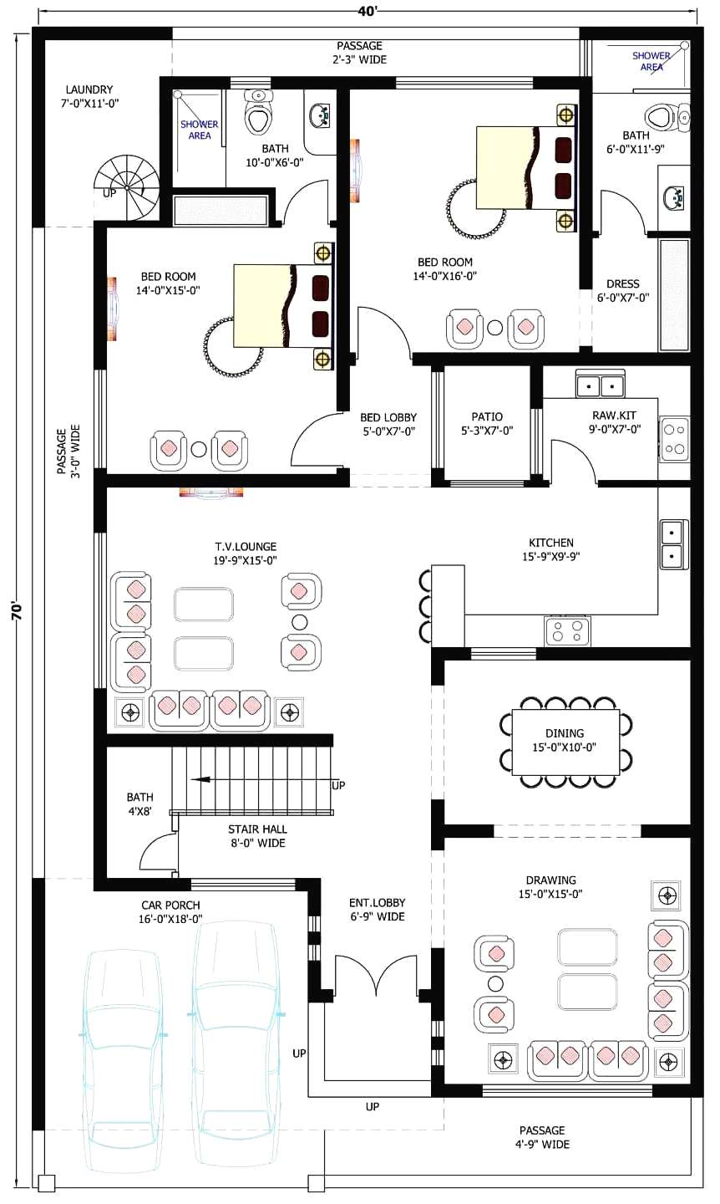
Annex-“A”

