Assessment Evidence Guide
For
AutoCAD
Level-2
Formative Assessment
0611ICT1605- Develop 2D Drawings in AutoCAD

Date 4th -9th Nov, 2024
Lahore


National Vocational & Technical
Training Commission

Instruction Sheet for the Candidate
Qualification | National Vocation Certificate Level -2 in AutoCAD
Competency Standard | 0611ICT1605-Develop 2D Drawings in AutoCAD
Purpose of Assessment | Formative Assessment
Candidate Details | Name______________________________________________________  Registration/Roll Number_______________________________________
Guidance for Candidate | To meet this standard, you are required to complete the following within 04 Hrs. time frame (for practical:  - Develop 2D Objects  - Prepare the Final set of 2D Drawings  Activity:1  Create a House Plan (30’-9” x 45’-9”) “Annex-A”  OR  Activity:2  Create Mechanical Drawing using AutoCAD 2D commands according to given Dwg “Annex-B”
Time: 4 Hrs. | During a practical assessment, under observation by an assessor, you are required to
Minimum Evidence Required | - Develop 2D Objects  - Setup user interface and save drawing interface for required specifications  - Create 2D objects with given measurements.  - Edit 2D Objects to meet set standards.  2. Prepare the Final set of 2D Drawings  - Develop 2D Drawing with given project specification and measurements.  - Plot/print drawing on scale according to required size & orientation  - Use AI Tools for assistance.

Self-Assessment Checklist
Candidate Name
Registration No.
Qualification | National Vocation Certificate Level -2 in AutoCAD
Competency Standard | 0611ICT1605-Develop 2D Drawings in AutoCAD
Purpose of Assessment | Formative Assessment
Assessment Task | - Develop 2D Objects  - Prepare the Final set of 2D Drawings  Activity:1  Create a House Plan (30’-9” x 45’-9”) “Annex-A”  OR  Activity:2  Create Mechanical Drawing using AutoCAD 2D commands according to given Dwg “Annex-B”
I can……………….
Performance Criteria | Yes | No
- Setup user interface and save drawing interface for required specifications
- Create 2D objects with given measurements.
- Edit 2D Objects to meet set standards.
- Develop 2D Drawing with given project specification and measurements.
- Plot/print drawing on scale according to required size & orientation
- Use AI Tools for assistance.

Candidate’s Signature__________________ Assessor’s Signature____________________

Date: _______________________________

Assessors Judgment Guide
Qualification | National Vocation Certificate Level -2 in AutoCAD
Competency Standard | 0611ICT1605-Develop 2D Drawings in AutoCAD
Purpose of Assessment | Formative Assessment
Candidate Details | Name: ___________________________________________  Registration/Roll Number: _______________Signature: _______________
Assessment Outcome | COMPETENT NOT YET COMPETENT  Name of the Assessor________________________________________________  Assessor’s code: ______________Signature: ____________________

Assessment Summary (to be filled by the assessor)
Activity | Method |  |  |  |  | Result
Nature of Activity | Written | Oral | Observation | Portfolio | Role Play | Competent | Not Yet Competent
Practical Skill Demonstration
Knowledge Assessment
Other Requirement

Observation Checklist
Assessment Task |  | Activity:1  Create a House Plan (30’-9” x 45’-9”) “Annex-A”  OR  Activity:2  Create Mechanical Drawing using AutoCAD 2D commands according to given Dwg “Annex-B”
During the practical assessment, candidate demonstrated the following: |  |  |  | Yes | No | Remarks
 | Setup user interface and save drawing interface for required specifications
 | Create 2D objects with given measurements.
 | Edit 2D Objects to meet set standards.
 | Develop 2D Drawing with given project specification and measurements.
 | Plot/print drawing on scale according to required size & orientation
 | Use AI Tools for assistance.
Competent |  |  | Not Yet Competent

Knowledge Assessment
Qualification | National Vocation Certificate Level -2 in AutoCAD
Competency Standard | 0611ICT1605-Develop 2D Drawings in AutoCAD
Purpose of Assessment | Formative Assessment
Candidate Details | Name: ____________________________________________________  Registration/Roll Number: _________________  Candidate Signature: ___________
Assessment Outcome | COMPETENT NOT YET COMPETENT  Name of the Assessor: ____________________________________  Assessor’s code: ________________Signature of the Assessor: _________

Candidate’s response is not required to be identical, but similar concepts and/or keywords must be used. Oral questioning may be used to clarify candidate understanding of topic and its application.

Questions (Candidate confidently answered questions correctly and demonstrated understanding of the topics and their application) |  | Satisfactory | Not Satisfactory
 | Which company provide AutoCAD software.
 | What is the purpose of the "Trim" command in AutoCAD?
 | What is deference between chamfer and fillet command.
 | Difference between Line and 2D Polyline?
 | What do you know about Array command in AutoCAD?

Feedback to the Candidate
Candidate’s Signature__________________ Assessor’s Signature _________________

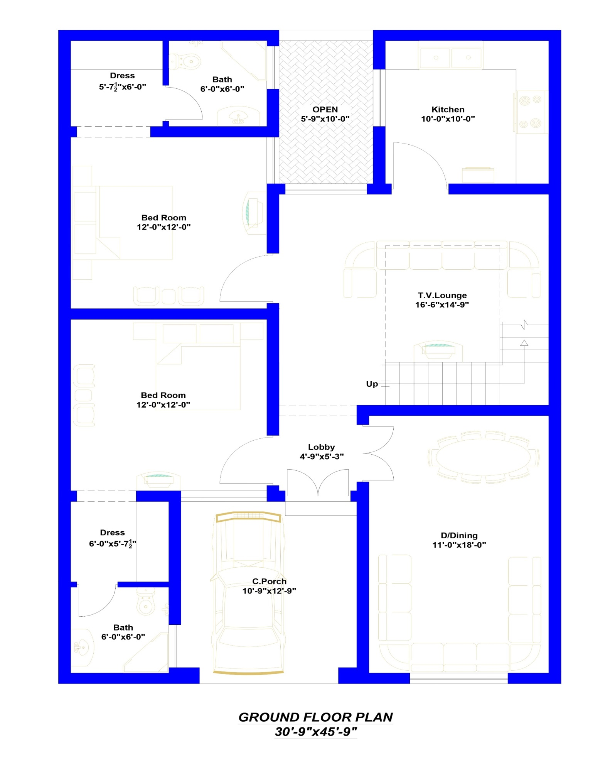
Annex-A
Annex-B
