Assessment Evidence Guide
For
Auto CAD Level-2
(Civil)
Summative Assessment

Date 4th -9th Nov, 2024
Lahore


National Vocational & Technical
Training Commission

Instruction Sheet for the Candidate
Qualification | National Vocation Certificate Level 2 in Auto CAD
Competency Standard | 0611ICT1601-Follow Occupational Health and Safety practices  0611ICT1602-Demonstrate Basic Numeracy Skills  0611ICT1603-Perform Basic Computer Operations  0611ICT1604-Perform Basic Manual Drawing  0611ICT1605-Develop 2D Drawings in Auto CAD  0611ICT1606-Develop 3D Model in AutoCAD  0611ICT1607- Develop Entrepreneurial Skills
Purpose of Assessment | Summative Assessment
Candidate Details | Name______________________________________________________  Registration/Roll Number_______________________________________
Guidance for Candidate | To meet this standard, you are required to complete the following within 05 Hrs. time frame (for practical demonstration & assessment):  Activity1:  Calculate plot covered area and each Portion (Bed room, Bath etc.) covered area in MS Excel “Annex-A”.  Activity2:  Draw 2D ground floor plan, Elevation of the given plot according to given dimensions and change it into 3D. “Annex-A”
Time: 06 Hrs. | During a practical assessment, under observation by an assessor, you are required to
Minimum Evidence Required | Activity 1  - Perform inter conversion of Measuring units  - Develop a worksheet as per given data.  - Apply Formulas according to the requirement.  Activity 2  - Develop 2D Drawing with given project specification and measurements.  - Plot drawing on scale according to required size & orientation  - Create 3D models (civil)  - Assign cameras to execute different views of required 3D Model.  - Render and print the 3D model according to required size & orientation

Self-Assessment Checklist
Candidate Name
Registration No.
Qualification | National Vocation Certificate Level 2 in Auto CAD
Competency Standard | 0611ICT1601-Follow Occupational Health and Safety practices  0611ICT1602-Demonstrate Basic Numeracy Skills  0611ICT1603-Perform Basic Computer Operations  0611ICT1604-Perform Basic Manual Drawing  0611ICT1605-Develop 2D Drawings in Auto CAD  0611ICT1606-Develop 3D Model in AutoCAD  0611ICT1607- Develop Entrepreneurial Skills
Purpose of Assessment | Summative Assessment
Assessment Task | Activity1:  Calculate plot covered area and each Portion (Bed room, Bath etc.) covered area in MS Excel “Annex-A”.  Activity2:  Draw 2D ground floor plan, Elevation of the given plot according to given dimensions and change it into 3D. “Annex-A”
I can……………….
Performance Criteria | Yes | No
Activity 1
- Perform inter conversion of Measuring units
- Develop a worksheet as per given data.
- Apply Formulas according to the requirement.
Activity 2
- Develop 2D Drawing with given project specification and measurements.
- Plot drawing on scale according to required size & orientation
- Create 3D models (civil)
- Assign cameras to execute different views of required 3D Model.
- Render and print the 3D model according to required size & orientation

Candidate’s Signature__________________ Assessor’s Signature____________________
Date: ______________________________

Assessors Judgment Guide
Qualification | National Vocation Certificate Level 2 in Auto CAD
Competency Standard | 0611ICT1601-Follow Occupational Health and Safety practices  0611ICT1602-Demonstrate Basic Numeracy Skills  0611ICT1603-Perform Basic Computer Operations  0611ICT1604-Perform Basic Manual Drawing  0611ICT1605-Develop 2D Drawings in Auto CAD  0611ICT1606-Develop 3D Model in AutoCAD  0611ICT1607- Develop Entrepreneurial Skills
Purpose of Assessment | Summative Assessment
Candidate Details | Name: ___________________________________________________  Registration/Roll Number: _____________________  Signature: _______________
Assessment Outcome | COMPETENT NOT YETCOMPETENT  Name of the Assessor________________________________________________  Assessor’s code_________  Signature: ________________________________

Assessment Summary (to be filled by the assessor)
Activity | Method |  |  |  |  | Result
Nature of Activity | Written | Oral | Observation | Portfolio | Role Play | Competent | Not Yet Competent
Practical Skill Demonstration
Knowledge Assessment
Other Requirement

Observation Checklist
Assessment Task |  | Activity1:  Calculate plot covered area and each Portion (Bed room, Bath etc.) covered area in MS word/ MS Excel “Annex-A”.  Activity2:  Draw 2D ground floor plan, Elevation of the given plot according to given dimensions and change it into 3D. “Annex-A”
During the practical assessment, candidate demonstrated the following: |  |  |  | Yes | No | Remarks
Activity 1
 | Performed inter conversion of Measuring units
 | Developed a worksheet as per given data.
 | Applied Formulas according to the requirement.
Activity 2
 | Developed 2D Drawing with given project specification and measurements.
 | Plotted drawing on scale according to required size & orientation
 | Created 3D models (civil)
 | Assigned cameras to execute different views of required 3D Model.
 | Rendered and printed the 3D model according to required size & orientation
Competent |  |  | Not yet Competent

Knowledge Assessment
Qualification | National Vocation Certificate Level 2 in Auto CAD
Competency Standard | 0611ICT1601-Follow Occupational Health and Safety practices  0611ICT1602-Demonstrate Basic Numeracy Skills  0611ICT1603-Perform Basic Computer Operations  0611ICT1604-Perform Basic Manual Drawing  0611ICT1605-Develop 2D Drawings in Auto CAD  0611ICT1606-Develop 3D Model in AutoCAD  0611ICT1607- Develop Entrepreneurial Skills
Purpose of Assessment | Summative Assessment
Candidate Details | Name: ______________________________________________________________  Registration/Roll Number: _________________  Candidate Signature: ___________
Assessment Outcome | COMPETENT NOT YETCOMPETENT  Name of the Assessor: _________________________________  Assessor’s code: ____________________________________  Signature of the Assessor: _______________________
 | Candidate’s response is not required to be identical, but similar concepts and/or keywords must be used. Oral questioning may be used to clarify candidate understanding of topic and its application.

Questions (Candidate confidently answered questions correctly and demonstrated understanding of the topics and their application) |  | Satisfactory | Not Satisfactory
 | “Auto CAD” stands for
 | Shortcut for “list” command
 | Shortcut for Ortho on/off command
 | What is the purpose of subtract command in Auto CAD?
 | What do you mean by Boundary command?

Feedback to the Candidate
Candidate’s Signature__________________ Assessor’s Signature _________________

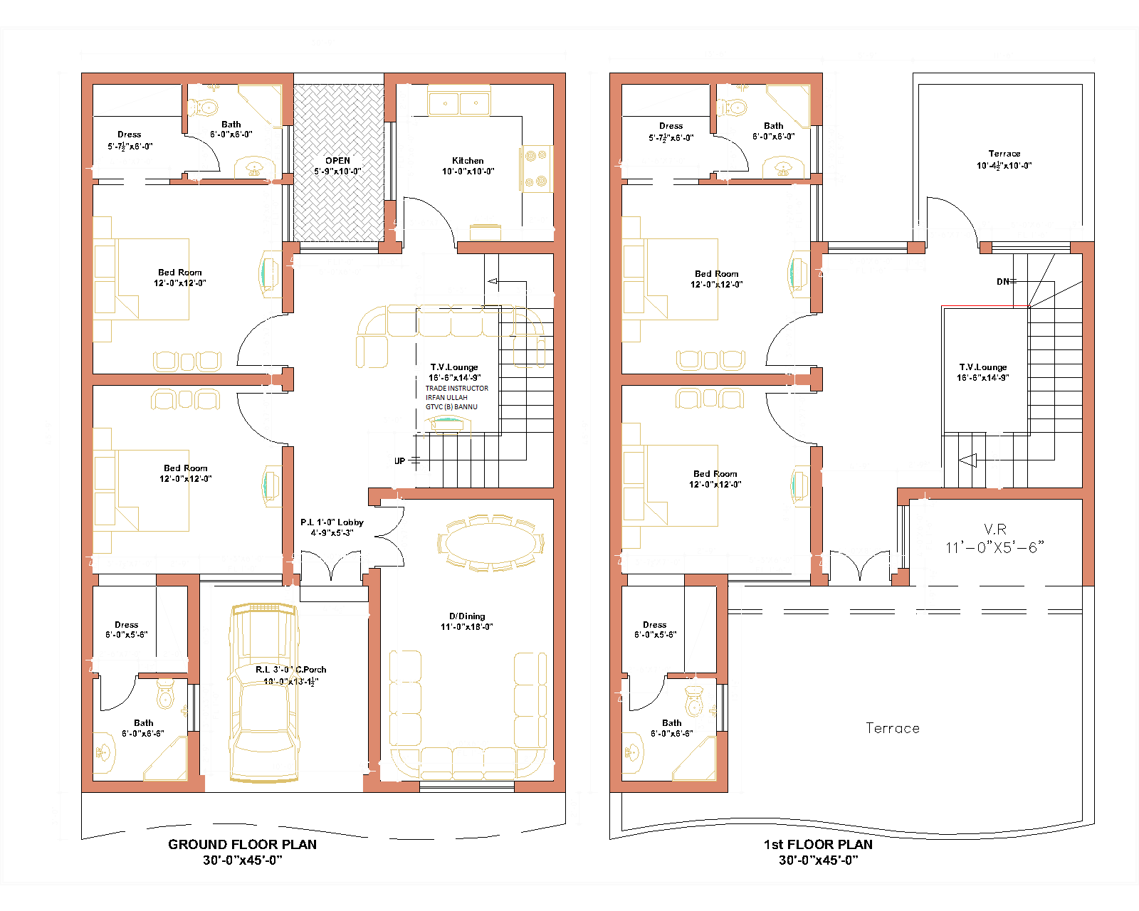
ANNEXURE-“A” PAGE-1

ANNEXURE- “A” PAGE-2
