Assessment Evidence Guide
For
Auto CAD Level-2
(Mechanical)
Summative Assessment

Date 4th -9th November, 2024
Lahore


National Vocational & Technical
Training Commission

Instruction Sheet for the Candidate
Qualification | National Vocation Certificate Level - 2 Auto CAD
Competency Standard | 0611ICT1601-Follow Occupational Health and Safety practices  0611ICT1602-Demonstrate Basic Numeracy Skills  0611ICT1603-Perform Basic Computer Operations  0611ICT1604-Perform Basic Manual Drawing  0611ICT1605 -Develop 2D Drawings in Auto CAD  0611ICT1606-Develop 3D Model in AutoCAD  0611ICT1607-Develop Entrepreneurial Skills  0611ICT1608-Plan Market and Site Visit
Purpose of Assessment | Summative Assessment
Candidate Details | Name______________________________________________________  Registration/Roll Number_______________________________________
Guidance for Candidate | To meet this standard, you are required to complete the following within 05 Hrs. time frame (for practical demonstration & assessment):  Activity1:  Create 3D object according to given dimensions “Annex-A”  Activity2:  Create 3D object according to given dimensions and also make Orthographic Projection of this 3d Object “Annex-B”
Time: 06 Hrs. | During a practical assessment, under observation by an assessor, you are required to
Minimum Evidence Required | - Develop 2D Drawing with given project specification and measurements.  - Create 3D models (civil)  - Assign cameras to execute different views of required 3D Model.  - Render and printed the 3D model according to required size & orientation  - Adopt green practices as following:  - Use energy efficient computers  - Reduce paper usage/reuse paper  - Use both sides of paper  - Adjust monitor settings for brightness  - Use energy efficient lights  - Basic maintenance e of tool/equipment  - House keeping

Self-Assessment Checklist
Candidate Name
Registration No.
Qualification | National Vocation Certificate Level 02 Auto CAD
Competency Standard | 0611ICT1601-Follow Occupational Health and Safety practices  0611ICT1602-Demonstrate Basic Numeracy Skills  0611ICT1603-Perform Basic Computer Operations  0611ICT1604-Perform Basic Manual Drawing  0611ICT1605 -Develop 2D Drawings in Auto CAD  0611ICT1606-Develop 3D Model in AutoCAD  0611ICT1607-Develop Entrepreneurial Skills  0611ICT1608-Plan Market and Site Visit
Purpose of Assessment | Summative Assessment
Assessment Task | Activity1:  Create 3D object according to given dimensions “Annex-A”  Or  Activity2:  Create 3D object according to given dimensions and also make Orthographic Projection of this 3d Object “Annex-B”

I can……………….
Performance Criteria | Yes | No
- Adopt green practices as following:
- Use energy efficient computers
- Reduce paper usage/reuse paper
- Use both sides of paper
- Adjust monitor settings for brightness
- Use energy efficient lights
- Basic maintenance e of tool/equipment
- House keeping
- Develop 2D Drawing with given project specification and measurements.
- Create 3D models (civil)
- Assign cameras to execute different views of required 3D Model.
- Render and printed the 3D model according to required size & orientation

Candidate’s Signature__________________ Assessor’s Signature____________________
Date: _________________________
Assessors Judgment Guide
Qualification | National Vocation Certificate Level - 2 Auto CAD
Competency Standard | 0611ICT1601-Follow Occupational Health and Safety practices  0611ICT1602-Demonstrate Basic Numeracy Skills  0611ICT1603-Perform Basic Computer Operations  0611ICT1604-Perform Basic Manual Drawing  0611ICT1605 -Develop 2D Drawings in Auto CAD  0611ICT1606-Develop 3D Model in AutoCAD  0611ICT1607-Develop Entrepreneurial Skills  0611ICT1608-Plan Market and Site Visit
Purpose of Assessment | Summative Assessment
Candidate Details | Name: _____________________________________________________  Registration/Roll Number: ______________________  Signature: _______________
Assessment Outcome | COMPETENT NOT YETCOMPETENT  Name of the Assessor_____________________________________________  Assessor’s code: ____________________  Signature: ________________________________

Assessment Summary (to be filled by the assessor)
Activity | Method |  |  |  |  | Result
Nature of Activity | Written | Oral | Observation | Portfolio | Role Play | Competent | Not Yet Competent
Practical Skill Demonstration
Knowledge Assessment
Other Requirement

Observation Checklist
Assessment Task |  | Activity1:  Create 3D object according to given dimensions “Annex-A”  Or  Activity2:  Create 3D object according to given dimensions and also make Orthographic Projection of this 3d Object “Annex-B”
During the practical assessment, candidate demonstrated the following: |  |  |  | Yes | No | Remarks
Adopt green practices as following:
- Use energy efficient computers
- Reduce paper usage/reuse paper
- Use both sides of paper
- Adjust monitor settings for brightness
- Use energy efficient lights
- Basic maintenance e of tool/equipment
- House keeping
 | Develop 2D Drawing with given project specification and measurements.
 | Create 3D models (civil)
 | Assign cameras to execute different views of required 3D Model.
 | Render and printed the 3D model according to required size & orientation
Competent |  |  | Not yet Competent

Knowledge Assessment
Qualification | National Vocation Certificate Level - 2 Auto CAD
Competency Standard | 0611ICT1601-Follow Occupational Health and Safety practices  0611ICT1602-Demonstrate Basic Numeracy Skills  0611ICT1603-Perform Basic Computer Operations  0611ICT1604-Perform Basic Manual Drawing  0611ICT1605 -Develop 2D Drawings in Auto CAD  0611ICT1606-Develop 3D Model in AutoCAD  0611ICT1607-Develop Entrepreneurial Skills  0611ICT1608-Plan Market and Site Visit
Purpose of Assessment | Summative Assessment
Candidate Details | Name: ______________________________________________________________  Registration/Roll Number: _________________  Candidate Signature: ___________
Assessment Outcome | COMPETENT NOT YETCOMPETENT  Name of the Assessor: ________________________________________________  Assessor’s code: ___________Signature of the Assessor: ____________
 | Candidate’s response is not required to be identical, but similar concepts and/or keywords must be used. Oral questioning may be used to clarify candidate understanding of topic and its application.

Questions (Candidate confidently answered questions correctly and demonstrated understanding of the topics and their application) |  | Satisfactory | Not Satisfactory
 | “3D” means
 | Shortcut for “list” command
 | Shortcut for Ortho on/off command
4. | What is the purpose of subtract command in Auto CAD?
5. | What do you mean by Boundary command?

Feedback to the Candidate
Candidate’s Signature__________________ Assessor’s Signature _________________

ANNEXURE- “A”

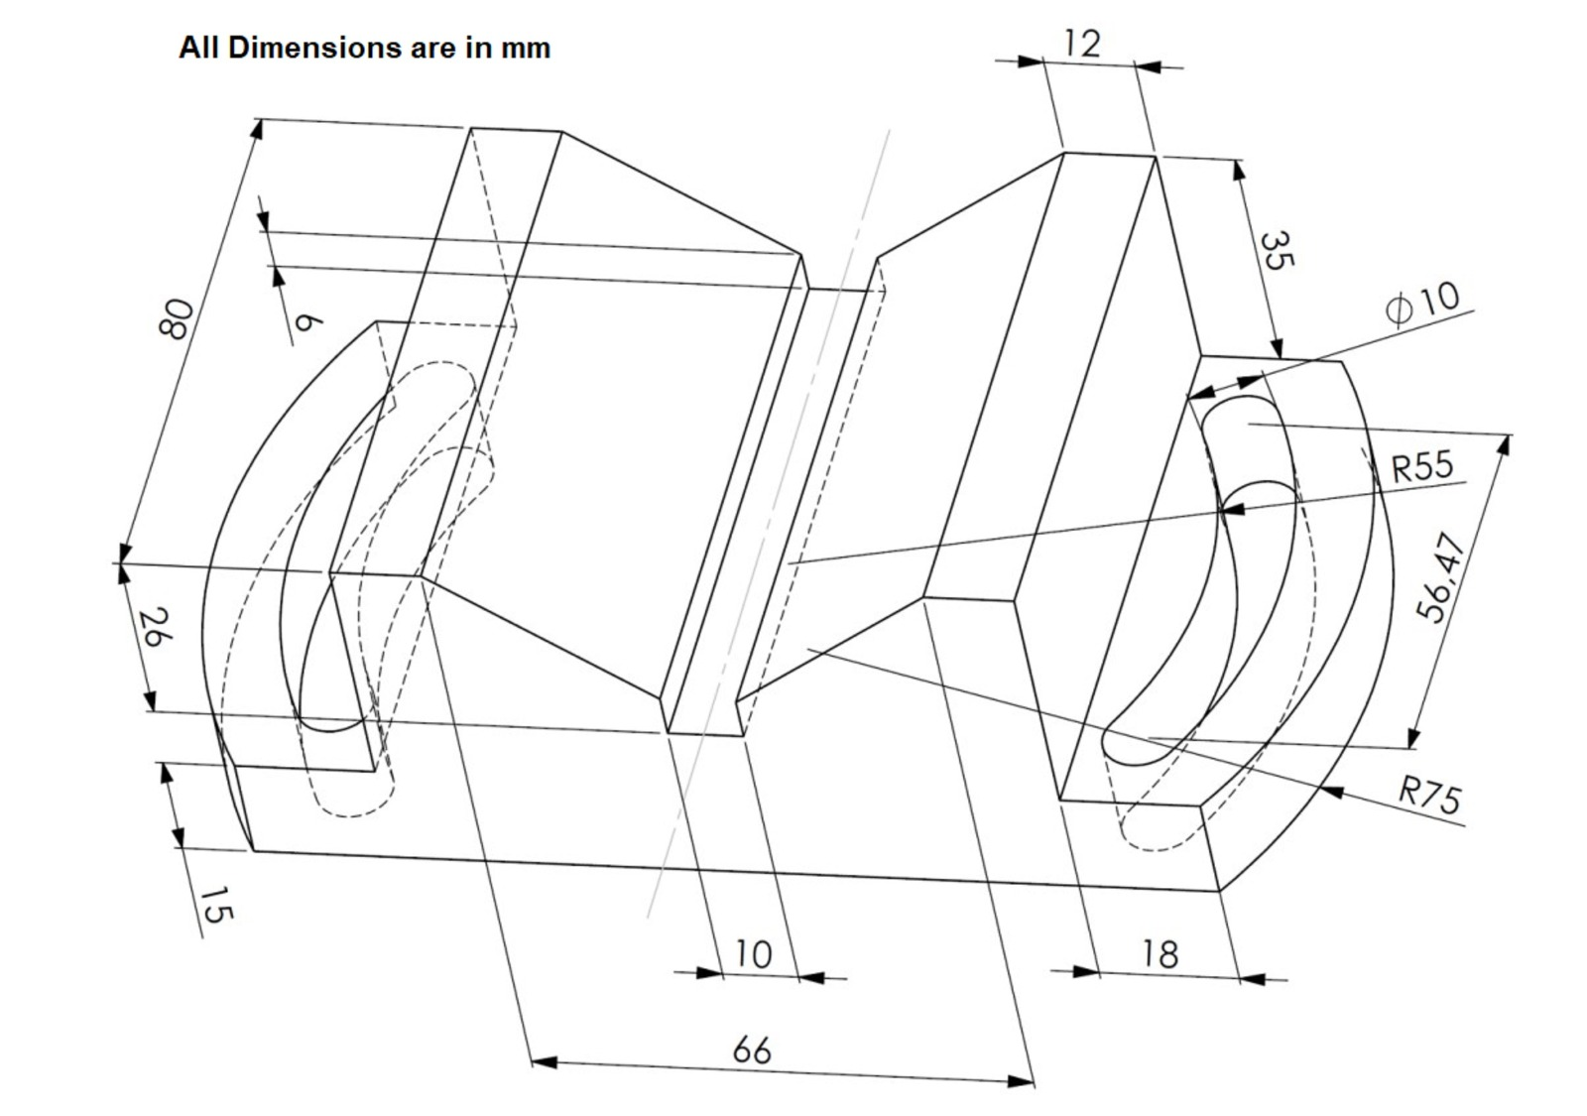

ANNEXURE-“B”

