Assessment Evidence Guide
For
CNC MACHINIST
Level IV
0715MMT3603 Interpret and Develop Drawing and Design
Date 04-09 November 2024
Lahore


National Vocational & Technical
Training Commission

Instruction Sheet for the Candidate
Qualification | CNC MACHINIST Level IV
Competency Standard | 0715MMT3603 Interpret and Develop Drawing and Design
Purpose of Assessment | Formative Assessment
Candidate Details | Name______________________________________________________  Registration/Roll Number_______________________________________
Guidance for Candidate | To meet this standard, you are required to complete the following within 04 Hrs. time frame (for practical demonstration & assessment):  - Develop Fundamentals of Engineering Drawing  - Interpret and Develop 2D Drawing/Sketch  - Develop 3D Model  Activity:  As per Annexure A:  Interpret and Develop 3D Model of the given drawing.
Time: 04 Hrs. | During a practical assessment, under observation by an assessor, you are required to:
Minimum Evidence Required | - Check and inspect design requirements for the product or component to be produced.  - Use appropriate computer software for developing 3D model of the product, component or assembly.  - Use appropriate user interface and apply relevant commands for developing 3D model or component.  - Select proper drawing units  - Select coordinate system  - Apply different types of commands (Line, Polyline, Arc, Chamfer, Fillet etc.)  - Draw different types of angles.  - Apply different types of 3D commands (Extrude, Extrude Cut, Revolve, Sweep, Blend, Loft etc.)  - Modify 3D Model in line with the requirements.  - Use appropriate computer software for developing 3D model of the product, component or assembly.  - Use appropriate user interface and apply relevant commands for developing 3D models or components.  - Modify 3D Model in line with the requirements.

Self-Assessment Checklist
Candidate Name
Registration No.
Qualification | CNC MACHINIST Level IV
Competency Standard | 0715MMT3603 Interpret and Develop Drawing and Design
Purpose of Assessment | Formative Assessment
Assessment Task | - Develop Fundamentals of Engineering Drawing  - Interpret and Develop 2D Drawing/Sketch  - Develop 3D Model  Activity:  As per Annexure A:  Interpret and Develop 3D Model of the given drawing.
I can……………….
Performance Criteria | Yes | No
- Check and inspect design requirements for the product or component to be produced.
- Use appropriate computer software for developing 3D model of the product, component or assembly.
- Use appropriate user interface and apply relevant commands for developing 3D model or component.
- Select proper drawing units
- Select coordinate system
- Apply different types of commands (Line, Polyline, Arc, Chamfer, Fillet etc.)
- Draw different types of angles.
- Apply different types of 3D commands (Extrude, Extrude Cut, Revolve, Sweep, Blend, Loft etc.)
- Modify 3D Model in line with the requirements.

Candidate’s Signature__________________ Assessor’s Signature____________________

Date: _______________________________

Assessors Judgment Guide
Qualification | CNC MACHINIST Level IV
Competency Standard | 0715MMT3603 Interpret and Develop Drawing and Design
Purpose of Assessment | Formative Assessment
Candidate Details | Name: ______________________________________________________________  Registration/Roll Number: ______________________ Signature: _______________
Assessment Outcome | COMPETENT NOT YET COMPETENT  Name of the Assessor________________________________________________  Assessor’s code: ____________________________________________________  Signature: ________________________________

Assessment Summary (to be filled by the assessor)
Activity | Method |  |  |  |  | Result
Nature of Activity | Written | Oral | Observation | Portfolio | Role Play | Competent | Not Yet Competent
Practical Skill Demonstration
Knowledge Assessment
Other Requirement

Observation Checklist
Assessment Task |  | - Develop Fundamentals of Engineering Drawing  - Interpret and Develop 2D Drawing/Sketch  - Develop 3D Model  Activity:  As per Annexure A:  Interpret and Develop 3D Model of the given drawing.
During the practical assessment, candidate demonstrated the following: |  |  |  | Yes | No | Remarks
 | Did the candidate check and inspect design requirements for the product or component to be produced?
 | Did the candidate use appropriate computer software for developing 3D model of the product, component or assembly?
 | Did the candidate use appropriate user interface and apply relevant commands for developing 3D model or component?
 | Did the candidate select proper drawing units?
 | Did the candidate select coordinate system?
 | Did the candidate apply different types of commands (Line, Polyline, Arc, Chamfer, Fillet etc.)?
 | Did the candidate draw different types of angles?
 | Did the candidate apply different types of 3D commands (Extrude, Extrude Cut, Revolve, Sweep, Blend, Loft etc.)?
 | Did the candidate modify 3D Model in line with the requirements?
Competent |  |  | Not Yet Competent

Knowledge Assessment
Qualification | CNC MACHINIST Level IV
Competency Standard | 0715MMT3603 Interpret and Develop Drawing and Design
Purpose of Assessment | Formative Assessment
Candidate Details | Name: ______________________________________________________________  Registration/Roll Number: _________________ Candidate Signature: ___________
Assessment Outcome | COMPETENT NOT YET COMPETENT  Name of the Assessor: ________________________________________________  Assessor’s code: ____________________________________________________  Signature of the Assessor: _______________________

Candidate’s response is not required to be identical, but similar concepts and/or keywords must be used. Oral questioning may be used to clarify candidate understanding of topic and its application.

Questions (Candidate confidently answered questions correctly and demonstrated understanding of the topics and their application) |  | Satisfactory | Not Satisfactory
 | Which coordinate system is typically used in engineering drawings for defining positions?
 | How do you create a rounded corner between two lines in CAD?
 | What command would you use to modify an existing line in a CAD drawing?
 | What software would you typically use to develop 3D models of CNC parts or assemblies?
 | When would you use the "Loft" command in 3D modeling?
 | Which command in CAD is used to create a 3D object from a 2D shape?
 | How do you check the design requirements for a product or component in 3D modeling?

Feedback to the Candidate
Candidate’s Signature__________________ Assessor’s Signature _________________

Annexure A
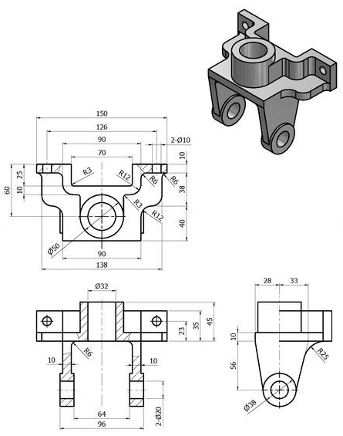

Answers Sheet
Which coordinate system is typically used in engineering drawings for defining positions?
The Cartesian coordinate system (X, Y, Z axes) is commonly used for defining positions.
How do you create a rounded corner between two lines in CAD?
The "Fillet" command is used to create a rounded corner between two lines.
What command would you use to modify an existing line in a CAD drawing?
The "Edit" or "Modify" command can be used to adjust an existing line.
What software would you typically use to develop 3D models of CNC parts or assemblies?
SolidWorks, Autodesk Fusion 360, or CATIA are commonly used for developing 3D models.
When would you use the "Loft" command in 3D modeling?
The "Loft" command is used to create a 3D shape by blending two or more different profiles.
Which command in CAD is used to create a 3D object from a 2D shape?
The "Extrude" command is used to create a 3D object from a 2D shape.
How do you check the design requirements for a product or component in 3D modeling?
Review the design specifications, dimensions, and material requirements provided in the drawing

