Assessment Evidence Guide
For
National Competency Standards
CNC MACHINIST
Level IV
Formative Assessment
0715MMT3604 Perform CNC Lathe Operation
Date 04-09 November, 2024
Lahore


National Vocational & Technical
Training Commission

Instruction Sheet for the Candidate
Qualification | CNC MACHINIST Level IV
Competency Standard | 0715MMT3604 Perform CNC Lathe Operation
Purpose of Assessment | Formative Assessment
Candidate Details | Name______________________________________________________  Registration/Roll Number_______________________________________
Guidance for Candidate | To meet this standard, you are required to complete the following within 04 Hrs. time frame (for practical demonstration & assessment):  - Understand and operate the control panel  - Calculate coordinates of job  - Mount and align the job (Tool and work offset)  - Prepare Manual Program  - Prepare canned cycle program  - Perform Simulation (e.g. Swansoft/CIMCO etc) Simulators  - Feed the Program in machine for production  Activity: Manufacture the workpiece according to the specifications outlined in Annexure A, using CNC lathe machine. This can be achieved through manual programming or by utilizing CAD/CAM software.
Time: 4 Hrs. | During a practical assessment, under observation by an assessor, you are required to
Minimum Evidence Required | - Perform machine zero positioning to ensure accurate reference points.  - Move the turret along the X and Z axes using the Jog/Manual/MPG keys.  - Utilize program editing keys such as Program, Edit, MDI, Insert, Alter, EOB, Cancel, and Delete for adjustments.  - Adjust the feed and spindle speed using the Override keys.  - Calculate the turning job's coordinates based on the drawing.  - Secure the job on the CNC Lathe machine's table.  - Properly set and align the tool in the tool holder.  - Perform work reference setting (tool offsetting) for each tool.  - Demonstrate the use of G-codes and M-codes in CNC Lathe operations.  - Develop a program in accordance with the drawing.  - Create a threading program based on the drawing.  - Insert the part program into the simulation software.  - Run the program simulation to detect and correct potential errors.  - Input the program into the CNC machine using PROGRAM, EDIT, INSERT, ALTER, and EOB keys.  - Run the program in single-block mode to ensure proper execution.  - Execute the program for production operations.
Self-Assessment Checklist
Candidate Name
Registration No.
Qualification | CNC MACHINIST Level IV
Competency Standard | 0715MMT3604 Perform CNC Lathe Operation
Purpose of Assessment | Formative Assessment
Assessment Task | - Understand and operate the control panel  - Calculate coordinates of job  - Mount and align the job (Tool and work offset)  - Prepare Manual Program  - Prepare canned cycle program  - Perform Simulation (e.g. Swansoft/CIMCO etc) Simulators  - Feed the Program in machine for production  Activity: Manufacture the workpiece according to the specifications outlined in Annexure A, using CNC lathe machine. This can be achieved through manual programming or by utilizing CAD/CAM software.
I can……………….
Performance Criteria | Yes | No
- Perform machine zero positioning to ensure accurate reference points.
- Move the turret along the X and Z axes using the Jog/Manual/MPG keys.
- Utilize program editing keys such as Program, Edit, MDI, Insert, Alter, EOB, Cancel, and Delete for adjustments.
- Adjust the feed and spindle speed using the Override keys.
- Calculate the turning job's coordinates based on the drawing.
- Secure the job on the CNC Lathe machine's table.
- Properly set and align the tool in the tool holder.
- Perform work reference setting (tool offsetting) for each tool.
- Demonstrate the use of G-codes and M-codes in CNC Lathe operations.
- Develop a program in accordance with the drawing.
- Create a threading program based on the drawing.
- Insert the part program into the simulation software.
- Run the program simulation to detect and correct potential errors.
- Input the program into the CNC machine using PROGRAM, EDIT, INSERT, ALTER, and EOB keys.
- Run the program in single-block mode to ensure proper execution.
- Execute the program for production operations.
Candidate’s Signature__________________ Assessor’s Signature____________________
Date: _______________________________
Assessors Judgment Guide
Qualification | CNC MACHINIST Level IV
Competency Standard | 0715MMT3604-Perform CNC Lathe Operation
Purpose of Assessment | Formative Assessment
Candidate Details | Name: ______________________________________________________________  Registration/Roll Number: ______________________ Signature: _______________
Assessment Outcome | COMPETENT NOT YET COMPETENT  Name of the Assessor________________________________________________  Assessor’s code: ____________________________________________________  Signature: ________________________________

Assessment Summary (to be filled by the assessor)
Activity | Method |  |  |  |  | Result
Nature of Activity | Written | Oral | Observation | Portfolio | Role Play | Competent | Not Yet Competent
Practical Skill Demonstration
Knowledge Assessment
Other Requirement

Observation Checklist
Assessment Task |  | • Understand and operate the control panel  • Calculate coordinates of job  • Mount and align the job (Tool and work offset)  • Prepare Manual Program  • Prepare canned cycle program  • Perform Simulation  • Feed the Program in machine for production  Activity: Manufacture the workpiece according to the specifications outlined in Annexure A, using CNC lathe machine. This can be achieved through manual programming or by utilizing CAD/CAM software.
During the practical assessment, candidate demonstrated the following: |  |  |  | Yes | No | Remarks
 | Machine zero positioning is performed to establish accurate reference points.
 | The turret is moved along the X and Z axes using Jog, Manual, or MPG keys.
 | Program editing keys, such as Program, Edit, MDI, Insert, Alter, EOB, Cancel, and Delete, are used for necessary adjustments.
 | Feed and spindle speed are adjusted through the Override keys.
 | Turning job coordinates are calculated based on the drawing.
 | The job is securely mounted on the CNC Lathe machine's table.
 | The tool is properly set and aligned in the tool holder.
 | Work reference setting (tool offsetting) is conducted for each tool.
 | G-codes and M-codes are used to manage CNC Lathe operations.
 | A program is developed in accordance with the drawing specifications.
 | A threading program is created based on the drawing.
 | The part program is inserted into the simulation software.
 | The program simulation is run to identify and correct potential errors.
 | The program is input into the CNC machine using PROGRAM, EDIT, INSERT, ALTER, and EOB keys.
 | The program is initially run in single-block mode to verify correct execution.
 | The program is executed for production operations.
 | The manufactured part was checked and inspected.
Competent |  |  | Not Yet Competent

Knowledge Assessment
Qualification | CNC MACHINIST Level IV
Competency Standard | 0715MMT3604-Perform CNC Lathe Operation
Purpose of Assessment | Formative Assessment
Candidate Details | Name: ______________________________________________________________  Registration/Roll Number: _________________ Candidate Signature: ___________
Assessment Outcome | COMPETENT NOT YET COMPETENT  Name of the Assessor: ________________________________________________  Assessor’s code: ____________________________________________________  Signature of the Assessor: _______________________

Candidate’s response is not required to be identical, but similar concepts and/or keywords must be used. Oral questioning may be used to clarify candidate understanding of topic and its application.

Questions (Candidate confidently answered questions correctly and demonstrated understanding of the topics and their application) |  | Satisfactory | Not Satisfactory
 | Define CNC lathe.
 | List three common types of lathe tools.
 | Name four main components of a CNC lathe.
 | What role does a chuck play in a CNC lathe?
 | Why is coolant used in CNC lathes?
 | What are G and M codes in CNC?
 | Define what CAD and CAM stand for.
Annexure A
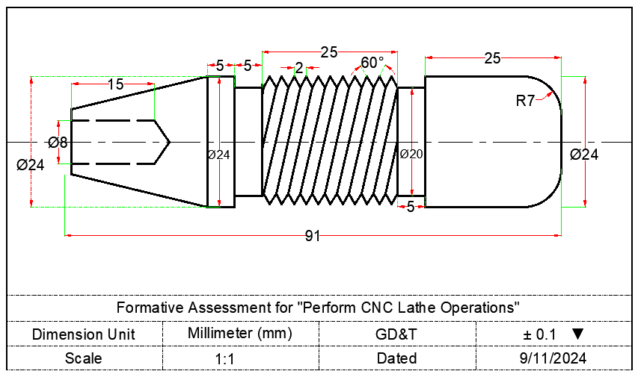
Feedback to the Candidate
Candidate’s Signature__________________ Assessor’s Signature _________________

