Assessment Evidence Guide
For
CNC MACHINIST
Level IV
Formative Assessment
0715MMT3605 Perform CNC Milling Operations
Date 04-09 November, 2024
Lahore


National Vocational & Technical
Training Commission

Instruction Sheet for the Candidate
Qualification | CNC MACHINIST Level IV
Competency Standard | 0715MMT3605 CNC Perform CNC Milling Operations
Purpose of Assessment | Formative Assessment
Candidate Details | Name______________________________________________________  Registration/Roll Number_______________________________________
Guidance for Candidate | To meet this standard, you are required to complete the following within 05 Hrs. time frame (for practical demonstration & assessment):  - Mounting the Workpiece  - Program Generation  - Running Simulation  - Feeding the Program into the Machine  - Performing CNC Milling  Activity: Create a CAD drawing and corresponding CAM program, then produce the part on the CNC milling machine according to the specifications in Annexure A.
Time: 5 Hrs. | During a practical assessment, under observation by an assessor, you are required to
Minimum Evidence Required | - Mount the workpiece according to job specifications.  - Use appropriate fixtures to ensure dimensional accuracy.  - Verify tool and workpiece alignment (co-axiality, concentricity).  - Implement safety measures to prevent accidental operation.  - Import the 3D model correctly into the selected CAM software.  - Define the reference point and material for machining, ensuring the XYZ zero point aligns with the work offset.  - Apply necessary machining features and toolpath strategies.  - Generate the part program correctly using the CNC machine’s post-processor.  - Ensure correct G/M codes, coordinates, and feed rates are used.  - Save and document the part program properly for the machine.  - Load the part program successfully into the simulation platform.  - Verify tool movements against the defined sequence.  - Identify and modify any errors as needed.  - Ensure synchronization between the CNC control unit and the program.  - Select the correct part program for execution.  - Confirm all safety operation protocols.  - Adjust feeds, speeds, and machine overrides correctly.  - Set the machine to execution mode and start the machining sequence.  - Monitor movements during operation.  - Inspect the final product for accuracy and precision against design specifications.

Self-Assessment Checklist
Candidate Name
Registration No.
Qualification | CNC MACHINIST Level-IV
Competency Standard | 0715MMT3605 CNC Perform CNC Milling Operations
Purpose of Assessment | Formative Assessment
Assessment Task | - Mounting the Workpiece  - Program Generation  - Running Simulation  - Feeding the Program into the Machine  - Performing CNC Milling  Activity: Create a CAD drawing and corresponding CAM program, then produce the part on the CNC milling machine according to the specifications in Annexure A.
I can……………….
Performance Criteria | Yes | No
- Mount the workpiece according to job specifications.
- Use appropriate fixtures to ensure dimensional accuracy.
- Verify tool and workpiece alignment (co-axiality, concentricity).
- Implement safety measures to prevent accidental operation.
- Import the 3D model correctly into the selected CAM software.
- Define the reference point and material for machining, ensuring the XYZ zero point aligns with the work offset.
- Apply necessary machining features and toolpath strategies.
- Generate the part program correctly using the CNC machine’s post-processor.
- Ensure correct G/M codes, coordinates, and feed rates are used.
- Save and document the part program properly for the machine.
- Load the part program successfully into the simulation platform.
- Verify tool movements against the defined sequence.
- Identify and modify any errors as needed.
- Ensure synchronization between the CNC control unit and the program.
- Select the correct part program for execution.
- Confirm all safety operation protocols.
- Adjust feeds, speeds, and machine overrides correctly.
- Set the machine to execution mode and start the machining sequence.
- Monitor movements during operation.
- Inspect the final product for accuracy and precision against design specifications.
Candidate’s Signature__________________ Assessor’s Signature____________________
Date: _____________________________
Assessors Judgment Guide
Qualification | CNC MACHINIST Level IV
Competency Standard | 0715MMT3605 Perform CNC Milling Operations
Purpose of Assessment | Formative Assessment
Candidate Details | Name: ______________________________________________________________  Registration/Roll Number: ______________________ Signature: _______________
Assessment Outcome | COMPETENT NOT YET COMPETENT  Name of the Assessor________________________________________________  Assessor’s code: ____________________________________________________  Signature: ________________________________

Assessment Summary (to be filled by the assessor)
Activity | Method |  |  |  |  | Result
Nature of Activity | Written | Oral | Observation | Portfolio | Role Play | Competent | Not Yet Competent
Practical Skill Demonstration
Knowledge Assessment
Other Requirement

Observation Checklist
Assessment Task |  | - Mounting the Workpiece  - Program Generation  - Running Simulation  - Feeding the Program into the Machine  - Performing CNC Milling  Activity: Create a CAD drawing and corresponding CAM program, then produce the part on the CNC milling machine according to the specifications in Annexure A.
During the practical assessment, candidate demonstrated the following: |  |  |  | Yes | No | Remarks
 | Is appropriate personal protective equipment (PPE) being worn?
 | Has the CNC machine been inspected for visible issues before operation?
 | Are electrical connections and cables checked for safety and proper insulation?
 | Is the workpiece mounted according to job specifications?
 | Are appropriate fixtures used to ensure dimensional accuracy?
 | Is the tool and workpiece alignment verified (co-axiality, concentricity)?
 | Have safety measures been implemented to prevent accidental operation?
 | Is the 3D model correctly imported into the selected CAM software?
 | Is the reference point and material defined for machining?
 | Have the necessary machining features and toolpath strategies been applied?
 | Is the part program generated correctly using the CNC machine's post-processor?
 | Are the correct G/M codes, coordinates, and feed rates used?
 | Is the part program saved and documented properly for the machine?
 | Is the part program successfully loaded into the simulation platform?
 | Are the tool movements verified against the defined sequence?
 | Have any errors been identified and modified as needed?
 | Is there proper synchronization between the CNC control unit and the program?
 | Is the machine switched to receiving mode before loading the program?
 | Is the correct part program selected for execution?
 | Are all safety operation protocols confirmed?
 | Are feeds, speeds, and machine overrides adjusted correctly?
Competent |  |  | Not Yet Competent

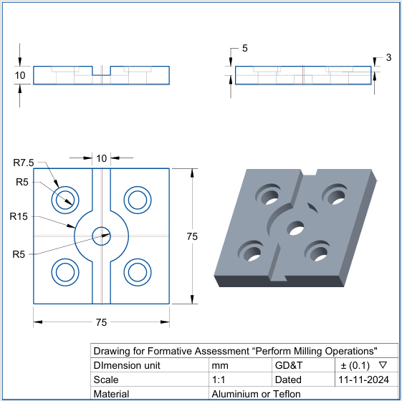
Drawing Annexure, A
Knowledge Assessment
Qualification | CNC MACHINIST Level IV
Competency Standard | 0715MMT3605-Perform CNC Milling Operations
Purpose of Assessment | Formative Assessment
Candidate Details | Name: ______________________________________________________________  Registration/Roll Number: _________________ Candidate Signature: ___________
Assessment Outcome | COMPETENT NOT YET COMPETENT  Name of the Assessor: ________________________________________________  Assessor’s code: ____________________________________________________  Signature of the Assessor: _______________________

Candidate’s response is not required to be identical, but similar concepts and/or keywords must be used. Oral questioning may be used to clarify candidate understanding of topic and its application.

 | Questions (Candidate confidently answered questions correctly and demonstrated understanding of the topics and their application) |  | Satisfactory | Not Satisfactory
 |  | Define CNC
 |  | What is a work offset in CNC?
 |  | List three common types of milling cutters
 |  | Enlist common G-codes used for work offset.
 |  | Define RPM.
 |  | What are G and M codes in CNC?
 |  | Define CAM.
Feedback to the Candidate
Candidate’s Signature__________________ Assessor’s Signature _________________

