Assessment Evidence Guide
For
CNC Machinist
Level IV

Formative Assessment
0715MMT3606 Perform CNC Wire Cut Operations
Date 04-09 November, 2024
Lahore


National Vocational & Technical
Training Commission

Instruction Sheet for the Candidate
Qualification | CNC Machinist Level IV
Competency Standard | 0715MMT3606 Perform CNC Wire Cut Operations
Purpose of Assessment | Formative Assessment
Candidate Details | Name______________________________________________________  Registration/Roll Number_______________________________________
Guidance for Candidate | To meet this standard, you are required to complete the following within 04 Hrs. time frame (for practical demonstration & assessment):  - Prepare CNC Wire Cut for operations  - Generate the program  - Mount the job / Work Offset  - Run the program  Activity: Manufacture the job on the CNC wire cut machine according to the specifications in Annexure A.
Time: 4 Hrs. | During a practical assessment, under observation by an assessor, you are required to
Minimum Evidence Required | 1. Rewind EDM Wire for CNC operations.  2. Perform routine maintenance (Check Dielectric fluid, Adjust Fixture/Holding device etc.) to prepare the machine for operations.  3. Draw the sketch as per drawing.  4. Make tool path on CNC wire cut controller.  5. Check simulation of the tool path and modify tool path for errors.  6. Select Machining parameters that may include wire offset, wire speed and current settings etc.  7. Set up and align the job on the holding device at workstation.  8. Set up the machine to machine zero position according to the job requirement.  9. Set Wire and feed roller according to required sequence of operations.  10. Start the machine, adjust parameters material, finish and accuracy desired.  11. Run the program  12. Check the cutting path, finish and accuracy.  13. Finish and remove the job after completion from holding device.  14. Retract the program for machine zero.

Self-Assessment Checklist
Candidate Name
Registration No.
Qualification | CNC Machinist Level IV
Competency Standard | 0715MMT3606 Perform CNC Wire Cut Operations
Purpose of Assessment | Formative Assessment
Assessment Task | - Prepare CNC Wire Cut for operations  - Generate the program  - Mount the job / Work Offset  - Run the program  Activity: Manufacture the job on the CNC wire cut machine according to the specifications in Annexure A.
I can……………….
Performance Criteria | Yes | No
- Rewind EDM Wire for CNC operations.
- Perform routine maintenance (Check Dielectric fluid, Adjust Fixture/Holding device etc.) to prepare the machine for operations.
- Draw the sketch as per drawing.
- Make tool path on CNC wire cut controller.
- Check simulation of the tool path and modify tool path for errors.
- Select Machining parameters that may include wire offset, wire speed and current settings etc.
- Set up and align the job on the holding device at workstation.
- Set up the machine to machine zero position according to the job requirement.
- Set Wire and feed roller according to required sequence of operations.
- Start the machine, adjust parameters material, finish and accuracy desired.
- Run the program
- Check the cutting path, finish and accuracy.
- Finish and remove the job after completion from holding device.
- Retract the program for machine zero.

Candidate’s Signature__________________ Assessor’s Signature____________________
Date: _______________________________
Assessors Judgment Guide
Qualification | CNC Machinist Level IV
Competency Standard | 0715MMT3606 Perform CNC Wire Cut Operations
Purpose of Assessment | Formative Assessment
Candidate Details | Name: ______________________________________________________________  Registration/Roll Number: ______________________ Signature: _______________
Assessment Outcome | COMPETENT NOT YET COMPETENT  Name of the Assessor________________________________________________  Assessor’s code: ____________________________________________________  Signature: ________________________________

Assessment Summary (to be filled by the assessor)
Activity | Method |  |  |  |  | Result
Nature of Activity | Written | Oral | Observation | Portfolio | Role Play | Competent | Not Yet Competent
Practical Skill Demonstration
Knowledge Assessment
Other Requirement

Observation Checklist
Assessment Task |  | - Prepare CNC Wire Cut for operations  - Generate the program  - Mount the job / Work Offset  - Run the program  Activity: Manufacture the job on the CNC wire cut machine according to the specifications in Annexure A.
During the practical assessment, candidate demonstrated the following: |  |  |  | Yes | No | Remarks
 | Did the candidate rewind EDM Wire for CNC operations?
 | Did the candidate perform routine maintenance (Check Dielectric fluid, Adjust Fixture/Holding device etc.) to prepare the machine for operations?
 | Did the candidate draw the sketch as per drawing?
 | Did the candidate make tool path on CNC wire cut controller?
 | Did the candidate check simulation of the tool path and modify tool path for errors?
 | Did the candidate select machining parameters that may include wire offset, wire speed and current settings etc.?
 | Did the candidate set up and align the job on the holding device at workstation?
 | Did the candidate set up the machine to machine zero position according to the job requirement?
 | Did the candidate set Wire and feed roller according to required sequence of operations?
 | Did the candidate start the machine, adjust parameters material, finish and accuracy desired?
 | Did the candidate run the program?
 | Did the candidate check the cutting path, finish and accuracy?
 | Did the candidate finish and remove the job after completion from holding device?
 | Did the candidate retract the program for machine zero?
Competent |  |  | Not Yet Competent

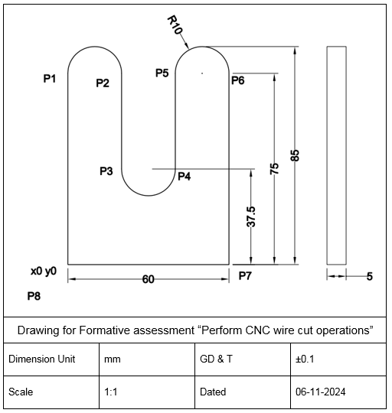
Drawing Annexure, A

Knowledge Assessment
Qualification | CNC Machinist Level IV
Competency Standard | 0715MMT3606 Perform CNC Wire Cut Operations
Purpose of Assessment | Formative Assessment
Candidate Details | Name: ______________________________________________________________  Registration/Roll Number: _________________ Candidate Signature: ___________
Assessment Outcome | COMPETENT NOT YET COMPETENT  Name of the Assessor: ________________________________________________  Assessor’s code: ____________________________________________________  Signature of the Assessor: _______________________

Candidate’s response is not required to be identical, but similar concepts and/or keywords must be used. Oral questioning may be used to clarify candidate understanding of topic and its application.

 | Questions (Candidate confidently answered questions correctly and demonstrated understanding of the topics and their application) |  | Satisfactory | Not Satisfactory
 |  | Define EDM.
 |  | Describe components of CNC wire cut.
 |  | Describe types of conducting materials.
 |  | Describe function of dielectric fluid in EDM machines.
 |  | Define 2D drawing.
 |  | Describe material used for CNC wire cut machine.
 |  | Differentiate between current and voltage.
Feedback to the Candidate
Candidate’s Signature__________________ Assessor’s Signature _________________

