Assessment Evidence Guide
For
CNC Machinist
Level-IV

Summative Assessment

Date 04-09 November, 2024
Lahore


National Vocational & Technical
Training Commission

Instruction Sheet for the Candidate
Qualification | 0715MMT36 CNC Machinist Level IV
Competency Standard | 1022OHS01 Follow occupational health and safety practices.  0031BCS01 Develop basic communication skills.  0715MMT3601 Perform measurement, calculation and checking techniques.  0715MMT3602 Identify machine, cutting tools & its attachments.  0715MMT3603 Interpret and develop drawing and design.  0715MMT3604 Perform CNC Lathe Operations.  0715MMT3605 Perform CNC Milling Operations  0715MMT3606 Perform CNC Wire Cut Operations  0715MMT3607 Maintain CNC machines and tools.  0715MMT3608 Adopt green practices.
Purpose of Assessment | Summative Assessment
Candidate Details | Name______________________________________________________  Registration/Roll Number_______________________________________
Guidance for Candidate | To meet this standard, you are required to complete the following within 05 Hrs. time frame (for practical demonstration & assessment):  - Manufacture the job on the CNC lathe machine according to the specifications in Annexure A, ensuring strict adherence to safety protocols and maintaining the required accuracy throughout the process.
Time: 5 Hrs. | During a practical assessment, under observation by an assessor, you are required to
Minimum Evidence Required | - Practice effective use of communication skills.  - Interpret the given drawing of job effectively.  - Calculate coordinates of drawing as per drawing.  - Develop the program of part as per drawing.  - Run simulation of program to identify and correct potential errors in part program. (if any)  - Wear appropriate personal protective equipment.  - Identify appropriate machine, cutting tools and its attachments as per given drawing.  - Perform routine maintenance (Check Dielectric fluid, Adjust Fixture/Holding device etc.) to prepare the machine for operations.  - Mount the job on work holding device of CNC Lathe Machine.  - Set and align tool properly in the tool holder.  - Perform machine zero positioning.  - Check position of axis by using Position key.  - Use program editing keys like Program, Edit, MDI, Insert, Alter, EOB, Cancel and Delete.  - Perform work reference setting for different tools. (Tool offsetting).  - Input the program in CNC lathe machine and run the program.  - Change Feed and Spindle Speed using Override Keys.  - Finish and remove the job after completion from holding device.  - Check the finish and accuracy of manufactured part.  - Retract the program for machine zero.

Self-Assessment Checklist
Candidate Name
Registration No.
Qualification | 0715MMT36 CNC Machinist Level IV
Competency Standard | 1022OHS01 Follow occupational health and safety practices.  0031BCS01 Develop basic communication skills.  0715MMT3601 Perform measurement, calculation and checking techniques.  0715MMT3602 Identify machine, cutting tools & its attachments.  0715MMT3603 Interpret and develop drawing and design.  0715MMT3604 Perform CNC Lathe Operations.  0715MMT3605 Perform CNC Milling Operations  0715MMT3606 Perform CNC Wire Cut Operations  0715MMT3607 Maintain CNC machines and tools.  0715MMT3608 Adopt green practices.
Purpose of Assessment | Summative Assessment
Assessment Task | - Manufacture the job on the CNC lathe machine according to the specifications in Annexure A, ensuring strict adherence to safety protocols and maintaining the required accuracy throughout the process.
I can……………….
Performance Criteria | Yes | No
- Practice effective use of communication skills.
- Interpret the given drawing of job effectively.
- Calculate coordinates of drawing as per drawing.
- Develop the program of part as per drawing.
- Run simulation of program to identify and correct potential errors in part program. (if any)
- Wear appropriate personal protective equipment.
- Identify appropriate machine, cutting tools and its attachments as per given drawing.
- Perform routine maintenance (Check Dielectric fluid, Adjust Fixture/Holding device etc.) to prepare the machine for operations.
- Mount the job on work holding device of CNC Lathe Machine.
- Set and align tool properly in the tool holder.
- Perform machine zero positioning.
- Check position of axis by using Position key.
- Use program editing keys like Program, Edit, MDI, Insert, Alter, EOB, Cancel and Delete.
- Perform work reference setting for different tools. (Tool offsetting).
- Input the program in CNC lathe machine and run the program.
- Change Feed and Spindle Speed using Override Keys.
- Finish and remove the job after completion from holding device.
- Check the finish and accuracy of manufactured part.
- Retract the program for machine zero.

Candidate’s Signature__________________ Assessor’s Signature____________________

Date: _______________________________

Assessors Judgment Guide
Qualification | 0715MMT36 CNC Machinist Level IV
Competency Standard | 1022OHS01 Follow occupational health and safety practices.  0031BCS01 Develop basic communication skills.  0715MMT3601 Perform measurement, calculation and checking techniques.  0715MMT3602 Identify machine, cutting tools & its attachments.  0715MMT3603 Interpret and develop drawing and design.  0715MMT3604 Perform CNC Lathe Operations.  0715MMT3605 Perform CNC Milling Operations  0715MMT3606 Perform CNC Wire Cut Operations  0715MMT3607 Maintain CNC machines and tools.  0715MMT3608 Adopt green practices.
Purpose of Assessment | Summative Assessment
Candidate Details | Name: ______________________________________________________________  Registration/Roll Number: ______________________ Signature: _______________
Assessment Outcome | COMPETENT NOT YET COMPETENT  Name of the Assessor________________________________________________  Assessor’s code: ____________________________________________________  Signature: ________________________________

Assessment Summary (to be filled by the assessor)
Activity | Method |  |  |  |  | Result
Nature of Activity | Written | Oral | Observation | Portfolio | Role Play | Competent | Not Yet Competent
Practical Skill Demonstration
Knowledge Assessment
Other Requirement

Observation Checklist
Assessment Task |  | - Manufacture the job on the CNC lathe machine according to the specifications in Annexure A, ensuring strict adherence to safety protocols and maintaining the required accuracy throughout the process.
During the practical assessment, candidate demonstrated the following: |  |  |  | Yes | No | Remarks
 | Did the candidate practice effective use of communication skills?
 | Did the candidate interpret the given drawing of job effectively?
 | Did the candidate calculate coordinates of drawing as per drawing?
 | Did the candidate develop the program of part as per drawing?
 | Did the candidate run simulation of program to identify and correct potential errors in part program. (if any)
 | Did the candidate wear appropriate personal protective equipment?
 | Did the candidate identify the appropriate machine, cutting tools and its attachments as per the given drawing?
 | Did the candidate perform routine maintenance (Check Dielectric fluid, Adjust Fixture/Holding device etc.) to prepare the machine for operations?
 | Did the candidate mount the job on work holding device of CNC Lathe Machine?
 | Did the candidate set and align tool properly in the tool holder?
 | Did the candidate perform machine zero positioning?
 | Did the candidate check position of axis by using Position key?
 | Did the candidate use program editing keys like Program, Edit, MDI, Insert, Alter, EOB, Cancel and Delete?
 | Did the candidate perform work reference setting for different tools (Tool offsetting)?
 | Did the candidate input the program in CNC lathe machine and run the program?
 | Did the candidate change Feed and Spindle Speed using Override Keys?
 | Did the candidate finish and remove the job after completion from holding device?
 | Did the candidate check the finish and accuracy of manufactured part?
 | Did the candidate retract the program for machine zero?
Competent |  |  | Not Yet Competent

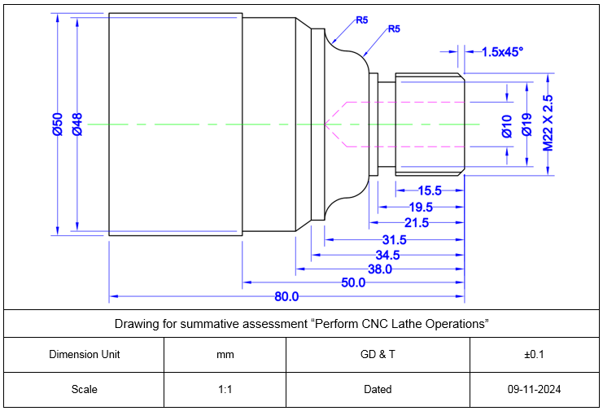
Annexure A

Knowledge Assessment
Qualification | 0715MMT36 CNC Machinist Level IV
Competency Standard | 1022OHS01 Follow occupational health and safety practices.  0031BCS01 Develop basic communication skills.  0715MMT3601 Perform measurement, calculation and checking techniques.  0715MMT3602 Identify machine, cutting tools & its attachments.  0715MMT3603 Interpret and develop drawing and design.  0715MMT3604 Perform CNC Lathe Operations.  0715MMT3605 Perform CNC Milling Operations  0715MMT3606 Perform CNC Wire Cut Operations  0715MMT3607 Maintain CNC machines and tools.  0715MMT3608 Adopt green practices.
Purpose of Assessment | Summative Assessment
Candidate Details | Name: ______________________________________________________________  Registration/Roll Number: _________________ Candidate Signature: ___________
Assessment Outcome | COMPETENT NOT YET COMPETENT  Name of the Assessor: ________________________________________________  Assessor’s code: ____________________________________________________  Signature of the Assessor: _______________________

Candidate’s response is not required to be identical, but similar concepts and/or keywords must be used. Oral questioning may be used to clarify candidate understanding of topic and its application.

Questions (Candidate confidently answered questions correctly and demonstrated understanding of the topics and their application) |  | Satisfactory | Not Satisfactory
 | Why is workplace safety important?
 | What are 5 basic communication?
 | Can you convert 2 inch to millimeter?
 | What is the function of faceplate used for lathe machine?
 | Define sectional view?
 | What is the difference between absolute and incremental system?
 | What is the file extension of CNC lathe machine?
 | What is the function of dry run button on CNC lathe machine controller?

Feedback to the Candidate
Candidate’s Signature__________________ Assessor’s Signature _________________

