Assessment Evidence Guide
For
CNC Machinist
Level IV

Summative Assessment

Date 04-09 Nov, 2024
Lahore


National Vocational & Technical
Training Commission

Instruction Sheet for the Candidate
Qualification | 0715MMT36 CNC Machinist Level IV
Competency Standard | 1022OHS01 Follow occupational health and safety practices.  0031BCS01 Develop basic communication skills.  0715MMT3601 Perform measurement, calculation and checking techniques.  0715MMT3602 Identify machine, cutting tools & its attachments.  0715MMT3603 Interpret and develop drawing and design.  0715MMT3604 Perform CNC Lathe Operations.  0715MMT3605 Perform CNC Milling Operations  0715MMT3606 Perform CNC Wire Cut Operations  0715MMT3607 Maintain CNC machines and tools.  0715MMT3608 Adopt green practices.
Purpose of Assessment | Summative Assessment
Candidate Details | Name______________________________________________________  Registration/Roll Number_______________________________________
Guidance for Candidate | To meet this standard, you are required to complete the following within 05 Hrs. time frame (for practical demonstration & assessment):  - Manufacture the job on the CNC wire cut machine according to the specifications in Annexure A, ensuring strict adherence to safety protocols and maintaining the required accuracy throughout the process.
Time: 5 Hrs. | During a practical assessment, under observation by an assessor, you are required to
Minimum Evidence Required | - Wear appropriate personal protective equipment.  - Practice effective use of communication skills.  - Identify appropriate machine, cutting tools and its attachments as per given drawing.  - Interpret the given drawing of job effectively.  - Perform routine maintenance (Check Dielectric fluid, Adjust Fixture/Holding device etc.) to prepare the machine for operations.  - Rewind EDM Wire for CNC operations.  - Set up and align the job on the holding device at workstation.  - Set up the machine to machine zero position according to the job requirement.  - Set Wire and feed roller according to required sequence of operations.  - Draw the sketch as per drawing.  - Make tool path on CNC wire cut controller.  - Check simulation of the tool path and modify tool path for errors.  - Select Machining parameters that may include wire offset, wire speed and current settings etc.  - Start the machine, adjust parameters material, finish and accuracy desired.  - Run the program  - Check the cutting path, finish and accuracy.  - Finish and remove the job after completion from holding device.  - Retract the program for machine zero.

Self-Assessment Checklist
Candidate Name
Registration No.
Qualification | 0715MMT36 CNC Machinist Level IV
Competency Standard | 1022OHS01 Follow occupational health and safety practices.  0031BCS01 Develop basic communication skills.  0715MMT3601 Perform measurement, calculation and checking techniques.  0715MMT3602 Identify machine, cutting tools & its attachments.  0715MMT3603 Interpret and develop drawing and design.  0715MMT3604 Perform CNC Lathe Operations.  0715MMT3605 Perform CNC Milling Operations  0715MMT3606 Perform CNC Wire Cut Operations  0715MMT3607 Maintain CNC machines and tools.  0715MMT3608 Adopt green practices.
Purpose of Assessment | Summative Assessment
Assessment Task | - Manufacture the job on the CNC wire cut machine according to the specifications in Annexure A, ensuring strict adherence to safety protocols and maintaining the required accuracy throughout the process.
I can……………….
Performance Criteria | Yes | No
- Wear appropriate personal protective equipment.
- Practice effective use of communication skills.
- Identify appropriate machine, cutting tools and its attachments as per given drawing.
- Interpret the given drawing of job effectively.
- Perform routine maintenance (Check Dielectric fluid, Adjust Fixture/Holding device etc.) to prepare the machine for operations.
- Rewind EDM Wire for CNC operations.
- Set up and align the job on the holding device at workstation.
- Set up the machine to machine zero position according to the job requirement.
- Set Wire and feed roller according to required sequence of operations.
- Draw the sketch as per drawing.
- Make tool path on CNC wire cut controller.
- Check simulation of the tool path and modify tool path for errors.
- Select Machining parameters that may include wire offset, wire speed and current settings etc.
- Start the machine, adjust parameters material, finish and accuracy desired.
- Run the program
- Check the cutting path, finish and accuracy.
- Finish and remove the job after completion from holding device.
- Retract the program for machine zero.

Candidate’s Signature__________________ Assessor’s Signature____________________

Date: _______________________________

Assessors Judgment Guide
Qualification | 0715MMT36 CNC Machinist Level IV
Competency Standard | 1022OHS01 Follow occupational health and safety practices.  0031BCS01 Develop basic communication skills.  0715MMT3601 Perform measurement, calculation and checking techniques.  0715MMT3602 Identify machine, cutting tools & its attachments.  0715MMT3603 Interpret and develop drawing and design.  0715MMT3604 Perform CNC Lathe Operations.  0715MMT3605 Perform CNC Milling Operations  0715MMT3606 Perform CNC Wire Cut Operations  0715MMT3607 Maintain CNC machines and tools.  0715MMT3608 Adopt green practices.
Purpose of Assessment | Summative Assessment
Candidate Details | Name: ______________________________________________________________  Registration/Roll Number: ______________________ Signature: _______________
Assessment Outcome | COMPETENT NOT YET COMPETENT  Name of the Assessor________________________________________________  Assessor’s code: ____________________________________________________  Signature: ________________________________

Assessment Summary (to be filled by the assessor)
Activity | Method |  |  |  |  | Result
Nature of Activity | Written | Oral | Observation | Portfolio | Role Play | Competent | Not Yet Competent
Practical Skill Demonstration
Knowledge Assessment
Other Requirement

Observation Checklist
Assessment Task |  | - Manufacture the job on the CNC wire cut machine according to the specifications in Annexure A, ensuring strict adherence to safety protocols and maintaining the required accuracy throughout the process.
During the practical assessment, candidate demonstrated the following: |  |  |  | Yes | No | Remarks
 | Did the candidate wear appropriate personal protective equipment?
 | Did the candidate practice effective use of communication skills?
 | Did the candidate identify appropriate machine, cutting tools and its attachments as per given drawing?
 | Did the candidate interpret the given drawing of job effectively?
 | Did the candidate perform routine maintenance (Check Dielectric fluid, Adjust Fixture/Holding device etc.) to prepare the machine for operations?
 | Did the candidate rewind EDM Wire for CNC operations?
 | Did the candidate set up and align the job on the holding device at workstation?
 | Did the candidate set up the machine to machine zero position according to the job requirement?
 | Did the candidate set Wire and feed roller according to required sequence of operations?
 | Did the candidate draw the sketch as per drawing?
 | Did the candidate make a tool path on CNC wire cut controller?
 | Did the candidate check simulation of the tool path and modify tool path for errors?
 | Did the candidate select machining parameters that may include wire offset, wire speed and current settings etc.?
 | Did the candidate start the machine, adjust parameters material, finish and accuracy desired?
 | Did the candidate run the program?
 | Did the candidate check the cutting path, finish and accuracy?
 | Did the candidate finish and remove the job after completion from holding device?
 | Did the candidate retract the program for machine zero?
Competent |  |  | Not Yet Competent

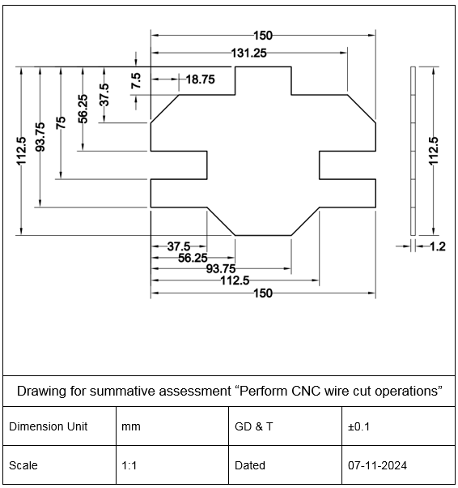
Annexure A

Knowledge Assessment
Qualification | 0715MMT36 CNC Machinist Level IV
Competency Standard | 1022OHS01 Follow occupational health and safety practices.  0031BCS01 Develop basic communication skills.  0715MMT3601 Perform measurement, calculation and checking techniques.  0715MMT3602 Identify machine, cutting tools & its attachments.  0715MMT3603 Interpret and develop drawing and design.  0715MMT3604 Perform CNC Lathe Operations.  0715MMT3605 Perform CNC Milling Operations  0715MMT3606 Perform CNC Wire Cut Operations  0715MMT3607 Maintain CNC machines and tools.  0715MMT3608 Adopt green practices.
Purpose of Assessment | Summative Assessment
Candidate Details | Name: ______________________________________________________________  Registration/Roll Number: _________________ Candidate Signature: ___________
Assessment Outcome | COMPETENT NOT YET COMPETENT  Name of the Assessor: ________________________________________________  Assessor’s code: ____________________________________________________  Signature of the Assessor: _______________________

Candidate’s response is not required to be identical, but similar concepts and/or keywords must be used. Oral questioning may be used to clarify candidate understanding of topic and its application.

Questions (Candidate confidently answered questions correctly and demonstrated understanding of the topics and their application) |  | Satisfactory | Not Satisfactory
 | Why is workplace safety important?
 | What are 5 basic communication?
 | Can you convert 2 inch to millimeter?
 | What is the function of faceplate used for lathe machine?
 | Define sectional view?
 | What is spark gap in EDM?
 | What liquid is used in CNC wire EDM?
 | What is the principle of wire cutting?

Feedback to the Candidate
Candidate’s Signature__________________ Assessor’s Signature _________________

