Assessment Evidence Guide
For
0715MMT36“CNC MACHINIST”
(Level – IV)
(Mechanical Technology)
Summative Assessment

Date 13-14 April, 2023
Lahore


National Vocational & Technical
Training Commission

Instruction Sheet for the Candidate
Qualification | 0715MMT36 CNC MACHINIST (Level – IV) (Mechanical Technology)
Competency Standard | - Follow Occupational Health and Safety  - Develop Basic Communication Skills  - Perform Measurement, Calculation and Checking Techniques  - Identify Machines, Cutting tools & its attachments  - Interpret and Develop Drawing and Design  - Perform CNC Milling Operations  - Maintain Machines and Tools  - Adopt Green Practices
Purpose of Assessment | Summative Assessment
Candidate Details | Name______________________________________________________  Registration/Roll Number_______________________________________
Guidance for Candidate | To meet this standard, you are required to complete the following within 05 Hrs. time frame (for practical demonstration & assessment):  - Create a CAD drawing and corresponding CAM program, then produce the part on the CNC milling machine according to the specifications in Annexure A.
Time: 05 Hrs. | During a practical assessment, under observation by an assessor, you are required to
Minimum Evidence Required | - Wear PPE and follow safety protocols.  - Practice clear and effective communication.  - Measure, calculate, and check all dimensions.  - Select correct machines and tools.  - Read and create technical drawings.  - Operate CNC milling machine as per requirement.  - Perform routine cleaning and lubrication.  - Recycle materials and minimize waste.

Self-Assessment Checklist
Candidate Name
Registration No.
Qualification | 0715MMT36 “CNC MACHINIST” (Level – IV) (Mechanical Technology)
Competency Standard | - Follow Occupational Health and Safety  - Develop Basic Communication Skills  - Perform Measurement, Calculation and Checking Techniques  - Identify Machines, Cutting tools & its attachments  - Interpret and Develop Drawing and Design  - Perform CNC Milling Operations  - Maintain Machines and Tools  - Adopt Green Practices
Purpose of Assessment | Summative Assessment
Assessment Task | - Create a CAD drawing and corresponding CAM program, then produce the part on the CNC milling machine according to the specifications in Annexure A.

I can……………….
Performance Criteria | Yes | No
- Mount the workpiece according to job specifications.
- Use appropriate fixtures to ensure dimensional accuracy.
- Verify tool and workpiece alignment (co-axiality, concentricity).
- Implement safety measures to prevent accidental operation.
- Import the 3D model correctly into the selected CAM software.
- Define the reference point and material for machining, ensuring the XYZ zero point aligns with the work offset.
- Apply necessary machining features and toolpath strategies.
- Generate the part program correctly using the CNC machine’s post-processor.
- Ensure correct G/M codes, coordinates, and feed rates are used.
- Save and document the part program properly for the machine.
- Load the part program successfully into the simulation platform.
- Verify tool movements against the defined sequence.
- Identify and modify any errors as needed.
- Ensure synchronization between the CNC control unit and the program.
- Switch the machine to receiving mode before loading the program.
- Select the correct part program for execution.
- Confirm all safety operation protocols.
- Adjust feeds, speeds, and machine overrides correctly.
- Set the machine to execution mode and start the machining sequence.
- Monitor movements during operation.
- Inspect the final product for accuracy and precision against design specifications.

Candidate’s Signature__________________ Assessor’s Signature____________________
Date: ______________________________

Assessors Judgment Guide
Qualification | 0715MMT36 “CNC MACHINIST” (Level – IV) (Mechanical Technology)
Competency Standard | - Follow Occupational Health and Safety  - Develop Basic Communication Skills  - Perform Measurement, Calculation and Checking Techniques  - Identify Machines, Cutting tools & its attachments  - Interpret and Develop Drawing and Design  - Perform CNC Milling Operations  - Maintain Machines and Tools  - Adopt Green Practices
Purpose of Assessment | Summative Assessment
Candidate Details | Name: ______________________________________________________________  Registration/Roll Number: ______________________Signature: _______________
Assessment Outcome | COMPETENT NOT YETCOMPETENT  Name of the Assessor________________________________________________  Assessor’s code: ____________________________________________________  Signature: ________________________________

Assessment Summary (to be filled by the assessor)
Activity | Method |  |  |  |  | Result
Nature of Activity | Written | Oral | Observation | Portfolio | Role Play | Competent | Not Yet Competent
Practical Skill Demonstration
Knowledge Assessment
Other Requirement

Observation Checklist
Assessment Task |  | - Create a CAD drawing and corresponding CAM program, then produce the part on the CNC milling machine according to the specifications in Annexure A.
During the practical assessment, candidate demonstrated the following: |  |  |  | Yes | No | Remarks
 | Is appropriate personal protective equipment (PPE) being worn?
 | Has the CNC machine been inspected for visible issues before operation?
 | Are electrical connections and cables checked for safety and proper insulation?
 | Is the workpiece mounted according to job specifications?
 | Are appropriate fixtures used to ensure dimensional accuracy?
 | Is the tool and workpiece alignment verified (co-axiality, concentricity)?
 | Have safety measures been implemented to prevent accidental operation?
 | Is the 3D model correctly imported into the selected CAM software?
 | Is the reference point and material defined for machining?
 | Have the necessary machining features and toolpath strategies been applied?
 | Is the part program generated correctly using the CNC machine's post-processor?
 | Are the correct G/M codes, coordinates, and feed rates used?
 | Is the part program saved and documented properly for the machine?
 | Is the part program successfully loaded into the simulation platform?
 | Are the tool movements verified against the defined sequence?
 | Have any errors been identified and modified as needed?
 | Is there proper synchronization between the CNC control unit and the program?
 | Is the machine switched to receiving mode before loading the program?
 | Is the correct part program selected for execution?
 | Are all safety operation protocols confirmed?
 | Are feeds, speeds, and machine overrides adjusted correctly?
Competent |  |  | Not Yet Competent
Knowledge Assessment
Qualification | “CNC MACHINIST” (Level – IV) (Mechanical Technology)
Competency Standard | - Follow Occupational Health and Safety  - Develop Basic Communication Skills  - Perform Measurement, Calculation and Checking Techniques  - Identify Machines, Cutting tools & its attachments  - Interpret and Develop Drawing and Design  - Perform CNC Milling Operations  - Maintain Machines and Tools  - Adopt Green Practices
Purpose of Assessment | Summative Assessment
Candidate Details | Name: ______________________________________________________________  Registration/Roll Number: _________________ Candidate Signature: ___________
Assessment Outcome | COMPETENT NOT YETCOMPETENT  Name of the Assessor: ________________________________________________  Assessor’s code: ____________________________________________________  Signature of the Assessor: _______________________

Candidate’s response is not required to be identical, but similar concepts and/or keywords must be used. Oral questioning may be used to clarify candidate understanding of topic and its application.

Questions (Candidate confidently answered questions correctly and demonstrated understanding of the topics and their application) |  | Satisfactory | Not Satisfactory
 | Define CNC
 | What is a work offset in CNC?
 | List three common types of milling cutters
 | List common G-codes used for work offset.
 | Define RPM.
 | What are G and M codes in CNC?
 | Define CAM.
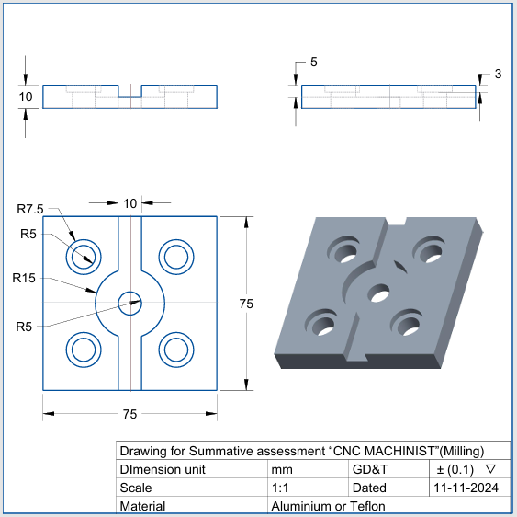
Drawing Annexure, A
Feedback to the Candidate
Candidate’s Signature__________________ Assessor’s Signature _________________

