Assessment Evidence Guide
For
“Machinist”
Level-2
Formative Assessment
0715MMT3410. Perform Shaping Operations
Date 4-9 November, 2024
Lahore


National Vocational & Technical
Training Commission

Instruction Sheet for the Candidate

Qualification | Machinist Level 2
Competency Standard(s) | 0715MMT3410. Perform Shaping Operations
Purpose of Assessment | Formative Assessment
Candidate Details | Name____________________________________________________  Registration/Roll Number_______________________________________________
Guidance for Candidate | To meet this standard, you are required to complete the following within the given time frame.  - Prepare Materials for Shaping Operations  - Select Tools and Equipment  - Set Shaper Machine for Operations  Activity: Perform the various shaping operations on the work piece as per given drawing in Annex-A.
Time: 4 hrs. | During a practical assessment, under observation by an assessor, you are required to  - Cut the block accurately to the specified size (80 mm x 80 mm x 20 mm) with smooth, burr-free edges.  - Interpret the drawing correctly to determine required dimensions and tolerances.  - Select appropriate shaping tools for cutting, smoothing, and grooving operations.  - Choose suitable clamping devices to secure the workpiece safely and securely.  - Arrange and use measuring instruments to verify dimensions during and after machining.  - Machine down the block to the specified final dimensions (70 mm x 70 mm x 20 mm).  - Maintain accurate, square edges and flat surfaces while machining.  - Cut a 6x6 slot as per drawing.  - Check the dimensions.  - Shut the machine properly.
Minimum Evidence Required

Self-Assessment Checklist
Candidate Name
Registration No.
Qualification | Machinist Level 2
Competency Standards | 0715MMT3410. Perform Shaping Operations
Assessment Task | - Prepare Materials for Shaping Operations  - Select Tools and Equipment  - Set Shaper Machine for Operations  Activity: Perform the various shaping operations on the work piece as per given drawing in Annex-A.

I can……………….
Performance Criteria | Yes | No
- Cut the block accurately to the specified size (80 mm x 80 mm x 20 mm) with smooth, burr-free edges. | 
- Interpret the drawing correctly to determine required dimensions and tolerances.
- Select appropriate shaping tools for cutting, smoothing, and grooving operations.
- Choose suitable clamping devices to secure the workpiece safely and securely.
- Arrange and use measuring instruments to verify dimensions during and after machining.
- Machine down the block to the specified final dimensions (70 mm x 70 mm x 20 mm).
- Maintain accurate, square edges and flat surfaces while machining.
- Cut a 6x6 slot as per drawing.
- Check the dimensions.
- Shut the machine properly.

Candidate’s Signature___________________ Assessor’s Signature______________
Date: ________________________________

Assessors Judgment Guide
Qualification | Machinist Level 2
Competency Standard(s) | 0715MMT3410. Perform Shaping Operations
Candidate Details | Name: ______________________________________________  Registration/Roll Number: _________________Signature: ____________________
Assessment Outcome | COMPETENT NOT YET COMPETENT  Name of the Assessor________________________ Assessor’s code: ________  Signature: __________________________________

Assessment Summary (to be filled by the assessor)
Activity | Method |  |  |  |  | Result
Nature of Activity | Written | Oral | Observation | Portfolio | Role Play | Competent | Not Yet Competent
Practical Skill Demonstration
Knowledge Assessment
Other Requirement

Observation Checklist
Assessment Task |  | - Prepare Materials for Shaping Operations  - Select Tools and Equipment  - Set Shaper Machine for Operations  Activity: Perform the various shaping operations on the work piece as per given drawing in Annex-A.
During the practical assessment, candidate demonstrated the following: |  |  |  | Yes | No | Remarks
 | Cut the block accurately to the specified size (80 mm x 80 mm x 20 mm) with smooth, burr-free edges.
 | Interpret the drawing correctly to determine required dimensions and tolerances.
 | Select appropriate shaping tools for cutting, smoothing, and grooving operations.
 | Choose suitable clamping devices to secure the workpiece safely and securely.
 | Arrange and use measuring instruments to verify dimensions during and after machining.
 | Machine down the block to the specified final dimensions (70 mm x 70 mm x 20 mm).
 | Maintain accurate, square edges and flat surfaces while machining.
 | Cut a 6x6 slot as per drawing.
 | Check the dimensions.
 | Shut the machine properly.
Competent |  |  | Not Yet Competent

Knowledge Assessment
Qualification | Machinist Level 2
Competency Standard(s) | 0715MMT3410. Perform Shaping Operations
Candidate Details | Name: ______________________________________________________________  Registration/Roll Number: _______________ Candidate Signature: ____________
Assessment Outcome | COMPETENT NOT YET COMPETENT  Name of the Assessor: __________________Assessor’s code: _________________  Signature of the Assessor: _______________________
Candidate’s response is not required to be identical, but similar concepts and/or keywords must be used. Oral questioning may be used to clarify candidate understanding of topic and its application.

Questions (Candidate confidently answered questions correctly and demonstrated understanding of the topics and their application) |  | Satisfactory | Not Satisfactory
 | Define Shaper.
 | Parts of Shaper
 | In Shaper which one move job or tool?
 | How many parts can mount in shaper at once?
 | What is Ram in Shaper?

Feedback to the Candidate
Candidate’s Signature___________________ Assessor’s Signature ____________

Annex-A
Activity: Perform the various shaping operations on the work piece as per given drawing.

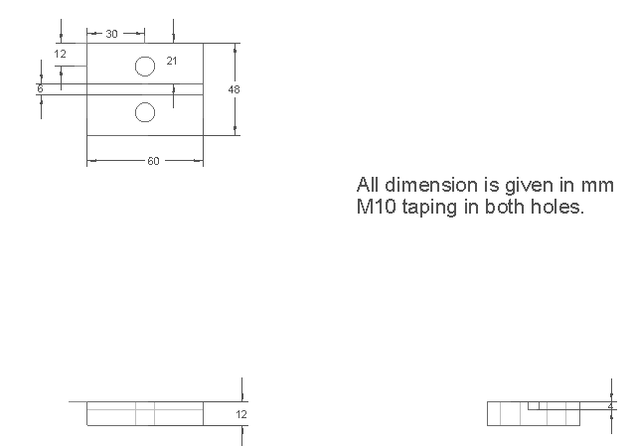

Note: All the dimensions are in mm. While the value for tolerance is as ±0.2mm.

