Assessment Evidence Guide
For
“Machinist”
Level-2
Formative Assessment
0715MMT3406. Carryout Bench Work
Date 4-9November, 2024
Lahore


National Vocational & Technical
Training Commission

Instruction Sheet for the Candidate

Qualification | Machinist Level 2
Competency Standard(s) | 0715MMT3406. Carryout Bench Work
Purpose of Assessment | Formative Assessment
Candidate Details | Name____________________________________________________  Registration/Roll Number_______________________________________________
Guidance for Candidate | To meet this standard, you are required to complete the following within the given time frame.  - Carry-Out Sawing  - File the Work piece  - Carry-Out Drilling  - Produce Threads on the work piece with Tap and Die  - Perform Chipping & Scrapping  - Perform Hand Polishing  - Perform Hand Reaming  Activity: Perform a sequence of operations on the workpiece as per drawing given in Annex-A.
Time: 4 hrs. | During a practical assessment, under observation by an assessor, you are required to  - Mark the flat work piece for one sawing and cut with Hand hacksaw as per drawing.  - Clamp work piece as required.  - File the work piece with flat file as per given sizes.  - Mark and Centre punch the filed work piece.  - Drill the works piece as per drawing.  - Cut Internal threading on drilled hole work piece as per drawing (Annex-A) with the help of tap.  - Finish and deburr the work piece.
Minimum Evidence Required

Self-Assessment Checklist
Candidate Name
Registration No.
Qualification | Machinist Level 2
Competency Standards | 0715MMT3406. Carryout Bench Work
Assessment Task | - Carry-Out Sawing  - File the Work piece  - Carry-Out Drilling  - Produce Threads on the work piece with Tap and Die  - Perform Chipping & Scrapping  - Perform Hand Polishing  - Perform Hand Reaming  Activity: Perform a sequence of operations on the workpiece as per drawing given in Annex-A.

I can……………….
Performance Criteria | Yes | No
- Mark the flat work piece for one sawing and cut with Hand hacksaw as per drawing. | 
- Clamp work piece as required.
- File the work piece with flat file as per given sizes.
- Mark and Centre punch the field work piece.
- Drill the works piece as per drawing.
- Cut Internal threading on drilled hole work piece as per drawing with the help of tap.
- Finish and deburr the work piece.

Candidate’s Signature___________________ Assessor’s Signature______________
Date: ________________________________

Assessors Judgment Guide
Qualification | Machinist Level 2
Competency Standard(s) | 0715MMT3406. Carryout Bench Work
Candidate Details | Name: ______________________________________________  Registration/Roll Number: ________________________Signature: ______________
Assessment Outcome | COMPETENT NOT YET COMPETENT  Name of the Assessor________________________ Assessor’s code: _________  Signature: __________________________________

Assessment Summary (to be filled by the assessor)
Activity | Method |  |  |  |  | Result
Nature of Activity | Written | Oral | Observation | Portfolio | Role Play | Competent | Not Yet Competent
Practical Skill Demonstration
Knowledge Assessment
Other Requirement

Observation Checklist
Assessment Task |  | - Carry-Out Sawing  - File the Work piece  - Carry-Out Drilling  - Produce Threads on the work piece with Tap and Die  - Perform Chipping & Scrapping  - Perform Hand Polishing  - Perform Hand Reaming  Activity: Perform a sequence of operations on the workpiece as per drawing given in Annex-A.
During the practical assessment, candidate demonstrated the following: |  |  |  | Yes | No | Remarks
 | Mark the flat work piece for one sawing and cut with Hand hacksaw as per drawing.
 | Clamp work piece as required.
 | File the work piece with flat file as per given sizes.
 | Mark and Centre punch the field work piece.
 | Drill the works piece as per drawing.
 | Cut Internal threading on drilled hole work piece as per drawing with the help of tap.
 | Finish and deburr the work piece.
Competent |  |  | Not Yet Competent

Knowledge Assessment
Qualification | Machinist Level 2
Competency Standard(s) | 0715MMT3406. Carryout Bench Work
Candidate Details | Name: ___________________________________________________________________  Registration/Roll Number: __________________ Candidate Signature: _________________
Assessment Outcome | COMPETENT NOT YET COMPETENT  Name of the Assessor: _________________Assessor’s code: _________________  Signature of the Assessor: _______________________
Candidate’s response is not required to be identical, but similar concepts and/or keywords must be used. Oral questioning may be used to clarify candidate understanding of topic and its application.

Questions (Candidate confidently answered questions correctly and demonstrated understanding of the topics and their application) |  | Satisfactory | Not Satisfactory
 | What is sawing?
 | Describe the proper way to using a hand hacksaw?
 | Enlist the drill machine types?
 | Describe the sequence of drilling?
 | Describe the sequence of taping?

Feedback to the Candidate
Candidate’s Signature___________________ Assessor’s Signature ____________

Annex-A
Activity: Perform a sequence of operations on the workpiece

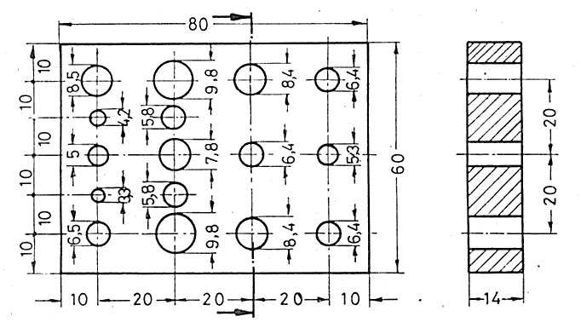

Note: All the dimensions are in mm. While the value for tolerance is as ±0.2mm.

