Assessment Evidence Guide
For
“Machinist”
Level-2
Formative Assessment
0715MMT3408. Perform Drilling Machine Operation
Date 4-9 November, 2024
Lahore


National Vocational & Technical
Training Commission

Instruction Sheet for the Candidate

Qualification | Machinist Level 2
Competency Standard(s) | 0715MMT3408. Perform Drilling Machine Operation
Purpose of Assessment | Formative Assessment
Candidate Details | Name____________________________________________________  Registration/Roll Number_______________________________________________
Guidance for Candidate | To meet this standard, you are required to complete the following within the given time frame.  - Drill the hole using drill machine  - Perform counter boring and counter sinking  - Perform machine reaming  Activity: Perform the drilling operations as per drawing given in Annex-A using appropriate drilling machine.
Time: 4 hrs. | During a practical assessment, under observation by an assessor, you are required to  - Perform drilling operation on the work piece according to the drawing  - Perform counter-boring operation on the work piece according to the drawing  - Perform counter-sinking operation on the work piece according to the drawing  - Perform reaming operation in drilled hole
Minimum Evidence Required

Self-Assessment Checklist
Candidate Name
Registration No.
Qualification | Machinist Level 2
Competency Standards | 0715MMT3408. Perform Drilling Machine Operation
Assessment Task | - Drill the hole using drill machine  - Perform counter boring and counter sinking  - Perform machine reaming  Activity: Perform the drilling operations as per drawing given in Annex-A using appropriate drilling machine.

I can……………….
Performance Criteria | Yes | No
- Perform drilling operation on the work piece according to the drawing | 
- Perform counter-boring operation on the work piece according to the drawing
- Perform counter-sinking operation on the work piece according to the drawing
- Perform reaming operation in drilled hole

Candidate’s Signature___________________ Assessor’s Signature______________
Date: ________________________________

Assessors Judgment Guide
Qualification | Machinist Level 2
Competency Standard(s) | 0715MMT3408. Perform Drilling Machine Operation
Candidate Details | Name: ______________________________________________  Registration/Roll Number: _________________Signature: ____________________
Assessment Outcome | COMPETENT NOT YET COMPETENT  Name of the Assessor______________ Assessor’s code: ___________________  Signature: __________________________________

Assessment Summary (to be filled by the assessor)
Activity | Method |  |  |  |  | Result
Nature of Activity | Written | Oral | Observation | Portfolio | Role Play | Competent | Not Yet Competent
Practical Skill Demonstration
Knowledge Assessment
Other Requirement

Observation Checklist
Assessment Task |  | - Drill the hole using drill machine  - Perform counter boring and counter sinking  - Perform machine reaming  Activity: Perform the drilling operations as per drawing given in Annex-A using appropriate drilling machine.
During the practical assessment, candidate demonstrated the following: |  |  |  | Yes | No | Remarks
 | Perform drilling operation on the work piece according to the drawing
 | Perform counter-boring operation on the work piece according to the drawing
 | Perform counter-sinking operation on the work piece according to the drawing
 | Perform reaming operation in drilled hole
Competent |  |  | Not Yet Competent

Knowledge Assessment
Qualification | Machinist Level 2
Competency Standard(s) | 0715MMT3408. Perform Drilling Machine Operation
Candidate Details | Name: ______________________________________________________________  Registration/Roll Number: __________ Candidate Signature: _________________
Assessment Outcome | COMPETENT NOT YET COMPETENT  Name of the Assessor: _________________Assessor’s code: _________________  Signature of the Assessor: _______________________
Candidate’s response is not required to be identical, but similar concepts and/or keywords must be used. Oral questioning may be used to clarify candidate understanding of topic and its application.

Questions (Candidate confidently answered questions correctly and demonstrated understanding of the topics and their application) |  | Satisfactory | Not Satisfactory
 | What is counter Boring?
 | What is counter sinking?
 | Describe the use of counter boring and counter sinking?
 | Describe the use of coolant during drilling?
 | Describe the operating of drill machine?

Feedback to the Candidate
Candidate’s Signature___________________ Assessor’s Signature ___________

Annex-A
Activity: Perform the drilling operations as per drawing given using appropriate drilling machine.
- Square Plate: 60mm
- Hole Size: 12mm
- Number of holes: 5

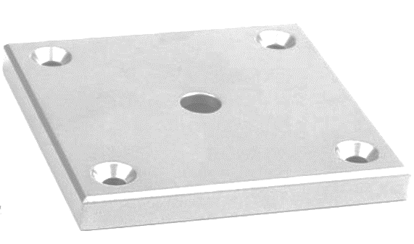

Note: All the dimensions are in mm. While the value for tolerance is as ±0.2mm.

