Assessment Evidence Guide
For
“Machinist”
Level-2
Summative Assessment

Date 4-9November, 2024
Lahore


National Vocational & Technical
Training Commission

Instruction Sheet for the Candidate
Qualification | Machinist (Level – 2)
Competency Standards | - Develop Basic Communication Skills  - Maintain Safe Work Environment  - Maintain Tools & Equipment  - Carry Out Calculations and Prepare Estimates  - Carryout General Maintenance  - Carryout Bench Work  - Perform Basic Grinding Operations  - Perform Drilling Machine Operation  - Perform Turning Operations  - Perform Shaping Operations  - Workshop Projects-I
Purpose of Assessment | Summative Assessment
Candidate Details | Name_______________________________________________________  Registration Number_________________________________________________
Guidance for Candidate | To meet this standard, you are required to complete the following within 05 Hrs. time frame (for practical demonstration & assessment):  - Perform machining operations (facing, turning, step turning, taper turning, and threading) as per attached drawing Annex-A.  OR  - Perform shaper operation as per drawing of Annex-B to shape a workpiece with a 6mm slot and 2 holes of M10
Time: 5 Hrs | During a practical assessment, under observation by an assessor, you are required to demonstrating the following criteria:
Minimum Evidence Required | A. Perform machining operations (facing, turning, step turning, taper turning, and threading) as per attached drawing Annex-A.  - Interpret drawing  - Follow safety protocols  - Perform facing operation to achieve the length of 65 mm.  - Turn the job to a diameter 23 mm up to a length of 22 mm.  - Turn the first step turning diameter 11 mm upto 4 mm length.  - Perform taper turning to reduce diameter from 16 mm to 12 mm for a length of 21 mm.  - Turn a second step to achieve 8 mm diameter for a length of 4 mm.  - Cut M10 external V-thread having pitch 1.5 mm for a 14mm length.  B. Perform shaper operation as per drawing of Annex-B to shape a workpiece with a 6mm slot and 2 holes of M10.  - Set up the shaper machine mounting appropriate tool.  - Mount the workpiece in shaper machine vice.  - Shape the job size as 60mm x 48mm x 12mm.  - Align the tool at 21mm from the top edge for slot cutting.  - Cut a groove of 6mm width and 4mm depth.  - Drill two holes as per drawing.  - Clean the hole through reamer.  - Cut internal threads of M10 with a Tap.  - Deburr all edges of the workpiece  - Clean the work area  - Turn off the machine

Self-Assessment Checklist
Candidate Name
Registration No.
Qualification | Machinist (Level 02)
Competency Standards | - Develop Basic Communication Skills  - Maintain Safe Work Environment  - Maintain Tools & Equipment  - Carry Out Calculations and Prepare Estimates  - Carryout General Maintenance  - Carryout Bench Work  - Perform Basic Grinding Operations  - Perform Drilling Machine Operation  - Perform Turning Operations  - Perform Shaping Operations.  - Workshop Projects-I
Assessment Task | - Perform machining operations (facing, turning, step turning, taper turning, and threading) as per attached drawing Annex-A.  OR  - Perform shaper operation as per drawing of Annex-B to shape a workpiece with a 6mm slot and 2 holes of M10.
I can……………….
Performance Criteria | Yes | No
- Perform machining operations (facing, turning, step turning, taper turning, and threading) as per attached drawing Annex-A.
- Interpret drawing
- Follow safety protocols
- Perform facing operation to achieve the length of 65 mm.
- Turn the job to a diameter 23 mm up to a length of 22 mm.
- Turn the first step turning diameter 11 mm upto 4 mm length.
- Perform taper turning to reduce diameter from 16 mm to 12 mm for a length of 21 mm.
- Turn a second step to achieve 8 mm diameter for a length of 4 mm.
- Cut M10 external V-thread having pitch 1.5 mm for a 14mm length.
- Perform an operation as per drawing of Annex-B to shape a workpiece with a 6mm slot and 2 holes of M10.
- Set up the shaper machine mounting appropriate tool.
- Mount the workpiece in shaper machine vice.
- Shape the job size as 60mm x 48mm x 12mm.
- Align the tool at 21mm from the top edge for slot cutting.
- Cut a groove of 6mm width and 4mm depth.
- Drill two holes as per drawing.
- Clean the hole through reamer.
- Cut internal threads of M10 with a Tap.
- Deburr all edges of the workpiece
- Clean the work area
- Turn off the machine

Candidate’s Signature__________________ Assessor’s Signature__________________
Date: _______________________________

Assessors Judgment Guide
Qualification | Machinist (Level 02)
Competency Standards | - Develop Basic Communication Skills  - Maintain Safe Work Environment  - Maintain Tools & Equipment  - Carry Out Calculations and Prepare Estimates  - Carryout General Maintenance  - Carryout Bench Work  - Perform Basic Grinding Operations  - Perform Drilling Machine Operation  - Perform Turning Operations  - Perform Shaping Operations.  - Workshop Projects-I
Candidate Details | Name: ______________________________________________________________  Registration Number: ________________________ Signature: _________________
Assessment Outcome | COMPETENT NOT YET COMPETENT  Name of the Assessor________________________________________________  Assessor’s code: ___________________ Signature: _____________________

Assessment Summary (to be filled by the assessor)
Activity | Method |  |  |  |  | Result
Nature of Activity | Written | Oral | Observation | Portfolio | Role Play | Competent | Not Yet Competent
Practical Skill Demonstration
Knowledge Assessment
Other Requirement

Observation Checklist
Assessment Task |  | - Perform machining operations (facing, turning, step turning, taper turning, and threading) as per attached drawing Annex-A.  OR  - Perform shaper operation as per drawing of Annex-B to shape a workpiece with a 6mm slot and 2 holes of M10.
During the practical assessment, candidate demonstrated the following: |  |  |  | Yes | No | Remarks
- Perform machining operations (facing, turning, step turning, taper turning, and threading) as per attached drawing Annex-A.
 | Interpret drawing
 | Follow safety protocols
 | Perform facing operation to achieve the length of 65 mm.
 | Turn the job to a diameter 23 mm up to a length of 22 mm.
 | Turn the first step turning diameter 11 mm upto 4 mm length.
 | Perform taper turning to reduce diameter from 16 mm to 12 mm for a length of 21 mm.
 | Turn a second step to achieve 8 mm diameter for a length of 4 mm.
 | Cut M10 external V-thread having pitch 1.5 mm for a 14mm length.
B. Perform shaper operation as per drawing of Annex-B to shape a workpiece with a 6mm slot and 2 holes of M10.
 | Set up the shaper machine mounting appropriate tool.
 | Mount the workpiece in shaper machine vice.
 | Shape the job size as 60mm x 48mm x 12mm.
 | Align the tool at 21mm from the top edge for slot cutting.
 | Cut a groove of 6mm width and 4mm depth.
 | Drill two holes as per drawing.
 | Clean the hole through reamer.
 | Cut internal threads of M10 with a Tap.
 | Deburr all edges of the workpiece
 | Clean the work area
 | Turn off the machine
Competent |  |  | Not Competent

Knowledge Assessment
Qualification | Machinist (Level 02)
Competency Standards | - Develop Basic Communication Skills  - Maintain Safe Work Environment  - Maintain Tools & Equipment  - Carry Out Calculations and Prepare Estimates  - Carryout General Maintenance  - Carryout Bench Work  - Perform Basic Grinding Operations  - Perform Drilling Machine Operation  - Perform Turning Operations  - Perform Shaping Operations.  - Workshop Projects-I
Candidate Details | Name: __________________________________________________________  Registration Number: __________________ Candidate Signature: _____________
Assessment Outcome | COMPETENT NOT YET COMPETENT  Name of the Assessor: __________________________  Assessor’s code: _________________ Signature of the Assessor: _______________

Candidate’s response is not required to be identical, but similar concepts and/or keywords must be used. Oral questioning may be used to clarify candidate understanding of topic and its application.
Questions (Candidate confidently answered questions correctly and demonstrated understanding of the topics and their application) |  | Satisfactory | Not Satisfactory
 | How many tools can mount in lathe tool post at a time?
 | What is the difference between a tap and a die?
 | What is the primary function of a tailstock in a lathe?
 | How many mm in 1 inch?
 | What is the function of coolant in machining operations?
 | Enlist 5 major parts of Shaper machine
 | What is meant by Twist Drill?
 | What is meant by precision measuring tool?
 | Where scriber used in machine shop?
 | Define Thread Pitch Gauge.
 | Define Guide Ways.
 | Enlist 3 PPEs used in Mechanical workshop.
Feedback to the Candidate
Candidate’s Signature__________________ Assessor’s Signature __________________

Annex-A
Perform machining operations (Facing, Turning, Step Turning, Taper Turning, and Threading).

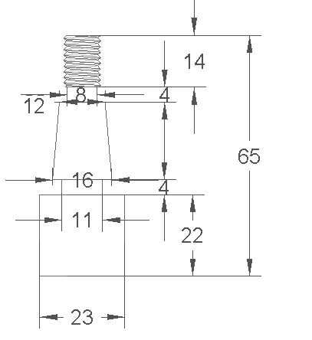

Note: All the dimensions are in mm. While the value for tolerance is as ±0.2mm.

Annex-B
Perform an operation as per drawing to shape a workpiece with a 6mm slot and 2 holes of M10.

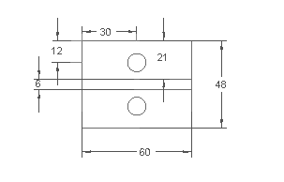
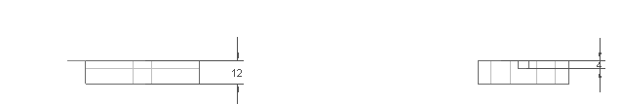

Note: All the dimensions are in mm. While the value for tolerance is as ±0.2mm.

