Assessment Evidence Guide
For
“Machinist”
Level-3
Formative Assessment
0715MMT3508. Perform Milling Operations
Date 4-9November, 2024
Lahore


National Vocational & Technical
Training Commission

Instruction Sheet for the Candidate

Qualification | Machinist Level-3
Competency Standard(s) | 0715MMT3508. Perform Milling Operations
Purpose of Assessment | Formative Assessment
Candidate Details | Name____________________________________________________  Registration/Roll Number_______________________________________________
Guidance for Candidate | To meet this standard, you are required to complete the following within the given time frame.  - Prepare Blank for Generating the Gear.  - Select Tools and Equipment for Gear Cutting.  - Produce a square shaped work piece.  - Generate spur gear (Direct Indexing) On Milling Machine.  - Generate spur gear (Differential Indexing) On Milling Machine.  - Generate Helical Gear on Milling Machine.  - Preform slotting or grooving on work piece.  - Perform drilling or boring using milling machine.  - Cut T-slot on Milling machine.  - Cut Bevel gear on milling machine.  - Practice of spur rack cutting.  - Practice of helical rack cutting.  Activity: Generate a rack gear as per drawing provided in Annex-A.
Time: 4 hrs. | During a practical assessment, under observation by an assessor, you are required to  - Set up the workpiece on the milling table, aligning it accurately.  - Mount the appropriate gear cutter for rack teeth cutting.  - Position the workpiece, setting the first cut 15 mm from the edge.  - Calculate spacing by setting the machine feed to 6.28 mm.  - Set the depth of cut to 4.33 mm as specified.  - Perform the first cut, moving the cutter to the set depth.  - Index the workpiece forward by 6.28 mm and repeat for 11 cuts.  - Inspect each cut to ensure correct tooth profile and spacing.  - Deburr the rack gear, removing all sharp edges.  - Conduct a final inspection to verify all dimensions match specifications.
Minimum Evidence Required

Self-Assessment Checklist
Candidate Name
Registration No.
Qualification | Machinist Level-3
Competency Standards | 0715MMT3508. Perform Milling Operations
Assessment Task | - Prepare Blank for Generating the Gear.  - Select Tools and Equipment for Gear Cutting.  - Produce a square shaped work piece.  - Generate spur gear (Direct Indexing) On Milling Machine.  - Generate spur gear (Differential Indexing) On Milling Machine.  - Generate Helical Gear on Milling Machine.  - Preform slotting or grooving on work piece.  - Perform drilling or boring using milling machine.  - Cut T-slot on Milling machine.  - Cut Bevel gear on milling machine.  - Practice of spur rack cutting.  - Practice of helical rack cutting.  Activity: Generate a rack gear as per drawing provided in Annex-A.

I can……………….
Performance Criteria | Yes | No
- Set up the workpiece on the milling table, aligning it accurately. | 
- Mount the appropriate gear cutter for rack teeth cutting.
- Position the workpiece, setting the first cut 15 mm from the edge.
- Calculate spacing by setting the machine feed to 6.28 mm.
- Set the depth of cut to 4.33 mm as specified.
- Perform the first cut, moving the cutter to the set depth.
- Index the workpiece forward by 6.28 mm and repeat for 11 cuts.
- Inspect each cut to ensure correct tooth profile and spacing.
- Deburr the rack gear, removing all sharp edges.
- Conduct a final inspection to verify all dimensions match specifications.

Candidate’s Signature___________________ Assessor’s Signature_____________
Date: ________________________________

Assessors Judgment Guide
Qualification | Machinist Level-3
Competency Standard(s) | 0715MMT3508. Perform Milling Operations
Candidate Details | Name: ______________________________________________  Registration/Roll Number: ________________________Signature: _____________
Assessment Outcome | COMPETENT NOT YET COMPETENT  Name of the Assessor______________ Assessor’s code: ___________________  Signature: __________________________________

Assessment Summary (to be filled by the assessor)
Activity | Method |  |  |  |  | Result
Nature of Activity | Written | Oral | Observation | Portfolio | Role Play | Competent | Not Yet Competent
Practical Skill Demonstration
Knowledge Assessment
Other Requirement

Observation Checklist
Assessment Task |  | - Prepare Blank for Generating the Gear.  - Select Tools and Equipment for Gear Cutting.  - Produce a square shaped work piece.  - Generate spur gear (Direct Indexing) On Milling Machine.  - Generate spur gear (Differential Indexing) On Milling Machine.  - Generate Helical Gear on Milling Machine.  - Preform slotting or grooving on work piece.  - Perform drilling or boring using milling machine.  - Cut T-slot on Milling machine.  - Cut Bevel gear on milling machine.  - Practice of spur rack cutting.  - Practice of helical rack cutting.  Activity: Generate a rack gear as per drawing provided in Annex-A.
During the practical assessment, candidate demonstrated the following: |  |  |  | Yes | No | Remarks
 | Set up the workpiece on the milling table, aligning it accurately.
 | Mount the appropriate gear cutter for rack teeth cutting.
 | Position the workpiece, setting the first cut 15 mm from the edge.
 | Calculate spacing by setting the machine feed to 6.28 mm.
 | Set the depth of cut to 4.33 mm as specified.
 | Perform the first cut, moving the cutter to the set depth.
 | Index the workpiece forward by 6.28 mm and repeat for 11 cuts.
 | Inspect each cut to ensure correct tooth profile and spacing.
 | Deburr the rack gear, removing all sharp edges.
 | Conduct a final inspection to verify all dimensions match specifications.
Competent |  |  | Not Yet Competent

Knowledge Assessment
Qualification | Machinist Level-3
Competency Standard(s) | 0715MMT3508. Perform Milling Operations
Candidate Details | Name: ____________________________________________________________________  Registration/Roll Number: __________________ Candidate Signature: __________
Assessment Outcome | COMPETENT NOT YET COMPETENT  Name of the Assessor: __________________________Assessor’s code: _________  Signature of the Assessor: _______________________
Candidate’s response is not required to be identical, but similar concepts and/or keywords must be used. Oral questioning may be used to clarify candidate understanding of topic and its application.

Questions (Candidate confidently answered questions correctly and demonstrated understanding of the topics and their application) |  | Satisfactory | Not Satisfactory
 | Define Gear
 | Define milling machine
 | Why is it important to choose the correct cutting speed and feed rate?
 | Difference in Spur and Helical gear.
 | What is climb milling?

Feedback to the Candidate
Candidate’s Signature___________________ Assessor’s Signature ____________

Annex-A
Activity: Generate a rack gear as per drawing provided.

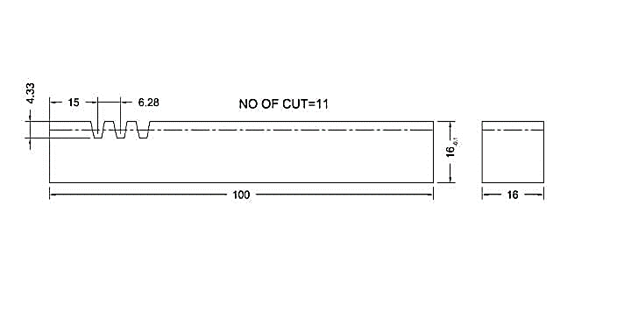

Note: All the dimensions are in mm. While the value for tolerance is as ±0.2mm.

