Assessment Evidence Guide
For
“Machinist”
Level-3
Summative Assessment

Date 4-9November, 2024
Lahore


National Vocational & Technical
Training Commission

Instruction Sheet for the Candidate
Qualification | Machinist Level – 3
Competency Standards | - Maintain Health and Safety at work place  - Develop Basic computer operating skills  - Develop Professionalism  - Perform off hand grinding  - Perform Surface Grinding  - Perform Cylindrical and centerless grinding  - Perform Tool & Cutter Grinding  - Perform Milling Operations  - Generate Gears on Hobbing Machine  - Perform broaching operation  - Workshop Projects-II
Purpose of Assessment | Summative Assessment
Candidate Details | Name_______________________________________________________  Registration Number_________________________________________________
Guidance for Candidate | To meet this standard, you are required to complete the following within 05 Hrs. time frame (for practical demonstration & assessment):  - Perform milling operation on a blank for generating a spur gear as per drawing given in Annex-A.  OR  - Perform step milling operation on a rectangular plate as per given drawing in Annex-B.
Time: 5 Hrs. | During a practical assessment, under observation by an assessor, you are required to demonstrating the following criteria:
Minimum Evidence Required | - Perform milling operation on a blank for generating a spur gear as per drawing given in Annex-A.  - Cut a gear blank with Ø48 mm diameter and 20 mm thickness.  - Drill Ø16 mm hole at the center of the blank as per the drawing.  - Ream the hole to ensure a smooth finish.  - Mount the gear blank securely on the milling machine.  - Select the correct module cutter for the gear profile.  - Attach the indexing head to the machine and set it for 12 divisions (30° rotation per tooth).  - Index precisely for 12 teeth positioning.  - Mill 12 teeth on the blank to form the gear as per the drawing.  - Shape each tooth with a R20 radius.  - Inspect the tooth profile and alignment for accuracy.  - Clean the work area thoroughly.  - Power down the machine.  B. Perform step milling operation on a rectangular plate as per given drawing in Annex-B.  - Install the appropriate milling cutter.  - Mount the workpiece on the milling machine table.  - Face mill for a length of 80 mm.  - Side mill to achieve a width of 25 mm.  - Face mill the workpiece for a thickness of 30 mm.  - Step mill for a 40 mm depth.  - Step mill for a 10 mm depth.  - Step mill for a 5 mm depth.  - Step mill for a depth of 60 mm.  - Clear the work area.  - Shut down the machine.

Self-Assessment Checklist
Candidate Name
Registration No.
Qualification | Machinist Level-3
Competency Standards | 1. Maintain Health and Safety at work place  2. Develop Basic computer operating skills  3. Develop Professionalism  4. Perform off hand grinding  5. Perform Surface Grinding  6. Perform Cylindrical and centerless grinding  7. Perform Tool & Cutter Grinding  8. Perform Milling Operations  9. Generate Gears on Hobbing Machine  10. Perform broaching operation.  11. Workshop Projects-II
Assessment Task | - Perform milling operation on a blank for generating a spur gear as per drawing given in Annex-A.  OR  - Perform step milling operation on a rectangular plate as per given drawing in Annex-B.
I can……………….
Performance Criteria | Yes | No
- Perform milling operation on a blank for generating a spur gear as per drawing given in Annex-A.
- Cut a gear blank with Ø48 mm diameter and 20 mm thickness.
- Drill Ø16 mm hole at the center of the blank as per the drawing.
- Ream the hole to ensure a smooth finish.
- Mount the gear blank securely on the milling machine.
- Select the correct module cutter for the gear profile.
- Attach the indexing head to the machine and set it for 12 divisions (30° rotation per tooth).
- Index precisely for 12 teeth positioning.
- Mill 12 teeth on the blank to form the gear as per the drawing.
- Shape each tooth with a R20 radius.
- Inspect the tooth profile and alignment for accuracy.
- Clean the work area thoroughly.
- Power down the machine.
B. Perform step milling operation on a rectangular plate as per given drawing in Annex-B.
- Install the appropriate milling cutter.
- Mount the workpiece on the milling machine table.
- Face mill for a length of 80 mm.
- Side mill to achieve a width of 25 mm.
- Face mill the workpiece for a thickness of 30 mm.
- Step mill for a 40 mm depth.
- Step mill for a 10 mm depth.
- Step mill for a 5 mm depth.
- Step mill for a depth of 60 mm.
- Clear the work area.
- Shut down the machine.

Candidate’s Signature__________________ Assessor’s Signature__________________
Date: _______________________________

Assessors Judgment Guide
Qualification | Machinist Level-3
Competency Standards | - Maintain Health and Safety at work place  - Develop Basic computer operating skills  - Develop Professionalism  - Perform off hand grinding  - Perform Surface Grinding  - Perform Cylindrical and centerless grinding  - Perform Tool & Cutter Grinding  - Perform Milling Operations  - Generate Gears on Hobbing Machine  - Perform broaching operation  - Workshop Projects-II
Candidate Details | Name: ______________________________________________________________  Registration Number: ________________________ Signature: _________________
Assessment Outcome | COMPETENT NOT YET COMPETENT  Name of the Assessor________________________________________________  Assessor’s code: ___________________ Signature: _____________________

Assessment Summary (to be filled by the assessor)
Activity | Method |  |  |  |  | Result
Nature of Activity | Written | Oral | Observation | Portfolio | Role Play | Competent | Not Yet Competent
Practical Skill Demonstration
Knowledge Assessment
Other Requirement

Observation Checklist
Assessment Task |  | - Perform milling operation on a blank for generating a spur gear as per drawing given in Annex-A.  OR  B. Perform step milling operation on a rectangular plate as per given drawing in Annex-B.
During the practical assessment, candidate demonstrated the following: |  |  |  | Yes | No | Remarks
A. Perform milling operation on a blank for generating a spur gear as per drawing given in Annex-A.
 | Cut a gear blank with Ø48 mm diameter and 20 mm thickness.
 | Drill Ø16 mm hole at the center of the blank as per the drawing.
 | Ream the hole to ensure a smooth finish.
 | Mount the gear blank securely on the milling machine.
 | Select the correct module cutter for the gear profile.
 | Attach the indexing head to the machine and set it for 12 divisions (30° rotation per tooth).
 | Index precisely for 12 teeth positioning.
 | Mill 12 teeth on the blank to form the gear as per the drawing.
 | Shape each tooth with a R20 radius.
 | Inspect the tooth profile and alignment for accuracy.
 | Clean the work area thoroughly.
 | Power down the machine.
B. Perform step milling operation on a rectangular plate as per given drawing in Annex-B.
 | Install the appropriate milling cutter.
 | Mount the workpiece on the milling machine table.
 | Face mill for a length of 80 mm.
 | Side mill to achieve a width of 25 mm.
 | Face mill the workpiece for a thickness of 30 mm.
 | Step mill for a 40 mm depth.
 | Step mill for a 10 mm depth.
 | Step mill for a 5 mm depth.
 | Step mill for a depth of 60 mm.
 | Clear the work area.
 | Shut down the machine.
Competent |  |  | Not Competent

Knowledge Assessment
Qualification | Machinist Level-3
Competency Standards | - Maintain Health and Safety at work place  - Develop Basic computer operating skills  - Develop Professionalism  - Perform off hand grinding  - Perform Surface Grinding  - Perform Cylindrical and centerless grinding  - Perform Tool & Cutter Grinding  - Perform Milling Operations  - Generate Gears on Hobbing Machine  - Perform broaching operation  - Workshop Projects-II
Candidate Details | Name: __________________________________________________________  Registration Number: __________________ Candidate Signature: _____________
Assessment Outcome | COMPETENT NOT YET COMPETENT  Name of the Assessor: __________________________  Assessor’s code: _________________ Signature of the Assessor: _______________

Candidate’s response is not required to be identical, but similar concepts and/or keywords must be used. Oral questioning may be used to clarify candidate understanding of topic and its application.
Questions (Candidate confidently answered questions correctly and demonstrated understanding of the topics and their application) |  | Satisfactory | Not Satisfactory
 | Name two types of milling cutters.
 | How does climb milling differ from conventional milling?
 | Explain the purpose of an indexing head in milling.
 | What does the term grit size mean in grinding?
 | What is centerless grinding?
 | Define hob.
 | How does pull broaching differ from push broaching?
 | What is a broach tool?
 | Difference in Spur and Helical gear.
 | Define Universal Milling machine.
 | What is a grinding wheel’s bond?
 | Define grinding burn.
Feedback to the Candidate
Candidate’s Signature__________________ Assessor’s Signature ___________________

Annex-A
A. Perform milling operation on a blank for generating a spur gear as per drawing.

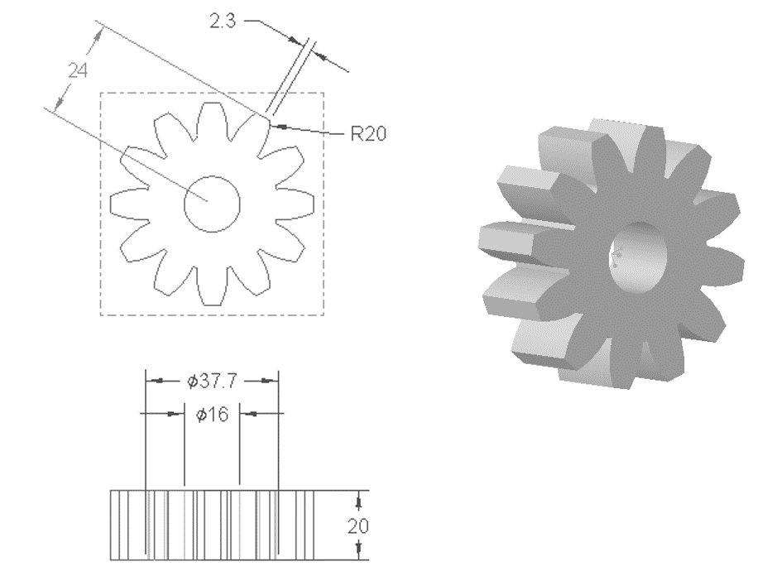

Note: All the dimensions are in mm. While the value for tolerance is as ±0.2mm.

Annex-B
Perform step milling operation on a rectangular plate as per given drawing.
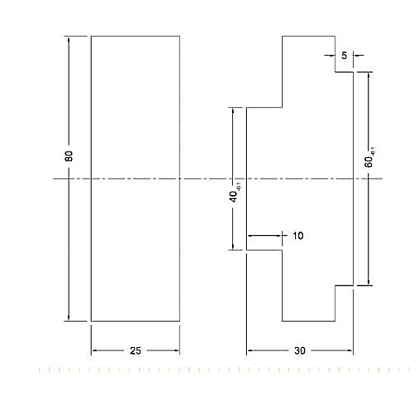

Note: All the dimensions are in mm. While the value for tolerance is as ±0.2mm.

