Assessment Evidence Guide

for

“Mason Helper Level 2”

Perform Basic Brick/Block Masonry Work for Given Building Project (Formative Assessment)
21th to 25th June 2021

National Vocational & Technical
Training Commission

Title of Qualification:  National Vocational Certificate Level 2 in Construction (Mason Helper) |  | CS Code: | Level:  2 | Version:  01
Competency Standard Title:  Perform Basic Brick/Block Masonry Work for Given Building Project  Maintain Personal Health, Hygiene and Safety  Perform Basic Communication  Carryout General Maintenance  Perform Basic Green Skills for Construction |  | Assessment Date (DD/MM/YY):  Assessment Time : 5 hrs
Candidate Details | Name:  Registration/Roll Number:
Guidance for Candidate | To meet this standard, you are required to complete the following within the given time frame (for practical demonstration & assessment):  Assessment Task 1: Candidate is required to construct L-shaped wall as per instructions given by assessor (for reference see ANNEX-I).  Assessment Task 2: Candidate is required to construct drain as per instructions given by assessor (for reference see ANNEX-II).  Assessment Task 3: Candidate is required to construct underground chamber wall as per instructions given by assessor (for reference see ANNEX-III).  And complete:  - Knowledge assessment test (Written or Oral)  - Portfolios at the time of assessment (if any)
Minimum Evidence Required | During a practical assessment, under observation by an assessor, you will complete:  Assessment Task 1  Performance Criteria 1: Select workplace  Performance Criteria 2: Interpret given drawing  Performance Criteria 3: Select material according to the task  Performance Criteria 4: Select tools according to the task  Performance Criteria 5: Perform cleaning, grubbing and leveling of workplace as per drawings  Performance Criteria 6: Perform brick/block soaking process  Performance Criteria 7: Prepare mortar according to the given ratio  Performance Criteria 8: Perform layout as per drawing  Performance Criteria 9: Perform excavation as per layout  Performance Criteria 10: Lay down mortar as per standards  Performance Criteria 11: Perform laying of brick/block courses in foundation and plinth as per drawing  Performance Criteria 12: Carryout horizontal alignment and vertical plumb in foundation and superstructure  Performance Criteria 13: Check water supply source  Performance Criteria 14: Connect plastic pipe with the source of water  Performance Criteria 15: Apply jute cloth on masonry work as per requirement  Performance Criteria 16: perform curing as per standards  Performance Criteria 17: Select materials as per task  Performance Criteria 18: Select knot for fastening  Performance Criteria 19: Perform placing of components  Performance Criteria 20: Carryout knotting as per task  Performance Criteria 21: Carryout brick masonry as per drawing  Performance Criteria 22: Interpret work processes and procedures correctly  Performance Criteria 23: Select personal protective equipment in terms of type and quantity according to work orders.  Performance Criteria 24: Wear, adjust, and maintain personal protective equipment to ensure correct fit and optimum protection in compliance with company procedures.  Performance Criteria 25: Comply with Health, hygiene and safety precautions before starting work  Performance Criteria 26: Deal with resolvable problems according to prescribed procedures  Performance Criteria 27: Carefully listen and note down the instructions of Supervisor  Performance Criteria 28: Apply appropriate methods and techniques for cleanliness and maintenance of machines & tools  Performance Criteria 29: Fill the checklist for daily cleanliness of the workplace  Performance Criteria 30: Identify various types of construction waste  Performance Criteria 31: Apply waste reduction techniques during construction process  Performance Criteria 32: Ensure appropriate storage of water
Assessment Task 2
Performance Criteria 1: Perform layout as per drawing
Performance Criteria 2: Carryout excavation
Performance Criteria 3: Perform compaction
Performance Criteria 4: Check gradient
Performance Criteria 5: Apply lean concrete
Performance Criteria 6: Carryout brick masonry as per drawing
Performance Criteria 7: Perform plastering as per prescribed ratio
Performance Criteria 8: Perform curing as per standards
Performance Criteria 9: Identify risk to Health, hygiene and safety
Performance Criteria 10: Maintain cleanliness and hygiene as per organizational policy
Performance Criteria 11: Follow organizational Health, hygiene and safety guidelines during work
Performance Criteria 12: Report unresolved problems to immediate supervisor
Performance Criteria 13: Place the tools equipment etc. at their prescribed place after completion of work
Performance Criteria 14: Carry out the instructions of the supervisor
Performance Criteria 15: Respond appropriately to safety hazards on all tools and machines
Performance Criteria 16: Categorize reusable waste
Performance Criteria 17: Dispose unusable waste as per set standards
Performance Criteria 18:Avoid wastage of water
Assessment Task 3
Performance Criteria 1: Perform layout as per drawing
Performance Criteria 2: Carryout excavation
Performance Criteria 3: Perform compaction
Performance Criteria 4: Apply lean concrete
Performance Criteria 5: Carryout brick masonry as per drawing
Performance Criteria 6: Fix iron rungs
Performance Criteria 7: Carry out flooring/benching
Performance Criteria 8: Perform plastering as per ratio
Performance Criteria 9: Perform curing as per standards
Performance Criteria 10: Recognize processes, tools, equipment and consumable materials that have the potential to cause harm
Performance Criteria 11: Ensure personal protective equipment is cleaned and stored in proper place.
Performance Criteria 12: Treat team members with respect and maintain positive relationships to achieve common organizational goals
Performance Criteria 13: Place all the tools & material in proper place to ensure safe work
Performance Criteria 14: Fill the checklists to conduct maintenance and housekeeping of machines & tools
Performance Criteria 15: Place reusable material at designated storage area
Performance Criteria 16: Transport waste material to designated place
Performance Criteria 17: Explore options for reuse of water
Assessors Judgment Guide (to be completed by the Assessor and signed both by the assessor and the candidate after the assessment)
Candidate Details | Name: Registration/Roll Number:  Candidate Signature:
Assessment Outcome | COMPETENT NOT YET COMPETENT  Name of the Assessor: Assessor’s code:  Signature of the  Assessor:
Assessment Summary (to be filled by the assessor)
Activity |  | Method |  |  |  |  | Result
Nature of Activity |  | Written | Oral | Observation | Portfolio | Role Play | Competent | Not Yet Competent
Practical Skill Demonstration
Knowledge Assessment
Other Requirement

Assessment Task 1 |  |  | Description of assessment task 1  Candidate is required to construct L-shaped wall as per instructions given by assessor (for reference see ANNEX-I).
During the practical assessment, candidate demonstrated the following: |  |  |  | Yes | No | Remarks
 | Select workplace
 | Interpret given drawing
 | Select material according to the task
 | Select tools according to the task
 | Perform cleaning, grubbing and leveling of workplace as per drawings
 | Perform brick/block soaking process
 | Prepare mortar according to the given ratio
 | Perform layout as per drawing
 | Perform excavation as per layout
 | Lay down mortar as per standards
 | Perform laying of brick/block courses in foundation and plinth as per drawing
 | Perform laying of brick/block courses in super structure as per drawing
 | Carryout horizontal alignment and vertical plumb in foundation and superstructure
 | Check water supply source
 | Connect plastic pipe with the source of water
 | Apply hessian on masonry work as per weather requirement
 | Perform curing as per standards
 | Select materials as per task
 | Select knot for fastening
 | Perform placing of components
 | Carryout knotting as per task
 | Interpret work processes and procedures correctly
 | Select personal protective equipment in terms of type and quantity according to work orders.
 | Wear, adjust, and maintain personal protective equipment to ensure correct fit and optimum protection in compliance with company procedures.
 | Comply with Health, hygiene and safety precautions before starting work
 | Deal with resolvable problems according to prescribed procedures
 | Carefully listen and note down the instructions of Supervisor
 | Apply appropriate methods and techniques for cleanliness and maintenance of machines & tools
 | Fill the checklist for daily cleanliness of the workplace
 | Identify various types of construction waste
 | Apply waste reduction techniques during construction process
 | Ensure appropriate storage of water
Competent |  | Not Yet Competent

Assessment Task 2 |  |  | Description of assessment task 2  Candidate is required to construct drain as per instructions given by assessor (for reference see ANNEX-II).
During the practical assessment, candidate demonstrated the following: |  |  |  | Yes | No | Remarks
 | Perform layout as per drawing
 | Carryout excavation
 | Perform compaction
 | Check gradient
 | Apply lean concrete
 | Carryout brick masonry as per drawing
 | Perform plastering as per prescribed ratio
 | Perform curing as per standards
 | Identify risk to Health, hygiene and safety
 | Maintain cleanliness and hygiene as per organizational policy
 | Follow organizational Health, hygiene and safety guidelines during work
 | Report unresolved problems to immediate supervisor
 | Place the tools equipment etc. at their prescribed place after completion of work
 | Carry out the instructions of the supervisor
 | Respond appropriately to safety hazards on all tools and machines
 | Categorize reusable waste
 | Dispose unusable waste as per set standards
 | Avoid wastage of water
Competent |  | Not Yet Competent

Assessment Task 3 |  |  | Description of assessment task 3  Candidate is required to construct underground chamber wall as per instructions given by assessor (for reference see ANNEX-III).
During the practical assessment, candidate demonstrated the following: |  |  |  | Yes | No | Remarks
 | Perform layout as per drawing
 | Carryout excavation
 | Perform compaction
 | Apply lean concrete
 | Carryout brick masonry as per drawing
 | Fix iron rungs
 | Carry out flooring/benching
 | Perform plastering as per ratio
 | Perform curing as per standards
 | Recognize processes, tools, equipment and consumable materials that have the potential to cause harm
 | Ensure personal protective equipment is cleaned and stored in proper place.
 | Treat team members with respect and maintain positive relationships to achieve common organizational goals
 | Place all the tools & material in proper place to ensure safe work
 | Fill the checklists to conduct maintenance and housekeeping of machines & tools
 | Place reusable material at designated storage area
 | Transport waste material to designated place
 | Explore options for reuse of water
Competent |  | Not Yet Competent

ANNEX-I

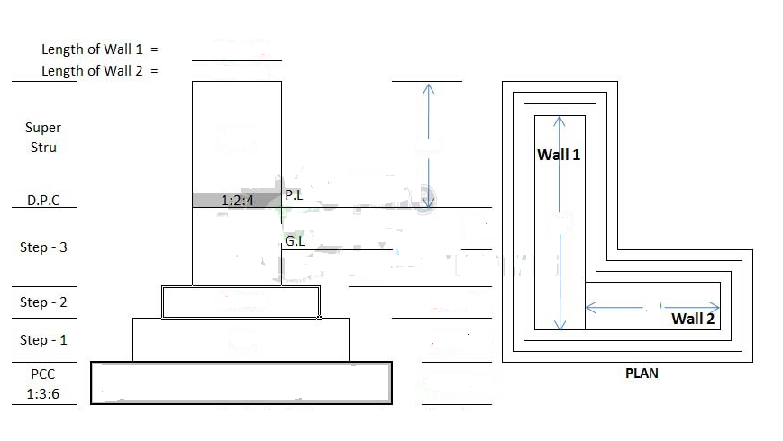
ANNEX-II

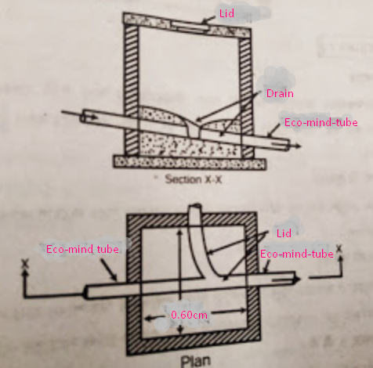

ANNEX-III

