Assessment Evidence Guide

for

“Mason Helper Level 2”

Perform Basic Stone Masonry Work for Given Project
(Formative Assessment)
21th to 25th June 2021

National Vocational & Technical
Training Commission

Title of Qualification:  National Vocational Certificate Level 2 in Construction (Mason Helper) |  | CS Code: | Level:  2 | Version:  01
Competency Standard Title:  Perform Basic Stone Masonry Work for Given Project  Maintain Personal Health, Hygiene and Safety  Perform Basic Communication  Carryout General Maintenance  Perform Basic Green Skills for Construction |  | Assessment Date (DD/MM/YY):  Assessment Time: 5 hrs
Candidate Details | Name:  Registration/Roll Number:
Guidance for Candidate | To meet this standard, you are required to complete the following within the given time frame (for practical demonstration & assessment):  Assessment Task 1: Candidate is required to construct T-shaped wall as per instructions given by assessor (for reference see ANNEX-I).  Assessment Task 2: Candidate is required to carry out stone pitching as per instructions given by assessor (for reference see ANNEX-II).  And complete:  - Knowledge assessment test (Written or Oral)  - Portfolios at the time of assessment (if any)
Minimum Evidence Required | During a practical assessment, under observation by an assessor, you will complete:  Assessment Task 1  Performance Criteria 1: Interpret given layout drawing  Performance Criteria 2: Select material according to the task  Performance Criteria 3: Select tools according to the task  Performance Criteria 4: Perform stone cutting and dressing process  Performance Criteria 5: Prepare mortar according to the given ratio  Performance Criteria 6: Perform layout as per drawing  Performance Criteria 7: Lay down mortar as per standards  Performance Criteria 8: Perform dressing of stone as per requirement  Performance Criteria 9: Perform laying of stone masonry in substructure  Performance Criteria 10: Carryout horizontal alignment in vertical plumb in substructure and super structure  Performance Criteria 11: Perform laying of stone masonry in super structure  Performance Criteria 12: Perform striking of joints as per design  Performance Criteria 13: Perform curing on stone masonry as per standards  Performance Criteria 14: Select personal protective equipment in terms of type and quantity according to work orders.  Performance Criteria 15: Wear, adjust, and maintain personal protective equipment to ensure correct fit and optimum protection in compliance with company procedures.  Performance Criteria 16: Comply with Health, hygiene and safety precautions before starting work  Performance Criteria 17: Deal with resolvable problems according to prescribed procedures  Performance Criteria 18: Carefully listen and note down the instructions of Supervisor  Performance Criteria 19: Apply appropriate methods and techniques for cleanliness and maintenance of machines & tools  Performance Criteria 20: Fill the checklist for daily cleanliness of the workplace  Performance Criteria 21: Identify various types of construction waste  Performance Criteria 22: Apply waste reduction techniques during construction process  Performance Criteria 23:Ensure appropriate storage of water
Minimum Evidence Required | Assessment Task 2  Performance Criteria 1: Perform dressing of slope as per drawing  Performance Criteria 2: Perform laying of stone course as per task  Performance Criteria 3: Perform grouting of sand on stone pitching  Performance Criteria 4: Identify risk to Health, hygiene and safety  Performance Criteria 5: Maintain cleanliness and hygiene as per organizational policy  Performance Criteria 6: Follow organizational Health, hygiene and safety guidelines during work  Performance Criteria 7: Report unresolved problems to immediate supervisor  Performance Criteria 8: Place the tools equipment etc. at their prescribed place after completion of work  Performance Criteria 9: Carry out the instructions of the supervisor  Performance Criteria 10: Respond appropriately to safety hazards on all tools and machines  Performance Criteria 11: Categorize reusable waste  Performance Criteria 12: Dispose unusable waste as per set standards

Assessors Judgment Guide (to be completed by the Assessor and signed both by the assessor and the candidate after the assessment)
Candidate Details | Name: Registration/Roll Number:  Candidate Signature:
Assessment Outcome | COMPETENT NOT YET COMPETENT  Name of the Assessor: Assessor’s code:  Signature of the  Assessor:
Assessment Summary (to be filled by the assessor)
Activity |  | Method |  |  |  |  | Result
Nature of Activity |  | Written | Oral | Observation | Portfolio | Role Play | Competent | Not Yet Competent
Practical Skill Demonstration
Knowledge Assessment
Other Requirement

Each Assessment Task (with performance criteria)
Assessment Task 1 |  |  | Description of assessment task 1  Candidate is required to construct T-shaped wall as per instructions given by assessor (for reference see ANNEX-I).
During the practical assessment, candidate demonstrated the following: |  |  |  | Yes | No | Remarks
 | Interpret given layout drawing
 | Select material according to the task
 | Select tools according to the task
 | Perform stone cutting and dressing process
 | Prepare mortar according to the given ratio
 | Perform layout as per drawing
 | Lay down mortar as per standards
 | Perform dressing of stone as per requirement
 | Perform laying of masonry in substructure
 | Carryout horizontal alignment in vertical plumb in substructure and super structure
 | Perform laying of stone masonry in super structure
 | Perform striking of joints as per design
 | Perform curing on stone masonry as per standards
 | Select personal protective equipment in terms of type and quantity according to work orders.
 | Wear, adjust, and maintain personal protective equipment to ensure correct fit and optimum protection in compliance with company procedures.
 | Comply with Health, hygiene and safety precautions before starting work
 | Deal with resolvable problems according to prescribed procedures
 | Carefully listen and note down the instructions of Supervisor
 | Apply appropriate methods and techniques for cleanliness and maintenance of machines & tools
 | Fill the checklist for daily cleanliness of the workplace
 | Identify various types of construction waste
 | Apply waste reduction techniques during construction process
 | Ensure appropriate storage of water
Competent |  | Not Yet Competent

Assessment Task 2 |  |  | Description of assessment task 2  Candidate is required to carry out stone pitching as per instructions given by assessor (for reference see ANNEX-II).
During the practical assessment, candidate demonstrated the following: |  |  |  | Yes | No | Remarks
 | Perform dressing of slope as per drawing
 | Perform laying of stone course as per task
 | Perform grouting of sand on stone pitching
 | Identify risk to Health, hygiene and safety
 | Maintain cleanliness and hygiene as per organizational policy
 | Follow organizational Health, hygiene and safety guidelines during work
 | Report unresolved problems to immediate supervisor
 | Place the tools equipment etc at their prescribed place after completion of work
 | Carry out the instructions of the supervisor
 | Respond appropriately to safety hazards on all tools and machines
 | Categorize reusable waste
 | Dispose unusable waste as per set standards
Competent |  | Not Yet Competent

ANNEX-I

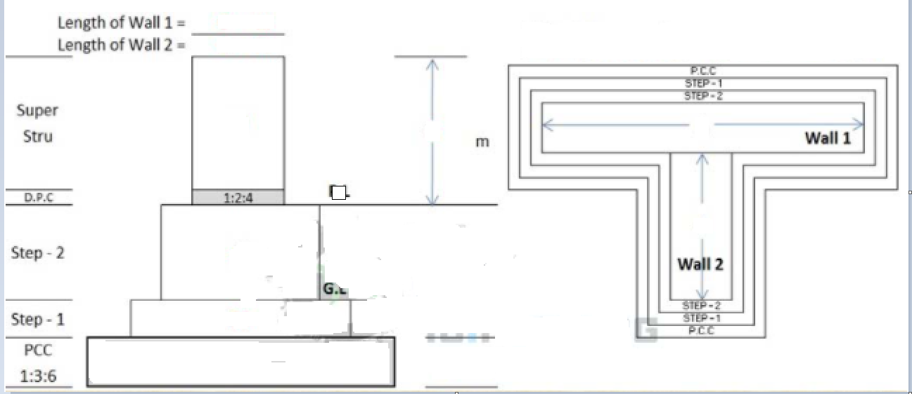

ANNEX-II

