Assessment Evidence Guide

for

“Mason Helper Level 2”

Perform Plain Cement Concrete Work (PCC) on Brick Masonry
(Formative Assessment)
21th to 25th June 2021

National Vocational & Technical
Training Commission

Title of Qualification:  National Vocational Certificate Level-2 in Construction (Mason Helper) |  | CS Code: | Level:  2 | Version:  01
Competency Standard Title:  Perform Plain Cement Concrete Work (PCC) on Brick Masonry  Maintain Personal Health, Hygiene and Safety  Perform Basic Communication  Carryout General Maintenance  Perform Basic Green Skills for Construction |  | Assessment Date (DD/MM/YY):  Assessment Time: 5 hrs
Candidate Details | Name:  Registration/Roll Number:
Guidance for Candidate | To meet this standard, you are required to complete the following within the given time frame (for practical demonstration & assessment):  Assessment Task 1: Candidate is required to pour PCC slab by hand mixing as per instructions given by assessor  Assessment Task 2: Candidate is required to pour concrete floor topping by machine mixing as per instructions given by assessor (for reference see ANNEX-I)  Assessment Task 3: Candidate is required to lay damp proof course as per instructions given by assessor (for reference see ANNEX-II).  And complete:  - Knowledge assessment test (Written or Oral)  - Portfolios at the time of assessment (if any)
Minimum Evidence Required | During a practical assessment, under observation by an assessor, you will complete:  Assessment Task 1  Performance Criteria 1: Interpret given layout drawing (example provided in annex-I) as per task  Performance Criteria 2: Select appropriate material according as per job specification  Performance Criteria 3: Select appropriate tools according to the task  Performance Criteria 4: Perform cleaning of fine aggregates  Performance Criteria 5: Preform washing of coarse aggregate  Performance Criteria 6: estimate the material quantities as per given standards  Performance Criteria 7: Perform batching of aggregate  Performance Criteria 4: Perform washing of coarse aggregate  Performance Criteria 5: Calculate the materials as per ratio  Performance Criteria 6:Perform batching of aggregates  Performance Criteria 7: Perform batching of coarse aggregate  Performance Criteria 8: Maintain water cement ratio  Performance Criteria 9: Prepare platform with available material  Performance Criteria 10: Spread coarse aggregate as per requirement  Performance Criteria 11: Spread fine aggregate over coarse aggregate as per requirement  Performance Criteria 12: Spread cement over fine aggregate as per requirement  Performance Criteria 13: Perform uniform mixing as per standard  Performance Criteria 14: Stretch mix material in circular shape and make a depression in the centre for water  Performance Criteria 15: Add water to maintain water cement ratio  Performance Criteria 16: Perform turning the mixture over and over again to achieve even color  Performance Criteria 17:Select the mode of transportation of concrete as per task  Performance Criteria 18:Transport the concrete with pan/wheel barrow  Performance Criteria 19:Place the concrete on prepared surface /formwork  Performance Criteria 20:Use chute as per requirement  Performance Criteria 21:Use tamping rod/needle vibrator for compaction as per task  Performance Criteria 22:Perform leveling and finishing as per task  Performance Criteria 23:Perform curing on concrete work as per standard  Performance Criteria 24:Interpret work processes and procedures correctly  Performance Criteria 25: Select personal protective equipment in terms of type and quantity according to work orders.  Performance Criteria 26: Wear, adjust, and maintain personal protective equipment to ensure correct fit and optimum protection in compliance with company procedures.  Performance Criteria 27:Comply with Health, hygiene and safety precautions before starting works  Performance Criteria 28:Deal with resolvable problems according to prescribed procedures  Performance Criteria 29:Carefully listen and note down the instructions of Supervisor  Performance Criteria 30:Apply appropriate methods and techniques for cleanliness and maintenance of machines & tools  Performance Criteria 31:Fill the checklist for daily cleanliness of the workplace  Performance Criteria 32:Identify various types of construction waste  Performance Criteria 33:Apply waste reduction techniques during construction process  Performance Criteria 34:Categorize reusable waste  Performance Criteria 35:Dispose unusable waste as per set standards  Performance Criteria 36:Place reusable material at designated storage area
Minimum Evidence Required | Performance Criteria 37:Transport waste material to designated place
Minimum Evidence Required | Assessment Task 2  Performance Criteria 1: add required quantity of water in mixing drum  Performance Criteria 2: Put crush in mixer hopper  Performance Criteria 3: Put sand in mixer hopper  Performance Criteria 4: Put cement in mixer hopper  Performance Criteria 5: Tilt the hopper into the mixing drum  Performance Criteria 6: Rotate the mixing drum as per standard  Performance Criteria 7: Unload the mixing drum on platform/wheel barrow  Performance Criteria 8: Select the mode of transportation of concrete as per task  Performance Criteria 9: Transport the concrete with pan/wheel barrow  Performance Criteria 10:Place the concrete on prepared surface /formwork  Performance Criteria 11:Use chute as per requirement  Performance Criteria 12:Use tamping rod/needle vibrator for compaction as per task  Performance Criteria 13:Perform leveling and finishing as per task  Performance Criteria 14:Perform curing on concrete work as per standard  Performance Criteria 15: Recognize processes, tools, equipment and consumable materials that have the potential to cause harm  Performance Criteria 16: Ensure personal protective equipment is cleaned and stored in proper place.  Performance Criteria 17: Treat team members with respect and maintain positive relationships to achieve common organizational goals  Performance Criteria 18: Place all the tools & material in proper place to ensure safe work  Performance Criteria 19: Fill the checklists to conduct maintenance and housekeeping of machines & tools
Minimum Evidence Required | Assessment Task 3  Performance Criteria 1: Clean and wash the top surface of wall at plinth level  Performance Criteria 2: apply the DPC on wall surface as per drawing (example attached in annex-II)  Performance Criteria 3: Perform curing on concrete work as per standard  Performance Criteria 4: Lay down water proofing layer as per requirement  Performance Criteria 5: Identify risk to Health, hygiene and safety  Performance Criteria 6 : Maintain cleanliness and hygiene as per organizational policy  Performance Criteria 7: Follow organizational Health, hygiene and safety guidelines during work  Performance Criteria 8: Report unresolved problems to immediate supervisor  Performance Criteria 9: Place the tools equipment etc at their prescribed place after completion of work  Performance Criteria 10: Carry out the instructions of the supervisor  Performance Criteria 11: Respond appropriately to safety hazards on all tools and machines  Performance Criteria 12:Ensure appropriate storage of water  Performance Criteria 13:Estimate water requirements for various stages of construction  Performance Criteria 14:Identify onsite water resources

Assessors Judgment Guide (to be completed by the Assessor and signed both by the assessor and the candidate after the assessment)
Candidate Details | Name: Registration/Roll Number:  Candidate Signature:
Assessment Outcome | COMPETENT NOT YET COMPETENT  Name of the Assessor: Assessor’s code:  Signature of the  Assessor:
Assessment Summary (to be filled by the assessor)
Activity |  | Method |  |  |  |  | Result
Nature of Activity |  | Written | Oral | Observation | Portfolio | Role Play | Competent | Not Yet Competent
Practical Skill Demonstration
Knowledge Assessment
Other Requirement

Each Assessment Task (with performance criteria)
Assessment Task 1 |  |  | Description of assessment task 1  Candidate is required to pour PCC slab by hand mixing as per instructions given by assessor.
During the practical assessment, candidate demonstrated the following: |  |  |  | Yes | No | Remarks
 | Interpret given layout drawing
 | Select appropriate material as per job specification
 | Select appropriate tools according to the task
 | Perform cleaning of fine aggregates
 | Perform washing of coarse aggregates
 | Estimate the material quantities as per prescribed ratio
 | Perform batching of aggregate
 | Ensure water cement ratio as per given standards
 | Prepare platform with available material
 | Spread coarse aggregate as per requirement
 | Spread fine aggregate over coarse aggregate as per requirement
 | Spread cement over fine aggregate as per requirement
 | Perform uniform mixing as per standard
 | Stretch mix material in circular shape and make a depression in the centre for water
 | Add water to maintain water cement ratio
 | Perform turning the mixture over and over again to achieve even color
 | Select the mode of transportation of concrete as per task
 | Transport the concrete with pan/wheel barrow
 | Place the concrete on prepared surface /formwork
 | Use chute as per requirement
 | Use tamping rod/needle vibrator for compaction as per task
 | Perform leveling and finishing as per task
 | Perform curing on concrete work as per standard
 | Interpret work processes and procedures correctly
 | Select personal protective equipment in terms of type and quantity according to work orders.
 | Wear, adjust, and maintain personal protective equipment to ensure correct fit and optimum protection in compliance with company procedures.
 | Comply with Health, hygiene and safety precautions before starting works
 | Deal with resolvable problems according to prescribed procedures
 | Carefully listen and note down the instructions of Supervisor
 | Apply appropriate methods and techniques for cleanliness and maintenance of machines & tools
 | Fill the checklist for daily cleanliness of the workplace
 | Identify various types of construction waste
 | Apply waste reduction techniques during construction process
 | Categorize reusable waste
 | Dispose unusable waste as per set standards
 | Place reusable material at designated storage area
 | Transport waste material to designated place
Competent |  | Not Yet Competent

Assessment Task 2 |  |  | Description of assessment task 2  Candidate is required to pour concrete floor topping by machine mixing as per instructions given by assessor (for reference see ANNEX-I)
During the practical assessment, candidate demonstrated the following: |  |  |  | Yes | No | Remarks
 | Add required quantity of water in mixing drum
 | Put crush in mixer hopper
 | Put sand in mixer hopper
 | Put cement in mixer hopper
 | Tilt the hopper into the mixing drum
 | Rotate the mixing drum as per standard
 | Unload the mixing drum on platform/wheel barrow
 | Select the mode of transportation of concrete as per task
 | Transport the concrete with pan/wheel barrow
 | Place the concrete on prepared surface /formwork
 | Use chute as per requirement
 | Use tamping rod/needle vibrator for compaction as per task
 | Perform leveling and finishing as per task
 | Perform curing on concrete work as per standard
 | Recognize processes, tools, equipment and consumable materials that have the potential to cause harm
 | Ensure personal protective equipment is cleaned and stored in proper place.
 | Treat team members with respect and maintain positive relationships to achieve common organizational goals
 | Place all the tools & material in proper place to ensure safe work
 | Fill the checklists to conduct maintenance and housekeeping of machines & tools
Competent |  | Not Yet Competent

Assessment Task 3 |  |  | Description of assessment task 3  Candidate is required to lay damp proof coarse as per instructions given by assessor (for reference see ANNEX-II).
During the practical assessment, candidate demonstrated the following: |  |  |  | Yes | No | Remarks
 | Clean and wash the top surface of wall at plinth level
 | Apply the DPC on wall surface as per drawing
 | Perform curing on concrete work as per standards
 | Identify risk to Health, hygiene and safety
 | Maintain cleanliness and hygiene as per organizational policy
 | Follow organizational Health, hygiene and safety guidelines during work
 | Report unresolved problems to immediate supervisor
 | Place the tools equipment etc at their prescribed place after completion of work
 | Carry out the instructions of the supervisor
 | Respond appropriately to safety hazards on all tools and machines
 | Ensure appropriate storage of water
 | Estimate water requirements for various stages of construction
 | Identify onsite water resources
Competent |  | Not Yet Competent

Annex-I

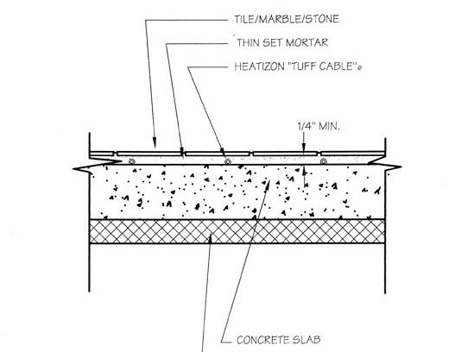

Concrete Slab Section

Annex-II

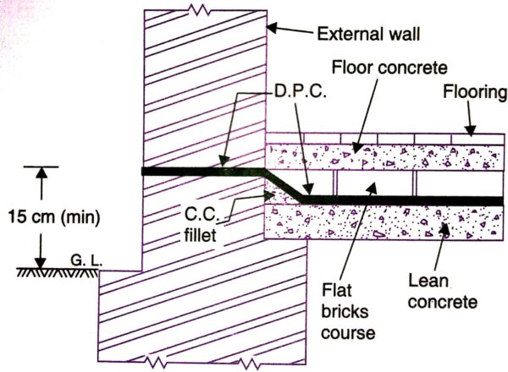

DPC in wall Section

