Assessment Evidence Guide

for

“Mason Helper Level 2”

Perform Soling on Ground Level
(Formative Assessment)
21th to 25th June 2021

National Vocational & Technical
Training Commission

Title of Qualification:  National Vocational Certificate Level -2 in Construction (Mason Helper) |  | CS Code: | Level:  2 | Version:  01
Competency Standard Title:  Perform Soling on Ground Level  Maintain Personal Health, Hygiene and Safety  Perform Basic Communication  Carryout General Maintenance  Perform Basic Green Skills for Construction |  | Assessment Date (DD/MM/YY):  Assessment Time : 5 hrs
Candidate Details | Name:  Registration/Roll Number:
Guidance for Candidate | To meet this standard, you are required to complete the following within the given time frame (for practical demonstration & assessment):  Assessment Task 1: Candidate is required to lay brick soling as per design given by assessor. (for reference see ANNEX-I)  Assessment Task 2: Candidate is required to lay tuff tile soling as per design given by assessor. (for reference see ANNEX-II)  And complete:  - Knowledge assessment test (Written or Oral)  - Portfolios at the time of assessment (if any)
Minimum Evidence Required | During a practical assessment, under observation by an assessor, you will complete:  Assessment Task 1  Performance criteria 1:Select appropriate material according to the task  Performance criteria 2:Select appropriate tools according to the task  Performance criteria 3:Prepare the boundary limits as per drawings (example given in annex-I)  Performance criteria 4:Perform compaction of sub-grade surface  Performance criteria 5:Prepare smooth surface as per requirement  Performance criteria 6:Lay sand cushion  Performance criteria 7:Perform compaction and level the sand  Performance criteria 8:Select the pattern as per requirement  Performance criteria 9:Lay the bricks on flat /edge with the help of rope  Performance criteria 10:Perform grouting with sand  Performance Criteria 11:Interpret work processes and procedures correctly  Performance Criteria 12: Select personal protective equipment in terms of type and quantity according to work orders.  Performance Criteria 13: Wear, adjust, and maintain personal protective equipment to ensure correct fit and optimum protection in compliance with company procedures.  Performance Criteria 14:Comply with Health, hygiene and safety precautions before starting work  Performance Criteria 15:Deal with resolvable problems according to prescribed procedures  Performance Criteria 16:Carefully listen and note down the instructions of Supervisor  Performance Criteria 17:Apply appropriate methods and techniques for cleanliness and maintenance of machines & tools  Performance Criteria 18:Fill the checklist for daily cleanliness of the workplace  Performance Criteria 19:Identify various types of construction waste  Performance Criteria 20:Apply waste reduction techniques during construction process  Performance Criteria 21:Ensure appropriate storage of water
Minimum Evidence Required | Assessment Task 2  Performance criteria 1:Lay base course as per drawing (example given in annex-II)  Performance criteria 2:Lay sand cushion as per drawing  Performance criteria 3:Perform compaction and level the sand as per drawing  Performance criteria 4:Select the pattern as per requirement  Performance criteria 5:Lay the tuff tile with the help of rope  Performance criteria 6: Perform grouting with sand  Performance criteria 7:Use plate compactors for more smoothness  Performance Criteria 8: Recognize processes, tools, equipment and consumable materials that have the potential to cause harm  Performance Criteria 9: Ensure personal protective equipment is cleaned and stored in proper place.  Performance Criteria 10: Treat team members with respect and maintain positive relationships to achieve common organizational goals  Performance Criteria 11: Place all the tools & material in proper place to ensure safe work  Performance Criteria 12: Fill the checklists to conduct maintenance and housekeeping of machines & tools  Performance Criteria 13: Place reusable material at designated storage area  Performance Criteria 14: Transport waste material to designated place  Performance Criteria 15: Explore options for reuse of water

Continued on following page
Assessors Judgment Guide (to be completed by the Assessor and signed both by the assessor and the candidate after the assessment)
Candidate Details | Name: Registration/Roll Number:  Candidate Signature:
Assessment Outcome | COMPETENT NOT YET COMPETENT  Name of the Assessor: Assessor’s code:  Signature of the  Assessor:
Assessment Summary (to be filled by the assessor)
Activity |  | Method |  |  |  |  | Result
Nature of Activity |  | Written | Oral | Observation | Portfolio | Role Play | Competent | Not Yet Competent
Practical Skill Demonstration
Knowledge Assessment
Other Requirement

Each Assessment Task (with performance criteria)
Assessment Task 1 |  |  | Description of assessment task 1  Candidate is required to lay brick soling as per design given by assessor. (for reference see ANNEX-I)
During the practical assessment, candidate demonstrated the following: |  |  |  | Yes | No | Remarks
 | Select appropriate material according to the task
 | Select appropriate tools according to the task
 | Prepare the boundary limits as per drawings
 | Perform compaction of sub-grade surface
 | Prepare smooth surface as per requirement
 | Lay sand cushion
 | Perform compaction and level the sand
 | Select the pattern as per requirement
 | Lay the bricks on flat /edge with the help of rope
 | Perform grouting with sand
 | Interpret work processes and procedures correctly
 | Select personal protective equipment in terms of type and quantity according to work orders.
 | Wear, adjust, and maintain personal protective equipment to ensure correct fit and optimum protection in compliance with company procedures.
 | Comply with Health, hygiene and safety precautions before starting work
 | Deal with resolvable problems according to prescribed procedures
 | Carefully listen and note down the instructions of Supervisor
 | Apply appropriate methods and techniques for cleanliness and maintenance of machines & tools
 | Fill the checklist for daily cleanliness of the workplace
 | Identify various types of construction waste
 | Apply waste reduction techniques during construction process
 | Ensure appropriate storage of water
Competent |  | Not Yet Competent

Each Assessment Task (with performance criteria)
Assessment Task 2 |  |  | Description of assessment task 2  Candidate is required to lay tuff tile soling as per design given by assessor. (for reference see ANNEX-II)
During the practical assessment, candidate demonstrated the following: |  |  |  | Yes | No | Remarks
 | Lay base course as per drawing
 | Lay sand cushion as per drawing
 | Perform compaction and level the sand as per drawing
 | Select the pattern as per requirement
 | Lay the tuff tile with the help of rope
 | Perform grouting with sand
 | Use plate compactors for more smoothness
 | Recognize processes, tools, equipment and consumable materials that have the potential to cause harm
 | Ensure personal protective equipment is cleaned and stored in proper place.
 | Treat team members with respect and maintain positive relationships to achieve common organizational goals
 | Place all the tools & material in proper place to ensure safe work
 | Fill the checklists to conduct maintenance and housekeeping of machines & tools
 | Place reusable material at designated storage area
 | Transport waste material to designated place
 | Explore options for reuse of water
Competent |  | Not Yet Competent

Annex-I

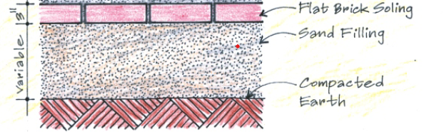


Brick Soling Pattern

Cross-section of Brick Soling

Annex-II

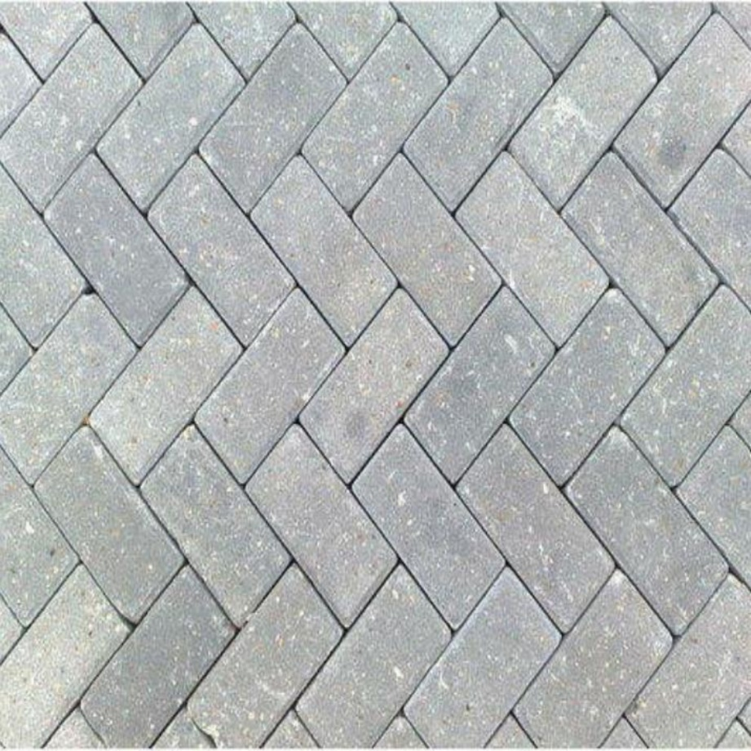

Tuff Tile Soling Pattern

