Assessment Evidence Guide

for

“Mason Helper Level 2”

Perform Repair Work of Existing Structure
(Formative Assessment)
21th to 25th June 2021

National Vocational & Technical
Training Commission

Title of Qualification:  National Vocational Certificate Level 2 in Construction (Mason Helper) |  | CS Code: | Level:  2 | Version:  01
Competency Standard Title:  Perform Repair Work of Existing Structure  Maintain Personal Health, Hygiene and Safety  Perform Basic Communication  Carryout General Maintenance  Perform Basic Green Skills for Construction |  | Assessment Date (DD/MM/YY):  Assessment Time :
Candidate Details | Name:  Registration/Roll Number:
Guidance for Candidate | To meet this standard, you are required to complete the following within the given time frame (for practical demonstration & assessment):  Assessment Task 1: Candidate is required to repair defective brick masonry as per instruction given by assessor (for reference see ANNEX-I)  Assessment Task 2: Candidate is required to repair defective plaster surface as per instruction given by assessor (for reference see ANNEX-II)  Assessment Task 3: Candidate is required to repair defective concrete floor as per instruction given by assessor (for reference see ANNEX-III)  And complete:  - Knowledge assessment test (Written or Oral)  - Portfolios at the time of assessment (if any)
Minimum Evidence Required | During a practical assessment, under observation by an assessor, you will complete:  Assessment Task 1  Performance criteria 1:Select material according to the task  Performance criteria 2:Select tools according to the task  Performance criteria 3:Mark defective area as per requirement  Performance criteria 4:Rack out defective bricks  Performance criteria 5:Clean defective areas  Performance criteria 6:Cure defective area  Performance criteria 7:Prepare mortar as per standards  Performance criteria 8:Apply mortar on defective area  Performance criteria 9:Fix new bricks on defective area  Performance criteria 10:Clean brick surface  Performance criteria 11:Cure repair surface  Performance Criteria 12: Identify risk to Health, hygiene and safety  Performance Criteria 13: Maintain cleanliness and hygiene as per organizational policy  Performance Criteria 14: Report unresolved problems to immediate supervisor  Performance Criteria 15: Place the tools equipment etc at their prescribed place after completion of work  Performance Criteria 16: Carry out the instructions of the supervisor  Performance Criteria 17: Dispose unusable waste as per set standards  Performance Criteria 18:Avoid wastage of water
Minimum Evidence Required | Assessment Task 2  Performance criteria 1:Select material according to the task  Performance criteria 2:Select tools according to the task  Performance criteria 3:Mark defective area as per requirement  Performance criteria 4:Remove defective plaster surface  Performance criteria 5:Clean defective areas  Performance criteria 6:Perform curing of defective area  Performance criteria 7:Prepare mortar as per requirement  Performance criteria 8:Apply layer cement slurry  Performance criteria 9:Apply mortar on defective area  Performance criteria 10:Finish plaster surface  Performance criteria 11:Perform curing of repair surface  Performance Criteria 12: Recognize processes, tools, equipment and consumable materials that have the potential to cause harm  Performance Criteria 13: Ensure personal protective equipment is cleaned and stored in proper place.  Performance Criteria 14: Treat team members with respect and maintain positive relationships to achieve common organizational goals  Performance Criteria 15: Fill the checklists to conduct maintenance and housekeeping of machines & tools  Performance Criteria 16: Place reusable material at designated storage area  Performance Criteria 17: Explore options for reuse of water
Minimum Evidence Required | Assessment Task 3  Performance criteria 1:Select material according to the task  Performance criteria 2:Select tools according to the task  Performance criteria 3:Mark defective area as per requirement  Performance criteria 4:Remove defective concrete area up to joint  Performance criteria 5:Clean defective areas  Performance criteria 6:Perform curing of defective area  Performance criteria 7:Prepare concrete as per standards  Performance criteria 8:Apply concrete on defective area  Performance criteria 9:Perform curing on repaired surface  Performance Criteria 10:Interpret work processes and procedures correctly  Performance Criteria 11: Wear, adjust, and maintain personal protective equipment to ensure correct fit and optimum protection in compliance with company procedures.  Performance Criteria 12:Comply with Health, hygiene and safety precautions before starting work  Performance Criteria 13:Carefully listen and note down the instructions of Supervisor  Performance Criteria 14:Apply appropriate methods and techniques for cleanliness and maintenance of machines & tools  Performance Criteria 15:Fill the checklist for daily cleanliness of the workplace  Performance Criteria 16:Identify various types of construction waste

Assessors Judgment Guide (to be completed by the Assessor and signed both by the assessor and the candidate after the assessment)
Candidate Details | Name: Registration/Roll Number:  Candidate Signature:
Assessment Outcome | COMPETENT NOT YET COMPETENT  Name of the Assessor: Assessor’s code:  Signature of the  Assessor:
Assessment Summary (to be filled by the assessor)
Activity |  | Method |  |  |  |  | Result
Nature of Activity |  | Written | Oral | Observation | Portfolio | Role Play | Competent | Not Yet Competent
Practical Skill Demonstration
Knowledge Assessment
Other Requirement

Each Assessment Task (with performance criteria)
Assessment Task 1 |  |  | Description of assessment task 1  Candidate is required to repair defective brick masonry as per instruction given by assessor. (for reference see ANNEX-I)
During the practical assessment, candidate demonstrated the following: |  |  |  | Yes | No | Remarks
 | Select material according to the task
 | Select tools according to the task
 | Mark defective area as per requirement
 | Rack out defective bricks
 | Clean defective areas
 | Cure defective area
 | Prepare mortar as per standards
 | Apply mortar on defective area
 | Fix new bricks on defective area
 | Clean brick surface
 | Cure repair surface
 | Identify risk to Health, hygiene and safety
 | Maintain cleanliness and hygiene as per organizational policy
 | Report unresolved problems to immediate supervisor
 | Place the tools equipment etc at their prescribed place after completion of work
 | Carry out the instructions of the supervisor
 | Dispose unusable waste as per set standards
 | Avoid wastage of water
Competent |  | Not Yet Competent

Assessment Task 2 |  |  | Description of assessment task 2  Candidate is required to repair defective plaster surface as per instruction given by assessor. (for reference see ANNEX-Ii)
During the practical assessment, candidate demonstrated the following: |  |  |  | Yes | No | Remarks
 | Select material according to the task
 | Select tools according to the task
 | Mark defective area as per requirement
 | Remove defective plaster surface
 | Clean defective areas
 | Perform curing of defective area
 | Prepare mortar as per requirement
 | Apply layer cement slurry
 | Apply mortar on defective area
 | Finish plaster surface
 | Perform curing of repair surface
 | Recognize processes, tools, equipment and consumable materials that have the potential to cause harm
 | Ensure personal protective equipment is cleaned and stored in proper place.
 | Treat team members with respect and maintain positive relationships to achieve common organizational goals
 | Fill the checklists to conduct maintenance and housekeeping of machines & tools
 | Place reusable material at designated storage area
 | Explore options for reuse of water
Competent |  | Not Yet Competent

Each Assessment Task (with performance criteria)
Assessment Task 3 |  |  | Description of assessment task 3  Candidate is required to repair defective concrete floor as per instruction given by assessor. (for reference see ANNEX-III)
During the practical assessment, candidate demonstrated the following: |  |  |  | Yes | No | Remarks
 | Select material according to the task
 | Select tools according to the task
 | Mark defective area as per requirement
 | Remove defective concrete area up to joint
 | Clean defective areas
 | Perform curing of defective area
 | Prepare concrete as per standards
 | Apply concrete on defective area
 | Perform curing on repaired surface
 | Interpret work processes and procedures correctly
 | Wear, adjust, and maintain personal protective equipment to ensure correct fit and optimum protection in compliance with company procedures.
 | Comply with Health, hygiene and safety precautions before starting work
 | Carefully listen and note down the instructions of Supervisor
 | Apply appropriate methods and techniques for cleanliness and maintenance of machines & tools
 | Fill the checklist for daily cleanliness of the workplace
 | Identify various types of construction waste
Competent |  | Not Yet Competent

ANNEX-I

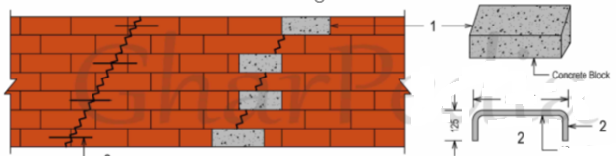

ANNEX-II

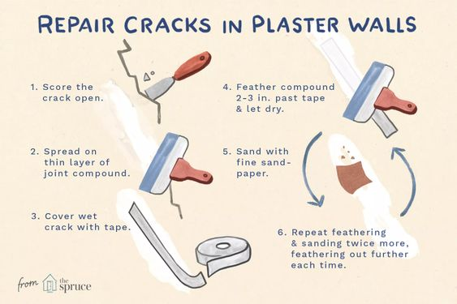

ANNEX-III

DRY PACKING
