National Vocational Certificate Level 2 in Construction Sector
(Mason Helper)

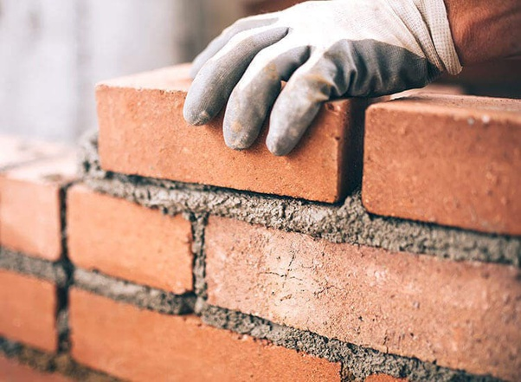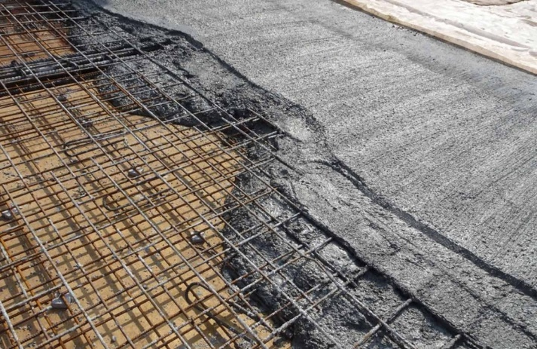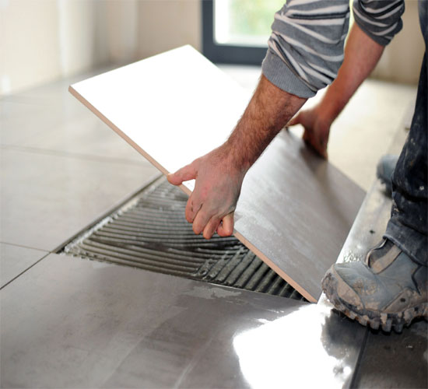

Assessment Pack

National Vocational and Technical Training Commission (NAVTTC), Government of Pakistan

Assessment Evidence Guide

for

“Mason Helper Level 2”

Demonstrate Basic Numeracy Skill
(Formative Assessment)
September 2021

National Vocational & Technical
Training Commission

Title of Qualification:  National Vocational Certificate Level 2 in Construction (Assistant Mason) |  | CS Code: | Level:  2 | Version:  01
Competency Standard Title:  Demonstrate Basic Numeracy Skills  Perform Basic Communication |  | Assessment Date (DD/MM/YY):  Assessment Time: 1 hr
Guidance for Candidate | To complete your assessment for this Competency Standard, you need to answer the questions on the following pages successfully.

Assessors Guide (to be completed by the Assessor and signed both by the assessor and the candidate after the assessment)
Candidate Details | Name: Registration/Roll Number:  Candidate Signature:
Written Assessment Outcome | COMPETENT NOT YET COMPETENT  Name of the Assessor: Assessor’s code:  Signature of the  Assessor:

Title of Qualification:  National Vocational Certificate Level 2 in  Construction (Assistant Mason) | CS Code: | Level:2 | Version:01
Competency Standard Title:  Demonstrate Basic Numeracy Skills  Perform Basic Communication | Assessment Date (DD/MM/YY):  Assessment Time: 30 min
WRITTEN ASSESSMENT
Question | Candidate’s answer
- How many inches in 4’-6”?
- Room external size is 14’x12’; wall thickness is 9’’.Find out inside area of the room?
- How many bricks used in 100cubic feet brick masonry?
- Calculate the volume of cylinder, having diameter of 6 cm & height is 50 cm?
- Brick soling floor on edge size is 20’x15’. Calculate area of flooring?
- How many cement bags used in 100 CFT PCC (1:2:4)?
- Find out volume of concrete when roof slab having area is 3000 sq.ft with thickness of 6”?
- Enlist any five Verbal communication techniques?

ANSWER KEY
Sr. | Answers
 | 54”
 | 131.25 sq.ft
 | 1350
 | 1413.90 cm³
 | 300 sq.ft
 | 17.6 Bags
 | 1500 cu.ft
- Active listening
- Clarity and conciseness
- Confidence
- Empathy
- Friendliness
- Open-mindedness
- Giving and soliciting feedback
- Confidence
- Respectfulness

Assessment Evidence Guide

for

“Mason Helper Level 2”

Demonstrate Basic Numeracy Skill
(Formative Assessment)
September 2021
National Vocational & Technical
Training Commission

Title of Qualification:  National Vocational Certificate Level 2 in Construction (Mason Helper) |  | CS Code: | Level:  2 | Version:  01
Competency Standard Title:  Demonstrate Basic Numeracy Skill  Perform Basic Communication |  | Assessment Date (DD/MM/YY):  Assessment Time : 2 hrs
Candidate Details | Name:  Registration/Roll Number:
Guidance for Candidate | To meet this standard, you are required to complete the following within the given time frame (for practical demonstration & assessment):  Assessment Task 1: Candidate is required to calculate area of four geometrical figures assigned by assessor. (for reference see ANNEX-I)  Assessment Task 2: Candidate is required to calculate volume of hollow concrete block assigned by assessor. (for reference see ANNEX-II)  And complete:  - Knowledge assessment test (Written or Oral)  - Portfolios at the time of assessment (if any)
Minimum Evidence Required | During a practical assessment, under observation by an assessor, you will complete:  Assessment Task 1  Performance Criteria 1: Identify basic mathematical operations (addition, subtraction, multiplication and division)  Performance Criteria 2: Apply addition operation  Performance Criteria 3: Apply of subtraction operation  Performance Criteria 4: Apply multiplication operation  Performance Criteria 5: Apply division operation  Performance Criteria 6: Calculate area of basic plane figures  Performance Criteria 7: Perform inter conversion of Measuring units  Performance Criteria 8: Record the results.  Performance Criteria 9: Carefully listen and note down the instructions of Supervisor
Minimum Evidence Required | Assessment Task 2  Performance Criteria 1: Identify measuring tools  Performance Criteria 2: Collect appropriate measuring tools  Performance Criteria 3: Identify inch, foot and yard  Performance Criteria 4: Identify millimeter, centimeter and meter  Performance Criteria 5: Interpret basic mathematical operations of addition, subtraction, multiplication and division  Performance Criteria 6: Apply basic addition operation  Performance Criteria 7: Apply subtraction operation  Performance Criteria 8: Apply multiplication operation  Performance Criteria 9: Apply division operation  Performance Criteria 10: Calculate surface area and volume of cylindrical and cubical shapes  Performance Criteria 11: Carry out the instructions of the supervisor

Assessors Judgment Guide (to be completed by the Assessor and signed both by the assessor and the candidate after the assessment)
Candidate Details | Name: Registration/Roll Number:  Candidate Signature:
Assessment Outcome | COMPETENT NOT YET COMPETENT  Name of the Assessor: Assessor’s code:  Signature of the  Assessor:
Assessment Summary (to be filled by the assessor)
Activity |  | Method |  |  |  |  | Result
Nature of Activity |  | Written | Oral | Observation | Portfolio | Role Play | Competent | Not Yet Competent
Practical Skill Demonstration
Knowledge Assessment
Other Requirement

Each Assessment Task (with performance criteria)
Assessment Task 1 |  |  | Description of Assessment Task 1  Candidate is required to calculate area of four geometrical figures assigned by assessor (for reference see ANNEX-I).
During the practical assessment, candidate demonstrated the following: |  |  |  | Yes | No | Remarks
 | Identify basic mathematical operations (addition, subtraction, multiplication and division)
 | Apply addition operation
 | Apply subtraction operation
 | Apply multiplication operation
 | Apply division operation
 | Calculate area of basic plane figures
 | Perform inter conversion of Measuring units
 | Record the results.
 | Carefully listen and note down the instructions of Supervisor
Competent |  | Not Yet Competent

Assessment Task 2 |  |  | Description of Assessment Task 2  Candidate is required to calculate volume of hollow concrete block assigned by assessor (for reference see ANNEX-II)
During the practical assessment, candidate demonstrated the following: |  |  |  | Yes | No | Remarks
 | Identify measuring tools
 | Collect appropriate measuring tools
 | Identify inch, foot and yard
 | Identify millimeter, centimeter and meter
 | Identify basic mathematical operations (addition, subtraction, multiplication and division)
 | Apply addition operation
 | Apply subtraction operation
 | Apply multiplication operation
 | Apply division operation
 | Calculate surface area and volume of cylindrical and cubical shapes
 | Carry out the instructions of the supervisor
Competent |  | Not Yet Competent

ANNEX-I

Q. Calculate Area for the following shapes

A. Diameter = 3.5 cm

B. Base= 4m
Height=10ft
C.

Base= 4.2m
Height=2m

ANNEX-II

Q. Calculate volume for the following shapes

A. diameter=12 ft
Height=3m

B.
Length= 12 in
Width=1 ft
Height= 10 in

Assessment Evidence Guide

for

“Mason Helper Level 2”

Carryout Layout Plan of Given Project (Formative Assessment)
September 2021

National Vocational & Technical
Training Commission

Title of Qualification:  National Vocational Certificate Level 2 in Construction (Assistant Mason) |  | CS Code: | Level:  2 | Version:  01
Competency Standard Title:  Carryout Layout Plan of Given Project  Maintain Personal Health, Hygiene and Safety  Perform Basic Communication |  | Assessment Date (DD/MM/YY):  Assessment Time: 30 min
Guidance for Candidate | To complete your assessment for this Competency Standard, you need to answer the questions on the following pages successfully.

Assessors Guide (to be completed by the Assessor and signed both by the assessor and the candidate after the assessment)
Candidate Details | Name: Registration/Roll Number:  Candidate Signature:
Written Assessment Outcome | COMPETENT NOT YET COMPETENT  Name of the Assessor: Assessor’s code:  Signature of the  Assessor:

Title of Qualification:  National Vocational Certificate Level 2 in Construction (Assistant Mason) | CS Code: | Level:2 | Version:01
Competency Standard Title:  Carryout Layout Plan of Given Project  Maintain Personal Health, Hygiene and Safety  Perform Basic Communication | Assessment Date (DD/MM/YY):  Assessment Time: 30min
WRITTEN ASSESSMENT
Question | Candidate’s answer
- What is a drawing?
- Enlist any three types of working drawing?
- Define layout?

- Define symbols.

- Enlist the name of any five materials used in layout.
- What are the 5 C’s of communication?
- PPE stands for?
- What is the meaning of the symbol given as und

ANSWER KEY
Sr. | Answers
 | Drawing is a form of visual communication
- Architectural Drawings
- Structural Drawings
- Electrical Drawings
- Plumbing and Sanitary Drawings
- Finishing Drawing
 | It is demarcation of drawing lines on the ground.
 | Symbols are means of representing material /structures on drawings.
- Lime powder
- Fish dory
- Thread
- Red oxide
- Steel Rod
- Clarity,
- Consistency,
- Creativity
- Content
- Connections
 | Personal Protective Equipment
 | Prohibition

Assessment Evidence Guide

for

“Mason Helper Level 2”

Carryout Layout Plan of Given Project
(Formative Assessment)
September 2021
National Vocational & Technical
Training Commission

Title of Qualification:  National Vocational Certificate Level 2 in Construction (Mason Helper) |  | CS Code: | Level:  2 | Version:  01
Competency Standard Title:  Carryout Layout Plan of Given Project  Maintain Personal Health, Hygiene and Safety  Perform Basic Communication  Carryout General Maintenance |  | Assessment Date (DD/MM/YY):  Assessment Time: 5 hrs
Candidate Details | Name:  Registration/Roll Number:
Guidance for Candidate | To meet this standard, you are required to complete the following within the given time frame (for practical demonstration & assessment):  Assessment Task 1: Candidate is required to perform layout of single room as per instructions given by assessor (for reference see ANNEX-I).  And complete:  - Knowledge assessment test (Written or Oral)  - Portfolios at the time of assessment (if any)
Minimum Evidence Required | During a practical assessment, under observation by an assessor, you will complete:  Assessment Task 1  Performance Criteria 1: Draw freehand sketch according to given task  Performance Criteria 2: Draw basic symbols of civil structures  Performance Criteria 3: Draw basic symbols of material  Performance Criteria 4: Mark reference point according to the orientation of task  Performance Criteria 5: Mark centre line according to the drawing  Performance Criteria 6: Construct masonry post  Performance Criteria 7: Demark the points of reference lines on post  Performance Criteria 8: Stretch the thread line between two reference points  Performance Criteria 9: Transfer reference lines on ground with lime powder  Performance Criteria 10: Perform dag-belling with the help of plie (kassi)  Performance Criteria 11: Select personal protective equipment in terms of type and quantity according to work orders.  Performance Criteria 12: Wear, adjust, and maintain personal protective equipment to ensure correct fit and optimum protection in compliance with company standard operating procedures.  Performance Criteria 13: Ensure personal protective equipment is cleaned and stored in proper place.  Performance Criteria 14: Deal with resolvable problems according to prescribed procedures  Performance Criteria 15: Listen to instructions carefully & comply with those instructions  Performance Criteria 16: Apply appropriate methods and techniques for cleanliness and maintenance of machines & tools  Performance Criteria 17: Place all the tools & material in proper place to ensure safe work

Assessors Judgment Guide (to be completed by the Assessor and signed both by the assessor and the candidate after the assessment)
Candidate Details | Name: Registration/Roll Number:  Candidate Signature:
Assessment Outcome | COMPETENT NOT YET COMPETENT  Name of the Assessor: Assessor’s code:  Signature of the  Assessor:
Assessment Summary (to be filled by the assessor)
Activity |  | Method |  |  |  |  | Result
Nature of Activity |  | Written | Oral | Observation | Portfolio | Role Play | Competent | Not Yet Competent
Practical Skill Demonstration
Knowledge Assessment
Other Requirement

Each Assessment Task (with performance criteria)
Assessment Task 1 |  |  | Description of assessment task 1  Candidate is required to perform layout of single room as per instructions given by assessor (for reference see ANNEX-I).
During the practical assessment, candidate demonstrated the following: |  |  |  | Yes | No | Remarks
 | Draw freehand sketch according to the measurement
 | Draw basic symbols of civil structures
 | Draw basic symbols of material
 | Mark reference point according to the orientation of task
 | Mark centre line according to the drawing
 | Construct masonry post
 | Demark the points of reference lines on post
 | Stretch the thread line between two reference points
 | Transfer reference lines on ground with lime powder
 | Perform dag-belling with the help of plie (kassi)
 | Select personal protective equipment in terms of type and quantity according to work orders.
 | Wear, adjust, and maintain personal protective equipment to ensure correct fit and optimum protection in compliance with company procedures.
 | Ensure personal protective equipment is cleaned and stored in proper place
 | Deal with resolvable problems according to prescribed procedures
 | Listen to instructions carefully & comply with those instructions
 | Apply appropriate methods and techniques for cleanliness and maintenance of machines & tools
 | Place all the tools & material in proper place to ensure safe work
Competent |  | Not Yet Competent

ANNEX-I

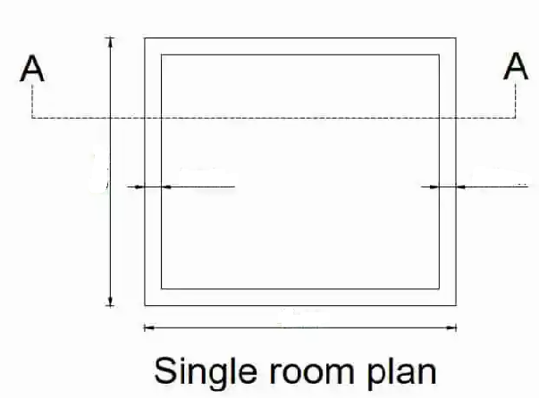

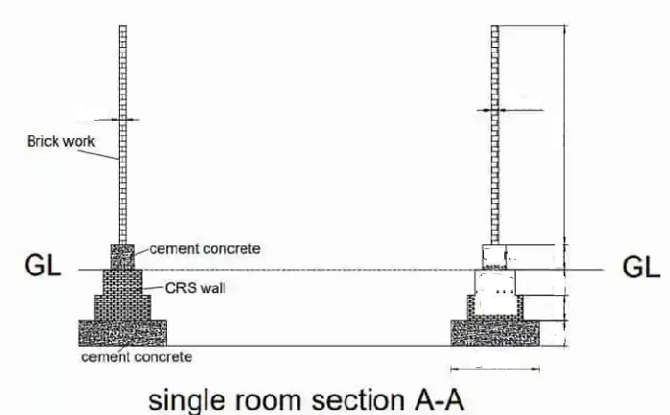

Assessment Evidence Guide

for

“Mason Helper Level 2”

Perform Basic Brick/Block Masonry Work for Given Building Project (Formative Assessment)
September 2021
National Vocational & Technical
Training Commission

Title of Qualification:  National Vocational Certificate Level 2 in Construction (Assistant Mason) |  | CS Code: | Level:  2 | Version:  01
Competency Standard Title:  Perform Basic Brick/Block Masonry Work for Given Building Project  Maintain Personal Health, Hygiene and Safety  Perform Basic Communication  Carryout General Maintenance  Perform Basic Green Skills for Construction |  | Assessment Date (DD/MM/YY):  Assessment Time: 30 mins
Guidance for Candidate | To complete your assessment for this Competency Standard, you need to answer the questions on the following pages successfully.

Assessors Guide (to be completed by the Assessor and signed both by the assessor and the candidate after the assessment)
Candidate Details | Name: Registration/Roll Number:  Candidate Signature:
Written Assessment Outcome | COMPETENT NOT YET COMPETENT  Name of the Assessor: Assessor’s code:  Signature of the  Assessor:

Title of Qualification:  National Vocational Certificate Level 2 in Construction (Assistant Mason) | CS Code: | Level:2 | Version:01
Competency Standard Title:  Perform Basic Brick/Block Masonry Work for Given Building Project  Maintain Personal Health, Hygiene and Safety  Perform Basic Communication  Carryout General Maintenance  Perform Basic Green Skills for Construction | Assessment Date (DD/MM/YY):  Assessment Time: 30 mins

WRITTEN ASSESSMENT
Question | Candidate’s answer
- Enlist the types of bricks.

- What is curing? Name any two methods

- What is mortar?
- What is drain?

- Enlist any two types of bonds in brick masonry.

- Name the symbol mentioned below (Red rectangle/square with black x)

- Write any three barriers to communication?
- What is green skill in construction?

ANSWER KEY
Sr. | Answers
 | First class, Second class, Third class Over burnt
Curing is the process to control heat of hydration during setting of cement.
- Water Curing
- Wet Covering
- Formwork Curing
- Membrane Curing
- Sheet Curing
- Curing by Absorbing Heat
- Chemical curing
 | Mortar is a mixture of cement, sand and water.
 | It is a small channel to dispose of waste water.
 | Stretcher bond, Header bond, English bond, Flemish bond.
 | Harmful
- The use of jargon. Over-complicated or unfamiliar terms.
- Emotional barriers and taboos.
- Lack of attention, interest, distractions, or irrelevance to the receiver.
- Differences in perception and viewpoint.
- Physical disabilities such as hearing problems or speech difficulties.
- Language differences and the difficulty in understanding unfamiliar accents.
- Cultural differences.
 | Use of natural resources in construction and avoid hazardous substances, waste, and emissions.

Assessment Evidence Guide

for

“Mason Helper Level 2”

Perform Basic Brick/Block Masonry Work for Given Building Project (Formative Assessment)
September 2021
National Vocational & Technical
Training Commission

Title of Qualification:  National Vocational Certificate Level 2 in Construction (Mason Helper) |  | CS Code: | Level:  2 | Version:  01
Competency Standard Title:  Perform Basic Brick/Block Masonry Work for Given Building Project  Maintain Personal Health, Hygiene and Safety  Perform Basic Communication  Carryout General Maintenance  Perform Basic Green Skills for Construction |  | Assessment Date (DD/MM/YY):  Assessment Time: 5 hrs
Candidate Details | Name:  Registration/Roll Number:
Guidance for Candidate | To meet this standard, you are required to complete the following within the given time frame (for practical demonstration & assessment):  Assessment Task 1: Candidate is required to construct L-shaped wall as per instructions given by assessor (for reference see ANNEX-I).  Assessment Task 2: Candidate is required to construct drain as per instructions given by assessor (for reference see ANNEX-II).  Assessment Task 3: Candidate is required to construct underground chamber wall as per instructions given by assessor (for reference see ANNEX-III).  And complete:  - Knowledge assessment test (Written or Oral)  - Portfolios at the time of assessment (if any)
Minimum Evidence Required | During a practical assessment, under observation by an assessor, you will complete:  Assessment Task 1  Performance Criteria 1: Select workplace  Performance Criteria 2: Interpret given drawing  Performance Criteria 3: Select material according to the task  Performance Criteria 4: Select tools according to the task  Performance Criteria 5: Perform cleaning, grubbing and leveling of workplace as per drawings  Performance Criteria 6: Perform brick/block soaking process  Performance Criteria 7: Prepare mortar according to the given ratio  Performance Criteria 8: Perform layout as per drawing  Performance Criteria 9: Perform excavation as per layout  Performance Criteria 10: Lay down mortar as per standards  Performance Criteria 11: Perform laying of brick/block courses in foundation and plinth as per drawing  Performance Criteria 12: Carryout horizontal alignment and vertical plumb in foundation and superstructure  Performance Criteria 13: Check water supply source  Performance Criteria 14: Connect plastic pipe with the source of water  Performance Criteria 15: Apply jute cloth on masonry work as per requirement  Performance Criteria 16: perform curing as per standards  Performance Criteria 17: Select materials as per task  Performance Criteria 18: Select knot for fastening  Performance Criteria 19: Perform placing of components  Performance Criteria 20: Carryout knotting as per task  Performance Criteria 21: Carryout brick masonry as per drawing  Performance Criteria 22: Interpret work processes and procedures correctly  Performance Criteria 23: Select personal protective equipment in terms of type and quantity according to work orders.  Performance Criteria 24: Wear, adjust, and maintain personal protective equipment to ensure correct fit and optimum protection in compliance with company procedures.  Performance Criteria 25: Comply with Health, hygiene and safety precautions before starting work  Performance Criteria 26: Deal with resolvable problems according to prescribed procedures  Performance Criteria 27: Carefully listen and note down the instructions of Supervisor  Performance Criteria 28: Apply appropriate methods and techniques for cleanliness and maintenance of machines & tools  Performance Criteria 29: Fill the checklist for daily cleanliness of the workplace  Performance Criteria 30: Identify various types of construction waste  Performance Criteria 31: Apply waste reduction techniques during construction process  Performance Criteria 32: Ensure appropriate storage of water
Assessment Task 2
Performance Criteria 1: Perform layout as per drawing
Performance Criteria 2: Carryout excavation
Performance Criteria 3: Perform compaction
Performance Criteria 4: Check gradient
Performance Criteria 5: Apply lean concrete
Performance Criteria 6: Carryout brick masonry as per drawing
Performance Criteria 7: Perform plastering as per prescribed ratio
Performance Criteria 8: Perform curing as per standards
Performance Criteria 9: Identify risk to Health, hygiene and safety
Performance Criteria 10: Maintain cleanliness and hygiene as per organizational policy
Performance Criteria 11: Follow organizational Health, hygiene and safety guidelines during work
Performance Criteria 12: Report unresolved problems to immediate supervisor
Performance Criteria 13: Place the tools equipment etc. at their prescribed place after completion of work
Performance Criteria 14: Carry out the instructions of the supervisor
Performance Criteria 15: Respond appropriately to safety hazards on all tools and machines
Performance Criteria 16: Categorize reusable waste
Performance Criteria 17: Dispose unusable waste as per set standards
Performance Criteria 18: Avoid wastage of water
Assessment Task 3
Performance Criteria 1: Perform layout as per drawing
Performance Criteria 2: Carryout excavation
Performance Criteria 3: Perform compaction
Performance Criteria 4: Apply lean concrete
Performance Criteria 5: Carryout brick masonry as per drawing
Performance Criteria 6: Fix iron rungs
Performance Criteria 7: Carry out flooring/benching
Performance Criteria 8: Perform plastering as per ratio
Performance Criteria 9: Perform curing as per standards
Performance Criteria 10: Recognize processes, tools, equipment and consumable materials that have the potential to cause harm
Performance Criteria 11: Ensure personal protective equipment is cleaned and stored in proper place.
Performance Criteria 12: Treat team members with respect and maintain positive relationships to achieve common organizational goals
Performance Criteria 13: Place all the tools & material in proper place to ensure safe work
Performance Criteria 14: Fill the checklists to conduct maintenance and housekeeping of machines & tools
Performance Criteria 15: Place reusable material at designated storage area
Performance Criteria 16: Transport waste material to designated place
Performance Criteria 17: Explore options for reuse of water
Assessors Judgment Guide (to be completed by the Assessor and signed both by the assessor and the candidate after the assessment)
Candidate Details | Name: Registration/Roll Number:  Candidate Signature:
Assessment Outcome | COMPETENT NOT YET COMPETENT  Name of the Assessor: Assessor’s code:  Signature of the  Assessor:
Assessment Summary (to be filled by the assessor)
Activity |  | Method |  |  |  |  | Result
Nature of Activity |  | Written | Oral | Observation | Portfolio | Role Play | Competent | Not Yet Competent
Practical Skill Demonstration
Knowledge Assessment
Other Requirement

Assessment Task 1 |  |  | Description of assessment task 1  Candidate is required to construct L-shaped wall as per instructions given by assessor (for reference see ANNEX-I).
During the practical assessment, candidate demonstrated the following: |  |  |  | Yes | No | Remarks
 | Select workplace
 | Interpret given drawing
 | Select material according to the task
 | Select tools according to the task
 | Perform cleaning, grubbing and leveling of workplace as per drawings
 | Perform brick/block soaking process
 | Prepare mortar according to the given ratio
 | Perform layout as per drawing
 | Perform excavation as per layout
 | Lay down mortar as per standards
 | Perform laying of brick/block courses in foundation and plinth as per drawing
 | Perform laying of brick/block courses in super structure as per drawing
 | Carryout horizontal alignment and vertical plumb in foundation and superstructure
 | Check water supply source
 | Connect plastic pipe with the source of water
 | Apply hessian on masonry work as per weather requirement
 | Perform curing as per standards
 | Select materials as per task
 | Select knot for fastening
 | Perform placing of components
 | Carryout knotting as per task
 | Interpret work processes and procedures correctly
 | Select personal protective equipment in terms of type and quantity according to work orders.
 | Wear, adjust, and maintain personal protective equipment to ensure correct fit and optimum protection in compliance with company procedures.
 | Comply with Health, hygiene and safety precautions before starting work
 | Deal with resolvable problems according to prescribed procedures
 | Carefully listen and note down the instructions of Supervisor
 | Apply appropriate methods and techniques for cleanliness and maintenance of machines & tools
 | Fill the checklist for daily cleanliness of the workplace
 | Identify various types of construction waste
 | Apply waste reduction techniques during construction process
 | Ensure appropriate storage of water
Competent |  | Not Yet Competent

Assessment Task 2 |  |  | Description of assessment task 2  Candidate is required to construct drain as per instructions given by assessor (for reference see ANNEX-II).
During the practical assessment, candidate demonstrated the following: |  |  |  | Yes | No | Remarks
 | Perform layout as per drawing
 | Carryout excavation
 | Perform compaction
 | Check gradient
 | Apply lean concrete
 | Carryout brick masonry as per drawing
 | Perform plastering as per prescribed ratio
 | Perform curing as per standards
 | Identify risk to Health, hygiene and safety
 | Maintain cleanliness and hygiene as per organizational policy
 | Follow organizational Health, hygiene and safety guidelines during work
 | Report unresolved problems to immediate supervisor
 | Place the tools equipment etc. at their prescribed place after completion of work
 | Carry out the instructions of the supervisor
 | Respond appropriately to safety hazards on all tools and machines
 | Categorize reusable waste
 | Dispose unusable waste as per set standards
 | Avoid wastage of water
Competent |  | Not Yet Competent

Assessment Task 3 |  |  | Description of assessment task 3  Candidate is required to construct underground chamber wall as per instructions given by assessor (for reference see ANNEX-III).
During the practical assessment, candidate demonstrated the following: |  |  |  | Yes | No | Remarks
 | Perform layout as per drawing
 | Carryout excavation
 | Perform compaction
 | Apply lean concrete
 | Carryout brick masonry as per drawing
 | Fix iron rungs
 | Carry out flooring/benching
 | Perform plastering as per ratio
 | Perform curing as per standards
 | Recognize processes, tools, equipment and consumable materials that have the potential to cause harm
 | Ensure personal protective equipment is cleaned and stored in proper place.
 | Treat team members with respect and maintain positive relationships to achieve common organizational goals
 | Place all the tools & material in proper place to ensure safe work
 | Fill the checklists to conduct maintenance and housekeeping of machines & tools
 | Place reusable material at designated storage area
 | Transport waste material to designated place
 | Explore options for reuse of water
Competent |  | Not Yet Competent

ANNEX-I

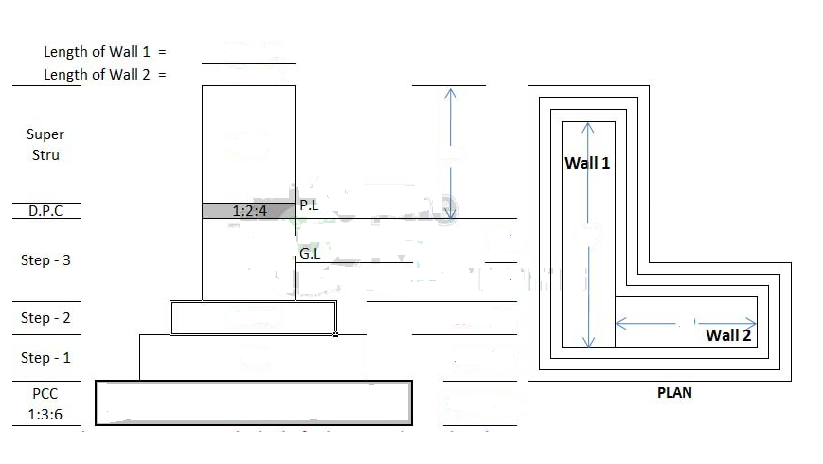
ANNEX-II

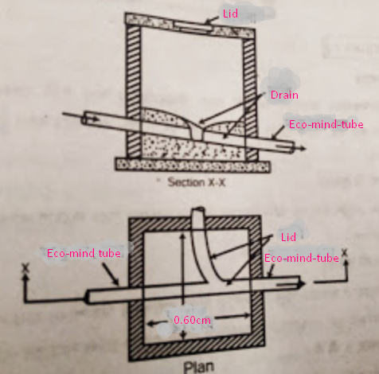

ANNEX-III

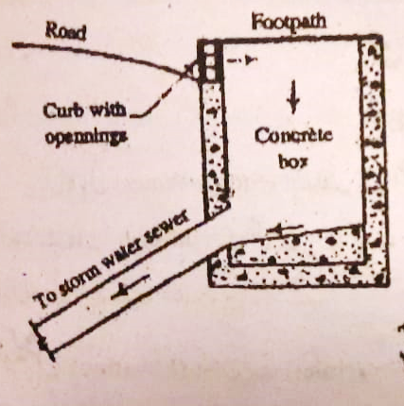

Assessment Evidence Guide

for

“Mason Helper Level 2”

Perform Basic Stone Masonry Work for Given Project
(Formative Assessment)
September 2021
National Vocational & Technical
Training Commission

Title of Qualification:  National Vocational Certificate Level 2 in Construction (Assistant Mason) |  | CS Code: | Level:  2 | Version:  01
Competency Standard Title:  Perform Basic Stone Masonry Work for Given Project  Maintain Personal Health, Hygiene and Safety  Perform Basic Communication  Carryout General Maintenance  Perform Basic Green Skills for Construction |  | Assessment Date (DD/MM/YY):  Assessment Time:
Guidance for Candidate | To complete your assessment for this Competency Standard, you need to answer the questions on the following pages successfully.

Assessors Guide (to be completed by the Assessor and signed both by the assessor and the candidate after the assessment)
Candidate Details | Name: Registration/Roll Number:  Candidate Signature:
Written Assessment Outcome | COMPETENT NOT YET COMPETENT  Name of the Assessor: Assessor’s code:  Signature of the  Assessor:

Title of Qualification:  National Vocational Certificate Level 2 in Construction (Assistant Mason) | CS Code: | Level:  2 | Version:  01
Competency Standard Title:  Perform Basic Brick/Block Masonry Work for Given Project  Maintain Personal Health, Hygiene and Safety  Perform Basic Communication  Carryout General Maintenance  Perform Basic Green Skills for Construction | Assessment Date (DD/MM/YY):  Assessment Time:30 min

WRITTEN ASSESSMENT
Question | Candidate’s answer
- Enlist any four construction materials used in stone masonry.

- Enlist any three types of stone masonry?

- What is stone cutting and dressing?

- What are construction Waste materials?
- What are the 3P’s in first aid?
- Yellow triangle with black outline and zigzag arrow
- Enlist non –verbal communication techniques?
- How to reduce construction waste?

ANSWER KEY
Sr. | Answers
 | Cement, Sand, Water, Gravel, Sand Stone, Marble, Granite, Limestone, Cast stone
 | Fine Ashlar Masonry, Ashlar Masonry, Coursed stone masonry, Random rubble masonry, Coursed rubble masonry
 | The stone dressing is a process of surfacing and shaping of rocks available naturally. Once quarried, the stones are cut into the suitable size and surface finishes.
 | Brick waste, Sand & cement waste, Concrete during pouring, Nails, Steel cut pieces, Wood
"Three P's":
- Preserve life
- Prevent further injury
- Provide pain relief
 | Warning sign – a sign giving warning of a hazard or danger (e.g. ‘danger: electricity’)
 | Body language, Tone of voice
 | Reduce construction mistake, Procure the required size and quantity of material

Assessment Evidence Guide

for

“Mason Helper Level 2”

Perform Basic Stone Masonry Work for Given Project
(Formative Assessment)
September 2021
National Vocational & Technical
Training Commission

Title of Qualification:  National Vocational Certificate Level 2 in Construction (Mason Helper) |  | CS Code: | Level:  2 | Version:  01
Competency Standard Title:  Perform Basic Stone Masonry Work for Given Project  Maintain Personal Health, Hygiene and Safety  Perform Basic Communication  Carryout General Maintenance  Perform Basic Green Skills for Construction |  | Assessment Date (DD/MM/YY):  Assessment Time: 5 hrs
Candidate Details | Name:  Registration/Roll Number:
Guidance for Candidate | To meet this standard, you are required to complete the following within the given time frame (for practical demonstration & assessment):  Assessment Task 1: Candidate is required to construct T-shaped wall as per instructions given by assessor (for reference see ANNEX-I).  Assessment Task 2: Candidate is required to carry out stone pitching as per instructions given by assessor (for reference see ANNEX-II).  And complete:  - Knowledge assessment test (Written or Oral)  - Portfolios at the time of assessment (if any)
Minimum Evidence Required | During a practical assessment, under observation by an assessor, you will complete:  Assessment Task 1  Performance Criteria 1: Interpret given layout drawing  Performance Criteria 2: Select material according to the task  Performance Criteria 3: Select tools according to the task  Performance Criteria 4: Perform stone cutting and dressing process  Performance Criteria 5: Prepare mortar according to the given ratio  Performance Criteria 6: Perform layout as per drawing  Performance Criteria 7: Lay down mortar as per standards  Performance Criteria 8: Perform dressing of stone as per requirement  Performance Criteria 9: Perform laying of stone masonry in substructure  Performance Criteria 10: Carryout horizontal alignment in vertical plumb in substructure and super structure  Performance Criteria 11: Perform laying of stone masonry in super structure  Performance Criteria 12: Perform striking of joints as per design  Performance Criteria 13: Perform curing on stone masonry as per standards  Performance Criteria 14: Select personal protective equipment in terms of type and quantity according to work orders.  Performance Criteria 15: Wear, adjust, and maintain personal protective equipment to ensure correct fit and optimum protection in compliance with company procedures.  Performance Criteria 16: Comply with Health, hygiene and safety precautions before starting work  Performance Criteria 17: Deal with resolvable problems according to prescribed procedures  Performance Criteria 18: Carefully listen and note down the instructions of Supervisor  Performance Criteria 19: Apply appropriate methods and techniques for cleanliness and maintenance of machines & tools  Performance Criteria 20: Fill the checklist for daily cleanliness of the workplace  Performance Criteria 21: Identify various types of construction waste  Performance Criteria 22: Apply waste reduction techniques during construction process  Performance Criteria 23:Ensure appropriate storage of water
Minimum Evidence Required | Assessment Task 2  Performance Criteria 1: Perform dressing of slope as per drawing  Performance Criteria 2: Perform laying of stone course as per task  Performance Criteria 3: Perform grouting of sand on stone pitching  Performance Criteria 4: Identify risk to Health, hygiene and safety  Performance Criteria 5: Maintain cleanliness and hygiene as per organizational policy  Performance Criteria 6: Follow organizational Health, hygiene and safety guidelines during work  Performance Criteria 7: Report unresolved problems to immediate supervisor  Performance Criteria 8: Place the tools equipment etc. at their prescribed place after completion of work  Performance Criteria 9: Carry out the instructions of the supervisor  Performance Criteria 10: Respond appropriately to safety hazards on all tools and machines  Performance Criteria 11: Categorize reusable waste  Performance Criteria 12: Dispose unusable waste as per set standards

Assessors Judgment Guide (to be completed by the Assessor and signed both by the assessor and the candidate after the assessment)
Candidate Details | Name: Registration/Roll Number:  Candidate Signature:
Assessment Outcome | COMPETENT NOT YET COMPETENT  Name of the Assessor: Assessor’s code:  Signature of the  Assessor:
Assessment Summary (to be filled by the assessor)
Activity |  | Method |  |  |  |  | Result
Nature of Activity |  | Written | Oral | Observation | Portfolio | Role Play | Competent | Not Yet Competent
Practical Skill Demonstration
Knowledge Assessment
Other Requirement

Each Assessment Task (with performance criteria)
Assessment Task 1 |  |  | Description of assessment task 1  Candidate is required to construct T-shaped wall as per instructions given by assessor (for reference see ANNEX-I).
During the practical assessment, candidate demonstrated the following: |  |  |  | Yes | No | Remarks
 | Interpret given layout drawing
 | Select material according to the task
 | Select tools according to the task
 | Perform stone cutting and dressing process
 | Prepare mortar according to the given ratio
 | Perform layout as per drawing
 | Lay down mortar as per standards
 | Perform dressing of stone as per requirement
 | Perform laying of masonry in substructure
 | Carryout horizontal alignment in vertical plumb in substructure and super structure
 | Perform laying of stone masonry in super structure
 | Perform striking of joints as per design
 | Perform curing on stone masonry as per standards
 | Select personal protective equipment in terms of type and quantity according to work orders.
 | Wear, adjust, and maintain personal protective equipment to ensure correct fit and optimum protection in compliance with company procedures.
 | Comply with Health, hygiene and safety precautions before starting work
 | Deal with resolvable problems according to prescribed procedures
 | Carefully listen and note down the instructions of Supervisor
 | Apply appropriate methods and techniques for cleanliness and maintenance of machines & tools
 | Fill the checklist for daily cleanliness of the workplace
 | Identify various types of construction waste
 | Apply waste reduction techniques during construction process
 | Ensure appropriate storage of water
Competent |  | Not Yet Competent

Assessment Task 2 |  |  | Description of assessment task 2  Candidate is required to carry out stone pitching as per instructions given by assessor (for reference see ANNEX-II).
During the practical assessment, candidate demonstrated the following: |  |  |  | Yes | No | Remarks
 | Perform dressing of slope as per drawing
 | Perform laying of stone course as per task
 | Perform grouting of sand on stone pitching
 | Identify risk to Health, hygiene and safety
 | Maintain cleanliness and hygiene as per organizational policy
 | Follow organizational Health, hygiene and safety guidelines during work
 | Report unresolved problems to immediate supervisor
 | Place the tools equipment etc at their prescribed place after completion of work
 | Carry out the instructions of the supervisor
 | Respond appropriately to safety hazards on all tools and machines
 | Categorize reusable waste
 | Dispose unusable waste as per set standards
Competent |  | Not Yet Competent

ANNEX-I

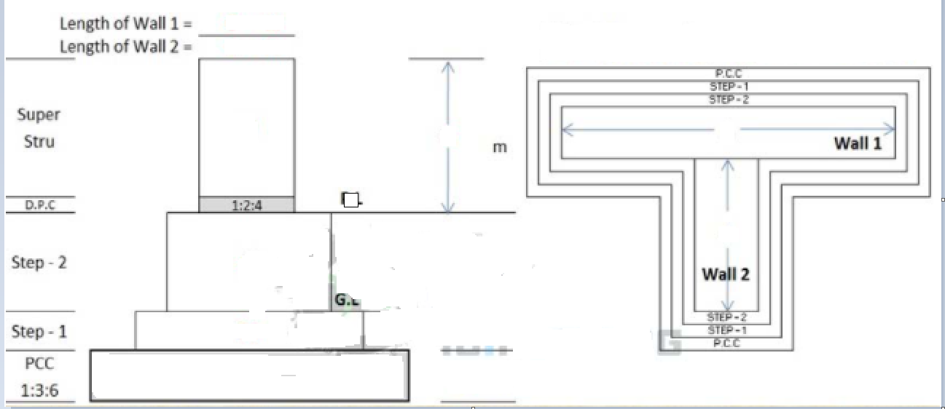

ANNEX-II

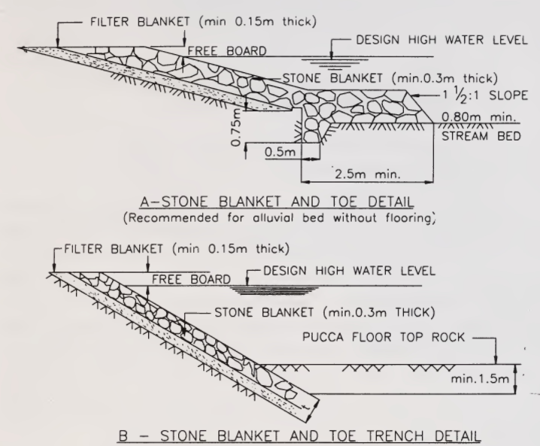

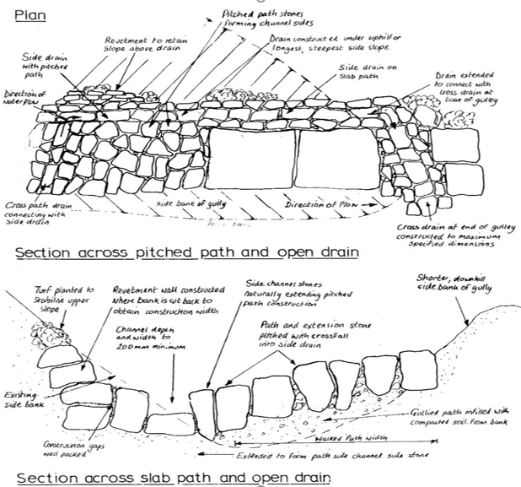

Assessment Evidence Guide

for

“Mason Helper Level 2”

Perform Plain Cement Concrete Work (PCC) on Brick Masonry
(Formative Assessment)
September 2021
National Vocational & Technical
Training Commission

Title of Qualification:  National Vocational Certificate Level-2 in Construction(Assistant Mason) |  | CS Code: | Level:  2 | Version:  01
Competency Standard Title:  Perform Plain Cement Concrete Work (PCC) on Brick Masonry  Maintain Personal Health, Hygiene and Safety  Perform Basic Communication  Carryout General Maintenance  Perform Basic Green Skills for Construction |  | Assessment Date (DD/MM/YY):  Assessment Time: 30 min
Guidance for Candidate | To complete your assessment for this Competency Standard, you need to answer the questions on the following pages successfully.

Assessors Guide (to be completed by the Assessor and signed both by the assessor and the candidate after the assessment)
Candidate Details | Name: Registration/Roll Number:  Candidate Signature:
Written Assessment Outcome | COMPETENT NOT YET COMPETENT  Name of the Assessor: Assessor’s code:  Signature of the  Assessor:

Title of Qualification:  National Vocational Certificate Level-2 in Construction (Assistant Mason) | CS Code: | Level:  2 | Version:  01
Competency Standard Title:  Perform Plain Cement Concrete Work (PCC) on Brick Masonry  Maintain Personal Health, Hygiene and Safety  Perform Basic Communication  Carryout General Maintenance  Perform Basic Green Skills for Construction | Assessment Date (DD/MM/YY):  Assessment Time : 30 min
WRITTEN ASSESSMENT
Question | Candidate’s answer
- What is concrete?

- What is plain cement concrete?

- Enlist any four types of concrete mixing.

- Enlist any four methods of concrete transportation.
- Enlist PCC tools.
- Write down any three basic safety symbols?
- What are the 5 C’s of communication?
- Why oiling or greasing is necessary for machine?

ANSWER KEY
Sr. | Answers
 | Concrete is a mixture of cement, sand, crush and water.
 | Plain cement concrete is a concrete without steel
 | Batch mixers, Drum Types Mixer, Tilting drum mixers, Non-tilting drum mixer, Reversing drum mixer, Pan Type Mixer, Continuous mixers, Hand mixing
 | Wheelbarrow or motorized buggy, Truck mixer, Bucket or steel skip, Chute, Belt conveyor, Concrete pump, Pneumatic placer.
 | Wheelbarrows, Shovels, Digging Bars, Screeds, Vibrators, Measuring tape, Floats, Straight edge
Most safety signs and symbols fall into one of four categories:
Prohibition, Warning, Mandatory, Emergency
- Clarity,
- Consistency,
- Creativity
- Content
- Connections
 | Oiling and greasing is required for machine to perform better without noise and less frictions, which will increase the life of machine.

Assessment Evidence Guide

for

“Mason Helper Level 2”

Perform Plain Cement Concrete Work (PCC) on Brick Masonry
(Formative Assessment)
September 2021
National Vocational & Technical
Training Commission

Title of Qualification:  National Vocational Certificate Level-2 in Construction (Mason Helper) |  | CS Code: | Level:  2 | Version:  01
Competency Standard Title:  Perform Plain Cement Concrete Work (PCC) on Brick Masonry  Maintain Personal Health, Hygiene and Safety  Perform Basic Communication  Carryout General Maintenance  Perform Basic Green Skills for Construction |  | Assessment Date (DD/MM/YY):  Assessment Time: 5 hrs
Candidate Details | Name:  Registration/Roll Number:
Guidance for Candidate | To meet this standard, you are required to complete the following within the given time frame (for practical demonstration & assessment):  Assessment Task 1: Candidate is required to pour PCC slab by hand mixing as per instructions given by assessor  Assessment Task 2: Candidate is required to pour concrete floor topping by machine mixing as per instructions given by assessor (for reference see ANNEX-I)  Assessment Task 3: Candidate is required to lay damp proof course as per instructions given by assessor (for reference see ANNEX-II).  And complete:  - Knowledge assessment test (Written or Oral)  - Portfolios at the time of assessment (if any)
Minimum Evidence Required | During a practical assessment, under observation by an assessor, you will complete:  Assessment Task 1  Performance Criteria 1: Interpret given layout drawing (example provided in annex I) as per task  Performance Criteria 2: Select appropriate material according as per job specification  Performance Criteria 3: Select appropriate tools according to the task  Performance Criteria 4: Perform cleaning of fine aggregates  Performance Criteria 5: Preform washing of coarse aggregate  Performance Criteria 6: estimate the material quantities as per given standards  Performance Criteria 7: Perform batching of aggregate  Performance Criteria 4: Perform washing of coarse aggregate  Performance Criteria 5: Calculate the materials as per ratio  Performance Criteria 6: Perform batching of aggregates  Performance Criteria 7: Perform batching of coarse aggregate  Performance Criteria 8: Maintain water cement ratio  Performance Criteria 9: Prepare platform with available material  Performance Criteria 10: Spread coarse aggregate as per requirement  Performance Criteria 11: Spread fine aggregate over coarse aggregate as per requirement  Performance Criteria 12: Spread cement over fine aggregate as per requirement  Performance Criteria 13: Perform uniform mixing as per standard  Performance Criteria 14: Stretch mix material in circular shape and make a depression in the centre for water  Performance Criteria 15: Add water to maintain water cement ratio  Performance Criteria 16: Perform turning the mixture over and over again to achieve even color  Performance Criteria 17: Select the mode of transportation of concrete as per task  Performance Criteria 18: Transport the concrete with pan/wheel barrow  Performance Criteria 19: Place the concrete on prepared surface /formwork  Performance Criteria 20: Use chute as per requirement  Performance Criteria 21: Use tamping rod/needle vibrator for compaction as per task  Performance Criteria 22: Perform leveling and finishing as per task  Performance Criteria 23: Perform curing on concrete work as per standard  Performance Criteria 24: Interpret work processes and procedures correctly  Performance Criteria 25: Select personal protective equipment in terms of type and quantity according to work orders.  Performance Criteria 26: Wear, adjust, and maintain personal protective equipment to ensure correct fit and optimum protection in compliance with company procedures.  Performance Criteria 27: Comply with Health, hygiene and safety precautions before starting works  Performance Criteria 28: Deal with resolvable problems according to prescribed procedures  Performance Criteria 29: Carefully listen and note down the instructions of Supervisor  Performance Criteria 30: Apply appropriate methods and techniques for cleanliness and maintenance of machines & tools  Performance Criteria 31: Fill the checklist for daily cleanliness of the workplace  Performance Criteria 32: Identify various types of construction waste  Performance Criteria 33: Apply waste reduction techniques during construction process  Performance Criteria 34: Categorize reusable waste  Performance Criteria 35: Dispose unusable waste as per set standards  Performance Criteria 36: Place reusable material at designated storage area  Performance Criteria 37: Transport waste material to designated place
Minimum Evidence Required | Assessment Task 2  Performance Criteria 1: add required quantity of water in mixing drum  Performance Criteria 2: Put crush in mixer hopper  Performance Criteria 3: Put sand in mixer hopper  Performance Criteria 4: Put cement in mixer hopper  Performance Criteria 5: Tilt the hopper into the mixing drum  Performance Criteria 6: Rotate the mixing drum as per standard  Performance Criteria 7: Unload the mixing drum on platform/wheel barrow  Performance Criteria 8: Select the mode of transportation of concrete as per task  Performance Criteria 9: Transport the concrete with pan/wheel barrow  Performance Criteria 10: Place the concrete on prepared surface /formwork  Performance Criteria 11: Use chute as per requirement  Performance Criteria 12: Use tamping rod/needle vibrator for compaction as per task  Performance Criteria 13: Perform leveling and finishing as per task  Performance Criteria 14: Perform curing on concrete work as per standard  Performance Criteria 15: Recognize processes, tools, equipment and consumable materials that have the potential to cause harm  Performance Criteria 16: Ensure personal protective equipment is cleaned and stored in proper place.  Performance Criteria 17: Treat team members with respect and maintain positive relationships to achieve common organizational goals  Performance Criteria 18: Place all the tools & material in proper place to ensure safe work  Performance Criteria 19: Fill the checklists to conduct maintenance and housekeeping of machines & tools
Minimum Evidence Required | Assessment Task 3  Performance Criteria 1: Clean and wash the top surface of wall at plinth level  Performance Criteria 2: apply the DPC on wall surface as per drawing (example attached in annex-II)  Performance Criteria 3: Perform curing on concrete work as per standard  Performance Criteria 4: Lay down water proofing layer as per requirement  Performance Criteria 5: Identify risk to Health, hygiene and safety  Performance Criteria 6: Maintain cleanliness and hygiene as per organizational policy  Performance Criteria 7: Follow organizational Health, hygiene and safety guidelines during work  Performance Criteria 8: Report unresolved problems to immediate supervisor  Performance Criteria 9: Place the tools equipment etc at their prescribed place after completion of work  Performance Criteria 10: Carry out the instructions of the supervisor  Performance Criteria 11: Respond appropriately to safety hazards on all tools and machines  Performance Criteria 12: Ensure appropriate storage of water  Performance Criteria 13: Estimate water requirements for various stages of construction  Performance Criteria 14: Identify onsite water resources

Assessors Judgment Guide (to be completed by the Assessor and signed both by the assessor and the candidate after the assessment)
Candidate Details | Name: Registration/Roll Number:  Candidate Signature:
Assessment Outcome | COMPETENT NOT YET COMPETENT  Name of the Assessor: Assessor’s code:  Signature of the  Assessor:
Assessment Summary (to be filled by the assessor)
Activity |  | Method |  |  |  |  | Result
Nature of Activity |  | Written | Oral | Observation | Portfolio | Role Play | Competent | Not Yet Competent
Practical Skill Demonstration
Knowledge Assessment
Other Requirement

Each Assessment Task (with performance criteria)
Assessment Task 1 |  |  | Description of assessment task 1  Candidate is required to pour PCC slab by hand mixing as per instructions given by assessor.
During the practical assessment, candidate demonstrated the following: |  |  |  | Yes | No | Remarks
 | Interpret given layout drawing
 | Select appropriate material as per job specification
 | Select appropriate tools according to the task
 | Perform cleaning of fine aggregates
 | Perform washing of coarse aggregates
 | Estimate the material quantities as per prescribed ratio
 | Perform batching of aggregate
 | Ensure water cement ratio as per given standards
 | Prepare platform with available material
 | Spread coarse aggregate as per requirement
 | Spread fine aggregate over coarse aggregate as per requirement
 | Spread cement over fine aggregate as per requirement
 | Perform uniform mixing as per standard
 | Stretch mix material in circular shape and make a depression in the centre for water
 | Add water to maintain water cement ratio
 | Perform turning the mixture over and over again to achieve even color
 | Select the mode of transportation of concrete as per task
 | Transport the concrete with pan/wheel barrow
 | Place the concrete on prepared surface /formwork
 | Use chute as per requirement
 | Use tamping rod/needle vibrator for compaction as per task
 | Perform leveling and finishing as per task
 | Perform curing on concrete work as per standard
 | Interpret work processes and procedures correctly
 | Select personal protective equipment in terms of type and quantity according to work orders.
 | Wear, adjust, and maintain personal protective equipment to ensure correct fit and optimum protection in compliance with company procedures.
 | Comply with Health, hygiene and safety precautions before starting works
 | Deal with resolvable problems according to prescribed procedures
 | Carefully listen and note down the instructions of Supervisor
 | Apply appropriate methods and techniques for cleanliness and maintenance of machines & tools
 | Fill the checklist for daily cleanliness of the workplace
 | Identify various types of construction waste
 | Apply waste reduction techniques during construction process
 | Categorize reusable waste
 | Dispose unusable waste as per set standards
 | Place reusable material at designated storage area
 | Transport waste material to designated place
Competent |  | Not Yet Competent

Assessment Task 2 |  |  | Description of assessment task 2  Candidate is required to pour concrete floor topping by machine mixing as per instructions given by assessor (for reference see ANNEX-I)
During the practical assessment, candidate demonstrated the following: |  |  |  | Yes | No | Remarks
 | Add required quantity of water in mixing drum
 | Put crush in mixer hopper
 | Put sand in mixer hopper
 | Put cement in mixer hopper
 | Tilt the hopper into the mixing drum
 | Rotate the mixing drum as per standard
 | Unload the mixing drum on platform/wheel barrow
 | Select the mode of transportation of concrete as per task
 | Transport the concrete with pan/wheel barrow
 | Place the concrete on prepared surface /formwork
 | Use chute as per requirement
 | Use tamping rod/needle vibrator for compaction as per task
 | Perform leveling and finishing as per task
 | Perform curing on concrete work as per standard
 | Recognize processes, tools, equipment and consumable materials that have the potential to cause harm
 | Ensure personal protective equipment is cleaned and stored in proper place.
 | Treat team members with respect and maintain positive relationships to achieve common organizational goals
 | Place all the tools & material in proper place to ensure safe work
 | Fill the checklists to conduct maintenance and housekeeping of machines & tools
Competent |  | Not Yet Competent

Assessment Task 3 |  |  | Description of assessment task 3  Candidate is required to lay damp proof coarse as per instructions given by assessor (for reference see ANNEX-II).
During the practical assessment, candidate demonstrated the following: |  |  |  | Yes | No | Remarks
 | Clean and wash the top surface of wall at plinth level
 | Apply the DPC on wall surface as per drawing
 | Perform curing on concrete work as per standards
 | Identify risk to Health, hygiene and safety
 | Maintain cleanliness and hygiene as per organizational policy
 | Follow organizational Health, hygiene and safety guidelines during work
 | Report unresolved problems to immediate supervisor
 | Place the tools equipment etc at their prescribed place after completion of work
 | Carry out the instructions of the supervisor
 | Respond appropriately to safety hazards on all tools and machines
 | Ensure appropriate storage of water
 | Estimate water requirements for various stages of construction
 | Identify onsite water resources
Competent |  | Not Yet Competent

Annex-I

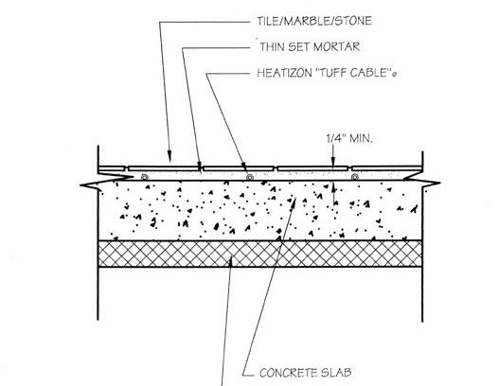

Concrete Slab Section

Annex-II

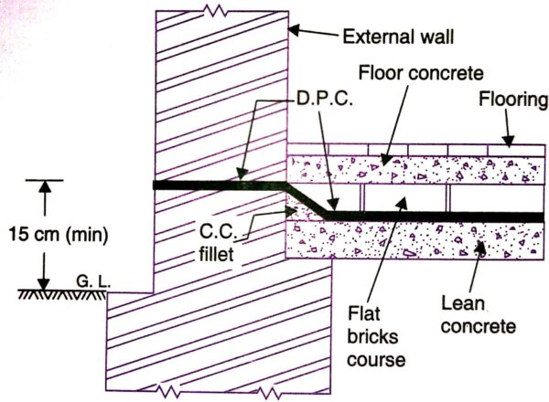

DPC in wall Section

Assessment Evidence Guide

for

“Mason Helper Level 2”

Carryout Plaster Work on Brick Masonry
(Formative Assessment)
September 2021
National Vocational & Technical
Training Commission

Title of Qualification:  National Vocational Certificate Level -2 in Construction (Assistant Mason) |  | CS Code: | Level:  2 | Version:  01
Competency Standard Title:  Carryout Plaster Work on Brick Masonry  Maintain Personal Health, Hygiene and Safety  Perform Basic Communication  Carryout General Maintenance  Perform Basic Green Skills for Construction |  | Assessment Date (DD/MM/YY):  Assessment Time:30 min
Guidance for Candidate | To complete your assessment for this Competency Standard, you need to answer the questions on the following pages successfully.

Assessors Guide (to be completed by the Assessor and signed both by the assessor and the candidate after the assessment)
Candidate Details | Name: Registration/Roll Number:  Candidate Signature:
Written Assessment Outcome | COMPETENT NOT YET COMPETENT  Name of the Assessor: Assessor’s code:  Signature of the  Assessor:

Title of Qualification:  National Vocational Certificate Level -2 in Construction (Assistant Mason) | CS Code: | Level:  2 | Version:  01
Competency Standard Title:  Carryout Plaster Work on Brick Masonry  Maintain Personal Health, Hygiene and Safety  Perform Basic Communication  Carryout General Maintenance  Perform Basic Green Skills for Construction | Assessment Date (DD/MM/YY):  Assessment Time: 30 min
WRITTEN ASSESSMENT
Question | Candidate’s answer
- What is plaster?

- Explain batching.

- Enlist mixing methods of mortar.

- Enlist the alignment tools for plaster.

- How to save reusable materials?

- What should an assistant mason do before operation of any machine?
- Green rectangle/sequre

- Enlist any three Verbal communication techniques?

ANSWER KEY
Sr. | Answers
 | Plaster is a thin protective or decorative layer on walls and ceilings.
 | Batching is the process of measuring the materials.
 | Hand mixing, Machine mixing
 | Level peg, Straight edge, Plumb bob
 | When the job is completed stack the reusable material to the designated place and store it safely for next job.
 | Fill the checklist and report to the supervisor if machine is faulty
 | Information about safe condition
- Active listening
- Clarity and conciseness
- Confidence
- Empathy
- Friendliness
- Open-mindedness
- Giving and soliciting feedback
- Confidence
- Respectfulness

Assessment Evidence Guide

for

“Mason Helper Level 2”

Carryout Plaster Work on Brick Masonry
(Formative Assessment)
September 2021
National Vocational & Technical
Training Commission

Title of Qualification:  National Vocational Certificate Level -2 in Construction (Mason Helper) |  | CS Code: | Level:  2 | Version:  01
Competency Standard Title:  Carryout Plaster Work on Brick Masonry  Maintain Personal Health, Hygiene and Safety  Perform Basic Communication  Carryout General Maintenance  Perform Basic Green Skills for Construction |  | Assessment Date (DD/MM/YY):  Assessment Time: 5 hrs
Candidate Details | Name:  Registration/Roll Number:
Guidance for Candidate | To meet this standard, you are required to complete the following within the given time frame (for practical demonstration & assessment):  Assessment Task 1: Candidate is required to perform plastering on vertical surface of wall as per instructions given by assessor (for reference see ANNEX-I)  Assessment Task 2: Candidate is required to perform plastering on ceiling of slab as per instructions given by assessor.  And complete:  - Knowledge assessment test (Written or Oral)  - Portfolios at the time of assessment (if any)
Minimum Evidence Required | During a practical assessment, under observation by an assessor, you will complete:  Assessment Task 1  Performance criteria 1: Select material as per specifications  Performance criteria 2: Select tools according to the task  Performance criteria 3: Fix level pegs on wall with reference to the off lines  Performance criteria 4: Prepare mortar according to the given ratio  Performance criteria 5: Rack the joints  Performance criteria 6: Chip off and clean the wall  Performance criteria 7: Apply mortar with trowel/float on wall surface within the level pegs  Performance criteria 8: Remove extra mortar from off line of pegs  Performance criteria 9: Fill depression of surface with additional mortar  Performance criteria 10: Level the plaster surface with straight edge  Performance criteria 11: Finish the plaster surface with float  Performance criteria 12: Apply foam for smooth finish  Performance criteria 13: Perform curing after specified time  Performance Criteria 14: Interpret work processes and procedures correctly  Performance Criteria 15: Select personal protective equipment in terms of type and quantity according to work orders.  Performance Criteria 16: Wear, adjust, and maintain personal protective equipment to ensure correct fit and optimum protection in compliance with company procedures.  Performance Criteria 17: Comply with Health, hygiene and safety precautions before starting work  Performance Criteria 18: Deal with resolvable problems according to prescribed procedures  Performance Criteria 19: Carefully listen and note down the instructions of Supervisor  Performance Criteria 20: Apply appropriate methods and techniques for cleanliness and maintenance of machines & tools  Performance Criteria 21: Fill the checklist for daily cleanliness of the workplace  Performance Criteria 22: Identify various types of construction waste  Performance Criteria 23: Apply waste reduction techniques during construction process  Performance Criteria 24: Ensure appropriate storage of water
Minimum Evidence Required | Assessment Task 2  Performance criteria 1: Select appropriate material as per specifications  Performance criteria 2: Select appropriate tools according to the task  Performance criteria 3: Fix level pegs on ceiling with reference to the off lines  Performance criteria 4: Prepare mortar according to the given ratio  Performance criteria 5: Chip off and clean the ceiling  Performance criteria 6: Apply cement slurry on ceiling  Performance criteria 7: Apply mortar with trowel/float on wall surface within the level pegs  Performance criteria 8: Remove extra mortar from off line of pegs  Performance criteria 9: Fill depression of surface with additional mortar  Performance criteria 10: Level the plaster surface with straight edge  Performance criteria 11: Finish the plaster surface with float  Performance criteria 12: Apply foam for smooth finish  Performance criteria 13: Perform curing after specified time  Performance Criteria 14: Identify risk to Health, hygiene and safety  Performance Criteria 15: Maintain cleanliness and hygiene as per organizational policy  Performance Criteria 16: Follow organizational Health, hygiene and safety guidelines during work  Performance Criteria 17: Report unresolved problems to immediate supervisor  Performance Criteria 18: Place the tools equipment etc at their prescribed place after completion of work  Performance Criteria 19: Carry out the instructions of the supervisor  Performance Criteria 20: Respond appropriately to safety hazards on all tools and machines  Performance Criteria 21: Categorize reusable waste  Performance Criteria 22: Dispose unusable waste as per set standards  Performance Criteria 23:Avoid wastage of water

Assessors Judgment Guide (to be completed by the Assessor and signed both by the assessor and the candidate after the assessment)
Candidate Details | Name: Registration/Roll Number:  Candidate Signature:
Assessment Outcome | COMPETENT NOT YET COMPETENT  Name of the Assessor: Assessor’s code:  Signature of the  Assessor:
Assessment Summary (to be filled by the assessor)
Activity |  | Method |  |  |  |  | Result
Nature of Activity |  | Written | Oral | Observation | Portfolio | Role Play | Competent | Not Yet Competent
Practical Skill Demonstration
Knowledge Assessment
Other Requirement

Each Assessment Task (with performance criteria)
Assessment Task 1 |  |  | Description of assessment task 1  Candidate is required to perform plastering on vertical surface of wall as per instructions given by assessor (for reference see ANNEX-I)
During the practical assessment, candidate demonstrated the following: |  |  |  | Yes | No | Remarks
 | Select material as per specifications
 | Select tools according to the task
 | Fix level pegs on wall with reference to the off lines
 | Prepare mortar according to the given ratio
 | Rack the joints
 | Chip off and clean the wall
 | Apply mortar with trowel/float on wall surface within the level pegs
 | Remove extra mortar from off line of pegs
 | Fill depression of surface with additional mortar
 | Level the plaster surface with straight edge
 | Finish the plaster surface with float
 | Apply foam for smooth finish
 | Perform curing after specified time
 | Interpret work processes and procedures correctly
 | Select personal protective equipment in terms of type and quantity according to work orders.
 | Wear, adjust, and maintain personal protective equipment to ensure correct fit and optimum protection in compliance with company procedures.
 | Comply with Health, hygiene and safety precautions before starting work
 | Deal with resolvable problems according to prescribed procedures
 | Carefully listen and note down the instructions of Supervisor
 | Apply appropriate methods and techniques for cleanliness and maintenance of machines & tools
 | Fill the checklist for daily cleanliness of the workplace
 | Identify various types of construction waste
 | Apply waste reduction techniques during construction process
 | Ensure appropriate storage of water
Competent |  | Not Yet Competent

Assessment Task 2 |  |  | Description of assessment task 2  Candidate is required to perform plastering on ceiling of slab as per instructions given by assessor
During the practical assessment, candidate demonstrated the following: |  |  |  | Yes | No | Remarks
 | Select appropriate material as per specifications
 | Select appropriate tools according to the task
 | Fix level pegs on ceiling with reference to the off lines
 | Prepare mortar according to the given ratio
 | Chip off and clean the ceiling
 | Apply cement slurry on ceiling
 | Apply mortar with trowel/float on wall surface within the level pegs
 | Remove extra mortar from off line of pegs
 | Fill depression of surface with additional mortar
 | Level the plaster surface with straight edge
 | Finish the plaster surface with float
 | Apply foam for smooth finish
 | Perform curing after specified time
 | Identify risk to Health, hygiene and safety
 | Maintain cleanliness and hygiene as per organizational policy
 | Follow organizational Health, hygiene and safety guidelines during work
 | Report unresolved problems to immediate supervisor
 | Place the tools equipment etc at their prescribed place after completion of work
 | Carry out the instructions of the supervisor
 | Respond appropriately to safety hazards on all tools and machines
 | Categorize reusable waste
 | Dispose unusable waste as per set standards
 | Avoid wastage of water
Competent |  | Not Yet Competent

ANNEX-I

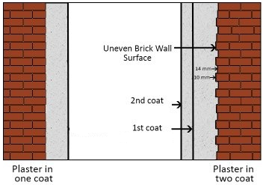

Assessment Evidence Guide

for

“Mason Helper Level 2”

Perform Soling on Ground Level
(Formative Assessment)
September 2021
National Vocational & Technical
Training Commission

Title of Qualification:  National Vocational Certificate Level -2 in Construction (Assistant Mason) |  | CS Code: | Level:  2 | Version:  01
Competency Standard Title:  Perform Soling on Ground Level  Maintain Personal Health, Hygiene and Safety  Perform Basic Communication  Carryout General Maintenance  Perform Basic Green Skills for Construction |  | Assessment Date (DD/MM/YY):  Assessment Time : 30 min
Guidance for Candidate | To complete your assessment for this Competency Standard, you need to answer the questions on the following pages successfully.

Assessors Guide (to be completed by the Assessor and signed both by the assessor and the candidate after the assessment)
Candidate Details | Name: Registration/Roll Number:  Candidate Signature:
Written Assessment Outcome | COMPETENT NOT YET COMPETENT  Name of the Assessor: Assessor’s code:  Signature of the  Assessor:

Title of Qualification:  National Vocational Certificate Level -2 in Construction (Assistant Mason) | CS Code: | Level:  2 | Version:  01
Competency Standard Title:  Perform Soling on Ground Level  Maintain Personal Health, Hygiene and Safety  Perform Basic Communication  Carryout General Maintenance  Perform Basic Green Skills for Construction | Assessment Date (DD/MM/YY):  Assessment Time : 30 min
WRITTEN ASSESSMENT
Question | Candidate’s answer
- What is soling?
- Enlist the soling materials.

- Enlist any three soling patterns.

- Enlist non-recyclable materials?

- What is housekeeping?

- What are green energy resources?

- Enlist non-verbal communication techniques?
- Enlist any three PPPs.

ANSWER KEY

Sr. | Answers
 | Soling is laying of bricks / tuff tiles in sequence grouted with sand.
 | Sand, Bricks, Tuff Tile
 | Single Piece, Multi Piece, Match Plate, Gate, Skeleton, Sweep, Loose Piece
- Garbage.
- Food waste.
- Food-tainted items (such as: used paper plates or boxes, paper towels, or paper napkins)
- Ceramics and kitchenware.
- Windows and mirrors.
- Plastic wrap.
- Packing peanuts and bubble wrap.
- Wax boxes
 | Housekeeping refers to the practice of keeping your site clean and tidy.
 | The energy sources such as sunlight, wind, rain, tides, etc. can be called as green energy.
 | Tone of voice, Body language
 | Safety gloves, safety goggles, helmets, safety shoes etc.

Assessment Evidence Guide

for

“Mason Helper Level 2”

Perform Soling on Ground Level
(Formative Assessment)
September 2021
National Vocational & Technical
Training Commission

Title of Qualification:  National Vocational Certificate Level -2 in Construction (Mason Helper) |  | CS Code: | Level:  2 | Version:  01
Competency Standard Title:  Perform Soling on Ground Level  Maintain Personal Health, Hygiene and Safety  Perform Basic Communication  Carryout General Maintenance  Perform Basic Green Skills for Construction |  | Assessment Date (DD/MM/YY):  Assessment Time: 5 hrs
Candidate Details | Name:  Registration/Roll Number:
Guidance for Candidate | To meet this standard, you are required to complete the following within the given time frame (for practical demonstration & assessment):  Assessment Task 1: Candidate is required to lay brick soling as per design given by assessor. (for reference see ANNEX-I)  Assessment Task 2: Candidate is required to lay tuff tile soling as per design given by assessor. (for reference see ANNEX-II)  And complete:  - Knowledge assessment test (Written or Oral)  - Portfolios at the time of assessment (if any)
Minimum Evidence Required | During a practical assessment, under observation by an assessor, you will complete:  Assessment Task 1  Performance criteria 1: Select appropriate material according to the task  Performance criteria 2: Select appropriate tools according to the task  Performance criteria 3: Prepare the boundary limits as per drawings (example given in annex-I)  Performance criteria 4: Perform compaction of sub-grade surface  Performance criteria 5: Prepare smooth surface as per requirement  Performance criteria 6: Lay sand cushion  Performance criteria 7: Perform compaction and level the sand  Performance criteria 8: Select the pattern as per requirement  Performance criteria 9: Lay the bricks on flat /edge with the help of rope  Performance criteria 10: Perform grouting with sand  Performance Criteria 11: Interpret work processes and procedures correctly  Performance Criteria 12: Select personal protective equipment in terms of type and quantity according to work orders.  Performance Criteria 13: Wear, adjust, and maintain personal protective equipment to ensure correct fit and optimum protection in compliance with company procedures.  Performance Criteria 14: Comply with Health, hygiene and safety precautions before starting work  Performance Criteria 15: Deal with resolvable problems according to prescribed procedures  Performance Criteria 16: Carefully listen and note down the instructions of Supervisor  Performance Criteria 17: Apply appropriate methods and techniques for cleanliness and maintenance of machines & tools  Performance Criteria 18: Fill the checklist for daily cleanliness of the workplace  Performance Criteria 19: Identify various types of construction waste  Performance Criteria 20: Apply waste reduction techniques during construction process  Performance Criteria 21: Ensure appropriate storage of water
Minimum Evidence Required | Assessment Task 2  Performance criteria 1: Lay base course as per drawing (example given in annex-II)  Performance criteria 2: Lay sand cushion as per drawing  Performance criteria 3: Perform compaction and level the sand as per drawing  Performance criteria 4: Select the pattern as per requirement  Performance criteria 5: Lay the tuff tile with the help of rope  Performance criteria 6: Perform grouting with sand  Performance criteria 7: Use plate compactors for more smoothness  Performance Criteria 8: Recognize processes, tools, equipment and consumable materials that have the potential to cause harm  Performance Criteria 9: Ensure personal protective equipment is cleaned and stored in proper place.  Performance Criteria 10: Treat team members with respect and maintain positive relationships to achieve common organizational goals  Performance Criteria 11: Place all the tools & material in proper place to ensure safe work  Performance Criteria 12: Fill the checklists to conduct maintenance and housekeeping of machines & tools  Performance Criteria 13: Place reusable material at designated storage area  Performance Criteria 14: Transport waste material to designated place  Performance Criteria 15: Explore options for reuse of water

Assessors Judgment Guide (to be completed by the Assessor and signed both by the assessor and the candidate after the assessment)
Candidate Details | Name: Registration/Roll Number:  Candidate Signature:
Assessment Outcome | COMPETENT NOT YET COMPETENT  Name of the Assessor: Assessor’s code:  Signature of the  Assessor:
Assessment Summary (to be filled by the assessor)
Activity |  | Method |  |  |  |  | Result
Nature of Activity |  | Written | Oral | Observation | Portfolio | Role Play | Competent | Not Yet Competent
Practical Skill Demonstration
Knowledge Assessment
Other Requirement

Each Assessment Task (with performance criteria)
Assessment Task 1 |  |  | Description of assessment task 1  Candidate is required to lay brick soling as per design given by assessor. (for reference see ANNEX-I)
During the practical assessment, candidate demonstrated the following: |  |  |  | Yes | No | Remarks
 | Select appropriate material according to the task
 | Select appropriate tools according to the task
 | Prepare the boundary limits as per drawings
 | Perform compaction of sub-grade surface
 | Prepare smooth surface as per requirement
 | Lay sand cushion
 | Perform compaction and level the sand
 | Select the pattern as per requirement
 | Lay the bricks on flat /edge with the help of rope
 | Perform grouting with sand
 | Interpret work processes and procedures correctly
 | Select personal protective equipment in terms of type and quantity according to work orders.
 | Wear, adjust, and maintain personal protective equipment to ensure correct fit and optimum protection in compliance with company procedures.
 | Comply with Health, hygiene and safety precautions before starting work
 | Deal with resolvable problems according to prescribed procedures
 | Carefully listen and note down the instructions of Supervisor
 | Apply appropriate methods and techniques for cleanliness and maintenance of machines & tools
 | Fill the checklist for daily cleanliness of the workplace
 | Identify various types of construction waste
 | Apply waste reduction techniques during construction process
 | Ensure appropriate storage of water
Competent |  | Not Yet Competent

Each Assessment Task (with performance criteria)
Assessment Task 2 |  |  | Description of assessment task 2  Candidate is required to lay tuff tile soling as per design given by assessor. (for reference see ANNEX-II)
During the practical assessment, candidate demonstrated the following: |  |  |  | Yes | No | Remarks
 | Lay base course as per drawing
 | Lay sand cushion as per drawing
 | Perform compaction and level the sand as per drawing
 | Select the pattern as per requirement
 | Lay the tuff tile with the help of rope
 | Perform grouting with sand
 | Use plate compactors for more smoothness
 | Recognize processes, tools, equipment and consumable materials that have the potential to cause harm
 | Ensure personal protective equipment is cleaned and stored in proper place.
 | Treat team members with respect and maintain positive relationships to achieve common organizational goals
 | Place all the tools & material in proper place to ensure safe work
 | Fill the checklists to conduct maintenance and housekeeping of machines & tools
 | Place reusable material at designated storage area
 | Transport waste material to designated place
 | Explore options for reuse of water
Competent |  | Not Yet Competent

Annex-I

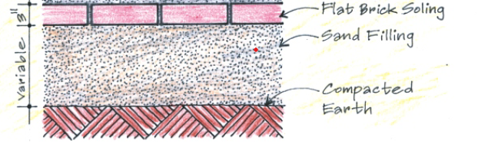


Brick Soling Pattern

Cross-section of Brick Soling

Annex-II

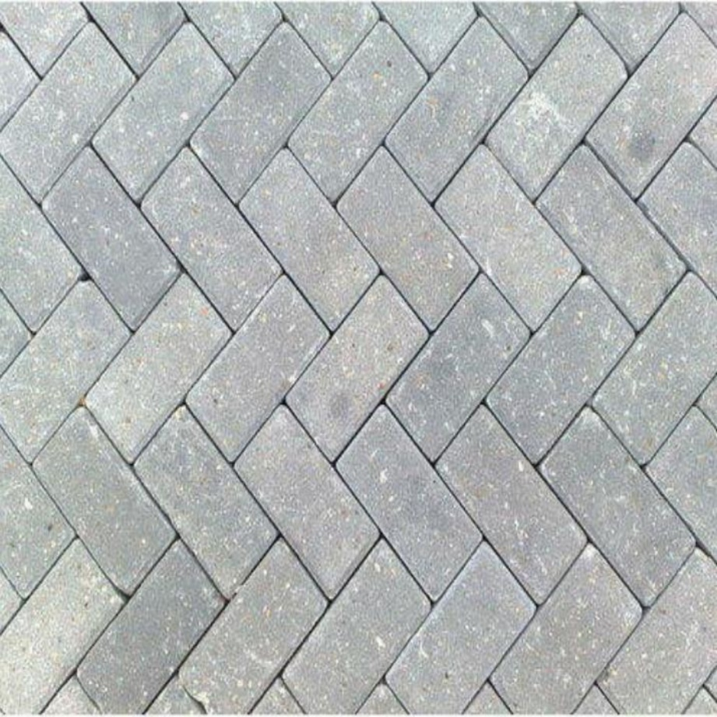

Tuff Tile Soling Pattern

Assessment Evidence Guide

for

“Mason Helper Level 2”

Perform Repair Work of Existing Structure
(Formative Assessment)
September 2021
National Vocational & Technical
Training Commission

Title of Qualification:  National Vocational Certificate Level -2 in Construction (Assistant Mason) |  | CS Code: | Level:  2 | Version:  01
Competency Standard Title:  Perform Repair Work of Existing Structure  Maintain Personal Health, Hygiene and Safety  Perform Basic Communication  Carryout General Maintenance  Perform Basic Green Skills for Construction |  | Assessment Date (DD/MM/YY):  Assessment Time : 30 min
Guidance for Candidate | To complete your assessment for this Competency Standard, you need to answer the questions on the following pages successfully.

Assessors Guide (to be completed by the Assessor and signed both by the assessor and the candidate after the assessment)
Candidate Details | Name: Registration/Roll Number:  Candidate Signature:
Written Assessment Outcome | COMPETENT NOT YET COMPETENT  Name of the Assessor: Assessor’s code:  Signature of the  Assessor:

Title of Qualification:  National Vocational Certificate Level -2 in Construction (Assistant Mason) | CS Code: | Level:  2 | Version:  01
Competency Standard Title:  Perform Repair Work of Existing Structure  Maintain Personal Health, Hygiene and Safety  Perform Basic Communication  Carryout General Maintenance  Perform Basic Green Skills for Construction | Assessment Date (DD/MM/YY):  Assessment Time : 30 min
WRITTEN ASSESSMENT
Question | Candidate’s answer
- Enlist any three concrete repairing materials.

- Enlist different types of brick masonry repairing materials.

- Enlist any five repairing tools.

- Enlist any three repairing techniques of concrete.

- What is chipping in construction?

- Write the communication skills?
- How do you maintain safety in the workplace?

- What are three types of personal hygiene?

ANSWER KEY
Sr. | Answers
 | Non-Shrink Grouts, Epoxy Resins, Epoxy Mortar, Quick-Setting Cement Mortar, Mechanical Anchors. Ferrocement – Fiber Concrete, Fiber Reinforced Plastics (FRP)
 | Cement, Sand, Bricks, Water
Hammer, Nails, A set of screwdrivers (flat head and Phillips), Screws, Measuring tape, Small hand saw, Sprit Level, Pliers, Trowel, Straight edge
Chisel etc.
Epoxy injection, Routing and sealing, Grouting, Stitching, Drilling and plugging
Gravity filling of cracks in concrete etc.
 | Chipping is a process of removing hard or dried mortar
 | Reading, Writing, Speaking, Listening
- Understand the risks.
- Reduce workplace stress.
- Take regular breaks.
- Avoid stooping or twisting.
- Use mechanical aids whenever possible.
- Protect your back.
- Wear protective equipment to suit the task.
- Stay sober
 | Shower hygiene, Nail hygiene, Teeth hygiene, Sickness hygiene, Hands hygiene.

Assessment Evidence Guide

for

“Mason Helper Level 2”

Perform Repair Work of Existing Structure
(Formative Assessment)
September 2021
National Vocational & Technical
Training Commission

Title of Qualification:  National Vocational Certificate Level 2 in Construction (Mason Helper) |  | CS Code: | Level:  2 | Version:  01
Competency Standard Title:  Perform Repair Work of Existing Structure  Maintain Personal Health, Hygiene and Safety  Perform Basic Communication  Carryout General Maintenance  Perform Basic Green Skills for Construction |  | Assessment Date (DD/MM/YY):  Assessment Time :
Candidate Details | Name:  Registration/Roll Number:
Guidance for Candidate | To meet this standard, you are required to complete the following within the given time frame (for practical demonstration & assessment):  Assessment Task 1: Candidate is required to repair defective brick masonry as per instruction given by assessor (for reference see ANNEX-I)  Assessment Task 2: Candidate is required to repair defective plaster surface as per instruction given by assessor (for reference see ANNEX-II)  Assessment Task 3: Candidate is required to repair defective concrete floor as per instruction given by assessor (for reference see ANNEX-III)  And complete:  - Knowledge assessment test (Written or Oral)  - Portfolios at the time of assessment (if any)
Minimum Evidence Required | During a practical assessment, under observation by an assessor, you will complete:  Assessment Task 1  Performance criteria 1: Select material according to the task  Performance criteria 2: Select tools according to the task  Performance criteria 3: Mark defective area as per requirement  Performance criteria 4: Rack out defective bricks  Performance criteria 5: Clean defective areas  Performance criteria 6: Cure defective area  Performance criteria 7: Prepare mortar as per standards  Performance criteria 8: Apply mortar on defective area  Performance criteria 9: Fix new bricks on defective area  Performance criteria 10: Clean brick surface  Performance criteria 11: Cure repair surface  Performance Criteria 12: Identify risk to Health, hygiene and safety  Performance Criteria 13: Maintain cleanliness and hygiene as per organizational policy  Performance Criteria 14: Report unresolved problems to immediate supervisor  Performance Criteria 15: Place the tools equipment etc at their prescribed place after completion of work  Performance Criteria 16: Carry out the instructions of the supervisor  Performance Criteria 17: Dispose unusable waste as per set standards  Performance Criteria 18: Avoid wastage of water
Minimum Evidence Required | Assessment Task 2  Performance criteria 1: Select material according to the task  Performance criteria 2: Select tools according to the task  Performance criteria 3: Mark defective area as per requirement  Performance criteria 4: Remove defective plaster surface  Performance criteria 5: Clean defective areas  Performance criteria 6: Perform curing of defective area  Performance criteria 7: Prepare mortar as per requirement  Performance criteria 8: Apply layer cement slurry  Performance criteria 9: Apply mortar on defective area  Performance criteria 10: Finish plaster surface  Performance criteria 11: Perform curing of repair surface  Performance Criteria 12: Recognize processes, tools, equipment and consumable materials that have the potential to cause harm  Performance Criteria 13: Ensure personal protective equipment is cleaned and stored in proper place.  Performance Criteria 14: Treat team members with respect and maintain positive relationships to achieve common organizational goals  Performance Criteria 15: Fill the checklists to conduct maintenance and housekeeping of machines & tools  Performance Criteria 16: Place reusable material at designated storage area  Performance Criteria 17: Explore options for reuse of water
Minimum Evidence Required | Assessment Task 3  Performance criteria 1: Select material according to the task  Performance criteria 2: Select tools according to the task  Performance criteria 3: Mark defective area as per requirement  Performance criteria 4: Remove defective concrete area up to joint  Performance criteria 5: Clean defective areas  Performance criteria 6: Perform curing of defective area  Performance criteria 7: Prepare concrete as per standards  Performance criteria 8: Apply concrete on defective area  Performance criteria 9: Perform curing on repaired surface  Performance Criteria 10: Interpret work processes and procedures correctly  Performance Criteria 11: Wear, adjust, and maintain personal protective equipment to ensure correct fit and optimum protection in compliance with company procedures.  Performance Criteria 12: Comply with Health, hygiene and safety precautions before starting work  Performance Criteria 13: Carefully listen and note down the instructions of Supervisor  Performance Criteria 14: Apply appropriate methods and techniques for cleanliness and maintenance of machines & tools  Performance Criteria 15: Fill the checklist for daily cleanliness of the workplace  Performance Criteria 16: Identify various types of construction waste

Assessors Judgment Guide (to be completed by the Assessor and signed both by the assessor and the candidate after the assessment)
Candidate Details | Name: Registration/Roll Number:  Candidate Signature:
Assessment Outcome | COMPETENT NOT YET COMPETENT  Name of the Assessor: Assessor’s code:  Signature of the  Assessor:
Assessment Summary (to be filled by the assessor)
Activity |  | Method |  |  |  |  | Result
Nature of Activity |  | Written | Oral | Observation | Portfolio | Role Play | Competent | Not Yet Competent
Practical Skill Demonstration
Knowledge Assessment
Other Requirement

Each Assessment Task (with performance criteria)
Assessment Task 1 |  |  | Description of assessment task 1  Candidate is required to repair defective brick masonry as per instruction given by assessor. (for reference see ANNEX-I)
During the practical assessment, candidate demonstrated the following: |  |  |  | Yes | No | Remarks
 | Select material according to the task
 | Select tools according to the task
 | Mark defective area as per requirement
 | Rack out defective bricks
 | Clean defective areas
 | Cure defective area
 | Prepare mortar as per standards
 | Apply mortar on defective area
 | Fix new bricks on defective area
 | Clean brick surface
 | Cure repair surface
 | Identify risk to Health, hygiene and safety
 | Maintain cleanliness and hygiene as per organizational policy
 | Report unresolved problems to immediate supervisor
 | Place the tools equipment etc at their prescribed place after completion of work
 | Carry out the instructions of the supervisor
 | Dispose unusable waste as per set standards
 | Avoid wastage of water
Competent |  | Not Yet Competent

Assessment Task 2 |  |  | Description of assessment task 2  Candidate is required to repair defective plaster surface as per instruction given by assessor. (for reference see ANNEX-Ii)
During the practical assessment, candidate demonstrated the following: |  |  |  | Yes | No | Remarks
 | Select material according to the task
 | Select tools according to the task
 | Mark defective area as per requirement
 | Remove defective plaster surface
 | Clean defective areas
 | Perform curing of defective area
 | Prepare mortar as per requirement
 | Apply layer cement slurry
 | Apply mortar on defective area
 | Finish plaster surface
 | Perform curing of repair surface
 | Recognize processes, tools, equipment and consumable materials that have the potential to cause harm
 | Ensure personal protective equipment is cleaned and stored in proper place.
 | Treat team members with respect and maintain positive relationships to achieve common organizational goals
 | Fill the checklists to conduct maintenance and housekeeping of machines & tools
 | Place reusable material at designated storage area
 | Explore options for reuse of water
Competent |  | Not Yet Competent

Each Assessment Task (with performance criteria)
Assessment Task 3 |  |  | Description of assessment task 3  Candidate is required to repair defective concrete floor as per instruction given by assessor. (for reference see ANNEX-III)
During the practical assessment, candidate demonstrated the following: |  |  |  | Yes | No | Remarks
 | Select material according to the task
 | Select tools according to the task
 | Mark defective area as per requirement
 | Remove defective concrete area up to joint
 | Clean defective areas
 | Perform curing of defective area
 | Prepare concrete as per standards
 | Apply concrete on defective area
 | Perform curing on repaired surface
 | Interpret work processes and procedures correctly
 | Wear, adjust, and maintain personal protective equipment to ensure correct fit and optimum protection in compliance with company procedures.
 | Comply with Health, hygiene and safety precautions before starting work
 | Carefully listen and note down the instructions of Supervisor
 | Apply appropriate methods and techniques for cleanliness and maintenance of machines & tools
 | Fill the checklist for daily cleanliness of the workplace
 | Identify various types of construction waste
Competent |  | Not Yet Competent

ANNEX-I

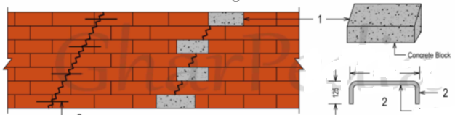

ANNEX-II

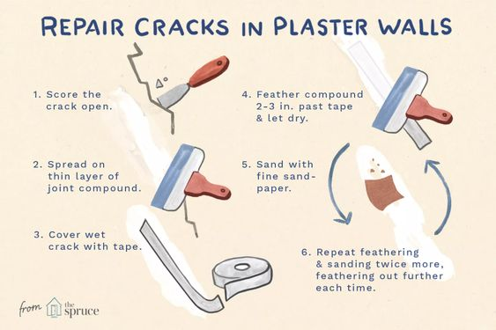

ANNEX-III

DRY PACKING
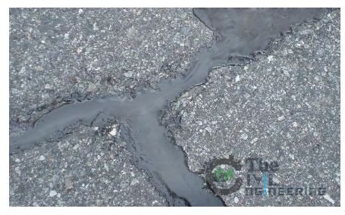

Assessment Evidence Guide

for

“Mason Helper Level 2”

(Summative Assessment)
September 2021
National Vocational & Technical
Training Commission

Title of Qualification:  National Vocational Certificate Level -2 in Construction (Mason helper) |  | CS Code: | Level:  2 | Version:  01
Competency Standard Title:  Maintain Personal Health, Hygiene and Safety  Perform Basic Communication Skills  Carryout General Maintenance  Demonstrate Basic Numeracy Skills  Carryout Layout Plan of Given Project  Perform Basic Brick/Block Masonry Work for Given Building Project  Perform Basic Stone Masonry Work for Given Project  Perform Plain Cement Concrete Work (PCC) on Brick Masonry  Carryout Plaster Work on Brick Masonry  Perform Soling on Ground Level  Perform Repair Work of Existing Structure  Perform Basic Green Skills in Construction |  | Assessment Date (DD/MM/YY):  Assessment Time : 30 min
Guidance for Candidate | To complete your assessment for this Competency Standard, you need to answer the questions on the following pages successfully.

Assessors Guide (to be completed by the Assessor and signed both by the assessor and the candidate after the assessment)
Candidate Details | Name: Registration/Roll Number:  Candidate Signature:
Written Assessment Outcome | COMPETENT NOT YET COMPETENT  Name of the Assessor: Assessor’s code:  Signature of the  Assessor:

Title of Qualification:  National Vocational Certificate Level 2 in Construction (Mason Helper) | CS Code: | Level:  2 | Version:  01
Competency Standard Title:  Maintain Personal Health, Hygiene and Safety  Perform Basic Communication skills  Carryout General Maintenance  Demonstrate Basic Numeracy skills  Perform Layout  Perform Basic Brick/Block Masonry Work  Perform Basic Stone Masonry Work  Perform Plain Cement Concrete Work (PCC)  Perform Plaster Work  Perform Soling  Perform Repair Work | Assessment Date (DD/MM/YY):  Assessment Time : 60 min
WRITTEN ASSESSMENT
Question | Candidate’s answer
- Volume of one cement bag is?
- Convert 10 meter in feet?
- Plot size is 35’x65’. Find out area in square meter?
- Define layout?
- What is a three quarter bat?
- What is the king closer?
- What is DPC?
- What is the queen closer?
- What is stone pitching?
- Enlist workplace hazards?
- What is 1:4:8 foundations PCC?
- Enlist any four methods of concrete compaction?
- Define water cement ratio?
- What is grouting?
- What is compaction method used in soling?
- What is chipping in construction?
- Enlist the alignment tools for plaster.
- What are green energy resources?
- Enlist non-verbal communication techniques?
- What are four types of safety signs?

ANSWER KEY
Sr. | Answers
 | 1.25 Cubic Feet
 | 10x3.281=32.81’
 | 211.43 square meter
 | It is demarcation of drawing lines on the ground.
 | It is a brick having length ¾th of its full length.
 | It is a brick chamfered at one corner.
 | A damp proof course is layer, which is provided to save the structure from dampness.
 | It is a half brick cut in length wise
 | Stone pitching is laying of stone on sloping surface.
 | Tripping hazards, Burn hazards, Falling debris hazards etc
 | Concrete comprising of one part is cement, 4 parts is sand and 8 parts is aggregate.
 | Manual Compaction (Hand Compaction), By Pressure and Jolting, By Spinning, Mechanical Compaction by Vibration, Internal Vibrator for Concrete Compaction, Flexible shaft type internal vibrator
 | The water–cement ratio is the ratio of the weight of water to the weight of cement used in a concrete mix.
 | Grouting is processes which fill the voids to prevent dampness.
 | Hand compactor, Machine compactor
 | Chipping is a process of removing hard or dried mortar
 | Level peg, Straight edge, Plumb bob
 | The energy sources such as sunlight, wind, rain, tides, etc. can be called as green energy.
 | Body language, tone of voice
- Prohibition,
- Warning,
- Mandatory
- Emergency.

Assessment Evidence Guide

for

“Mason Helper Level 2”

(Summative Assessment)
September 2021
National Vocational & Technical
Training Commission

Title of Qualification:  National Vocational Certificate Level 2 in Construction (Mason Helper) |  | CS Code: | Level:  2 | Version:  01
Competency Standard Title:  Maintain Personal Health, Hygiene and Safety  Perform Basic Communication Skills  Carryout General Maintenance  Demonstrate Basic Numeracy Skills  Carryout Layout Plan of Given Project  Perform Basic Brick/Block Masonry Work for Given Building Project  Perform Basic Stone Masonry Work for Given Project  Perform Plain Cement Concrete Work (PCC) on Brick Masonry  Carryout Plaster Work on Brick Masonry  Perform Soling on Ground Level  Perform Repair Work of Existing Structure  Perform Basic Green Skills in Construction |  | Assessment Date (DD/MM/YY):  Assessment Time : 4 ½ hours
Candidate Details | Name:  Registration/Roll Number:
Guidance for Candidate | To meet this standard, you are required to complete the following within the given time frame (for practical demonstration & assessment):  Assessment Task 1: Candidate is required to prepare L-shape 9 inch thick wall having external length 4’x4’ in which following procedures are done as per instruction given by assessor (example attached as Annex-I)  - Layout for wall  - Excavation  - Lay DPC 1 ½ “ thick (1:2:4) at plinth level  - Lay Brick masonry (1:6) in super structure  - Apply plaster (1:4) on super structure inside  - Perform brick soling at the inner side of wall  And complete:  - Knowledge assessment test (Written or Oral)  - Portfolios at the time of assessment (if any)
Minimum Evidence Required | During a practical assessment, under observation by an assessor, you will complete:  Assessment Task 1  Performance criteria 1: Select workplace  Performance criteria 2: Interpret given drawing  Performance criteria 3: Select material according to the task  Performance criteria 4: Select tools according to the task  Performance criteria 5: Mark reference point according to the orientation of task  Performance criteria 6: Mark center line according to the drawing  Performance criteria 7: Construct masonry post  Performance criteria 8: Demark the points of reference lines on post  Performance criteria 9: Stretch the thread line between two reference points  Performance criteria 10: Transfer reference lines on ground with lime powder  Performance criteria 11: Perform dag-belling with the help of plie (kassi)  Performance criteria 12: Perform brick/block soaking process  Performance criteria 13: Prepare mortar according to the given ratio  Performance criteria 14: Perform layout as per drawing  Performance criteria 15: Perform excavation as per layout  Performance criteria 16: Lay down mortar as per standards  Performance criteria 17: Perform laying of brick/block courses in foundation and plinth as per specified bond  Performance criteria 18: Perform laying of brick/block courses in super structure as per specified bond  Performance criteria 19: Carryout horizontal alignment and vertical plumb  Performance criteria 20: Interpret given layout drawing as per task  Performance criteria 21: Perform cleaning and washing of fine and coarse aggregate  Performance criteria 22: Calculate the materials as per ratio  Performance criteria 23: Perform batching of fine aggregate  Performance criteria 24: Perform batching of coarse aggregate  Performance criteria 25: Maintain water cement ratio  Performance criteria 26: Prepare platform with available material  Performance criteria 27: Spread coarse aggregate as per requirement  Performance criteria 28: Spread fine aggregate over coarse aggregate as per requirement  Performance criteria 29: Spread cement over fine aggregate as per requirement  Performance criteria 30: Perform uniform mixing as per standard  Performance criteria 31: Stretch mix material in circular shape and make a depression in the centre for water  Performance criteria 32: Add water to maintain water cement ratio  Performance criteria 33: Perform turning the mixture over and over again to achieve even color  Performance criteria 34: Select the mode of transportation of concrete as per task  Performance criteria 35: Transport the concrete with pan/wheel barrow  Performance criteria 36: Place the concrete on prepared surface /formwork  Performance criteria 37: Use chute as per requirement  Performance criteria 38: Use tamping rod/needle vibrator for compaction as per task  Performance criteria 39: Perform leveling and finishing as per task  Performance criteria 40: Perform curing on concrete work as per standard  Performance criteria 41: Clean and wash the top surface of wall  Performance criteria 42: Apply DPC on wall surface as per drawing  Performance criteria 43: Perform curing on concrete work as per requirement  Performance criteria 44: Select material according to the task (for plastering)  Performance criteria 45: Select tools according to the task  Performance criteria 46: Fix level pegs on wall /ceiling with reference to the off lines  Performance criteria 47: Prepare mortar according to the given ratio  Performance criteria 48: Rack the joints  Performance criteria 49: Chip off and Clean the wall/ceiling  Performance criteria 50: Apply cement slurry on ceiling  Performance criteria 51: Apply mortar with trowel/float on wall surface within the level pegs  Performance criteria 52: Remove extra mortar from off line of pegs  Performance criteria 53: Fill depression of surface with additional mortar  Performance criteria 54: Level the plaster surface with straight edge  Performance criteria 55: Finish the plaster surface with float  Performance criteria 56: Apply foam for smooth finish  Performance criteria 57: Perform curing after specified time  Performance criteria 58: Select appropriate material according to the task (soling)  Performance criteria 59: Select appropriate tools according to the task  Performance criteria 60: Prepare the boundary limits as per drawings  Performance criteria 61: Perform compaction of sub-grade surface  Performance criteria 62: Prepare smooth surface as per requirement  Performance criteria 63: Lay sand cushion  Performance criteria 64: Perform compaction and level the sand  Performance criteria 65: Select the pattern as per requirement  Performance criteria 66: Lay the bricks on flat /edge with the help of string  Performance criteria 67: Perform grouting with sand  Performance criteria 68: Wear, adjust, and maintain personal protective equipment to ensure correct fit and optimum protection in compliance with company procedures.  Performance criteria 69: Apply appropriate methods and techniques for cleanliness and maintenance of machines & tools  Performance criteria 70: Respond appropriately to safety hazards on all tools and machines  Performance criteria 71: Place all the tools & material in proper place to ensure safe work  Performance criteria 72: Ensure personal protective equipment is cleaned and stored in proper place.  Performance criteria 73: Follow organizational Health, hygiene and safety guidelines during work  Performance criteria 74: Listen to instructions carefully & comply with those instructions  Performance criteria 75: Carry out the instructions of the supervisor  Performance criteria 76: Categorize reusable waste  Performance criteria 77: Dispose unusable waste as per set standards  Performance criteria 78: Place reusable material at designated storage area  Performance criteria 79: Estimate water requirements for various stages of construction
Minimum Evidence Required | Portfolios required at the time of assessment (if any) for  - Folder includes calculation of different areas and volumes  - Folder includes different layout drawings and symbols  - Folder includes evidences of basic scaffolding, masonry works of drain and underground chamber  - Folder includes evidence of basic stone masonry work  - Folder includes evidence of machine mixing of concrete  - Folder includes evidence of tuff tile soling  - Folder includes evidence of different repair works project  Performance criteria 1: Interpret work processes and procedures correctly  Performance criteria 2: Recognize processes, tools, equipment and consumable Performance criteria 3: Identify materials that have the potential to cause harm  Performance criteria 4: Identify risk to Health, hygiene and safety  Performance criteria 5: Deal with resolvable problems according to prescribed procedures  Performance criteria 6: Report unresolved problems to immediate supervisor  Performance criteria 7: Place the tools equipment etc at their prescribed place after completion of work  Performance criteria 8: Adopt maintenance schedule carefully  Performance criteria 9: Follow oiling and greasing chart (daily, weekly as per machine requirement)  Performance criteria 10: Inspect and assess the general condition of an assigned machine on regular basis  Performance criteria 11: Observe problems and carry out routine maintenance as per given instructions and schedules  Performance criteria 12: Identify faulty/damaged/ worn out parts and take appropriate steps to get those replaced  Performance criteria 13: Report faults and problems of the machines, if not controllable, to the person concerned  Performance criteria 14: Identify basic mathematical operations (addition, subtraction, multiplication, and division)  Performance criteria 15: Apply addition operation  Performance criteria 16: Apply subtraction operation  Performance criteria 17: Apply multiplication operation  Performance criteria 18: Apply division operations  Performance Criteria 19: Calculate area of basic plane figures  Performance Criteria 20: Perform inter conversion of Measuring units  Performance Criteria 21: Record the results.  Performance criteria 22: Identify measuring tools  Performance criteria 23: Collect appropriate measuring tools  Performance criteria 24: Identify inch, foot and yard  Performance criteria 25: Identify millimeter, centimeter and meter  Performance criteria 26: Interpret basic measuring units and its inter conversion  Performance criteria 27: Perform addition operation  Performance criteria 28: Perform subtraction operation  Performance criteria 29: Perform multiplication operation  Performance criteria 30: Perform division operations  Performance criteria 31: Calculate surface area and volume of cylindrical and cubical shapes  Performance criteria 32: Calculate volume of materials, masonry and concrete  Performance criteria 33: Calculate quantities of materials (Masonry, soling and concrete) by incorporating time saving practices  Performance criteria 34: Draw freehand sketch according to given task  Performance criteria 35: Draw basic symbols of civil structures  Performance criteria 36: Draw basic symbols of material  Performance criteria 37: Select materials as per task  Performance criteria 38: Select knot for fastening  Performance criteria 39: Perform placing of components  Performance criteria 40: Carryout knotting as per task  Performance criteria 41: Perform layout as per drawing  Performance criteria 42: Carryout excavation  Performance criteria 43: Perform plastering as per ratio  Performance criteria 44: Perform curing  Performance criteria 45: Perform compaction  Performance criteria 46: Carryout brick masonry as per pattern  Performance criteria 47: Apply lean concrete  Performance criteria 48: Check gradient  Performance criteria 49: Fix iron rungs  Performance criteria 50: Carry out flooring/benching  Performance criteria 51: Perform plastering as per ratio  Performance criteria 52: Lay down mortar as per standards  Performance criteria 53: Perform dressing of stone as per requirement  Performance criteria 54: Perform laying of stone course as per task  Performance criteria 55: Carryout horizontal alignment and vertical plumb  Performance criteria 56: Perform striking of joints as per design  Performance criteria 57: Perform curing on stone masonry as per standards  Performance criteria 58: Perform dressing of slope as per drawing  Performance criteria 59: Perform laying of stone course as per task  Performance criteria 60: Perform grouting of sand on stone pitching  Performance criteria 61: Add half quantity of water in mixing drum  Performance criteria 62: Put crush in mixer hopper  Performance criteria 63: Put sand in mixer hopper  Performance criteria 64: Put cement in mixer hopper  Performance criteria 65: Tilt the hopper into the mixing drum  Performance criteria 66: Rotate the mixing drum as per standard  Performance criteria 67: Unload the mixing drum on platform/wheel barrow  Performance criteria 68: Lay base course as per task  Performance criteria 69: Lay sand cushion  Performance criteria 70: Perform compaction and level the sand  Performance criteria 71: Select the pattern as per requirement  Performance criteria 72: Lay the tuff tile with the help of string  Performance criteria 73: Perform grouting with sand  Performance criteria 74: Use plate compactors for more smoothness  Performance criteria 75: Rack out defective bricks  Performance criteria 76: Clean defective areas  Performance criteria 77: Cure defective area  Performance criteria 78: Prepare mortar  Performance criteria 79: Apply mortar on defective area  Performance criteria 80: Fix new bricks on defective area  Performance criteria 81: Clean brick surface  Performance criteria 82: Cure repair surface  Performance criteria 83: Remove defective plaster surface  Performance criteria 84: Perform curing of defective area  Performance criteria 85: Prepare mortar as per requirement  Performance criteria 86: Apply layer cement slurry  Performance criteria 87: Apply mortar on defective area  Performance criteria 88: Finish plaster surface  Performance criteria 89: Remove defective concrete area up to joint  Performance criteria 90: Prepare concrete  Performance criteria 91: Apply concrete on defective area  Performance criteria 92: Perform curing on repaired surface  Performance criteria 93: Apply concrete on defective area  Performance criteria 94: Transport waste material to designated place  Performance criteria 95: Estimate water requirements for various stages of construction  Performance criteria 96: Identify onsite water resources
Assessors Judgment Guide (to be completed by the Assessor and signed both by the assessor and the candidate after the assessment)
Candidate Details | Name: Registration/Roll Number:  Candidate Signature:
Assessment Outcome | COMPETENT NOT YET COMPETENT  Name of the Assessor: Assessor’s code:  Signature of the  Assessor:
Assessment Summary (to be filled by the assessor)
Activity |  | Method |  |  |  |  | Result
Nature of Activity |  | Written | Oral | Observation | Portfolio | Role Play | Competent | Not Yet Competent
Practical Skill Demonstration
Knowledge Assessment
Other Requirement

Each Assessment Task (with performance criteria)
Assessment Task 1 |  |  | Description of assessment task 1  Candidate is required to prepare L-shape 9 inch thick wall having external length 4’x4’ in which following procedures are done as per instruction given by assessor  - Layout for wall  - Excavation  - Lay DPC 1 ½ “ thick (1:2:4) at plinth level  - Lay Brick masonry (1:6) in super structure  - Apply plaster (1:4) on super structure inside  - Perform brick soling at the inner side of wall
During the practical assessment, candidate demonstrated the following: |  |  |  | Yes | No | Remarks
 | Select workplace
 | Interpret given drawing
 | Select material according to the task
 | Select tools according to the task
 | Mark reference point according to the orientation of task
 | Mark centre line according to the drawing
 | Construct masonry post
 | Demark the points of reference lines on post
 | Stretch the thread line between two reference points
 | Transfer reference lines on ground with lime powder
 | Perform dag-belling with the help of plie (kassi)
 | Perform brick/block soaking process
 | Prepare mortar according to the given ratio
 | Perform layout as per drawing
 | Perform excavation as per layout
 | Lay down mortar as per standards
 | Perform laying of brick/block courses in foundation and plinth as per specified bond
 | Perform laying of brick/block courses in super structure as per specified bond
 | Carryout horizontal alignment and vertical plumb
 | Interpret given layout drawing as per task
 | Perform cleaning and washing of fine and coarse aggregate
 | Calculate the materials as per ratio
 | Perform batching of fine aggregate
 | Perform batching of coarse aggregate
 | Maintain water cement ratio
 | Prepare platform with available material
 | Spread coarse aggregate as per requirement
 | Spread fine aggregate over coarse aggregate as per requirement
 | Spread cement over fine aggregate as per requirement
 | Perform uniform mixing as per standard
 | Stretch mix material in circular shape and make a depression in the centre for water
 | Add water to maintain water cement ratio
 | Perform turning the mixture over and over again to achieve even color
 | Select the mode of transportation of concrete as per task
 | Transport the concrete with pan/wheel barrow
 | Place the concrete on prepared surface /formwork
 | Use chute as per requirement
 | Use tamping rod/needle vibrator for compaction as per task
 | Perform leveling and finishing as per task
 | Perform curing on concrete work as per standard
 | Clean and wash the top surface of wall
 | Apply DPC on wall surface as per drawing
 | Perform curing on concrete work as per requirement
 | Select material according to the task (plastering)
 | Select tools according to the task
 | Fix level pegs on wall /ceiling with reference to the off lines
 | Prepare mortar according to the given ratio
 | Rack the joints
 | Chip off and Clean the wall/ceiling
 | Apply cement slurry on ceiling
 | Apply mortar with trowel/float on wall surface within the level pegs
 | Remove extra mortar from off line of pegs
 | Fill depression of surface with additional mortar
 | Level the plaster surface with straight edge
 | Finish the plaster surface with float
 | Apply foam for smooth finish
 | Perform curing after specified time
 | Select appropriate material according to the task
 | Select appropriate tools according to the task
 | Prepare the boundary limits as per drawings
 | Perform compaction of sub-grade surface
 | Prepare smooth surface as per requirement
 | Lay sand cushion
 | Perform compaction and level the sand
 | Select the pattern as per requirement
 | Lay the bricks on flat /edge with the help of string
 | Perform grouting with sand
 | Wear, adjust, and maintain personal protective equipment to ensure correct fit and optimum protection in compliance with company procedures.
 | Apply appropriate methods and techniques for cleanliness and maintenance of machines & tools
 | Respond appropriately to safety hazards on all tools and machines
 | Place all the tools & material in proper place to ensure safe work
 | Ensure personal protective equipment is cleaned and stored in proper place.
 | Follow organizational Health, hygiene and safety guidelines during work
 | Listen to instructions carefully & comply with those instructions
 | Carry out the instructions of the supervisor
 | Categorize reusable waste
 | Dispose unusable waste as per set standards
 | Place reusable material at designated storage area
 | Estimate water requirements for various stages of construction
Competent |  | Not Yet Competent

Portfolio |  | Description of portfolio  - Folder includes calculation of different areas and volumes  - Folder includes different layout drawings and symbols  - Folder includes evidence of basic scaffolding, masonry works of drain and underground chamber  - Folder includes evidence of basic stone masonry work  - Folder includes evidence of machine mixing of concrete  - Folder includes evidence of tuff tile soling  - Folder includes evidence of different repair works project
Current Sufficient Authentic Valid Reliable
Portfolio meet the following performance standards: |  |  | Yes | No | Remarks
 | Interpret work processes and procedures correctly
 | Recognize processes, tools, equipment and consumable
 | Identify materials that have the potential to cause harm
 | Identify risk to Health, hygiene and safety
 | Deal with resolvable problems according to prescribed procedures
 | Report unresolved problems to immediate supervisor
 | Place the tools equipment etc at their prescribed place after completion of work
 | Adopt maintenance schedule carefully
 | Follow oiling and greasing chart (daily, weekly as per machine requirement)
 | Inspect and assess the general condition of an assigned machine on regular basis
 | Observe problems and carry out routine maintenance as per given instructions and schedules
 | Identify faulty/damaged/ worn out parts and take appropriate steps to get those replaced
 | Report faults and problems of the machines, if not controllable, to the person concerned
 | Identify basic mathematical operations (addition, subtraction, multiplication and division)
 | Apply addition operation
 | Apply subtraction operation
 | Apply multiplication operation
 | Apply division operations
 | Calculate area of basic plane figures
 | Perform inter conversion of Measuring units
 | Record the results.
 | Identify measuring tools
 | Collect appropriate measuring tools
 | Identify inch, foot and yard
 | Identify millimeter, centimeter and meter
 | Interpret basic measuring units and its inter conversion
 | Perform addition operation
 | Perform subtraction operation
 | Perform multiplication operation
 | Perform division operation
 | Calculate surface area and volume of cylindrical and cubical shapes
 | Calculate volume of materials, masonry and concrete
 | Calculate quantities of materials (Masonry, soling and concrete) by incorporating time saving practices
 | Draw freehand sketch according to the given task
 | Draw basic symbols of civil structures
 | Draw basic symbols of material
 | Select materials as per task
 | Select knot for fastening
 | Perform placing of components
 | Carryout knotting as per task
 | Perform layout as per drawing
 | Carryout excavation
 | Perform plastering as per ratio
 | Perform curing
 | Perform compaction
 | Carryout brick masonry as per pattern
 | Apply lean concrete
 | Check gradient
 | Fix iron rungs
 | Carry out flooring/benching
 | Perform plastering as per ratio
 | Lay down mortar as per standards
 | Perform dressing of stone as per requirement
 | Perform laying of stone course as per task
 | Carryout horizontal alignment and vertical plumb
 | Perform striking of joints as per design
 | Perform curing on stone masonry as per standards
 | Perform dressing of slope as per drawing
 | Perform laying of stone course as per task
 | Perform grouting of sand on stone pitching
 | Add half quantity of water in mixing drum
 | Put crush in mixer hopper
 | Put sand in mixer hopper
 | Put cement in mixer hopper
 | Tilt the hopper into the mixing drum
 | Rotate the mixing drum as per standard
 | Unload the mixing drum on platform/wheel barrow
 | Lay base course as per task
 | Lay sand cushion
 | Perform compaction and level the sand
 | Select the pattern as per requirement
 | Lay the tuff tile with the help of string
 | Perform grouting with sand
 | Use plate compactors for more smoothness
 | Rack out defective bricks
 | Clean defective areas
 | Cure defective area
 | Prepare mortar
 | Apply mortar on defective area
 | Fix new bricks on defective area
 | Clean brick surface
 | Cure repair surface
 | Remove defective plaster surface
 | Perform curing of defective area
 | Prepare mortar as per requirement
 | Apply layer cement slurry
 | Apply mortar on defective area
 | Finish plaster surface
 | Remove defective concrete area up to joint
 | Prepare concrete
 | Apply concrete on defective area
 | Perform curing on repaired surface
 | Apply concrete on defective area
 | Transport waste material to designated place
 | Estimate water requirements for various stages of construction
 | Identify onsite water resources
Competent |  | Not Yet Competent

Annex-I
Cross-Section and Plan of L-shaped wall

Brick Soling Pattern

Cross-section of Brick Soling

