Assessment Evidence Guide
For
“PLUMBER”
Level-2
Formative Assessment
0732BCE1503 Perform Basic Metal Work
Date 04-09 November, 2024
Lahore


National Vocational & Technical
Training Commission

Instruction Sheet for the Candidate
Qualification | Plumber Level-2
Competency Standard | 0732BCE1503 Perform Basic Metal Work
Purpose of Assessment | Formative Assessment
Candidate Details | Name______________________________________________________  Registration/Roll Number_______________________________________
Guidance for Candidate | To meet this standard, you are required to complete the following within 04 Hrs. time frame (for practical demonstration & assessment):  - Perform Measuring & marking on Job according to drawing  - Perform Filling & Chipping as per given Drawing  - Perform Sawing As per given Task  - Perform Drilling and Reaming as per instruction  - Perform Counter sinking & Boring as per given drawing  ACTIVITY  Perform basic metalworking skills by performing measuring, marking, filing, chipping, sawing, drilling, reaming and countersinking on a metal plate (Annex 1)
Time: 4 Hrs. | During a practical assessment, under observation by an assessor, you are required to
Minimum Evidence Required | - Measure given job as per instruction  - Mark given job as per Measurement  - Perform Center punching as per Marking  - Perform Filling on given job as per instruction  - Perform chipping on given job as per instruction  - Perform Riveting according to requirement  - Measure given job as per instructions  - Saw job as per requirements  - Create a circular hole in Metal as per specifications  - Perform Reaming on pipe as per specification.  - Create a tapered surface of a hole as per instruction  - Perform Boring as per specification
Self-Assessment Checklist
Candidate Name
Registration No.
Qualification | Plumber Level-2
Competency Standard | 0732BCE1503 Perform Basic Metal Work
Purpose of Assessment | Formative Assessment
Assessment Task | - Perform Measuring & marking on Job according to drawing  - Perform Filling & Chipping as per given Drawing  - Perform Sawing As per given Task  - Perform Drilling and Reaming as per instruction  - Perform Counter sinking & Boring as per given drawing  ACTIVITY  - Perform basic metalworking skills by performing measuring, marking, filing, chipping, sawing, drilling, reaming and countersinking on a metal plate (Annex 1)
I can……………….
Performance Criteria | Yes | No
- Measure given job as per instruction
- Mark given job as per Measurement
- Perform Center punching as per Marking
- Perform Filling on given job as per instruction
- Perform chipping on given job as per instruction
- Perform Riveting according to requirement
- Measure given job as per instructions
- Saw job as per requirements
- Create a circular hole in Metal as per specifications
- Perform Reaming on pipe as per specification.
- Create a tapered surface of a hole as per instruction
- Perform Boring as per specification
Candidate’s Signature__________________ Assessor’s Signature____________________
Date: _______________________________

Assessors Judgment Guide
Qualification | Plumber Level-2
Competency Standard | 0732BCE1503 Perform Basic Metal Work
Purpose of Assessment | Formative Assessment
Candidate Details | Name: ______________________________________________________________  Registration/Roll Number: ______________________ Signature: _______________
Assessment Outcome | COMPETENT NOT YET COMPETENT  Name of the Assessor________________________________________________  Assessor’s code: ____________________________________________________  Signature: ________________________________

Assessment Summary (to be filled by the assessor)
Activity | Method |  |  |  |  | Result
Nature of Activity | Written | Oral | Observation | Portfolio | Role Play | Competent | Not Yet Competent
Practical Skill Demonstration
Knowledge Assessment
Other Requirement

Observation Checklist
Assessment Task |  | - Perform Measuring & marking on Job according to drawing  - Perform Filling & Chipping as per given Drawing  - Perform Sawing As per given Task  - Perform Drilling and Reaming as per instruction  - Perform Counter sinking & Boring as per given drawing  ACTIVITY:  - Perform basic metalworking skills by performing measuring, marking, filing, chipping, sawing, drilling, reaming and countersinking on a metal plate. (Annex 1)
During the practical assessment, candidate demonstrated the following: |  |  |  | Yes | No | Remarks
 | Measure given job as per instruction
 | Mark given job as per Measurement
 | Perform Center punching as per Marking
 | Perform Filling on given job as per instruction
 | Perform chipping on given job as per instruction
 | Perform Riveting according to requirement
 | Measure given job as per instructions
 | Saw job as per requirements
 | Create a circular hole in Metal as per specifications
 | Perform Reaming on pipe as per specification.
 | Create a tapered surface of a hole as per instruction
 | Perform Boring as per specification
Competent |  |  | Not Yet Competent

Knowledge Assessment
Qualification | Plumber Level-2
Competency Standard | 0732BCE1503 Perform Basic Metal Work
Purpose of Assessment | Formative Assessment
Candidate Details | Name: ______________________________________________________________  Registration/Roll Number: _________________ Candidate Signature: ___________
Assessment Outcome | COMPETENT NOT YET COMPETENT  Name of the Assessor: ________________________________________________  Assessor’s code: ____________________________________________________  Signature of the Assessor: _______________________

Candidate’s response is not required to be identical, but similar concepts and/or keywords must be used. Oral questioning may be used to clarify candidate understanding of topic and its application.

Questions (Candidate confidently answered questions correctly and demonstrated understanding of the topics and their application) |  | Satisfactory | Not Satisfactory
 | Define filing?
 | Define basic operations?
 | Describe use of center punch?
 | Describe counter sinking and counter boring?
 | Which type of tools used for drilling exercise?
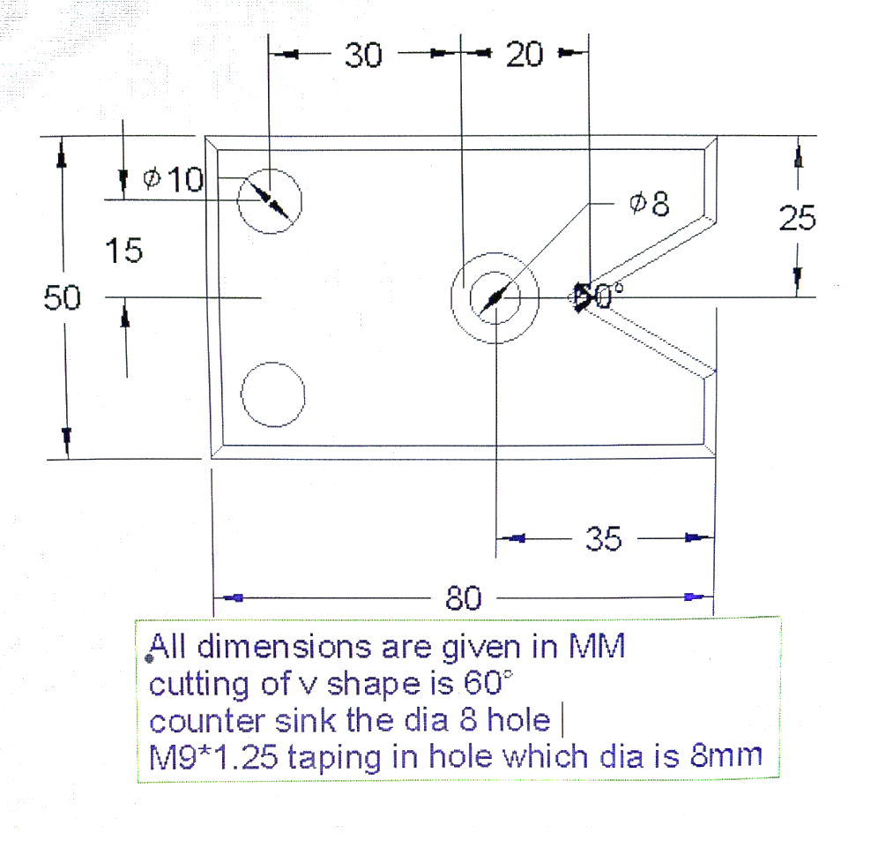
Annex-1
Feedback to the Candidate
Candidate’s Signature__________________ Assessor’s Signature _________________

