Assessment Evidence Guide
For
Summative Assessment
“PLUMBER”
LEVEL-2

Date 04-09 April, 2024
Lahore


National Vocational & Technical
Training Commission

Instruction Sheet for the Candidate
Qualification | National Vocation Certificate “PLUMBER” LEVEL-2
Competency Standard | 0732BCE1501 Maintain Safety at the Workplace  0732BCE1502 Prepare Plumbing Drawing  0732BCE1503 Perform Basic Metal Work  0732BCE1504 Carry Out Plumbing Job  0732BCE1505 Join Pipe & Fittings  0732BCE1506 Perform Sanitary Work  0732BCE1507 IT Fundamentals
Purpose of Assessment | Summative Assessment
Candidate Details | Name______________________________________________________  Registration/Roll Number_______________________________________
Guidance for Candidate | To meet this standard, you are required to complete the following within 05 Hrs. time frame (for practical & assessment):  Task 1: Install a single open shower unit following the provided plumbing drawing, ensuring all connections are accurate, secure, and leak free. (Annex 1)  OR  Task 2: Install a washbasin in the designated hall as per the provided drawing. (Annex 2)
Time: 05 Hrs. | During a practical assessment, under observation by an assessor, you are required to
Minimum Evidence Required | TASK 1:  - Apply required PPEs and Maintain workplace safety.  - Refer to plumbing drawing for layout confirmation.  - Measure and cut pipes to specified lengths.  - Cut 16 mm threading for pipe connections.  - Apply lubrication during pipe threading.  - Use clamp to fix the job securely on the training wall.  - Install shower unit in specified position as per drawing.  - Connect hot and cold-water lines to shower valve.  - Ensure secure pipe joints using appropriate fittings.  - Test for leaks and adjust connections as needed.  - Check water flow rate and adjust if necessary.  - Perform sanitary sealing around the installation.  - Document installation process and tools equipments.  TASK 2:  - Apply required PPEs and Maintain workplace safety.  - Select proper tools for installation according to drawing.  - Review plumbing drawing for exact basin placement.  - Prepare and cut pipes as per measurement requirements.  - Use Teflon tape on threaded connections to prevent leaks.  - Mount basin and secure it to wall/frame as specified.  - Check proper leveling of the basin before final fixation.  - Connect water supply and waste pipe fittings to basin.  - Apply waterproof sealant around basin edges.  - Check for and fix any leaks in the connections.  - Ensure proper drainage flow from basin to outlet.  - Inspect the sanitary condition of the installation.

Self-Assessment Checklist
Candidate Name
Registration No.
Qualification | National Vocation Certificate “PLUMBER” LEVEL-2
Competency Standard | 0732BCE1501 Maintain Safety at the Workplace  0732BCE1502 Prepare Plumbing Drawing  0732BCE1503 Perform Basic Metal Work  0732BCE1504 Carry Out Plumbing Job  0732BCE1505 Join Pipe & Fittings  0732BCE1506 Perform Sanitary Work  0732BCE1507 IT Fundamentals
Purpose of Assessment | Summative Assessment
Assessment Task | Task 1: Install a single open shower unit following the provided plumbing drawing, ensuring all connections are accurate, secure, and leak-free. (Annex 1)  OR  Task 2: Install a washbasin in the designated hall as per the provided drawing. (Annex 2

I can……………….
Performance Criteria | Yes | No
TASK 1:
- Apply required PPEs and Maintain workplace safety.
- Refer to plumbing drawing for layout confirmation.
- Measure and cut pipes to specified lengths.
- Cut 16 mm threading for pipe connections.
- Apply lubrication during pipe threading.
- Use clamp to fix the job securely on the training wall.
- Install shower unit in specified position as per drawing.
- Connect hot and cold-water lines to shower valve.
- Ensure secure pipe joints using appropriate fittings.
- Test for leaks and adjust connections as needed.
- Check water flow rate and adjust if necessary.
- Perform sanitary sealing around the installation.
- Document installation process and tools equipments.
TASK 2:
- Apply required PPEs and Maintain workplace safety.
- Select proper tools for installation according to drawing.
- Review plumbing drawing for exact basin placement.
- Prepare and cut pipes as per measurement requirements.
- Use Teflon tape on threaded connections to prevent leaks.
- Mount basin and secure it to wall/frame as specified.
- Check proper leveling of the basin before final fixation.
- Connect water supply and waste pipe fittings to basin.
- Apply waterproof sealant around basin edges.
- Check for and fix any leaks in the connections.
- Ensure proper drainage flow from basin to outlet.
- Inspect the sanitary condition of the installation

Candidate’s Signature__________________ Assessor’s Signature____________________
Date: ______________________________

Assessors Judgment Guide
Qualification | National Vocation Certificate “PLUMBER” LEVEL 2
Competency Standard | 0732BCE1501 Maintain Safety at the Workplace  0732BCE1502 Prepare Plumbing Drawing  0732BCE1503 Perform Basic Metal Work  0732BCE1504 Carry Out Plumbing Job  0732BCE1505 Join Pipe & Fittings  0732BCE1506 Perform Sanitary Work  0732BCE1507 IT Fundamentals
Purpose of Assessment | Summative Assessment
Candidate Details | Name: ______________________________________________________________  Registration/Roll Number: ______________________Signature: _______________
Assessment Outcome | COMPETENT NOT YETCOMPETENT  Name of the Assessor________________________________________________  Assessor’s code: ____________________________________________________  Signature: ________________________________

Assessment Summary (to be filled by the assessor)
Activity | Method |  |  |  |  | Result
Nature of Activity | Written | Oral | Observation | Portfolio | Role Play | Competent | Not Yet Competent
Practical Skill Demonstration
Knowledge Assessment
Other Requirement

Observation Checklist
Assessment Task |  | Task 1: Install a single open shower unit following the provided plumbing drawing, ensuring all connections are accurate, secure, and leak-free. (Annex 1)  OR  Task 2: Install a washbasin in the designated hall as per the provided drawing.. (Annex 2
During the practical assessment, candidate demonstrated the following: |  |  |  | Yes | No | Remarks
TASK 1:
01 | Apply required PPEs and Maintain workplace safety.
02 | Refer to plumbing drawing for layout confirmation.
03 | Measure and cut pipes to specified lengths.
04 | Cut 16 mm threading for pipe connections.
05 | Apply lubrication during pipe threading.
06 | Use clamp to fix the job securely on the training wall.
07 | Install shower unit in specified position as per drawing.
08 | Connect hot and cold-water lines to shower valve.
09 | Ensure secure pipe joints using appropriate fittings.
10 | Test for leaks and adjust connections as needed.
11 | Check water flow rate and adjust if necessary.
12 | Perform sanitary sealing around the installation.
13 | Document installation process and tools equipments.
TASK 2:
01 | Apply required PPEs and Maintain workplace safety.
02 | Select proper tools for installation according to drawing.
03 | Review plumbing drawing for exact basin placement.
04 | Prepare and cut pipes as per measurement requirements.
05 | Use Teflon tape on threaded connections to prevent leaks.
06 | Mount basin and secure it to wall/frame as specified.
07 | Check proper leveling of the basin before final fixation.
08 | Connect water supply and waste pipe fittings to basin.
09 | Apply waterproof sealant around basin edges.
10 | Check for and fix any leaks in the connections.
11 | Ensure proper drainage flow from basin to outlet.
12 | Inspect the sanitary condition of the installation
Competent |  |  | Not yet Competent

Knowledge Assessment
Qualification | National Vocation Certificate “PLUMBER” LEVEL 2
Competency Standard | - 0732BCE1501 Maintain Safety at the Workplace  - 0732BCE1502 Prepare Plumbing Drawing  - 0732BCE1503 Perform Basic Metal Work  - 0732BCE1504 Carry Out Plumbing Job  - 0732BCE1505 Join Pipe & Fittings  - 0732BCE1506 Perform Sanitary Work  - 0732BCE1507 IT Fundamentals
Purpose of Assessment | Summative Assessment
Candidate Details | Name: ______________________________________________________________  Registration/Roll Number: _________________ Candidate Signature: ___________
Assessment Outcome | COMPETENT NOT YETCOMPETENT  Name of the Assessor: ________________________________________________  Assessor’s code: ____________________________________________________  Signature of the Assessor: _______________________

Candidate’s response is not required to be identical, but similar concepts and/or keywords must be used. Oral questioning may be used to clarify candidate understanding of topic and its application.

Questions (Candidate confidently answered questions correctly and demonstrated understanding of the topics and their application) |  | Satisfactory | Not Satisfactory
 | Define PPE and explain why it is necessary on a plumbing job site
 | Define plumbing drawing and describe its purpose in plumbing installations
 | Define the purpose of installing an open shower unit in plumbing.
 | Define/Enlist the tools needed for installing a single open shower unit.
 | Define a stop cock and its function in plumbing.
 | Define a Tee and its purpose in plumbing systems.
 | What is the standard height of a shower from the floor level in millimeters?
 | What are the standard measurements required for installing a wash basin?
 | Name the different types of wash basins commonly used.
 | Which excavation tools are needed for installing PVC pipes for drainage?
 | What is Self Cleaning Velocity?
 | What is the difference between a vanity and a wash basin?

Feedback to the Candidate
Candidate’s Signature__________________ Assessor’s Signature _________________

Annexure 1:
Installation of Single Open Shower:
- Height from floor level to main border is: 18 inch
- Bib Cock Point: 24 inch
- Stop Cock Point: 36 Inch
- Shower Head Point: 84 inch
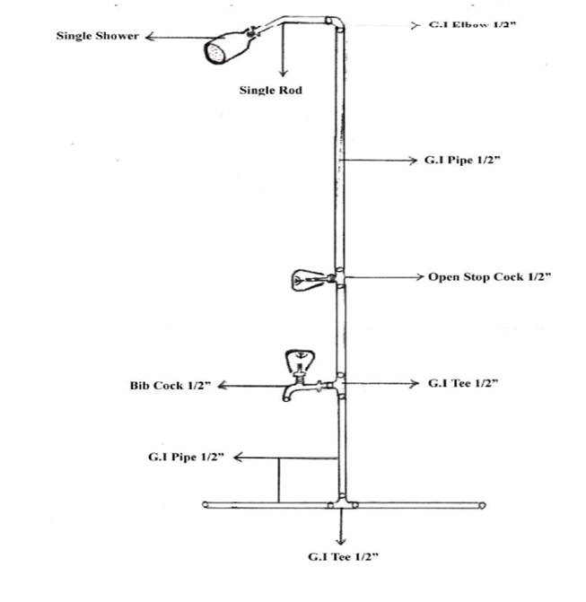
Note: All dimensions will be measure from the Floor level.

Annexure 2:
Installation of wash basin (PPRC or GI Pipe)
- Connection point from floor level: 580 mm
- Dimension between two connection points T-Cock cold & hot: 300 mm c/c.
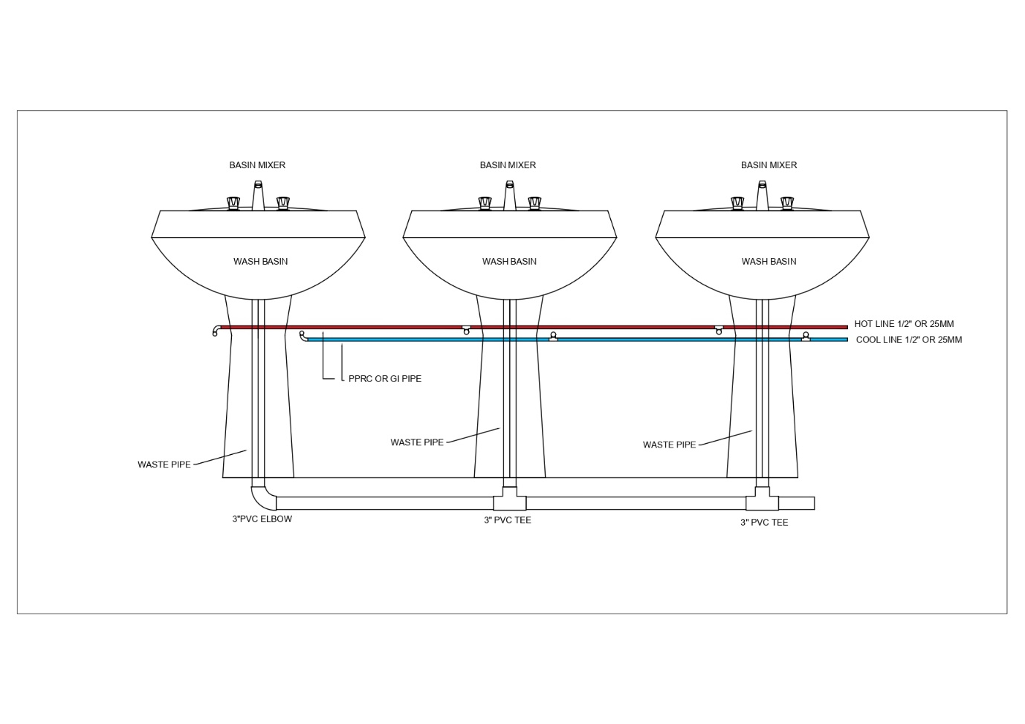
Note: All dimensions will be measure from the Floor level.

