National Competency Standards
“Plumber” Level-2
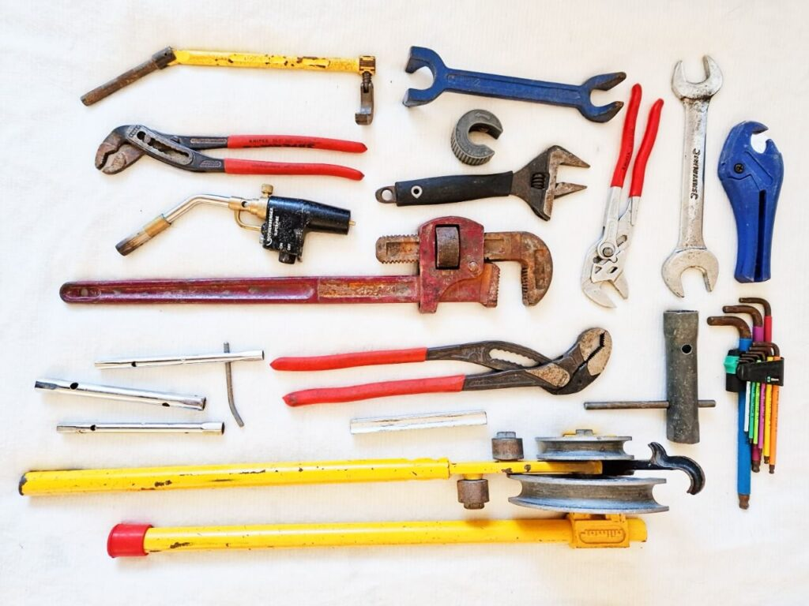
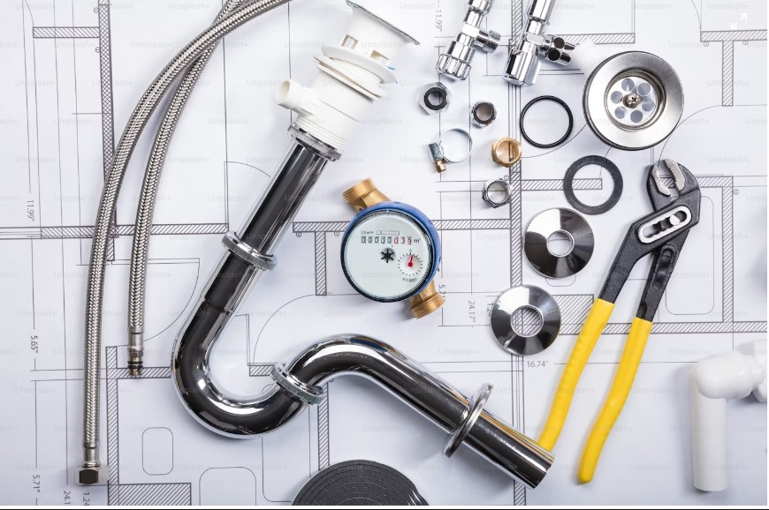

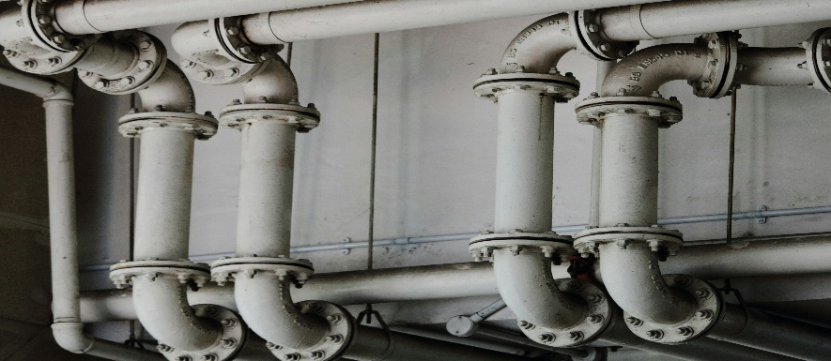

80 Credit Hours

National Vocational and Technical Training Commission (NAVTTC)
Government of Pakistan

Forewords

National Vocational and Technical Training Commission (NAVTTC) extends its gratitude and appreciation to representatives of business, industry, academia, government agencies, provincial TEVTAs, sector skill councils and trade associations who spared time and extended their expertise for the development of National Vocational Qualification for PLUMBER level-2. This work would not have been possible without the technical support of the experts.

It may not be out of place to mention here that all the experts of Industry, Academia and TVET experts of TEVTAs, BTEs and PVTC work diligently for making this qualification worthy and error free for which all credit goes to them. However, NAVTTC accepts the responsibility of all the errors and omissions still prevailing in the Qualification document.

It is also noteworthy that development of Skill Standards is a dynamic and ongoing process, and the developed competency standards needs periodic review and updating owing to the constant technological advancements, development in scientific knowledge, and growing experience of implementation at the grass root level as well as the demand of industry. The NAVTTC, Government of Pakistan will ensure to keep the qualifications abreast with the changing demands of both national and international job markets.

Executive Director (NAVTTC)

Table of Contents

Introduction 4
Purpose of the Qualification 5
Date of Development 5
Date of Validation 5
Date of Review 5
Codes of Qualifications 5
Entry Requirements 5
Summary of Competency Standards and contact hours 6
Members of Qualifications Review Committee 6
Detail of Competency Standards 7
0732BCE1501 Maintain Safety at the Workplace 7
0732BCE1502 Prepare Plumbing Drawing 9
0732BCE1503 Perform Basic Metal Work 10
0732BCE1504 Carry Out Plumbing Job 12
0732BCE1505 Join Pipe & Fittings 14
0732BCE1506 Perform Sanitary Work 17
0732BCE1507 IT Fundamentals 19
List of Tools, Equipment, Machinery & Consumable materials for of 25 Students 21

Introduction

The National Vocational and Technical Training Commission (NAVTTC) recognizes the importance of vocational and technical education in equipping the workforce with the necessary skills and competencies to meet the evolving needs of the industry. In line with its commitment to promoting skill development and enhancing employability, NAVTTC intends to develop competency standards (CS) for the trade of "Plumbing Technology" in Pakistan.
The construction industry, one of the leading industries in Pakistan, the Middle East and other parts of the world, offer a range of prosperous occupational areas, such as plumbing. Plumbers play a vital role in installing, repairing and maintaining pipes, fixtures and other plumbing used for water distribution and wastewater disposal in residential, commercial and industrial buildings. The increased use of solar energy has further added to the demand of Plumbers having the skills to install and maintain solar-thermal water heating systems. Thus, the ever-growing demand of industry has led to the design of this training program as a response to providing appropriate skills.
The development of competency standards for the trade of Plumbing Technology aims to establish a framework that defines the essential knowledge, skills, and attitudes required for individuals to perform effectively in this field. These standards will serve as a benchmark for training providers, employers, and learners, ensuring that the workforce is equipped with the competencies necessary to meet industry requirements and contribute to Pakistan's economic growth.

Green skills incorporation in TVET aims to build capacity of skilled workforce, which is aware of environmental hazards and accordingly adopts more sustainable and environment friendly practices at the workplace. The workforce that possesses competencies and relevant knowledge & understanding oriented to green occupations is more employable and become an asset for businesses, enterprises and communities in developing green economies that results in improved human well-being and reducing environmental risks.

This qualification can create a considerable impact in Plumbing field especially in the following areas:

- Hazardous Materials Handling
- Pipe Installation and Repair
- Fixture Installation
- Smart Plumbing System Design
- Water Conservation

Structural changes will realign sectors that are likely to decline as a result of the greening of the economy and workers will need to be retrained accordingly. The successful transition to a low-carbon economy will only be possible if workers can flexibly adapt and practice to go green as per their industry standards.

Purpose of the Qualification

The Qualifications are in line with the vision of Pakistan’s National Skills Strategy (NSS), National TVET Policy and National Vocational Qualification Framework (NVQF) based on demand of respective employers. This provides policy directions, support and an enabling environment to the public and private sectors to impart training for skills development to enhance social and economic profile. The National Competency Standards could be used as a referral document for the development of curricula and Assessment Packages to be used by training institutions and Qualification Awarding Bodies respectively.

The purpose of the training is to provide the Green skills to the trainees in the field of Plumbing and convert it into value added product, which is acceptable by International market and fit-in a skilled graduate into National Vocational Qualification Framework for his / her vertical career progression and qualification equivalencies at par with acceptable international standards.

Date of Development

The National Competency Standards Level-2 for Plumber has been
Developed by the Qualifications Validation Committee (QVC) members on 27 July, 2024 and will remain valid for three years i.e. 27 July, 2027

Date of Validation

The National Competency Standards Level-2 for Plumber has been validated by
Qualifications Validation Committee (QVC) members on 27 July, 2024 and will remain valid for
three years i.e. 27 July, 2027.

Date of Review

The National Competency Standards Level-2 for Plumber has been validated by the
Qualifications Validation Committee (QVC) members on 27 July, 2024 and shall be reviewed after
three years i.e. 27 July, 2027.

Codes of Qualifications

The International Standard Classification of Education (ISCED) is a framework for assembling, compiling and analyzing cross-nationally comparable statistics on education and training. ISCED codes for these qualifications are assigned as follows:

0732BCE15 | National Vocational Certificate Level 2 in Plumbing Technology

Entry Requirements

The entry level for National Vocational Certificate Plumber Level-2 is primary certificate, Preferably Middle Certificate.

Summary of Competency Standards and contact hours
Competency Standards | NVQF  Level | Category | Estimated Contact Hours |  |  | Cr Hr
Competency Standards | NVQF  Level | Category | Th | Pr | Total | Cr Hr
(0732BCE1501) Maintain Safety at The Workplace | 2 | Functional | 10 | 38 | 48 | 4.8
(0732BCE1502) Prepare Plumbing Drawing | 2 | Technical | 14 | 56 | 70 | 7
(0732BCE1503) Perform Basic Metal Work | 2 | Technical | 22 | 88 | 110 | 11
(0732BCE1504) Carry Out Plumbing Job | 2 | Technical | 24 | 96 | 120 | 12
(0732BCE1505) Join Pipe & Fittings | 2 | Technical | 36 | 144 | 180 | 18
(0732BCE1506) Perform Sanitary Work | 2 | Technical | 42 | 168 | 210 | 21
(0732BCE1507) IT Fundamentals | 2 | Generic | 12 | 50 | 62 | 6.2
Total |  |  | 160 | 640 | 800 | 80

Members of Qualifications Review Committee

The following members participated in the qualification review committee of this qualification held at Lahore:

S# | Name | Designation | Organization
1 | Mr. Ali Sardar | Instructor | Govt. CoE-GTTI Mughalpura,  P-TEVTA, Lahore
2 | Mr. Muhammad Ibrar | Jr. Trade Instructor | GTVC (B) Mardan KP- TEVTA, Peshawar
3 | Mr. Syed Khalid Shah | Instructor | GTTI Gujar Khan
4 | Syed Salman Nasir Ali Shah | DACUM Facilitator | P- TEVTA, Lahore
Conveners
1 | Muhammad Ishaq | Deputy Director | NAVTTC Islamabad
2 | Muhammad Aasim | Deputy Director | NAVTTC Islamabad
3 | Shams Shahbaz | Assistant Director | Operation II, P-TEVTA
4 | Engr Waqas Hashmi | Assistant Director Curriculum | Curriculum, P-TEVTA

Detail of Competency Standards

0732BCE1501 Maintain Safety at the Workplace

Overview

After this Competency Standard, the Trainee will be able to develop skill and competence required to maintain Health and Safety and take remedial measures to deal with the emergencies in a professional manner, thus minimizing the losses and providing a safe and healthy working environment. The learner will also be able to practice green skills and become more environmentally friendly.

Competency Units | Performance Criteria
- Apply personal protective equipment (PPE) | - Arrange required personal protective equipment  - Check functional condition of PPE’s  - Wear personal protective equipment during task  - Store PPE at correct place after use
- Adopt workplace policies and procedures | - Adopt plumbing safety policy  - Adopt company safety procedure  - Advocate worker with company safety policy  - Follow sign board as per standard
- Operate fire extinguisher as Per requirement | - Select the fire extinguisher based on the type and size of the fire  - Apply appropriate fire extinguishing technique such as using the PASS method (Pull, Aim, Squeeze, Sweep) for extinguishing the small fire
- Perform first-aid as per Requirement | - Check expiry of medicines  - Apply first aid treatment against electric shocks  - Apply first aid treatment / bandages against minor injuries.  - Dispose waste and hazardous materials as per set Standards

Knowledge & Understanding:
- Factors affecting Health & Safety in the workplace.
- Personal Protective Equipment (PPE)
- First-Aid-Box.
- Emergency medicines and expiry
- Methods of treatment against electric shock and Burning
- Methods of treatment against minor injuries
- Types and uses of Fire Extinguisher
- Types of work site Hazards.

Critical Evidence(s) Required

The candidate needs to produce following critical evidence(s) in order to be competent in this competency standard:

- Types of hazards that are most likely to cause harm to health and safety
- Health & safety signs and precautions
- Describe fire-fighting methods
- Demonstrate correct use of Fire Extinguisher
- Demonstrate correct use of Personal Protective Equipment (PPE) for the assigned job
- Demonstrate removal and disposal of hazardous material.

Tools and equipment Required for 25 Students

The tools and equipment required for this competency standard are given below:
S.No | Name | QTY. REQUIRED
1 | Apron | 25
2 | Safety shoes | 25
3 | Safety goggles | 25
4 | Hearing protection | 25
5 | Respiratory mask | 25
6 | First Aid Box | 5
7 | Stretcher | 5
8 | Fire Buckets | 4
9 | Fire Extinguisher | 8
10 | Emergency Alarm/Bell | 5
11 | Exhaust Fan | 5
12 | Safety Helmet | 25
13 | Safety Harness | 12
14 | Ear muffs | 25

List of Consumables for 25 Students
SR.NO | NAME | QTY. REQUIRED
Not Required

0732BCE1502 Prepare Plumbing Drawing

Overview:
After this Competency Standard, the Trainee will be able to Draw plumbing symbols, Understand Plumbing Systems, interpret drawing and Create Plumbing Layout Plans. Interpret Plumbing Documents. Also be able to Apply Plumbing Standards and Codes. Coordinate with Other Disciplines

Competency Units | Performance Criteria
- Draw plumbing symbols as per given instructions | - Draw Pipelines and fitting Symbols  - Draw Valve Symbols  - Draw Fixture Symbols
CU2. Draw basic plumbing sketches related to task | - Draw Piping Layout  - Draw Fittings and symbols on layout  - Apply Color Codes according to plumbing Standards
Knowledge & Understanding:
- Kind of lines
- Importance of Pipe Symbols.
- Line diagram of hot & cold water line
- Plumbing Standards and Codes

Critical Evidence(s) Required
The candidate needs to produce following critical evidence(s) in order to be competent in this competency standard:
- Draw Plumbing Sketches
- Draw Plumbing Symbols
- Enlist Plumbing Standards and Codes

Tools and equipment Required for 25 Students
The tools and equipment required for this competency standard are given below:
SR. NO | NAME | QTY. REQUIRED
1 | Drawing Boards | 25
2 | Set Square | 25
3 | Steel Foot rule | 25
List of Consumables for 25 Students
SR.NO | NAME | QTY. REQUIRED
1 | Drawing Sheets | 100 Nos
2 | Lead Pencils | 50 Nos
3 | Rubber | 25 Nos
4 | Sharpener | 25 Nos
5 | Markers | 50 Nos

0732BCE1503 Perform Basic Metal Work

Overview:

After this Competency Standard, the Trainee will be able to perform basic metal work. Measuring of different metals, marking on working area. Define and perform filling, Sawing, Reaming, Counter Sinking and Boring.

Competency Units | Performance Criteria
CU1. Perform Measuring & marking on Job according to drawing | - Measure given job as per instruction  - Mark given job as per Measurement  - Perform Center punching as per Marking
CU2. Perform Filling & Chipping as per given Drawing | - Perform Filling on given job as per instruction  - Perform chipping on given job as per instruction  - Perform Riveting according to requirement
CU3. Perform Sawing As per given Task | - Measure given job as per instruction  - Saw job as per requirements
CU4. Perform Drilling and Reaming as per instruction | P1. Create a circular hole in Metal as per specification.  P2. Perform Reaming on pipe as per specification.
CU5. Perform Counter sinking & Boring as per given drawing | P1. Create a tapered surface of a hole as per instruction.  P2. Perform Boring as per specification.

Knowledge & Understanding
- Measuring, Marking of working area
- Filling and Chipping Operations
- Sawing Operations
- Drill and Reaming Operations
- Counter Sinking and Boring Operations

Critical Evidence(s) Required
The candidate needs to produce following critical evidence(s) in order to be competent in this competency standard:
- Measure, Mark working area as per given requirement
- Perform Filling and Chipping Operations
- Perform Sawing Operations
- Perform Drill and Reaming Operations
- Carry out Counter Sinking and Boring Operations

Tools and equipment Required for 25 Students

The tools and equipment required for this competency standard are given below:
SR. NO | NAME | QTY. REQUIRED
1 | Measuring Tape | 25
2 | Drill Machine (Pedestal) | 01
3 | Hand Drill Machin Electric | 05
4 | Hammer 250 g | 15
5 | Hammer 500 g | 15
6 | Hand Hacksaw frame | 15
7 | Flat file 300 mm | 25
8 | Round file | 25
9 | Drill 4mm, 6mm, 8mm, | 5 each
10 | Oil can | 10
11 | Scriber | 10

List of Consumables for 25 Students

SR.NO | NAME | QTY. REQUIRED
1 | G.I Pipe ½” | 80 feet
2 | MS Chanel Bar | 25 Kg
3 | Mobil Oil | 5 Liter
4 | Hack Saw Blade | 3 Dozen
5 | MS sheet 12” x 12” | 5 Nos

0732BCE1504 Carry Out Plumbing Job

Overview:

After this Competency Standard, the Trainee will be able to perform various plumbing tasks efficiently, including installation, maintenance, and repair of plumbing systems and components. Accurately read and interpret plumbing blueprints and schematics to guide the installation and repair processes. Utilize a range of plumbing tools and equipment effectively and safely to complete plumbing jobs. Keep the work area clean and organized, following best practices for safety and efficiency throughout the plumbing job.

Competency Units | Performance Criteria
CU1. Measure & mark Job according to Instructions | - Identify working area as per requirement  - Select correct Measuring and Marking tool  - Measure designated area  - Mark according to instructions
CU2. Cut Material as per the given instructions | - Choose correct cutting tools as per requirement.  - Cut Pipe as per specification.  - Keep steady and make precise cutting
CU3. Cut Threads on the pipe as per specification | - Choose correct threading tools as per requirement.  - Make Threads on Pipe as per Specifications
CU4. Apply Correct fitting tool according to the job | - Select right tool according to fitting type and material  - Apply specific tool as per given task.  - Use tool properly following best practices and safety guidelines.
Knowledge & Understanding

- Measuring Techniques
- Marking Techniques
- Interpret Plumbing Diagrams & Layouts
- Troubleshooting and Problem-Solving
- Safety Standards and Regulations
- Properties of Different Plumbing Materials

Critical Evidence(s) Required
The candidate needs to produce following critical evidence(s) in order to be competent in this competency standard:
- Measure & Mark as per given Instructions
- Cut material as per instruction
- Cut Threads on pipes as per requirement

Tools and equipment required for 25 Students

The tools and equipment required for this competency standard are given below:
SR. NO | NAME | QTY. REQUIRED
1 | Measuring Tape | 25
2 | Centre Punch | 25
3 | Line Scriber | 25
4 | Steel Foot rule | 25
5 | Threading Die ½” to 1 ¼” | 10
6 | Inside and outside Caliper | 25
7 | Pipe Wrench 12” | 12 each
8 | Adjustable wrench 10”, 12” | 12 each
9 | Grip Plier | 12 each
10 | Bench vice | 10
11 | Pipe Vice | 12
12 | Oil Can | 12
13 | Wire Brush | 15
14 | Reamer | 12
15 | Hammer 500g | 15
16 | Chesil | 12
17 | Water Level | 12
18 | Flat file | 25
19 | Round File | 25
20 | Half Round File | 25
21 | Hand Hacksaw | 25

List of Consumables for 25 Students

SR.NO | NAME | QTY. REQUIRED
1 | G.I Pipe ½” | 80 feet
2 | Mobil Oil | 5 Liter
3 | Hack Saw Blade | 3 Dozen
4 | Elbow ½” | 15Nos
5 | Tee ½” | 15Nos
6 | Socket ½” | 15Nos
7 | Marker | 5Nos

0732BCE1505 Join Pipe & Fittings

Overview:

After this Competency Standard, the Trainee will be able to define various pipe types, including metal, non-metal, and composite, and their respective uses. Explain the differences in pipe sizes and dimensions, as well as the methods used to connect them. Identify different fittings such as elbows, tees, reducers, couplings, and unions, and their specific purposes. Understand the materials and connection methods used for fittings. Apply knowledge of pipes and fittings to plumbing scenarios in residential, commercial, and industrial scenario recognize the significance of selecting suitable materials and fittings for different environmental conditions and pressures.

Competency Units | Performance Criteria
CU1. Install pipes, fittings & valves as per given drawing | - Interpret drawing, layout, dimensions, types of fittings and valves required  - Select Correct Materials according to drawing  - Perform Marking and Measuring  - Perform Cutting to prepare Pipes according to drawing  - Join Fittings and apply Thread Sealant to prevent leaks.  - Install valves at designated points.
CU2. Perform pipe cutting & threading as per requirement | - Measure & Mark Pipe as per requirement  - Cut Pipe as per requirement  - Choose the correct threading tools as per requirement.  - Make Threads on Pipe as per Specifications
CU3. Connect pipes & fittings according to drawing. | - Interpret drawing, layout, dimensions, types of fittings and valves required  - Select Pipe and fittings as per Drawing  - Perform Cutting and Threading on Pipe according to layout.  - Connect Fittings and pipes as per drawing
CU4. Install cold & hot water pipelines according to drawing | - Review the Drawing  - Select Materials such as pipe, fittings  - Make route for both cold and hot water pipelines  - Prepare Work Area as per job  - Cut pipe and Assemble Fittings according to drawing  - Install Valves and Fixtures as per requirement  - Support and Secure Pipelines as per set standards
CU5. Perform house water connection as per given requirements | - Identify location of main water line  - Select correct tools and equipment for required job  - Install Main Pipe line according to drawing

Knowledge & Understanding:
- Types of Pipes.
- Types of Fitting
- Types of Valves
- Types of Threads.
- Types of Threading Dies
- Methods of Pipe joining
- Methods of treatment against minor injuries

Critical Evidence(s) Required

The candidate needs to produce following critical evidence(s) in order to be competent in this competency standard:

- Install pipes, fittings & valves
- Describe Techniques and methods to join pipes and fitting
- Demonstrate Threading and their uses
- Demonstrate use of Valves
- Demonstrate use of correct tool for the assigned job.

Tools and equipment Required for 25 Candidates

The tools and equipment required for this competency standard are given below:
SR. NO | NAME | QTY. REQUIRED
1 | Measuring Tape | 25
2 | Scriber | 25
3 | Hand Hacksaw | 25
4 | Pipe Wrench 12”, 14”, 18 “ | 25 each
5 | Adjustable Wrench | 25
6 | Plier | 25
7 | Pipe Cutter | 12
8 | Pipe Reamer | 25
9 | Pipe Threading / Ratchet die Die (1/2” to 1 ¼”) | 12
10 | Pipe Vice | 08
11 | Bench Vice | 12
12 | Aluminum Level | 12
13 | PPRC Cutter | 12
14 | PPRC Heater | 15
15 | Oil can metal | 15

List of Consumables for 25 Students
SR.NO | NAME | QTY. REQUIRED
 | G.I Pipe ½”, ¾” | 100 feet each
 | Thread roll | 10 Pkt
 | Valves ½” all types | 10 each
 | PPRC Pipe 25 mm , 32 mm | 120 ft
 | Teflon Tape / Thread Tape | 100 Nos Each
 | Pipe Clamps | 25 Nos
 | G.I Elbow | 50 no’s
 | G.I Tee | 25 Nos
 | G.I Union | 25 Nos
 | G.I Socket | 25 Nos
 | G.I Reducers | 25 Nos
 | G.I Bend | 25 Nos
 | Mobil Oil | 5 Liter
 | Hack Saw Blade | 3 Dozen
 | Elbow ppr 25,32mm | 25 Nos
 | Union ppr 25.32mm | 25 Nos
 | Cross bend ppr 25.32mm | 25 Nos
 | Tee ppr 25,32mm | 25 Nos
 | Socket ppr 25,32mm | 25 Nos

0732BCE1506 Perform Sanitary Work

Overview:

After this Competency Standard, the Trainee will be able to define and install various WC like Asian and European and their Accessories maintenance. Explain the differences between Bottle trap and waste pipe as well as the methods used to connect them. Identify different Sinks and Cocks and their specific purposes. Understand the materials and connection methods used for fittings.

Competency Units | Performance Criteria
CU1. Excavate according to plan | - Survey and Mark designated area  - Select correct Excavation Equipment  - Perform Excavation according to mark.
CU2. Mark out installation points for fixtures | - Prepare the Area as per job  - Mark Horizontal and Vertical Lines  - Install Fixtures according to drawing.
CU3. Install wash basin & wall shower according to plan | - Select correct Tools and Materials  - Prepare Installation Area  - Install Faucet as per Requirement  - Attach Drain as per specification  - Mount Wash Basin according to drawing  - Install the Shower Arm and Shower Head as per specification  - Connect Water Supply Lines according to drawing
CU4. Install WC (Asian & European) according to given drawing | - Prepare Area according to drawing  - Set WC Position according to drawing  - Check WC Level according to set standards  - Install the Toilet Seat according to drawing  - Install Valves and Fixtures as per specification  - Connect the Water Supply Lines according to drawing
CU5. Install sink & water filter as per given plan | - Prepare Area according to drawing  - Set Sink Position and Check Level according to drawing  - Install the Filter according to drawing  - Install Valves and Fixtures as per specification  - Connect the Water Supply Lines according to drawing
Knowledge & Understanding:
- Understand Parts of WC (Asian).
- Understand Parts of WC (European).
- Understand Types of Valves and Cocks
- Understand Types of Faucets.
- Understand Types of Sink and Filters.

Critical Evidence(s) Required

The candidate needs to produce following critical evidence(s) in order to be competent in this competency standard:
- Install Faucets according to drawing
- Install WC Asia and European
- Install Sink ad water filter
- Install Wash Basin

Tools and equipment required for 25 Students

The tools and equipment required for this competency standard are given below:
SR. NO | NAME | QTY. REQUIRED
1 | Measuring Tape | 25
2 | Scriber | 12
3 | Hand Hacksaw | 3 Dozen
4 | Pipe Wrench 12”, 14”, 18 “ | 25 Nos
5 | Adjustable Wrench | 15 Nos
6 | WC Asian | 05 Nos
7 | WC European | 05 Nos
8 | Sink | 05 Nos
9 | Trapes | 12 Nos
10 | Wash Basin Complete Set with Accessories | 05 Nos
11 | Screw Driver plan | 05 set
12 | Screw Driver Philips | 05 set

List of Consumables for 25 Students

SR.NO | NAME | QTY. REQUIRED
1 | Stop Cocks | 25 Nos
2 | Rubber connection pipe | 50 Nos
3 | Wash Basin Bolt Kit | 10 set
4 | Basin Mixture / Piler Cocks | 06 Nos
5 | Sink Mixer | 06 Nos
6 | Bottle Traps | 06 Nos
7 | Waste Coupling and pipe for Basin | 06 Nos
8 | Waste Coupling and pipe for Sink | 06 Nos
9 | Rawal plug | 05 pkt
10 | Rawal bolt | 05 pkt
11 | Bolt kit | 05 pkt

0732BCE1507 IT Fundamentals

Overview:

After this Competency Standard, the Trainee will be able to Communicate with customers with basic policies and procedures as per SOPs of Plumbing. Define computer applications Navigate Operating Systems. Operate Computer Application Define Internet and email.

Competency Units | Performance Criteria
- Communicate basic policies & procedures as per SOPs | - Apply 7-Cs of Communications  - Adopt SOPs Need to Communicate
CU2. Perform computer operations as per the given instructions | - Operate computer Applications  - Manage Printers and Devices  - Save files as per requirement
CU3. Perform e-mail & internet surfing operations as per given instructions | - Write and send Email as per requirement  - Browse internet according to requirement

Knowledge & Understanding:
- Communicating basic policies and procedures as per Standard Operating Procedures
- Navigate Operating Systems
- Basic Computer Operations

Critical Evidence(s) Required

The candidate needs to produce following critical evidence(s) in order to be competent in this competency standard:

- Apply 7-Cs of Communication
- Perform Computer operations according to given instructions
- Perform E-mail & internet surfing as per requirement

Tools and equipment Required for 25 Students

The tools and equipment required for this competency standard are given below:

SR. NO | NAME | QTY. REQUIRED
1 | Computers | 26
2 | Printer | 02
3 | Scanner | 02
4 | Internet Device | 01
5 | Multimedia Projector | 01

List of Consumables for 25 Students

SR.NO | NAME | QTY. REQUIRED
1 | Paper A4 | 02 Rim
2 | Marker | 04 Nos
3 | Duster | 04 Nos
4 | Ball points | 02 Pkt

Tools, Equipment, Machinery for of 25 Students
Plumber L-2
Sr. No | Name of Item | Quantity | Unit
1 | Adjustable wrench 8” to 18” | 25 | No's
2 | Bench vice | 10 | No's
3 | Pipe Wrench Set | 25 | No's
4 | Chisel set 12 " | 10 | Set
5 | Files | 25 | No's Each
6 | Hacksaw frame | 25 | No's
7 | Hammer | 15 | Sets
8 | Screw driver set | 10 | Sets
9 | Double Ring Spanner set | 10 | Sets
10 | Tools box | 25 | No's
11 | Pipe vice with stand | 12 | No's
12 | Measuring tape | 25 | No's
13 | Pipe Cutter (for GI Pipes) | 10 | No's
14 | Pipe vice | 08 | No's
15 | Center Punch | 15 | No's
16 | Plier set | 12 | No's
17 | Oil Can | 08 | No's
18 | Wire Brush | 12 | No's
19 | Pipe Reamer | 12 | No's
20 | PPRC cutter | 10 | No's
21 | Level Indicator | 10 | No's
22 | Steel scale | 25 | No's
23 | Hand bit | 5 | Sets
24 | Grip plier | 10 | No's
25 | Die (Ratchet) Set | 10 | No's
26 | First Aid box | 10 | No's
27 | Safety Men Work Gloves | 25 | No's
28 | Safety Goggles | 25 | No's
29 | Safety Shoes | 25 | No's
30 | Safety Ear muffs | 25 | No's
31 | Safety Helmet | 25 | No's
32 | Hand Electric Drill machine (hammering) | 05 | No's
33 | Electric Wall Cutter | 05 | No's
34 | PPRC Heater | 10 | No's
35 | Electric Grinder (Pedestal) | 01 | No's
36 | Pipe Bender Machine | 05 | No's
37 | Computers | 26 | No's
38 | Printer | 2 | No's
39 | Scanner | 2 | No's
40 | Internet Device | 1 | No's
41 | Multimedia Projector | 1 | No's
42 | Printer | 05 | No's

Consumable Material
Plumber Level 2
Sr. No | Name of Item | Quantity | Unit
1 | Pipe G.I 1/2", 3/4" | 100, 50 | Lengths
2 | Fittings .I (Elbow, Tee, Socket, Reducer, Cross over, Union, Cross-Tee etc)1/2" | 100 | Nos Each
3 | Valves Brass Safety valve, Handle Valve, Gate Valve, Ferule Valve, Non-retune Valve1/2" | 100 | Nos
4 | Pipe PPRC 25 mm, 32 mm | 500 | Lengths
5 | Fittings  PPRC (Elbow, Tee, Socket, Reducer, Cross over, Union, Cross-Tee etc) 25 mm | 150 | No's
6 | Hack Saw Blade | 72 | No's
7 | Pipe Hooks | 50 | No's
8 | G.I. Pipe flanges | 10 | No's
9 | Tee Stop Cock | 50 | No's
10 | Tap 1/2” | 50 | No's
11 | Traps | 10 | No's
12 | Shower set | 10 | No's
13 | Hand Shower | 10 | No's
14 | Wash Hand Basin with Pedestal (medium size) | 05 | No's
15 | Sink | 05 | No's
16 | WC (Asian) | 05 | No's
17 | WC (English) | 05 | No's
18 | Urinal | 05 | No's
19 | Thread chaser | 06 | Sets
20 | Mobil oil | 30 | Liter

