National Curriculums for
Plumber Level-2

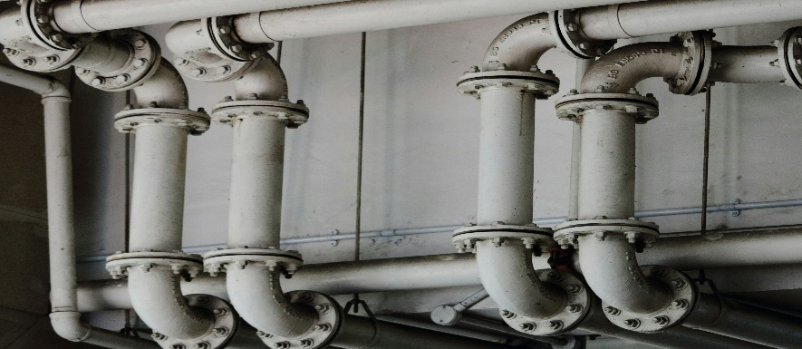
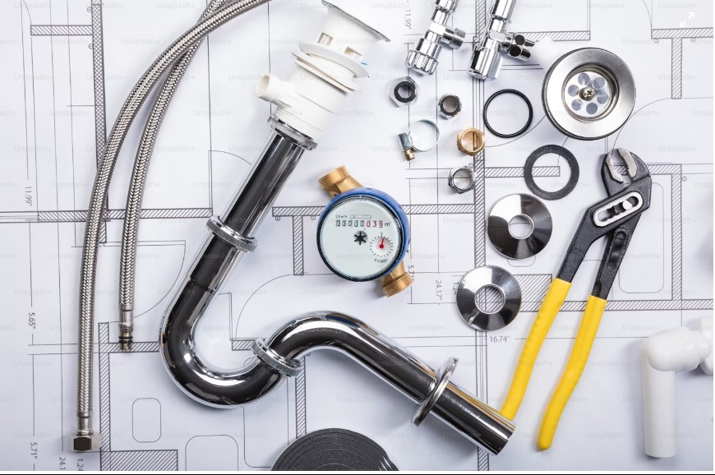
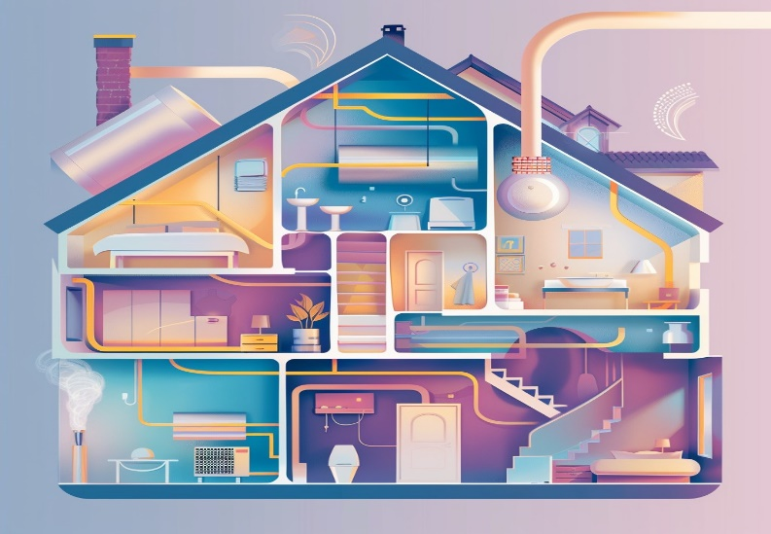
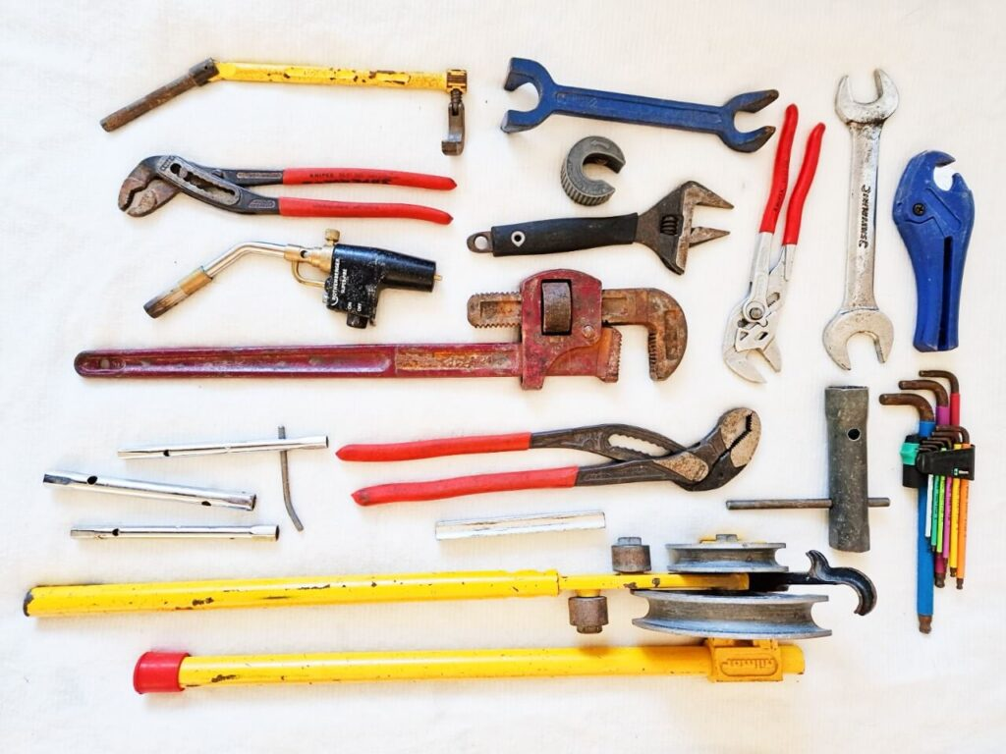

80 Credit Hours

National Vocational and Technical Training Commission (NAVTTC)
Government of Pakistan
FOREWORDS

National Vocational and Technical Training Commission (NAVTTC) extends its gratitude and appreciation to representatives of business, industry, academia, government agencies, provincial TEVTAs, sector skill councils and trade associations who spared time and extended their expertise for the development of National Vocational Qualification for Plumber LEVEL-2. This work would not have been possible without the technical support of the experts.

It may not be out of place to mention here that all the experts of Industry, Academia and TVET experts of TEVTAs, BTEs and PVTC work diligently for making this qualification worthy and error free for which all credit goes to them. However, NAVTTC accepts the responsibility of all the errors and omissions still prevailing in the Qualification document.

It is also noteworthy that development of Skill Standards is a dynamic and ongoing process, and the developed competency standards needs periodic review and updating owing to the constant technological advancements, development in scientific knowledge, and growing experience of implementation at the grass root level as well as the demand of industry. The NAVTTC, Government of Pakistan will ensure to keep the qualifications abreast with the changing demands of both national and international job markets.

Executive Director (NAVTTC)
TABLE OF CONTENTS

1 Introduction 04
2 Purpose of the Qualification 05
3 Overall objectivesof training course 05
4 Competenciesto be gained after completion of course 06
5 Job oppertunities available immedietly and in the future 06
6 Trainee entry level 06
7 Minimum Qualification of Trainer 06
8 Recomended Trainer Trainee Ratio 07
9 Medium of Instruction 07
- Curriculum Development Committee 07
- Duration of the course (total time, theory & practical) 08
Module 01 0732BCE1501 Maintain Safety at the Workplace 09
Module 02 0732BCE1502 Prepare Plumbing Drawing 15
Module 03 0732BCE1503 Perform Basic Metal Work 18
Module 04 0732BCE1504 Carry Out Plumbing Job 22
Module 05 0732BCE1505 Join Pipe & Fittings 27
Module 06 0732BCE1506 Perform Sanitary Work 35
Module 07 0732BCE1507 IT Fundamentals 42

- Introduction

The National Vocational and Technical Training Commission (NAVTTC) recognizes the importance of vocational and technical education in equipping the workforce with the necessary skills and competencies to meet the evolving needs of the industry. In line with its commitment to promoting skill development and enhancing employability, NAVTTC intends to develop competency standards (CS) for the trade of "Plumbing" in Pakistan.
The construction industry, one of the leading industries in Pakistan, the Middle East and other parts of the world, offer a range of prosperous occupational areas, such as plumbing. Plumbers play a vital role in installing, repairing and maintaining pipes, fixtures and other plumbing used for water distribution and wastewater disposal in residential, commercial and industrial buildings. The increased use of solar energy has further added to the demand of Plumbers having the skills to install and maintain solar-thermal water heating systems. Thus, the ever-growing demand of industry has led to the design of this training program as a response to providing appropriate skills.
The development of competency standards for the trade of Plumbing Technology aims to establish a framework that defines the essential knowledge, skills, and attitudes required for individuals to perform effectively in this field. These standards will serve as a benchmark for training providers, employers, and learners, ensuring that the workforce is equipped with the competencies necessary to meet industry requirements and contribute to Pakistan's economic growth.

Green skills incorporation in TVET aims to build capacity of skilled workforce, which is aware of environmental hazards and accordingly adopts more sustainable and environment friendly practices at the workplace. The workforce that possesses competencies and relevant knowledge & understanding oriented to green occupations is more employable and become an asset for businesses, enterprises and communities in developing green economies that results in improved human well-being and reducing environmental risks.

This qualification can create a considerable impact in Plumbing field especially in the following areas:

- Hazardous Materials Handling
- Pipe Installation and Repair
- Fixture Installation
- Smart Plumbing System Design
- Water Conservation

Structural changes will realign sectors that are likely to decline as a result of the greening of the economy and workers will need to be retrained accordingly. The successful transition to a low-carbon economy will only be possible if workers can flexibly adapt and practice to go green as per their industry standards.

Purpose of the Qualification

The Qualifications are in line with the vision of Pakistan’s National Skills Strategy (NSS), National TVET Policy and National Vocational Qualification Framework (NVQF) based on demand of respective employers. This provides policy directions, support and an enabling environment to the public and private sectors to impart training for skills development to enhance social and economic profile. The National Competency Standards could be used as a referral document for the development of curricula and Assessment Packages to be used by training institutions and Qualification Awarding Bodies respectively.
The purpose of the training is to provide the Green skills to the trainees in the field of Plumbing and convert it into value added product, which is acceptable by International market and fit-in a skilled graduate into National Vocational Qualification Framework for his / her vertical career progression and qualification equivalencies at par with acceptable international standards

Overall objectives of the training course
The primary objective of this training program is to provide the trainees with up-to-date knowledge and skills required by the construction sector with special reference to Plumbing in a comprehensive way to cope with the challenges of the construction Industry (building painting). After qualifying for the course at different levels the trainees will be able to get job in construction Industry (supervision) and able to perform as entrepreneurs. The contents of the course are specifically designed in such a way that it covers all the major areas of architect supervisor in construction sector of Pakistan.
The overall objectives of developing this qualification are to:
- Improve the overall quality of training delivery and set national benchmarks for training of Plumbing Supervisor in the country
- Provide flexible and progressive learning opportunities for trainees to receive relevant and up-to-date skills in the construction industry
- Provide basis for competency-based assessment which is recognized and accepted by employers in modern days
- Establish standardized and sustainable training in consultation with the construction industry.

Competencies to be gained after completion of course
After completing this course, the trainee will be capable of performing different activities in construction industry especially supervision effectively. Furthermore, this skilled training program enables the trainee to develop multispectral competencies such as creative thinking, problem solving, research skills, personal and group management, presentation and communication skills, technical and professional negotiations related to construction industry. The below listed competencies imprinted by this training program are quite prominent to the trainees’ profile to enhance their employability in their career in construction industry:
- Knowledge and concepts of supervision and management in the construction industry
- Creative thinking and troubleshooting skills in the construction industry
- Potential to translate theoretical knowledge into practice
- Identify and explore potential areas of opportunities in construction industry
- Develop strategies to maintain the quality and safety of the workplace
- Time management, working in teams and conflict handling among co-workers
- Safe and secure use of workplace tools, techniques and materials at worksites
- Digital documentation and effective communication skills
- Working on commercial setups and meeting the timelines

5.Job opportunities available immediately and in the future
The successful pass out of this course may avail entrepreneurial opportunities and/ or fetch job/ employment in construction sectors as Plumber skill worker / Technician plumber (Level-II)

6.Trainee entry level
The entry level for National Vocational Certificate Level 2 in Plumber Technology is Primary certificate Preferable Middle.

7.Minimum qualification of trainer
BE / B-Tech (Civil)/ G-II with 3 years of Relevant experience

8.Recommended trainer trainee ratio
The recommended trainer and trainee ratio per class is 1:25

Medium of instruction
Urdu, English or Local Language

Curriculum development committee
The following members participated in the Curriculum development workshop from 29 Nov to 03 Dec 2021, in Lahore:
Sr. No | Name | Designation &Organization
P -TEVTA
 | MR. ALI SARDAR | INSTRUCTOR (PLUMBER)  GOVERNMENT COE-GTTI MUGHALPURA LAHORE (PUNJAB-TEVTA)
 | Mr. FAKHR UL ISLAM | INSTRUCTOR (PLUMBER)  GOVERNMENT ATC TOWNSHIP LAHORE (PUNJAB-TEVTA)
 | MR. SYED KHALID SHAH | INSTRUCTOR (PLUMBER)  GTTI GUJAR KKHAN (PUNJAB-TEVTA)
 | MR. SYED SALMAN NASIR ALI SHAH | DACUM FACILITATOR  PUNJAB-TEVTA
 | MR. ENGR. WAQAS HASHMI | ASSISTANT DIRECTOR CURRICULUM  PUNJAB-TEVTA
 | MR. SHAMS SHABAZ | ASSISTANT DIRECTOR OPERATION II P-TEVTA
B - TEVTA
1 | MR. NOOR SHAH | INSTRUCTOR PLUMBER GTTC QUETTA TEVTA BALOCHISTAN
2 | MR. MALIK ALI AHMED | INSTRUCTOR PLUMBER GTTC QUETTA TEVTA BALOCHISTAN
KP -TEVTA
1 | MR. NOMAN SHAH | INSTRUCTOR (PLUMBER)  GTVC(B) PESHAWER KP TEVTA

Duration of the course (total time, theory & practical)
Module. | Competency Standard | Theory Hours | Practical Hours | Total Contact Hours | Credit Hours
Module 01 | (0732BCE1501) Maintain Safety at The Workplace | 10 | 38 | 48 | 4.8
Module 02 | (0732BCE1502) Prepare Plumbing Drawing | 14 | 56 | 70 | 7
Module 03 | (0732BCE1503) Perform Basic Metal Work | 22 | 88 | 110 | 11
Module 04 | (0732BCE1504) Carry Out Plumbing Job | 24 | 96 | 120 | 12
Module 05 | (0732BCE1505) Join Pipe & Fittings | 36 | 144 | 180 | 18
Module 06 | (0732BCE1506) Perform Sanitary Work | 42 | 168 | 210 | 21
Module 07 | (0732BCE1507) IT Fundamentals | 12 | 50 | 62 | 6.2
 | Total | 160 | 640 | 800 | 180

0732BCE1501 Maintain Safety at the Workplace

Overview
After this Competency Standard, the Trainee will be able to develop skill and competence required to maintain Health and Safety and take remedial measures to deal with the emergencies in a professional manner, thus minimizing the losses and providing a safe and healthy working environment. The learner will also be able to practice green skills and become more environmental friendly.

Total Duration: 48 Hours Theory: 10 Hours Practice: 38 Hours

Learning Unit | Learning Outcomes | Learning Elements | Duration | Materials  Required | Learning  Place
LU1  Apply personal protective equipment (PPE)  LU2  Adopt workplace policies and procedures  LU3  Operate fire extinguisher as Per requirement  LU 4  Perform first-aid as per Requirement | Trainee will be able to:  - Arrange required personal protective equipment  - Check functional condition of PPE’s  - Wear personal protective equipment during task.  - Store PPE at correct place after use  - Adopt plumbing safety policy  - Adopt company safety procedure  - Advocate worker with company safety policy  - Follow sign board as per standard  - Select the fire extinguisher based on the type and size of the fire.  - Apply appropriate fire extinguishing technique such as using the PASS method (Pull, Aim, Squeeze, Sweep) for extinguishing the small fire  - Check expiry of medicines  - Apply first aid treatment against electric shocks  - Apply first aid treatment / bandages against minor injuries.  - Dispose waste and hazardous materials as per set Standards  - Dispose waste and hazardous materials as per set Standards | - Personal Protective Equipment (PPE)  - Types of work site Hazards.  - use of Personal Protective Equipment (PPE  - Details of suitable PPEs  - Types of PPEs  - State about storage of PPEs after use  ACTIVITY  - Practical Demonstration of PPEs  - Plumbing Safety Policy  - Step Down types of safety Policy  - Company safety procedure  - Purpose of company safety procedure  - Advocate worker with company safety policy  - Responsibilities management  - Importance of training in company safety policy  - Sign board standard  - Types of sign board  - Ensure Multilingual support  - Advantages of sign board  ACTIVITY  - Practical Demonstration of PPEs  - Explain Classes of Fire  - Describe fire-fighting methods  - Demonstrate correct use of Fire Extinguisher  - Advantages of fire extinguisher  - What are fire extinguisher  - Explain Fire Extinguisher Sizes  - Fire extinguisher  - Method of fire  - Extinguishing  - Fire Extinguishing Techniques:  ACTIVITY  - Demonstrate of putting out of fire with the use of fire extinguisher  - Define the Medicine Expiry Checklist:  - Verify the date of expiry medicines  - Check the format of medicines  - Explain the disadvantages of expired medicines  - Define the Methods of treatment against electric shock and Burning  - Explain the Methods of treatment against minor injuries.  - Explain Types of hazards  - Define hazardous  Material.  - What are the Best Practices of dispose waste and hazardous  ACTIVITY  - Practice of CPR  - Demonstration of the bandage | Theory 03 Hrs.  Practical Hrs.09  Total- 12 Hrs.  .  Theory 03 Hrs.  Practical Hrs.09  Total- 12 Hrs.  Theory 02 Hrs.  Practical Hrs.12  Theory 03 Hrs.  Practical Hrs.09  Total- 12 Hrs. | White Board  Marker  Duster  Multi Media Projector  Helmet  Safety glasses  Goggles  Face shields  Earplugs  White Board  Marker  Duster  Multi Media Projector  Helmet  Safety glasses  Goggles  Face shields  Earplugs  White Board  Marker  Duster  Multi Media Projector  Fire extinguisher  Fire simulator or training equipment  Fuel sources  Personal protective equipment  Gloves  Safety glasses  Face mask  White Board  Marker  Duster  Multi Media Projector  Fire-resistant clothing  Gloves (for handling expired medicines)  Mannequin or dummy  First aid kit  CPR equipment (if available)  Burn gel or simulated burn wounds  Scenario cards (optional | Class Room  Work Shop  Class Room  Work Shop  Class Room  Work shop  Class Room  Work shop

0732BCE1502 Prepare Plumbing Drawing
Overview:
After this Competency Standard, the Trainee will be able to Draw plumbing symbols, Understand Plumbing Systems, Interpret drawing and Create Plumbing Layout Plans. Interpret Plumbing Documents. Also be able to Apply Plumbing Standards and Codes.

Total Duration: 70 Hours Theory: 14 Hours Practice: 56 Hours

Learning Unit | Learning Outcomes | Learning Elements | Duration | Materials  Required | Learning  Place
LU 1  Draw plumbing symbols as per given instructions  LU2  Draw basic plumbing sketches related to task | Trainee will be able to:  - Draw Pipelines and fitting Symbols  - Draw Valve Symbols  - Draw Fixture Symbols  - Draw Piping Layout  - Draw Fittings and symbols on layout  - Apply Color Codes according to plumbing Standards | - Pipe Line/ Draw  - symbols of pipe line  - Type of Pipe line  - Symbols  - Symbol of ball valve  - Symbol of Gate Valve  - Symbol of Globe Valve  - Symbol of Check Valve  - Symbol of Sink  - Symbol of W/C  - Symbol of English commode  - Symbol of shower  - Symbol of urinal  - Symbol of Flash tank  ACTIVITY  - Draw on Drawing sheet all symbols of pipeline, valves, fixture etc.  - Layout of piping  - Purpose of piping layout  - Purpose the base line  - Key components  - Fittings symbol  - Basic symbol  - Color codes  - Plumbing symbols  - Purpose of color codes on pipe line  ACTIVITY  - Draw layout of pipe lines  - Color pipe lines according to their purpose  - Sketch down complete layout of pipelines and fittings on drawing sheet. | Theory. 08 Hrs.  Practical Hrs.27  Total- 35 Hrs.  Theory 08 Hrs.  Practical Hrs.27  Total- 35 Hrs. | White Board  Marker  Multimedia  Projector  Pencil  Sharpener  Sheet  Try square  Pencil  Sharpener  Sheet  Try square | Class Room  Work Shop  Class Room  Work Shop

0732BCE1503 Perform Basic Metal Work
Overview:
After this Competency Standard, the Trainee will be able to perform basic metal work. Measuring of different metals, marking on working area. Define and perform filling, Sawing, Reaming, Counter Sinking and Boring.

Total Duration: 110 Hours Theory: 22 Hours Practice: 88 Hours

Learning Unit | Learning Outcomes | Learning Elements | Duration | Materials  Required | Learning  Place
LU1  Measuring & marking according to drawing  LU2  Cut Material as per the given instructions  LU3  Sawing as per given measurement  LU4  Drilling and Reaming according to Instruction  LU5  Counter Sinking and Counter Boring as per Drawing | Trainee will be able to:  - Measure given job as per instruction  - Mark given job as per measurement  - Perform center punching as per marking  - Filing and chipping as per given drawing  - Perform filing on given job as per instruction  - Perform chipping on given job as per instruction  - Perform riveting on given job as per instruction  - Measure given job as per instruction  - Saw job as per requirements  - Create a circular hole in metal as per specification  - Perform reaming  - Select right tool according to fitting type and material  - Create a tapered surface of hole as per instruction  - Perform boring as per specification | - Measuring and advantages of measuring  - Marking  - Center punch  - Types of center punch  ACTIVITY  - Measure the job as per instruction  - File  - Types of files  - Chipping process  - Riveting  ACTIVITY  - Use according to job  - Perform Chipping a per instructions  - Conversion of measurement  - Hand hacksaw  - Parts of hand hack saw  ACTIVITY  - Perform cutting with help of hand hack saw  - Drill  - Parts of drill  - Reamer  - Types of Reamer  ACTIVITY  - Use reamer according pipe Diameter  - Use drill machine according to job  - Counter sinking  - use of counter  - counter boring  - use of counter boring  ACTIVITY  - perform counter sinking & counter boring by given specification | Theory 04 Hrs.  Practical Hrs.18  Total- 22 Hrs.  .  .  Theory 04 Hrs.  Practical Hrs.18  Total- 22 Hrs.  Theory 06 Hrs.  Practical Hrs.24  Total- 30 Hrs.  .  Theory 04 Hrs.  Practical Hrs.18  Total- 22 Hrs.  Theory 04 Hrs.  Practical Hrs.18  Total- 22 Hrs. | - White Board  - Marker  - Duster  - Multi Media Projector  - Measuring Tap  - Marking tools  - Center punch  - White Board  - Marker  - Duster  - Multi Media Projector  Flat file  Triangle file round file  - Handsaw  - White Board  - Marker  - Duster  - Multi Media Projector  - Hand hack saw  - Hand saw blade  - Measuring tape  - White Board  - Marker  - Duster  - Multi Media Projector  - Drill machine  - Pipe reamer  - Try square  - Vernier caliper  - Counter boring tool  - Counter sinking tool  - Vernier Caliper | Class Room  Work shop  Class Room  Work shop  Class Room  Work shop  Class Room  Work shop  Class Room  Work Shop

0732BCE1504 Carry Out Plumbing Job
Overview:
After this Competency Standard, the Trainee will be able to perform various plumbing tasks efficiently, including installation, maintenance, and repair of plumbing systems and components. Accurately read and interpret plumbing blueprints and schematics to guide the installation and repair processes. Utilize a range of plumbing tools and equipment effectively and safely to complete plumbing jobs. Keep the work area clean and organized, following best practices for safety and efficiency throughout the plumbing job.

Total Duration:120 Hours Theory: 24 Hours Practice: 96 Hours

Learning Unit | Learning Outcomes | Learning Elements | Duration | Materials  Required | Learning  Place
LU1  Measure & mark Job according to Instructions  LU2  Cut Material as per the given instructions  LU3  Cut Threads on the pipe as per specification  LU4  Apply Correct fitting tools according to the job | Trainee will be able to:  - Identify working area as per requirement  - Select correct Measuring and Marking tool  - Measure designated area  - Mark according to instructions  - Choose correct cutting tools as per requirement  - .Cut Pipe as per specification.  - Keep steady and make precise cutting  - Choose correct threading tools as per requirement.  - Make Threads on Pipe as per Specifications  - Select right tool according to fitting type and material  - Apply specific tool as per given task.  - Use tool properly following best practices and safety guidelines | Identification of working area  - Measuring  types of measuring tools  - Marking  Marking tools  ACTIVITY  - Identify area as per instructions  - select correct measuring and Marking tools as per job  - Measure the job then Mark according to drawing.  - Cutting Tools  - Pipe Cutter  - Purpose of pipe cutter  - Types of Pipe Cutter  - Parts of Pipe Cutter  - Cutting Process  ACTIVITY  - Select proper cutting tool as per job  - Measure and Mark the job as per instructions  - Cut the pipe as per given measurement  - Thread  - Types of Thread  - Pitch of Threads  - Use of threading die  - Gauge of Threads  - Cutting of Threads  - Use of threading die  - Shape of threads on pipe  - Cutting of Threads  ACTIVITY  - Select proper die  - Cut threads on pipe  - Make a pipe Nipple of 6 inch  - Fitting tools  - Types of Fitting tools  - Use of Pipe wrench  - Use of Chain pipe wrench  - use pipe vice during Fitting  - Use of Chain pipe wrench  - Use of Pipe wrench  ACTIVITY  - Select proper Pipe Wrench as per pipe die  - Hold pipe piece in stand pipe vice  - Fit the GI Elbow with pipe | Theory 06 Hrs.  Practical Hrs.24  Total- 30 Hrs.  .  .  Theory 06 Hrs.  Practical Hrs.24  Total- 30 Hrs.  Theory 06 Hrs.  Practical Hrs.24  Total- 30 Hrs.  .  Theory 06 Hrs.  Practical Hrs.24  Total- 30 Hrs. | - White Board  - Marker  - Duster  - Multi Media Projector  - Measuring Tap  - Marking tools  - White Board  - Marker  - Duster  - Multi Media Projector  - Pipe cuter  - Handsaw  - White Board  - Marker  - Duster  - Multi Media Projector  - Threading die  - Fix die  - Universal die  - Baby die  - White Board  - Marker  - Duster  - Multi Media Projector  - Pipe wrench  - Screw wrench  - Chain pipe wrench  - Spanner set | Class Room  Work shop  Class Room  Work shop  Class Room  Work shop  Class Room  Workshop

0732BCE1505 Join Pipe & Fitting

Overview:
After this Competency Standard, the Trainee will be able to define various pipe types, including metal, non-metal, and composite, and their respective uses. Explain the differences in pipe sizes and dimensions, as well as the methods used to connect them. Identify different fittings such as elbows, tees, reducers, couplings, and unions, and their specific purposes. Understand the materials and connection methods used for fittings. Apply knowledge of pipes and fittings to plumbing scenarios in residential, commercial, and industrial scenario recognize the significance of selecting suitable materials and fittings for different environmental conditions and pressures.

Total Duration: 180 Hours Theory: 36 Hours Practice: 144 Hours

Learning Unit | Learning Outcomes | Learning Elements | Duration | Materials  Required | Learning  Place
LU1  Install pipes, fittings & valves as per given drawing  LU2  Perform pipe cutting & threading as per requirement  LU3  Connect pipes &fittings according to drawing.  LU4  Install cold & hot water pipelines according to drawing  LU5  Perform house water connection as per given requirements | Trainee will be able to:  - Interpret drawing, layout, dimensions, types of fittings and valves required  - Select Correct Materials according to drawing  - Perform Marking and Measuring  - Perform Cutting to prepare Pipes according to drawing  - Join Fittings and apply Thread Sealant to prevent leaks.  - Install valves at designated points  - Measure & Mark Pipe as per requirement  - Cut Pipe as per requirement  - Choose the correct threading tools as per requirement.  - Make Threads on Pipe as per Specifications  - Interpret drawing, layout, dimensions, types of fittings and valves required  - Select Pipe and fittings as per Drawing  - Perform Cutting and Threading on Pipe according to layout.  - Connect Fittings and pipes as per drawing  - Review the Drawing  - Select Materials such as pipe, fittings  - Make route for both cold and hot water pipelines  - Prepare Work Area as per job  - Cut pipe and Assemble Fittings according to drawing  - Install Valves and Fixtures as per requirement  - Support and Secure Pipelines as per set standards  - Identify location of main water line  - Select correct tools and equipment for required job  - Install Main Pipe line according to drawing | - Drawing  - Lay out  - Dimension  - Types of Dimension  - Material  - Types of material  - Measuring tools  - Types of measuring tools  - Marking tools  - Cutting tools  - Types of cutting tools  - Cuter  - Difference between Leakage and Seepage  - Disadvantage of Leakage and Seepage  - Sealants  - Jutes  ACTIVITY  - Interpret drawing lay out  Point up dimensions  - Perform measuring, Marking, Cutting and filling for said job according to dewing  - Select proper materials according to job  - Measuring of Pipe piece  - Marking of actual size of pipe piece  - Tolerance  - Cutting of pipe piece  - Threading tools  - Types of threading die  - Fittings  - Types of Fittings  - Valve  - Types of pipe  ACTIVITY  - Measure and Mark the pipe piece  - Observe tolerance in measuring  - Cut the pipe piece according to measurement  - Thread on pipe piece  - Cutting tools  - Threading tools  - Use of pipe threading die  - Installation of main pipe line  - Selection of proper fittings  ACTIVITY  - Measure and Mark GI pipe piece and connect with GI Fittings  - Measure and Mark PPRC pipe and connect with PPRC Fittings  - Review Drawing  - Plumbing materials  - Installation of cold pipelines  - Installation of Hot Pipelines  - Hot and cold water pipe line color  - proper area as per job  - Color of pipelines  - Valve  - Fixtures  - Pipeline  ACTIVITY  - Prepare work area  - Measure and Mark Pipes  - Fit the fittings according to drawing  - install Valve in pipelines  - Check the Leakage  - Installation of House water connection  - Service line  - Distribution line  - Tools  - Types of tools  - Main line  - Calculation of pressure  ACTIVITY  - prepare work area  - Select proper tools and equipment according to installation  - insure availability of materials  - Measure and Mark area  - Measure and Mark pipes  - Select proper fittings  Select proper Valves | Theory 08 Hrs.  Practical Hrs.29  Total- 37 Hrs.  Theory 07 Hrs.  Practical Hrs.29  Total- 36 Hrs.  Theory 07 Hrs.  Practical Hrs.29  Total- 36 Hrs.  Theory 08 Hrs.  Practical Hrs.29  Total- 37 Hrs.  .  Theory 07 Hrs.  Practical Hrs.29  Total- 36 Hrs. | - White Board  - Marker  - Duster  - Multi Media Projector  - Drawing sheet  - Pencil  - Sharpener  - Material according to job  - Measurement tape  - Marking tools  - Cutting tools  - White Board  - Marker  - Duster  - Multi Media Projector  - Drawing sheet  - Pencil  - Sharpener  - Pipe  - Measuring tap  - Cutting tools  - Threading  - Drawing sheet  - White Board  - Marker  - Duster  - Multi Media Projector  - Drawing sheet  - Pencil  - Sharpener  - Pipe  - Fittings  - Cutting tools  - Threading tools  - Oil can  - Pipe line  - Fittings  - Cutting tools  - Threading tools  - Oil can  - Vales according to job | Class Room  Work shop  Class Room  Work shop  Class Room  Work shop  Class Room  Work shop  Class room  Work shop

0732BCE1506 Perform Sanitary Work
Overview:
After this Competency Standard, the Trainee will be able to define and install various WC like Asian and European and their Accessories maintenance. Explain the differences between Bottle trap and waste pipe as well as the methods used to connect them. Identify different Sinks and Cocks and their specific purposes. Understand the materials and connection methods used for fittings.

Total Duration: 210 Hours Theory: 42 Hours Practice: 168 Hours

Learning Unit | Learning Outcomes | Learning Elements | Duration | Materials  Required | Learning  Place
LU1.  Excavate according to plan  LU2.  Mark out installation points for fixtures  LU3.  Install wash basin & wall shower according to plan  LU4.  Install WC (Asian & European) according to given drawing  LU5.  Install sink & water filter as per given plan | Trainee will be able to:  - Survey and Mark designated area  - Select correct Excavation Equipment  - Perform Excavation according to mark.  - Prepare the Area as per job  - Mark Horizontal and Vertical Lines  - Install Fixtures according to drawing  - Select correct Tools and Materials  - Prepare Installation Area  - Install Faucet as per Requirement  - Attach Drain as per specification  - Mount Wash Basin according to drawing  - Install the Shower Arm and Shower Head as per specification  - Connect Water Supply Lines according to drawing  - Prepare Area according to drawing  - Set WC Position according to drawing  - Check WC Level according to set standards  - Install the Toilet Seat according to drawing  - Install Valves and Fixtures as per specification  - Connect the Water Supply Lines according to drawing  - Prepare Area according to drawing  - Set Sink Position and Check Level according to drawing  - Install the Filter according to drawing  - Install Valves and Fixtures as per specification  - Connect the Water Supply Lines according to drawing | - Survey  - Purpose of Survey  - Excavation  - Excavation equipment  ACTIVITY  - Measure and Mark proper area for Excavation  - Select proper excavation equipment’s  - Excavate marked area as per measurement  - Work area  - Measuring  - Marking  - Use of marking martials  - Fixture  - Types of fixtures  ACTIVITY  - Prepare work area according to job  - Install proper fixtures according to drawing  - Pipe wrench  - Screw wrench  - Chain pipe wrench  - Survey  - Leveling  - Scraping  - Surfacing  - Water taps  - Faucet  - Cocks  - UPVC Pipe  - CI Pipe  - RCC Pipe  - Hokey pipe  - Waste pipe  - Wash Basin uses  - Installation of Wash basin  - Purpose of wash basin and Vanity  - Installation of Vanity  - Water connection point for wash basin  - pillar cock  - Double mixture  - Shower Head  - Types Shower Head  - Installation process of supply line  ACTIVITY  - Define Wash Basin  - Installation of Wash basin  - Difference between wash basin and Vanity  - Installation of Vanity  - Water connection point for wash basin  - Define pillar cock  - define Double mixture  - Purpose of level  - WC  - Types of WC  - Traps  - types of Traps  - Level  - Advantage of level  - Installation of WC Asian  - Installation of WC European  - Purpose valve  - Advantages of valve  - Purpose of water supply line  ACTIVITY  - Install WC Asian  - Install WC European  - Install Muslim shower  - Advantages of Sink  - Purpose of filter  - Installation of Kitchen Sink  - Installation of Strainer  - Installation of Filter  - Advantages of Filter  - Drinking Water connection with filter  - Purpose of valve  - Advantages of valves  - Structure of valves  - Muslim shower  - Flash tank  ACTIVITY  - Install Kitchen sink according to drawing  - Install Filter according to drawing  - Installation of Install Valves and Fixtures | Theory 08Hrs.  Practical Hrs.34  Total- 42 Hrs.  .  Theory 08Hrs.  Practical Hrs.34  Total- 42 Hrs.  .  Theory 08Hrs.  Practical Hrs.34  Total- 42 Hrs.  .  Theory 08Hrs.  Practical Hrs.34  Total- 42 Hrs.  Theory 08Hrs.  Practical Hrs.34  Total- 42 Hrs. | - White Board  - Marker  - Duster  - Multi Media Projector  - Measuring Tape  - Scriber  - White Board  - Marker  - Duster  - Multi Media  - Projector  - Measuring Tape  - Scriber  - White Board  - Marker  - Duster  - Multi Media  - Projector  - Measuring Tape  - Scriber  - Hand Hacksaw  - Pipe Wrench 12”, 14”, 18 “  - Adjustable Wrench  - Traps  - Wash Basin Complete Set with Accessories  - Stop Cocks  - Rubber connection pipe  - Wash Basin Bolt Kit  - Basin Mixture / Paler Cocks  - Bottle Traps  - Waste Coupling and pipe for Basin  - White Board  - Marker  - Duster  - Multi Media  - Projector  - Measuring Tape  - Scriber  - Hand Hacksaw  - Pipe Wrench 12”, 14”, 18 “  - Adjustable Wrench  - WC Asian  - WC European  - Traps  - Sink Mixer  - Waste Coupling and pipe for Sink  - White Board  - Marker  - Duster  - Multi Media  - Projector  - Measuring Tape  - Scriber  - Hand Hacksaw  - Pipe Wrench 12”, 14”, 18 “  - Adjustable Wrench  - Sink  - Traps  - Sink Mixer  - Waste Coupling and pipe for Sink | Class Room  Work shop  Class Room  Work shop  Class Room  Work shop  Class Room  Workshop  classroom  Work shop

0732BCE1507 IT Fundamentals
Overview:
After this Competency Standard, the Trainee will be able to Communicate with customers with basic policies and procedures as per SOPs of Plumbing. Define computer application

Total Duration: 62 Hours Theory: 12 Hours Practice: 50 Hours

Learning Unit | Learning Outcomes | Learning Elements | Duration | Materials  Required | Learning  Place
 | - Apply 7-Cs of Communications  - Adopt SOPs Need to Communicate  - Operate computer Applications  - Manage Printers and Devices  - Save files as per requirement  - Write and send Email Operations  - Browse internet according to requirement | - 7CS of Communications  - IT Fundamentals  - SOPs for Communication  ACTIVITY  - Communicate basic policies and procedures\  - Purpose of Computer  - Parts of Computer  - Printers  - Devices  ACTIVITY  - Perform computer operations  - Print letter on printer Definition of printers  - Devices  - Using Email  - Purpose of Email  - Use of internet  ACTIVITY  - Perform Email and use internet surfing operations | Theory 04 Hrs.  Practical Hrs.17  Total- Hrs.21  Theory 04 Hrs.  Practical Hrs.17  Total- Hrs.21  Theory 03 Hrs.  Practical Hrs.17  Total- Hrs.20 | - White Board  - Marker  - Duster  - Multi Media Projector  - Printer  - Scanner  - Multimedia Projector  - White Board  - Marker  - Duster  - Multi Media  - Projector  - Paper A4  - Computers  - Printer  - Scanner  - Internet Device  - Multimedia Projector  - Paper A4  - White Board  - Marker  - Duster  - Multi Media  - Projector  - Computers  - Printer  - Scanner  - Internet Device  - Multimedia Projector | Class Room  Work shop  Class Room  Work shop  Class Room  Work shop
  LU1
  Communicate basic policies & procedures as per SOPs
  LU2
  Perform computer operations as per thriven instructions
  LU3
  Perform e-mail& internet surfing operations as per given instructions

